

Date: 23 August 2019

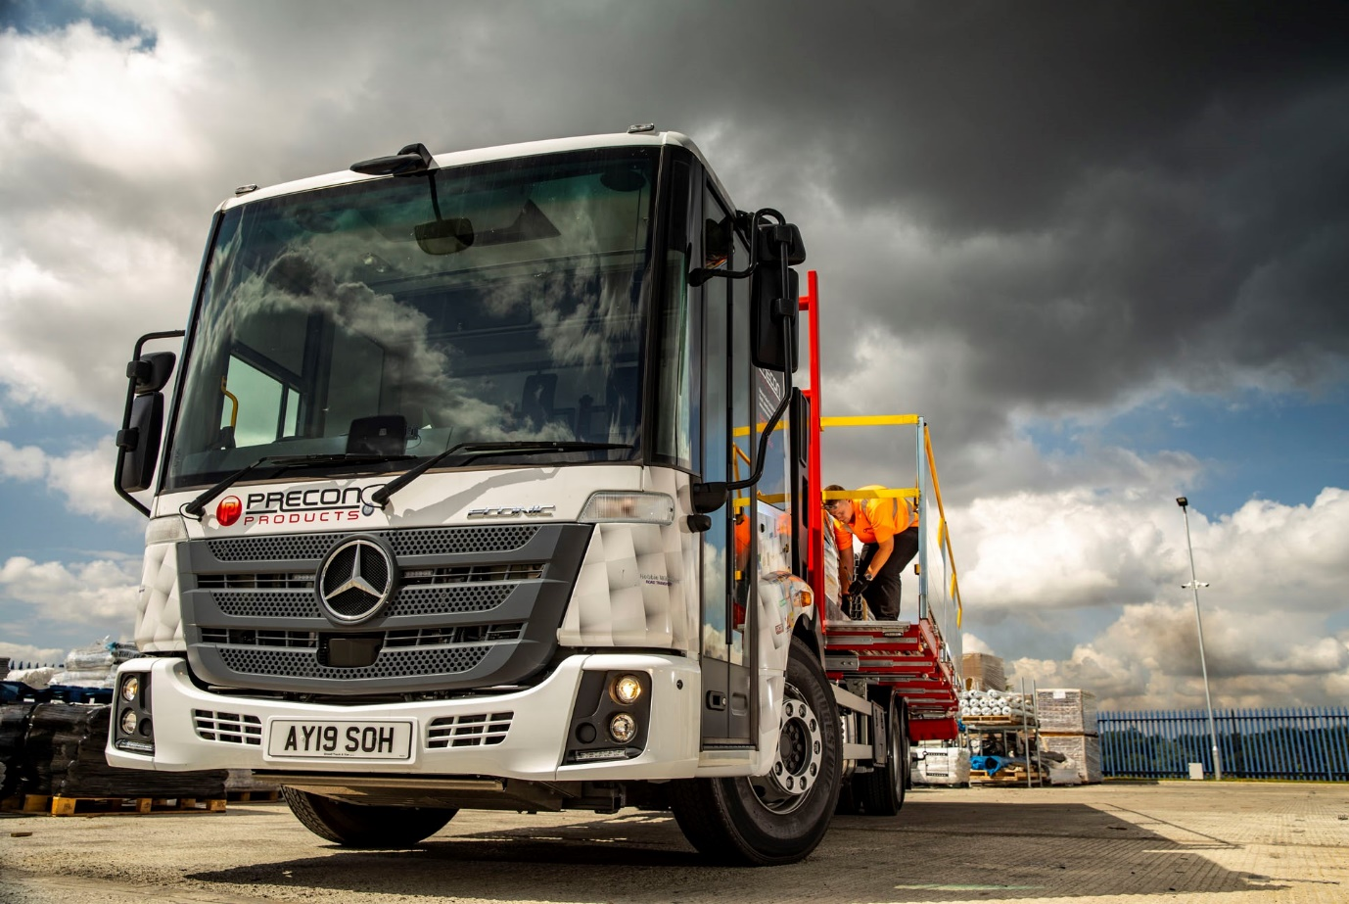

Precon Products takes a sideways look at safety with new Mercedes-Benz Econic

A heightened focus on the health and safety of truck drivers delivering to construction sites in London prompted Precon Products to develop an innovative dropside body concept based on a Mercedes-Benz Econic chassis.

The fast-growing company’s new 26-tonner is fitted with hydraulically operated walkways which run the full length of its bed and are accessed via fold-out steps. As a result, the driver does not have to clamber over the back to reach the load.

Precon Products, which has just moved the short distance from its previous base to a purpose-built headquarters on a four-acre site in Bury St Edmunds, took advantage of competitive funding support from Mercedes-Benz Finance to acquire its first truck.

Chosen primarily for its low-entry cab and impeccable Direct Vision safety credentials, the Econic 2635 L was supplied by East Anglia Dealer Orwell Truck & Van. It is powered by a high-torque, 7.7-litre straight-six engine which generates 260 kW (354 hp) and drives through a 12-speed Mercedes PowerShift 3 automated manual transmission.

The six-wheeler’s body was designed and built by ZJB Engineering, of Wisbech. Launched in June 2018 by Zennon Blackburn, who has an 18-year track record in the industry, the firm is already winning a reputation for its engineering capability.

Deployment of one or both of the 500 mm-wide walkways automatically activates strobe lights fitted beneath the platform at both ends. A fall arrest system means the dropsides are always raised when the walkways are in use. The truck is also equipped to FORS (Fleet Operator Recognition Scheme) Gold standard with a full complement of safety cameras and side scanners.

Finished in a distinctive livery applied by DJ Elbury & Son, also of Wisbech, it is being inspected and maintained under a Mercedes-Benz Complete Service Contract at Orwell Truck & Van’s Newmarket workshop.

Precon Products was established in 2008, and is now a £44-million turnover business, supplying a comprehensive range of products, tools, and accessories to the construction and building sectors nationwide. It also has depots in Northamptonshire, South Yorkshire, and Surrey.

Precon Products has supported developers working on a number of high-profile developments in London, including The Shard, and the new US Embassy. The company continues to rely on three haulage contractors to fulfil its transport commitments – between them they operate a fleet of 30 vehicles, all of which wear Precon Products’ colours.

“However, we’re employing a driver and running the Econic ourselves,” explained Managing Director Mike Philpot. “It’s all multi-drop work in London, which means that drivers often have to access the back of the truck to move products and materials around, and get them off.

“These days customers insist that vehicles must have side rails so no-one falls, which is great from a health and safety perspective. But if the truck is fully loaded there’s no room for the driver, so he ends up clambering over everything. That’s potentially dangerous in itself, and understandably the sites don’t like it.

“I therefore came up with the idea of adding walkways down the sides of the vehicle, which the driver can deploy at the touch of a button when he arrives on a site. He can then do whatever he needs to do, before getting off the back of the truck without risk of injury.”

Mr Philpot continued: “I’m not an engineer, so sat down with the bodybuilder and together we came up with a plan. There are other vehicles out there with variations of our walkway which drivers have to pull out manually. But when you’re on multi-drop deliveries time is of the essence, and to be quick you need an automatic solution. The truck is a prototype but the initial feedback from customers who’ve seen it has been very encouraging. If it works as we hope it will, then it could be a game-changer.”

Commenting on his choice of the Econic chassis, Mr Philpot added: “Mercedes-Benz trucks are widely recognised as the best on the market when it comes to reliability and whole-life costs.

“The Econic is also ideally suited to operation on London’s congested streets in terms of safety. Its deep, wraparound windscreen and full-height glazed side door contributes to excellent all-round visibility. The fact that the driver sits so much lower than he would in a conventional truck also allows him to make direct eye contact with vulnerable road users, especially cyclists, at junctions and in traffic.”

Although Precon Products has not previously operated its own trucks, it uses a trio of 3.5-tonne Mercedes-Benz Sprinter chassis cabs supplied by Orwell Truck & Van and fitted with dropside bodies to make urgent, same-day deliveries. “The Dealer provides an excellent service, and its Truck Sales Executive Chris Benefer was very helpful when we came to order the Econic,” added Mr Philpot.

www.preconproducts.co.uk

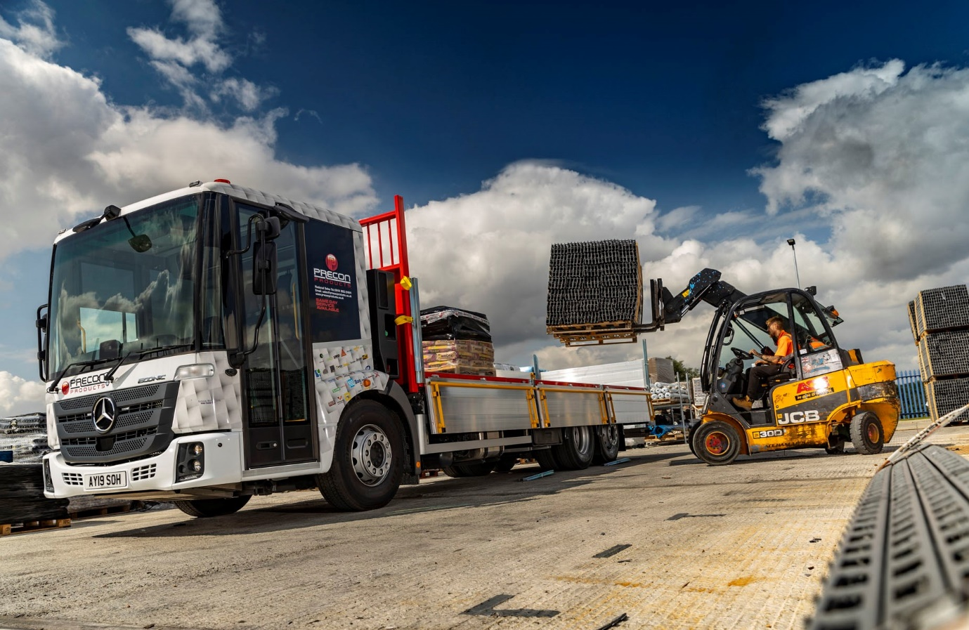

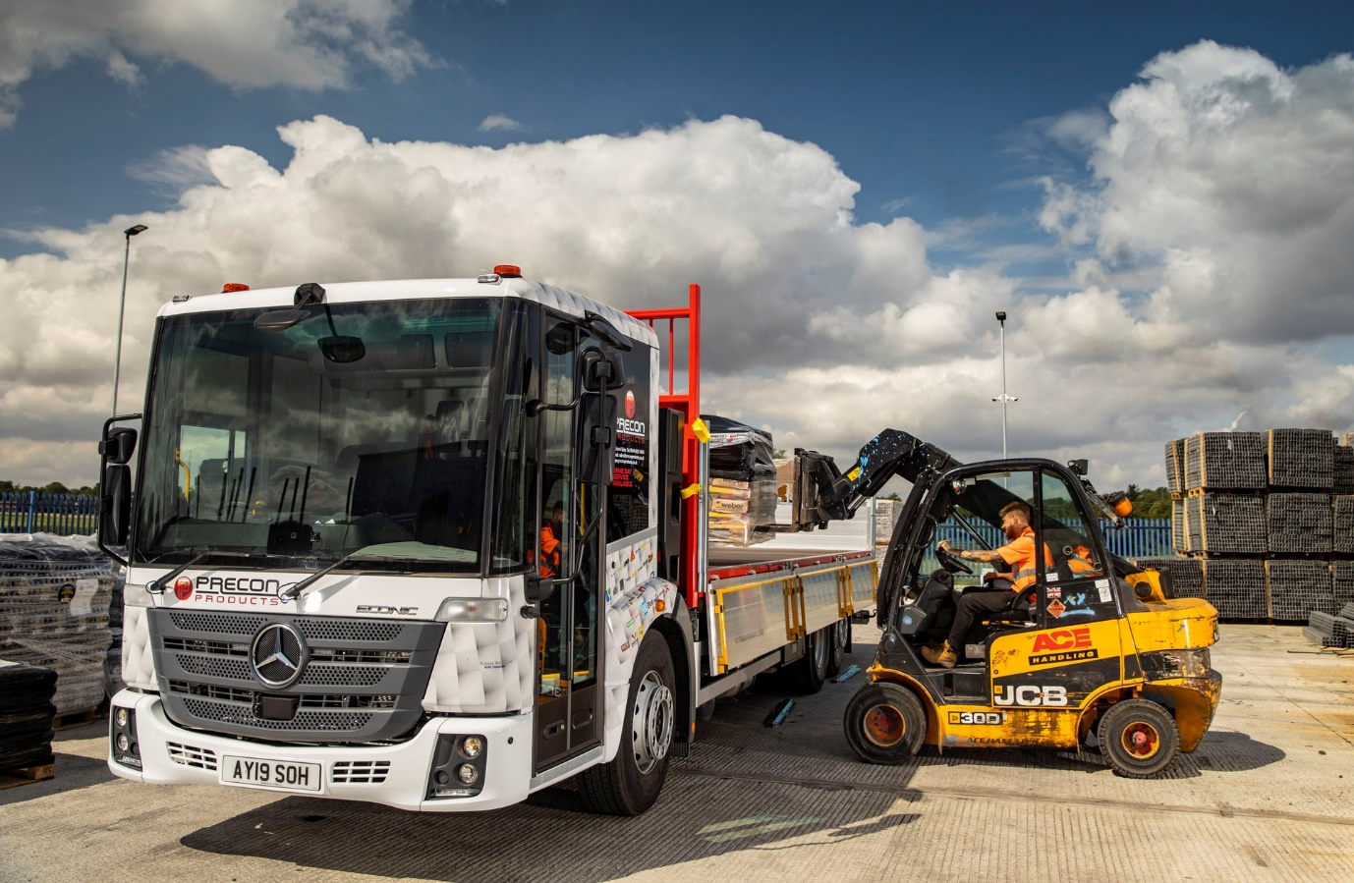

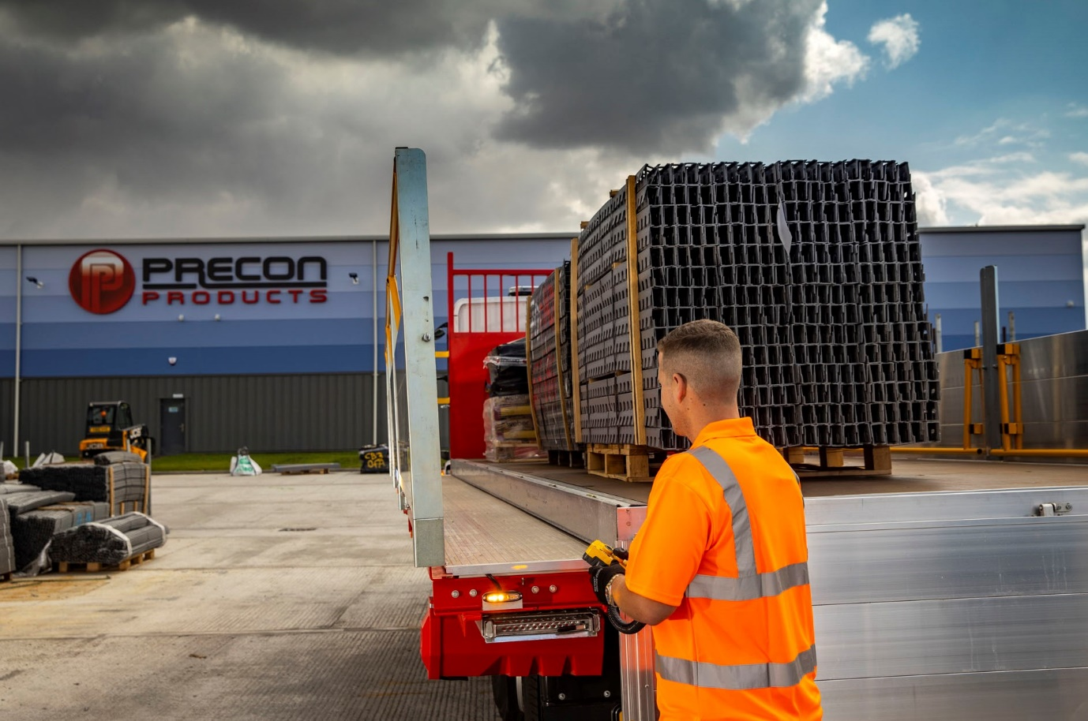

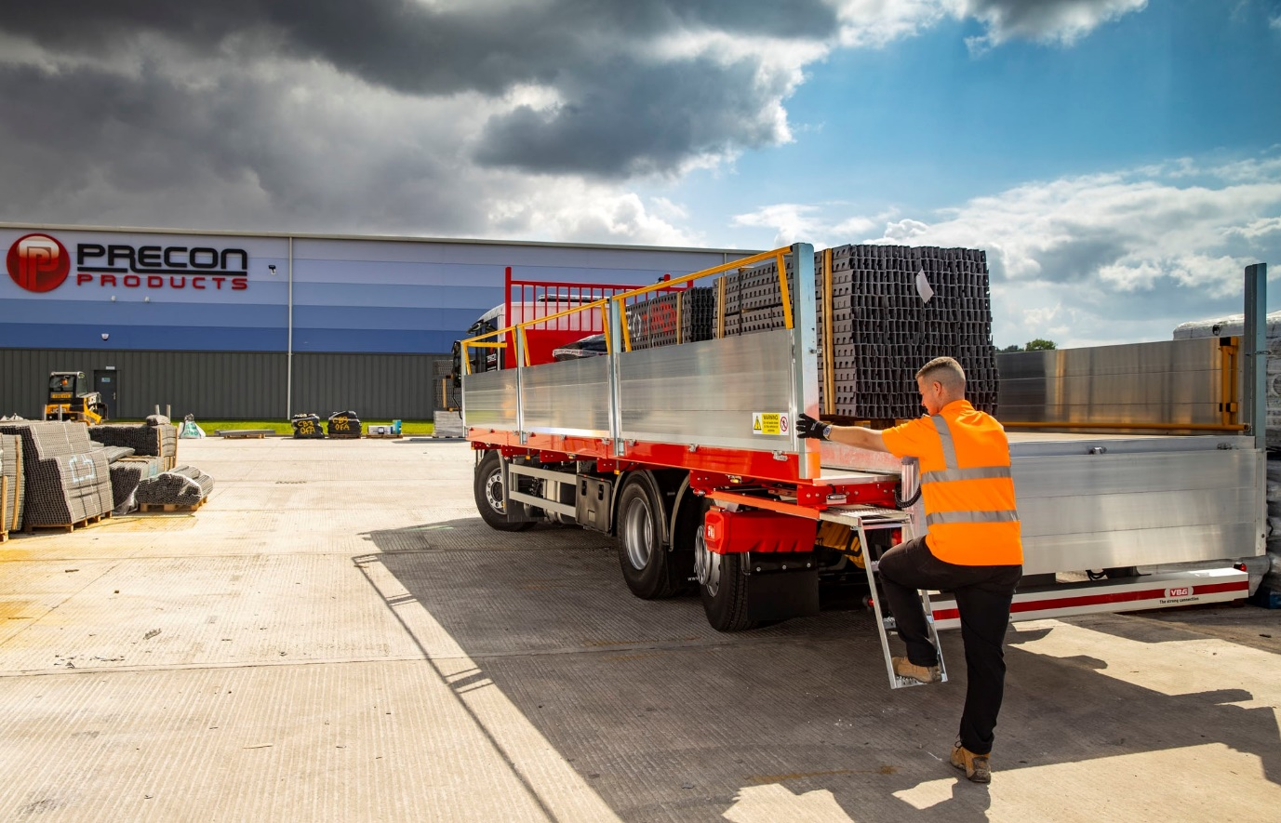

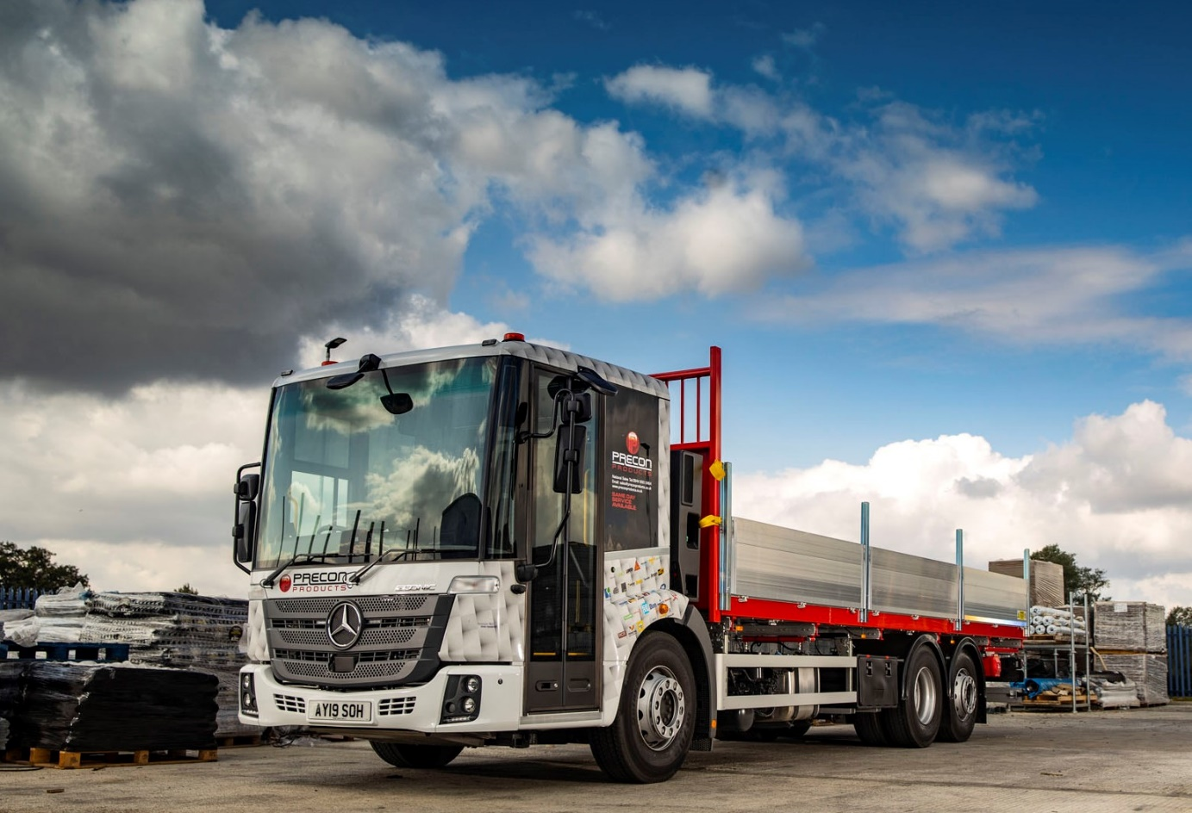

ends

For more information, or to request bigger/higher-res image files, please contact:
Steve Warren or John Ripley
Impact Communications, 01926 842126
John: 07771 484595, john@impactcom.co.uk
Steve: 07770 470251, steve@impactcom.co.uk

