

Date: 11 July 2019

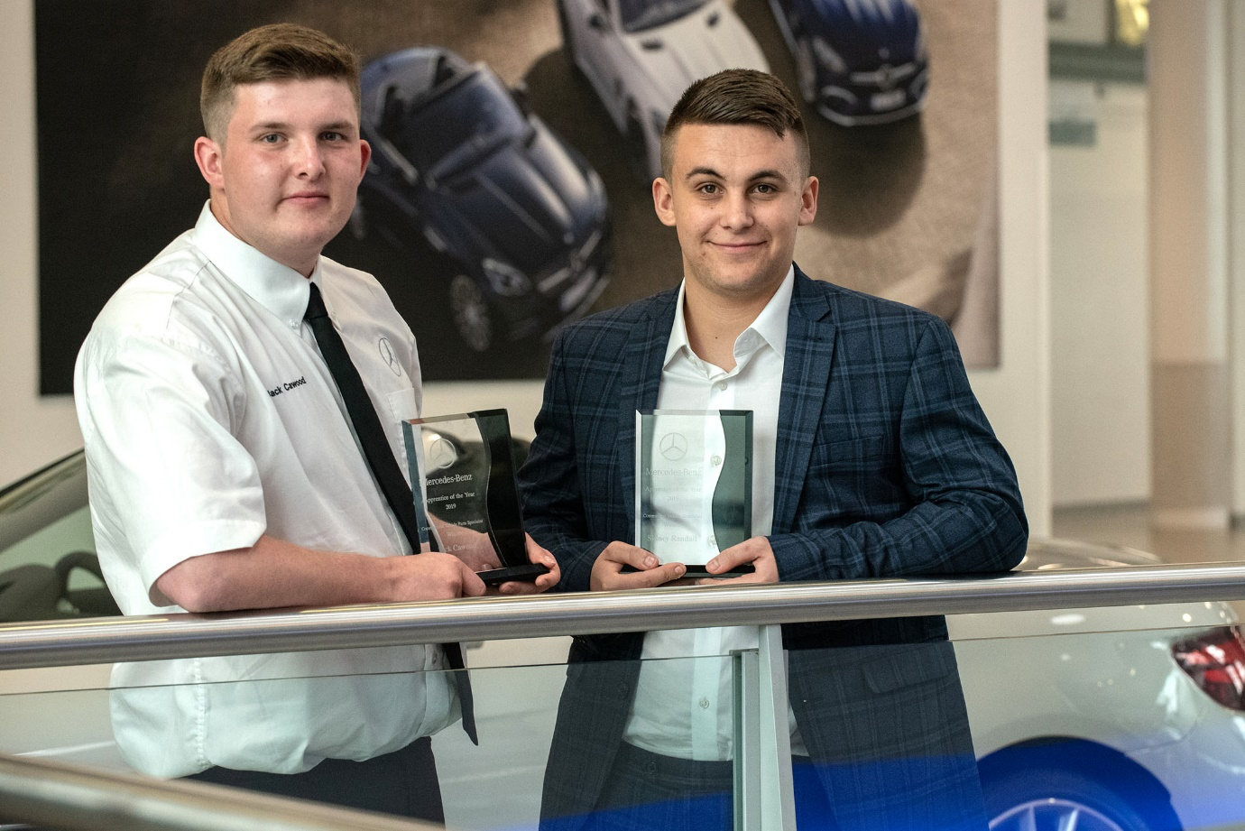

Off to a flyer: Award-winning Mercedes-Benz apprentices Jack Cawood, of Northside Truck & Van, left, and Sidney Randall, of Sparshatt Truck & Van, are now enjoying a behind-the-scenes insight into the high-octane world of Formula 1™

Mercedes-Benz crowns its truck and van stars of the future

Two of the truck and van industry’s brightest young talents have embarked on a ‘once-in-a-lifetime’ week of work experience with the Mercedes-AMG Petronas Formula 1™ team after winning prestigious accolades from Mercedes-Benz.

Jack Cawood, of Northside Truck & Van, landed the Mercedes-Benz Commercial Vehicle Parts Apprentice of the Year award, while Sparshatt Truck & Van’s Sidney Randall took the Technician Apprentice honours.

The two were chosen from shortlists of three for each job category, on the basis of their positive attitudes and behaviours, as well as their performances in online tests and practical assignments. Their prizes include an opportunity to work and learn at the Brackley headquarters of the Formula 1™ World Champions, in the run-up to the British Grand Prix at Silverstone.

Jack and Sidney were presented with their trophies by David Joyce, Mercedes-Benz Vans UK’s Director, Customer Services & Operations, and Sam Whittaker, Mercedes-Benz Trucks UK’s Director, Customer Service & Operations – all six finalists and their guests enjoyed a day to remember at the Mercedes-Benz World brand experience centre in Brooklands, Surrey.

Sam commented: “All of our finalists are right up there with the very best apprentices in the automotive industry. They have demonstrated exceptional levels of engagement and commitment to learning, while their drive to succeed is truly impressive.

“The individuals whose achievements we now celebrate will be the leaders of tomorrow. With their tremendous enthusiasm for the job, and clear grasp of the crucial importance of customer service, I have absolute confidence that the future of our business and brand is in safe hands.”

A former winner of the Large Employers prize at the National Apprenticeship Awards, Mercedes-Benz continues to invest heavily in the training and development of its young people. This year’s winners were chosen from the 688 apprentices who are currently on its apprenticeship programme.

In addition to on-the-job learning at their Dealerships, apprentices undertake block release study at the Mercedes-Benz Apprenticeship Academy in Milton Keynes. Staff take great pride in not only providing them with the product knowledge and practical skills they will need to excel in their roles, but also in supporting them with exemplary pastoral care.

Jack, aged 19, and from Brough, joined the Hull branch of Northside Truck & Van – Mercedes-Benz Trucks’ reigning Dealer of the Year – on leaving Hunsley Secondary School. He completes his three-year Parts Apprenticeship in August.

“I come from a family of truck drivers,” he explained. “My dad drives trucks, so do both my grandads, and various uncles and cousins. It’s only natural, I suppose, that I always wanted to get into the motor trade myself. I fancied doing something a bit different, though, so when I saw the advertisement for this apprenticeship I jumped at it.”

It is the second year running that a Northside Truck & Van trainee has won the Parts Apprentice award. “I love the job,” Jack continued. “There’s never a dull day, and always something new to learn. I work with a great team, too. One of the great things about Northside is that you’re told never to be afraid of asking what might turn out to be a stupid question. Instead, you’re actively encouraged to seek help, rather than keep your head down and struggle on, which has to be better in the long run.”

He added: “This is so much more than just another job. I have an opportunity to build a long-term career here, and I’m determined to make the most of it.”

Sidney is equally positive about the support he receives from his colleagues at Sparshatt Truck & Van. The 22-year-old, who lives in Grays, joined his father’s painting and decorating business on leaving school, but decided it wasn’t for him. He is almost two years into his three-year Technician Apprenticeship, and will then do a fourth, ‘finisher’ year.

“If senior colleagues realise you’re trying, they’re only too happy to help,” said Sidney. “And if they’re prepared to commit their time and effort to me, then the very least I can do is pay attention and learn from them. After all, that’s what I’m here for.”

Like the rest of Sparshatt’s Dartford team, Sidney has just transferred from the company’s previous base to a new, £2-million service facility. “It’s brilliant,” he enthused. “We’re so busy that we’d outgrown the old place some time ago. We didn’t have any pits before, but the new workshop has two, and they make the job so much easier.”
He added: “The training and support we receive from Mercedes-Benz is fantastic, and I’m really looking forward to my week of work experience with the Mercedes-AMG Petronas team – it’s something that money just can’t buy.”

The Mercedes-Benz Apprenticeship Academy has trained some 3,500 young parts specialists and technicians since its inception in 1995, of whom 65% are still working within its Dealer and Retailer networks.

The six Mercedes-Benz Commercial Vehicle Apprentice of the Year finalists were:

Parts Apprentices
Winner, Jack Cawood, Northside Truck & Van, Hull
Andrew Edwards, Roanza Truck & Van, Deeside
Sofia Keilholz, Intercounty Truck & Van, Wellingborough

Technician Apprentices
Winner, Sidney Randall, Sparshatt Truck & Van, Dartford
David Bainbridge, Northside Truck & Van, Hull
Harry Frolich, Rygor Commercials, Heathrow

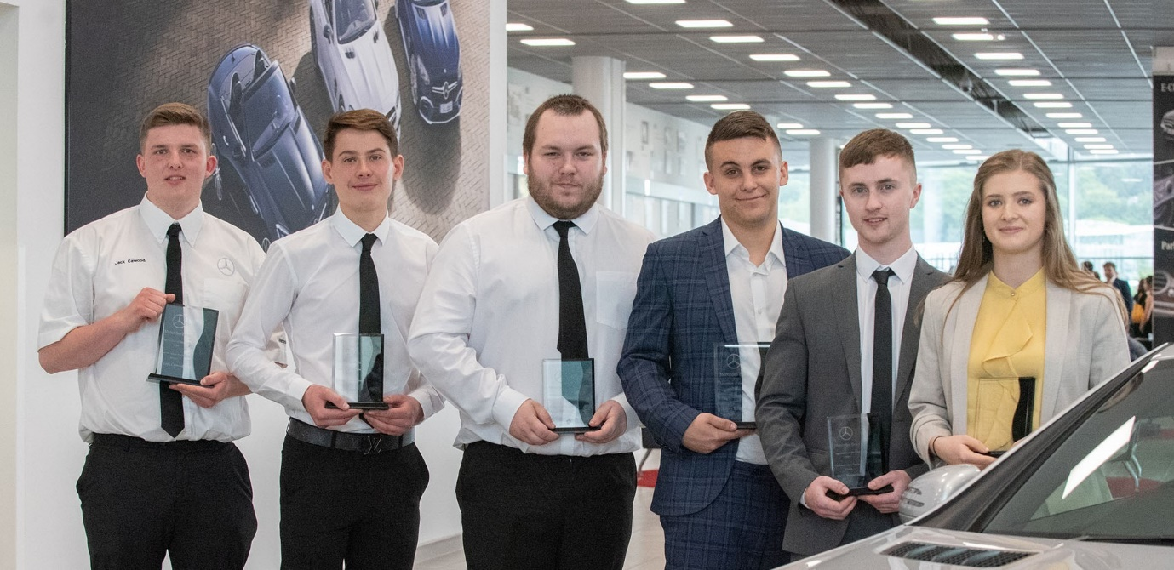

Winners all: From left, Jack Cawood, Northside Truck & Van; Harry Frolich, Rygor Commercials; Andrew Edwards, Roanza Truck & Van; Sidney Randall, Sparshatt Truck & Van; David Bainbridge, Northside Truck & Van; and Sofia Keilholz, Intercounty Truck & Van



Going down… but their careers are definitely ‘on the up’: The Mercedes-Benz Commercial Vehicle Apprentice of the Year finalists

ends

For further information, please contact:

Jamie Fretwell, PR & Internal Communications
Mercedes-Benz Trucks
07712 519230, Jamie.Fretwell@daimler.com
Caroline Burnell, PR & Internal Communications
Mercedes-Benz Vans
07876 217056, Caroline.Burnell@daimler.com
or

Steve Warren or John Ripley
Impact Communications, 01926 842126
John: 07771 484595, john@impactcom.co.uk
Steve: 07770 470251, steve@impactcom.co.uk

