

Date: 12 October 2022

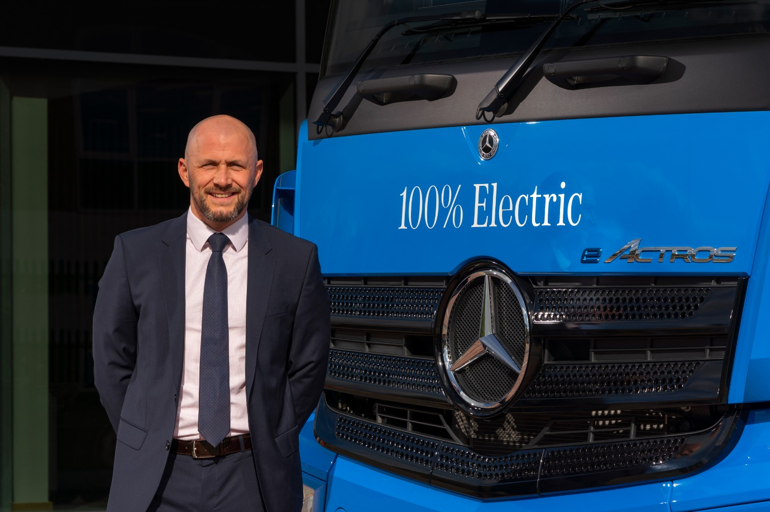

Proven performer: New Sales Director Stuart Jeggo is already a familiar face to many Mercedes-Benz Trucks UK customers

Mercedes-Benz Trucks UK appoints Stuart Jeggo as Sales Director

Stuart Jeggo has been promoted to the role of Sales Director at Mercedes-Benz Trucks UK. The appointment, which Stuart takes up on 15 October 2022, completes the manufacturer’s senior management team line-up.

As Head of Key Account Management, Stuart is already a well-known figure to Mercedes-Benz and FUSO truck customers and Dealer colleagues.

He joined the Mercedes-Benz Trucks family as a Business Development Manager in 2013, with responsibility for supporting the Dealer network in its efforts to provide the highest levels of customer service.

In 2016 Stuart was promoted to the position of Head of Strategic Accounts & Municipal Sales, then to Head of Key Account Management the following year. As Sales Director he will have oversight of all vehicle sales to operators, from the country’s largest fleets to owner-drivers, across the Mercedes-Benz Trucks and FUSO Canter brands.

Stuart’s appointment was welcomed by Mercedes-Benz Trucks UK Managing Director Heiko Selzam. He said: “Under Stuart’s leadership the Key Accounts team successfully changed the shape of our fleet business in the UK, encouraging growth through a clear strategy of building long-term, sustainable partnerships with our customers.

“By taking on the position of Sales Director, Stuart becomes the last piece of the jigsaw to round off our team of senior department heads,” he continued. “Along with Customer Service & Parts Director Can Balaban, and Chief Financial Officer Rodrigo Landi, he’ll be responsible for creating and implementing the strategies that will drive our business forward.”

Stuart added: “I’m really looking forward to deepening my relationships with truck operators, our Dealer partners and the wider Mercedes-Benz Trucks team as we continue on the journey towards decarbonisation together. Our industry will transform more in the next five years than it has in the previous 50, and I know we have the right products, the right services and the right team to bring the finest customer experience to everyone.”

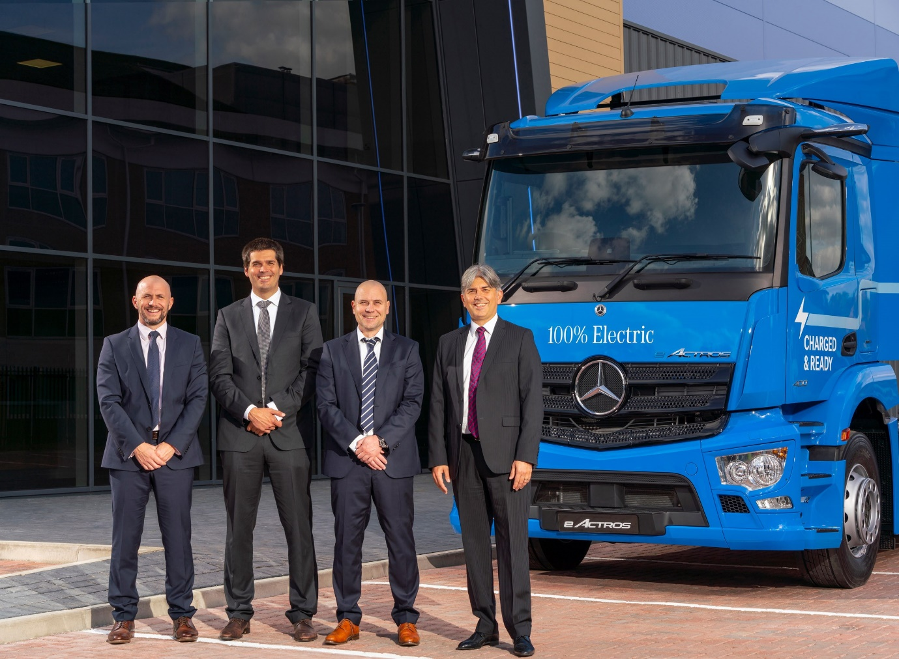

Top team: Mercedes Benz Trucks UK Managing Director Heiko Selzam, second from right, with, from left, Sales Director Stuart Jeggo, Chief Financial Officer Rodrigo Landi and Customer Service & Parts Director Can Balaban

ends

For more information, please contact:

Jamie Fretwell at Mercedes-Benz Trucks UK Ltd
07712 519230, jamie.fretwell@daimler.com

or

Steve Warren or John Ripley
Impact Communications
Steve: 07770 470251, steve@impactcom.co.uk
John: 07771 484595, john@impactcom.co.uk

