

Date: 14 April 2022

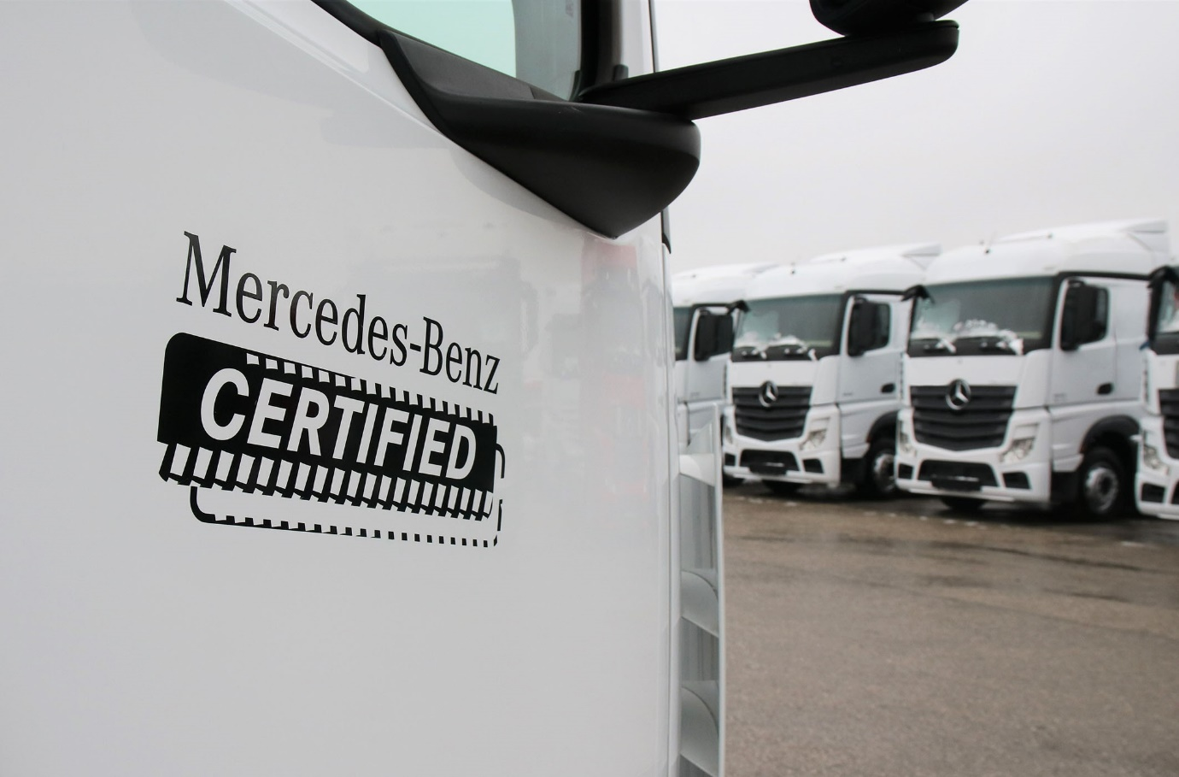

Mercedes-Benz Certified: ‘Made with pride, maintained by passion, driven by you’

Mercedes-Benz Certified delivers complete peace of mind for used truck buyers

There’s a new name for premium quality used trucks, and Mercedes-Benz Certified has raised the bar when it comes to customer confidence.

The new brand underscores the determination of Mercedes-Benz Trucks UK and its dealer partners to provide buyers with access to the industry’s finest pre-owned products and support packages.

Trust is key – every truck offered with a Certified stamp will have undergone an intensive, multi-point inspection by expert technicians at the Wentworth Park complex near Barnsley, which is home to the manufacturer’s commercial vehicle remarketing operation.

No truck offered for sale under the Certified banner will be more than five-and-a-half years old, or have covered in excess of 550,000 km. The first service will not be due for at least 20,000 km and tyres will have a tread depth of no less than 6mm.

It will be at least five months before the vehicle requires an MOT test and the manufacturer’s warranty will be valid for a minimum of 12 months; enhanced Extend and ExtendPlus cover for the driveline and full vehicle respectively is also available on all Certified trucks.

Customers, who have a 14-day right to exchange (subject to terms and conditions), can take advantage of a flexible and competitively priced Mercedes-Benz Finance package to fund their acquisition, and fix their maintenance costs by signing-up to a Mercedes-Benz Complete or Best Basic Service Contract. Nationwide aftersales back-up is provided by 78 Authorised Repairers, many of whose workshops are open round-the-clock.

“We understand that it’s not easy to find the right used truck,” said Tom Morris, Head of Used Trucks. “That’s why we created Certified. Offering confidence by the truckload, it’s nothing less than a personal guarantee that a vehicle has been meticulously prepared by a truly passionate team of Mercedes-Benz truck specialists.

“If a truck hasn’t been through our dedicated facility, which is home to a unique concentration of inspection, maintenance, testing and tooling capabilities, then it hasn’t been Certified.”

Tom said the Mercedes-Benz Trucks UK Dealer network had welcomed the launch of Mercedes-Benz Certified and the heightened focus on sales of pre-owned vehicles, particularly given the current strength of the used truck market.

“The Dealers are really excited about the new brand, which has consolidated and simplified our used truck offer,” he continued. “I’m not so naïve as to think that the unprecedented demand for pre-owned vehicles we’re seeing at the moment, is going to last. It won’t, because it’s a situation that’s arisen due to a very specific set of circumstances affecting not only our own industry but also wider economies, on an international scale.

“However, Mercedes-Benz Certified has not been designed to take advantage of a short-term phenomenon. Rather, it’s about sustainability and longevity. By managing the route to market for the very best used vehicles, we will underpin the premium values and future success of the entire Mercedes-Benz Trucks business here in the UK.

“Our ambition is that every Mercedes-Benz Certified customer should enjoy all the excitement and practical benefits in terms of reliability, fuel-efficiency and safety, as the truck’s original owner. If that vehicle is also going back into our Dealer network to be maintained under contract, so much the better.”

He added: “The team here at our truck remarketing facility live and breathe Certified. It’s a programme that’s run to the highest standards by total professionals. I trust them implicitly and, more importantly, so can our customers.”

Pre-owned examples from the entire range of trucks bearing the three-pointed star, which extends from 7.5-tonne rigids to 44-tonne tractor units, and also includes heavy-haulage variants, will be retailed through the Mercedes-Benz Certified programme. So, too, will FUSO Canters from 3.5 to 8.55 tonnes GVW – Mercedes-Benz Dealers also sell and support the popular FUSO light truck range in Britain.

To find out what’s currently available, operators should contact their local Mercedes-Benz Dealer or visit www.mbtruckselector.co.uk/

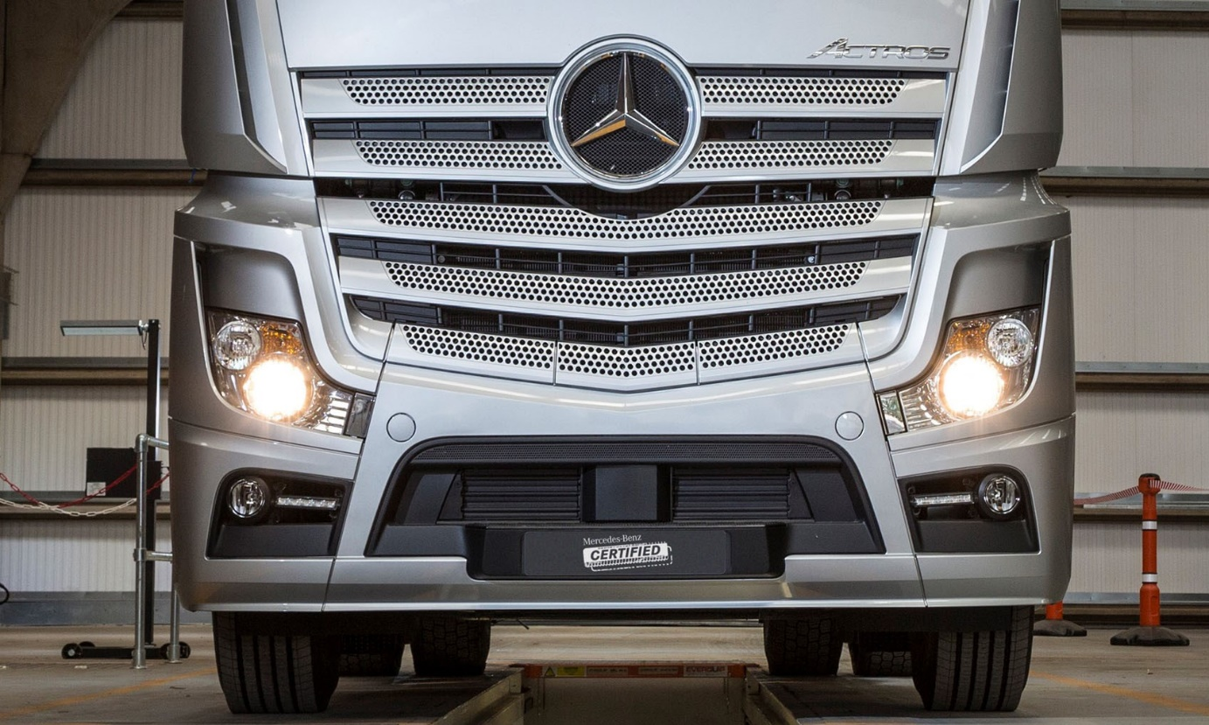



Tom Morris: “Mercedes-Benz Certified offers confidence by the truckload”

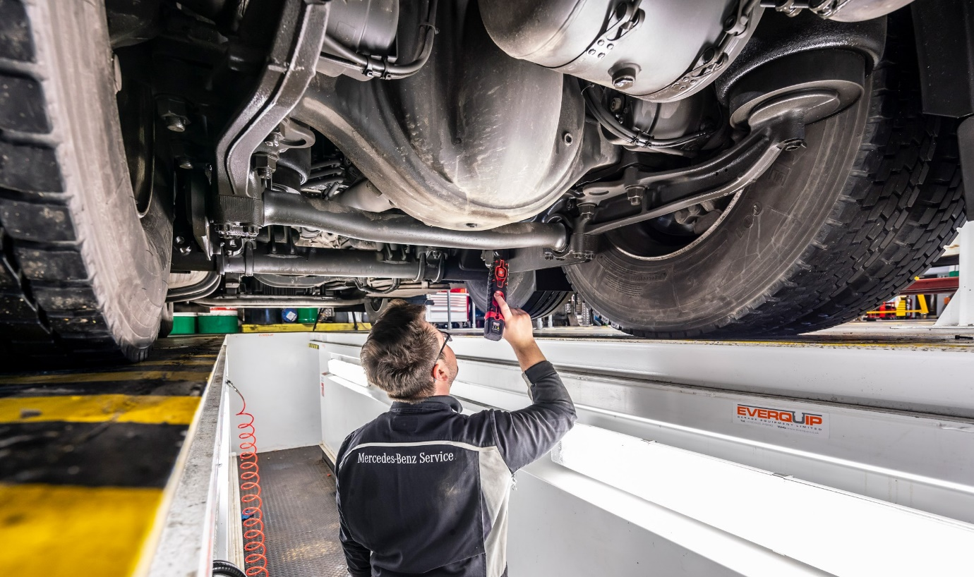

Quality assured: Every vehicle offers under the Mercedes-Benz Certified banner is the subject of a rigorous, multi-point inspection
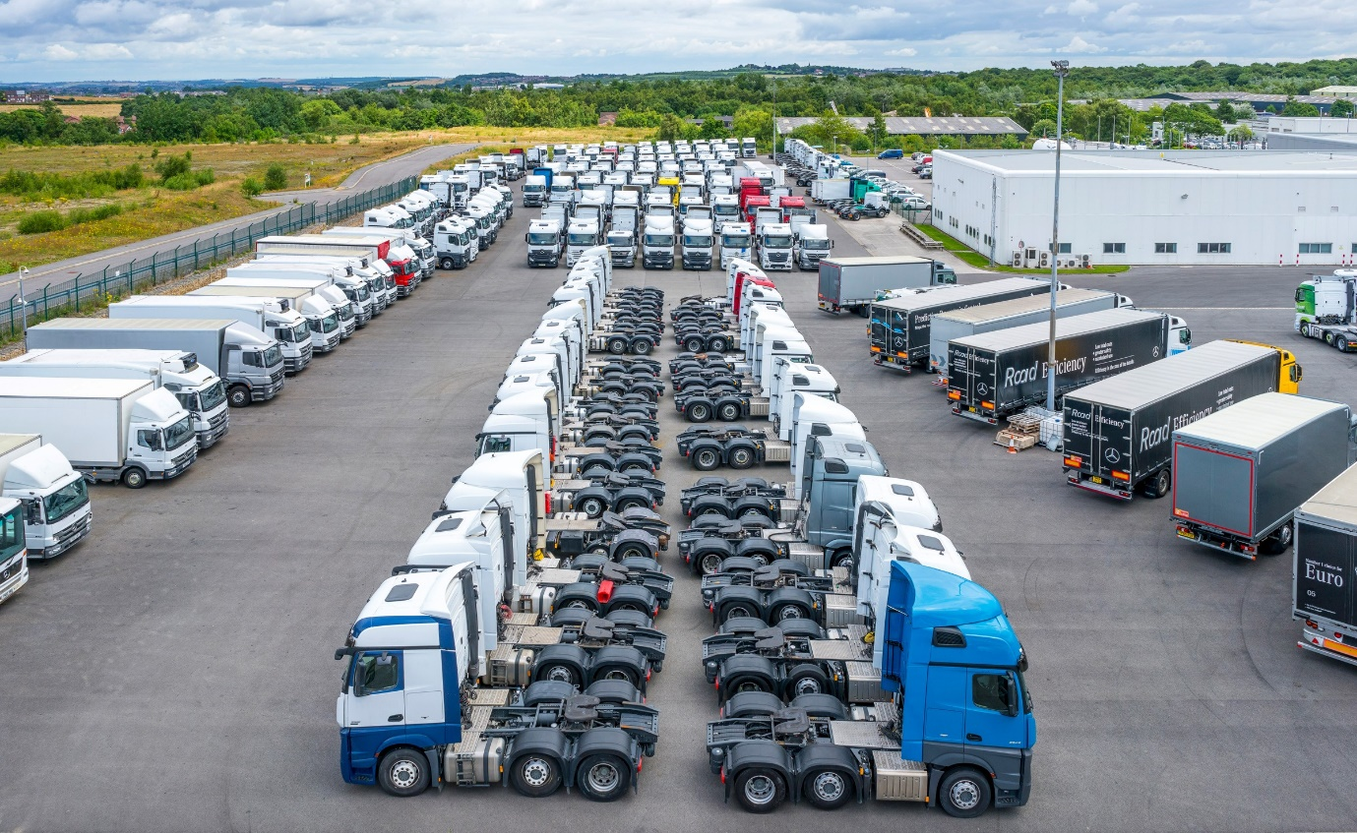

Dedicated facility: The Wentworth Park complex is home to Mercedes-Benz Trucks UK’s vehicle remarketing operation

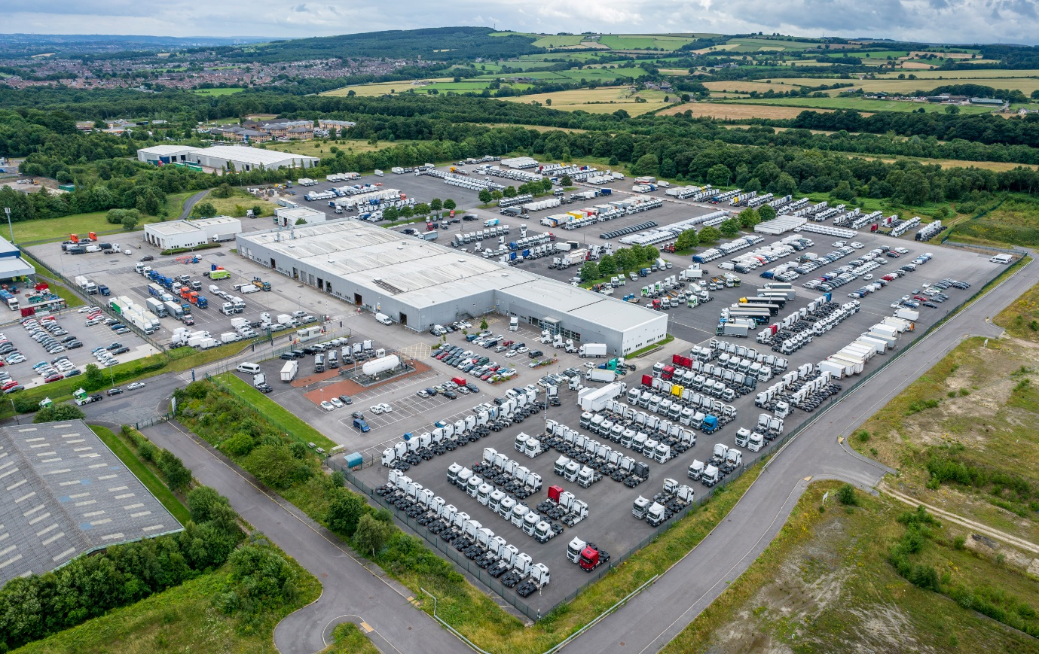

ends

For more information, please contact:

Jamie Fretwell at Mercedes-Benz Trucks UK Ltd
07712 519230, jamie.fretwell@daimler.com

or

Steve Warren or John Ripley
Impact Communications
Steve: 07770 470251, steve@impactcom.co.uk
John: 07771 484595, john@impactcom.co.uk

