

Date: 8 July 2022

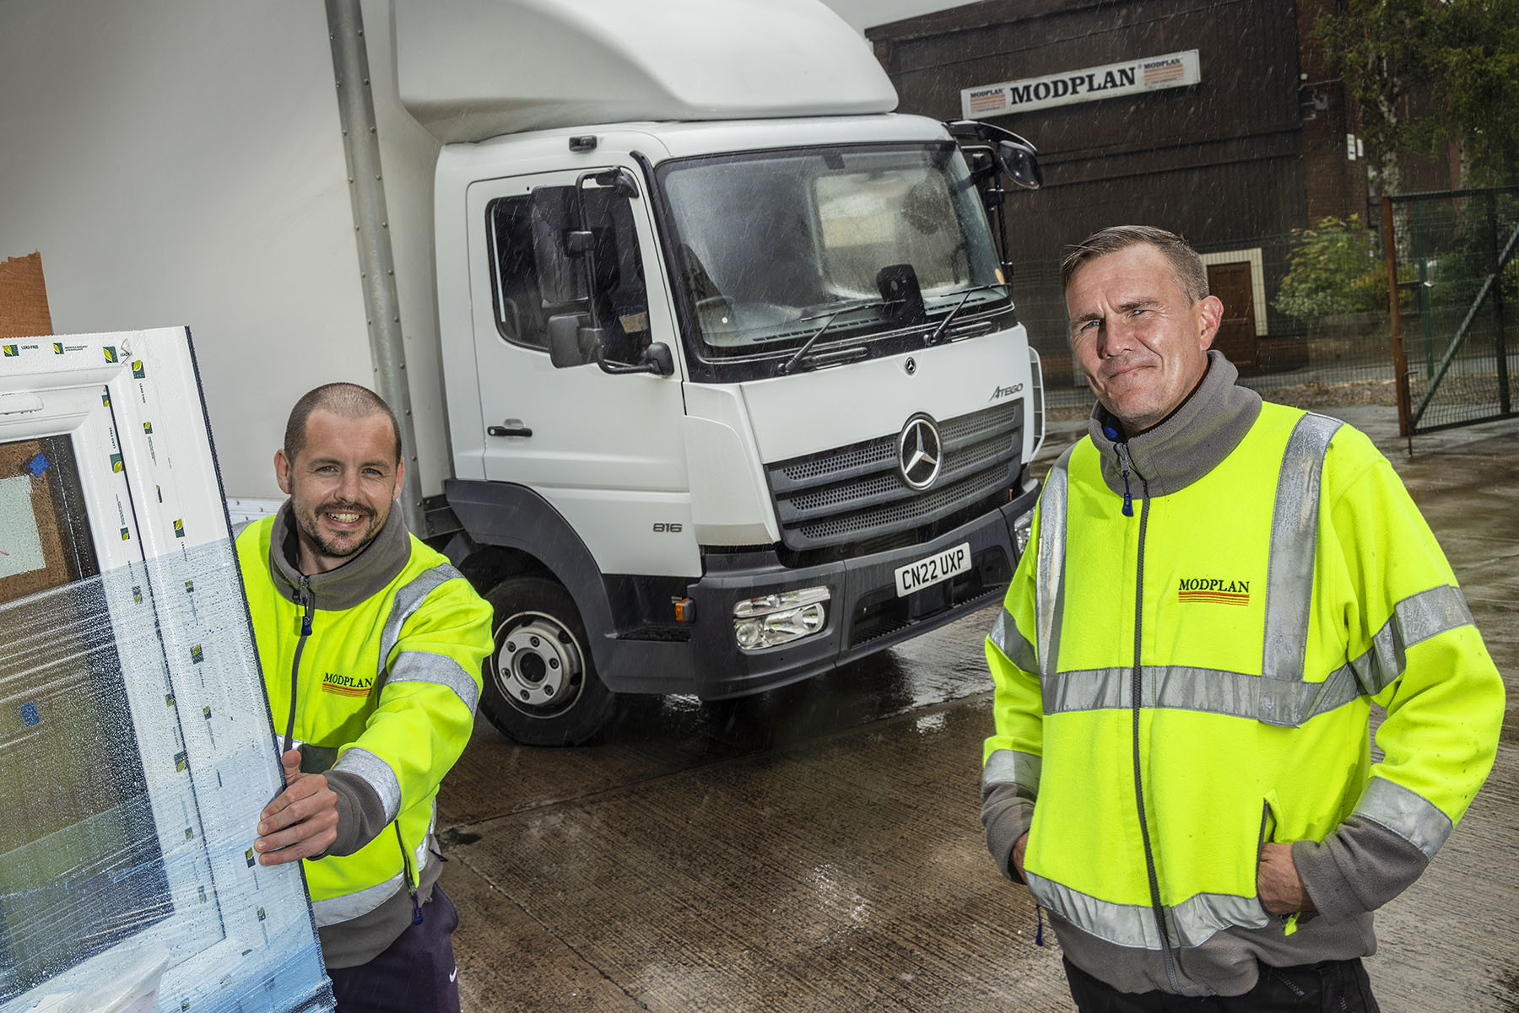

Window of opportunity: Logistics Manager Gareth Gough, left, and Transport Manager Alan Oldham are pictured with one of the new Mercedes-Benz Atego trucks that are now helping to support Modplan’s continued growth

Modplan opens the door to another clutch of ‘pane-free’ Mercedes-Benz Atego trucks from Euro Commercials

“Bombproof” build quality and customer-focused aftersales back-up led Newport-based Modplan back to its local Dealer for the latest 7.5-tonne additions to its all-Mercedes-Benz fleet.

The leading supplier of high-performance PVCu windows, doors and conservatories returned to Euro Commercials for seven more trucks from the Atego light- and medium-duty distribution range.

Three have replaced vehicles from the previous Atego model generation that provided highly reliable and cost-effective service for 10 years. The remaining four represent extensions to the fleet, and will support Modplan’s continued growth.

Gareth Gough, the company’s Logistics Manager, explained: “We needed more trucks to meet the increased demand for our products. With the price of fuel continuing to rise to eye-watering levels, it also made sound business sense to invest in newer equipment, which is more economical to run and better for the environment.”

Every one of Modplan’s 15 vehicles wears a three-pointed star and arrived via Euro Commercials. With the exception of a single 18-tonner, all have 7.5-tonne gross weights.

Modplan took advantage of competitive funding support from Mercedes-Benz Finance to acquire its new trucks, which have box bodies by Cardiff Truck & Bus. All are 816 variants with ClassicSpace S-cabs and 5.1-litre engines that produce 115 kW (156 hp).

As well as offering outstanding driving dynamics, comfort and manoeuvrability, the Mercedes-Benz Atego is renowned for its industry-leading reliability and durability. Modplan’s trucks deliver its premium-quality products to trade customers nationwide who account for up to 70% of its turnover; the rest is export business, most of it with Scandinavia.

Gareth Gough recalled: “We purchased our first batch of seven Mercedes-Benz trucks from Euro Commercials in 2012. They were so much better in every respect than the vehicles we were using previously that we’ve stuck with them ever since.

“Indeed, the Atego has proved to be pretty well bombproof, so much so that we still have three of those original trucks. Each has now covered in excess of half a million miles but they’re still out there doing the job, day in, day out, which is a great testament to the brand.”

In a new departure, rather than opting again for manual gearboxes Modplan specified its latest trucks with six-speed Mercedes PowerShift 3 automated manual transmissions, which offer slick changes and feature an EcoRoll mode that helps to reduce fuel consumption.

In another ‘first’, the operator has signed-up to five-year Mercedes-Benz Complete Service Contracts. “Euro Commercials has always looked after our Mercedes-Benz trucks at its Newport branch, but we’d not gone for a repair and maintenance agreement previously,” continued Mr Gough. “We’ve done so on this occasion because the package was particularly attractive, not least in terms of price.”

Transport Manager Alan Oldham added: “The Atego is ideally suited to our operation. It’s not the lightest or indeed the cheapest 7.5-tonner, but what you do get is indestructible build quality and reliability, plus an exceptionally high level of comfort. All of which mean it’s great value for money. What’s more, the trucks are very well-liked by the drivers, and particularly the new ones, which have suspended seats.”

Modplan also values highly, the support it receives from Euro Commercials. Gareth Gough praised the service provided by Truck Sales Executive Darren Hobbs: “Spot on, with very good communication. He’s done everything I could have asked for.”

Alan Oldham, meanwhile, is in regular contact with the Dealer’s workshop team, and singled out Service Manager Mike Jones, Workshop Controller Neil Wiltshire and Service Advisor Paul Robins for special praise.

“We have a fantastic relationship with the guys at Euro Commercials,” he enthused. “They’re very flexible when it comes to getting vehicles in for their six-weekly checks at times that suit us, and provide our drivers with courtesy vans in which to go home and return to collect their trucks.

“We also know that if ever we have a specific issue we can drop the truck with them and they’ll get a technician onto it very quickly. It’s a brilliant service and goes a long way towards explaining our continued loyalty to Mercedes-Benz.”

modplan.co.uk

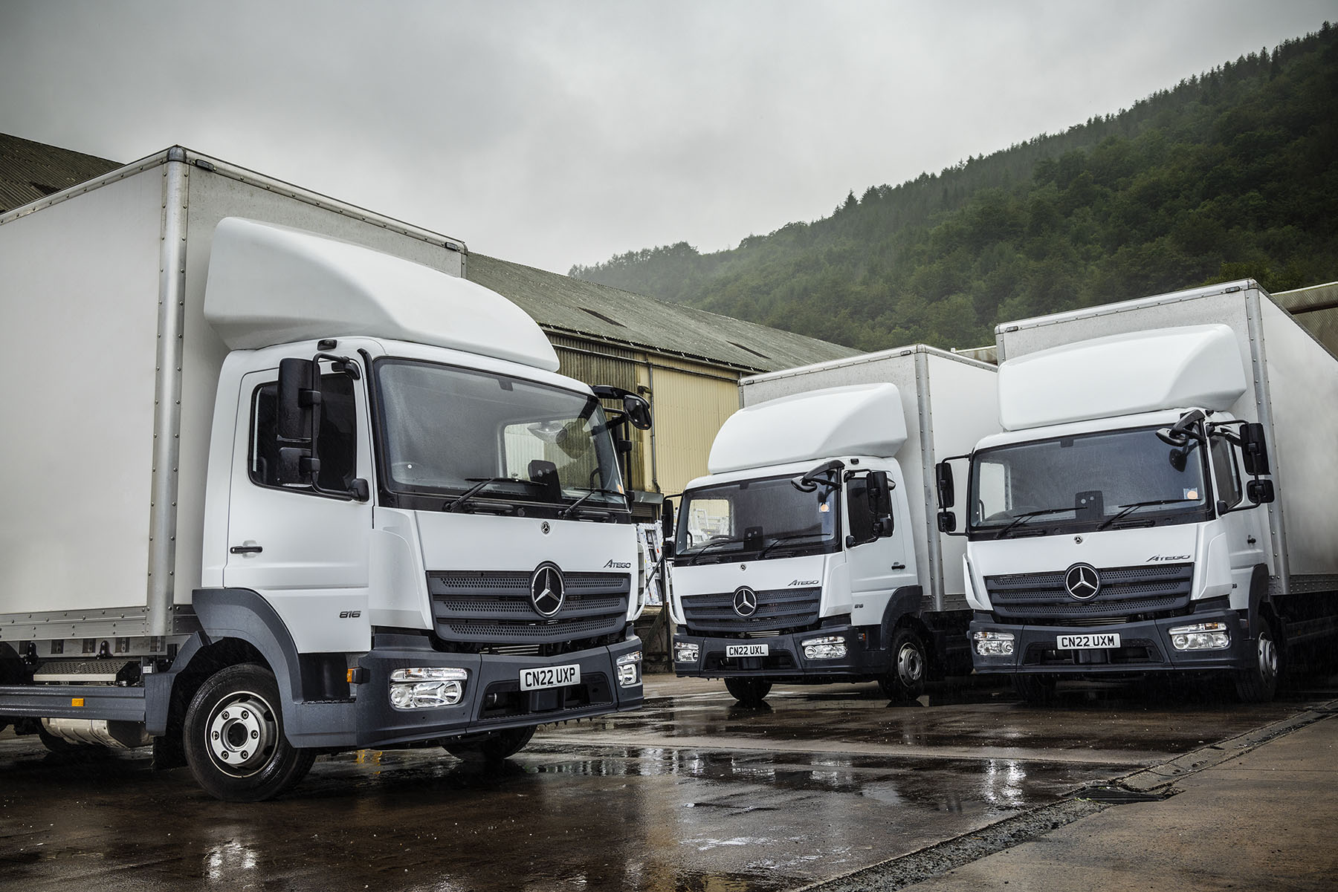

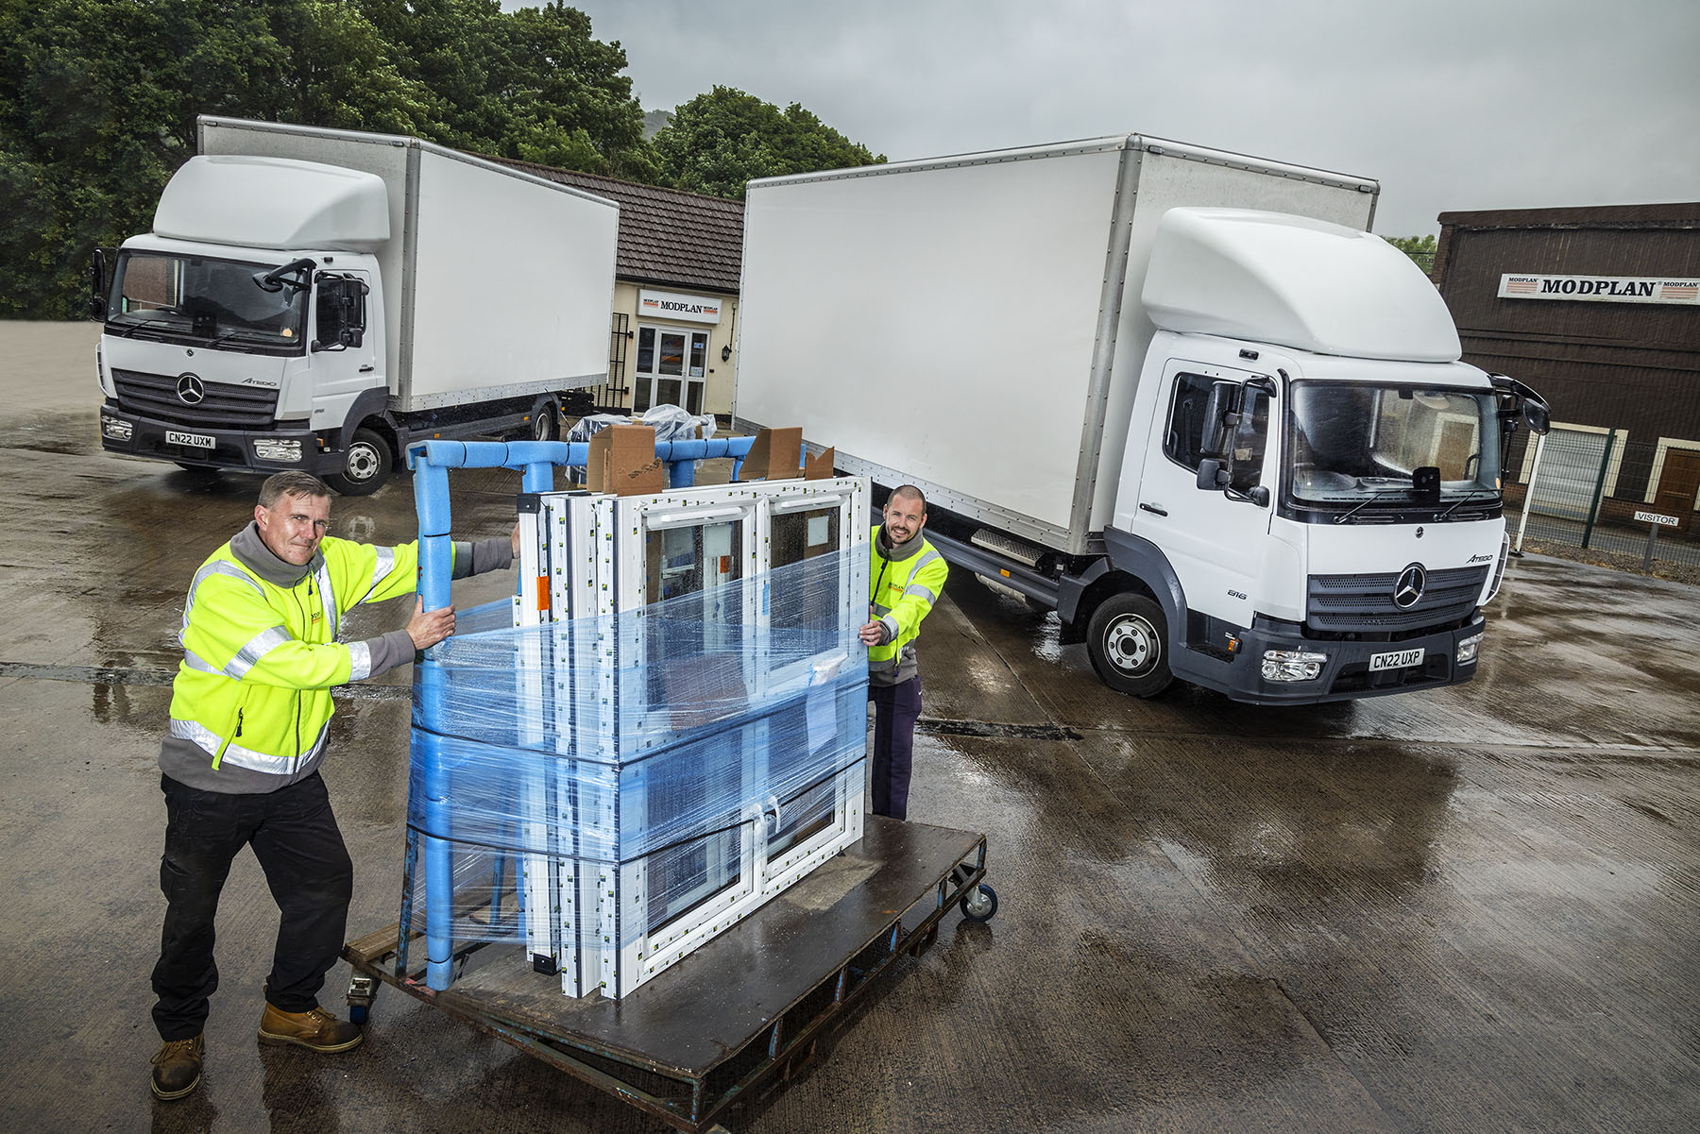

Frame game: Modplan Transport Manager Alan Oldham, left, and Logistics Manager Gareth Gough are pictured with two of the new Mercedes-Benz Atego supplied by Euro Commercials

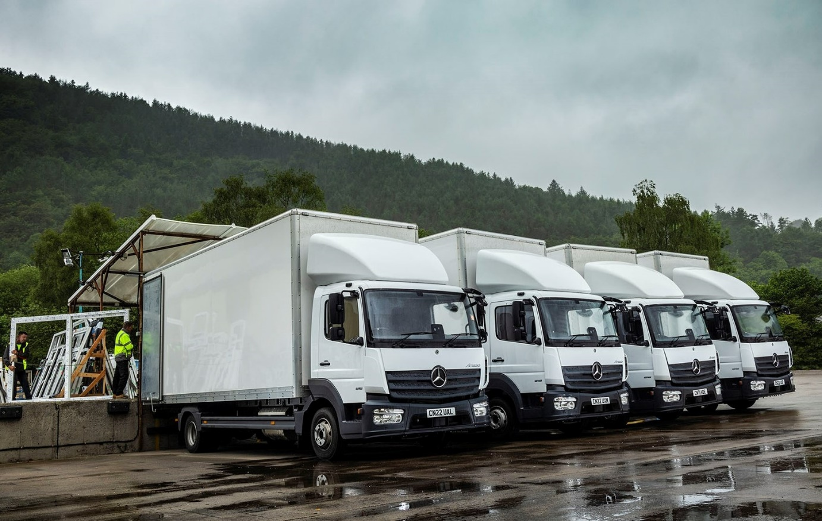

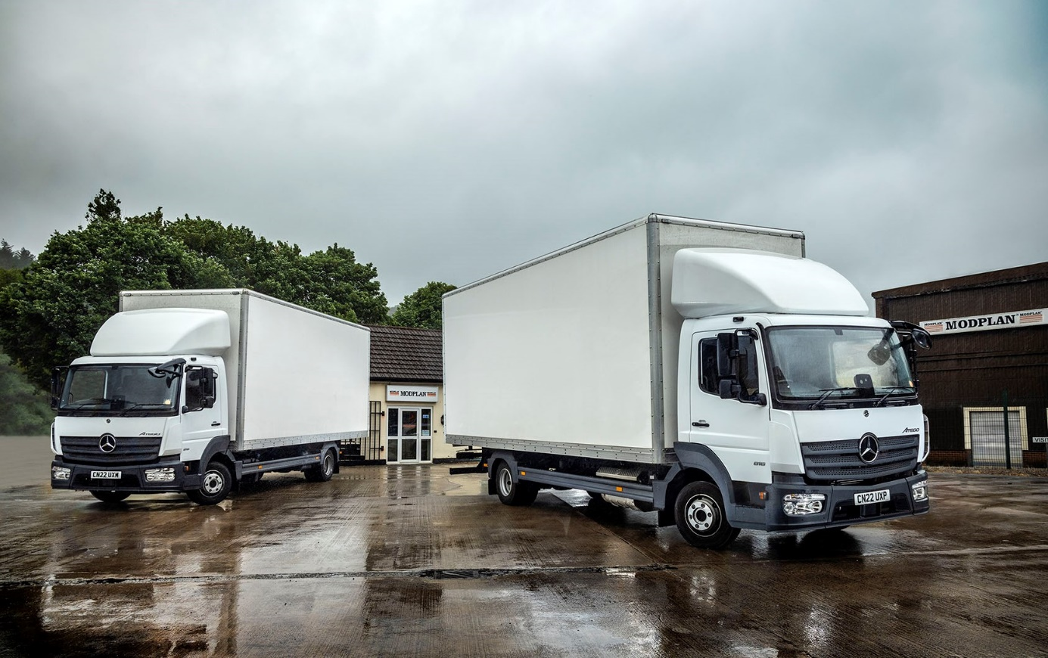

ends

For more information, or to request bigger/higher-res image files, please contact:
Steve Warren or John Ripley
Impact Communications
Steve: 07770 470251, steve@impactcom.co.uk
John: 07771 484595, john@impactcom.co.uk

