

Date: 12 June 2019

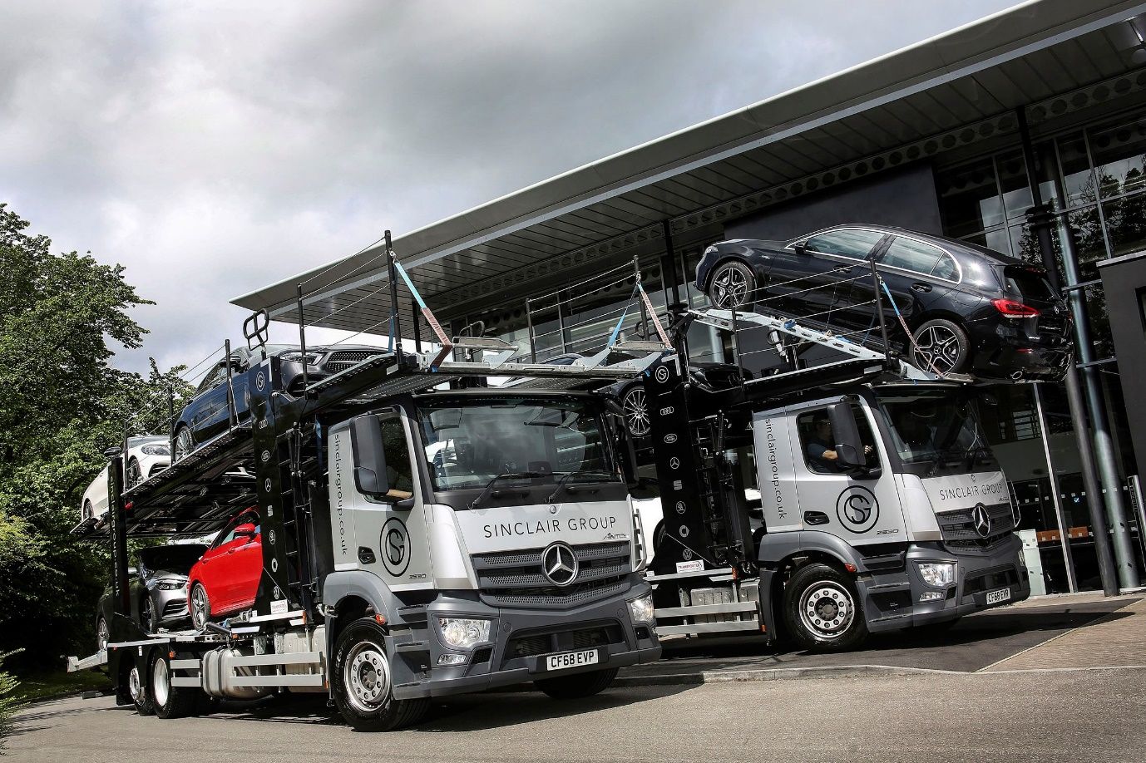

Sinclair Group puts its trust in new transporters from Mercedes-Benz Dealer Euro Commercials

A pair of 26-tonne Mercedes-Benz Antos car transporters are helping to ensure that vehicle retailer Sinclair Group stays on the road to success.

Supplied to the Bridgend-based company by South Wales Dealer Euro Commercials, both are 6x2 Antos 2530 models with 7.7-litre engines which produce 220 kW (300 hp) and drive through eight-speed Mercedes PowerShift 3 automated transmissions.

Their CompactSpace M-cabs have low roofs in order to accommodate bodywork by Transporter Engineering, of Halstead, Essex, which allows each to carry up to six cars.

The new trucks are now working across the Sinclair Group’s network of 20 retail outlets located throughout Wales. As well as delivering new cars to customers, and moving others between sites, they transport vehicles to and from workshops, or the group’s dedicated bodyshop, for maintenance and repairs.

Sinclair Group Transport Manager Rhydian Rees said: “We pride ourselves on providing an exemplary level of service to our customers. Mercedes-Benz trucks are renowned for their engineering quality, and we are confident that these vehicles will give us the all-important reliability we need to fulfil our delivery commitments.

“There were other considerations too, though. Our vehicles must also be cost-effective to operate, as well as comfortable and safe for our staff who drive them. The Antos are equipped to a very high standard and tick these boxes as well.”

The new trucks are now being inspected and maintained at Euro Commercials’ Cardiff and Swansea branches, under three-year Mercedes-Benz Complete Service Contracts. “The maintenance package provides comprehensive cover at highly competitive rates,” observed Mr Rees.

“Image is also important,” he continued. “We supply many prestige cars, and transporting them on trucks bearing three-pointed stars helps to reinforce our own premium brand values. Sinclair Group customers are entitled to expect a professional, high quality service, and that’s what we strive to deliver.”

He added: “We know that as a fellow representative of the Mercedes-Benz brand, Euro Commercials will endeavour always to provide us with the best possible service. The Dealer’s Sales Executive Steve Bastin handled our order efficiently and professionally, while I’ve also been impressed with what I’ve seen of its aftersales set-up.”

The Sinclair Group’s roots date back to 1945, when mechanic Bill Sinclair returned from the war and began repairing cars from a site next to a Port Talbot sawmill. Over the years the business grew relentlessly as it added sales outlets and took on more brands – it now represents seven leading vehicle marques.

www.sinclairgroup.co.uk

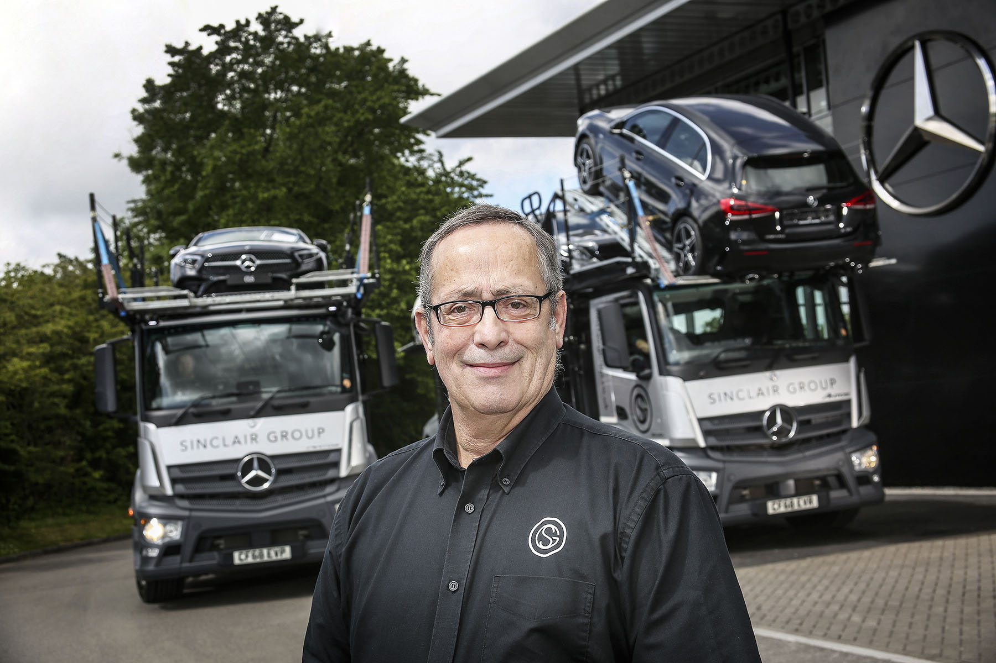

Double tops: Transport Manager Rhydian Rees with Sinclair Group’s new Mercedes-Benz Antos car transporters

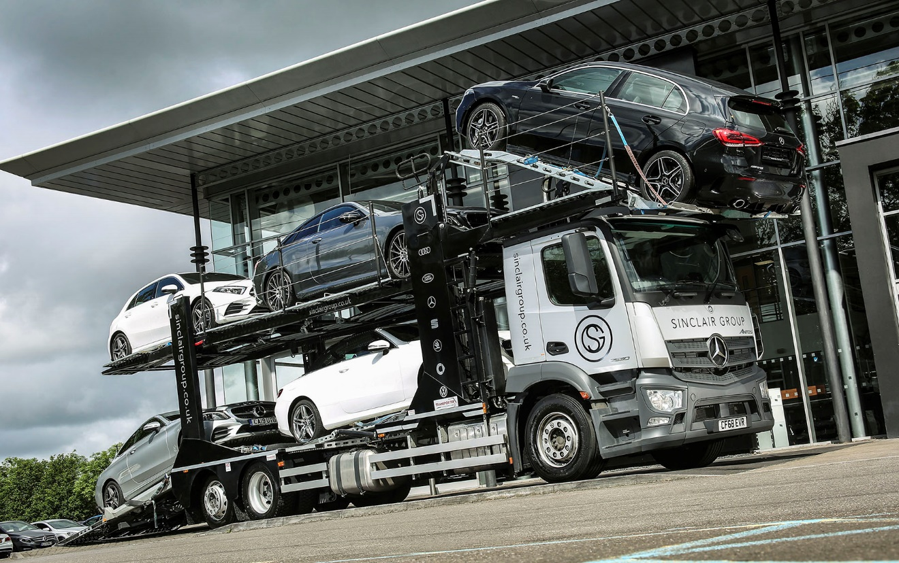

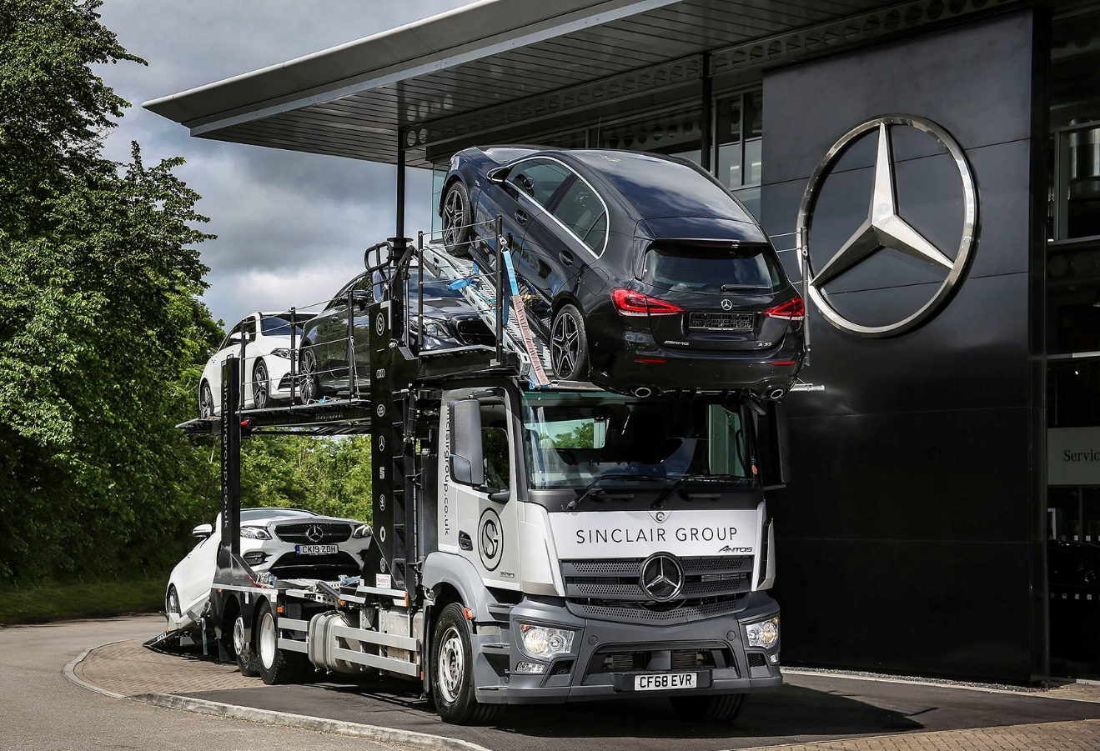

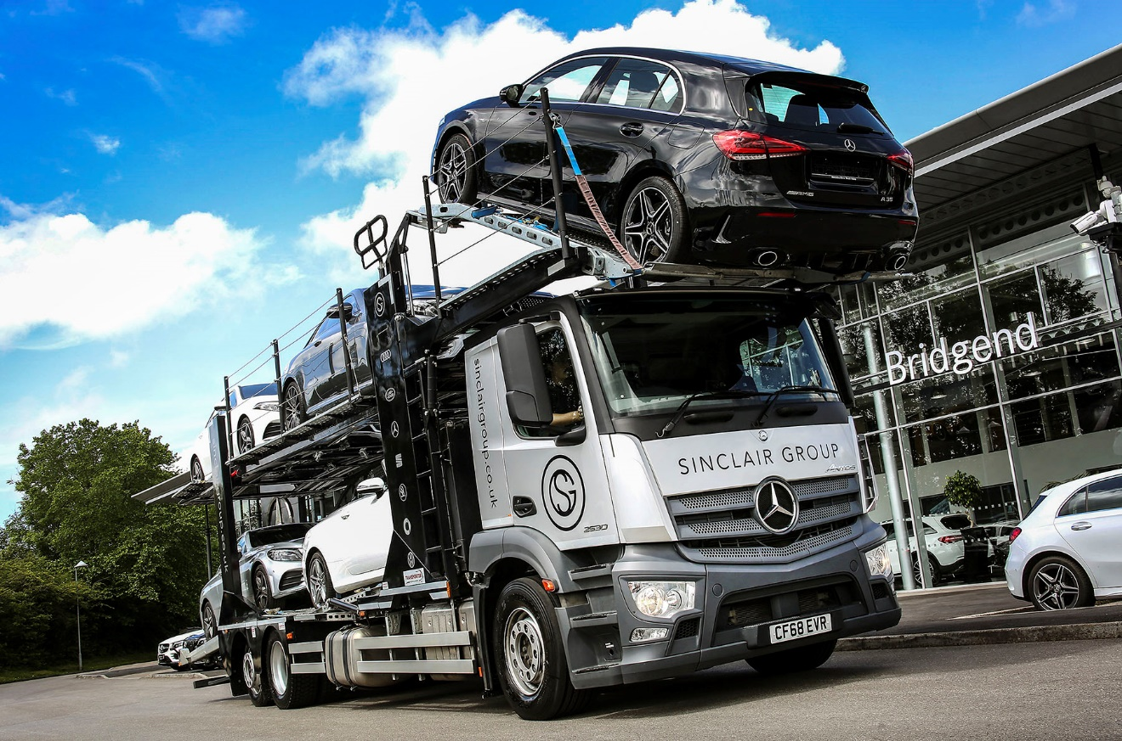

ends

For more information, or to request bigger/higher-res image files, please contact:
John Ripley or Steve Warren
Impact Communications, 01926 842126
John: 07771 484595, john@impactcom.co.uk
Steve: 07770 470251, steve@impactcom.co.uk

