

Date: 19 February 2021

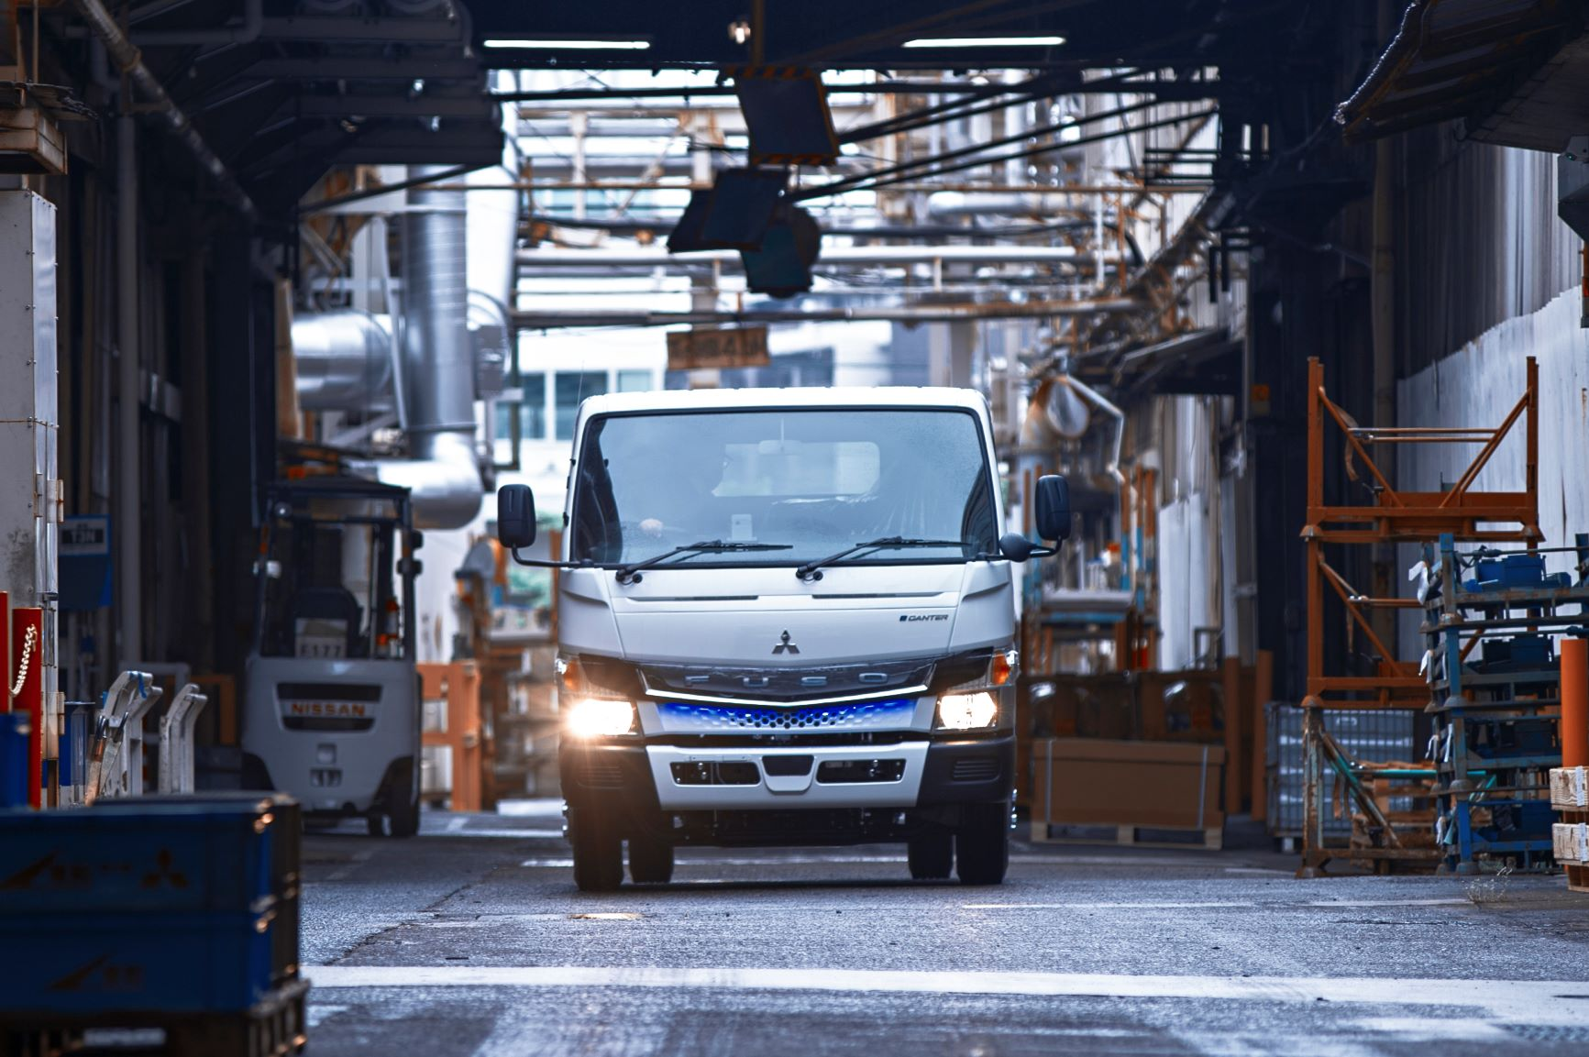

Electrifying Milestone: 200+ FUSO eCanter in daily customer operations around the globe

Stuttgart / Tokyo – Three years after the launch of small-series production, deliveries of Daimler Trucks’ all-electric light-duty truck FUSO eCanter have now surpassed 200 vehicles.

Customers in eleven countries and cities such as New York, Tokyo, Berlin, London, Amsterdam, Paris, Dublin, Oslo, Copenhagen, Helsinki or Lisbon trust in the reliable urban delivery truck. More deliveries are set to follow.

With the launch of the eCanter in 2017, FUSO has staked its claim as a pioneer and leader in electric trucks, working towards providing sustainable, CO₂-neutral transport. As of February 2021, more than 40 vehicles are running in the United States, over 60 trucks in Japan and another 100+ FUSO eCanter in customer operations in Europe. The total distance travelled by the global eCanter fleet now exceeds a combined three million kilometres driven locally emission free – equivalent to a staggering 75 circumventions of planet Earth.

The 7.49-tonne vehicle has a driving range of more than 100 kilometres with a single charge, and is particularly suited for locally zero-emission and quiet inner-city distribution. Moreover, the FUSO eCanter convinces with aspects such as its excellent chassis payload of up to 4.15 tonnes, which is more than sufficient for urban delivery purposes. Typical use cases of the vehicle include the short-radius delivery of packaged goods, e-commerce orders, post or even beverage and industrial gas transportation. Customers in Europe include logistical household names such as PostNL, Dachser, Deutsche Post DHL, Rhenus Group or DB Schenker.

As a pioneer of electric trucks, FUSO has set the vision to accelerate electrification and locally zero emission transportation in the commercial vehicle industry. In line with the sustainability strategy of Daimler Trucks, FUSO leads the commercial vehicle industry into the future and aims to have all new vehicles in the Triad (Europe, North America, and Japan) "tank-to-wheel" CO₂-neutral by 2039. The eCanter thereby plays a significant role toward achieving carbon neutral transportation, with the ongoing movement toward carbon neutral societies addressed by various governments in European countries as well as overseas.

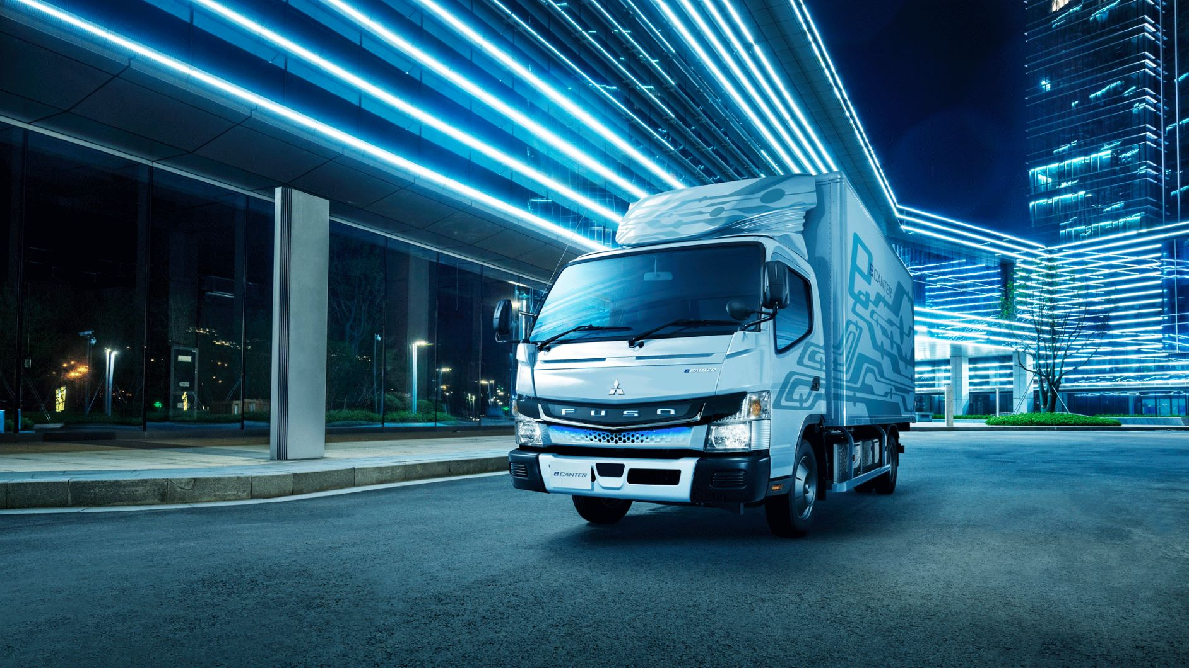

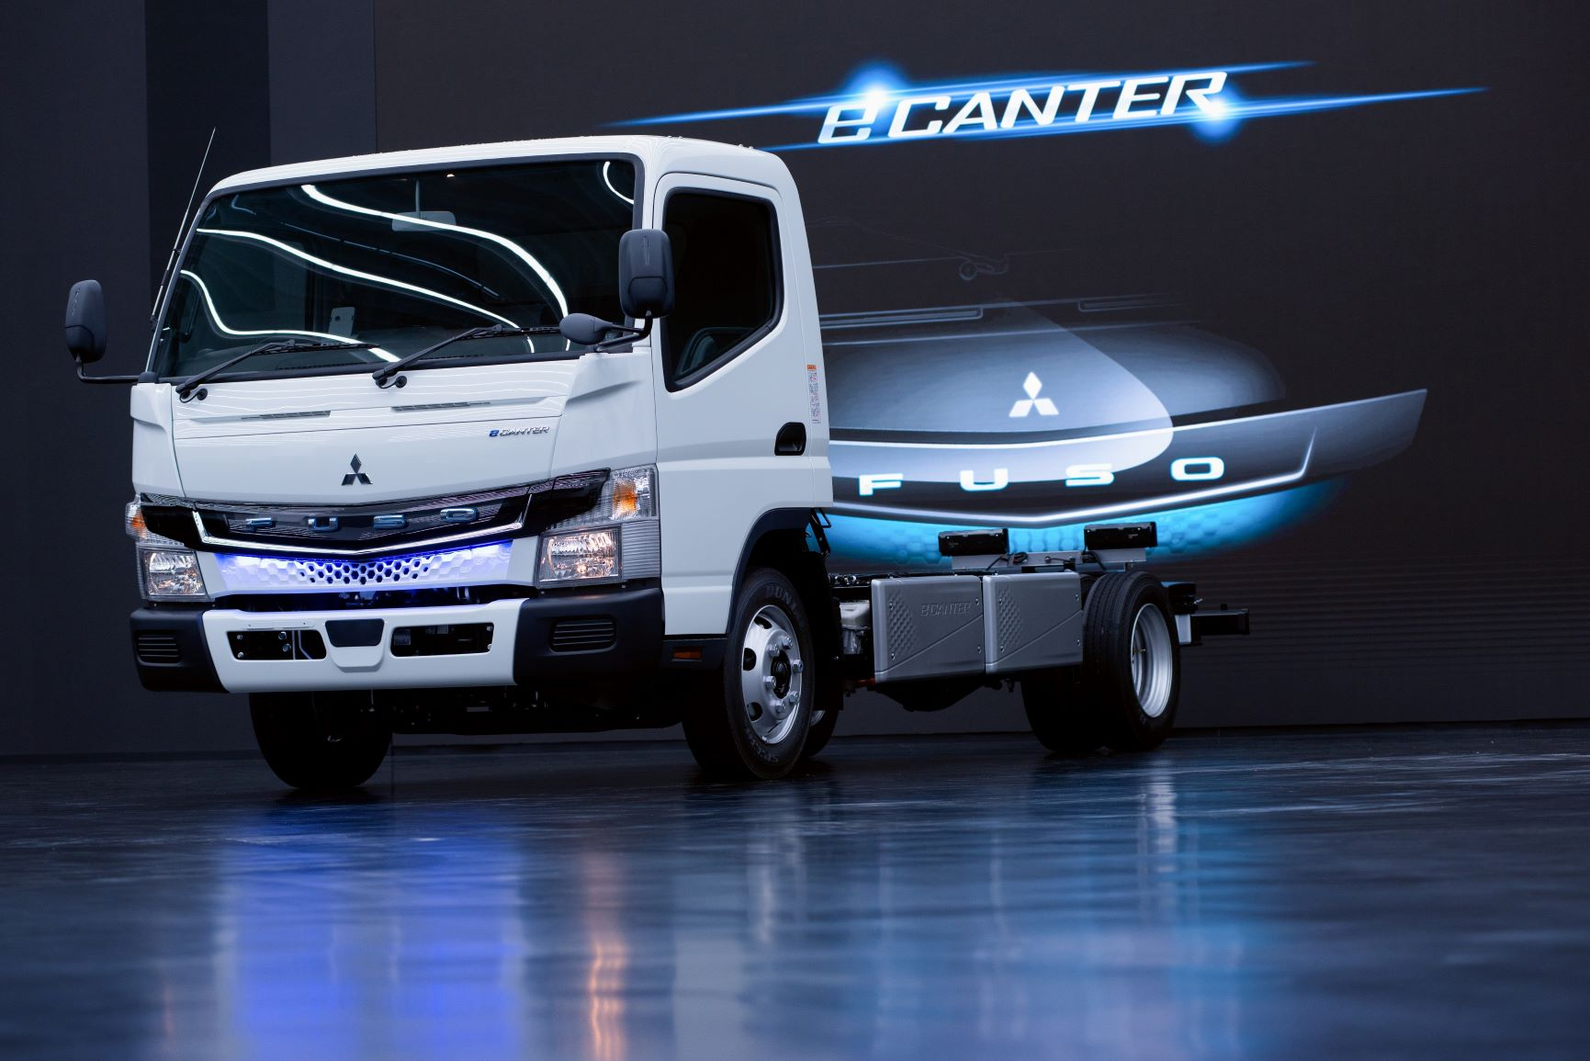

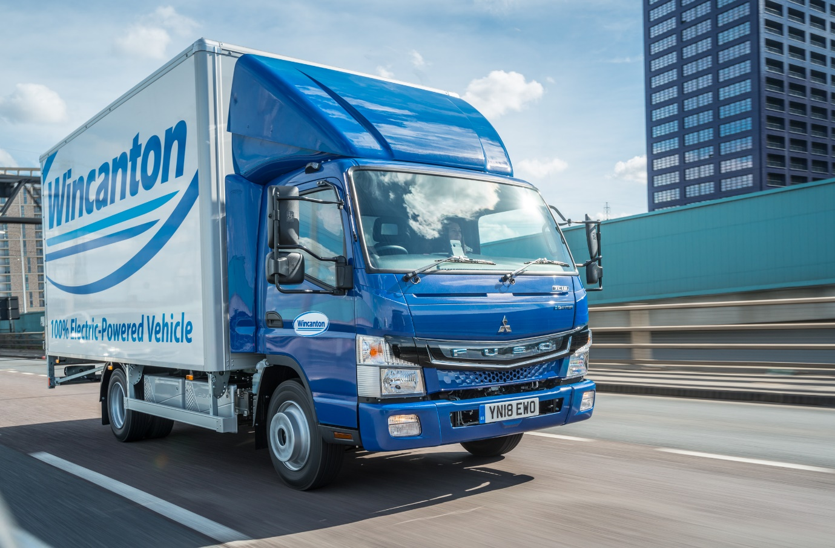

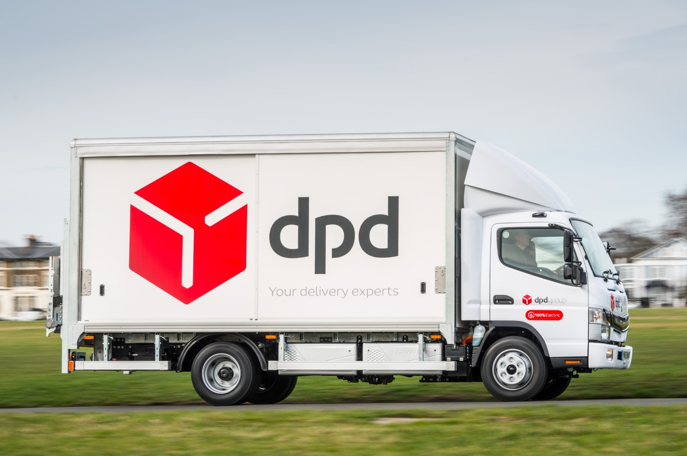

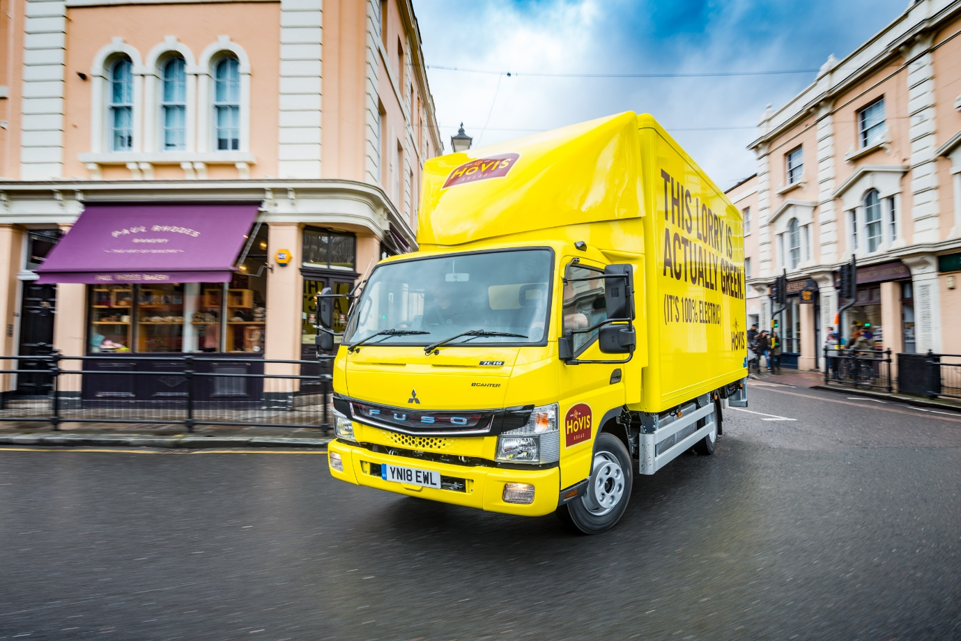

ends

For more information, please contact:

Paul Mandaiker
+49 (0) 711 17-8 33 26, paul.mandaiker@daimler.com
or

Jamie Fretwell at Mercedes-Benz Trucks UK Ltd
07712 519230, jamie.fretwell@daimler.com

Further information on FUSO is available at:
www.media.daimler.com and www.fuso-trucks.com

