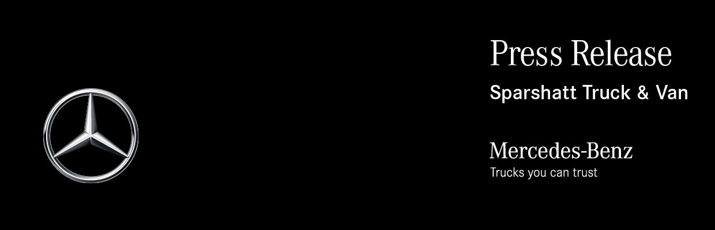

Date: 29 November 2022

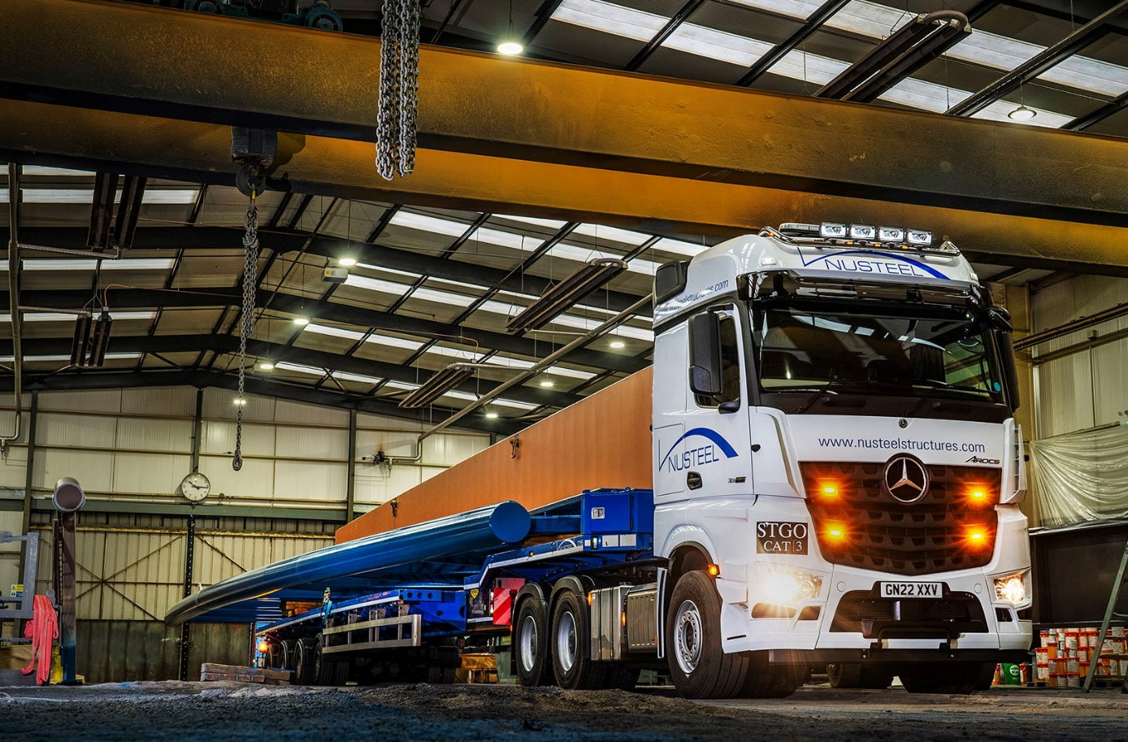

Nusteel builds bridges with Mercedes-Benz Arocs heavy hauler from Sparshatt Truck & Van

Bridge and gantry specialist Nusteel Structures is running its biggest and most powerful truck yet, and its first to wear the three-pointed star of Mercedes-Benz.

Supplied to the Kent-based company by local Dealer Sparshatt Truck & Van, the mighty 6x4 Arocs 3363 tractor unit is plated for Special Types operation at up to 150 tonnes GCW.

It has a flat-floored BigSpace cab, which is smartly finished with colour-coded bumpers and a roof-mounted Kelsa light bar, and employs a range-topping 460 kW (625 hp), 15.6-litre in-line six-cylinder engine. SB Components, of Wisbech, fitted a chassis catwalk infill.

Established in 1954, Nusteel Structures is a leading supplier of steel bridges, gantries and complex structures to the UK construction industry. Its comprehensive design, build and installation service extends to other products, such as balconies, steel moulds, props and walers.

The Arocs works from the company’s head office and fabrication facilities in Lympne, Hythe, and undertakes nationwide deliveries to sites of sections that can be up to 57 metres in length.

Nusteel Structures also runs a pair of 80-tonne tractor units by another manufacturer. However, as Transport Manager/driver Iain Bates explained: “The bridges and gantries we manufacture have gradually become bigger and structurally more robust over the years, and therefore significantly heavier. We’d reached the point at which we needed the increased capability of an uprated vehicle.”

Purpose-designed for construction-related applications, the muscular Arocs is ideally suited to the demands of the role. Nusteel’s truck was specified with the acclaimed Turbo Retarder Clutch, which works in conjunction with the 16-speed Mercedes PowerShift 3 automated manual transmission and replaces the traditional manual gearbox and torque converter clutch set-up.
Designed to be wear-free and fuel-efficient, the Turbo Clutch is capable of handling and delivering some 3,000 Nm of torque, significantly more than a torque converter. It also incorporates an important safety feature, in the shape of its own, powerful integrated retarder.

Nusteel also spoke to the local representatives of two other manufacturers – one was unable to supply a suitable product while the other could not match the competitively priced acquisition and maintenance package on offer from the Mercedes-Benz Dealer, or commit to deliver its vehicle within the same timeframe.

Iain Bates’ fellow Transport Manager/driver Doug Newsholme has worked for Nusteel Structures for 44 years and is hugely impressed with his new Mercedes-Benz. “We’ve operated Swedish-built units in the past but this is definitely the best truck we’ve ever had,” he enthused.

“The Arocs represents a big step forward in terms of quality. The cab is a really nice place to be, very well appointed and with a comfy seat and driving position. It’s also a good deal quieter than I expected.”

He continued: “I’ve always had manual gearboxes previously but the way the auto shift works in tandem with the Turbo Clutch is superb. Pulling away with a load on is easy – whatever the ground, there’s never an issue with traction.

“Heavy mode completely changes the feel of the vehicle, which drives like a train. A little while back it pulled 100 tonnes up Wrotham Hill, near Tonbridge, at 20 mph in 8th gear, without breaking sweat, which was some going.

“The integral retarder also holds you back when going down hills, which is very reassuring and exactly what you need. In fact, the system does everything we were promised, and it does it supremely well.”
Nusteel engaged with Sparshatt Truck & Van after receiving a speculative, but very timely, approach from the Dealer’s recently appointed Truck Sales Executive Janet Collins. She won her first truck order – for a 150-tonne tractor unit! – after quitting her previous career in premium brand car sales to pursue a fresh challenge.

“Janet’s service was fantastic throughout,” confirmed Doug Newsholme. “She kept us fully informed on progress and we were pleasantly surprised by how quickly the truck arrived.”

The subject of a five-year Mercedes-Benz Complete Service Contract, the Arocs is now being inspected and maintained at Sparshatt Truck & Van’s Ashford workshop. Iain Bates added: “The contract covers all our repair and maintenance needs at fixed, inflation-proof prices, so provides complete peace of mind.

“The timely, customer-focused back-up we’ve received from Service Manager Matthew Wootten and his colleagues has also been first class, and speaks volumes for the manufacturer’s commitment to minimising downtime for operators like ourselves.”

www.nusteelstructures.com

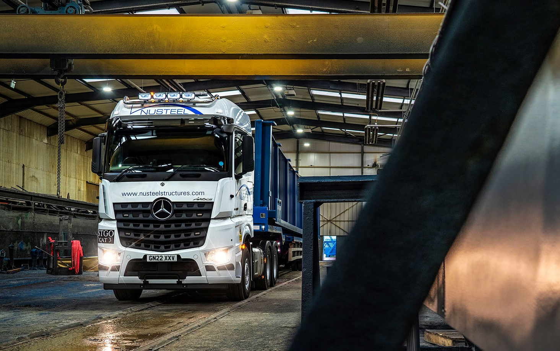

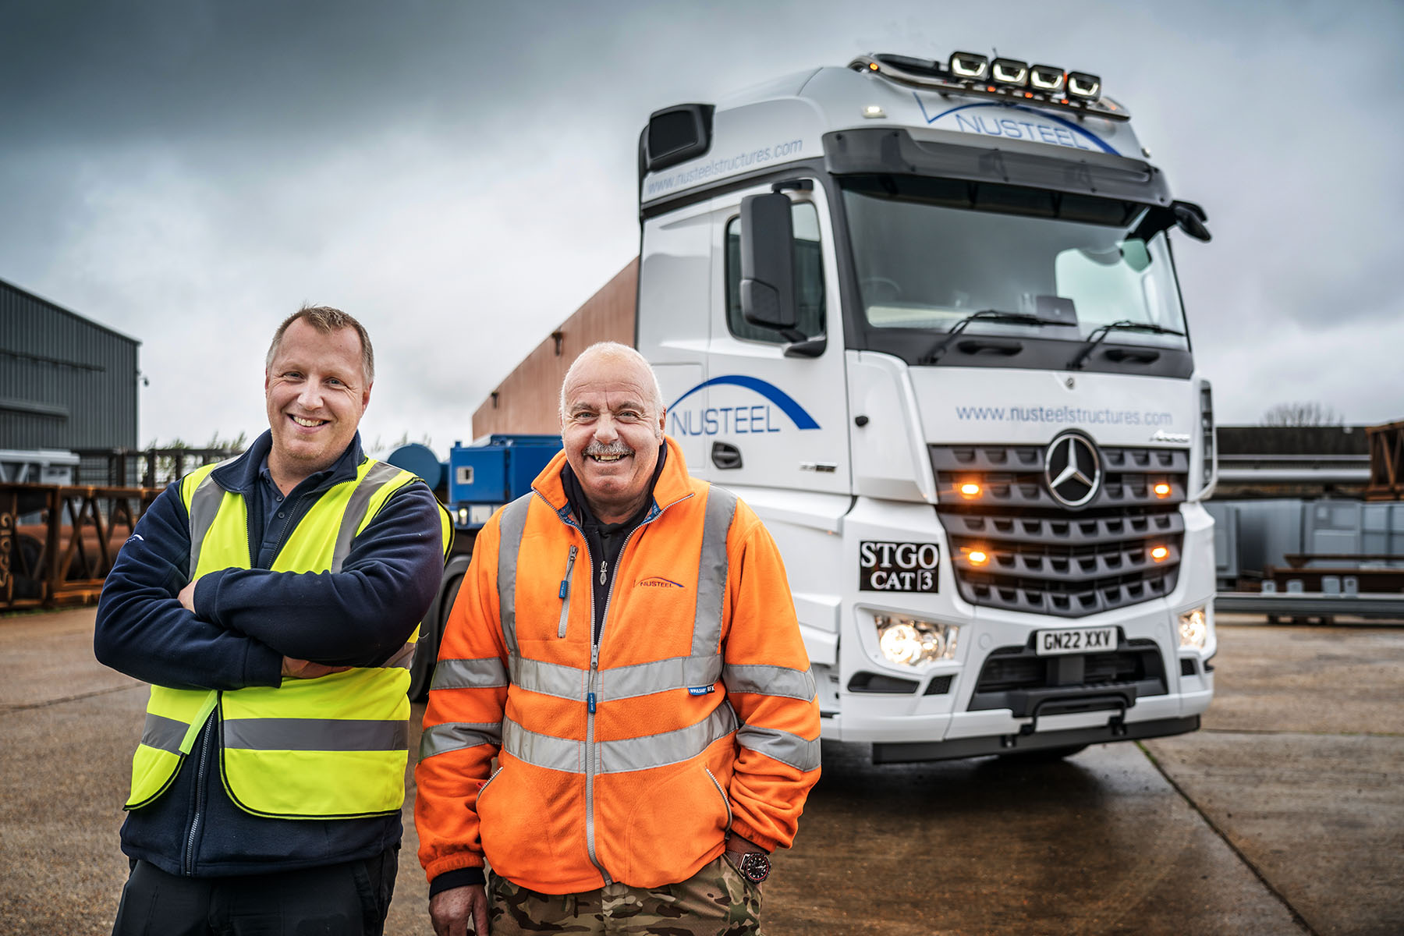

All pulling together: Nusteel Structures’ Transport Managers/drivers Iain Bates, left, and Doug Newsholme, with their new Mercedes-Benz Arocs

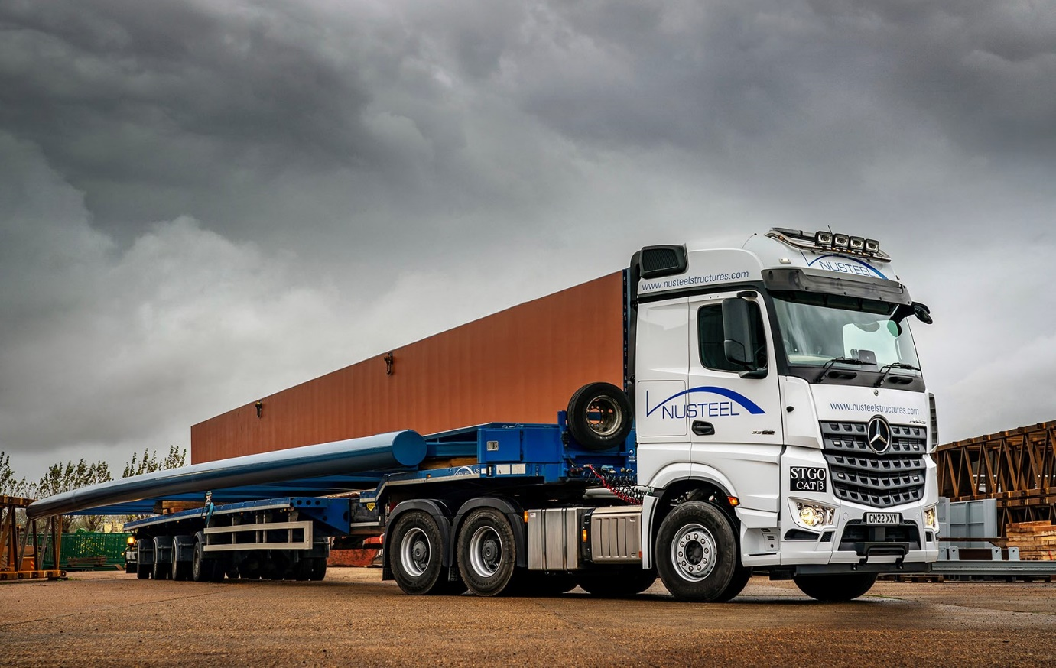

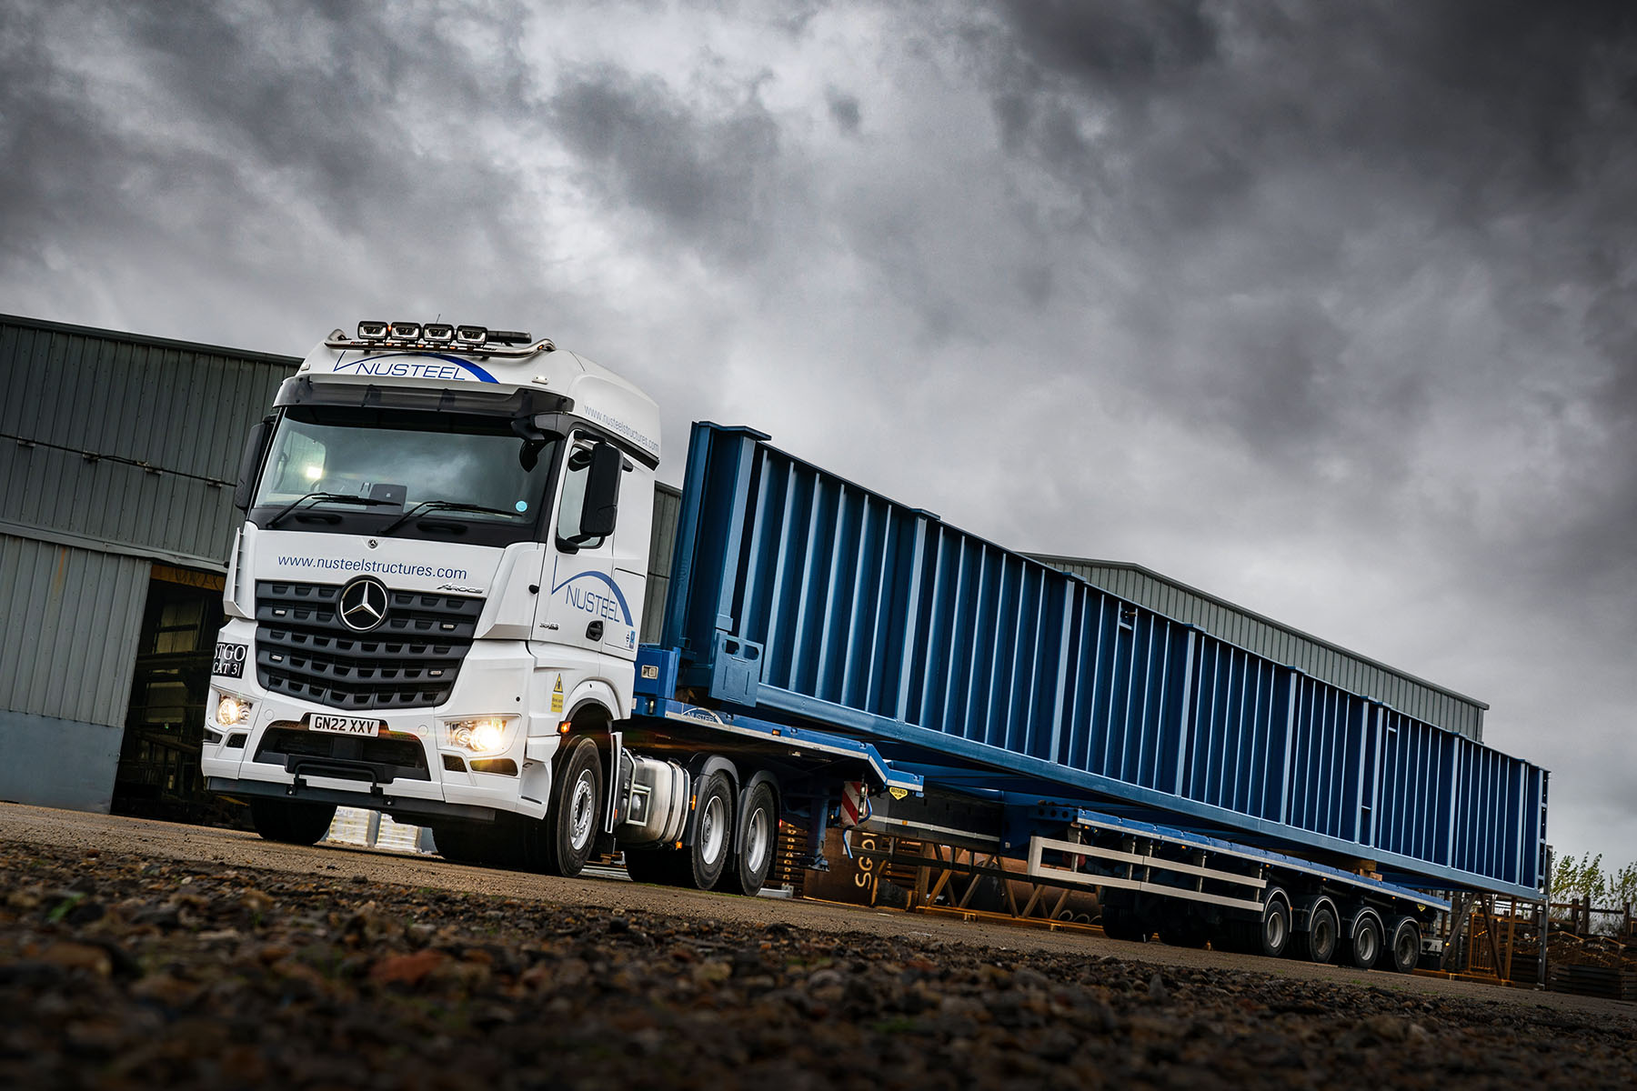

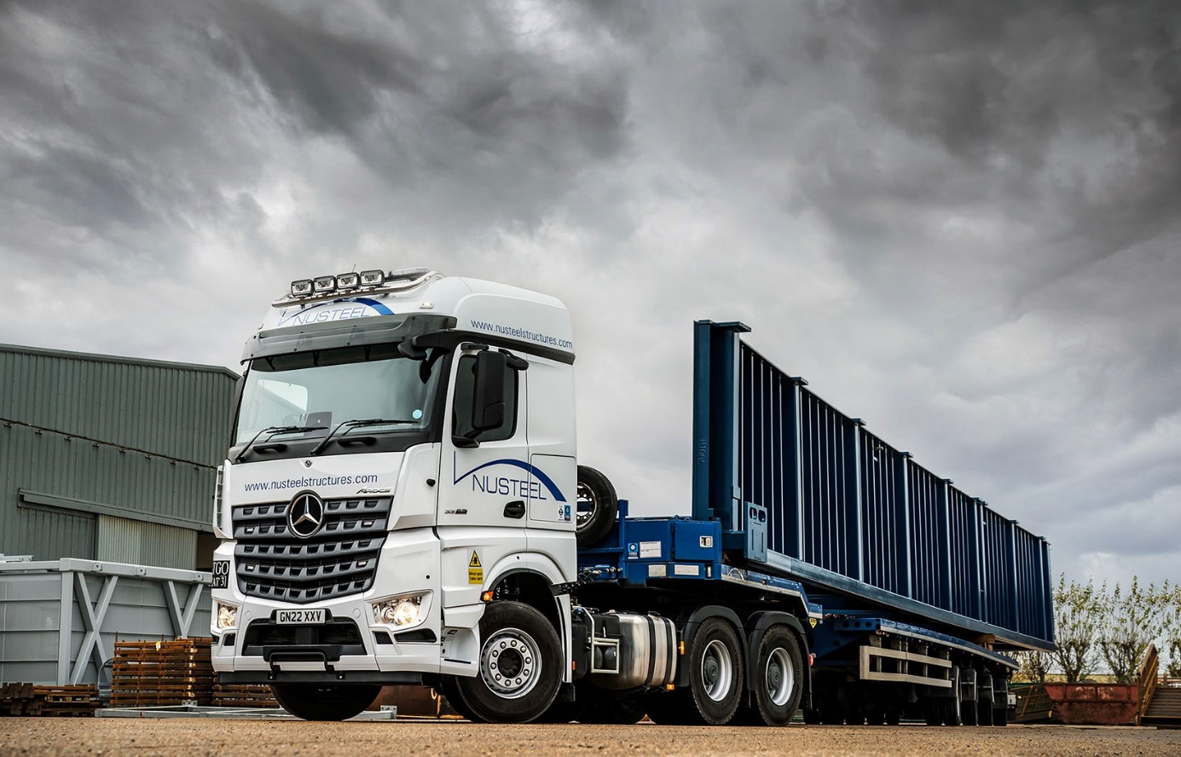

ends

For more information, or to request bigger/higher-res image files, please contact:
Steve Warren or John Ripley
Impact Communications
Steve: 07770 470251, steve@impactcom.co.uk
John: 07771 484595, john@impactcom.co.uk

