

Date: 9 November 2021

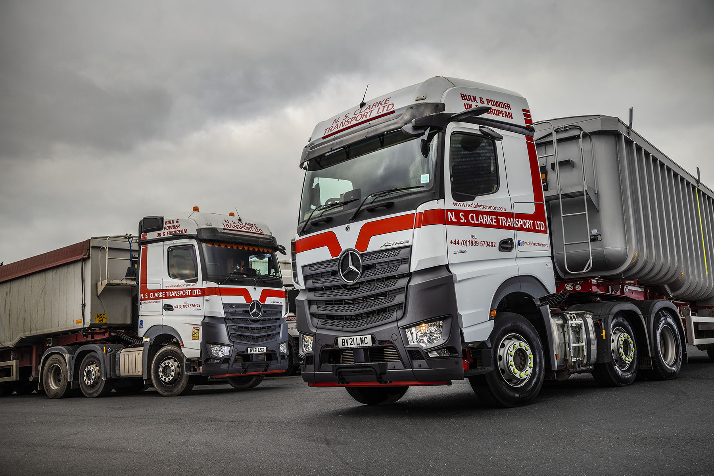

Just the job: NS Clarke’s first MirrorCam-equipped Mercedes-Benz Actros also came with steel front bumpers and raised ride heights

NS Clarke achieves valuable savings with damage-resistant upgrades to its Mercedes-Benz Actros

Bulk haulier NS Clarke Transport has reported a significant reduction in repair costs since it became one of the first customers for new options designed to protect Mercedes-Benz Actros that venture onto off-road sites.

Over the last year Dealer Midlands Truck & Van has supplied the Staffordshire-based operator with its first 12 units from the fifth-generation Actros range.

NS Clarke Managing Director Shaun Clarke led calls for Mercedes-Benz Trucks UK to introduce a more resilient steel front bumper that could be specified instead of the standard plastic item.

He was naturally delighted, therefore, when the manufacturer responded by adding to the long list of Actros options not only the steel bumper, but also the same straight front axle and headlight arrangement as a flat-floored unit from the Arocs range, which is purpose designed for construction-related applications.

The result is an Actros that offers up to 85mm (depending on tyre choice) of additional ground clearance, and therefore carries a lower risk of underbody damaged caused by ‘bottoming out’ or getting stuck while manoeuvring on rough ground.

NS Clarke also took the opportunity to equip its Actros with rubber-mounted steps that allow a certain amount of lateral movement. Already popular with Arocs customers, these rugged steps also offer repair cost savings.

Shaun Clarke explained: “We’ve always favoured the Actros over the Arocs because our trucks spend most of their time on the road. However, they also go to quarries and onto other sites, where they can take a bit of a battering.

“It can be very easy to take out a front corner, and if you’ve lost the headlight as well you’re looking at a pretty expensive repair bill. Over time the steel bumpers might not look as smart, as they get knocked about and the paintwork suffers, but I can live with that.

“Most importantly, the combination of raised height and the more rugged and durable construction bumper means we’ve seen a noticeable reduction in accident damage to our latest units. This, in turn, has resulted in some very welcome cost savings.”

“The same is true of the rubber-mounted step option. It just has that bit of ‘give’, so that if the driver catches one on a kerb it’s not necessarily going to break and need replacing.”

He continued: “It’s to Mercedes-Benz Trucks’ credit that it listened to what we were saying and introduced the steel bumper we were calling for. This option won’t be right for many operators, but for us, and for others in the same line of business, it’s a very important development.”

NS Clarke Transport works from headquarters in Rugeley and runs a fleet of 155 trucks which is dominated by the three-pointed star. In addition to its bulk powder and tipper operations, the company provides general haulage, flatbed transport and courier van services.

Its latest Actros are 2551 variants with flat-floored BigSpace cabs. Their 12.8-litre in-line six-cylinder engines produce 375 kW (510 hp) and are paired with smooth and fuel-efficient 12-speed Mercedes PowerShift automated manual transmissions.

Standard Actros specification now includes MirrorCam, Mercedes-Benz Trucks’ ground-breaking, camera-based alternative to conventional mirrors; the Multimedia Cockpit, which replaces switchgear with stylish and intuitively-operated twin screens; enhanced, fuel-saving Predictive Powertrain Control technology; and the Active Brake Assist 5 emergency braking system, with industry-leading pedestrian recognition capability.

The operator’s Mercedes-Benz vehicles are maintained under Complete Service Contracts by Midlands Truck & Van, which provides a collection and delivery service for inspections and scheduled maintenance, while also sending mobile technicians to its customer’s base at weekends, to undertake relatively minor tasks.

Shaun Clarke added: “Some weeks we’ll have 15 pieces of equipment going over to the workshop, while the fact that Midlands Truck & Van’s sends technicians over here on a Saturday or Sunday helps us to minimise downtime. Its team work very hard and do an excellent job.”

NS Clarke also runs a vehicle recovery arm. Established in 2016 to support its own fleet, this has proved so successful that the company is now contracted to recover breakdowns and accident-damaged vehicles from stretches of the M6 and M42 motorways. It supports other transport concerns too, as well as dealers, including Midlands Truck & Van’s Birmingham and Wolverhampton branches.

As with its other recovery units, the most recent additions to the fleet are by Mercedes-Benz. Midlands Truck & Van supplied an 8x4 Arocs 4153 and a 15-tonne Atego 1521, both of which were fitted with purpose-designed bodywork and equipment by specialist manufacturer Boniface.

Meanwhile, Shaun Clarke has added another string to his company’s bow by purchasing a 4x4 Mercedes-Benz Unimog from specialist Dealer Lloyd Ltd. A U5023 UHE extreme off-roader first registered in 2017, the vehicle spent the previous two winters with a rental customer in Scotland but had only covered 5,500 miles from new. It is fitted with a Palfinger crane and split dropside body, and came with a snowblade.

Mr Clarke was just 23 and his wife Janet 22 when they established their business in 1983 with a single truck, and now work alongside sons Russell and David. NS Clarke bought its first Mercedes-Benz truck in 2009 and has not looked back since.

www.nsclarketransport.com

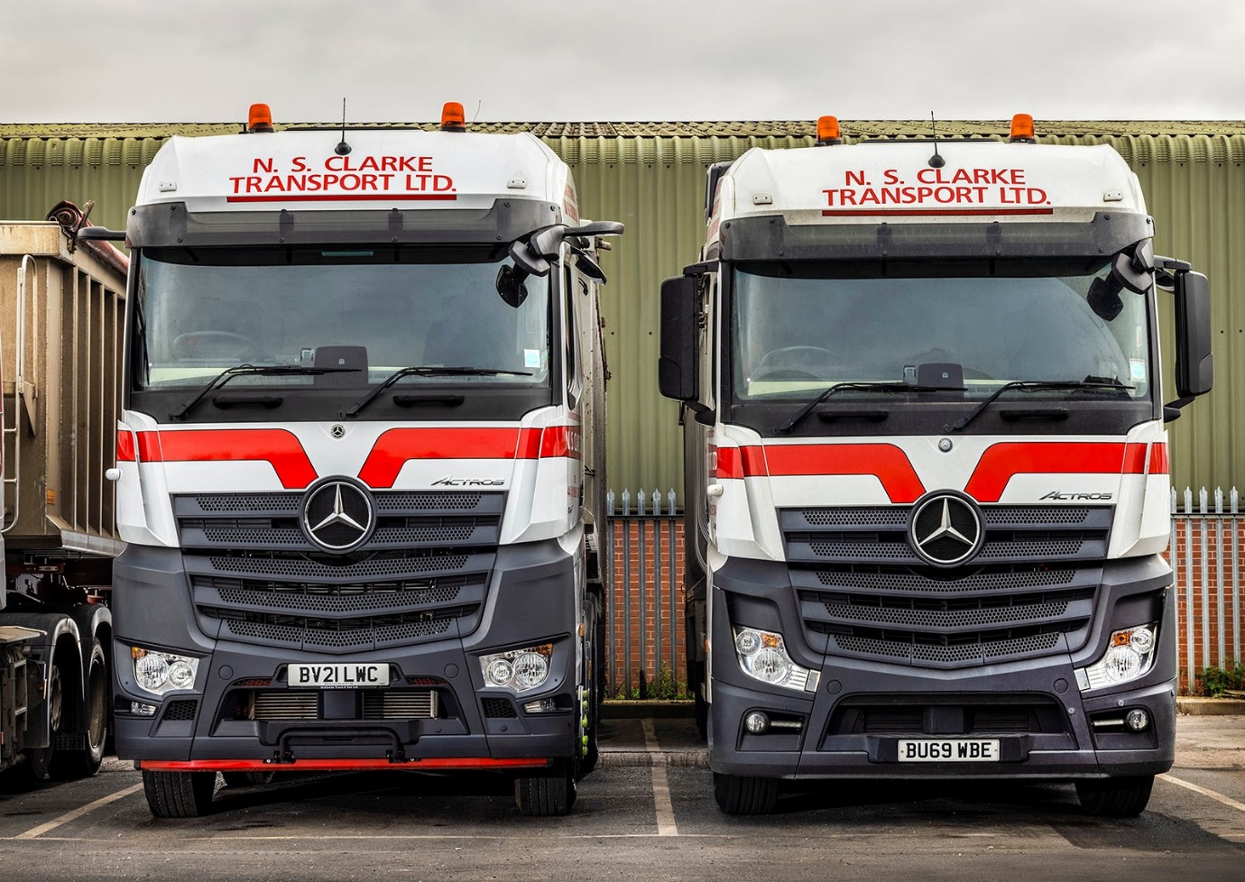

That was then, but this is now: NS Clarke’s latest Actros offer more ground clearance than their predecessors

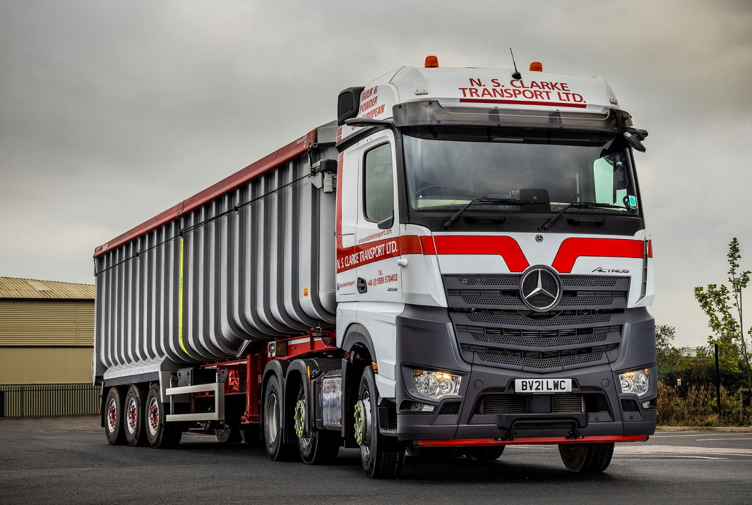
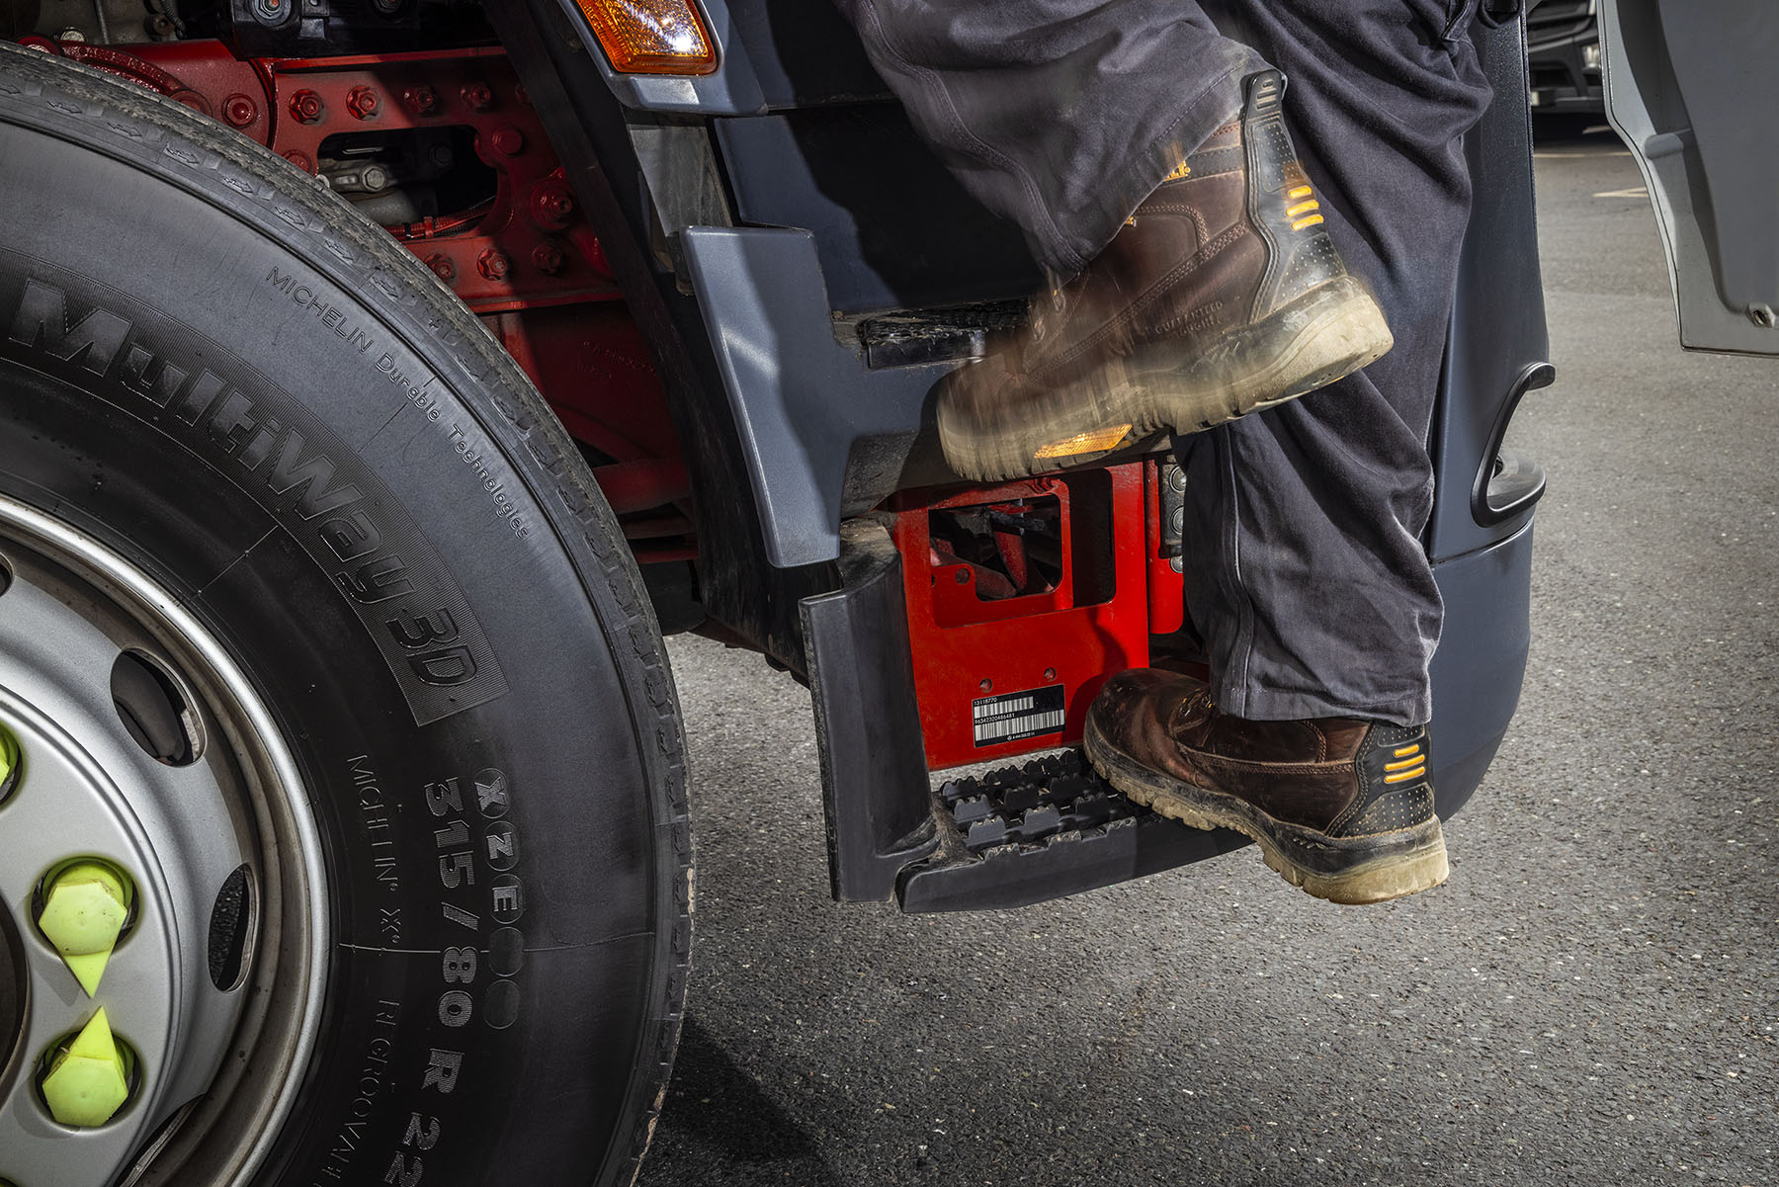

On the up: NS Clarke’s latest Actros have steps with rubber mounts which are more rugged than the standard items and designed for vehicles that work on construction sites

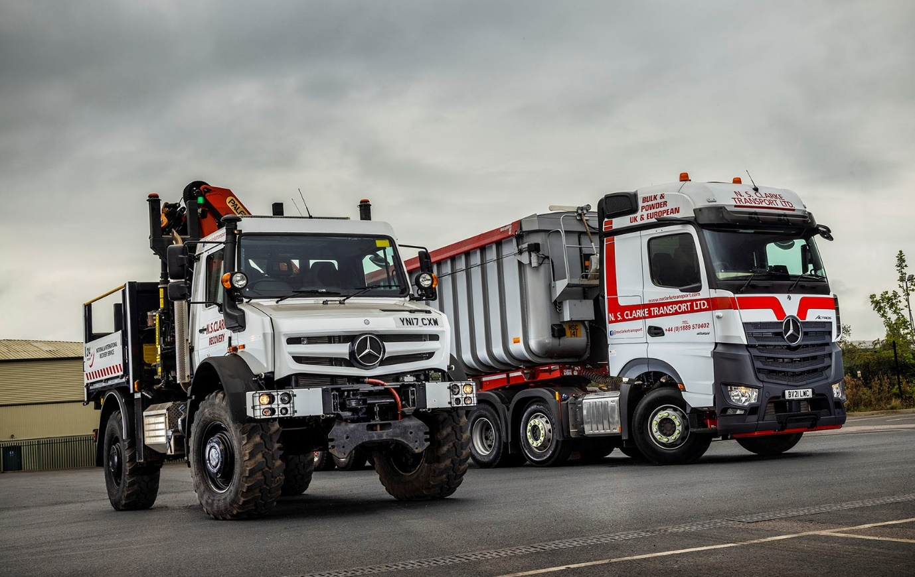

Different strokes: NS Clarke’s recent Mercedes-Benz acquisitions include its first fifth-generation Actros tractor units and a 4x4 Mercedes-Benz Unimog for vehicle recovery work

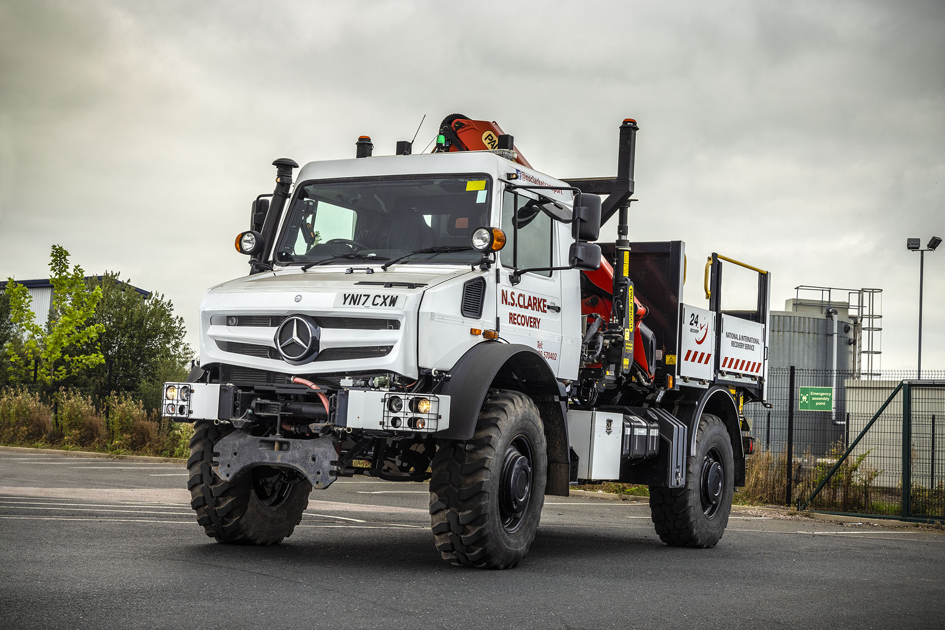

ends

For more information, or to request bigger/higher-res image files, please contact:
Steve Warren or John Ripley
Impact Communications
Steve: 07770 470251, steve@impactcom.co.uk
John: 07771 484595, john@impactcom.co.uk



