

Date: 5 November 2020

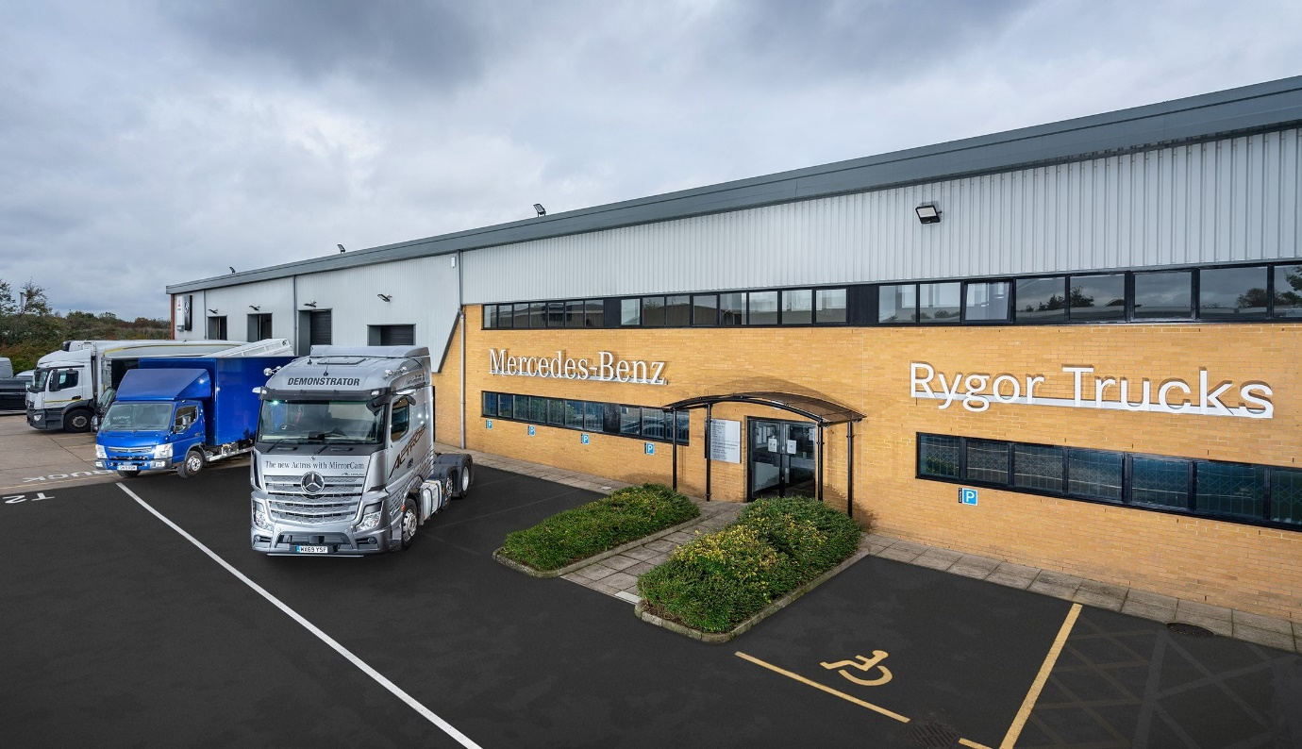

Two months in, and Rygor’s Heathrow Truck Centre has already won a resounding ‘thumbs up’ from Mercedes-Benz operators

Customers of Rygor Commercials have praised the industry-leading aftersales support they are now receiving from the team at the Mercedes-Benz Dealer’s impressive new Heathrow Truck Centre.

Opened at the beginning of September, the 30,000 sq ft facility boasts a workshop with 16 truck bays and two full-length pits in which technicians have access to the latest automated equipment, and a comprehensively stocked, two-storey Parts department.

Located at The Camgate Centre in Stanwell, the latest addition to Rygor Commercials’ network of 11 branches is easily accessed from the M25 and M4 motorways. Crucially, the site also offers ample space for parking and manoeuvring heavy trucks and semi-trailers.

Slough-based Goldstar Heathrow runs a fleet of nearly 100 commercial vehicles, all of which are by Mercedes-Benz or its sister brand FUSO. The haulier’s own workshop benefits from Rygor’s technical support and parts deliveries. However, 22 of its trucks – 10 tractor units and a dozen 18-tonners – are the subject of Mercedes-Benz Complete Service Contracts so inspected and maintained at the Dealer’s new, truck-dedicated facility.

Goldstar Heathrow Fleet Manager Lee Oakes commented: “We’ve relied on Rygor’s back-up over a number of years, and have an excellent relationship with the team, who have never let us down.

“The new workshop is a big step forward. It looks great, clean and modern, and because there’s so much more room on the site to get trucks in and out it’s going to make life a lot easier for drivers. The fact that it’s dedicated to trucks is a big plus too – every operator can be confident that their trucks are being looked after by the right technicians using the right equipment.”

Lee Oakes’ positive comments were echoed by those of Nathan Light, a Director at airfreight specialist Guest Express, of Colnbrook, whose fleet of 32 trucks and vans is dominated by the three-pointed star. As with Goldstar Heathrow, while a proportion of these vehicles are covered by contract agreements and maintained directly by Rygor Commercials, Guest Express also relies on the Dealer to support its own workshop.

Nathan Light said: “Rygor’s facility at The Camgate Centre is absolutely wonderful, so much better not only for visiting customers like ourselves but also for the people who work there. The parts service has always been particularly quick and efficient, but we’ve already noticed a definite reduction in workshop lead times as a result of the increased capacity the new place offers, which is obviously welcome.”

He added: “Our relationship with Rygor goes back more than 10 years now, and it’s the best Dealer we’ve worked with. I’d have no hesitation in recommending it to other operators.”

Meanwhile, Kevin Brown’s Chertsey-based business Directions is another well-established customer of Rygor’s Heathrow Parts team. “The service has always been good but it’s even better now,” he said. “They’re very quick to answer the phone and invariably have whatever we need.”

Rygor’s substantial investment in its new Heathrow Truck Centre was prompted by increased demand for its services. The workshop is open from 6am until 10pm on Mondays, then opens again at 6am on Tuesdays and does not close until 1pm on Saturdays.

Sean Joyce also oversees the Service operation at the Dealer’s long-established Heathrow branch on Stanwell Road, Bedfont, which is now dedicated to vans. He is supported at the Truck Centre by Service Manager Chris Baker and Parts Manager Emma Joyce, both of whom were promoted to their new roles from within the Rygor business.

“From a truck perspective we’d simply outgrown the previous site, where the shortage of parking space presented a particular challenge,” explained Sean. “Having talked about opening a dedicated truck facility for some time, things really got moving in January, when we identified the Stanwell site and realised its location was perfect.

“Customer feedback since we opened has been really positive. We have eight full-length truck and trailer parking bays, and with 16 truck bays there’s ample space in the workshop too – the technicians love that, as well as all of their new equipment. Features like the air-operated pit covers we’ve installed mean that we’ve created a working environment which as well as being highly efficient, is also exceptionally safe.”

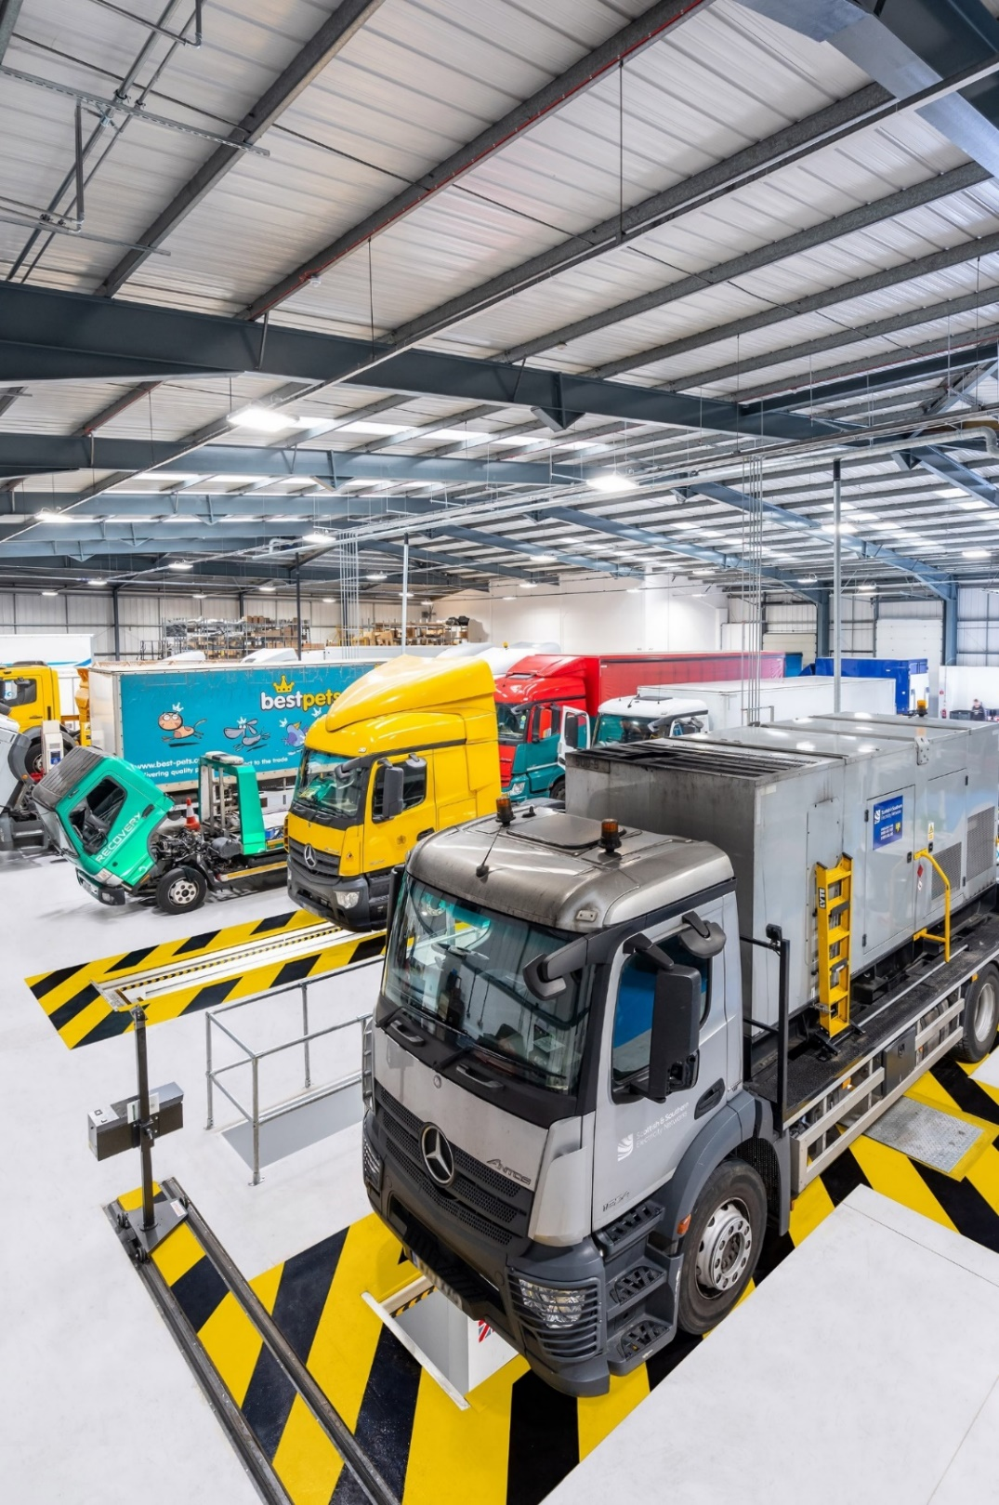
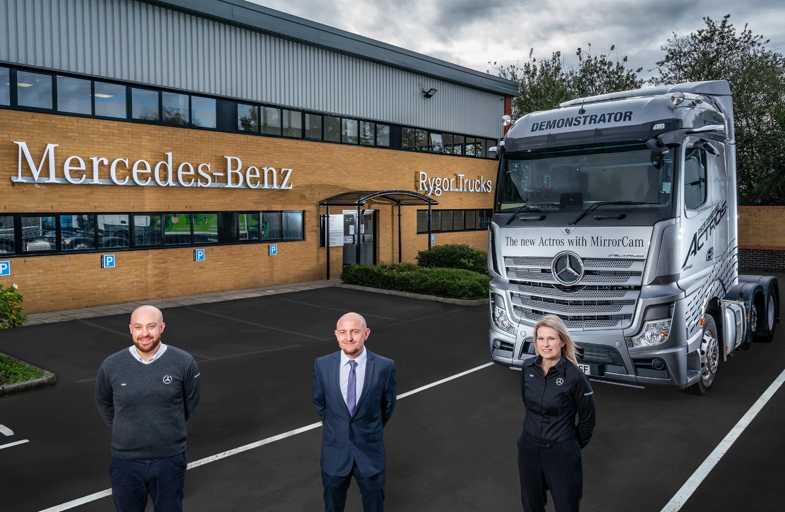

Customer focused: Pictured outside Rygor Commercials’ new Heathrow Truck Centre, Service Manager Sean Joyce is flanked by Heathrow Trucks Service Manager Chris Baker and Heathrow Trucks Parts Manager Emma Joyce

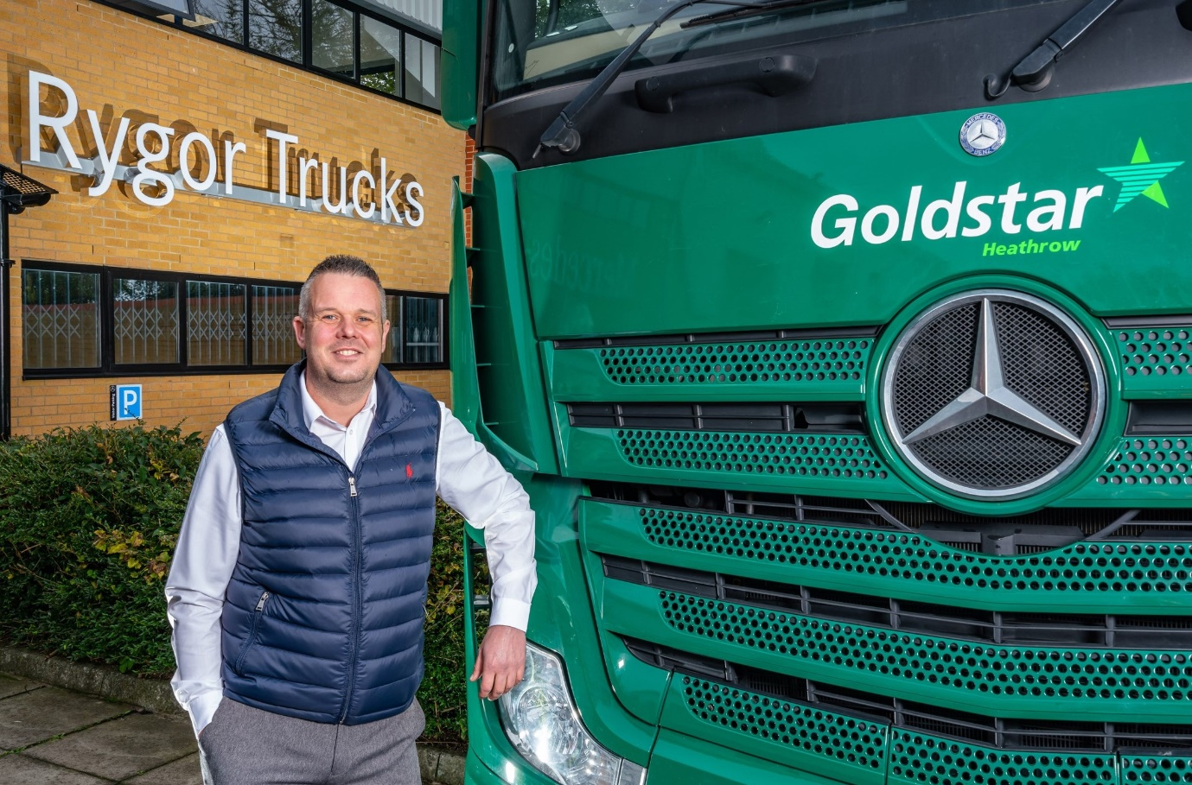

Impressed: That’s Rygor Truck Centre customer Lee Oakes, of Goldstar Heathrow
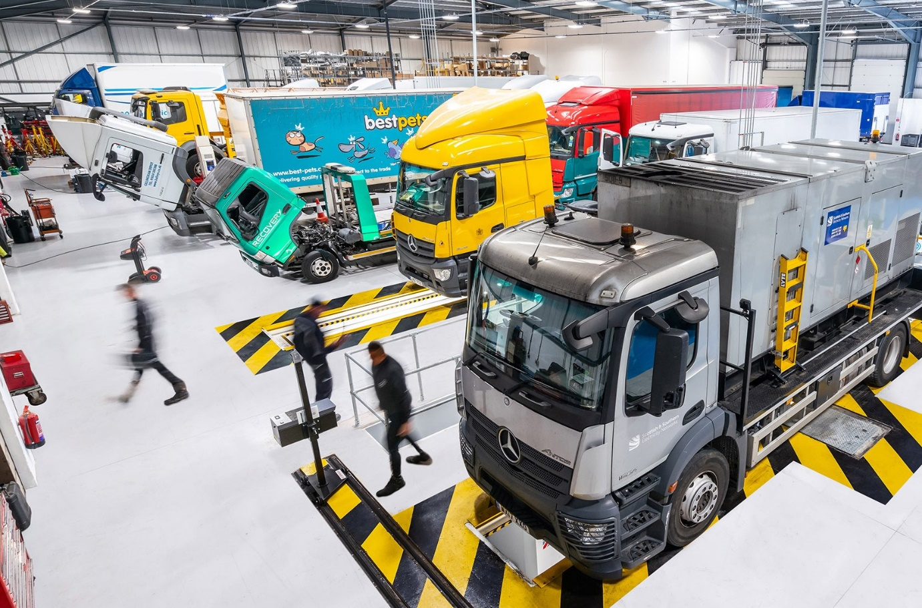

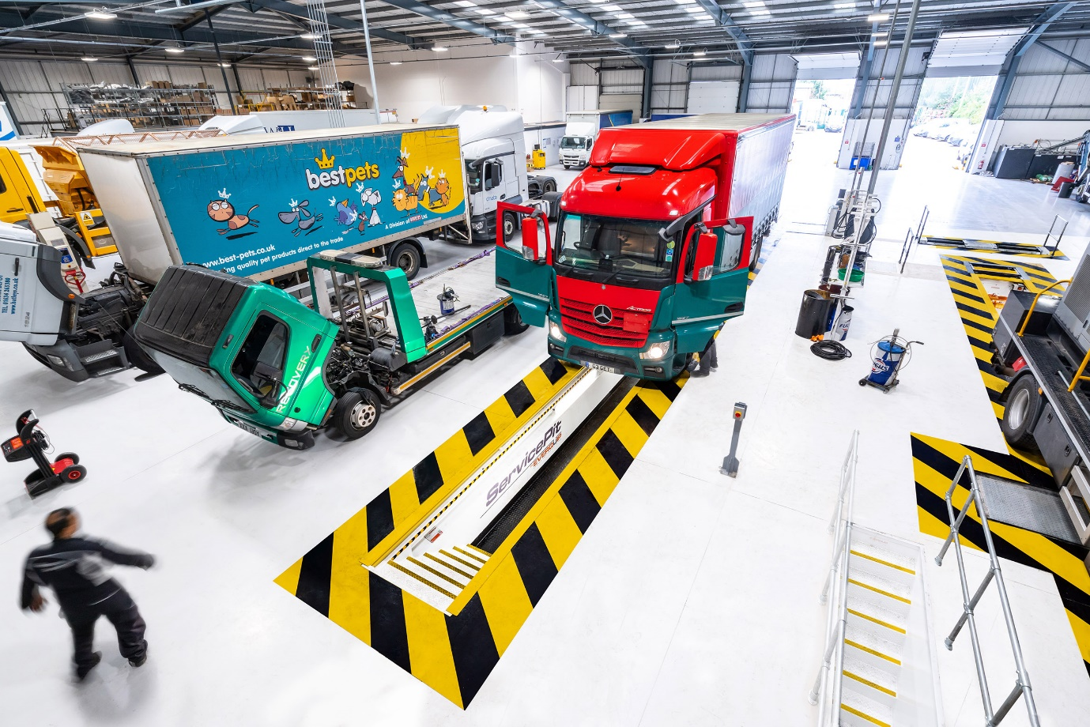

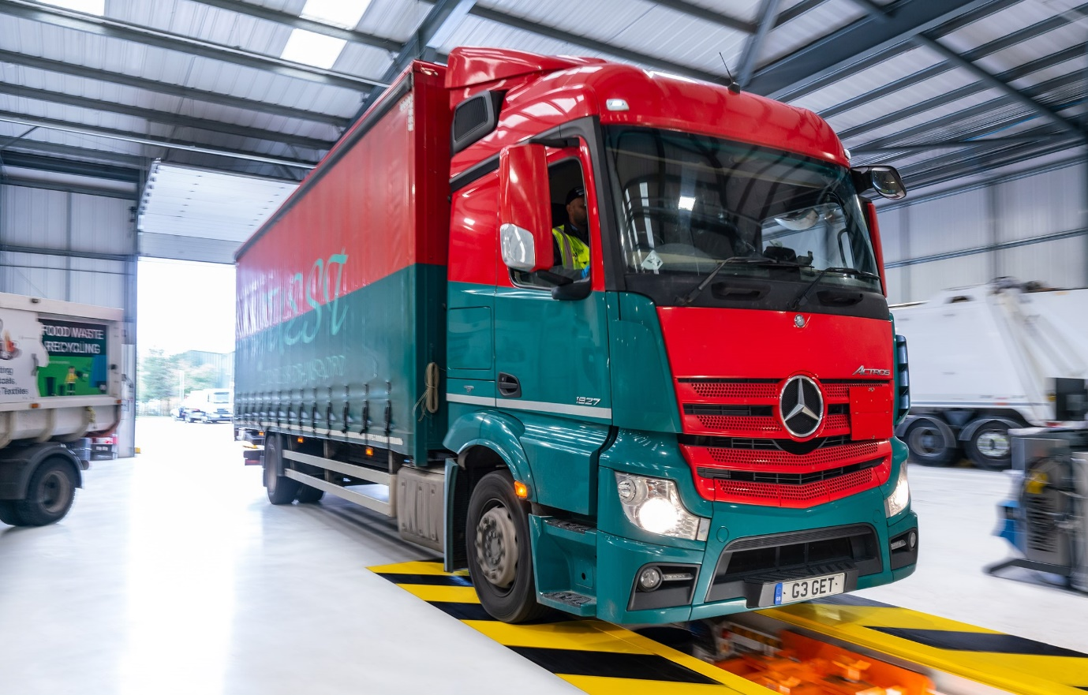

ends

For more information, or to request bigger/higher-res image files, please contact:
Steve Warren or John Ripley
Impact Communications, 01926 842126
Steve: 07770 470251, steve@impactcom.co.uk
John: 07771 484595, john@impactcom.co.uk

Notes to Editors: Rygor Commercials

Award-winning Mercedes-Benz Commercial Vehicle Dealer group, Rygor Commercials, has branches in Berkshire, Gloucestershire, Oxfordshire, Somerset, West London, Warwickshire, Wiltshire and Worcestershire, offering extensive coverage for customers throughout the M5, M4 and M42 corridors.

The Rygor business has developed and gone from strength to strength in recent years, investing in extensive renovations of its sites across the country, as well as a brand-new, dedicated Heathrow Truck Centre opened in 2020. With seven industry and network awards under its belt in the past 18 months, Rygor continues to be dedicated to providing exceptional customer service, which Set Standards. The Dealer was delighted to be announced as winners in the ‘Franchised Dealer of the Year’ category at the recent Commercial Motor Awards and ‘Van Dealer of The Year 2020’ at the WhatVan? Awards, accolades which not only demonstrate the company’s focus on customer satisfaction, but also its commitment to the development, training, and wellbeing of its team members.

With a proven track record, Rygor is proud to be selling, maintaining and supporting the most prestigious name in commercial vehicles.
For more information, in the first instance please contact Kate Ruberry-Shoemack, Head of People and Communications at Rygor – kateruberry-shoemack@rygor.co.uk

