

Date: 28 May 2019

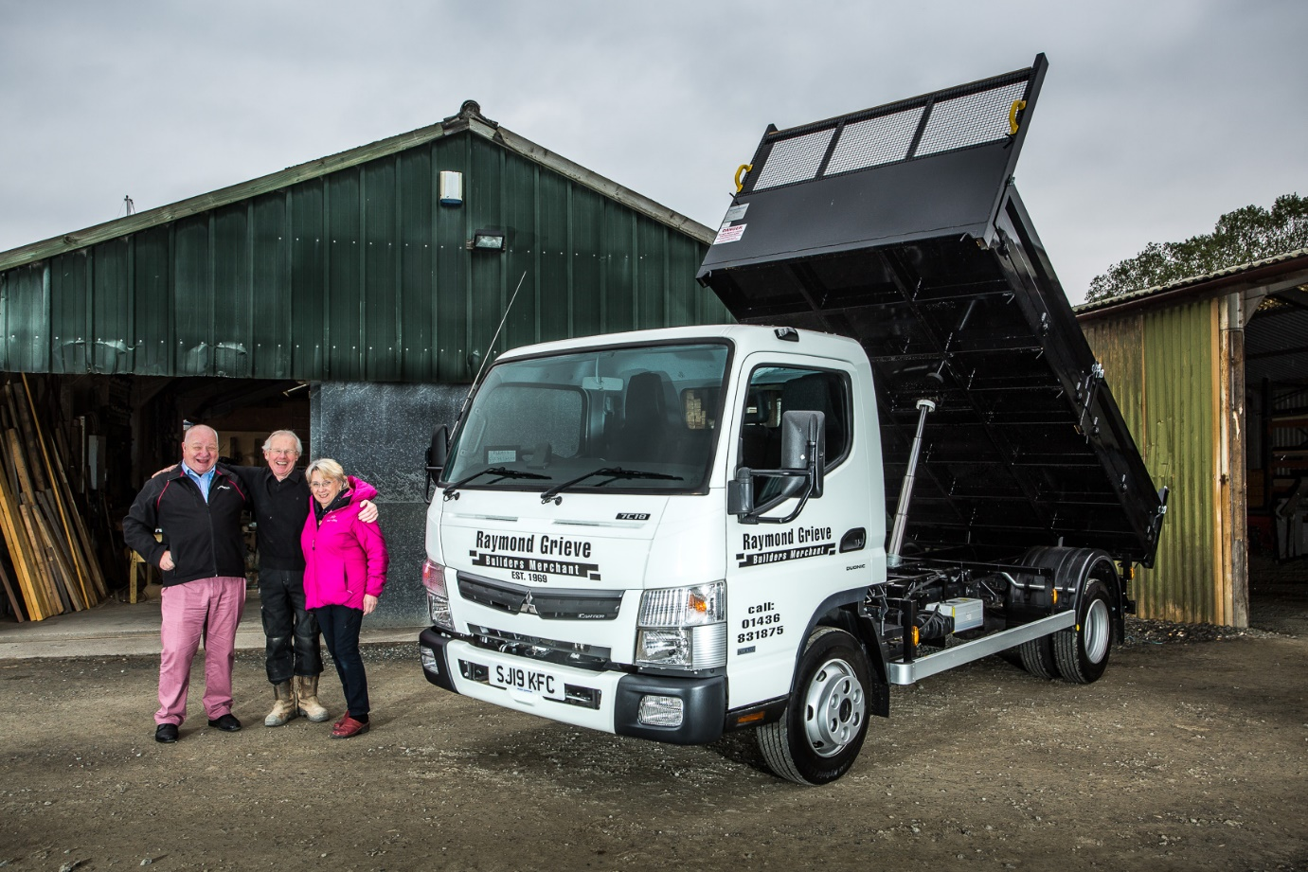

Turning the clock back: Just as they did in 2008, Raymond and Kathleen Grieve took delivery of their new Canter from Western Commercial’s Robert Snodgrass, left

Raymond Grieve goes ‘back to the future’ with new FUSO Canter from Western Commercial

Eleven years after he delivered Raymond Grieve Building Contractor, Joiners & Builders’ Merchant’s last Canter tipper, Western Commercial Truck Sales Executive Robert Snodgrass returned to his customer’s base near Helensburgh with the keys to its successor.

The previous truck’s outstanding strength and reliability, coupled with the 7.5-tonne Canter’s market-leading payload and impressive manoeuvrability, were all instrumental in persuading the operator to choose a like-for-like replacement.

Western Commercial sells and supports the popular FUSO Canter light truck range, as well as Mercedes-Benz Trucks and Mercedes-Benz vans, from branches in Edinburgh, Bellshill, Glasgow and Dundee.

Raymond Grieve Building Contractor, Joiners & Builders’ Merchants celebrates its 50th anniversary in September. Now 74, founder Raymond Grieve remains at the helm; his wife Kathleen looks after the firm’s finances, while their son Drew is its Joinery Manager, and several members of staff have chalked-up decades of loyal service.

Mr Grieve established his business in 1969, at the Camsail Works yard on the Rosneath Peninsula, Argyll & Bute. It works from the same premises to this day, providing local customers with a wide range of quality building and joinery services, as well as undertaking specialists restorations for Historic Scotland. Launched in 1980, the builders’ merchants operation supplies anything from a nail to a hand-crafted kitchen.

The new truck is a 7C18 model powered by a 3.0-litre turbo diesel engine with range-topping output of 129 kW (175 hp). It drives through a DUONIC dual clutch transmission. Developed by FUSO exclusively for Canter models, the smooth-shifting automated manual transmission delivers maximum fuel economy as well as a stress-free driving experience. It also has Eco Mode, Parking and Creep functions, plus standard-fit start-stop technology.

Delivered from stock in double-quick time by Western Commercial, the Canter has a 3400mm wheelbase, the shortest of the four options available. Its tipping dropside body is by DPH, of Bathgate, and has a steel floor and alloy capes, providing an ideal compromise between strength and light weight.

The 7.5-tonne FUSO Canter offers a body and payload allowance of more than 5.0 tonnes, which is approximately a tonne more than a conventional truck with the same gross weight. Built around a robust, ladder frame chassis, it also enjoys an enviable reputation for durability, which, says Mr Grieve, is fully deserved.

“Our previous Canter has been tremendous, and certainly doesn’t owe us anything,” he enthused. “It’s taken a bit of abuse over the years, thanks to one or two drivers who were not as careful as they might have been, but has never let us down. We already have a buyer lined up, but I’ll be sorry to see it go.”

As with the previous vehicle, the Raymond Grieve team will use their Canter to carry a multitude of materials, including timber and plywood, slabs, sand, cement and ballast, and topsoil.

“It’s our only truck so essential to the smooth running of the business, and although we don’t cover huge mileages – our last Canter has only done 80,000 km from new – we’ll certainly work it hard,” continued Mr Grieve.

“It will take significantly more weight than any other 7.5-tonner – the last truck had an all-steel body, but thanks to its aluminium dropsides we’ll get 4.2 tonnes on the back of the new one. It carries that weight really well, too, and is beautifully balanced, even when fully laden.

“The Canter’s compact footprint and excellent turning circle are big advantages, too. We work on sites that we simply couldn’t access with a bigger truck.”
The new Canter will be maintained under contract by the workshop team at Western Commercial’s branch in Govan, Glasgow. “It was nice to make contact again with Robert,” added Mr Grieve. “Just as he did back in 2008, he ensured that the process of acquiring our new truck was as simple as possible. We couldn’t have asked for more.”

www.raymondgrieve.co.uk

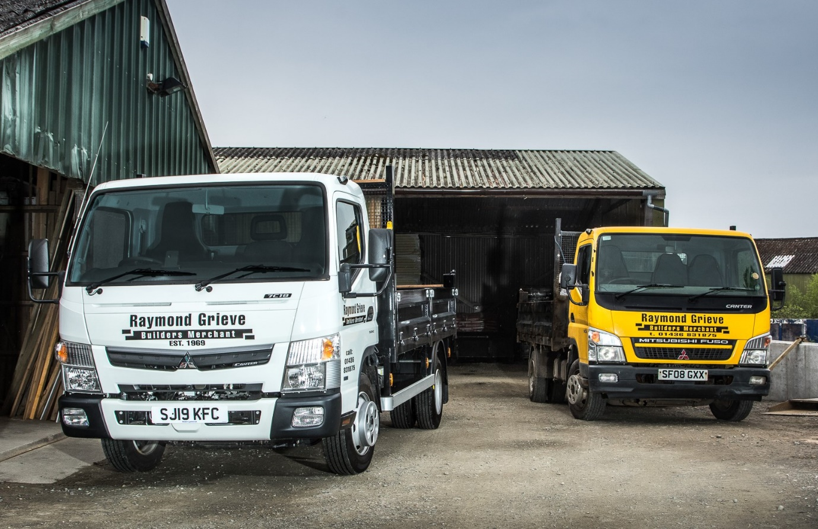

Two of a kind: Raymond Grieve’s new FUSO Canter, and the outstandingly reliable vehicle it replaces

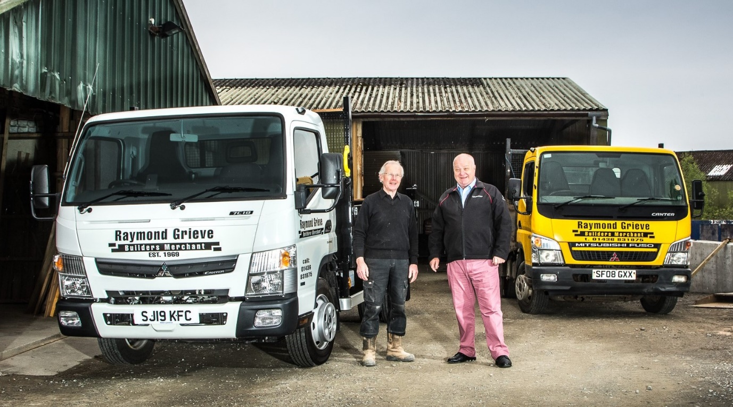

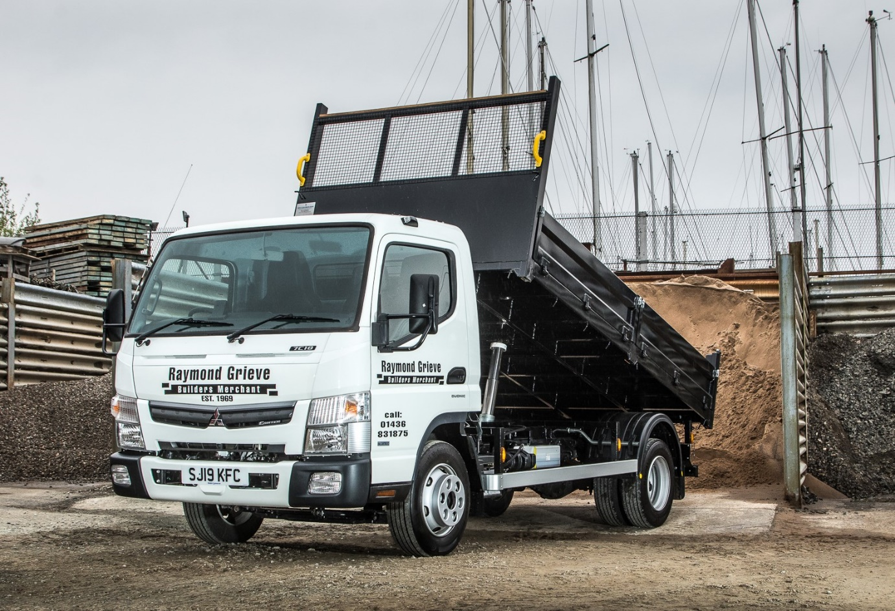

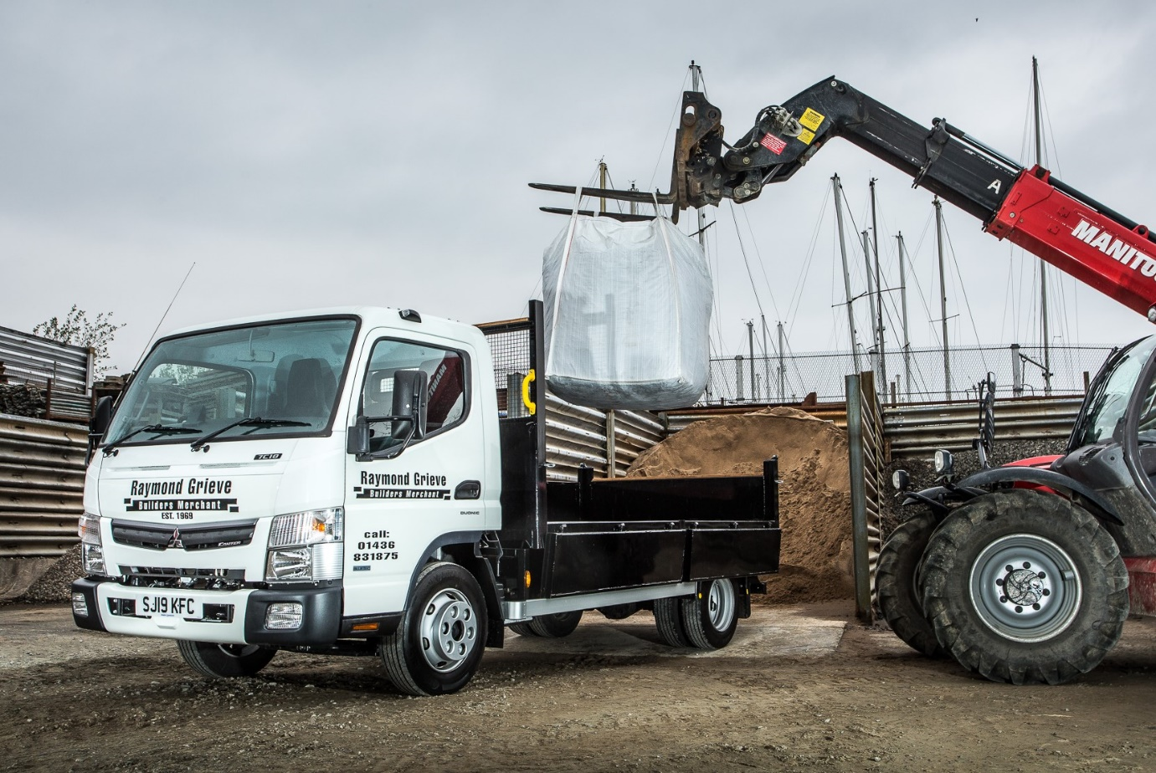

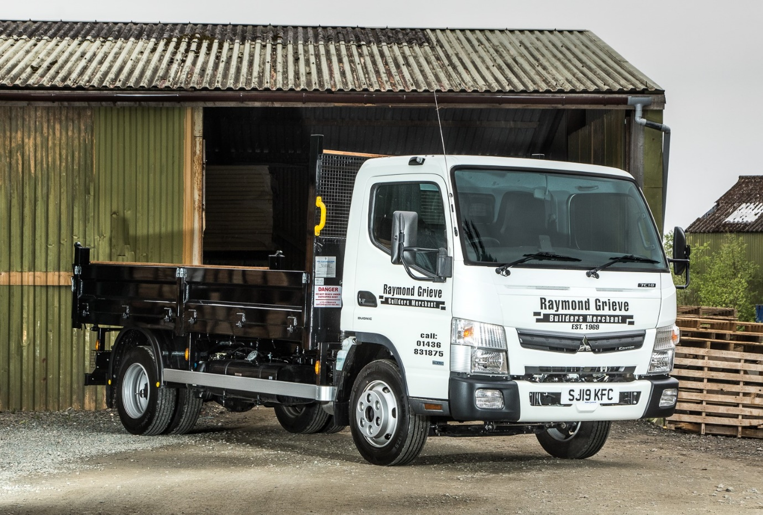

ends

For more information, or to request bigger/higher-res image files, please contact:
Steve Warren or John Ripley
Impact Communications, 01926 842126
Steve: 07770 470251, steve@impactcom.co.uk
John: 07771 484595, john@impactcom.co.uk



