

Date: 1 May 2019

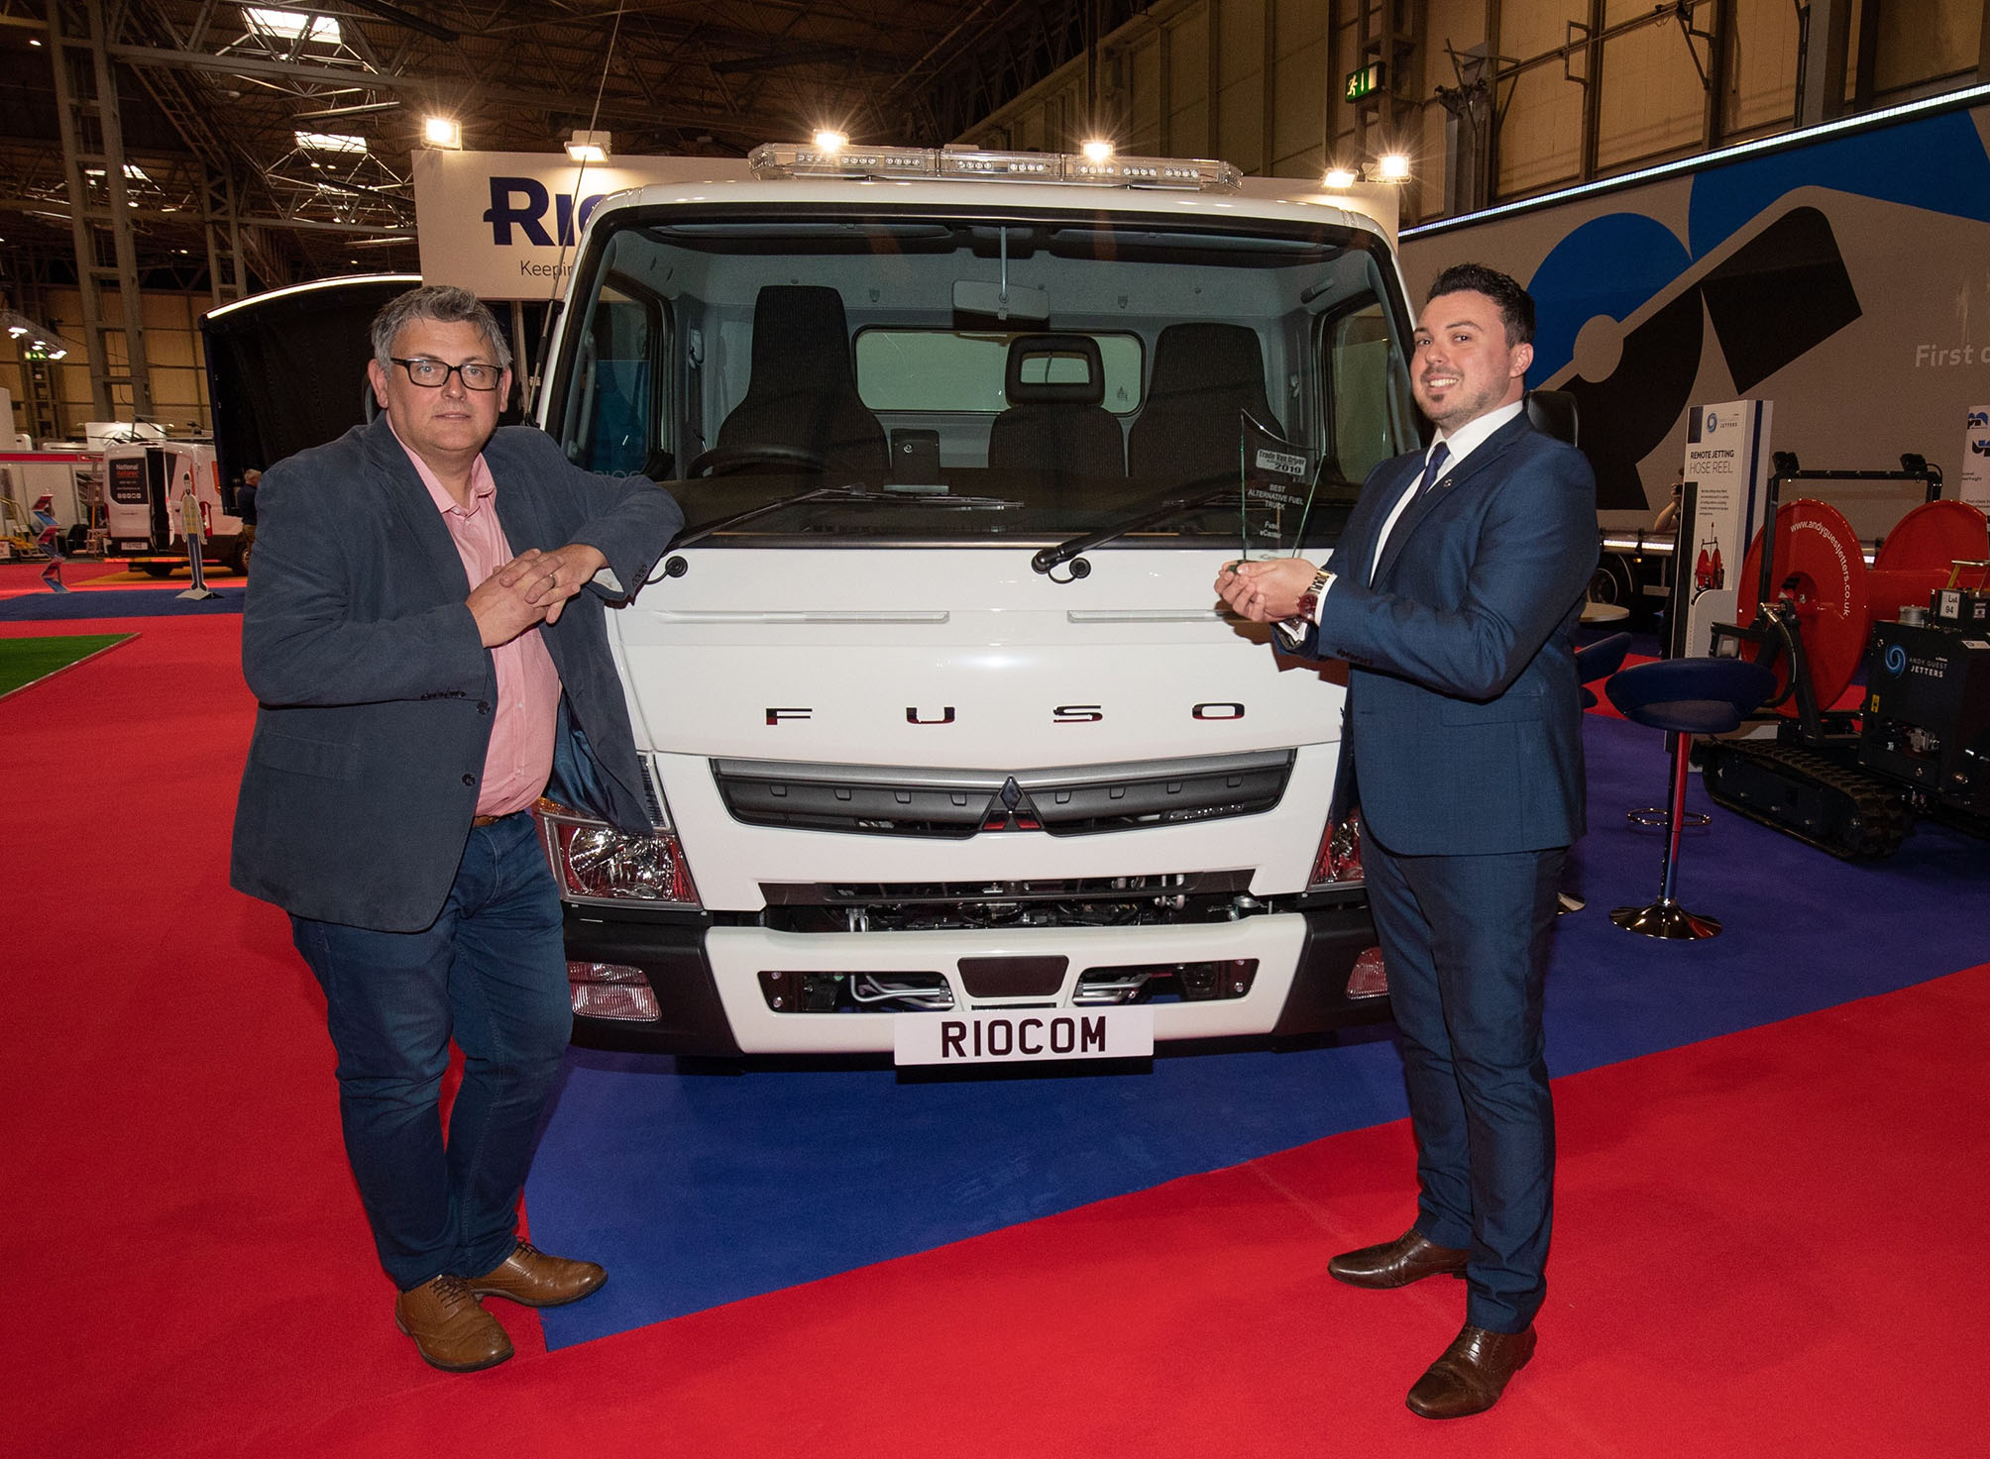

Show-stopper: FUSO Product Manager Joe Castronovo, right, accepted the eCanter’s Best Alternative Fuel Truck trophy from Trade Van Driver Editor Matthew Eisenegger at this year’s CV Show

FUSO Canter posts a repeat performance with two more top titles at 2019 Trade Van Driver Awards

A “solid and proven” fully electric model and a “feisty” off-road variant ensured another show-stopping role for the FUSO Canter at Trade Van Driver’s latest awards.

Mirroring their successes in last year’s competition, the FUSO eCanter was again named Best Alternative Fuel Truck by the leading small business user magazine, while the high-riding, all-wheel drive version took the Best Heavy Duty 4x4 honours for a remarkable sixth year running.

The FUSO Canter light truck family is sold and supported by Mercedes-Benz Dealers in Great Britain. Presented by Trade Van Driver Editor Matthew Eisenegger at the Commercial Vehicle Show 2019, this year’s awards were the first to be accepted on behalf of the manufacturer by Joe Castronovo, since his appointment in March to the role of FUSO Product Manager at Mercedes-Benz Trucks UK.

Trade Van Driver targets the owner-driver and small fleet operator, and prides itself on offering “a true reflection of the thoughts and feelings of our readership”. The magazine’s awards are judged not only by its own expert panel of journalists, but also by a panel of readers who use light commercial vehicles in their own businesses.

Whisper-quiet, and producing zero tail-pipe emissions, the 7.5-tonne FUSO eCanter is powered by six high-voltage, water-cooled lithium-ion batteries. It has been widely acknowledged as the first economically viable, fully electric truck – with a body and payload allowance of up to 4.5 tonnes, and a single charge allowing effective operating ranges of more than 62 miles (100 km), the eCanter also offers valuable operating cost savings compared to a conventional, diesel-engined truck.

The first examples are operating successfully in London, following delivery to high-profile customers DPD, Hovis and Wincanton PLC more than a year ago. As Trade Van Driver’s judges observed: “While many of the major manufacturers are dipping their toes into the alternative fuel pond, FUSO is way ahead of the game with its eCanter. Its technology is solid and proven, so any traders wishing to embrace environmental concerns can do so with confidence when choosing this vehicle.”
The well-established, 6.5-tonne Canter 4x4 is easily distinguished from its stablemates by its raised ride height. Powered by a 129 kW (175 hp) engine, and offering a body and payload allowance of up to 3,880 kg, it is equipped with selectable four-wheel drive. In 4x2 mode on road, the truck is impressively fuel-efficient, while all-wheel drive – which can be engaged or disengaged at the touch of a button – ensures powerful traction and impressive climbing ability on rugged terrain or for winter roads.

“Many operators require a vehicle that can deal with extreme conditions, and the FUSO Canter 4x4 offers that solution – and more,” enthused Trade Van Driver. “Off-road ability combined with functionality make this feisty off-roader the judges’ choice.”

A delighted Joe Castronovo declared: “A little over a month into the job, and I’m already picking up my first awards for the fantastic FUSO Canter. What’s not to like!”

He continued: “Aside from its exemplary environmental credentials, the eCanter offers a fantastic combination of high payload potential, competitive running costs and driver appeal. This vehicle represents a major breakthrough, and given the heightened focus on improving air quality in our towns and cities offers a genuinely sustainable solution to the challenge of urban operation.”

“Meanwhile, its sixth successive Trade Van Driver award confirms that when it comes to off-road performance and capability our 4x4 model is in a class of its own.”

Joe, who worked previously as a FUSO Canter sales specialist for a leading member of Mercedes-Benz Trucks UK’s franchised Dealer Network, added: “I genuinely believe in the Canter. It’s a brilliant product, sturdily built, highly practical and cost-effective to run.”

The Canter comprises variants with gross weights from 3.5-8.55 tonnes. Customers can choose from Comfort day cabs and Double crew cabs, and engine outputs from 96 kW (130 hp) to 129 kW (175 hp) – in addition to the eCanter, the line-up features a well-established diesel-electric Eco Hybrid model.

Its light yet strong ladder chassis contributes to the Canter’s low unladen weight – 7.5-tonne variants, in particular, offer market-leading payloads. The vehicle’s compact dimensions and excellent manoeuvrability also make it ideally suited to urban operation, and applications in which access is an issue.

Customers can also choose 3.5- and 7.5-tonne chassis pre-fitted at FUSO’s main European production facility in Tramagal, Portugal, with dropside and tipping bodies by the highly regarded Italian manufacturer Scattolini. This programme offers significant savings in time and administration.

www.canter.co.uk

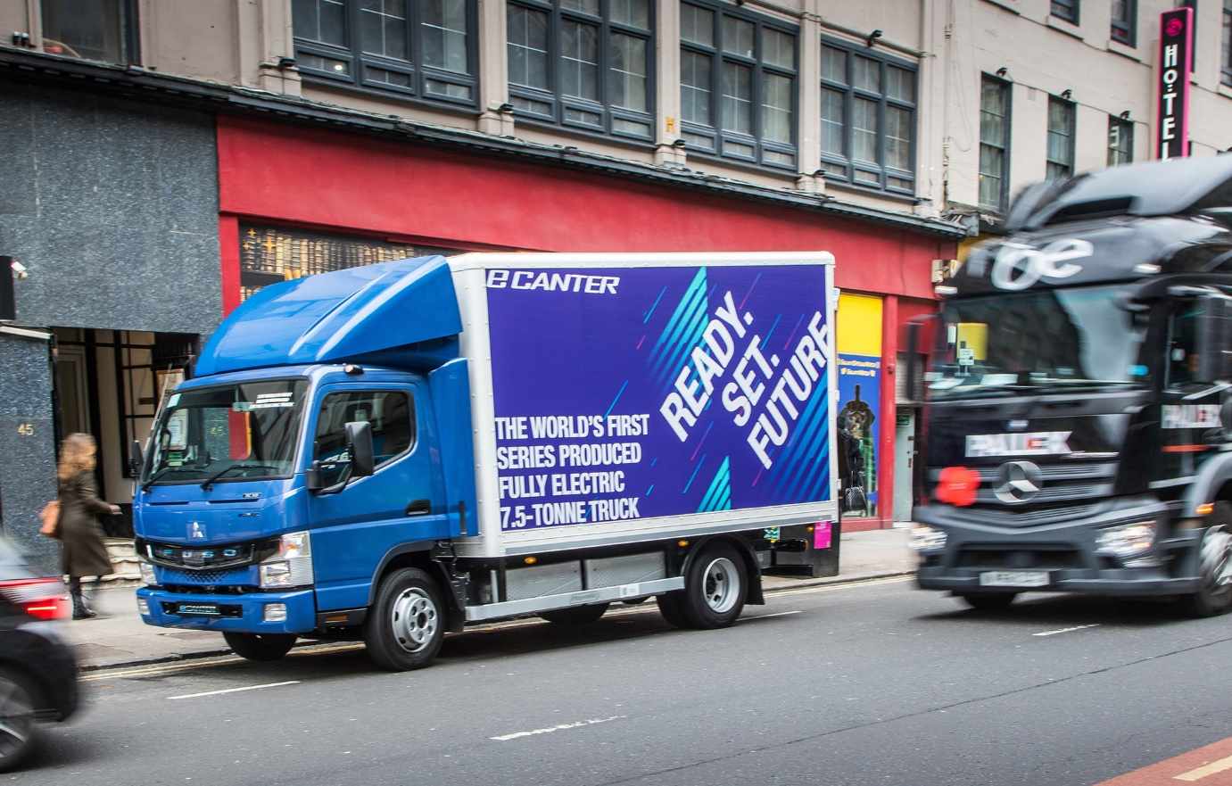

Sustainable solution: The all-electric FUSO eCanter can play an important role in the drive to improve air quality in towns and cities

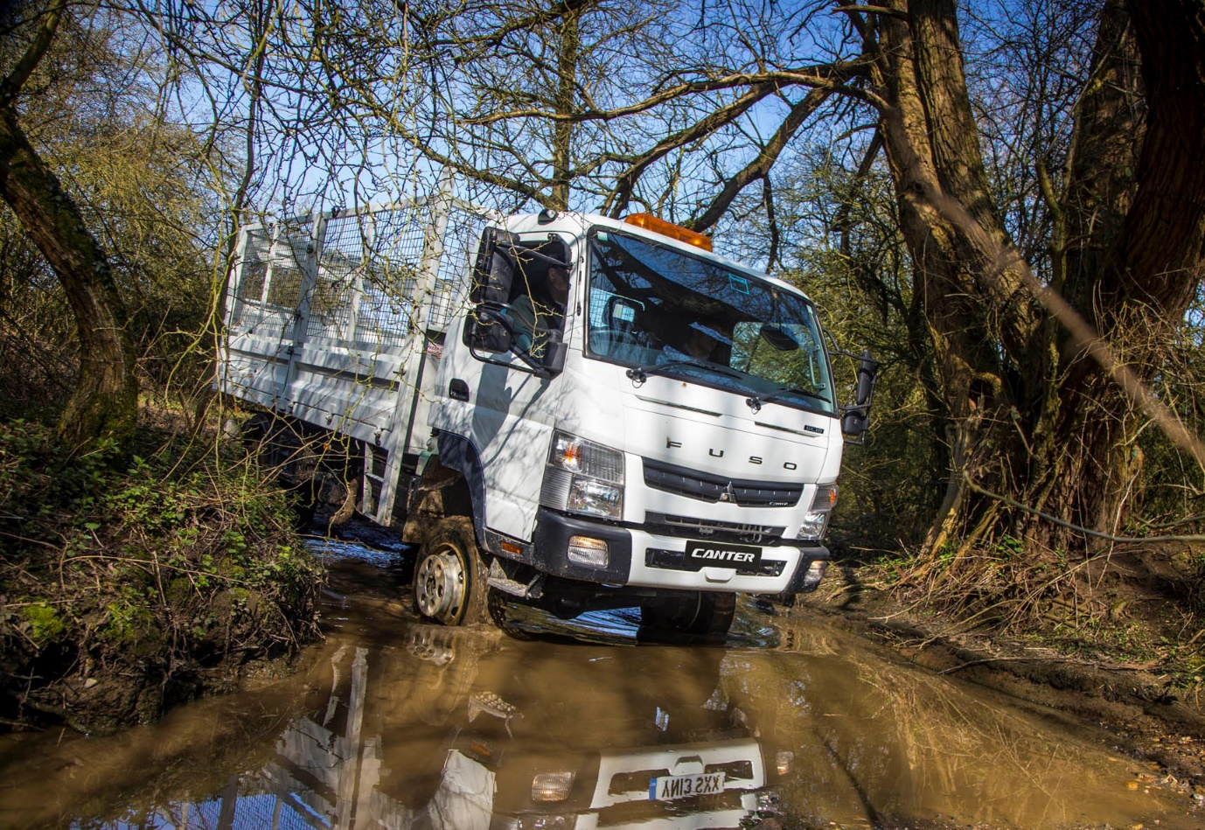

Six of the best: The FUSO Canter 4x4 has won Trade Van Driver’s off-road accolade every year since 2014

ends

About Mercedes-Benz Trucks UK Ltd

Mercedes-Benz Trucks UK Ltd is the sales and marketing organisation responsible for all Mercedes-Benz truck products in the UK, including FUSO Canter.

In 2018, the company registered 8,061 new trucks. After growth in 2017, Mercedes-Benz registrations levelled off to 7,223 trucks in 2018, ensuring it retained its title as the second-biggest truck brand in the UK. Meanwhile, FUSO made great strides to reach 838 registrations – including 675 new trucks over 6.0-tonnes.

For more than 125 years, Mercedes-Benz has stood for innovative vehicles that meet exceptionally high standards of quality. Our claim to perfection, sustainability and avant-garde design is now embodied in the next generation of trucks: Actros, Arocs, Atego, Econic and Unimog.

www.mbtrucks.co.uk

