

Date: 18 November 2022

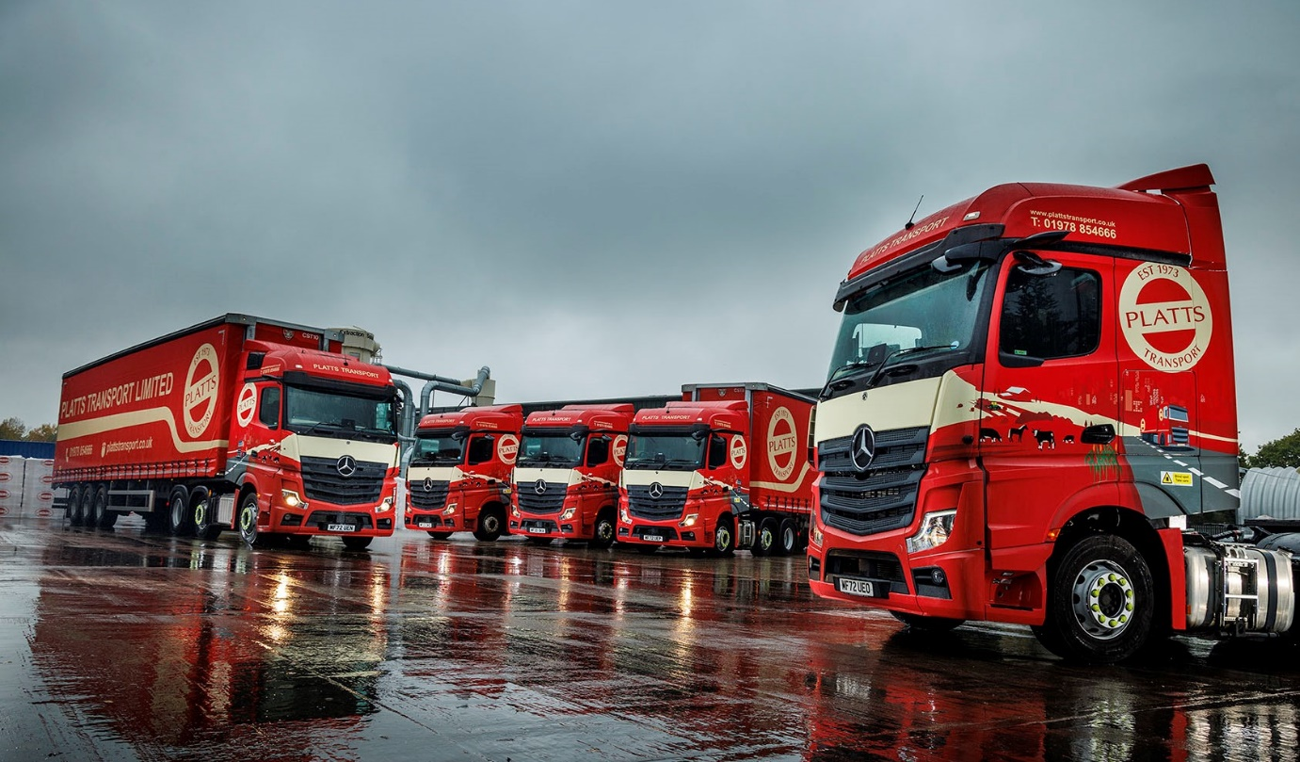

Bedding in nicely… Platts Transport’s five new Mercedes-Benz Actros Ls from eStar Truck & Van

Dairy farmers nationwide are now receiving deliveries of specialist cattle bedding and related products from Platts Transport’s first Mercedes-Benz trucks.

The company ordered the five, smartly finished Actros L tractors from eStar Truck & Van after trialling demonstration units that proved impressively fuel-efficient and won positive feedback from drivers.

Platts Transport is part of the Platts Group, which also comprises Platts Agriculture and Platts Commercial Services, and next year celebrates its 50th anniversary. Winner in May of the UK Family Business of the Year trophy at the FSB’s Celebrating Small Business Awards 2022, Platts employs 65 people across its three sites in Wrexham.
Having operated its own truck fleet for years, the Group launched Platts Transport as a stand-alone venture in the spring of 2020, to serve other companies needing logistics services during the first Covid lockdown and thereby safeguard colleagues’ jobs.

So successful has it proved that today, while Platts Transport continues to support its sister company, it has also built an impressive portfolio of third-party haulage customers that continues to grow.

Platts Transport’s fleet of 28 trucks is dominated by a Swedish brand – most of its vehicles are tractors although the line-up includes a handful of rigids. Reflecting the company’s heritage and range of services, the Mercedes-Benz units wear its distinctive ‘countryside to cityscape’ branding.

Actros L sets new standards in the segments for long-distance haulage and heavy-duty distribution. As well as a full complement of well-proven Mercedes-Benz technology, it comes with a host of features that deliver further improvements in efficiency, safety and comfort. Highlights include sophisticated aerodynamics, quieter cabs with improved heat insulation, and a lower, more comfortable seating position that also provides improved visibility.

The subject of Daimler Truck Financial Services UK funding agreements, Platts Transport’s Actros Ls are all 2545 variants with flat-floored BigSpace cabs and 12.8-litre in-line six-cylinder engines that produce 330 kW (450 hp).

When working for Platts Agriculture they collect raw materials and deliver to dairy farmers nationwide. Baled bedding is carried in curtainsiders, while walking-floor trailers are used for loose, bulk product.

Customers include the Royal Farms at Windsor, which Platts has served for more than a decade – the Group’s Royal Warrant reflects its commitment to sustainable and responsible business practices.

Platts diverts thousands of tonnes of material from landfill annually, then transforms it into finished products of superior quality that generate increased milk production through the promotion of animal welfare.

The Platts Group opened its own HGV garage in 2016. Platts Commercial Services has a DVSA-approved Authorised Testing Facility and as well as ensuring that Platts Transport’s vehicles are roadworthy and compliant, also serves third-party operators locally.

However, the new Actros Ls are being inspected and maintained under Mercedes-Benz Complete Service Contracts at eStar Truck & Van’s Deeside branch. Platts was already benefiting from the Dealer’s customer-focused support, as it ran a couple of eStar’s rental units prior to the arrival of its own trucks.

Platts Transport Managing Director Chris Whittaker is the son of Group MD Caroline Platt, and a grandson of the company’s founders, farmers Robert and Christine Platt, who established their business in 1973.

“These are still early days in our relationship but the Dealer’s aftersales support has been fantastic,” enthused Mr Whittaker. “Its workshop team are never late or too early when calling the Actros Ls in for their six-weekly inspections, so it’s all working very smoothly.”

Turning to the trucks themselves, he explained: “We were looking for more fuel-efficient vehicles that would support our environmental and sustainability goals, and the Actros Ls are certainly living up to their promise. We’re seeing average returns of 10 mpg, which is very good given the rural nature of many of our routes, and puts the Mercedes-Benz ahead of other trucks we’ve tried when it comes to economy.

“The drivers love them, too,” Mr Whittaker continued. “We don’t have any issues with recruitment and retention, and that’s partly down to our family-based culture, the benefits and shift patterns we offer, and our positive reputation within the local community.

“Also important, though, is our well-specified, high-end fleet, because good trucks attract high-calibre drivers. Ours are on distance work and regularly spend nights out in their cabs so it’s important that we provide these ambassadors for our business with top-quality equipment. That’s precisely what we’ve done with these Actros Ls.”

Standard-fit features on Platts’ Mercedes-Benz trucks include MirrorCam, the manufacturer’s ground-breaking, camera-based replacement for conventional mirrors; the radical Multimedia Cockpit dashboard, with its twin, tablet-style screens; and the Active Brake Assist 5 system, which boasts the industry’s most effective pedestrian-recognition capability.
“It’s all good as far as the drivers are concerned,” added Chris Whittaker. “The climate-controlled cabs are spacious and comfortable, while the high-tech driver aids help to relieve some of the stress from what can be a difficult job. The fact that our new Mercedes-Benz trucks also look great is just an added bonus.”

plattstransport.co.uk
plattsagriculture.co.uk

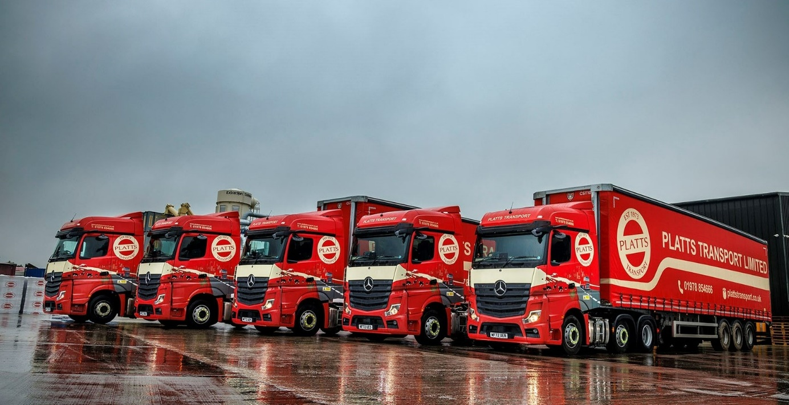
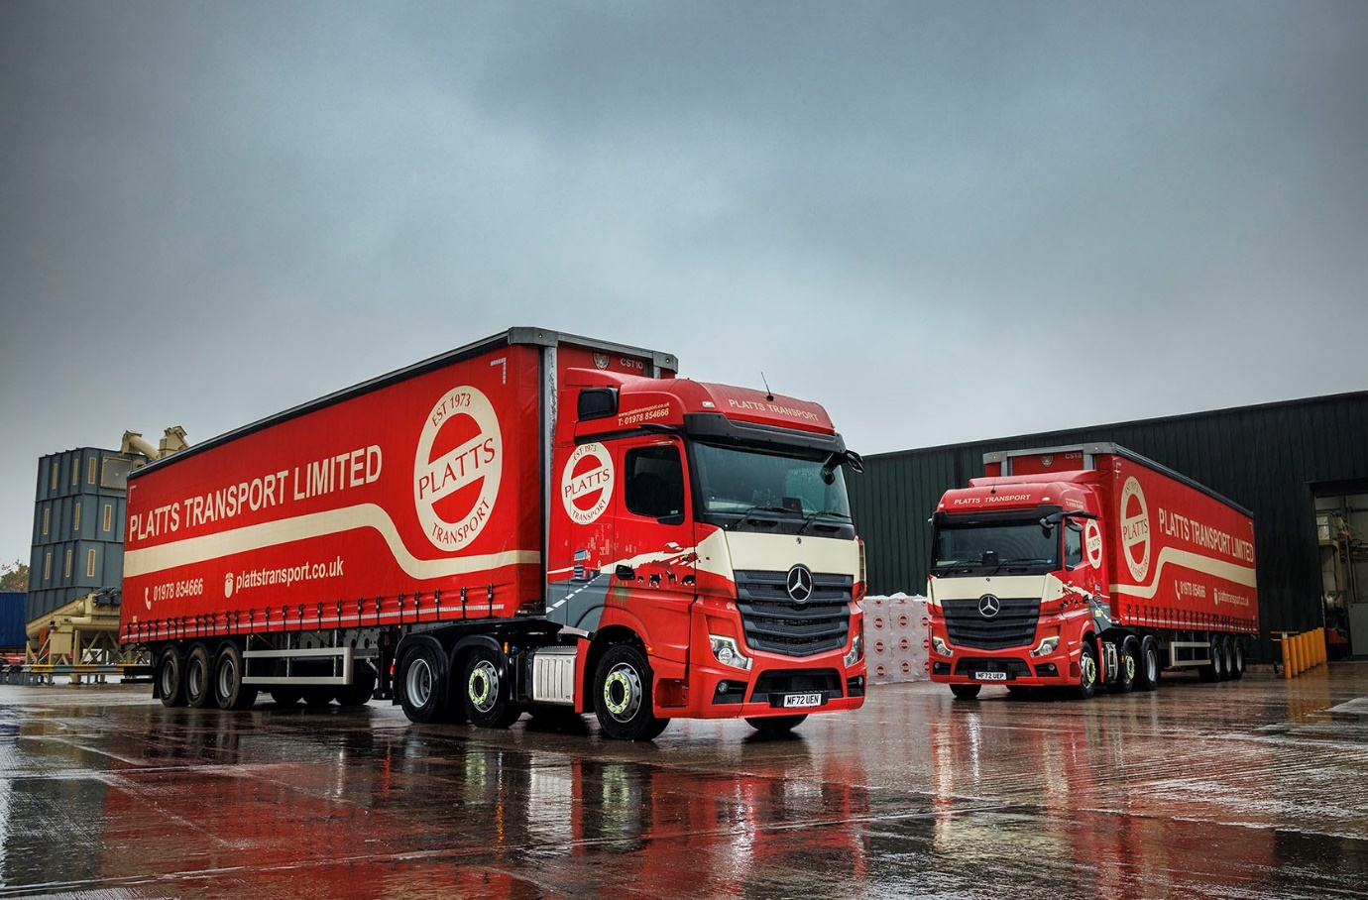

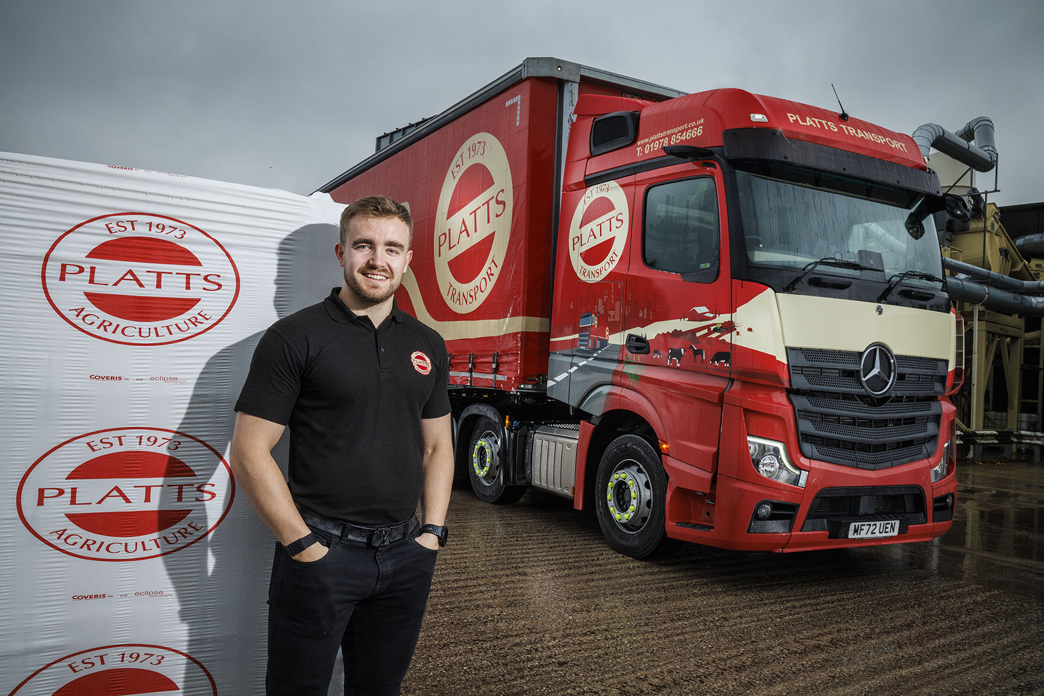

Cream of the crop: Now delivering to dairy farms nationwide, its new Mercedes-Benz Actros Ls are already the most economical trucks on the fleet, reports Platts Transport Managing Director Chris Whittaker

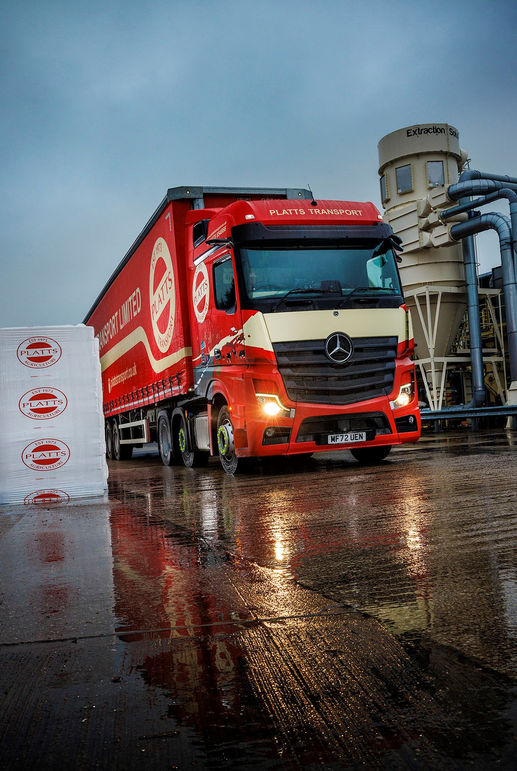

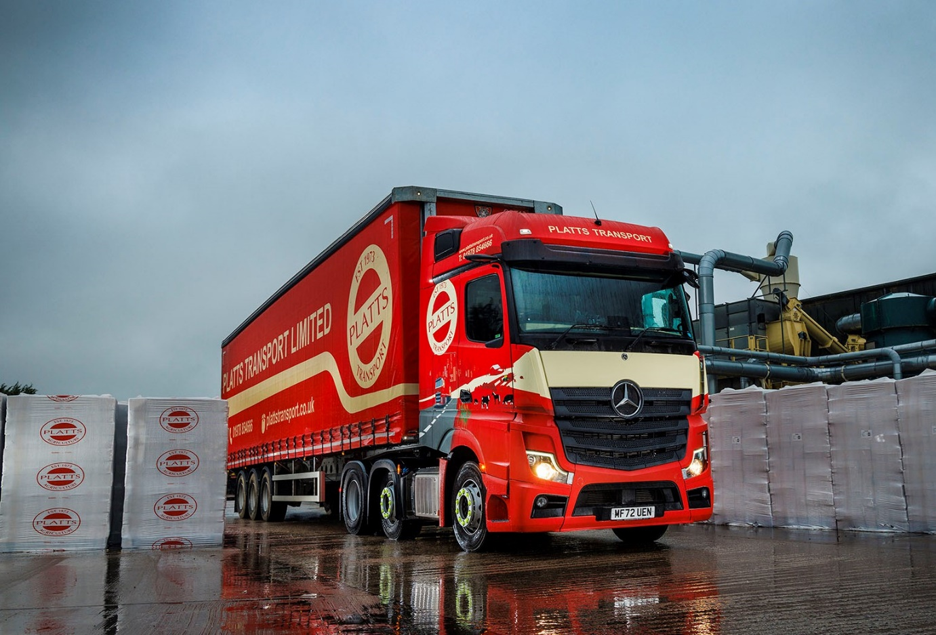

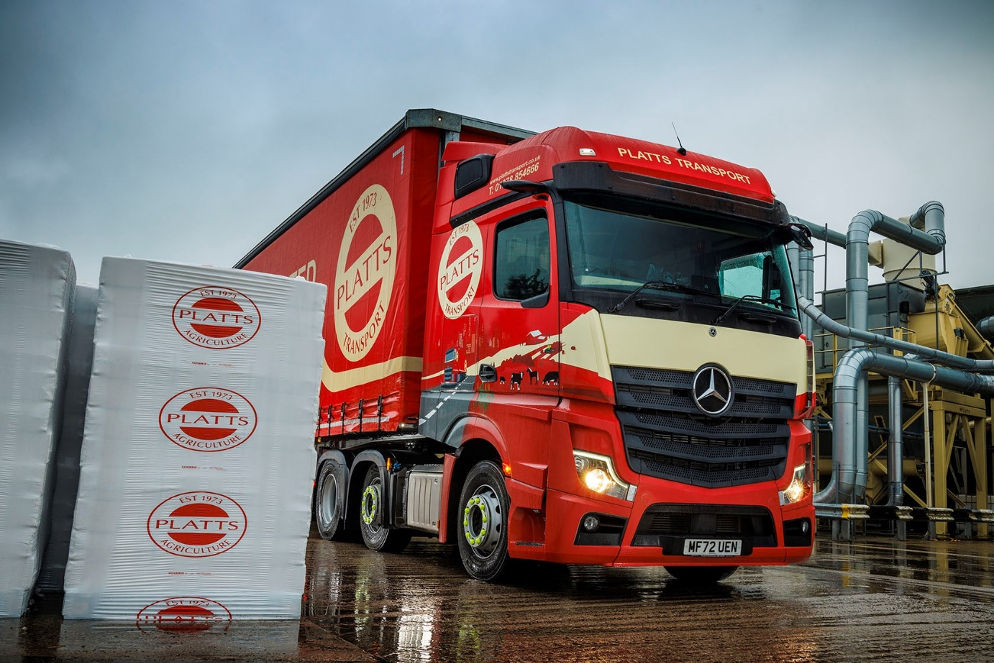

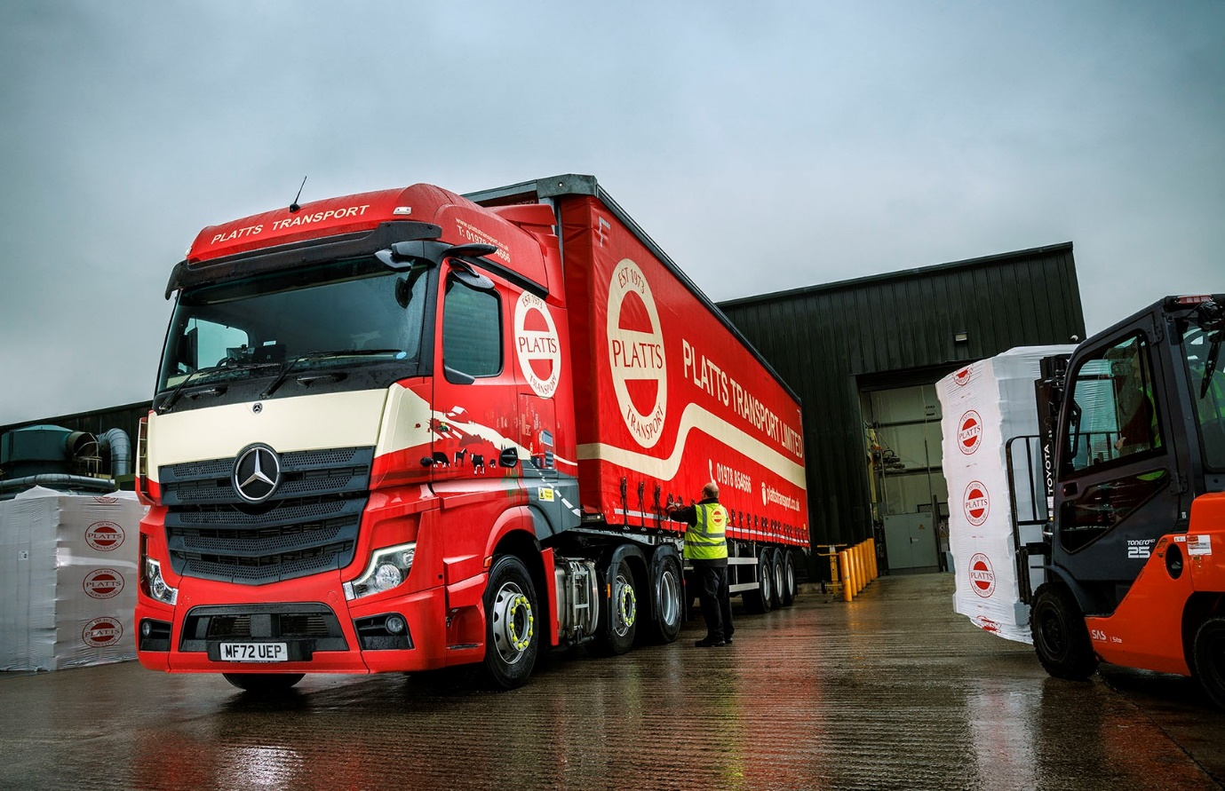

ends

For more information, or to request higher-resolution image files, please contact:
Steve Warren or John Ripley
Impact Communications
Steve: 07770 470251, steve@impactcom.co.uk
John: 07771 484595, john@impactcom.co.uk

