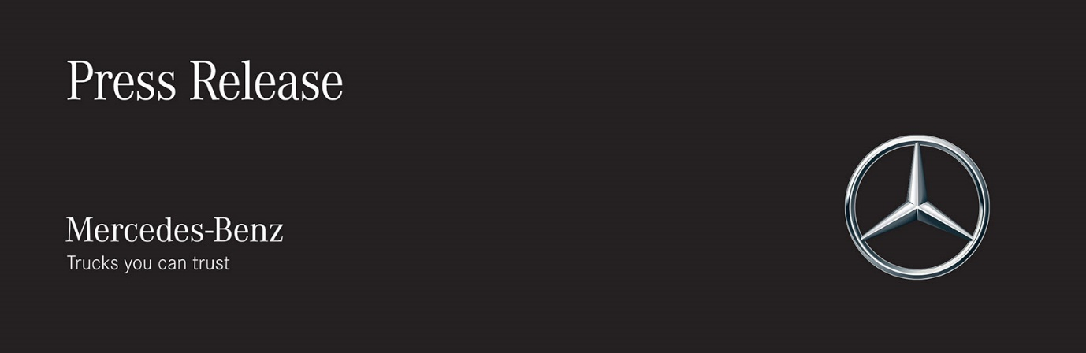

Date: 21 January 2019

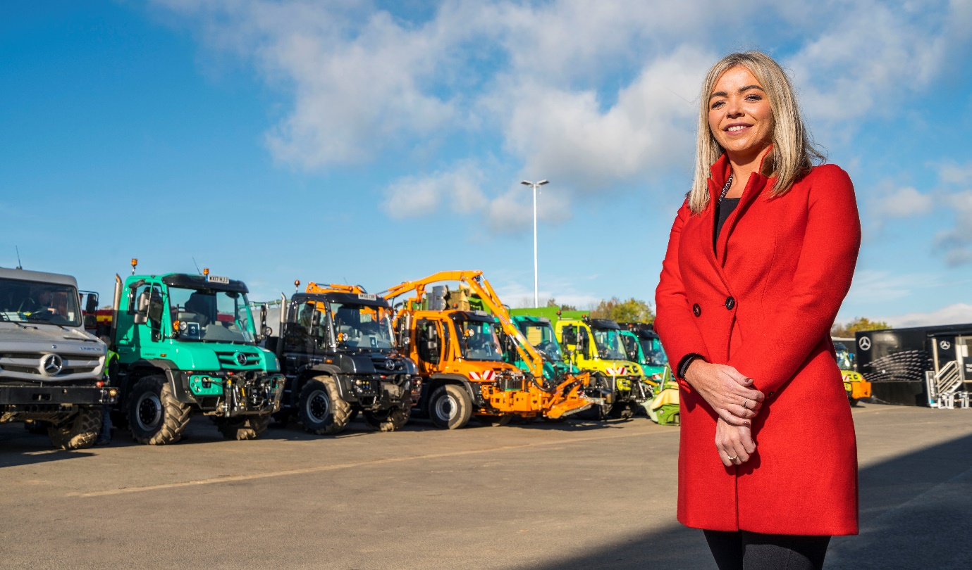

Mercedes-Benz appoints Katie Purcell as Head of Special Trucks – Unimog
Mercedes-Benz Trucks UK has appointed Katie Purcell to the position of Head of Special Trucks – Unimog.

In her new role Katie reports to Mercedes-Benz Trucks UK Managing Director Mike Belk, and is responsible for driving sales within the Special Vehicles sector. Although she is based in Milton Keynes, Katie will regularly travel around the country visiting customers and Dealer partners.

Commenting on her appointment, Katie said: “I am excited by the opportunity to set the strategy and grow the Unimog business in the UK. One of my first priorities will be to raise this halo product’s profile in the market, ensuring people understand what it stands for and appreciate what it offers.”

Katie has a proven track record in the automotive industry. Having started out in communications, she spent 10 years in Marketing and Product Management roles with two manufacturers – most recently she was Head of Electric Vehicles for a premium car brand.

Mike said: “Katie will further strengthen our Truck management team here in the UK at a time when our Unimog business is growing strongly. She brings a blend of experience as a manager of high performing teams, complemented by a deep understanding of the automotive sector, and specific technical skills in product management and marketing. This will enable us to capitalise on the significant potential for the Unimog in the UK market.”

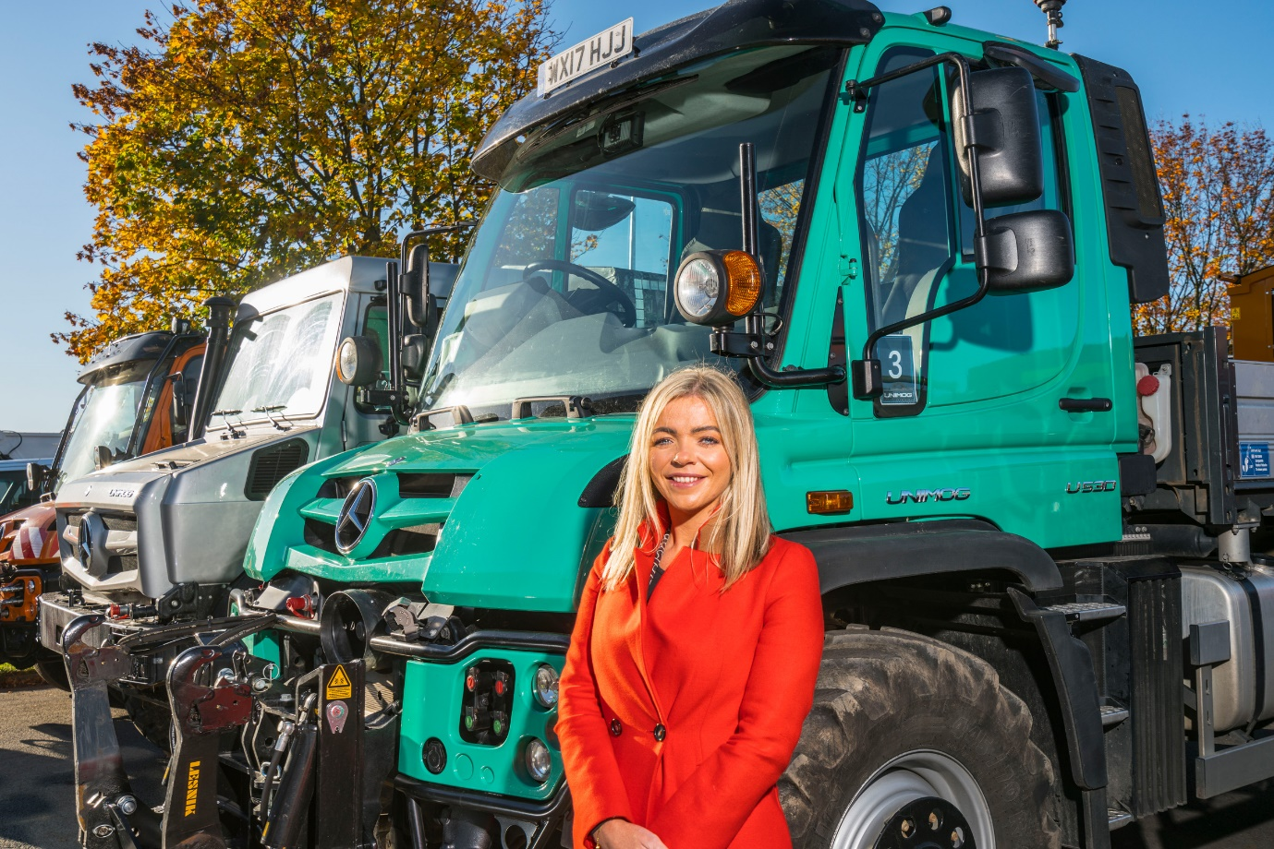

ends

For more information, or to request bigger/higher-res image files, please contact:

Jamie Fretwell, PR & Internal Communications, Mercedes-Benz Trucks UK
07712 519230, jamie.fretwell@daimler.com

About Mercedes-Benz Trucks UK Ltd

Mercedes-Benz Trucks UK Ltd is the sales and marketing organisation responsible for all Mercedes-Benz truck products in the UK, including FUSO Canter.

In 2017, Mercedes-Benz Trucks UK Ltd registered 8,385 new trucks. Mercedes-Benz registrations grew by 9% year-on-year, totalling 7,561 trucks. The company’s total market share for 2017 was 18.6% – making Mercedes-Benz the second-biggest truck brand in the UK.

For more than 125 years, Mercedes-Benz has stood for innovative vehicles that meet exceptionally high standards of quality. Our claim to perfection, sustainability and avant-garde design is now embodied in the next generation of trucks: Actros, Antos, Arocs, Atego, Econic and Unimog.

www.mbtrucks.co.uk

