

Date: 24 October 2022

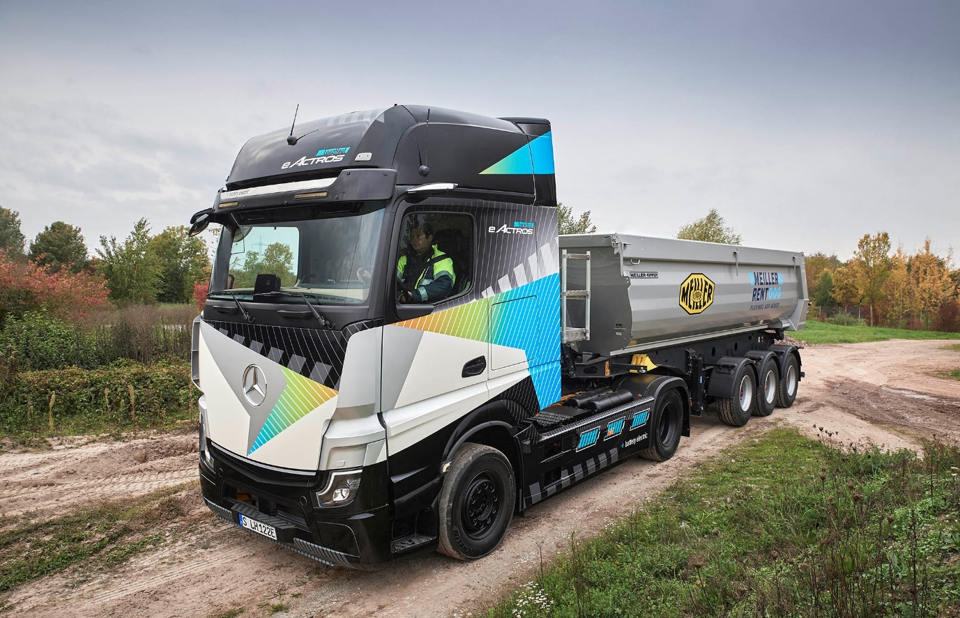

Tip for the top: Mercedes-Benz Trucks is presenting the eActros LongHaul ‘concept prototype’ with an electric PTO at the world’s leading construction show

Construction site traffic goes electric: Mercedes-Benz Trucks to present tailor-made, low-noise and locally CO₂-neutral vehicle solutions at bauma 2022

- The eActros LongHaul ‘concept prototype’ which recently won the 2023 Truck Innovation Award can be seen at bauma 2022 with an electric power take-off from MEILLER. This enables the vehicle for use with a hydraulic tipping semi-trailer or walking floor trailer, among other applications.

- Together with conversion specialist Paul Group, Mercedes-Benz Trucks will also present the Battery-Electric Arocs prototype with an electric truck mixer from LIEBHERR-Mischtechnik at bauma.

- Mercedes-Benz Trucks will also show the eActros 300 with an electrified hooklift from MEILLER.

- Since April 2022 the eActros 300 has come equipped with the second-generation MirrorCam with shorter camera arms and optimised image parameters.

- Features such as the Acoustic Vehicle Alerting System, Sideguard Assist S1R and the fifth-generation Active Brake Assist provide a high level of safety in eActros.

- Mercedes-Benz Trucks offers its customers a holistic transport solution consisting of vehicle technology, consulting, charging infrastructure and tailor-made services.

Stuttgart/Munich – Construction site traffic has many facets. Sometimes bulk materials such as sand, gravel or stones must be unloaded at a site. Another time it is necessary to transport heavy concrete parts for the assembly of an industrial plant over many kilometres of highways. This places high demands on the robustness, performance and efficiency, as well as the handling of vehicles that serve these applications. With vehicles from Mercedes-Benz Trucks, some of these requirements can now be met in a locally CO₂-neutral and low-noise manner. This can be experienced at bauma in Munich from 24-30 October, 2022. At the world’s leading trade show for construction applications, Mercedes-Benz Trucks will provide extensive insights into its electric vehicle portfolio, in addition to the diesel trucks it will have on display. On its trade show stand will be the eActros LongHaul concept prototype with an electric power take-off from MEILLER; the eActros 300 with an electrified tipper solution from MEILLER; and the Prototype Battery-Electric Arocs with an electric truck mixer from LIEBHERR-Mischtechnik, designed together with the Paul Group.

eActros LongHaul with electric power take-off as an industry-specific solution

Mercedes-Benz Trucks presented the ‘concept prototype’ of the eActros LongHaul just a few weeks ago at the IAA Transportation 2022 in Hanover. This battery-electric truck was developed for long-distance transport. It received the 2023 Truck Innovation Award from the International Truck of the Year jury at IAA and can now be seen in a road-oriented construction application at bauma. To this end, the Munich-based tipper manufacturer MEILLER, in co-operation with Mercedes-Benz Trucks, has developed an electric power take-off that enables hydraulic working equipment such as tipping semi-trailers or walking floor trailers to be efficiently operated.

The system developed for the eActros LongHaul, presented as a prototype at bauma, has a continuous output of 58 kW. In series production, the electric power take-off should generate significantly more power. Torque is 300 Nm. The system combines the inverter, the e-motor, the control unit and the usual tilting semi-trailer hydraulics in a design tailored to the vehicle to fit behind the cab. This electric auxiliary drive converts direct current from the high-voltage network into alternating current using the inverter. It drives an additional electric motor, which in turn drives the hydraulic pump to provide hydraulic power to operate the trailer. Advantages of this solution compared to the previous diesel-based operation: Complete local CO₂ neutrality and greatly reduced noise generation, which is particularly relevant in use in cities and residential areas. The compact design of the system also allows the eActros LongHaul to be operated with standard trailers – a major advantage for transport companies that use the vehicle for a wide variety of applications.

Long range, megawatt charging and LFP cell technology

The technological heart of the eActros LongHaul – planned for series production in 2024 and manufactured at the Wörth truck plant – is a new e-axle with two integrated electric motors that generate a continuous output of 400 kW and a peak output of over 600 kW. eActros LongHaul draws its energy from three battery packs, which are fitted in the form of drawers below the frame. This results in a total capacity of over 600 kWh. The batteries use lithium iron phosphate cell technology (LFP), characterised above all by a long service life and more usable energy. The eActros LongHaul is capable of high-performance or megawatt charging. Batteries can be charged from 20 to 80% in well under 30 minutes at a charging station with a capacity of around one megawatt. On a full charge eActros LongHaul will have a range of about 500 kilometres.

The first prototypes of the vehicle are already undergoing intensive testing and will be trialled on public roads this year. In the coming year near-series production prototypes will be sent to various customers for testing in real-world operations. Series production is scheduled for 2024.

Another innovation at bauma: Prototype Battery-Electric Arocs in co-operation with the Paul Group and LIEBHERR-Mischtechnik

Arocs is the robust and durable construction site truck from Mercedes-Benz Trucks, designed for tough jobs. In the future it will also be available as a battery-electric vehicle. In a first step, this will be implemented through a co-operation between Mercedes-Benz Trucks and the Paul Group, which, according to its own statements, is one of the European market leaders in the field of special vehicle construction. The company is electrifying the trucks, delivered by Mercedes-Benz Trucks from the Wörth truck plant, at its headquarters in Vilshofen near Passau, Germany, with an electric powertrain. Paul opted for an electrified central motor solution. In this way, the tried-and-proven planetary Arocs axles can continue to offer the ground clearance and off-road mobility required for use on construction sites.

The prototype of the Battery-Electric Arocs 8x4 with ClassicSpace M-cab shown at bauma in Munich is equipped with the ETM-905 electric truck-mixer body from LIEBHERR-Mischtechnik with a rated volume of nine cubic metres. It draws its energy from the Arocs batteries via a power take-off. This combination was chosen for a reason. Because truck mixers are an energy-intensive application, much CO₂ can be saved through electrification. At the same time, the low-noise vehicle also contributes to noise reduction, especially on construction sites in urban and inner-city areas.

The Paul Group specifies a continuous output of more than 300 kW and a peak output of more than 400 kW for the vehicle’s electric drive train. The Battery-Electric Arocs can be configured with either six or seven battery packs, each with 60 kWh of usable energy. According to Paul, ranges of well over 200 kilometres are possible. Two (for six packs) or three (for seven packs) of the battery packs are located in the battery tower behind the cab. The remaining batteries are installed in the chassis. The Battery-Electric Arocs has a future-proof 800 volt on-board electrical system and, according to the Paul Group, can be charged from 20 to 80% at a 150 kW charging station within about 1.5 hours with six battery packs. AC charging will also be available.

In the limited series by the end of 2023, flexible configurations with three and four axles are available for LIEBHERR truck mixers, flatbed and tipping applications. Primary sales will be handled by Paul; the company group also takes over all service and maintenance work on the truck. The vehicle will initially be available in Germany.

eActros 300 in combination with eWorX from ZF and hooklift from MEILLER

In addition to eActros LongHaul, Mercedes-Benz Trucks is also showing the already market-launched eActros 300 at this year’s bauma, as a variant for road-oriented construction applications. Mercedes-Benz Trucks has installed the eWorX electric power take-off developed by ZF, together with an electrified hooklift from MEILLER, in an eActros. ZF’s eWorX system converts the vehicle’s electrical energy into mechanical power on the shaft to drive the hydraulic pump for operating the body. To enable optimised operational efficiency, eWorX integrates components such as the e-motor, inverter, electronic control unit and application-specific software modules in a Plug-and-Work One-Box solution.

And this is how the solution works: The traction battery of the eActros provides the ZF system eWorX with electrical energy using a direct current interface. The eWorX electric motor in turn drives the hydraulic pump of the MEILLER hooklift.This means a mechanical connection to the traction motor is not required. eWorX ensures smooth communication between the electric truck and the body via a CAN bus interface.

The eActros, as presented with the MEILLER hooklift, is suitable for transporting containers. It enables the needs-based operation of the hydraulics thanks to the eWorX ZF system. The pump only runs when the body is moved. This prevents unnecessary energy consumption. In addition, there are none of the noise emissions of a combustion engine. The eActros presented at the bauma booth by PALFINGER, with a skiploader from the manufacturer of innovative lifting and crane solutions, also has the ZF eWorX system.

High-tech for sustainable performance and safety¹

For the eActros 300 Mercedes-Benz Trucks relies on an ePowertrain in the form of an electric rigid axle with two integrated electric motors and a two-speed transmission. The batteries consist of three battery packs, each offering an installed capacity of 112 kWh² and a usable capacity of around 97 kWh³. With three battery packs, the eActros 300 has a range of up to 300 kilometres. The eActros can be charged with up to 160 kW: The eActros 300’s three battery packs need a little more than an hour at a standard DC fast charging station, with a charging current of 400 A, to be charged from 20 to 80%.⁴

Safety features include the external Acoustic Vehicle Alerting System in accordance with legal requirements; fifth-generation Active Brake Assist with pedestrian detection; and Sideguard Assist S1R. For visual warnings, the turning assistant uses the MirrorCam display, which is installed in eActros in place of a conventional main and wide-angle mirror. The second-generation mirror camera system has been in use since April 2022, which, thanks to camera arms that are ten centimetres shorter on each side and new image parameters, can now support the driver even better in many road traffic situations – especially in tight construction sites.

One of the advantages of shortening the camera arms is that drivers find it easier to reverse in a straight line compared to the first generation. This is mainly due to the fact that the perspective of the MirrorCam is now more similar to that of the typical glass mirror, which in turn makes it easier to get used to MirrorCam. Collisions with objects along the way can also usually be avoided.

In addition, engineers at Mercedes-Benz Trucks have further optimised the Tone Mapping. Tone Mapping is a process of adjusting an image so that a wide range of tones are displayed correctly on a medium. The results can be seen in an improved contrast display. The evolution in the colour and brightness co-ordination of the camera system, which is already designed to be very bright, means the displays can now depict the area relevant to the driving situation even more precisely, especially under light-critical conditions.

Intelligent digital solutions for even more efficient use

In order to integrate battery-electric trucks into daily routines in the best possible way, to save time and effort and to make the switch to e-mobility as easy as possible, Mercedes-Benz Trucks is providing its customers with an entire range of digital solutions via its Fleetboard portal. This includes, for example, an individually developed charge management program for charging profiles, as well as a logbook with detailed information on driving, standing and charging times. There is also a mapping tool that shows in real time the location of a vehicle, whether it is driving, stationary or charging and the battery charge status.

With regard to optimal vehicle use, the Mercedes-Benz Complete Service contract is also available for eActros. This extensive service package covers work for maintenance and repair of the entire vehicle and drivetrain, including parts subject to wear. The service contract always includes intensive customer support from Mercedes-Benz Uptime. This intelligent system records all relevant vehicle data from tyre pressure to engine and battery status. In this context, Mercedes-Benz Uptime has already been expanded to include more than 100 e-specific rules which, for example, continuously monitor charging processes or voltage curves in connection with the high-voltage battery. In addition, information is available via the new cloud-based customer portal. By networking vehicles, Mercedes-Benz service and transport company enables visits to repair facilities to be more easily planned and to significantly reduce unforeseen breakdowns.

Competent advice for tailor-made e-mobility

Regardless of the drive technology, every investment in a commercial vehicle for transport companies must pay off in everyday use. In addition, it is important to address a long series of questions in advance, especially in connection with fully electric trucks: On which routes can I use electric vehicles? What about the charging infrastructure? What structural measures and investments should one expect for the depot? It is therefore all the more important not only to sell customers an electric truck, but to accompany them on their road to electrifying their fleet. After all, e-mobility is more than just a new driveline. That’s precisely why Mercedes-Benz Trucks has integrated eActros into a business ecosystem that includes consulting services to ensure high vehicle utilisation rates and optimization of the total cost of ownership. For example, based on existing routes we determine a usage profile of electric trucks that is as realistic and meaningful as possible for each respective customer. In addition to the electrification of the depot, eConsulting also includes – depending on the customer’s needs – planning, application and implementation related to the charging infrastructure and grid connection.

¹ With all assistance systems, Mercedes-Benz Trucks aims to support the driver as best possible within system limits when driving the vehicle. However, as stipulated by law, the driver remains fully responsible for driving the vehicle safely at all times.

² Nominal capacity of new battery, based on internally defined boundary conditions, may vary depending on use case and ambient conditions.

³ Energy available for regular truck operation with new batteries. Based on internally defined boundary conditions, may vary depending on use case and ambient conditions.

⁴ Based on internally determined empirical values under optimal conditions, including an ambient temperature of 20°C.

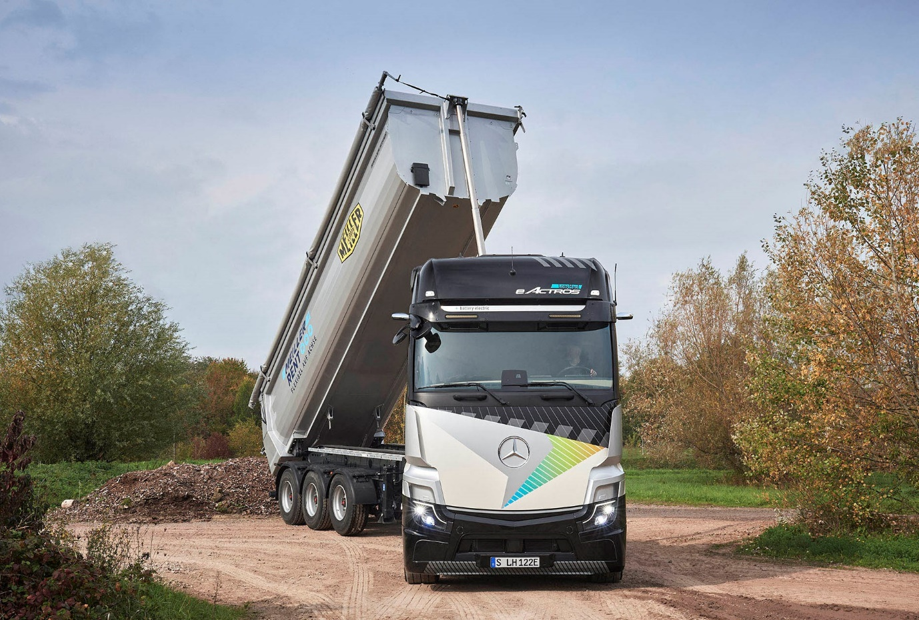

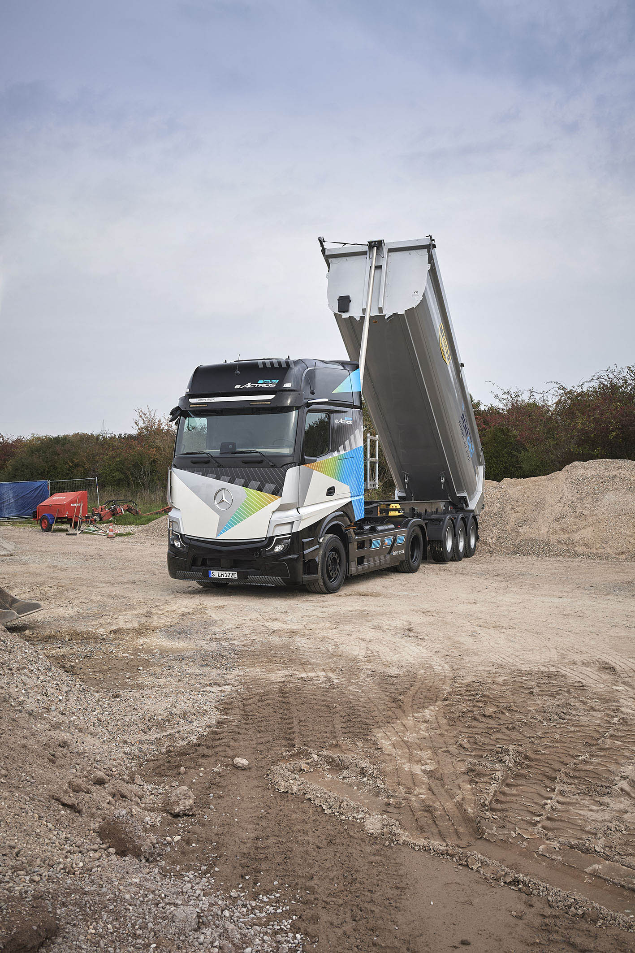

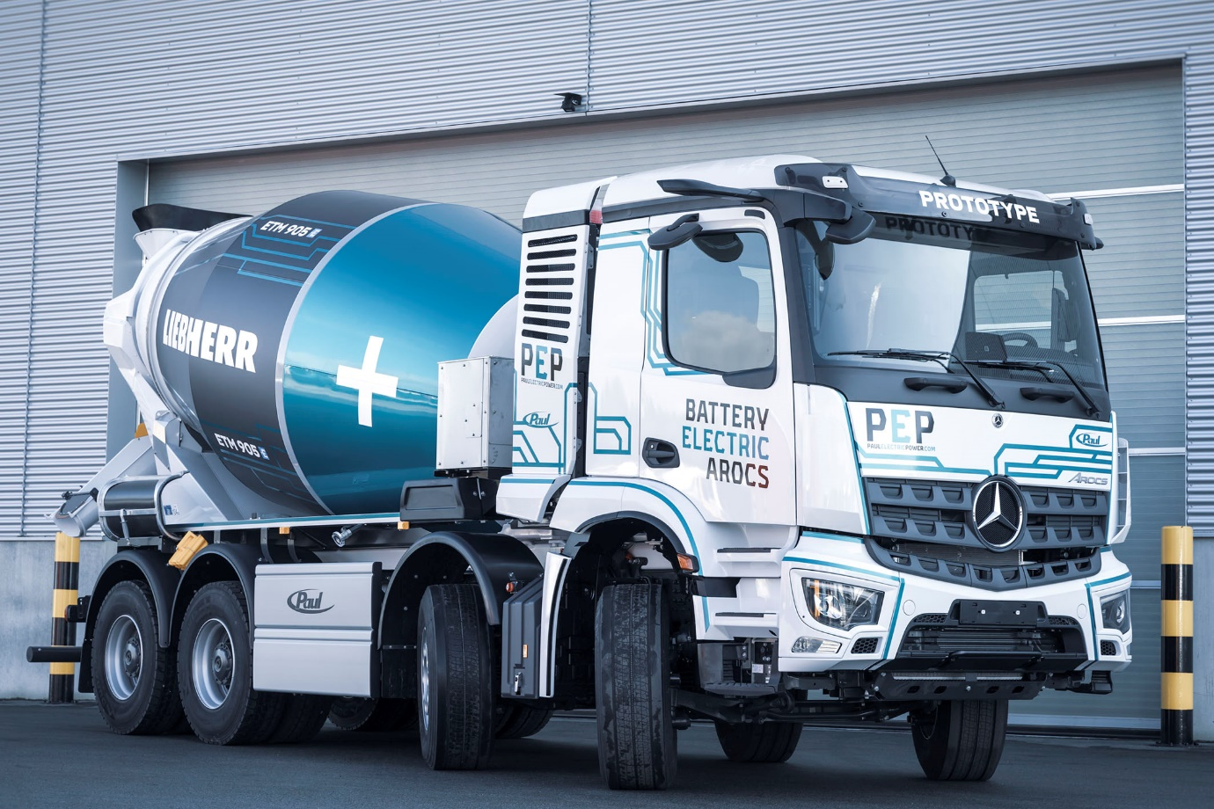

First appearance: The Battery-Electric Arocs prototype makes its debut at bauma 2022

ends

For more information, or to request higher-resolution images, please contact:

Jamie Fretwell at Mercedes-Benz Trucks UK Ltd
07712 519230, jamie.fretwell@daimler.com

or

Steve Warren or John Ripley
Impact Communications
Steve: 07770 470251, steve@impactcom.co.uk
John: 07771 484595, john@impactcom.co.uk

or

Ulrike Burkhart, +49 (0) 160 8613757, ulrike.burkhart@daimlertruck.com
Akim Enomoto, +49 (0) 176 30995099, akim.enomoto@daimlertruck.com
Peter Smodej, +49 (0) 176 30936446, peter.smodej@daimlertruck.com

Further information on Daimler Truck is available at:
www.media.daimlertruck.com and www.daimlertruck.com

Forward-looking statements:
This document contains forward-looking statements that reflect our current views about future events. The words “aim”, “ambition”, “anticipate,” “assume,” “believe,” “estimate,” “expect,” “intend,” “may,” ”can,” “could,” “plan,” “project,” “should” and similar expressions are used to identify forward-looking statements. These statements are subject to many risks and uncertainties, including an adverse development of global economic conditions, in particular a decline of demand in our most important markets; a deterioration of our refinancing possibilities on the credit and financial markets; events of force majeure including natural disasters, pandemics, acts of terrorism, political unrest, armed conflicts, industrial accidents and their effects on our sales, purchasing, production or financial services activities; changes in currency exchange rates, customs and foreign trade provisions; a shift in consumer preferences; a possible lack of acceptance of our products or services which limits our ability to achieve prices and adequately utilise our production capacities; price increases for fuel or raw materials; disruption of production due to shortages of materials, labour strikes or supplier insolvencies; a decline in resale prices of used vehicles; the effective implementation of cost-reduction and efficiency-optimization measures; the business outlook for companies in which we hold a significant equity interest; the successful implementation of strategic cooperations and joint ventures; changes in laws, regulations and government policies, particularly those relating to vehicle emissions, fuel economy and safety; the resolution of pending government investigations or of investigations requested by governments and the conclusion of pending or threatened future legal proceedings; and other risks and uncertainties, some of which are described under the heading “Risk and Opportunity Report” in the current Annual Report. If any of these risks and uncertainties materializes, or if the assumptions underlying any of our forward-looking statements prove to be incorrect, the actual results may be materially different from those we express or imply by such statements. We do not intend or assume any obligation to update these forward-looking statements since they are based solely on the circumstances at the date of publication.

Daimler Truck at a glance
Daimler Truck Holding AG ("Daimler Truck") is one of the world's largest commercial vehicle manufacturers, with over 40 main locations and more than 100,000 employees around the globe. The founders of Daimler Truck have invented the modern transportation industry with their trucks and buses a good 125 years ago. Unchanged to this day, the company's aspirations are dedicated to one purpose: Daimler Truck works for all who keep the world moving. Its customers enable people to be mobile and get goods to their destinations reliably, on time, and safely. Daimler Truck provides the technologies, products, and services for them to do so. This also applies to the transformation to CO2-neutral driving. The company is striving to make sustainable transport a success, with profound technological knowledge and a clear view of its customers' needs. Daimler Truck's business activities are structured in five reporting segments: Trucks North America (TN) with the truck brands Freightliner and Western Star and the school bus brand Thomas Built Buses. Trucks Asia (TA) with the FUSO and BharatBenz commercial vehicle brands. Mercedes-Benz (MB) with the truck brand of the same name. Daimler Buses (DB) with the Mercedes-Benz and Setra bus brands. Daimler Truck's new Financial Services business (DTFS) constitutes the fifth segment, the product range in the truck segments includes light, medium and heavy trucks for long-distance, distribution and construction traffic and special-purpose vehicles used mainly in the municipal and vocational sector. The product range of the bus segment includes city buses, school buses and intercity buses, coaches and bus chassis. In addition to the sale of new and used commercial vehicles, the company also offers aftersales services and connectivity solutions.

