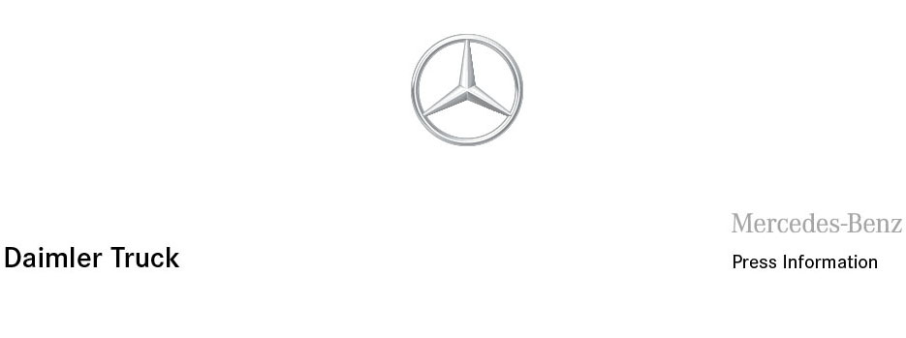

Date: 21 February 2022

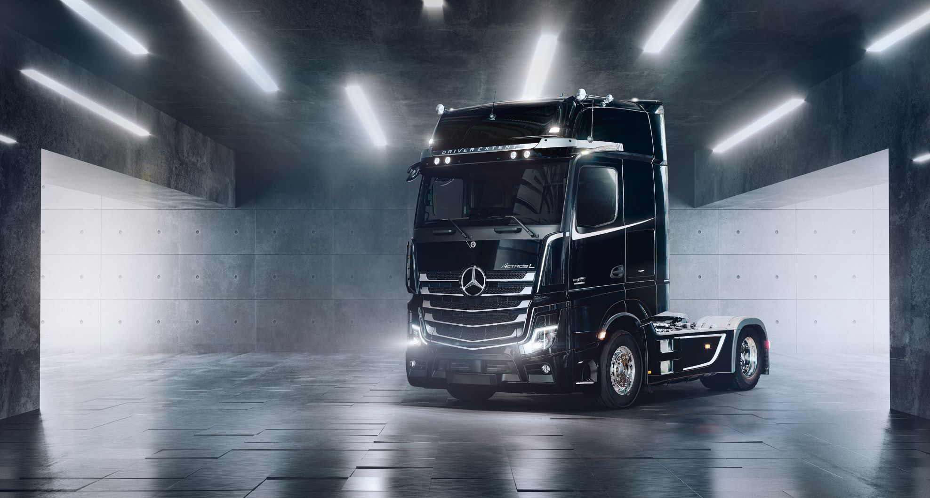

Strictly limited: The new Actros L Driver Extent+

Stuttgart – The Actros L Driver Extent+ further enhances the Mercedes-Benz premium truck and definitely makes for an unforgettable driving experience. The new special edition model is striking with its exclusive design and first-class comfort. A driver’s dream, strictly limited to 150 units.

The name speaks for itself: That’s why the model’s front panel flap features Actros lettering in elegant dark chrome. In addition, a badge visibly identifies the truck as an exclusive Driver Extent+ and limited special edition model.

The truck features exclusive decals in matt grey. This adds colour highlights under the side windows as well as on the sun visor, side trim and front. The cab colour can be freely selected.

The black closed panel makes the front of the vehicle more expressive and the illuminated Mercedes-Benz star even brighter.

The four round, roof-mounted headlamps keep everything in view and improve visibility for drivers in all weather conditions. The lights with energy-efficient LED technology have been installed in the sun visor. The front and rear axles are fitted with wheel stud covers, rear axle caps and wheel nut protection caps. These are available with black paintwork or in high-quality stainless steel. The closed aluminium frame covers offer two additional step plates and complement the standard steps.

The illuminated entrance badge with Mercedes-Benz lettering and the stainless steel entrance steps on the driver’s and front passenger’s side ensure the safest possible and most suitable entry into the exclusive special edition model.

But Driver Extent+ doesn’t stop on the outside: The ambient lighting with a total of 138 LEDs ensures pleasant, indirect light in the cab and can be individually adjusted in colour and intensity.

Another special feature is the pod coffee maker. In true style, it fits in with the Mercedes-Benz design in the vehicle’s interior and can be easily stored in the cup holder thanks to its handy size.

In addition, the CabLock anti-theft device provides increased protection for drivers. The system can be locked and opened independently of the central locking system.

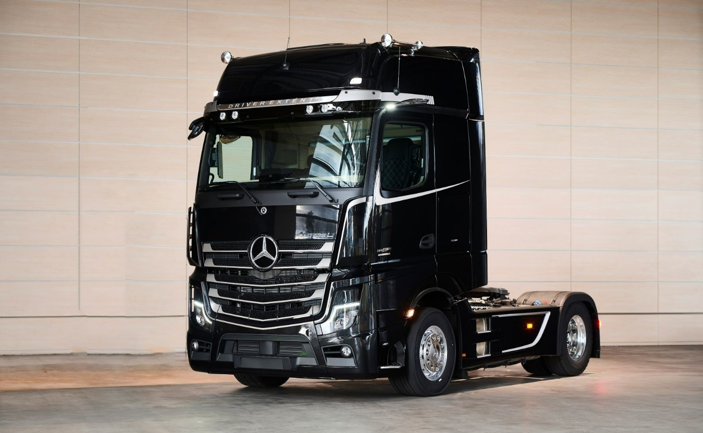
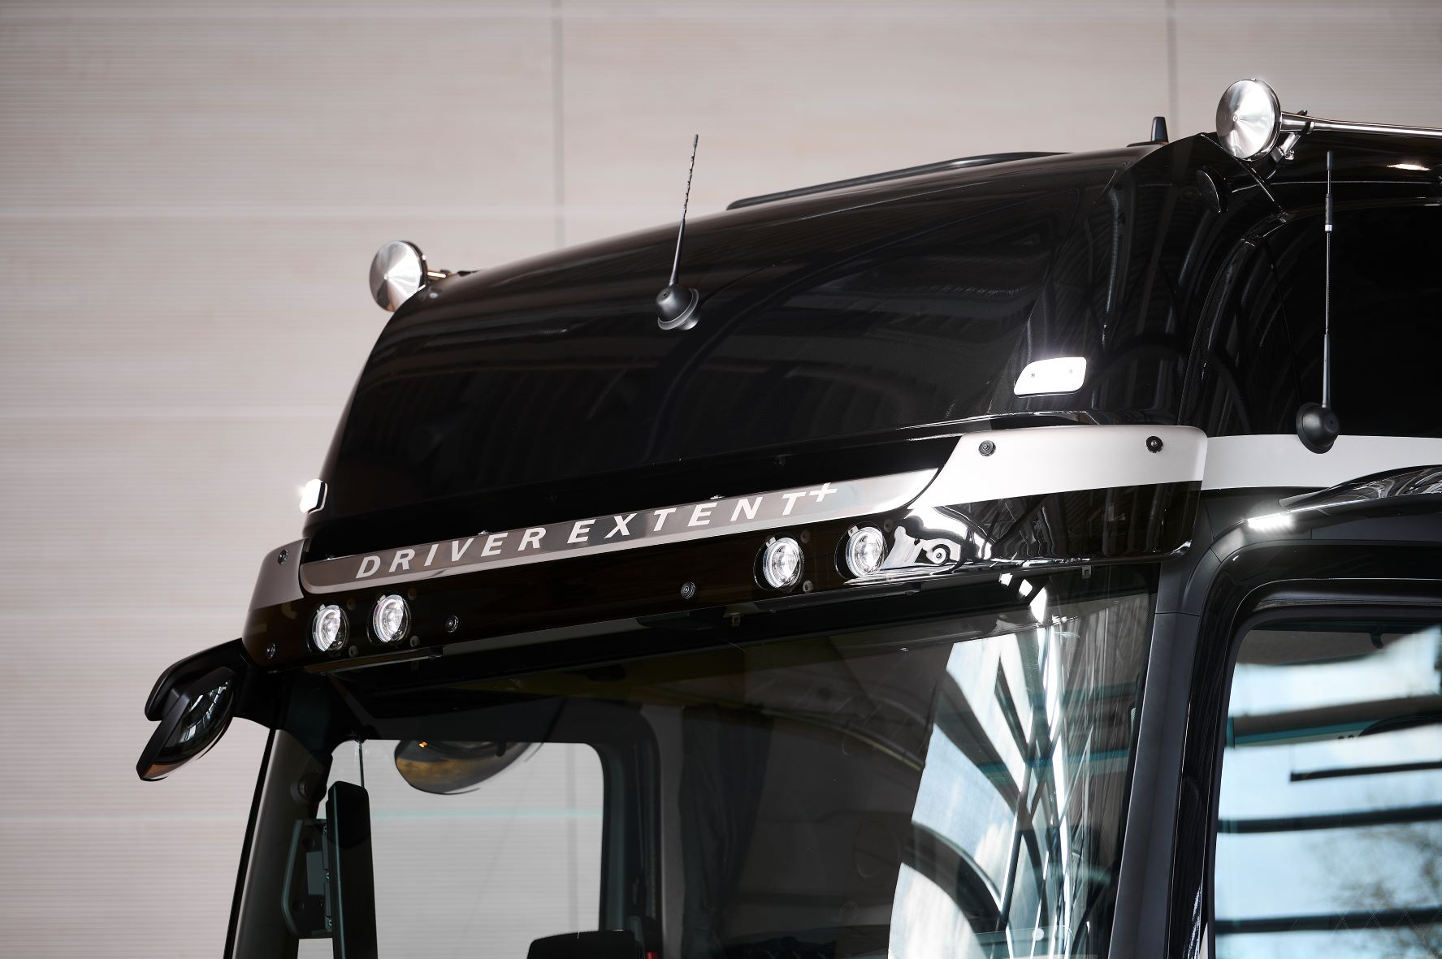

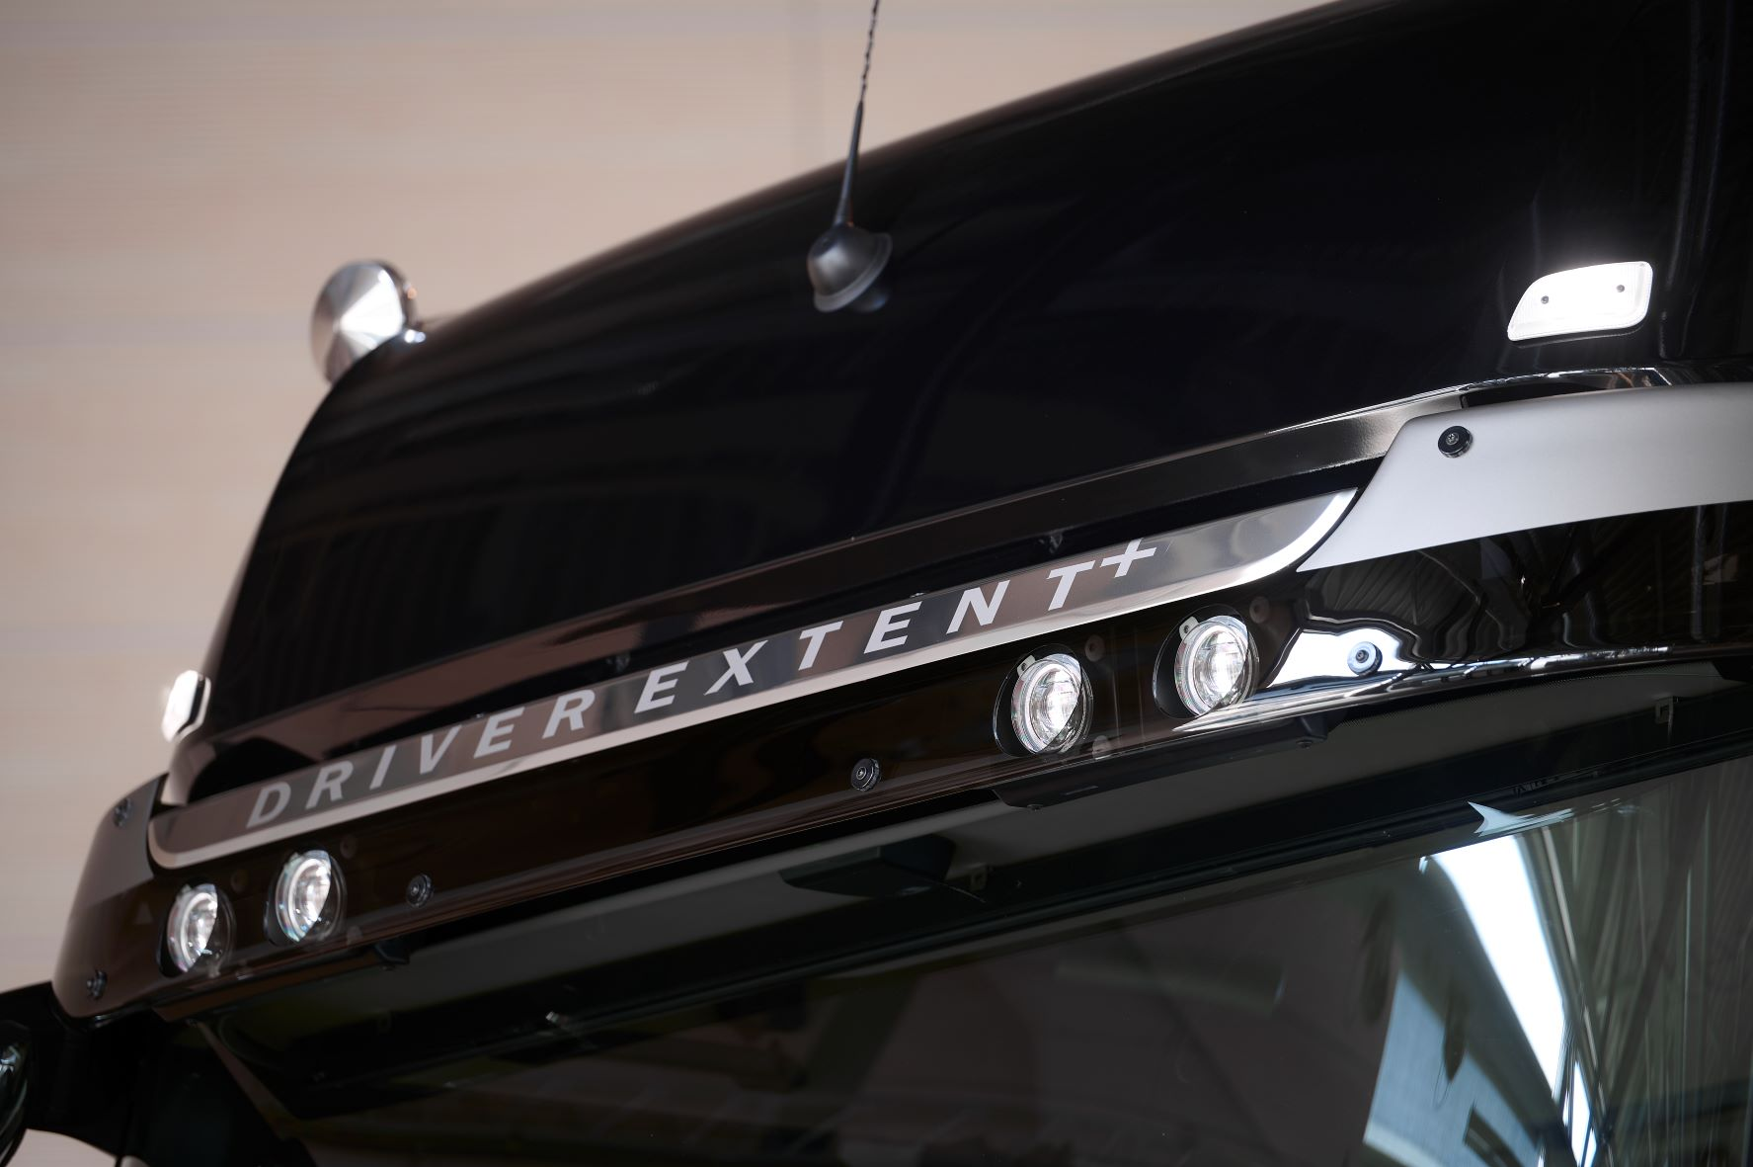
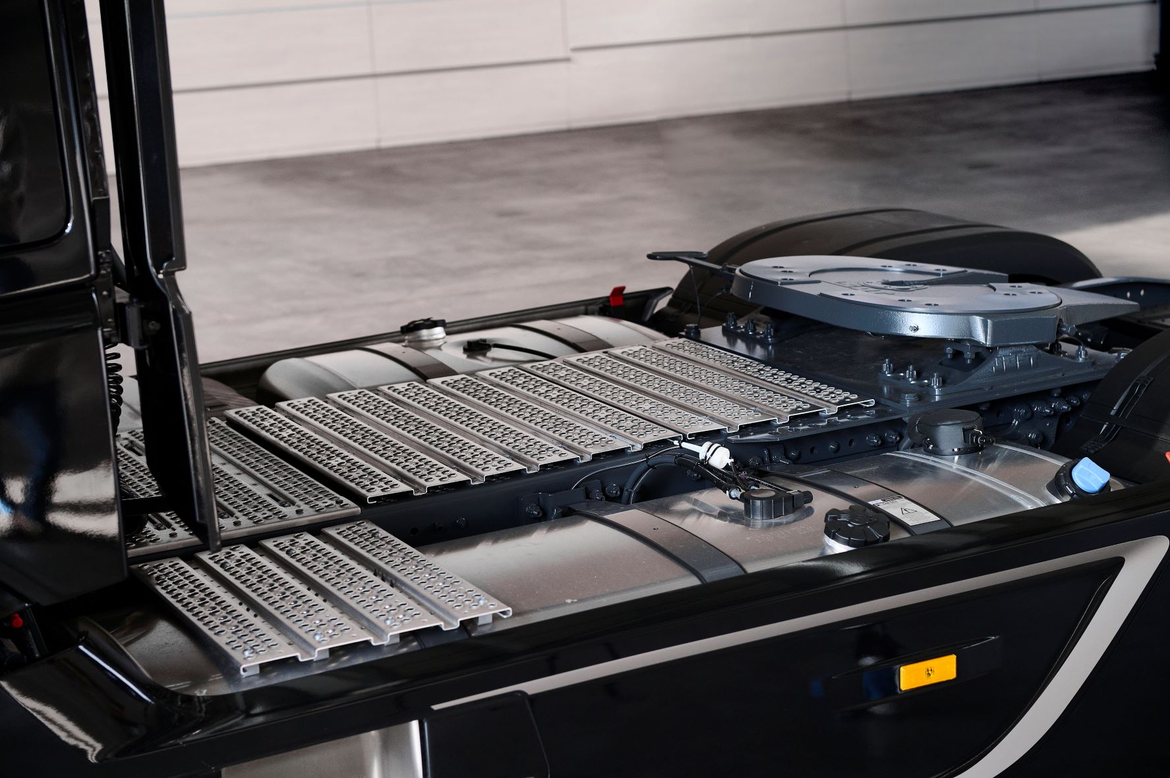

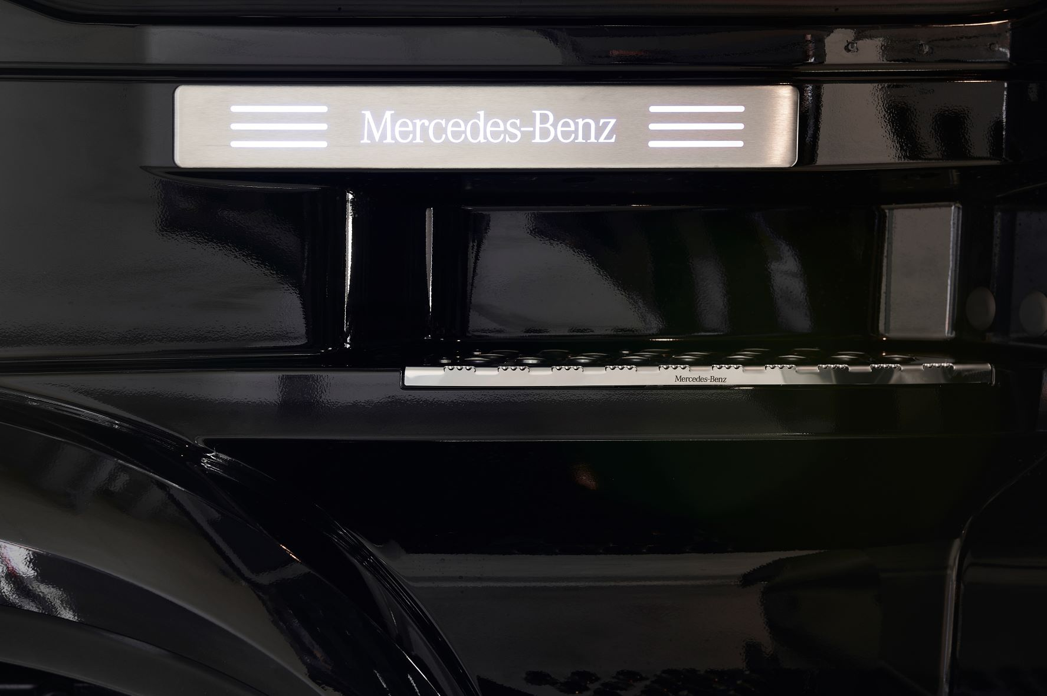
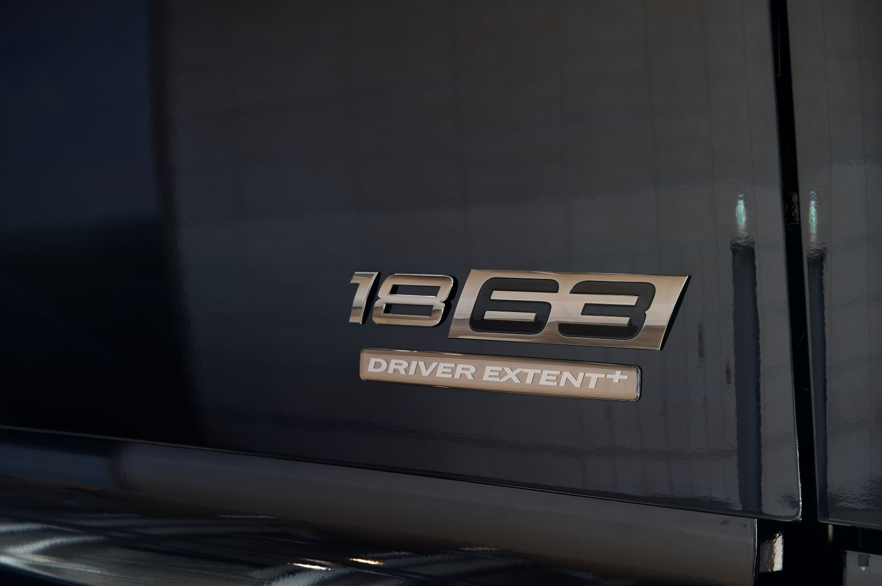

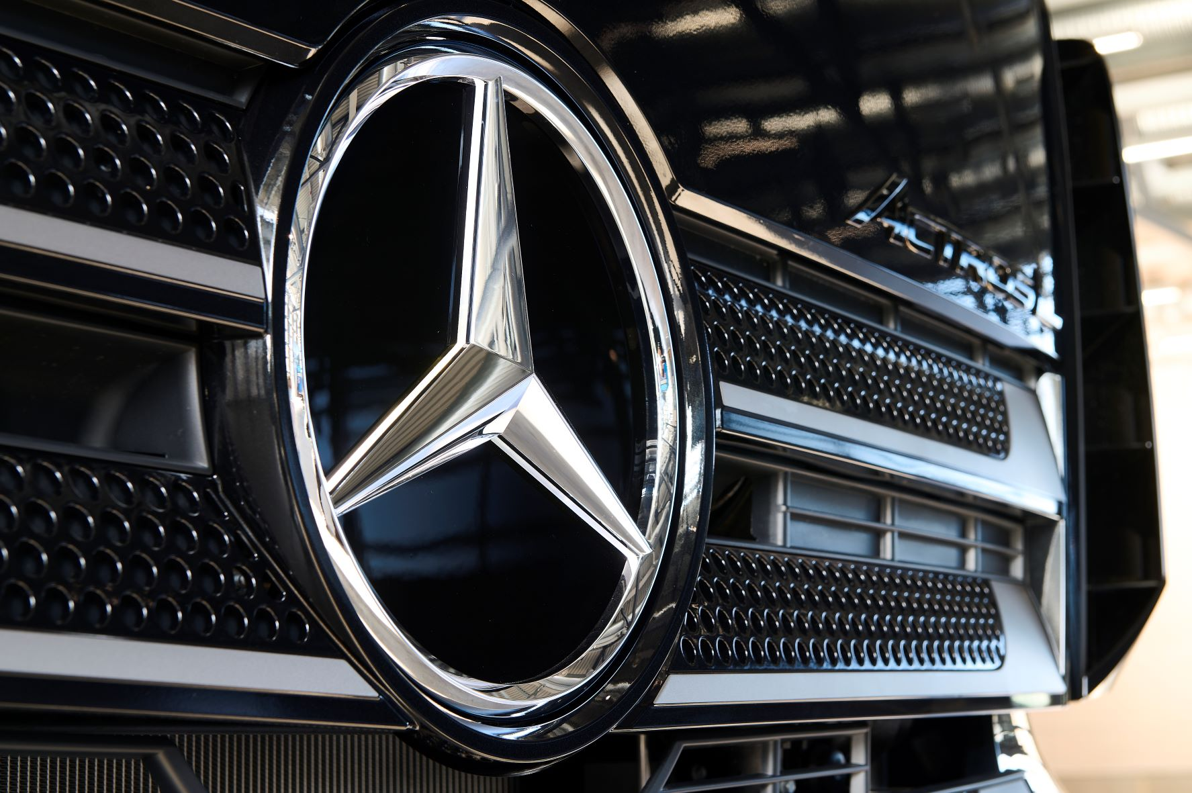

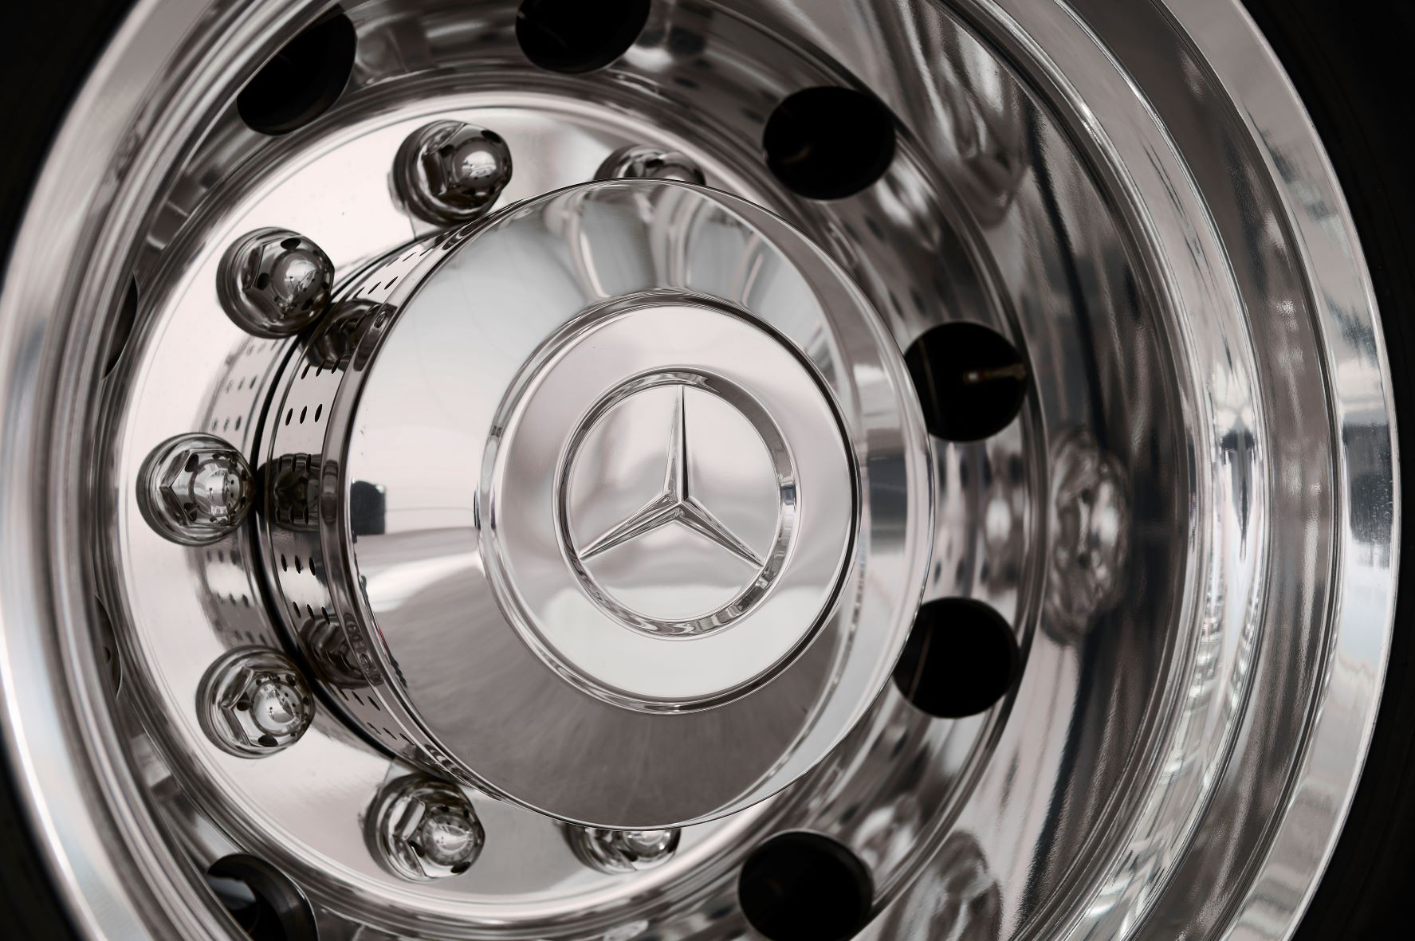

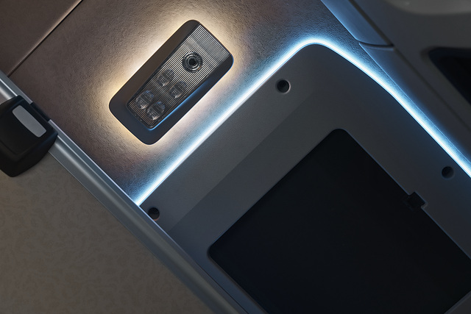

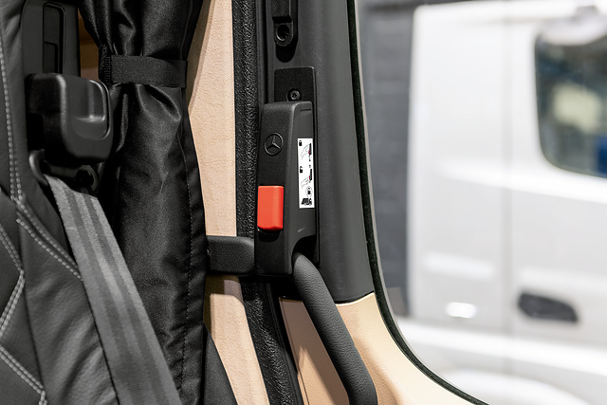



ends

For more information, or to request bigger/higher-res image files, please contact:

Jamie Fretwell at Mercedes-Benz Trucks UK Ltd
07712 519230, jamie.fretwell@daimler.com

or

Steve Warren or John Ripley
Impact Communications
Steve: 07770 470251, steve@impactcom.co.uk
John: 07771 484595, john@impactcom.co.uk

or

Carola Pfeifle, +49 160 8612423, carola.pfeifle@daimlertruck.com
Ulrike Burkhart, +49 160 861 3757, ulrike.burkhart@daimlertruck.com

Further information on Daimler Truck are available at:
www.media.daimlertruck.com and www.daimlertruck.com

Forward-looking statements:
This document contains forward-looking statements that reflect our current views about future events. The words “anticipate,” “assume,” “believe,” “estimate,” “expect,” “intend,” “may,” ”can,” “could,” “plan,” “project,” “should” and similar expressions are used to identify forward-looking statements. These statements are subject to many risks and uncertainties, including an adverse development of global economic conditions, in particular a decline of demand in our most important markets; a deterioration of our refinancing possibilities on the credit and financial markets; events of force majeure including natural disasters, pandemics, acts of terrorism, political unrest, armed conflicts, industrial accidents and their effects on our sales, purchasing, production or financial services activities; changes in currency exchange rates, customs and foreign trade provisions; a shift in consumer preferences towards smaller, lower-margin vehicles; a possible lack of acceptance of our products or services which limits our ability to achieve prices and adequately utilize our production capacities; price increases for fuel or raw materials; disruption of production due to shortages of materials, labor strikes or supplier insolvencies; a decline in resale prices of used vehicles; the effective implementation of cost-reduction and efficiency-optimization measures; the business outlook for companies in which we hold a significant equity interest; the successful implementation of strategic cooperations and joint ventures; changes in laws, regulations and government policies, particularly those relating to vehicle emissions, fuel economy and safety; the resolution of pending government investigations or of investigations requested by governments and the conclusion of pending or threatened future legal proceedings; and other risks and uncertainties, some of which are described under the heading “Risk and Opportunity Report” in this Annual Report. If any of these risks and uncertainties materializes or if the assumptions underlying any of our forward-looking statements prove to be incorrect, the actual results may be materially different from those we express or imply by such statements. We do not intend or assume any obligation to update these forward-looking statements since they are based solely on the circumstances at the date of publication.

Daimler Truck at a glance
Daimler Truck Holding AG ("Daimler Truck") is one of the world's largest commercial vehicle manufacturers, with over 40 main locations and more than 100,000 employees around the globe. The founders of Daimler Truck have invented the modern transportation industry with their trucks and buses a good 125 years ago. Unchanged to this day, the company's aspirations are dedicated to one purpose: Daimler Truck works for all who keep the world moving. Its customers enable people to be mobile and get goods to their destinations reliably, on time, and safely. Daimler Truck provides the technologies, products, and services for them to do so. This also applies to the transformation to CO2-neutral driving. The company is striving to make sustainable transport a success, with profound technological knowledge and a clear view of its customers' needs. Daimler Truck's business activities are structured in five reporting segments: Trucks North America (TN) with the truck brands Freightliner and Western Star and the school bus brand Thomas Built Buses. Trucks Asia (TA) with the FUSO and BharatBenz commercial vehicle brands. Mercedes-Benz (MB) with the truck brand of the same name. Daimler Buses (DB) with the Mercedes-Benz and Setra bus brands. Daimler Truck's new Financial Services business (DTFS) constitutes the fifth segment, the product range in the truck segments includes light, medium and heavy trucks for long-distance, distribution and construction traffic and special-purpose vehicles used mainly in the municipal and vocational sector. The product range of the bus segment includes city buses, school buses and intercity buses, coaches and bus chassis. In addition to the sale of new and used commercial vehicles, the company also offers aftersales services and connectivity solutions.

