

Date: 15 June 2020

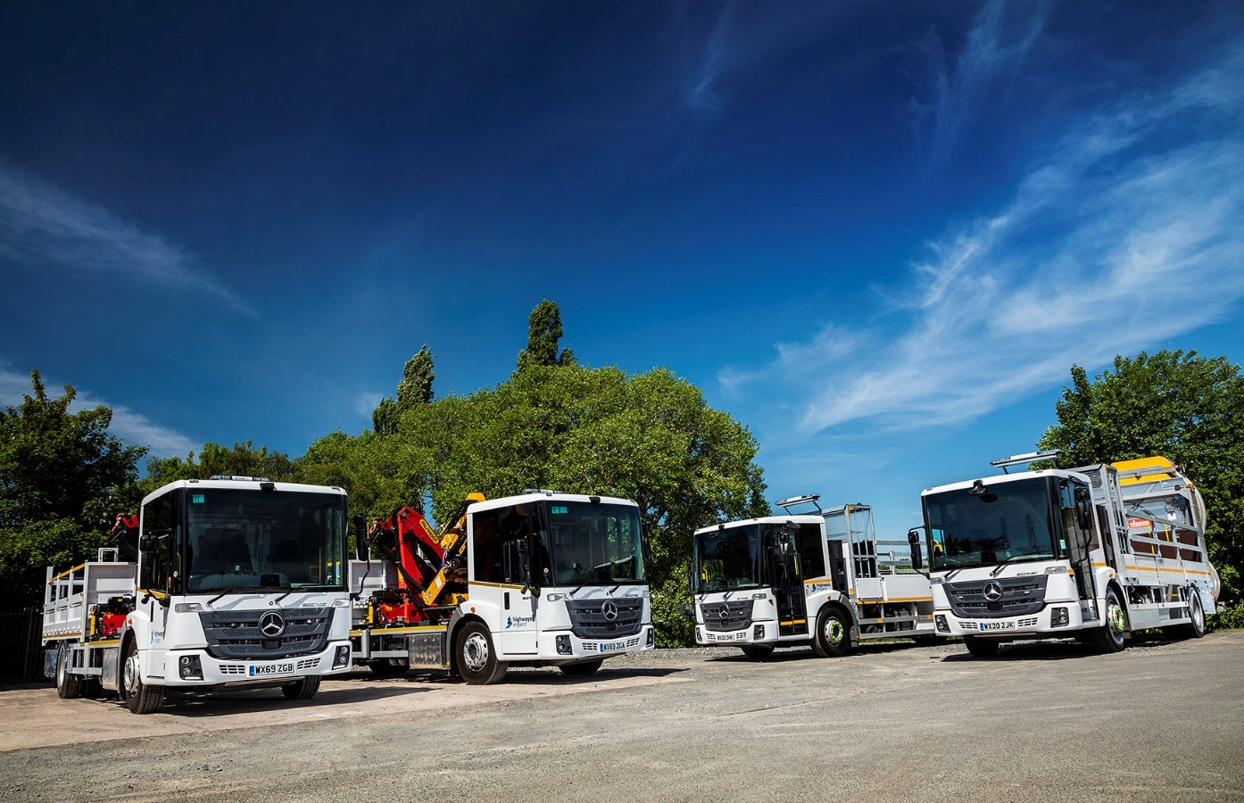

Seeing doubles: The first vehicles from Amey’s latest order for Mercedes-Benz Econic barrier rigs, left, and traffic management vehicles with sign boards and crash cushions

Amey’s highways heroes turn once again to Rygor Commercials and the Mercedes-Benz Econic

Infrastructure support service leader Amey will be relying on a new batch of tried and trusted
Mercedes-Benz Econics to keep north west transport links open as the UK continues to emerge from the Covid-19 pandemic lockdown.

Amey’s latest order for 15 Mercedes-Benz trucks includes a dozen low-entry Econic 18-tonners, chosen primarily for their unrivalled safety credentials and ease of access by crews.

All but one of these vehicles are destined for operation on the £325-million Area 10 Highways England maintenance and response contract on which Amey began work in 2019. This 15-year agreement covers routine maintenance, defect repairs, emergency incident responses and severe weather services, on 420 km of motorway and 80 km of major A roads in Greater Manchester, Merseyside, Cheshire and South Lancashire.

Dealer group Rygor Commercials has just delivered the first four new trucks – two traffic management vehicles with sign boards and Scorpion crash cushions, and a pair of multi-purpose barrier rigs with Palfinger cranes and cone wells.

The traffic management vehicles were built in Calne, Wiltshire, by leading specialist Acklea, while the barrier rigs are the work of Palfinger UK, which is part of the TH WHITE Group, of nearby Devizes. Both bodybuilders have long-standing associations with Amey.

Mercedes-Benz is one of two preferred truck suppliers to Amey. The high-profile operator also acquired a dozen new vehicles bearing three-pointed stars last year, and today the brand accounts for approximately three-quarters of its 500-strong truck fleet.

All of Amey’s Mercedes-Benz vehicles arrived via Rygor Commercials, a Dealer with which it has enjoyed a relationship that goes back many years. As with previous orders, the latest fleet is the subject of a contract hire agreement with supply chain partner and vehicle provider Hitachi Capital.

The 12 Econics are 1827L models with 7.7-litre in-line six-cylinder engines producing 200 kW (272 hp). These are paired with 12-speed Mercedes PowerShift 3 automated manual transmissions.

The Econics due for delivery later this year are also being built to traffic management vehicle specification by Acklea. The only one of these which has not been ordered for the Area 10 contract will work in Scotland, as will a 26-tonne Arocs 2630 gritter.

The two remaining vehicles, a pair of tippers which are also based on muscular Arocs chassis, in this case 18-tonne 1824 variants, are earmarked for Amey’s Area 7 contract with Highways England, which covers 787 km of roads in the East Midlands.

Amey was an early adopter of the Mercedes-Benz Econic for operation in applications other than trade and domestic waste collections. The company commissioned a batch of 11 traffic management vehicles and barrier rigs as long ago as 2009.

“Our experience over more than a decade confirms that the Econic is simply the best vehicle for this job,” said Amey Supply Chain Manager Jason Clement. “Like all Mercedes-Benz trucks, it’s well-built, reliable and cost-effective to operate. Just as importantly, the Econic leads the field in terms of safety, and is very popular with our crews. The opinions of front-line colleagues are key to Amey’s vehicle procurement strategy, and the low-entry
Mercedes-Benz scores particularly highly in terms of cab space and comfort.”

The Econic rides on full air suspension, and employs Active Brake Assist 4 emergency braking technology. Programmed to recognise other vehicles at higher speeds, as well as pedestrians when moving more slowly, this is capable of bringing it to a complete stop.

The truck, which has been awarded a five-star Direct Vision rating by Transport for London, also has an air-conditioned cab with deep panoramic windscreen, and accommodates up to four passengers. The driver’s low seating position, and the full-height, glazed folding side door specified by so many operators, including Amey, further aid visibility.

A single step and a predominantly flat floor that makes for easy cross-cab access also contribute to health and safety for operatives who may be in and out of the vehicle many times in a working day, by encouraging them always to use the safest side. To this comprehensive standard safety specification, Amey has added a full suite of cameras providing 360-degree visibility for drivers.

Jason Clement added: “Rygor Fleet Sales Manager Jeremy Price has been managing our account for many years and the relationship continues to work very well. He understands our requirements and liaises with the other suppliers involved to make the acquisition process as simple as possible for my team.”

In addition to its core transport infrastructure and waste collection operations, Amey undertakes other vital tasks, such as cleaning schools so they are safe for pupils and staff.

Jeremy Price commented: “While prioritising the safety of colleagues and customers, Rygor has remained open throughout the pandemic to provide support to front-line workers and keep key businesses like Amey moving. We’ve always been proud to count this prestigious company among our customers, but never more so than now.”

www.amey.co.uk

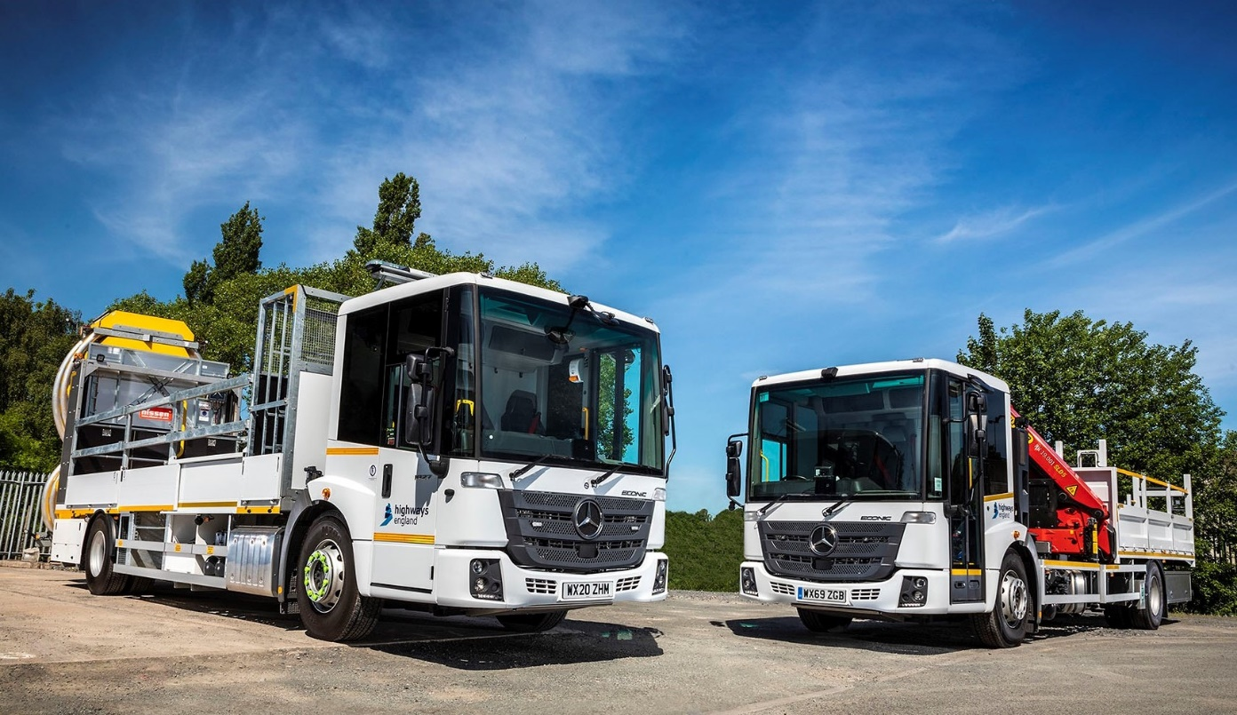

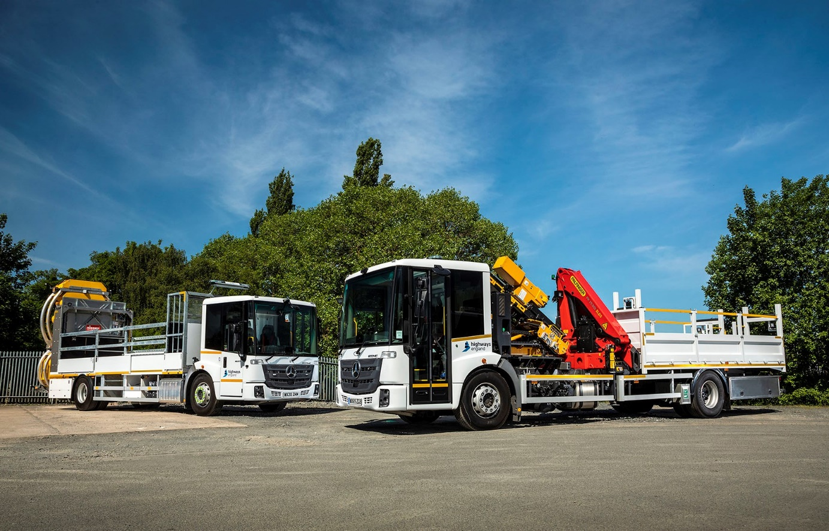

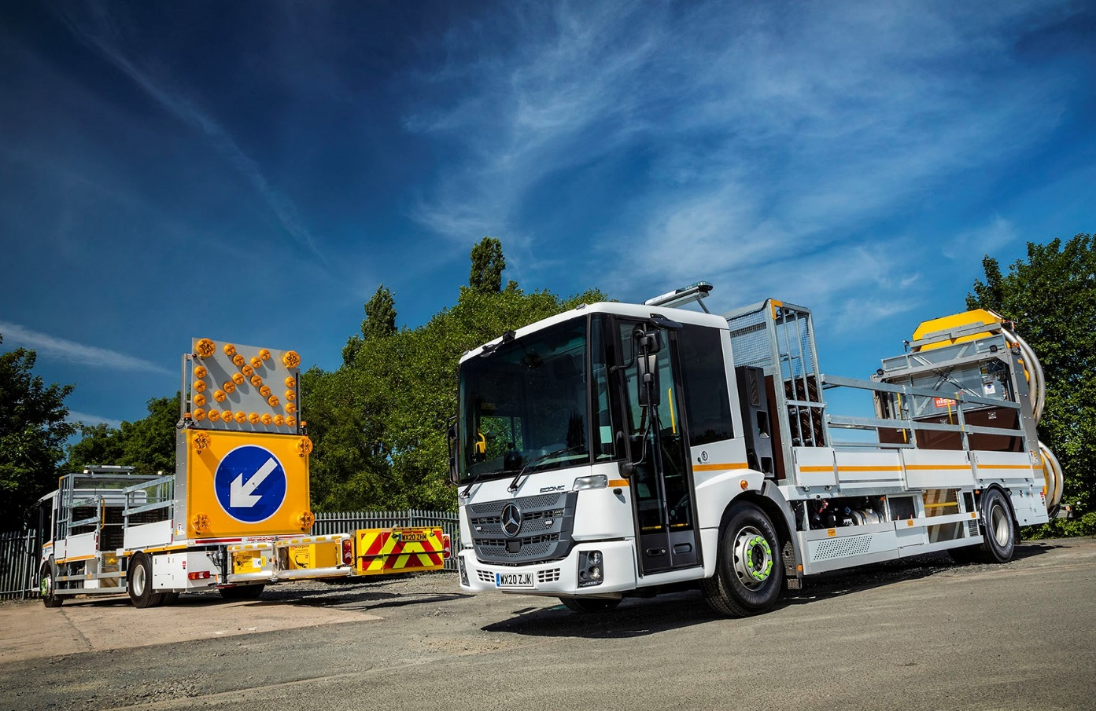

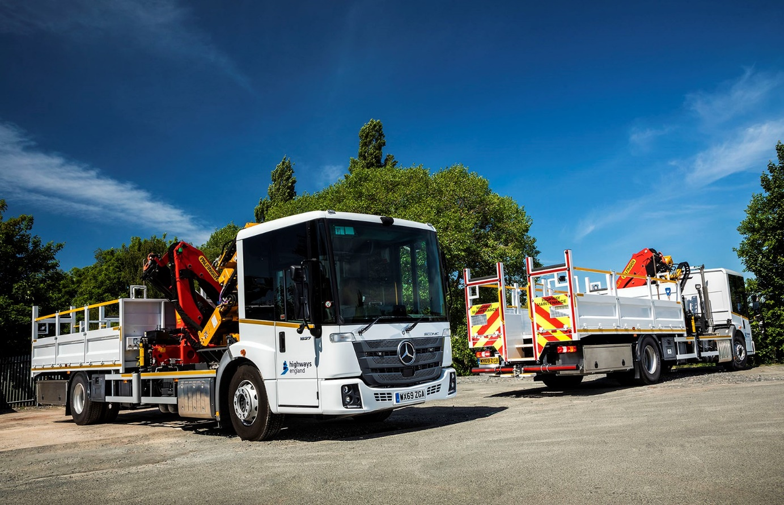

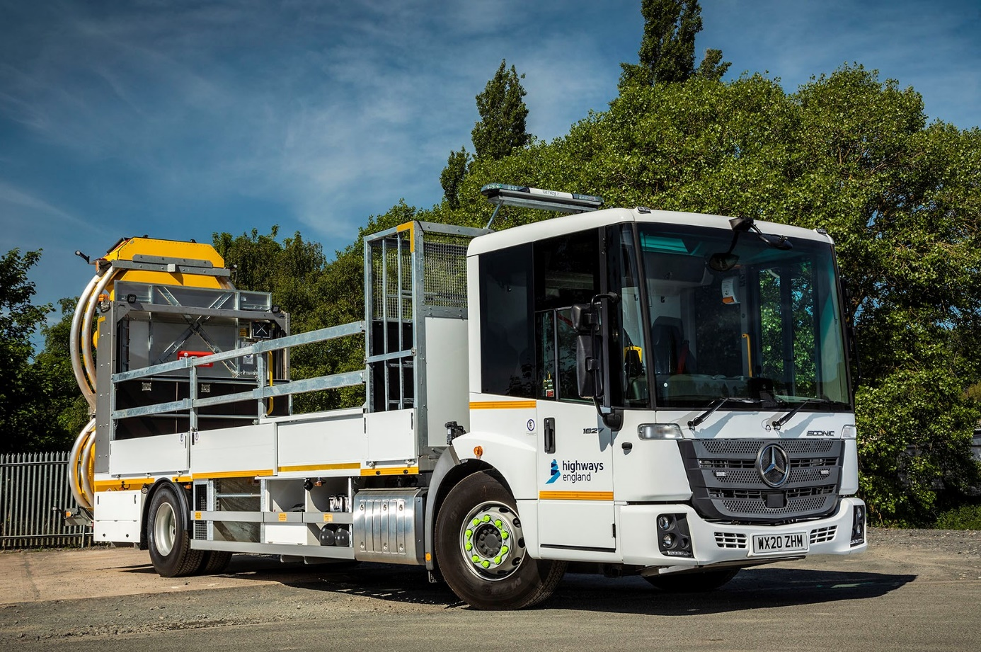

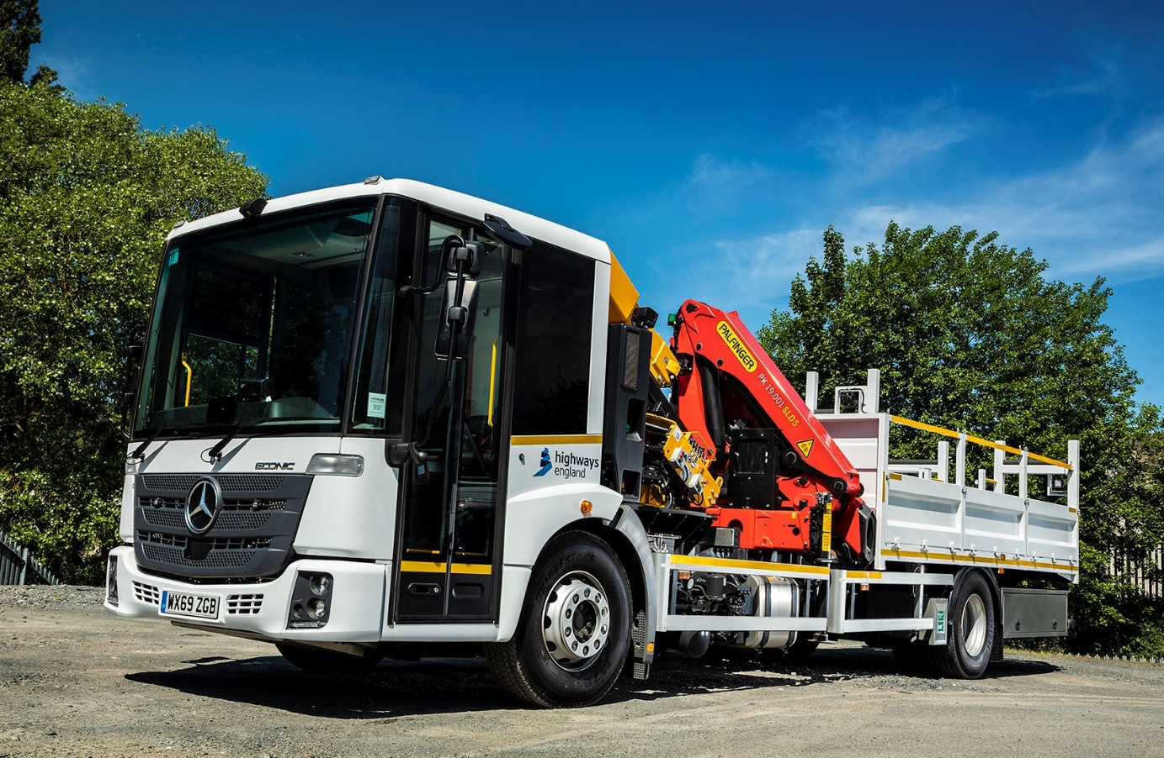

ends

For more information, or to request bigger/higher-res image files, please contact:
Steve Warren or John Ripley
Impact Communications, 01926 842126
Steve: 07770 470251, steve@impactcom.co.uk
John: 07771 484595, john@impactcom.co.uk

Notes to Editors: Rygor Commercials

Award-winning Mercedes-Benz Commercial Vehicle Dealer group, Rygor, has branches throughout Berkshire, Gloucestershire, Oxfordshire, Somerset, West London, Warwickshire, Wiltshire and Worcestershire, offering extensive coverage for customers throughout the M5, M4 and M42 corridors.

The Rygor business has expanded and gone from strength to strength in recent years, launching its flagship Gloucester branch in late 2016 (which won Showroom of the Year at the 2018 Commercial Motor Awards) and undergoing a significant refurbishment of its Oxford branch in 2018. Rygor was delighted to be announced as winner of the ‘Best Sales Team’ award at the 2019 AM Awards, demonstrating our continued commitment to our customers and dedication to providing exceptional customer service.

With a proven track record, Rygor is proud to be selling and supporting the most prestigious name in commercial vehicles.

For more information, in the first instance please contact Kate Ruberry-Shoemack, Head of People and Communications at Rygor – kateruberry-shoemack@rygor.co.uk

