

Date: 3 May 2019

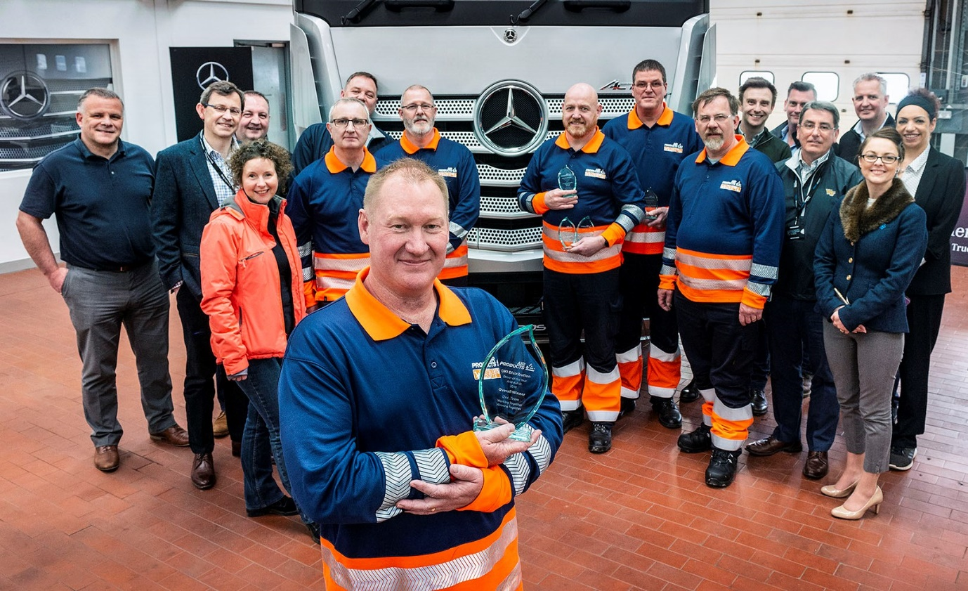

Best of the best: Air Products Driver of the Year Adrian Garlick, with fellow finalists and colleagues at Mercedes-Benz Trucks’ Wentworth Park centre

Air Products picks a winner... with a little help from Mercedes-Benz Dealer Roanza Truck & Van

World-leading industrial gases supplier Air Products has crowned its first Driver of the Year, at Mercedes-Benz Trucks’ Wentworth Park complex in South Yorkshire.

Adrian Garlick took the honours at a hugely successful event hosted by Dealer Roanza Truck & Van, which last year supplied its high-profile customer with 90 new Mercedes-Benz Actros, a combination of 6x2 tractor units and 26-tonners with tank bodies.

Six drivers were selected from 47 qualifiers on the basis of their exemplary scores in the fields of economic driving, compliance, safety and zero ‘Preventable Vehicle Accidents’ throughout 2018.

The 72-acre Wentworth Park site near Barnsley provided the perfect setting for the final of Air Products’ inaugural Driver of the Year competition. Adrian and his fellow contenders Andrew Cartwright, Dave Chadwick, Jeremy Cook, Clive Dennis and Alan Graham faced a series of trials which not only tested the skills they use every day at work, but also took them well outside their ‘comfort zones’. A lot of fun was had, too.

The programme included on-road driving in an Actros tractor unit, and a memorable opportunity to pilot a mighty all-wheel drive Unimog over Wentworth Park’s demanding off-road circuit. There were manoeuvring challenges in a fully-electric FUSO eCanter light truck, a tricky reversing task in an Econic refuse collection vehicle with blacked-out mirrors which meant the competitors had to rely solely on the truck’s camera system, and a fault recognition exercise based on the standard driver’s walk-around check process.

A quiz with questions on compliance, safety and the Highway Code, a crane handling challenge, and some light relief in the shape of a fun game which entailed piloting a radio-controlled scale-model of a Unimog around an obstacle course, completed the packed itinerary.

It was testament to the high professional standards of the Air Products drivers taking part, that going into the final sessions there was still all to play for. Ultimately, though, when the final scores were totted up, it was Adrian Garlick who emerged victorious.

He also took the individual prizes in the reversing, fault clinic and quiz elements of the competition, while Alan Graham won the on-road drive and manoeuvring tests, and Dave Chadwick beat the field in the off-road challenge.

Adrian only joined Air Products 18 months ago, although he has worked in the chemical and gas transport industry for more than 15 years. Based at the operator’s depot in Didcot, he now drives an Actros tractor unit hauling bulk liquids nationwide.

“I was up against some very tough competition from my colleagues, and I’m sure the margins were very tight, so I’m delighted to have won,” declared Adrian, after receiving his trophy, together with a Mercedes-Benz sports holdall filled by Roanza Truck & Van with branded ‘goodies’, including a cap, flask, high-vis jacket, torch and cosy sleeping bag.

Air Products UKI Distribution Manager Mark Pawsey said: “Today was really about celebrating our drivers – recognising those who are responsible for our trucks out on the road, and the contributions they make to our success.

“It was the first time we’d held an event like this, and it couldn’t have gone any better. Our partners from Roanza Truck & Van, together with the Wentworth Park team, organised everything superbly. I’m already looking forward to returning next year, for an even bigger, better competition.”

Roanza Truck & Van Sales Director Lester Freakley added: “We’re always looking for ways to support our customers and build ongoing relationships, so we were delighted to be offered the opportunity to help Air Products with their first Driver of the Year competition. It was great fun, of course, but with a serious side, too – the focus was very much on safety and compliance, as well as providing a well-earned pat on the back for six hard-working and highly professional drivers.”

Air Products’ Driver of the Year competition was the latest in a series of events to be held at Wentworth Park – Mercedes-Benz Trucks is mid-way through a major programme of investment that will transform the facility into a true Customer Experience Centre.

Underlining Air Products’ commitment to compliance and responsible operation, the 75 tractor units and 15 rigids which it acquired from Roanza Truck & Van last year were all specified with Mercedes-Benz Safety Packs. In addition to the remarkable Active Brake Assist 4 emergency braking system – which features a world ‘first’ in the shape of pedestrian recognition – these incorporate Proximity Control Assist technology and a driver’s airbag. The fleet is inspected and maintained under Mercedes-Benz Complete Service Contracts.

www.airproducts.co.uk

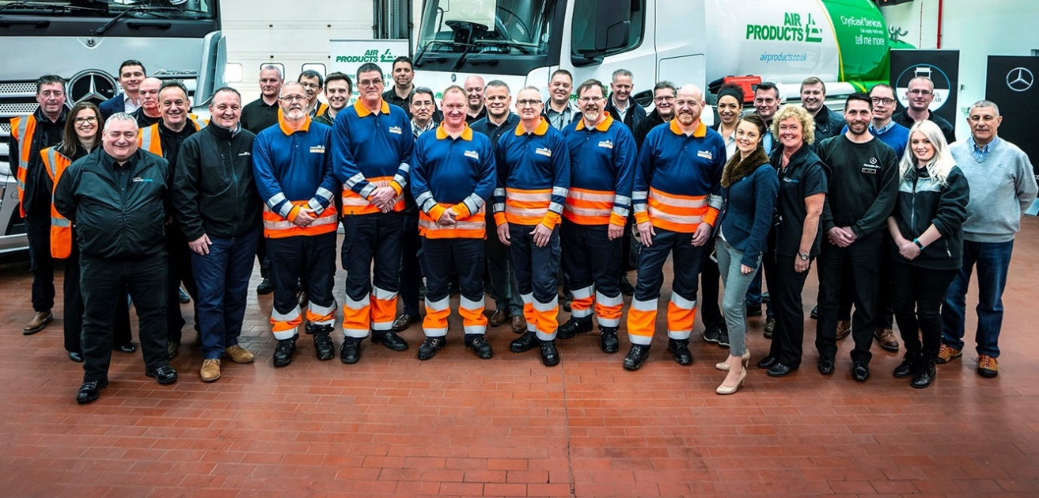

Working together: Air Products competitors and colleagues were joined on the day by hosts from Roanza Truck & Van and Mercedes-Benz Trucks

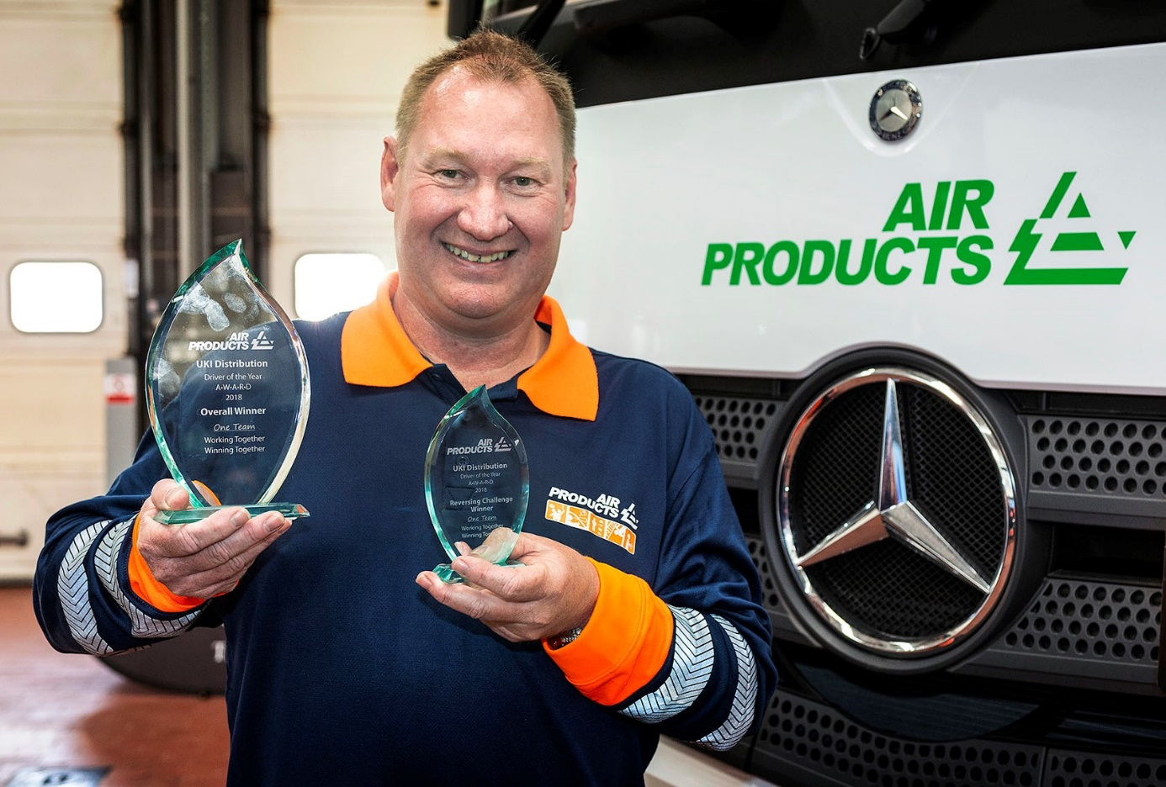

Victorious: Winner Adrian Garlick shows off his trophies

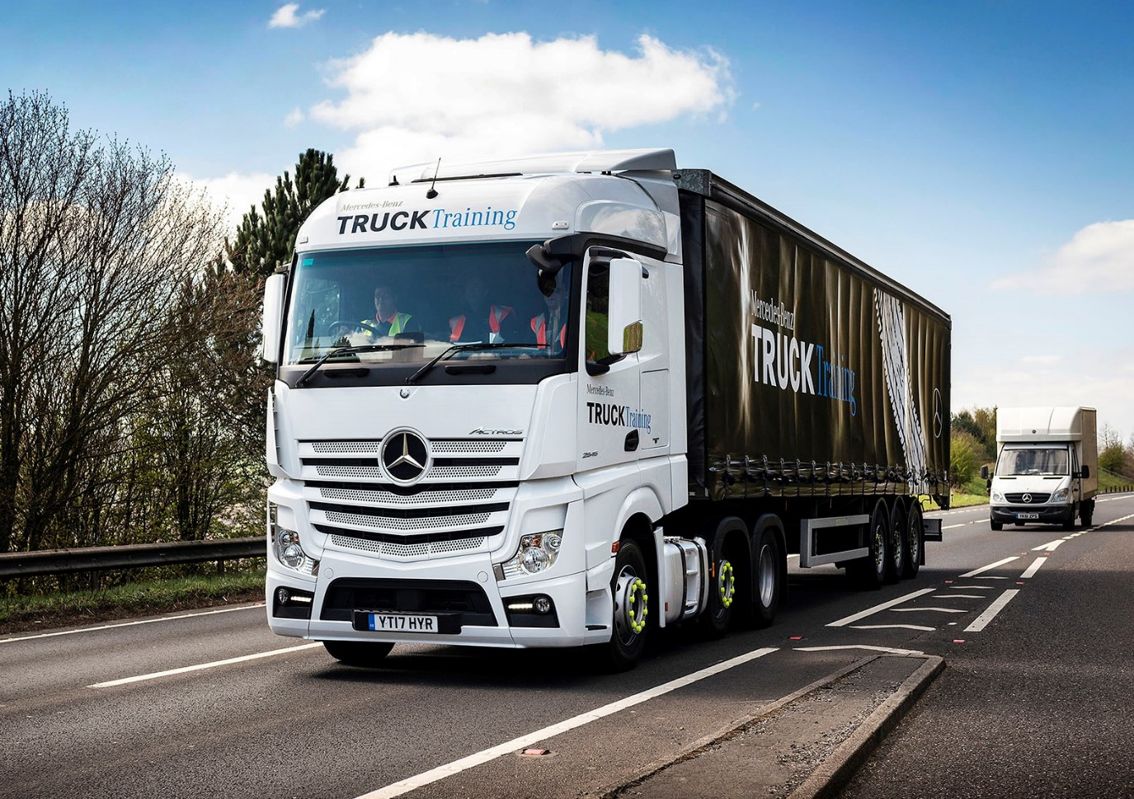
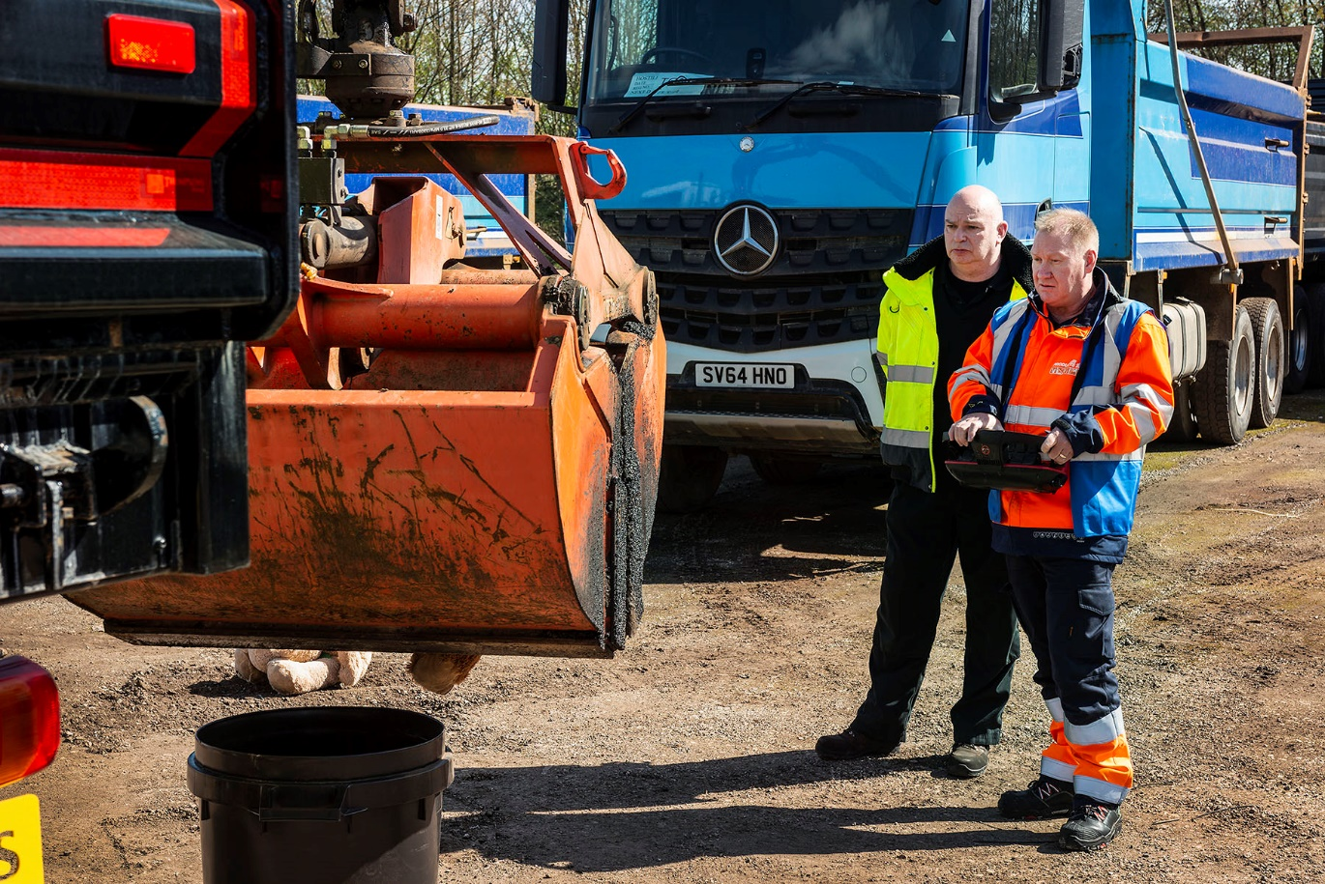

Gently does it: Winner Adrian Garlick is fully focused on the competition’s crane-handling challenge

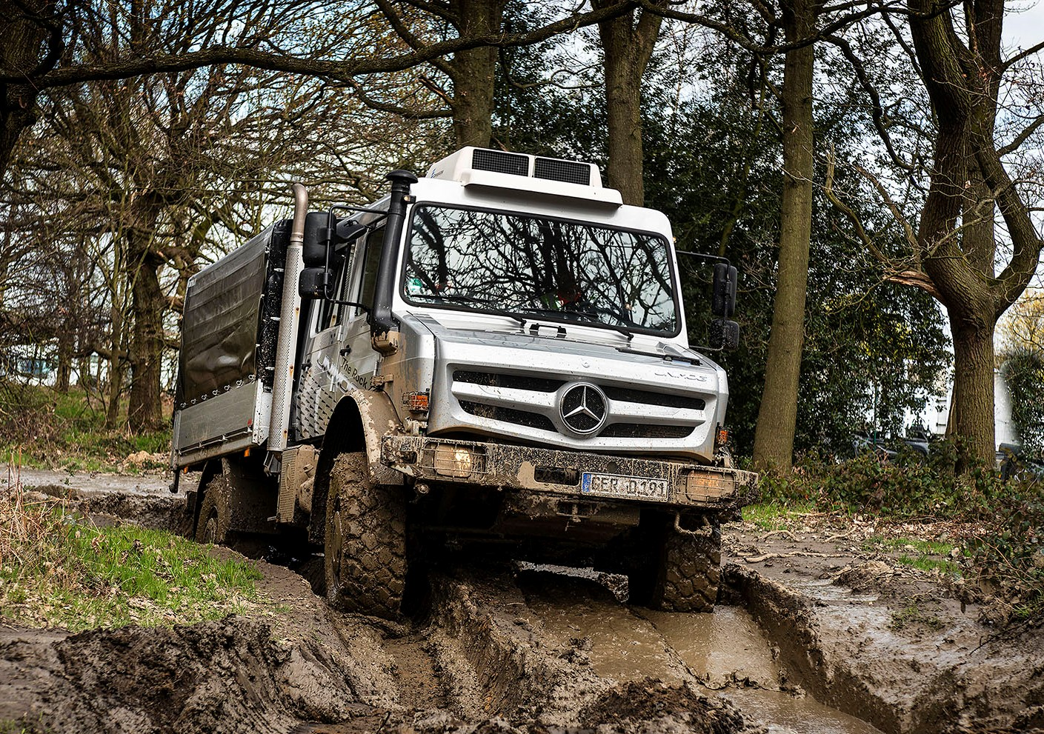

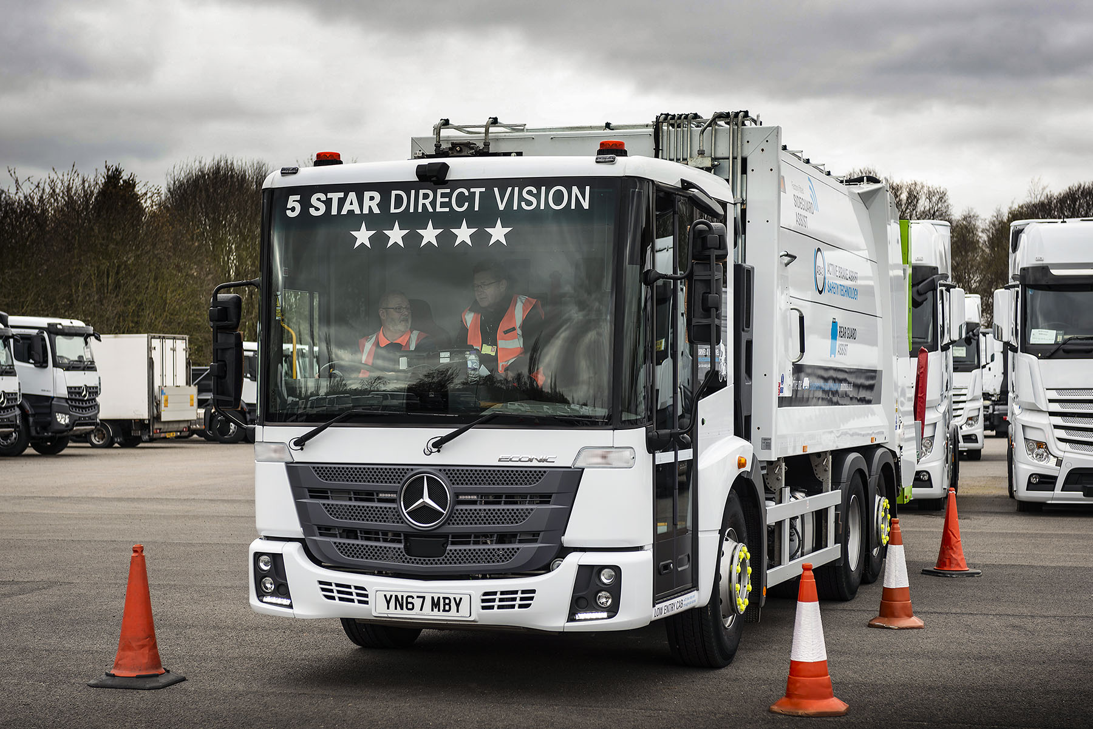

ends

For more information, or to request bigger/higher-res image files, please contact:
John Ripley or Steve Warren
Impact Communications, 01926 842126
John: 07771 484595, john@impactcom.co.uk
Steve: 07770 470251, steve@impactcom.co.uk

