

Date: 13 May 2019

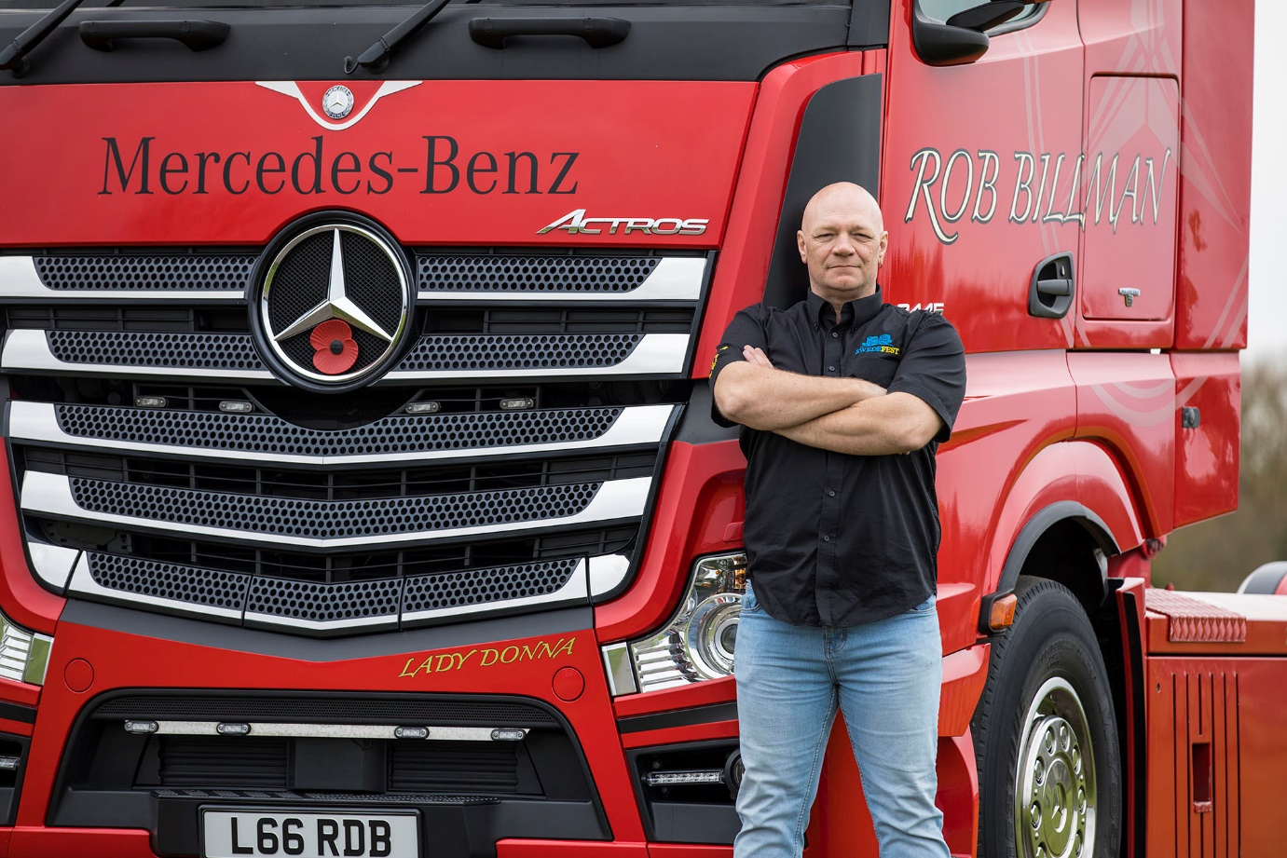

No going back: Rob Billman drove a succession of trucks by another manufacturer before switching to his first Mercedes-Benz in 2014

Rob’s Mercedes-Benz Actros ‘mashes the Swedes’

Five years after he took delivery of his beautifully finished Actros BigSpace tractor unit, Rob Billman jumped onto social media to announce: “Three-quarters of a million kilometres and not a day lost. Not a single breakdown, no brake pads. Who knew… Mercedes-Benz would be such a great move!”

The Norfolk-based owner-driver’s testimonial is all the more powerful, because he’d previously been such a fan of his Swedish-built trucks that he founded an annual celebration of the brand. He was repeatedly let down by his last vehicle, though, so bought his first
Mercedes-Benz from East Anglia Dealer Orwell Truck & Van in 2014.

A 2445 model with small-wheeled mid-lift axle, it was also the first truck Rob has owned from new, and it’s still turning heads today. The bright red paintwork, including colour-coded bumper, has lost none of its lustre, while other enhancements include special side skirts and a Hatcher air management kit, a chrome-trimmed grille and sun visor, and light bars and wheel trims.

Rob lives in North Walsham and is a long-established sub-contractor to high-profile haulier Bartrums, which operates from headquarters in Eye, Suffolk. Indeed, it was a contact at Bartrums who originally recommended the Actros. “He couldn’t wait to tell me what a fantastic difference Mercedes-Benz trucks had made to their business,” recalled Rob.

“If I’m honest, I didn’t think I was going to like the Actros. I’d been loyal for a long time to another make of truck, and had driven Mercedes-Benz vehicles on odd occasions in the past but never really been taken with them.

“However, I was very quickly sold on Orwell’s demonstrator. After three days the fuel consumption figures were looking seriously impressive, and a couple of days later I was asking the Dealer to sort me out a price.

“I was told by some that it would be a move I’d regret, but five years later I’d have no hesitation in describing the Actros as a fantastic truck,” he enthused. “It’s never let me down and has consistently returned between 9.5 and 10 mpg – that’s a good couple of miles per gallon better than I was getting from my previous truck.”

The work has entailed pulling a variety of products and commodities in curtainside trailers at between 38 and 44 tonnes GCW, primarily throughout the Midlands and East Anglia. “The Actros is easily the most comfortable vehicle I’ve driven and lived in,” Rob continued.

“It hasn’t given me any moments of worry, and the service agent has delivered on every promise. I couldn’t have asked for better support from Orwell Truck & Van. They do everything well; communication is excellent, and they have great respect both for the customer, and for the truck.

“Sales Executive Tony Simmons had a massive task when it came to meeting my requirements – I changed the spec three times before I was finally happy. The guys in the workshop have had their hands full too. I dare say I haven’t been the easiest customer to deal with, and at times have probably been a real pain. Well done to the guys, they deserve a medal.”

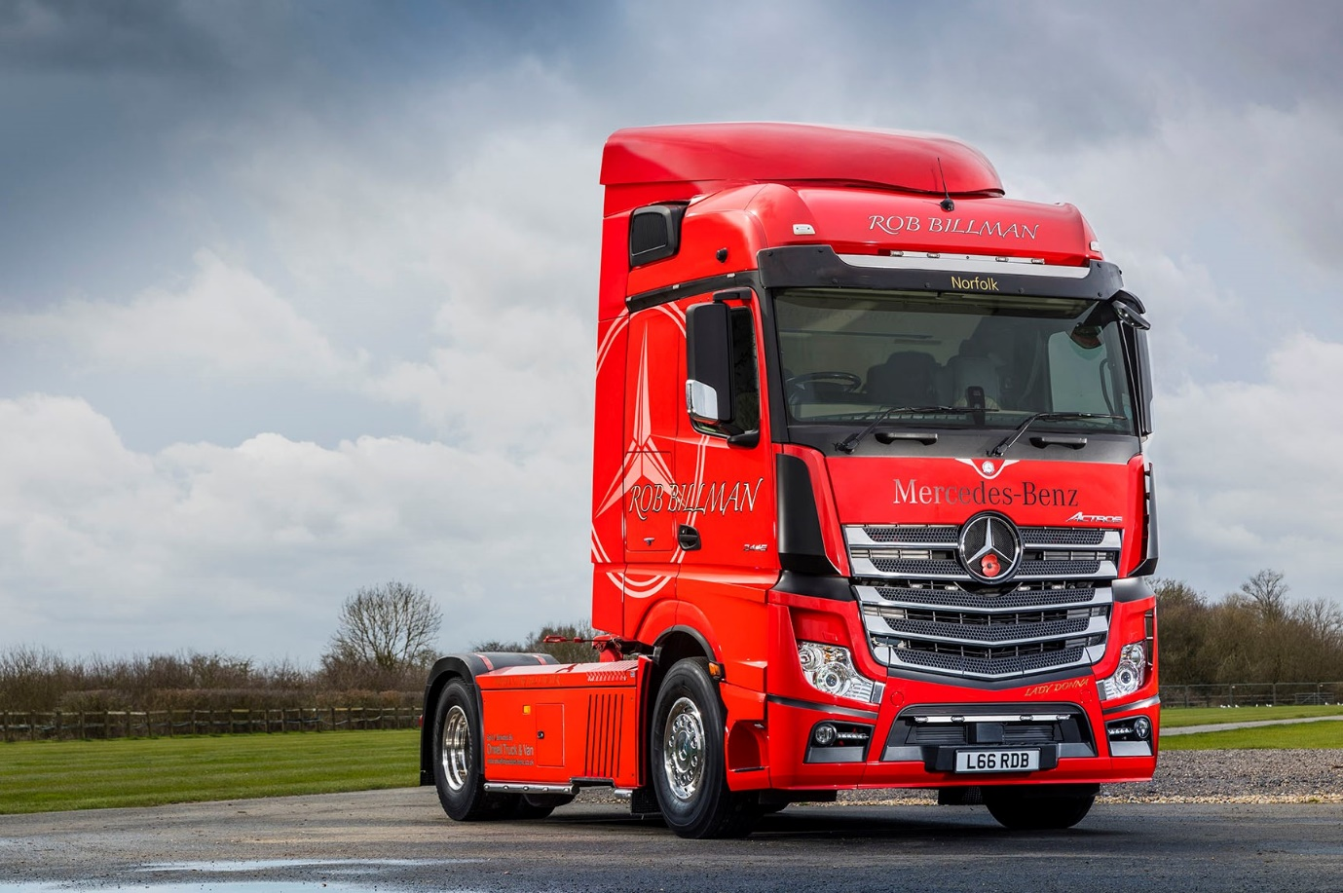

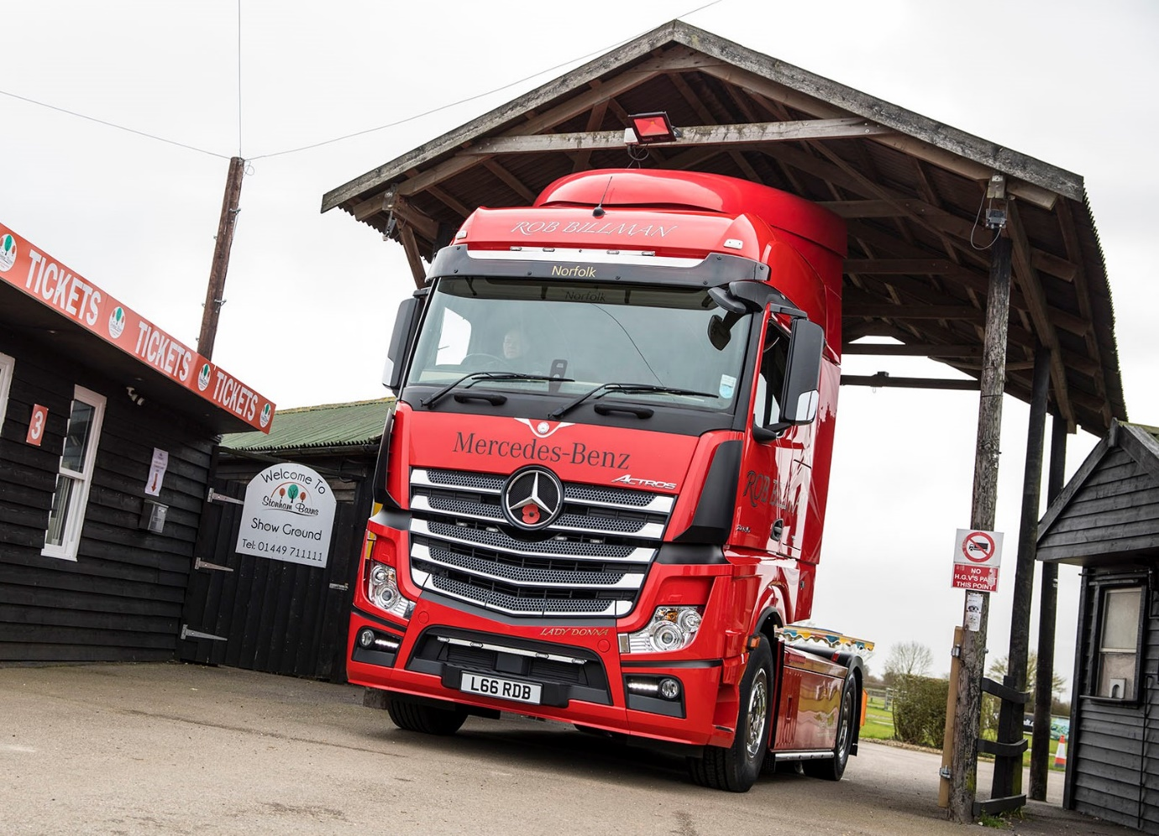

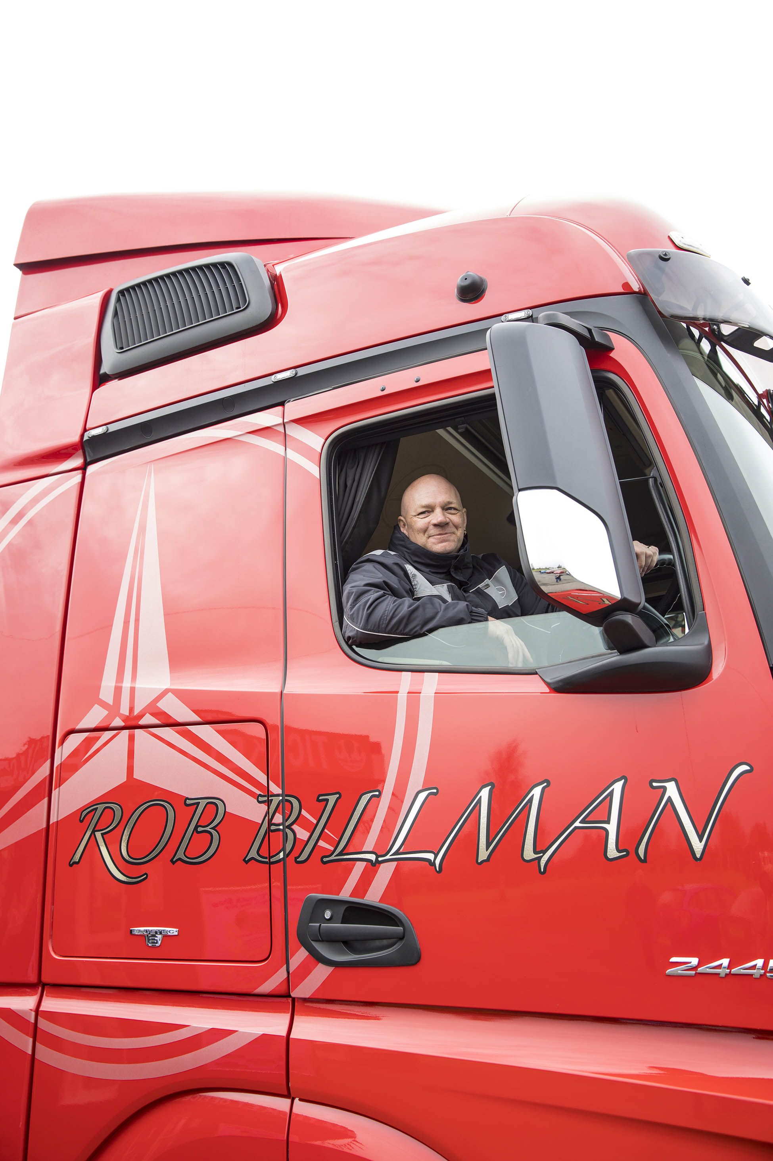

ends

For more information, or to request bigger/higher-res image files, please contact:
Steve Warren or John Ripley
Impact Communications, 01926 842126
John: 07771 484595, john@impactcom.co.uk
Steve: 07770 470251, steve@impactcom.co.uk

