

Date: 4 January 2022

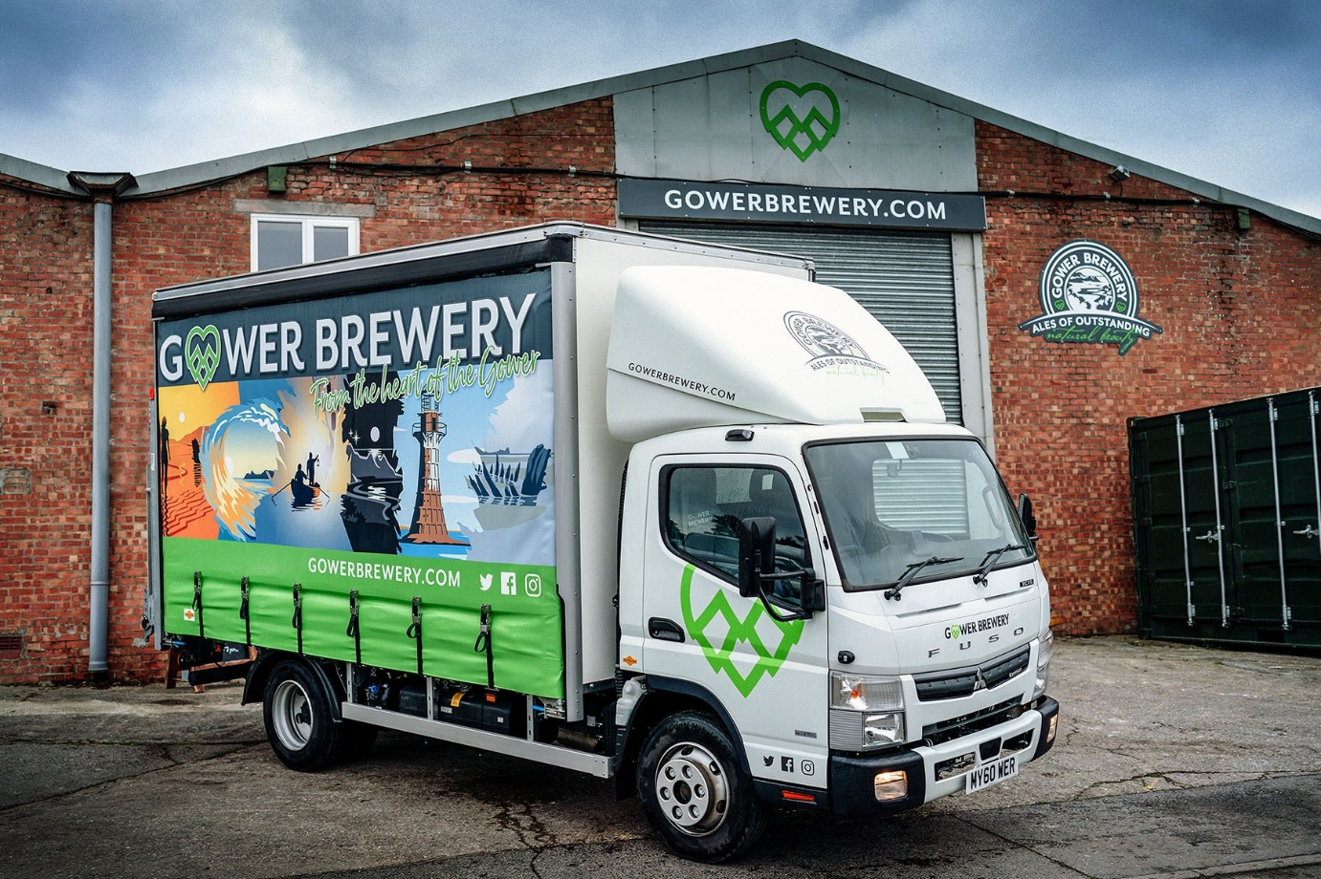

Gower Brewery raises a festive toast to its new FUSO Canter

So reliable was Gower Brewery’s first FUSO Canter that when it was finally due for replacement Director Chris Mabbett had no hesitation in returning to South Wales Dealer Euro Commercials for another.

Established in 2011, the multi-award-winning Gower Brewery employs traditional methods to produce handcrafted, premium-quality ales at its base on the Crofty Industrial Estate, Pen-clawdd.

Like its predecessor, which had been in service since 2013, the company’s new Canter has a gross weight of 7.5 tonnes. As a 7C15 variant it is powered by a 3.0-litre common-rail turbodiesel that produces 110 kW (150 hp) and an impressive 370 Nm of torque.

The truck has a cab roof-mounted air deflector while its body, which features strikingly printed curtains, is by Fred Smith & Sons, of West Bromwich. Also fitted are a Dhollandia column tail-lift with 1,000 kg capacity, and a CameraMatics system that provides 360-degree visibility for enhanced safety.

Euro Commercials is a long-standing member of the Mercedes-Benz Trucks franchised network, which also sells and supports the popular FUSO Canter range in Britain.

Gower Brewery took advantage of competitive funding support from Mercedes-Benz Finance to acquire its new vehicle, which is the subject of a Complete Service Contract and will be inspected and maintained by the workshop team at the Dealer’s Swansea branch.

The Canter makes next-day deliveries of Gower Brewery’s beers in bottles, kegs and casks, primarily to pubs but also to smaller supermarkets and other retailers within an 80-mile radius of its base. Many are located in the magnificent landscape of the Gower Peninsula, the UK’s first designated Area of Outstanding Natural Beauty.

Visitors can also enjoy a pint and a tour of the microbrewery, which is set back from the sheep-grazed salt marshes and teeming cocklebeds of the River Loughor estuary, a stone’s throw from the iconic Whitford Point Lighthouse.

Chris Mabbett, one of the shareholders who established the business, recalled: “Our first Canter was exceptionally good. We don’t cover huge mileages but it never let us down.”

The 7.5-tonne Canter offers a market-leading body and payload allowance of up to a tonne more than some rival products in the same gross weight segment. Meanwhile, its compact footprint, 3400mm wheelbase – second-shortest of the four available for the 7C15 – and tight turning circle mean the vehicle is also highly manoeuvrable.

“The previous Canter carried a full 4.0 tonnes,” continued Mr Mabbett. “Its heavier body means the new truck has a slightly reduced payload of 3.7 tonnes, but that’s still a lot more than we’d get on most competitors’ chassis, and we’ll use it to the full.

“Some of the pubs we supply are on narrow streets and difficult to access, so the fact that the Canter is also a good bit smaller than other vehicles in its class and very agile too, is another big advantage.”

Like so many companies that operate within the hospitality sector, Gower Brewery has endured a challenging couple of years. Despite the recent rise of the Omicron Covid variant, however, Mr Mabbett remains upbeat.

“We’re back on a positive footing and with its striking livery the new Canter is a great mobile advertisement for our brewery,” he enthused. “Driver John Adams is also really pleased, because it’s so much more comfortable than his old truck.”

Both of Gower Brewery’s FUSO trucks were delivered by Euro Commercials’ Swansea-based Truck Sales Executive Steve Bastin. Mr Mabbett added: “Steve provided a first class service once again, arranging both the finance and the competitively-priced maintenance plan that will give us complete peace of mind for the next five years.”

gowerbrewery.com

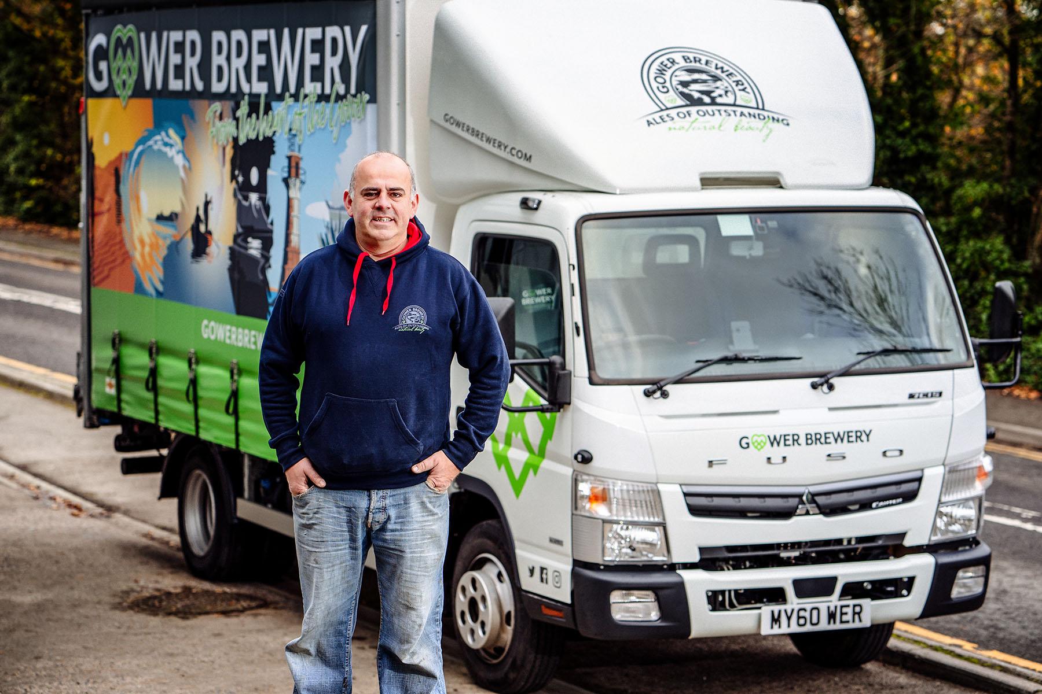

Gower power: Director Chris Mabbett is pictured with his award-winning microbrewery’s new 7.5-tonne FUSO Canter

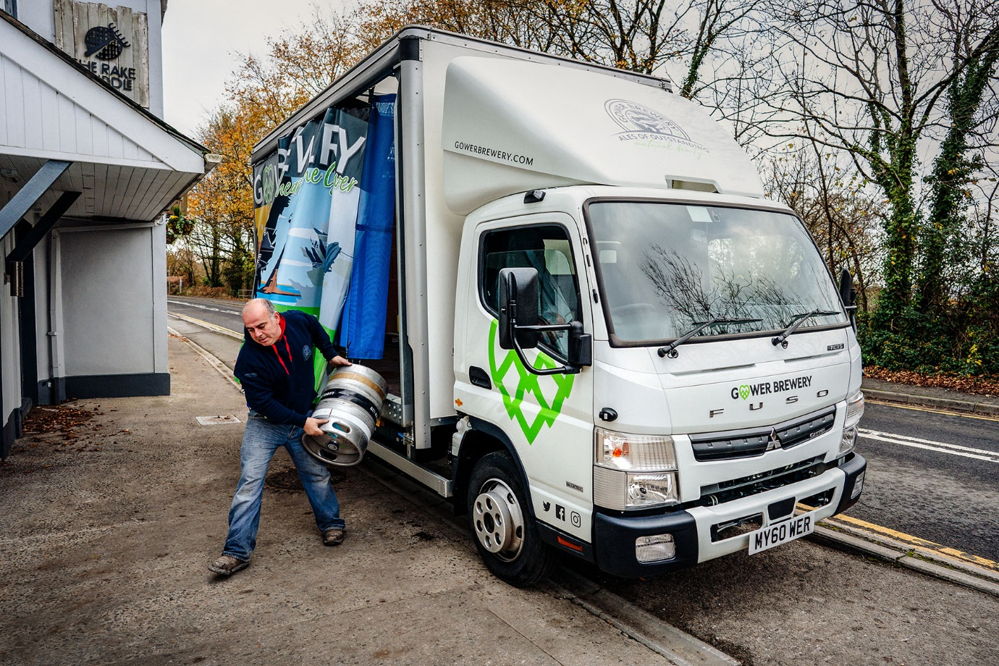

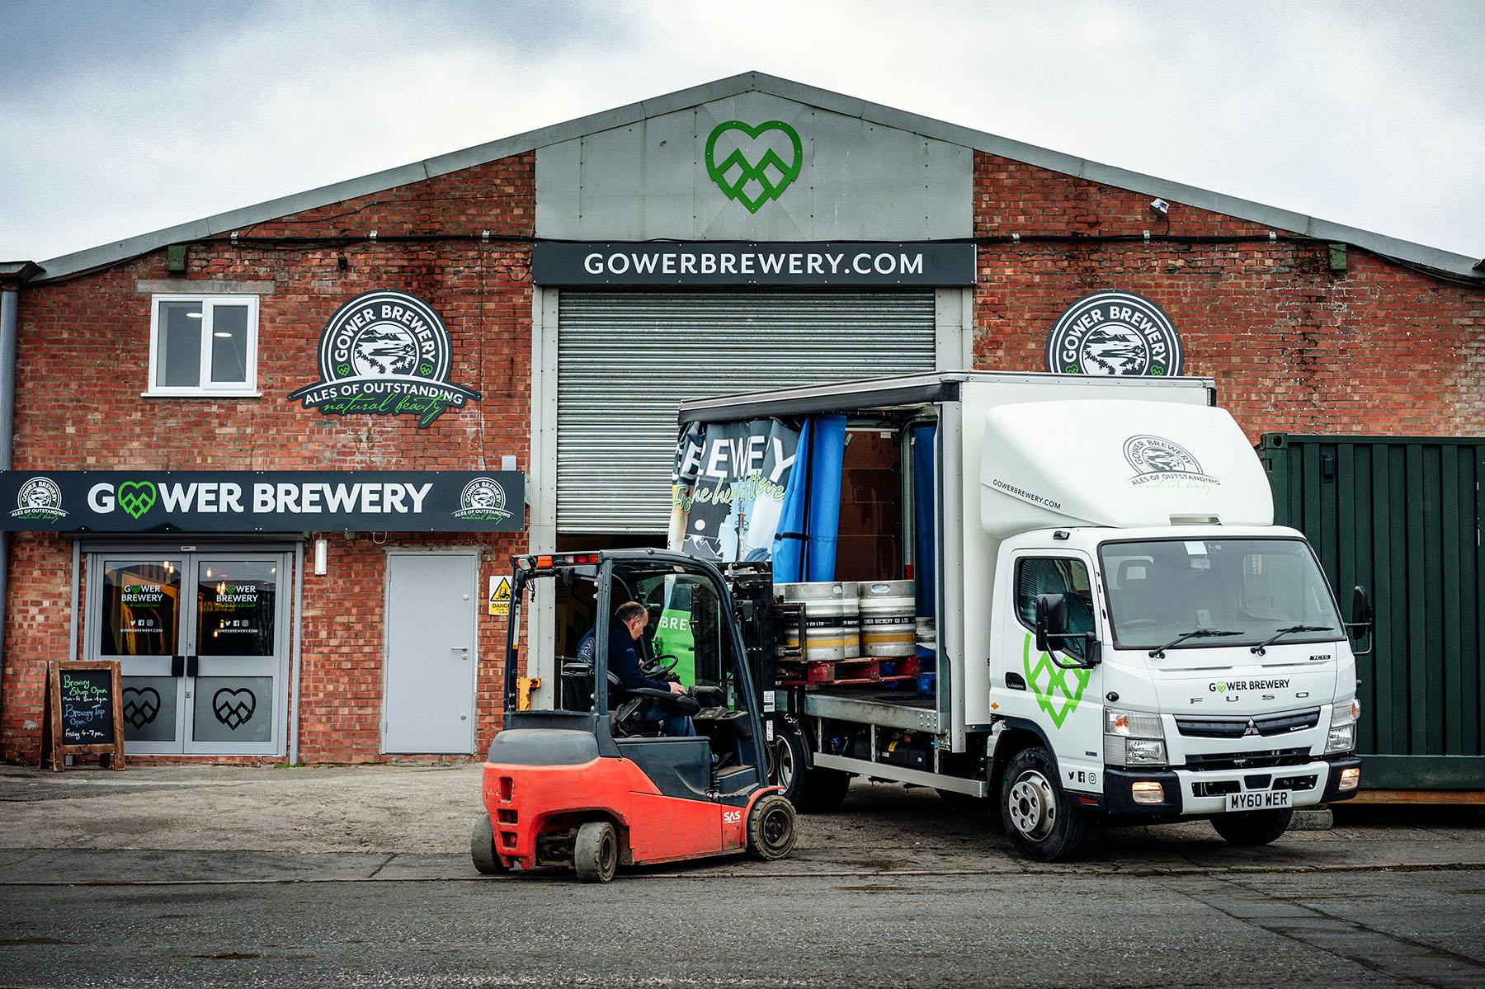

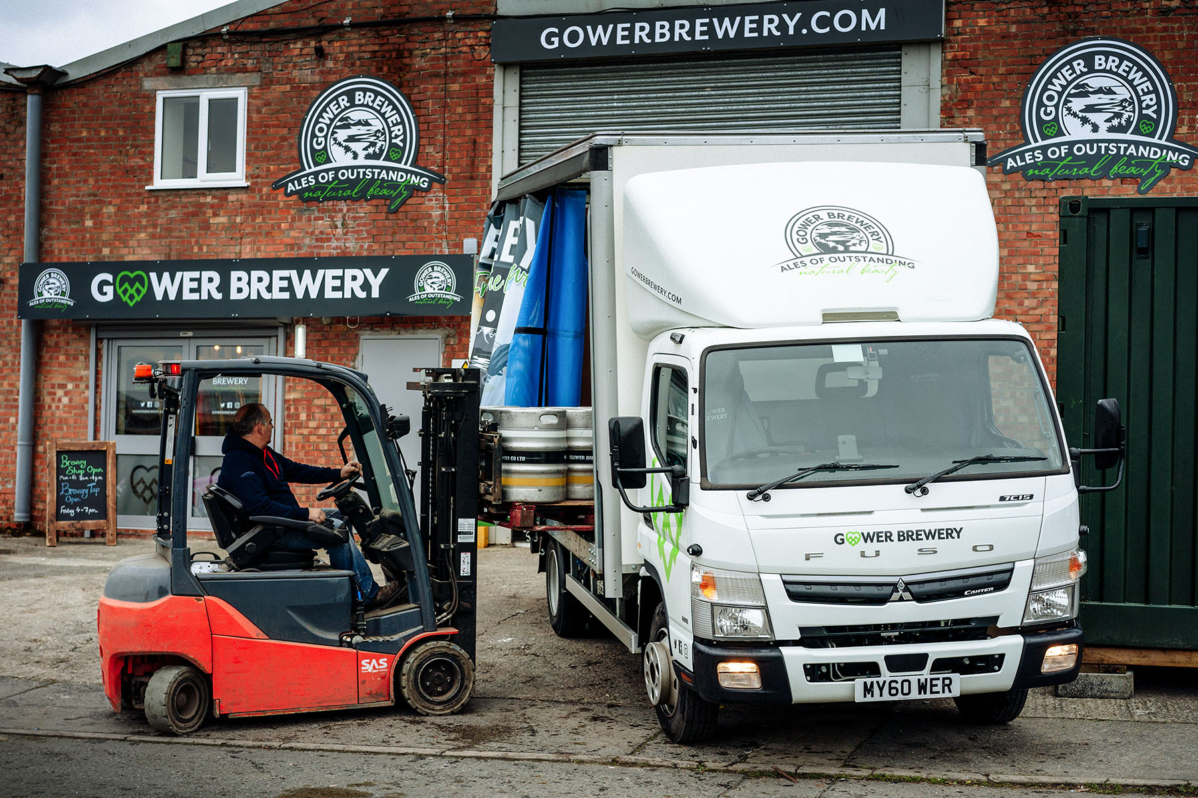

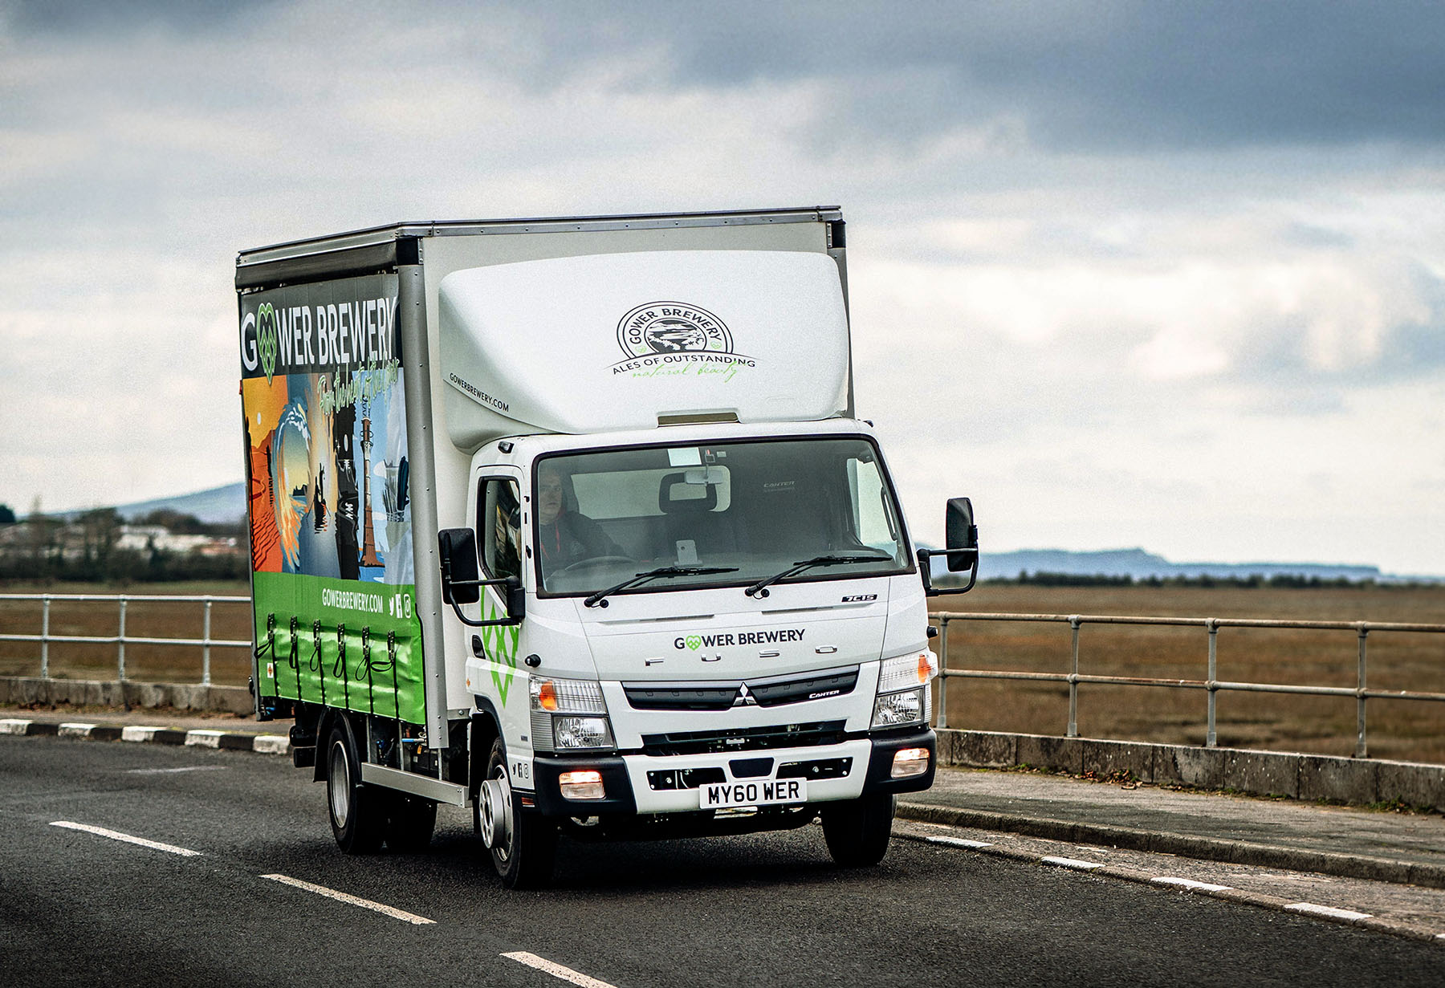

ends

For more information, or to request bigger/higher-res image files, please contact:
Steve Warren or John Ripley
Impact Communications
Steve: 07770 470251, steve@impactcom.co.uk
John: 07771 484595, john@impactcom.co.uk

