

Date: 6 December 2018

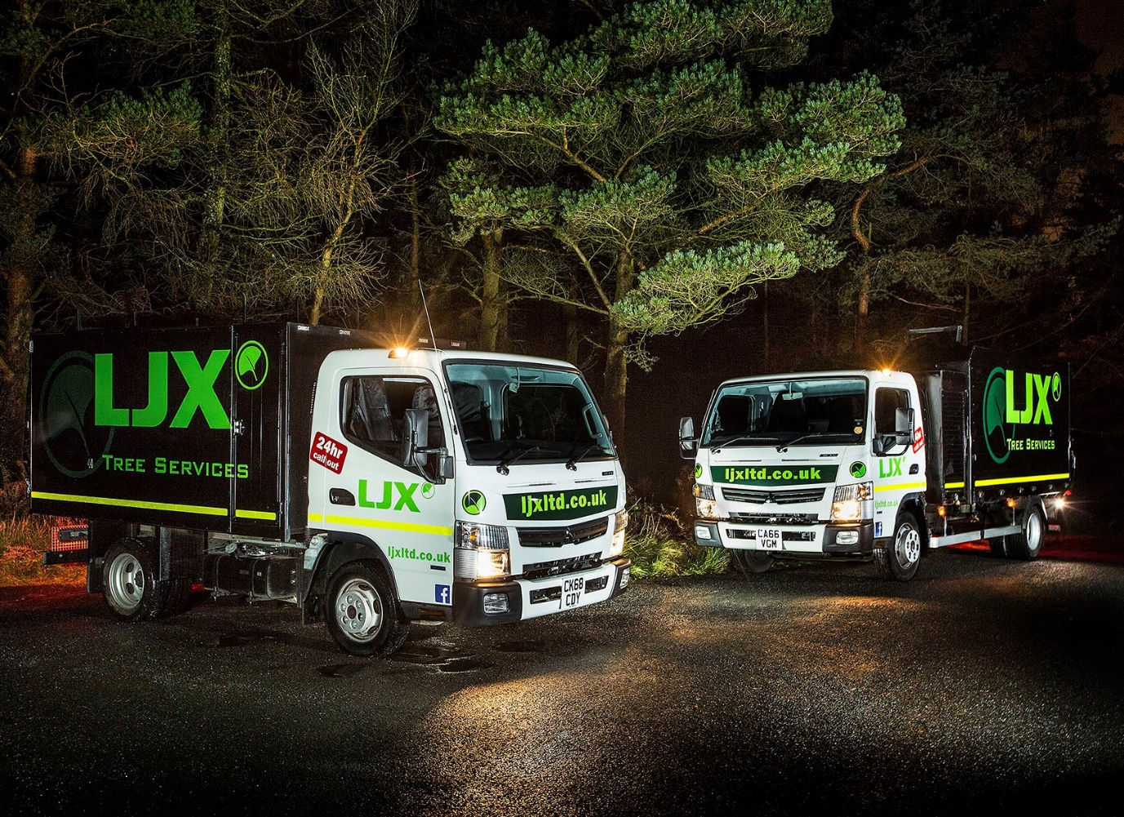

LJX turns over a new leaf with FUSO Canter

When it comes to buying the right truck, distance doesn’t matter to LJX Tree Services – which explains why the fast-growing Scottish firm has just acquired its third FUSO Canter within the last six months from South Wales Dealer Euro Commercials.

The latest is a 3.5-tonne Canter 3C13. It has joined another example of the same model and the 7.5-tonne Canter 7C15 which LJX was already running. All are powered by 3.0-litre common-rail turbo-diesel engines, which combine impressive economy with high levels of torque, and drive through fully-automated, dual-clutch DUONIC transmissions. The 3.5-tonners produce 96 kW (130 hp), while the 7.5-tonner has a 110 kW (150 hp) output.

A leading independent tree surgery company, LJX operates from headquarters at Langbank, on the western outskirts of Glasgow, and offices in the city and in Edinburgh. It provides a range of arboricultural services to the public and private sectors, including construction, utilities and transport businesses, and works throughout the country, although predominantly across the Central Belt.

The Canters are fitted with high-sided tipping bodies which are purpose-designed for arboricultural applications, and incorporate lockable tool boxes immediately behind their Comfort day cabs – those on the two smaller trucks are by Dragon Fabrications, while the bigger one’s is by Fruehauf.

Established in 2001 by Dan Kerr and Stephen Smith, LJX offers a full complement of tree pruning and felling, stump removal and site clearance services, as well as tree and vegetation management, bio-mass chipping and machinery hire. The firm, which runs four other commercial vehicles, has been forging ahead strongly, and was flat out during clean-up operations after September’s devastating Storm Ali, during which its teams appeared on local TV bulletins.

Euro Commercials, meanwhile, is a prominent member of the Mercedes-Benz Trucks Dealer Network, which is also exclusively responsible in Britain for sales and support of the popular FUSO light truck range.

Mr Kerr flew to Wales after spotting Euro Commercials’ advertisement for FUSO Canters with tree surgeons’ bodies, which had been pre-built and were available from stock. He was met at Cardiff Airport by Truck Sales Manager Gary Clark, and then, having viewed the vehicles and agreed a price, placed an order for the first two. The Dealer carried out a handful of modifications, before delivering both trucks to Scotland.

Mr Kerr was delighted not only with the vehicles, but also with the efficiency of Euro Commercials’ service. Faced with ever-increasing demand from customers, he therefore contacted the Dealer again shortly afterwards, to order a third.

“The fact that there are 400 miles between us hasn’t been a problem,” he explained. “Euro Commercials have been able to provide us with the right trucks, at the right price, and, crucially, within the very short timeframes that have allowed us to maintain service levels to our own customers – we’d have waited a lot longer if the vehicles had to be built from scratch.”

Based on an exceptionally strong ladder frame chassis, the rugged and durable FUSO Canter enjoys a well-earned reputation for reliability. It is also compact and highly manoeuvrable. These attributes, coupled with high carrying capacities – the 7.5-tonne variant offers a market-leading body and payload allowance of around 4.0 tonnes – make it ideally suited to arboricultural and related operations.

“The Canter also has three full-sized seats,” continued Mr Kerr. “This gives it a big advantage over one of its few competitors, which only has a small seat in the centre, because it means we can send a team out, and they can all travel in safety and comfort.

“The Canter is ideal, too, in terms of its size. We hold a major contract with a local authority’s highways department, and the truck’s relatively small footprint is very useful in enabling us to get up and down narrow streets.”

He continued: “Unlike most vehicles in its weight segment, the 3.5-tonne Canter is not based on a van, so isn’t too flimsy for the job. Instead, it’s a proper little truck. The 7.5-tonner, meanwhile, is highly productive, thanks to its fantastic payload potential.”

Mr Kerr added: “All in all, the Canter is perfect for our line of work. The new vehicles look great in our livery, and we’re very pleased with the upgrades we’ve made to our fleet.”

ljxtreesurgeons.com

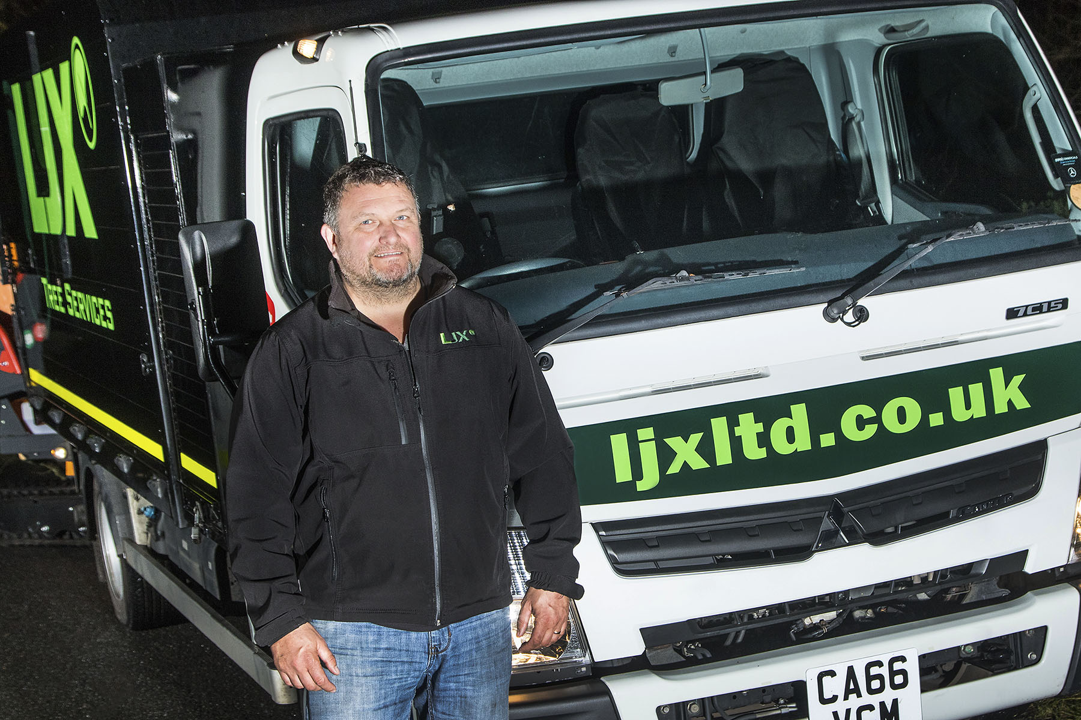

Branching out: Tree surgeon Dan Kerr has not looked back since switching to the FUSO Canter

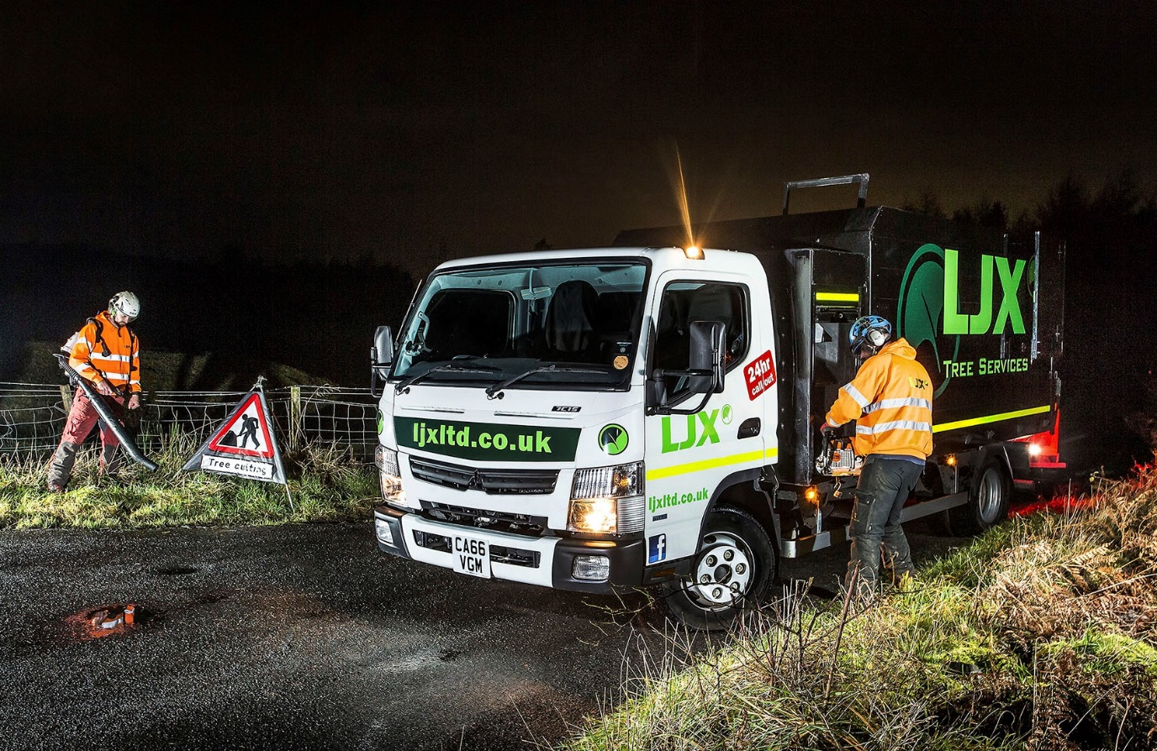

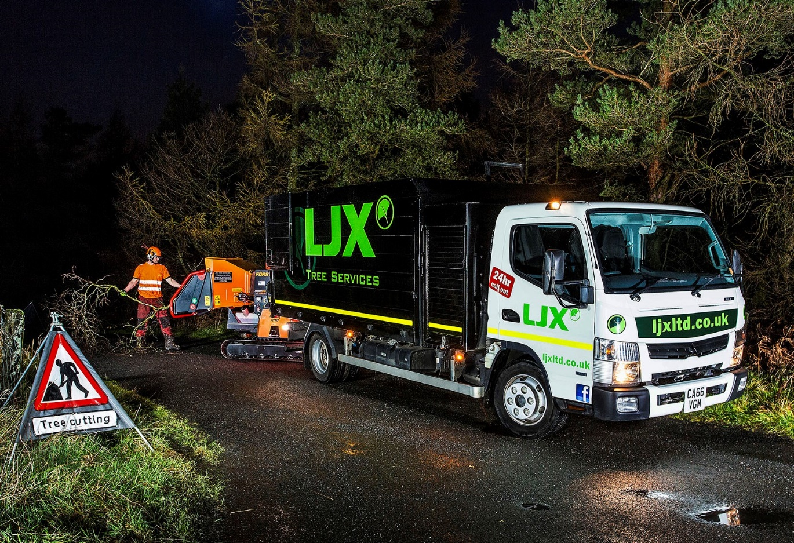

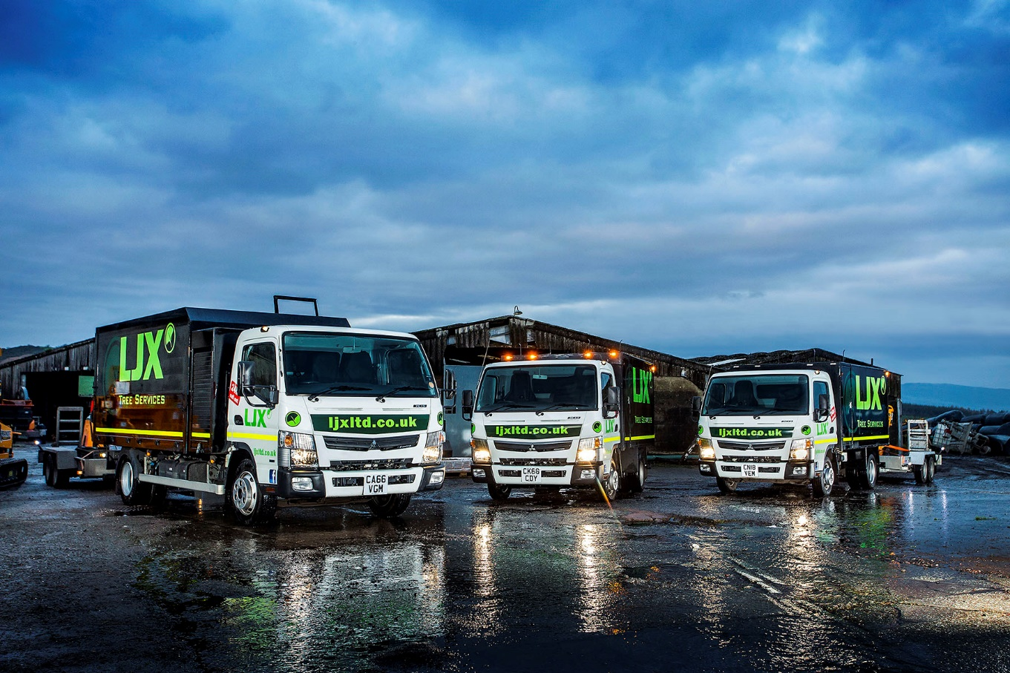

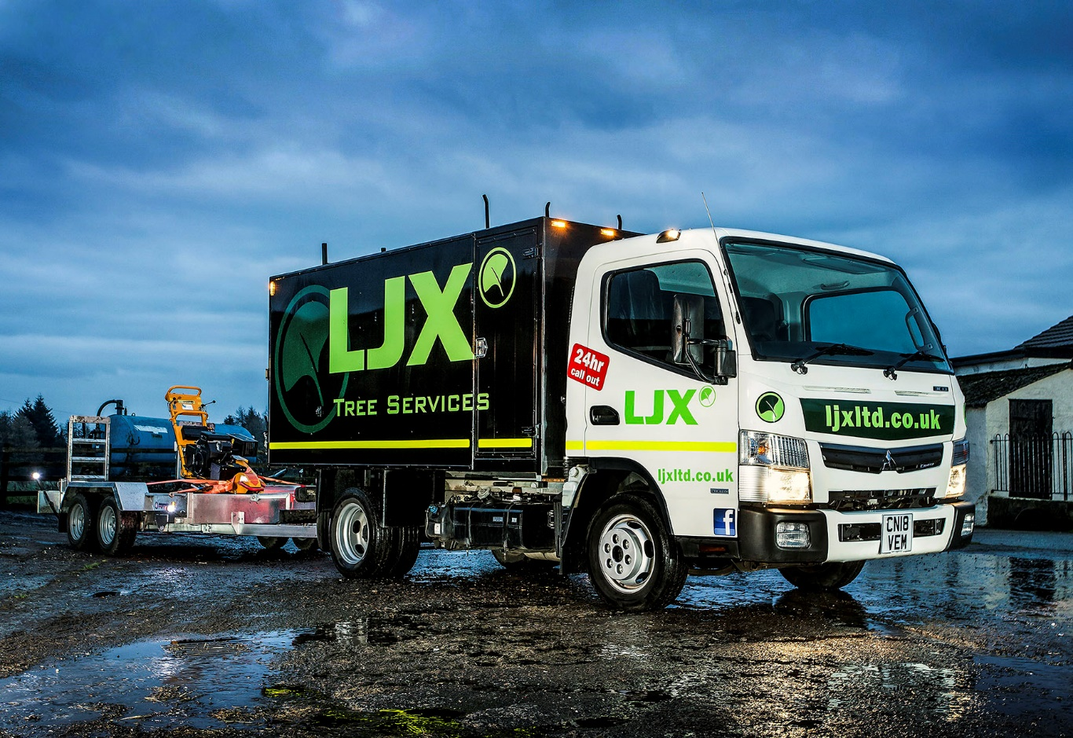

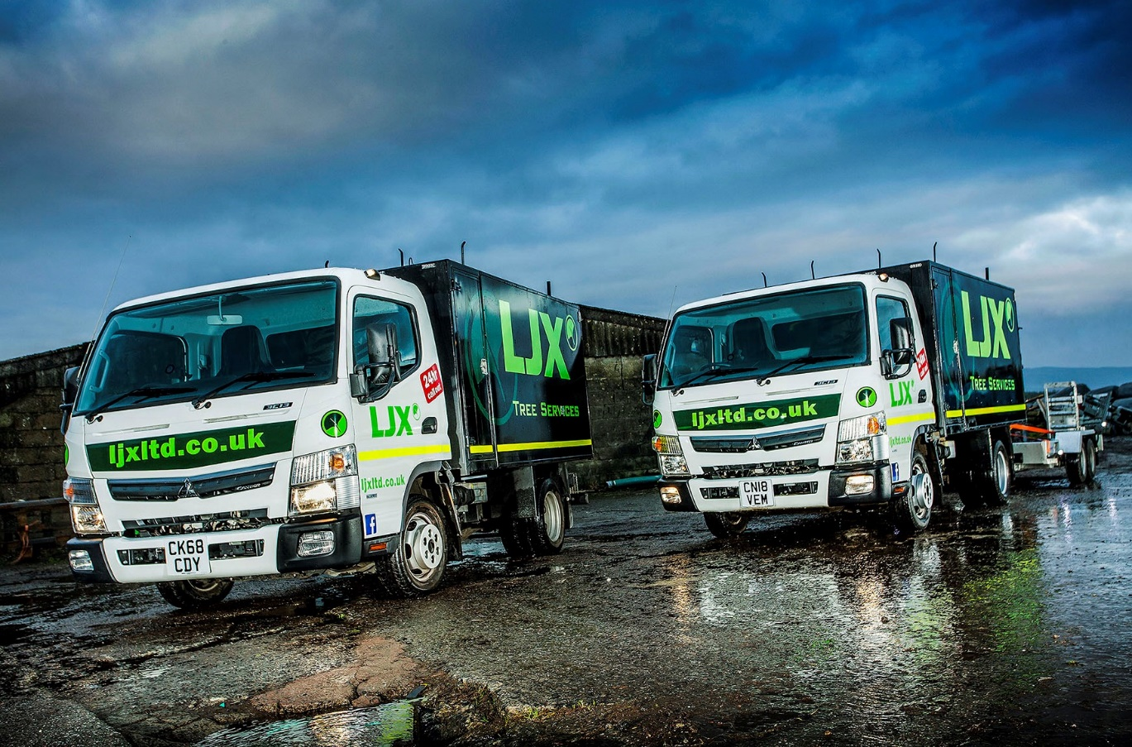

ends

For more information, or to request bigger/higher-res image files, please contact:
Steve Warren or John Ripley
Impact Communications, 01926 842126
Steve: 07770 470251, steve@impactcom.co.uk
John: 07771 484595, john@impactcom.co.uk



