

Date: 22 February 2022

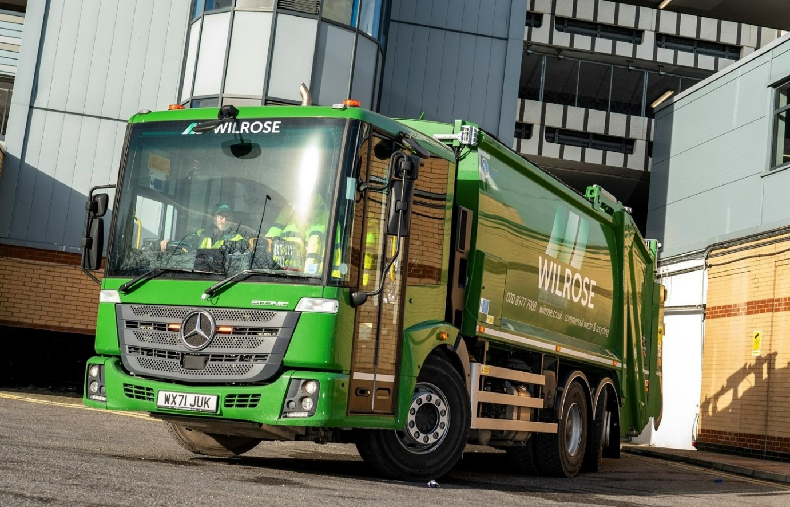

‘One-stop shop’ refuse collection vehicle specialist RVS teams up with City West Commercials to deliver a landmark Mercedes-Benz Econic

Three years after it began running Approved Used Mercedes-Benz Econics, Wilrose Environmental has commissioned its first with an entirely new chassis.

The company purchased its latest low-entry waste collection truck, pre-bodied and ready to work, from trusted supplier Refuse Vehicle Solutions (RVS).
RVS sourced the chassis from City West Commercials, the dedicated Mercedes-Benz Trucks Dealer for the South-West – the two businesses enjoy a long and successful partnership.

Wilrose Environmental has headquarters in Walton-on-Thames. It provides commercial waste collection services to customers from a wide range of sectors including retail, hospitality, health, education and industry, throughout its home county of Surrey, as well as Middlesex and London

Most of Wilrose Environmental’s 20 trucks wear three-pointed stars. The new arrival is its twelfth Econic refuse collection vehicle – all are 26-tonne six-wheelers with the exception of a single 4x2 18-tonner. The line-up also includes a pair of 32-tonne Mercedes-Benz Actros hook-loaders and an 18-tonne Antos skip-loader.

A 2630 L variant, the most recent addition to the fleet is powered by a 7.7-litre in-line six-cylinder engine that transmits its 220 kW (299 hp) output to the road via a six-speed automatic Allison gearbox. A rear-steer axle significantly enhances manoeuvrability in areas where access is restricted.

The Econic was delivered at short notice, having been pre-built for RVS’s RediTruck programme, which provides customers with a quick and easy way of avoiding long body manufacturer lead times. The vehicle’s Dennis Eagle Olympus OL21 compaction body is paired with a Beta 2 trade lift with 500kg capacity, by Terberg Matec.

Husband-and-wife team Andy and Carey Bishop founded Wilrose Environmental in 2015, the same year that RVS launched RediTruck. “We’ve been buying Mercedes-Benz vehicles since day one,” revealed Mr Bishop, who had gained previous experience of the brand’s products in other roles within the waste and recycling industry.

“Most have been supplied by RVS, on which we rely heavily to keep our fleet up to date and efficient. Its team are always accessible and provide a fantastic, no nonsense service. If I’d tried to line up a new chassis, body and bin lift myself it would have taken an eternity. RVS relieves me of all the hassle and can invariably deliver at short notice too.”

Mr Bishop continued: “We’ve bought pre-owned Econic chassis in the past, and they’ve always been reliable and cost-effective to run. As it’s completely new, though, I’d like to think the maintenance costs on the one we’ve just put to work will be even more attractive.

“The Econic’s air-conditioned, low-entry cab is also very popular with our drivers – in terms of access, it’s a winner all day long. Plus, of course, the Mercedes-Benz is well ahead of the rest when it comes to safety, and given that we operate on some of the country’s busiest and most congested streets that’s always a top priority.”

Econic drivers benefit from an unrivalled view of the conditions around them, thanks to the vehicle’s deep, wraparound windscreen and low seating position. The Econic attracts a top, five-star Direct Vision rating from Transport for London, when specified with the fully glazed, bus-style folding side door as fitted to Wilrose Environmental’s new truck. This allows the individual at the wheel to make direct eye contact with cyclists or pedestrians at junctions and in traffic, a key advantage in helping each to understand the other’s intentions.

The new Econic is also equipped with Active Brake Assist 5 emergency braking technology, which boasts an industry-leading pedestrian recognition capability, and an Electronic Parking Brake that is applied automatically when the engine is switched off.

Active Brake Assist 5 combines camera and radar technology to detect vehicles ahead and stationary objects in its own lane, at speeds of up to 56 mph (90 km/h). Detection of a dangerous situation triggers a three-stage reaction: first, the system warns the driver with visual and audible alerts; then, if the driver fails to react, it applies partial (approximately 50%) braking; finally, if the driver has still not intervened, it initiates maximum braking to bring the truck to a halt, applying the Electronic Parking Brake and activating the hazard warning lights to alert drivers behind.

At speeds of up to 31 mph (50 km/h) Active Brake Assist 5 is capable of applying full braking when encountering pedestrians crossing its path, approaching from the front or walking ahead. Not only does this remarkable system increase safety for vulnerable road users and vehicle crews, but it also helps to relieve stress for drivers.

RVS operates from two sites with a total of fifteen workshop bays and a two-storey parts department at Cam & Dursley, near Stroud. It offers a full complement of refuse vehicle services, including new or quality used vehicles for sale, vehicle remanufacturing, a substantial hire fleet, preventative maintenance and repairs, breakdown support, parts, finance and vehicle transportation.

The RediTruck solution is particularly attractive to operators that have to start work on a recently won contract at relatively short notice. RVS also purchases, refurbishes and in some cases modifies, then retails pre-owned refuse vehicles – each undergoes rigorous quality checks and a full service, and is supplied with a 12-month MoT.
Managing Director Spencer Law commented: “Wilrose Environmental is a highly valued customer and we’re very proud to have supplied Andy and Carey with their first refuse collection vehicle to be built on a new Econic chassis.

“For our part, RVS has purchased hundreds of Mercedes-Benz trucks since 2005. Last year alone we took more than 20 from City West Commercials, as well as a handful of 7.5-tonne FUSO Canters.
“We’ve worked with Truck Sales Executive Simon Johnson-Taylor for a long time now and he provides an excellent service, while the Dealer’s after sales support is great too. We rate it an excellent vehicle partner.”

wilrose.co.uk
refusevehiclesolutions.co.uk

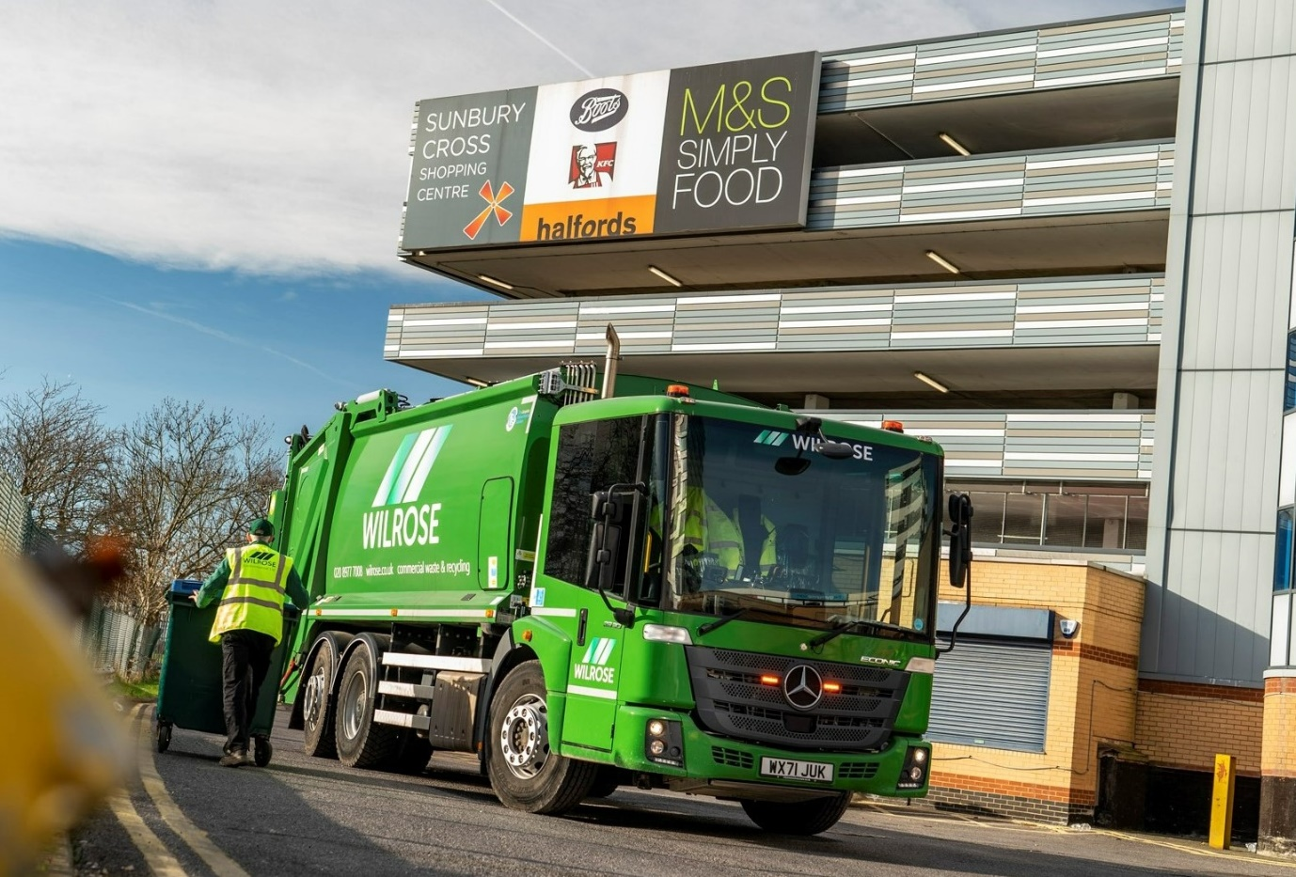

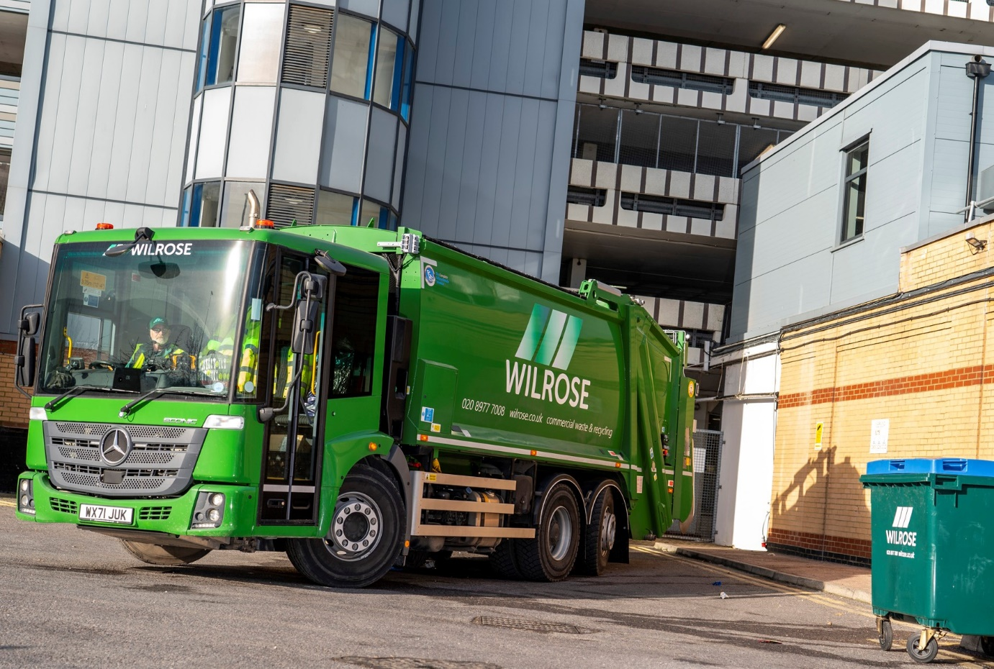

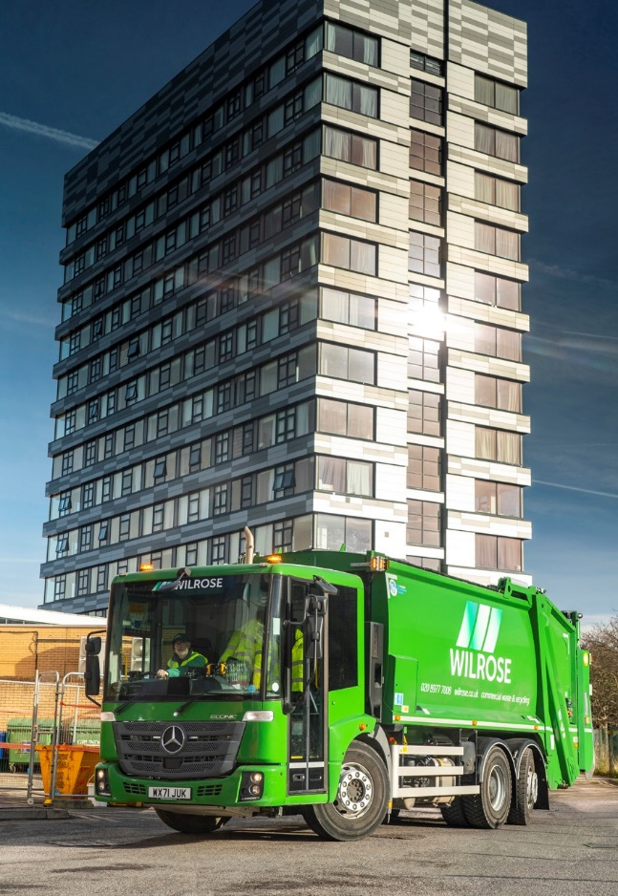

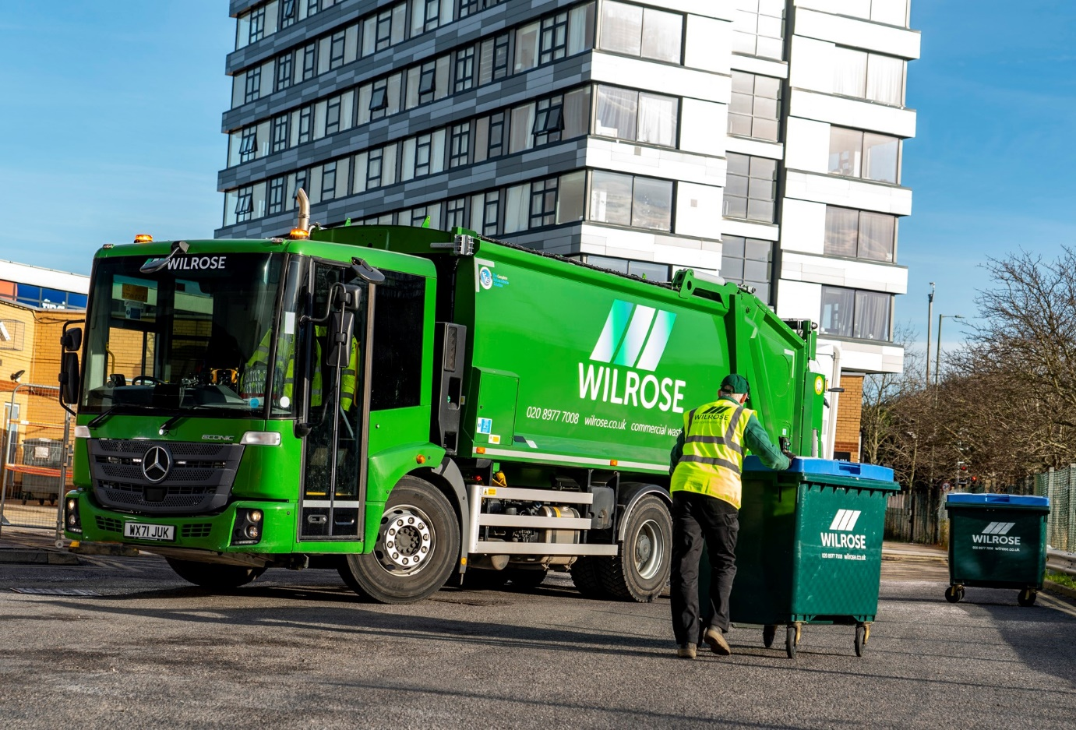

ends

For more information, or to request bigger/higher-res image files, please contact:
Steve Warren or John Ripley
Impact Communications
Steve: 07770 470251, steve@impactcom.co.uk
John: 07771 484595, john@impactcom.co.uk

