

Date: 22 December 2021

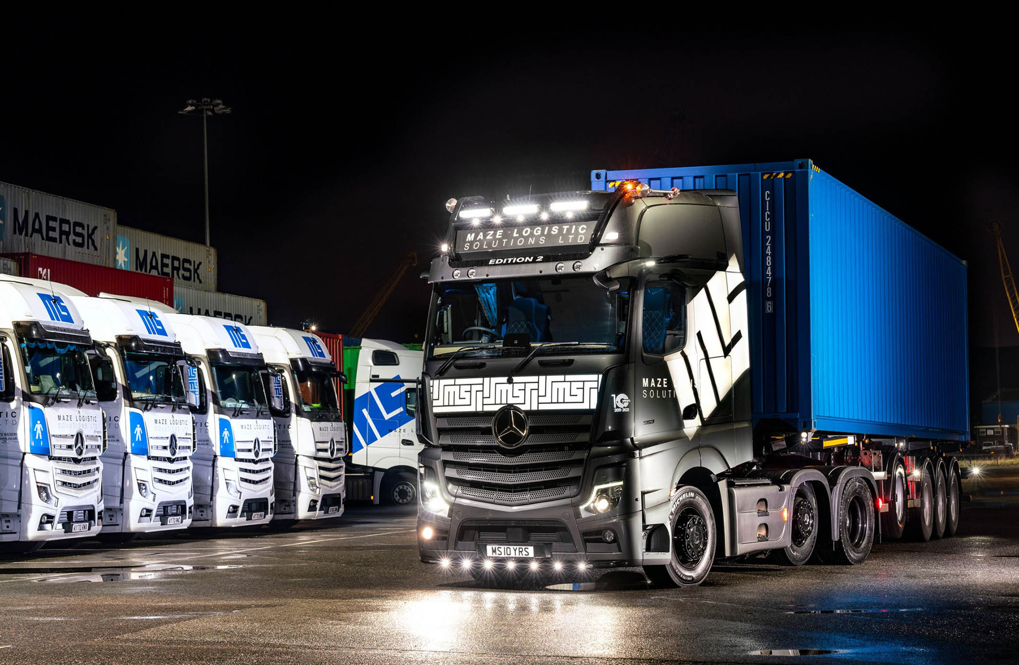

Mercedes-Benz operator Maze Logistic Solutions solves an anniversary puzzle with awesome Actros Edition 2

How best to mark the conclusion of your 10th year in business? Maze Logistic Solutions found its way to Motus Truck & Van for the answer – an exclusive Actros Edition 2 from Mercedes-Benz.

The Ipswich-based operator has relied on highly specified vehicles bearing the three-pointed star since it was established by Joint Managing Directors Jimmy Simmonds and Steve Snelling in 2011. Today, Mercedes-Benz Actros tractor units with range-topping GigaSpace cabs account for all but nine of the 26 trucks on a fleet that is set for further, significant growth next year.

Maze Logistic Solutions specialises in container movements and works for several shipping lines and ‘blue chip’ freight forwarders. It also provides warehousing, distribution and specialist haulage services, and offers bespoke supply chain management support covering all surface transportation, including ‘out of gauge’ cargoes, to help customers achieve the best performance and value.

Just 400 Actros Edition 2s have been built for customers worldwide, and of these only a handful reached the UK. Maze Logistic Solutions took delivery of its new flagship at a handover ceremony earlier this month, which was staged during an open day event to mark the launch of Motus Truck & Van’s state-of-the-art aftersales centre in Witham, Essex.

One of the best-looking trucks on the road, the Mercedes-Benz Actros Edition 2 also showcases the manufacturer’s industry-leading efficiency and safety technology, while simultaneously elevating driver appeal to a new level.

The truck is easily recognisable thanks to its Moonstone Grey grille and sun visor – this incorporating four additional LED headlights – above which is a deep black panel with EDITION 2 lettering. Other external highlights include an illuminated three-pointed star in dark chrome with a black closed cover, gloss black trim, stainless steel entrance steps, three more LED headlights behind the cab, and – for tractor units – a chassis frame cover.

The appearance of Maze Logistic Solutions’ truck is further enhanced by side skirts, paintwork with colour-coded bumpers in the same Moonstone Grey, and two sets of Lightfix light bars supplied and fitted by Kuda Automotive. It also wears an unusual, high-impact livery – applied by Chapple Signs, of Stowmarket, this incorporates black reflective elements that become photo-luminescent in the dark.

Driver Robert Chamberlain’s cab, meanwhile, is every bit as eye-catching on the inside. An abundance of stitched black Nappa leather contrasts with dashboard components in carbon. There is a sliding and tilting sunroof, eight colours of ambient lighting, and a driver’s suspension seat that incorporates climate and massage functions.

A rear wall locker system complete with a microwave and flat screen TV further enhances Robert’s living experience, while a brushed and polished aluminium badge on the co-driver’s side hails this Edition 2 as “One of 400”.

The subject of a flexible, low-cost Agility funding agreement from Mercedes-Benz Finance, Maze Logistic Solutions’ latest tractor unit is a 2553 variant and powered by a 390 kW (530 hp), 12.8-litre in-line six-cylinder engine.

MirrorCam, Mercedes-Benz Trucks’ pioneering alternative to conventional mirrors, is fitted as standard on all Actros. So, too, is the latest version of Predictive Powertrain Control, which manages gear changes to optimise fuel economy, and Active Brake Assist 5, the emergency braking system that outperforms its rivals, particularly in its responses to pedestrians stepping into the vehicle’s path.

Edition 2 drivers also benefit from the upgraded interactive version of the radical, twin-screen Multimedia Cockpit, which boasts a larger, 12in instrument panel and comes with extra functionality, including satellite navigation, together with Proximity Control Assist, Bi-xenon headlamps with a cleaning system, and LED tail-lights.

All of this equipment, and much else besides, is bundled into the Edition 2’s Driving, Comfort, Media, Stowage, Safety and Sight Packages, and ExtraLine design, to create a vehicle with an unmistakable “Wow!” factor.

Maze Logistic Solutions Director Ryan Jiggens confirmed: “We’ve not stopped throughout the pandemic. We continue to support our loyal customer base as the industry navigates its way through the challenge, and are forging ahead strongly with the support of Motus Truck & Van.

“The Actros is a great looking truck, and equipped to a very high standard both outside and in. Throughout our 10 years in business we have been very conscious of the needs of our drivers, and have chosen ever higher vehicle specifications as we’ve looked to enhance their driving experiences while simultaneously supporting our retention programme and building upon the company’s well-regarded reputation.

“We also enjoy very strong relationships with the Dealer’s Fleet Sales Manager Rob Dale, while its Ipswich workshop team provides fantastic back-up – nothing is too much trouble and the attention to us has never wavered. The maintenance and repair costs are also sensibly competitive, and the manufacturer’s UK-wide breakdown service is second-to-none.”

He continued: “Against this backdrop, when we decided to commission a new fleet flagship to mark our 10th anniversary a Mercedes-Benz was the obvious choice. To my mind the Edition 2 represents the very best of the best – ours look amazing and will be a great marketing tool.

“Robert is also very happy with the truck. He is an excellent employee and driver, and as with so many of his colleagues continues to support our growing business with regular enhancement suggestions for the fleet. As an avid truck enthusiast, he looks forward to presenting the Maze Edition 2 at shows next year.”

Deliveries in Essex and east London account for a significant proportion of the operator’s work, so Steve Snelling welcomed the opening of Motus Truck & Van’s Witham facility. “Downtime is so expensive that having another hub we can get into, especially one in such a perfect location, right next to the A12 trunk road, is going to be really helpful,” he said.

mazesolutions.co.uk

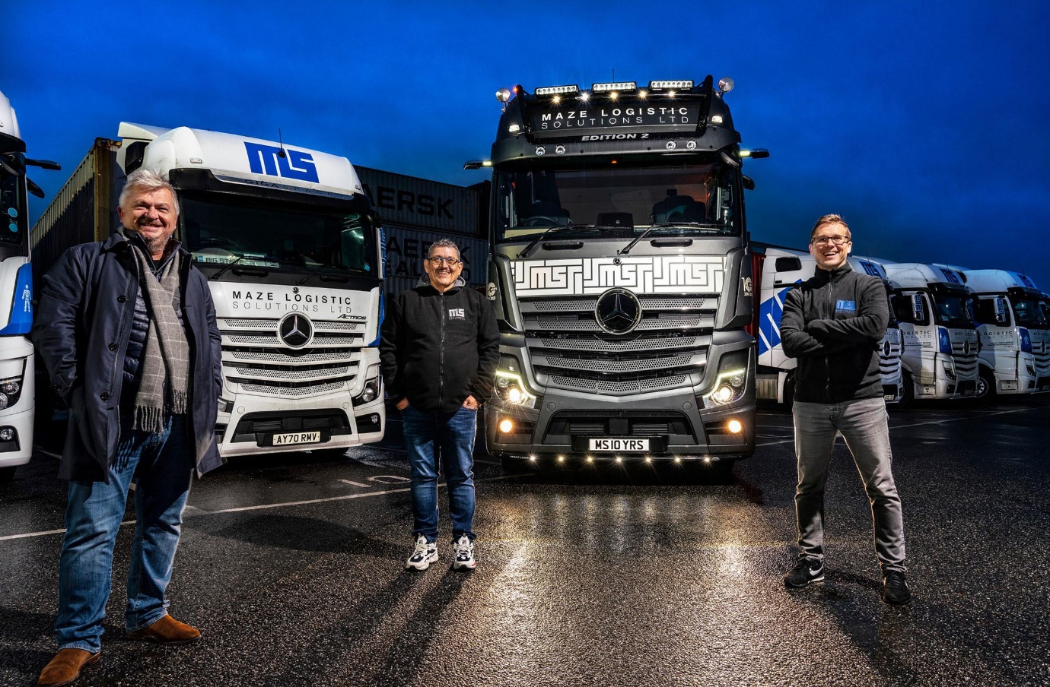

Fleet flagship: Joint Managing Director Steve Snelling, driver Robert Chamberlain, and Director Ryan Jiggens are pictured with Maze Logistic Solutions’ new Actros Edition 2

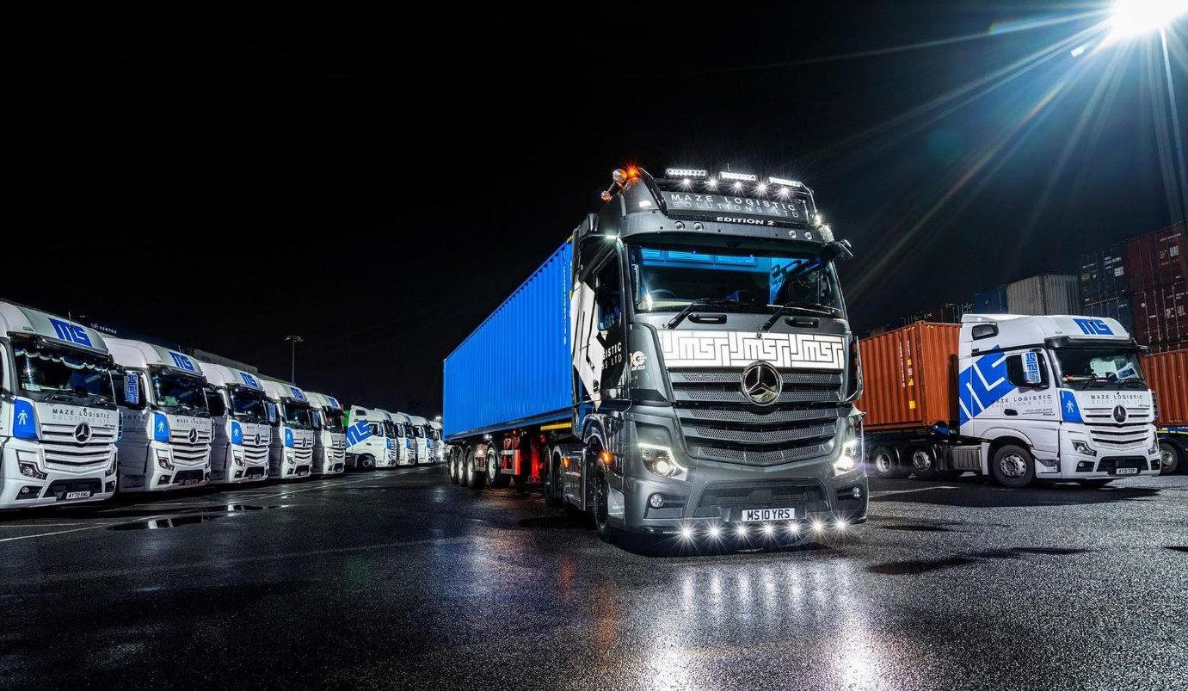

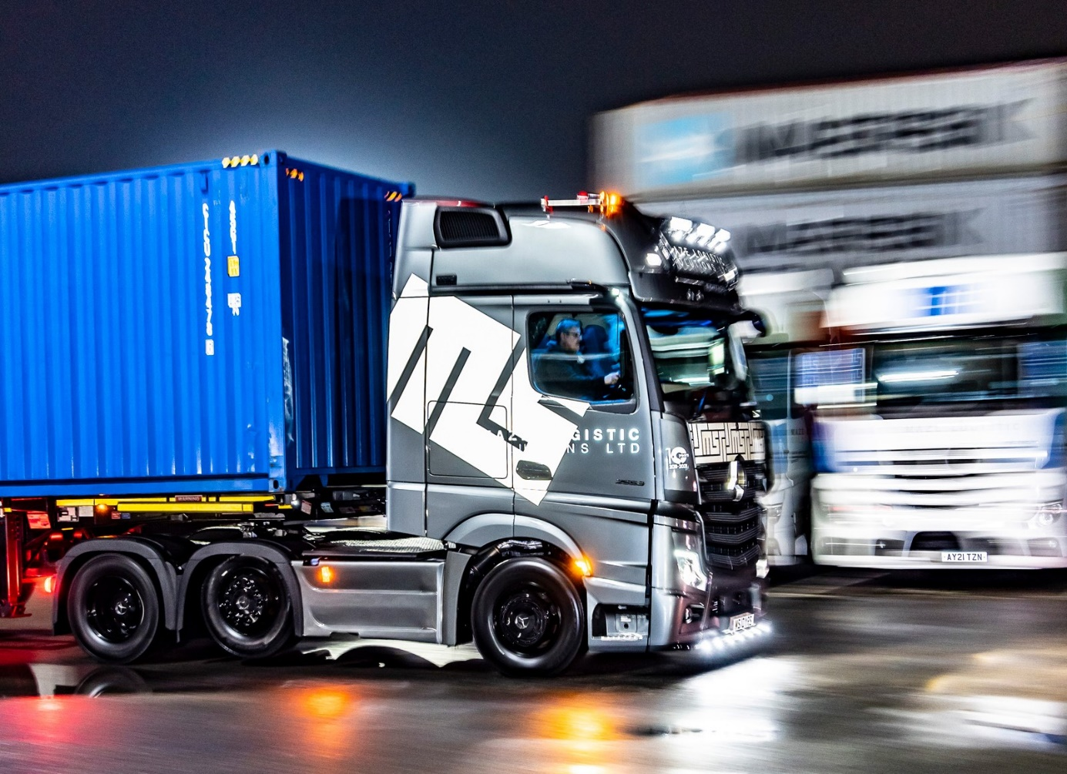

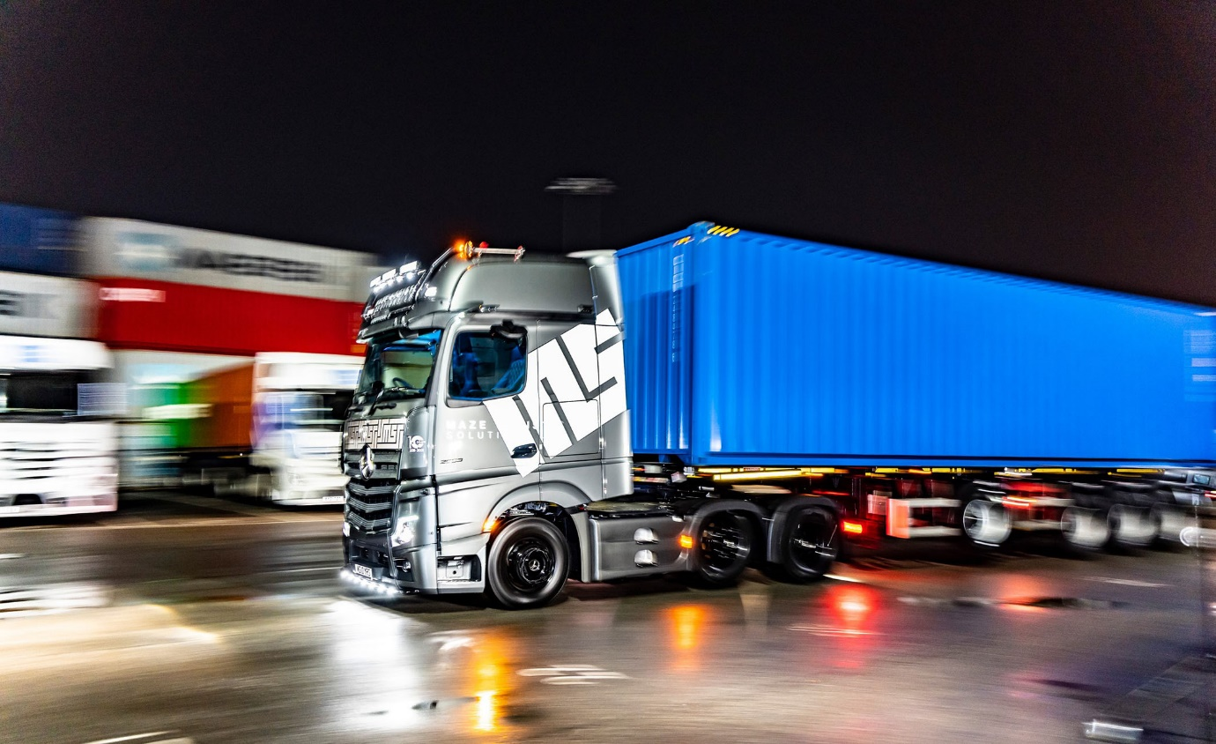

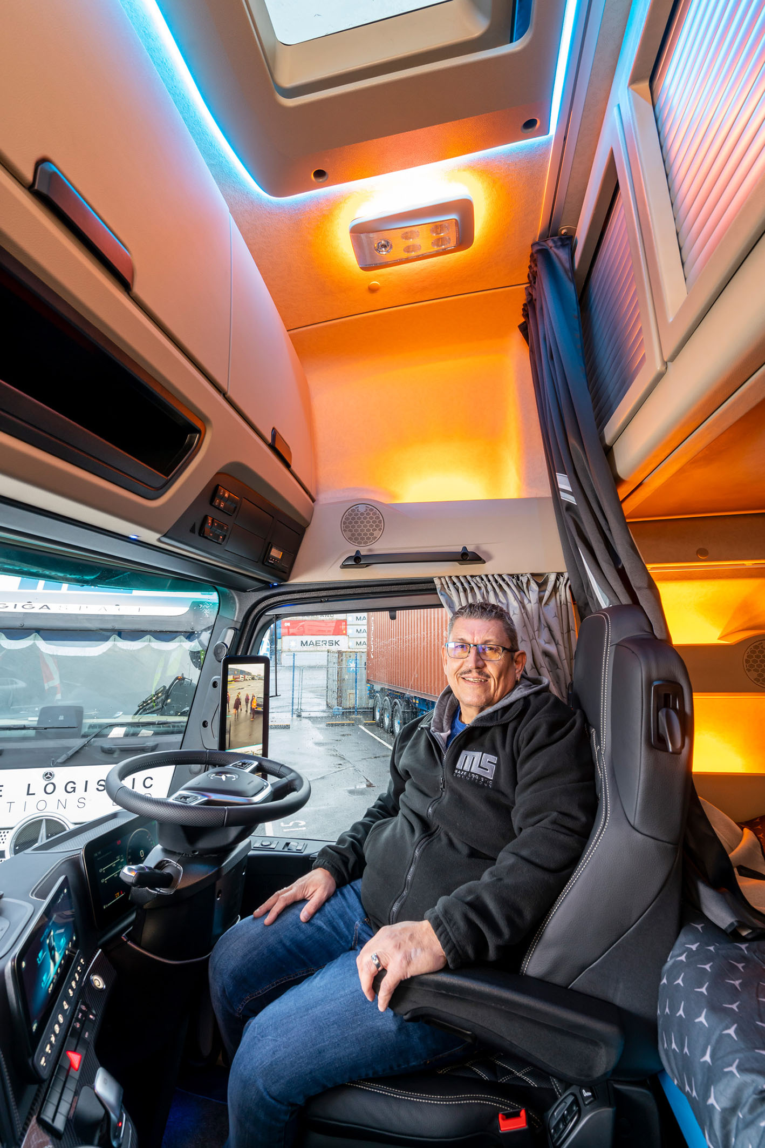

Light fantastic: Robert Chamberlain can choose from no fewer than eight colours of ambient lighting in his cab, and now looks forward to showing off his new Actros Edition 2 at truck shows next year
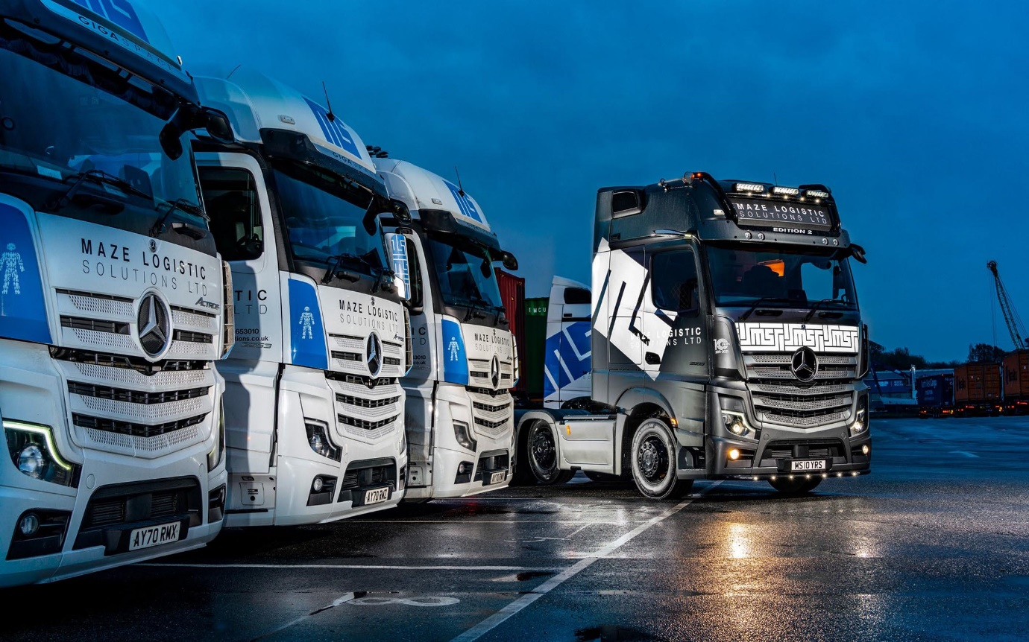

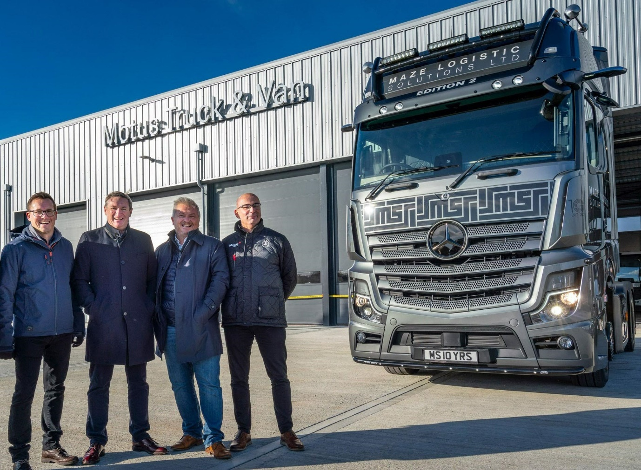

Handover: Maze Logistic Solutions Directors, from left, Ryan Jiggens, Jimmy Simmonds and Steve Snelling took delivery of their Actros Edition 2 from Rob Dale, right, Fleet Truck Sales Manager at Motus Truck & Van

ends

For more information, or to request higher-res image files, please contact:

Jamie Fretwell at Mercedes-Benz Trucks UK Ltd
07712 519230, jamie.fretwell@daimler.com

or

Steve Warren or John Ripley
Impact Communications, 01926 842126
Steve: 07770 470251, steve@impactcom.co.uk
John: 07771 484595, john@impactcom.co.uk

