

Date: 26 February 2021

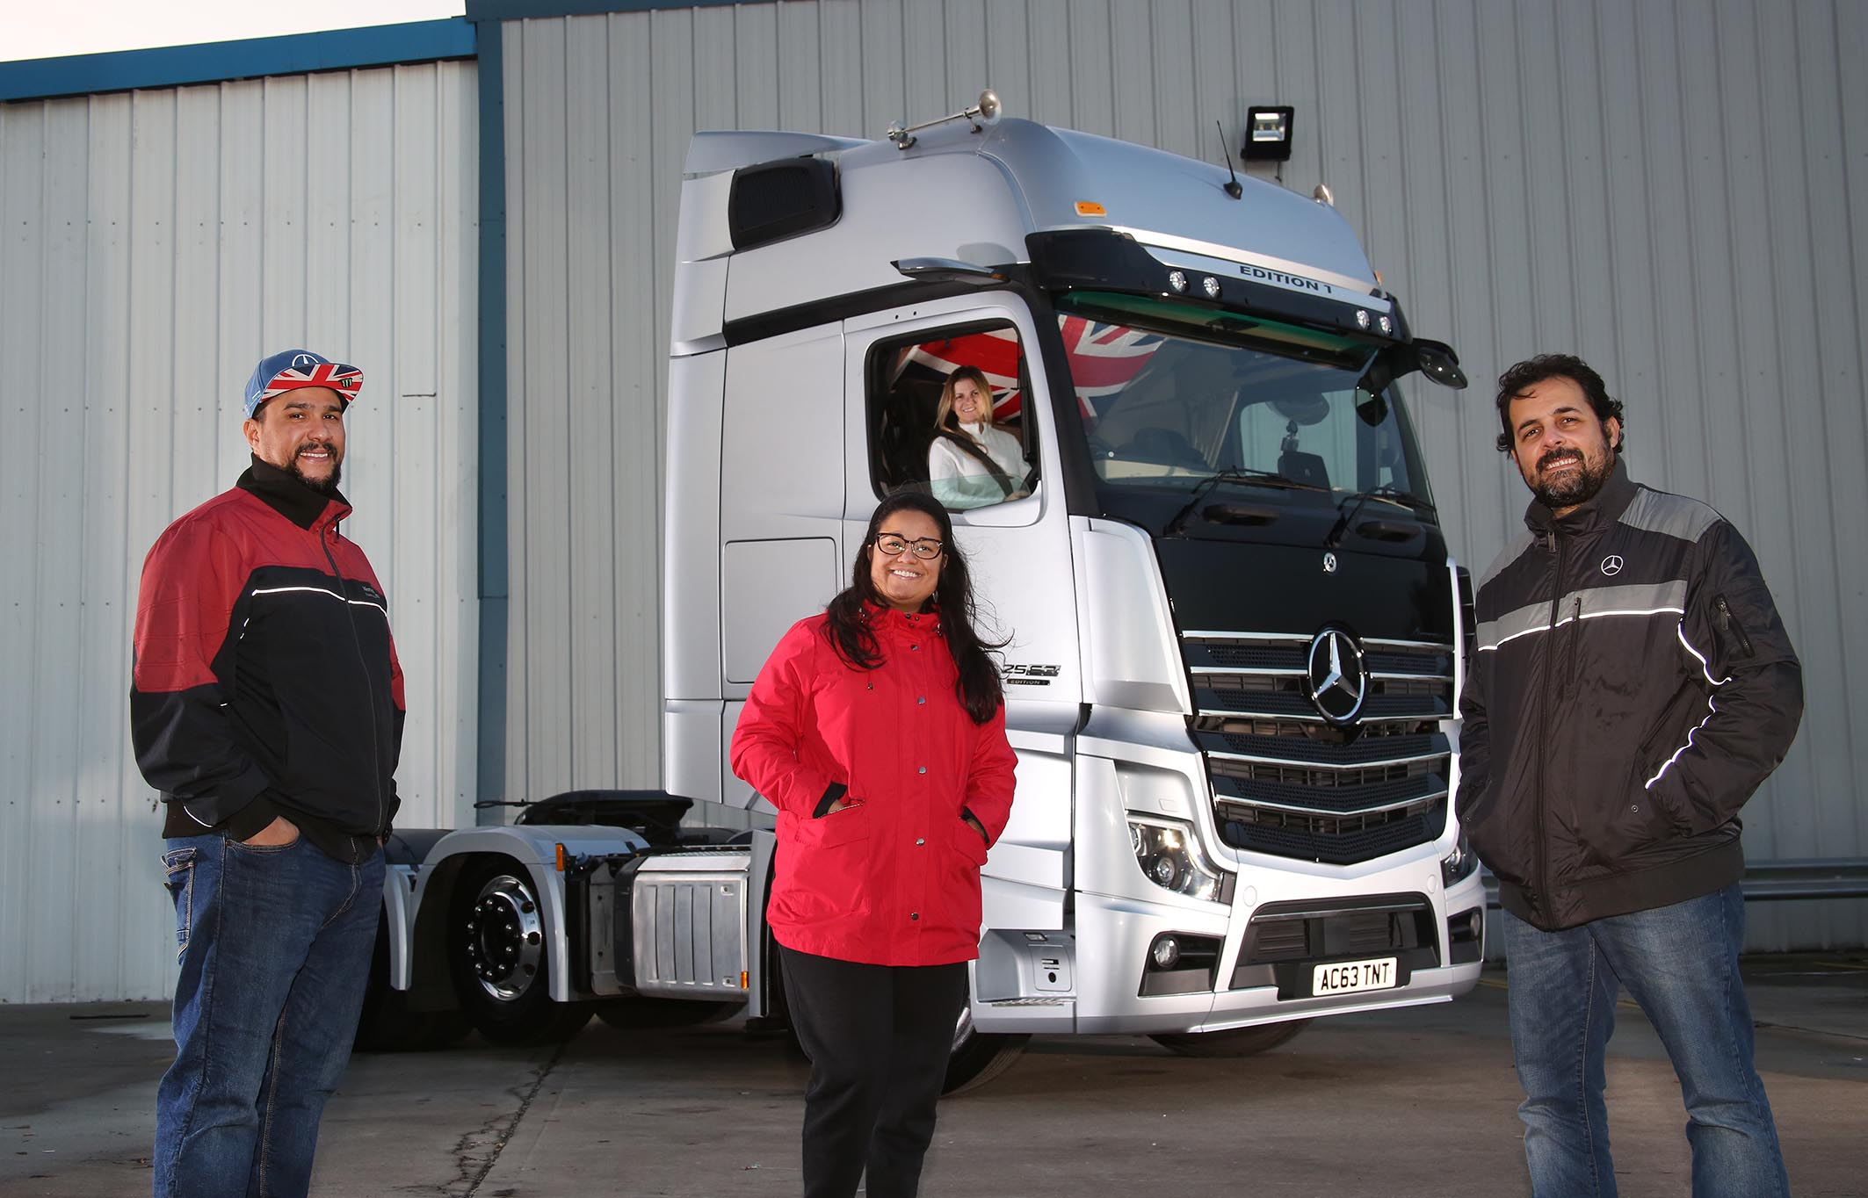

South American getaway: Pictured with their Mercedes-Benz Actros 1, the Tonnes & Tonnes team of, from left, Diogo Ferreira, Ludmilla Vieira, Sonara Ferreira and Guilherme Vieira have forged happy and successful lives in the UK

Tonnes & Tonnes’ Brazilians are nuts about their stunning Mercedes-Benz Actros Edition 1

Most truck drivers will spend an entire career on the road without getting an opportunity to pilot a vehicle as exclusive as the Mercedes-Benz Actros Edition 1 – no wonder newly-qualified Sonara Ferreira thanks her lucky three-pointed stars every time she takes a stint at the wheel of her company’s awesome fleet flagship.

Tonnes & Tonnes, which has just moved from its previous home in Grays, Essex, to a larger base at the port of Tilbury, works for one of the biggest names in home shopping.

The Edition 1 is a stunning showcase for the fifth-generation Actros range – just 400 have been built and of these only 35 were made available to UK customers. Tonnes & Tonnes’ example arrived via the Thurrock branch of Dealer S & B Commercials, from which the operator has also purchased three Approved Used Actros tractors over the last couple of years.

Tonnes & Tonnes was established in 2017 by Sonara’s husband Diogo and his brother-in-law Guilherme Vieira. The two Brazilians came to the UK 20 years ago as international students and have lived and worked here ever since.

They went into business together after Diogo, who was then employed as a motorcycle courier, was presented with an opportunity to buy a Swedish-built truck by a compatriot who was returning to their South American homeland.

Diogo and Guilherme were both passionate in their desire to break into the transport industry and with further backing from another Brazilian friend, Rafael Ferreira, who bought into the business 18 months ago and is now also driving one of its trucks, Tonnes & Tonnes has gone from strength to strength.

Diogo has always been on the front line and continues to drive on a daily basis – he and Sonara, who gained her Class 1 licence in September, share the Edition 1 between them. Guilherme and his wife Ludmilla, meanwhile, focus on the administration and management of the business.

Guilherme recalled: “Having started out with a single vehicle by another manufacturer we began networking and talking to others in the transport industry about which truck we should buy next. Several recommended the Actros as a modern, strong, comfortable and easy to drive tractor unit, so we contacted our local Mercedes-Benz Dealer S & B Commercials.

“Its used truck sales specialist Steve Jenkins was very knowledgeable and could not have been more helpful. We bought one pre-owned Actros shortly afterwards and were so pleased with it that we returned a couple of months later for two more.”

Explaining the decision to purchase its first new truck, Guilherme continued: “Business has been going well and Diogo wanted a special vehicle that would make a statement about how far we’ve come. Naturally, given our previous experience, we went for the very best that Mercedes-Benz had to offer.”

The Edition 1 is based on the imposing GigaSpace cab and is instantly recognisable thanks to its gloss black grille, darkened headlamp covers and rims, and branded sun visor incorporating four extra LED main-beam headlamps. Tonnes & Tonnes’ truck also features black hubs and wheel nut retainers, a treatment popular with truckers in Brazil.

Like most examples, it is powered by a range-topping 15.6-litre in-line six-cylinder engine that produces a potent 460 kW (625 hp). In addition to the many innovations that come as standard in the latest Actros – MirrorCam, Active Brake Assist 5, and enhanced Predictive Powertrain Control technology, for example – the limited-edition model is loaded with additional equipment.

The upgraded interactive version of the revolutionary Multimedia Cockpit incorporates a larger, 12in primary colour display, and the black leather-trimmed cab interior – which includes door handles with contrasting topstitching – features a polished and brushed aluminium dashboard badge that confirms each truck as ‘One of 400’ Edition 1s. Diogo and Sonara can also choose from no fewer than eight colours of ambient ceiling lighting.

“Our Actros Edition 1 looks amazing and is beautifully finished inside,” said Sonara. “It is a real privilege to be able to drive such a fantastic truck.”

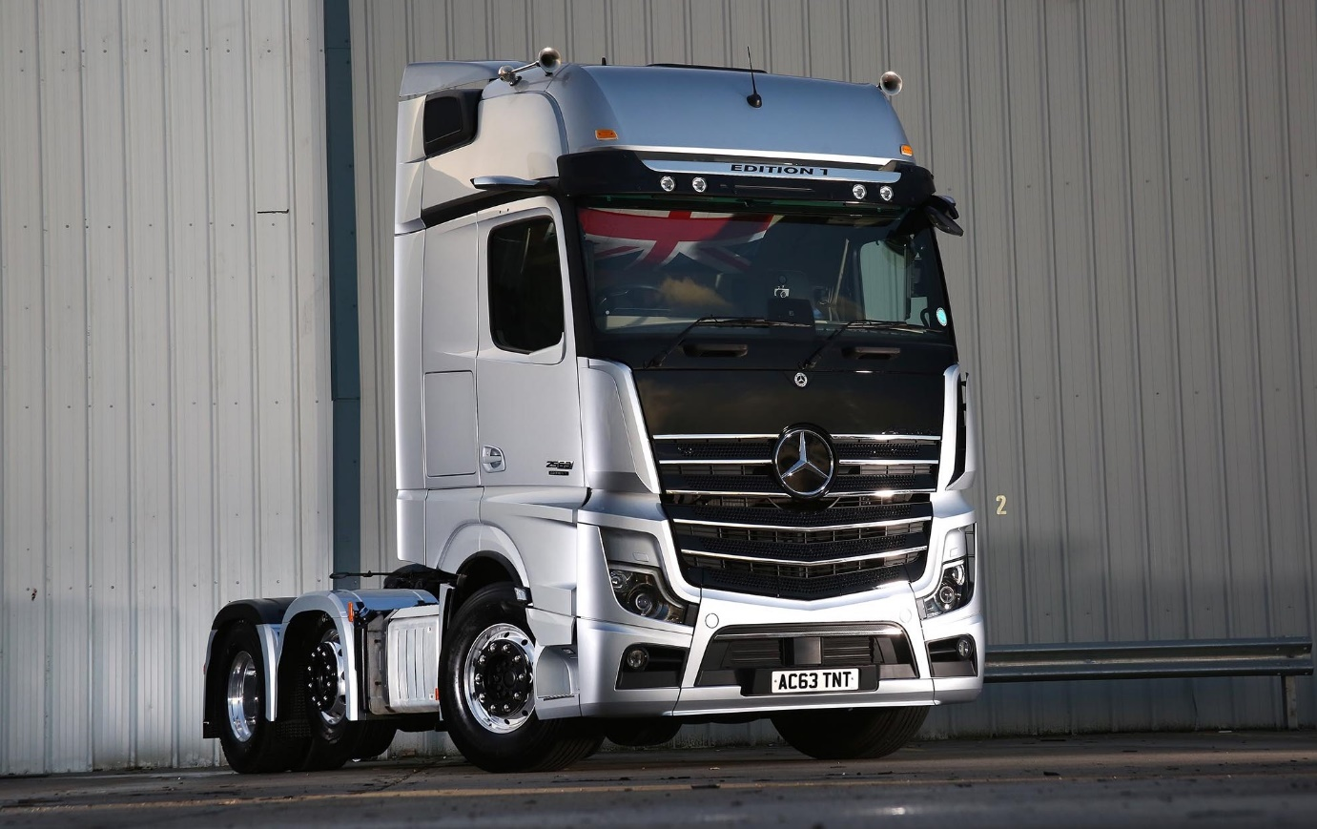

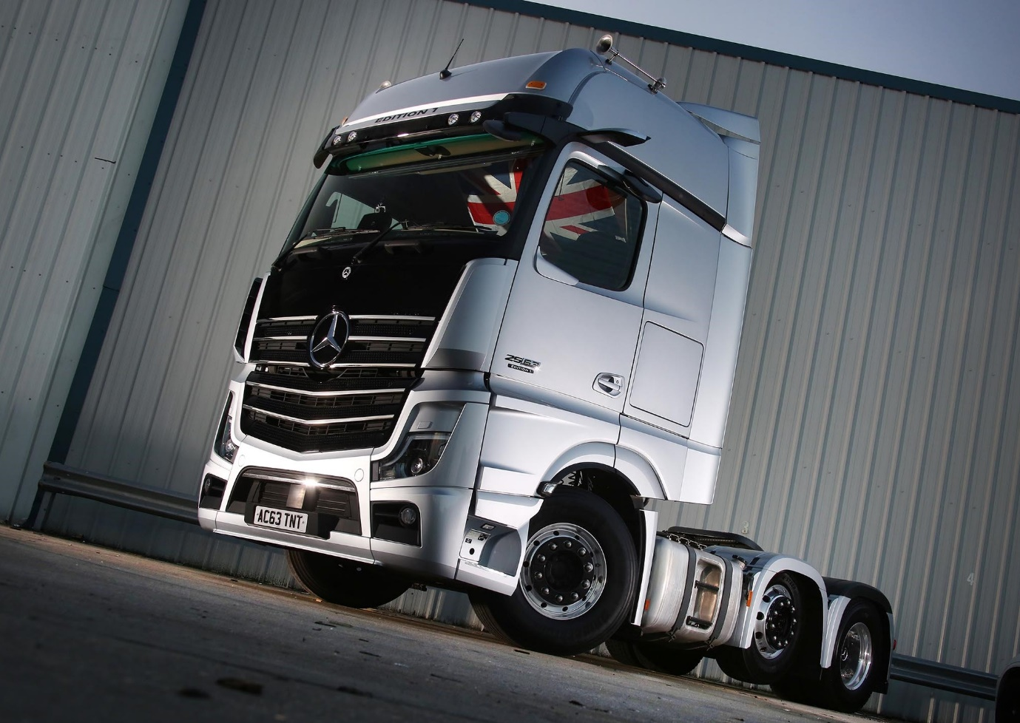



Seat of power: Tonnes & Tonnes’ Actros Edition 1 is a joy to drive for Sonara Ferreira
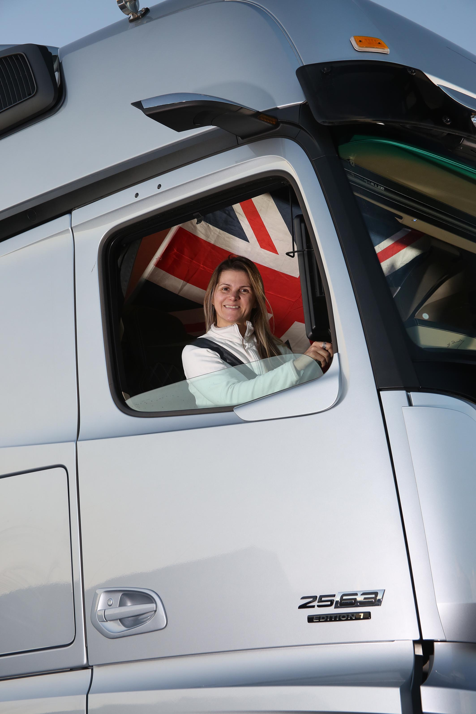

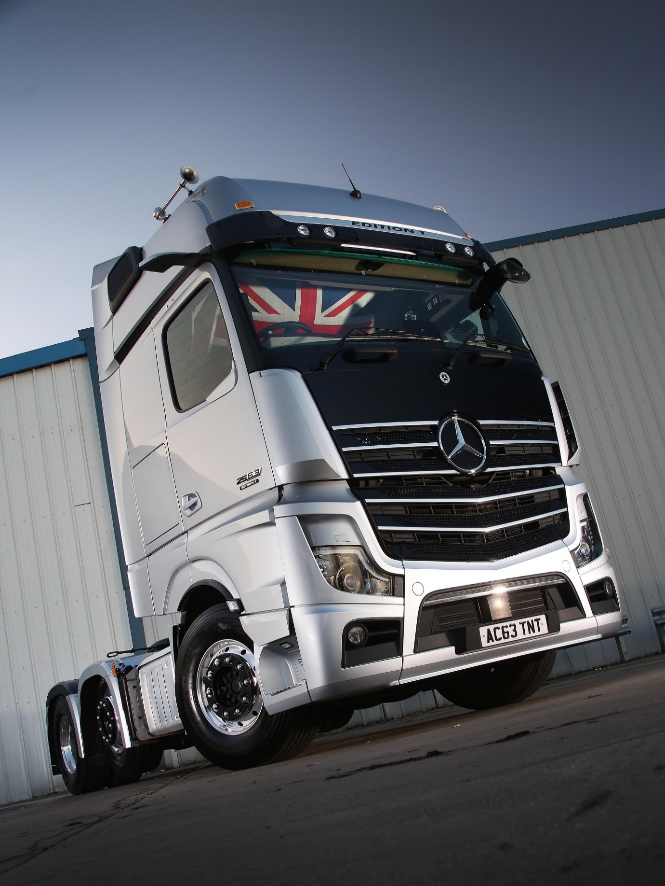

ends

For more information, or to request bigger/higher-res image files, please contact:
Steve Warren or John Ripley
Impact Communications, 01926 842126
Steve: 07770 470251, steve@impactcom.co.uk
John: 07771 484595, john@impactcom.co.uk



