

Date: 30 October 2019

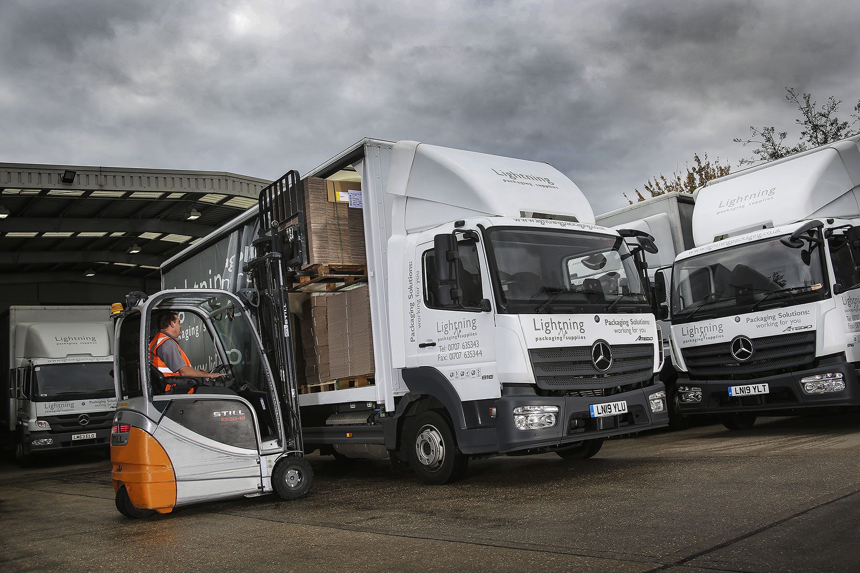

Lightning strikes again for Mercedes-Benz Atego

Thirty years after it opened for business, Hertfordshire’s Lightning Packaging Supplies continues to rely on the Mercedes-Benz trucks and outstanding back-up which have underpinned its success since day one.

The Hatfield-based company runs 15 Atego curtainsiders, including two new 7.5-tonners. Like all of its vehicles – including the four Mercedes-Benz Sprinter van-based chassis cabs which complete the fleet – they were supplied and are maintained by local Dealer S & B Commercials.

The latest trucks are the subject of a Mercedes-Benz Finance contract hire agreement – it is the first time the company has chosen this acquisition method. Both are Atego 816 variants with ClassicSpace S-cabs, and fuel-efficient 5.1-litre engines which produce 115 kW (156 hp). Their bodies, meanwhile, are by Wessex Vehicle Services, of Salisbury.

Acquired in 2017 by distribution and outsourcing multinational Bunzl, Lightning Packaging Supplies takes great pride in responding rapidly and efficiently to customer requirements. The company’s smartly presented Mercedes-Benz vehicles are key to its reputation for exemplary service.

All of the Atego rigids have 7.5-tonne gross weights with the exceptions of a pair of 12-tonne models, and each of these vehicles typically covers 80,000 km per year. In line with the operator’s long-established policy, the latest two have replaced trucks which were stood down after five years on the road.

The Mercedes-Benz Atego range from 7.5-16 tonnes GVW is purpose-designed for light- and medium-duty distribution applications. It offers outstanding dynamics, comfort and manoeuvrability, as well as the durability necessary for intensive, multi-drop delivery work.

Lightning Packaging Supplies, which has a second depot in Southall, west London, offers a comprehensive range of materials, included corrugated cases, tapes, cushioning, paper and polythene products, strappings, packing room equipment. As well as ‘off the shelf’ lines, it provides custom-made packaging solutions.

Operations Director Tony Ritson confirmed: “We started out with Mercedes-Benz 7.5-tonners purchased from S & B three decades ago, and have stuck with them ever since. As a business that produces a lot of time-sensitive bespoke packaging, the delivery commitments we make are crucial – we cannot afford to let our customers down.

“The Atego has always provided the outstanding reliability we need, as well as being economical to run, and well-liked by our drivers. We also believe that with their three-pointed stars and distinctive silver curtains, the vehicles enhance our company’s image and reputation for quality and professionalism.”
Lightning Packaging Supplies’ trucks and vans are maintained and repaired at S & B Commercials’ satellite workshop on the Hatfield Business Park, a ‘stone’s throw’ from its own headquarters. “Our relationship with the Dealer is every bit as important as the vehicles themselves,” continued Mr Ritson.

“Service Manager Steve Smedley understands the absolute importance of keeping our trucks and vans out on the road and earning, and provides fantastic support. He and his team will always bend over backwards to help us out, which is very reassuring. Breakdowns are very rare, but I know that should the worst happen I can trust S & B to treat it as a matter of urgency.”
www.lightningpackaging.co.uk

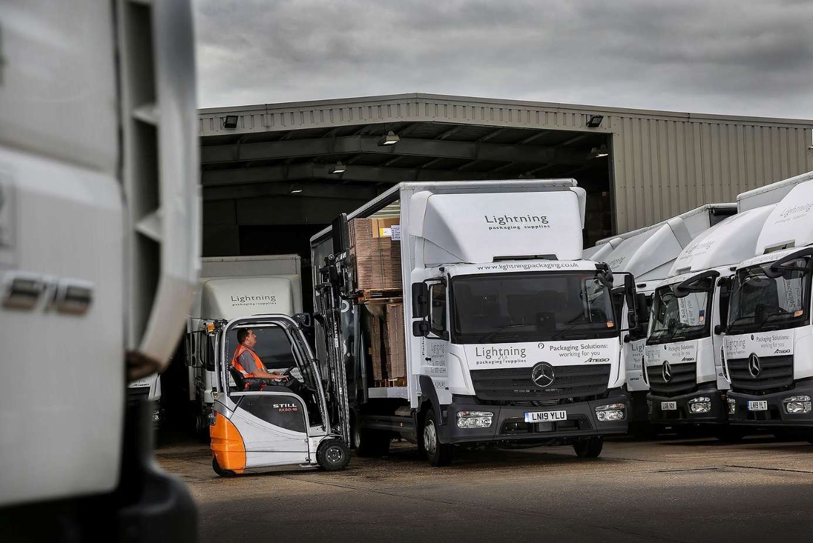

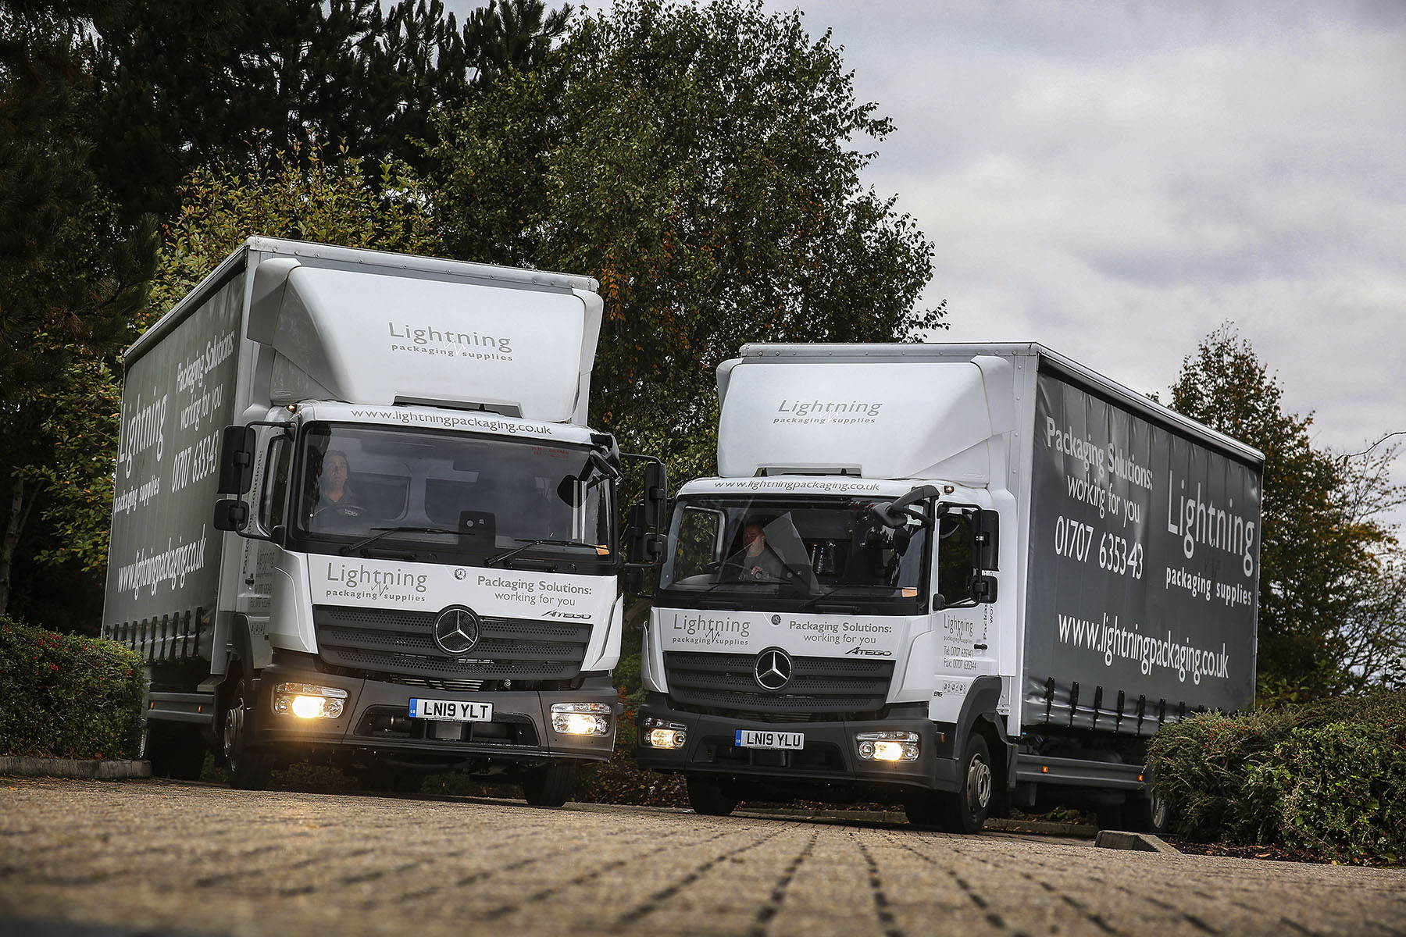

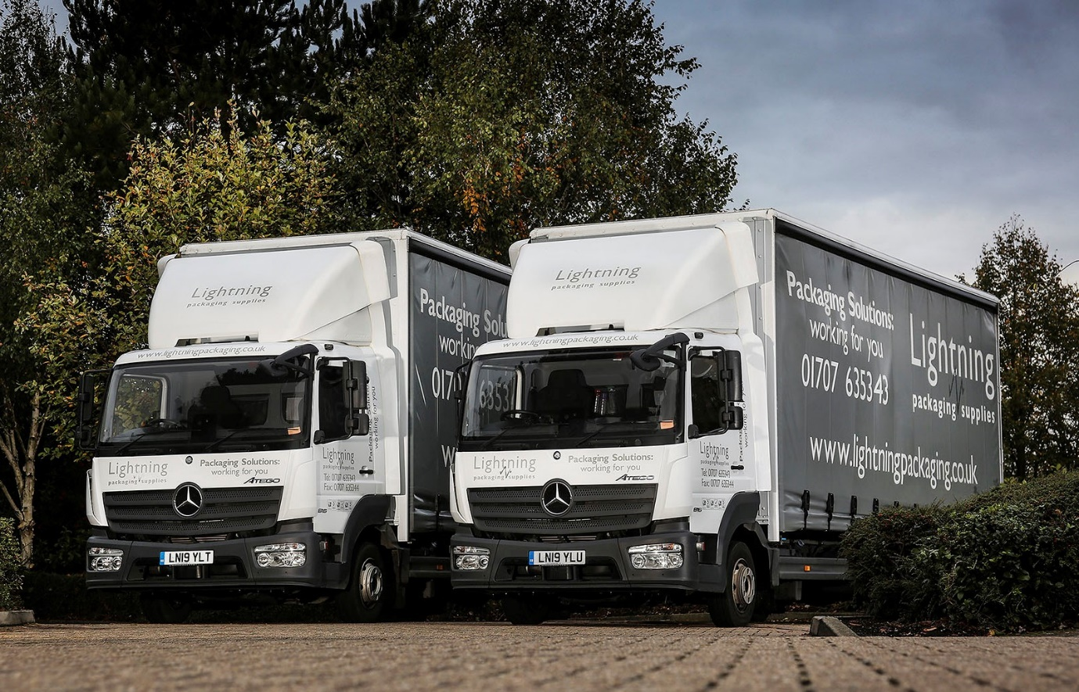

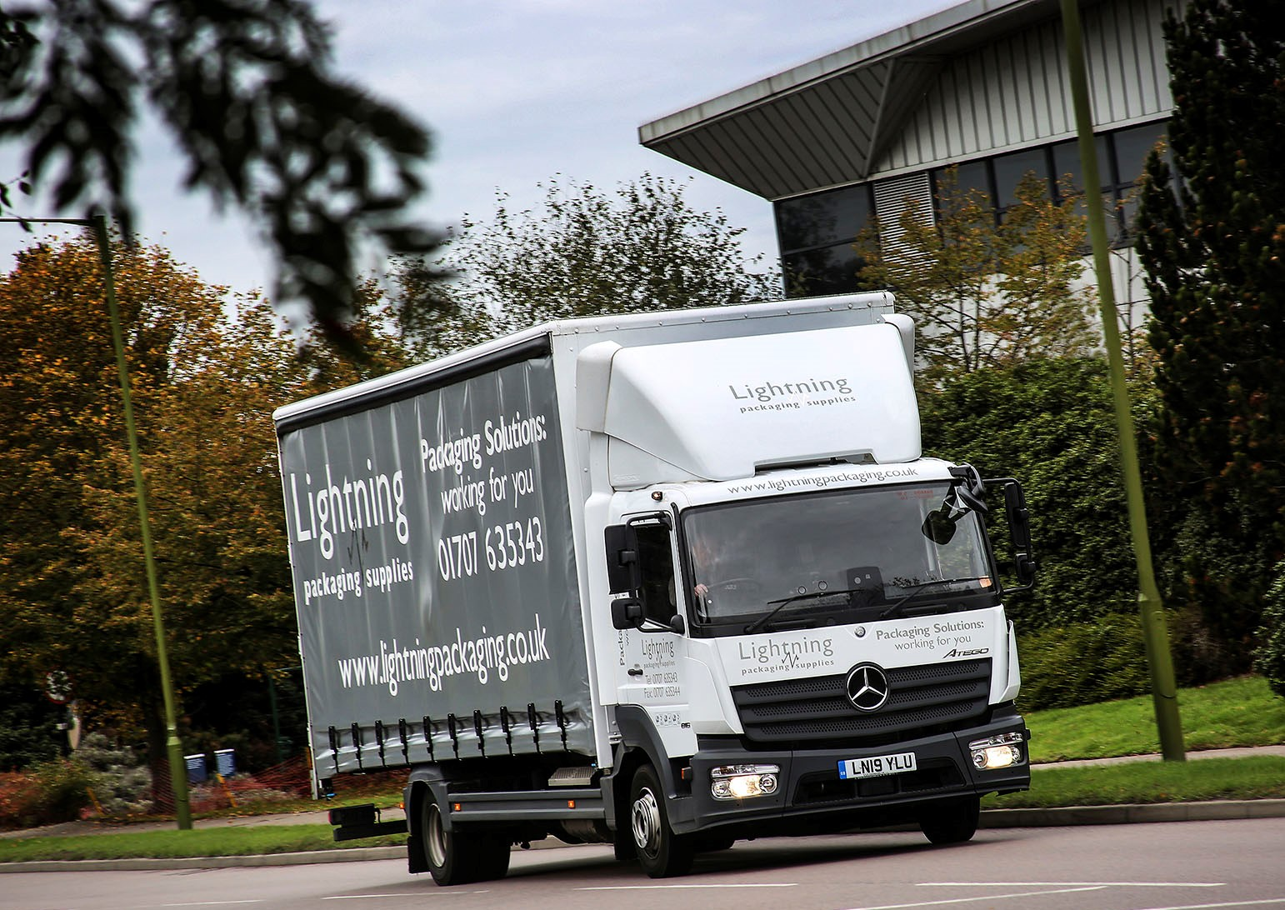

ends

For more information, or to request bigger/higher-res image files, please contact:
Steve Warren or John Ripley
Impact Communications, 01926 842126
Steve: 07770 470251, steve@impactcom.co.uk
John: 07771 484595, john@impactcom.co.uk

