

Date: 28 February 2020

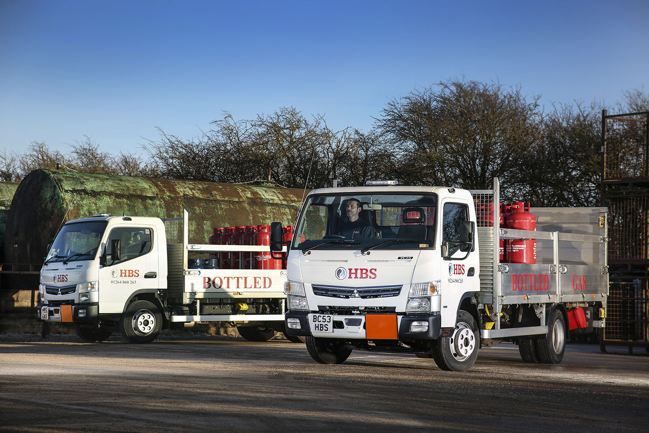

Robust, reliable FUSO Canter has more than enough ‘bottle’ for HBS Fuels

When domestic and commercial heating oil and gas supplier HBS Fuels decided the time had finally come to relegate two long-running FUSO Canters to support roles, their front-line replacements were always going to be updated versions of the same model.

Homes and businesses in the Hampshire town of Andover and surrounding villages have been benefiting from the family-owned company’s friendly, reliable service for 30 years.

Its new trucks arrived via local Dealer Marshall Truck & Van, which also represents Mercedes-Benz in Hampshire and Dorset. Both are 7.5-tonne Canter 7C15 variants, with Comfort day cabs.

Their economical 3.0-litre common-rail diesel engines offer impressive torque – 370 Nm is available over a broad engine speed range – and generate 110 kW (150 hp). The 3,400 mm wheelbase chassis are fitted with dropside bodies by Solent Bodybuilders, of Fareham, and 1,000 kg DEL tail-lifts.

Acquired with competitive funding support from Mercedes-Benz Finance, the new trucks wear personalised registration plates. They are now working alongside HBS Fuels’ 15-registered 7.5-tonne Canter and delivering bottled LPG gas within a 30-mile radius of the company’s base in Stockbridge.

Also 7.5-tonners, the two Canters which made way for the new arrivals had been on the road since 2006 and 2009 respectively and proved impressively reliable and cost-effective to operate. HBS Fuels has retained both vehicles as back-ups and for lighter work, although it also took the opportunity to sell a truck by another manufacturer.

HBS Fuels Operations Manager Steve Walker confirmed: “The Canter is very versatile, and the ideal size for our distribution operation. These trucks aren’t charging up and down the motorways, and they don’t do big mileages – the 2015 vehicle, for example, has only done 56,000 miles. But they are out all day on country lanes, and make multi-drop deliveries to plenty of farms and caravan parks, as well as residential and other commercial properties.”

He continued: “The Canter is well liked by our drivers. It’s comfortable and easy to drive, not least because it’s smaller and more agile than most 7.5-tonners, with an excellent turning circle. The vehicle’s compact footprint and manoeuvrability are a big advantage in this part of the world.”

The FUSO may be relatively diminutive compared to most competitors in the same gross weight segment, but with its ladder frame chassis it is exceptionally rugged and durable. It also leads the field when it comes to productivity, thanks to a body and payload allowance which exceeds those of more conventional 7.5-tonne trucks by anything up to 1.0 tonne.

HBS Fuels’ new Canters can each carry up to 3,250 kg. Most of the LPG cylinders they deliver have 47 kg capacities and when full weigh 85 kg apiece. “The Canter has the best payload on the market and with up to 38 bottles on board ours are invariably close to their maximum gross weight when they set off each morning,” said Mr Walker. “You wouldn’t get anything like that many bottles on the other makes of 7.5-tonne truck we’ve tried in the past.”

HBS Fuels was established in 1990 and specialised initially in the supply of domestic heating oil (kerosene). Expansion in 2009 brought the addition of LPG – which it delivers in bulk as well as cylinders – to its portfolio. “Small enough to care, and big enough to cope”, the company now delivers gas bottles to distributors as far afield as Oxford, while also providing farmers and other commercial customers with competitively priced gas oil and red diesel.

“Word of mouth has played a big part in our success over the last three decades,” continued Steve Walker. “This company’s ethos is all about high-quality, personal service, and that’s exactly what we’ve received from Marshall Truck & Van.”

The latest additions to the HBS Fuels fleet were supplied by Brent Sadler, FUSO Canter Sales Specialist at Marshall Truck & Van. “Brent took the time to explain the various improvements which have been made since we bought our last Canter more than four years, and helped us to specify the right vehicles for our precise requirements,” added Mr Walker. “I can’t fault his professional service.”

www.hbsfuels.com

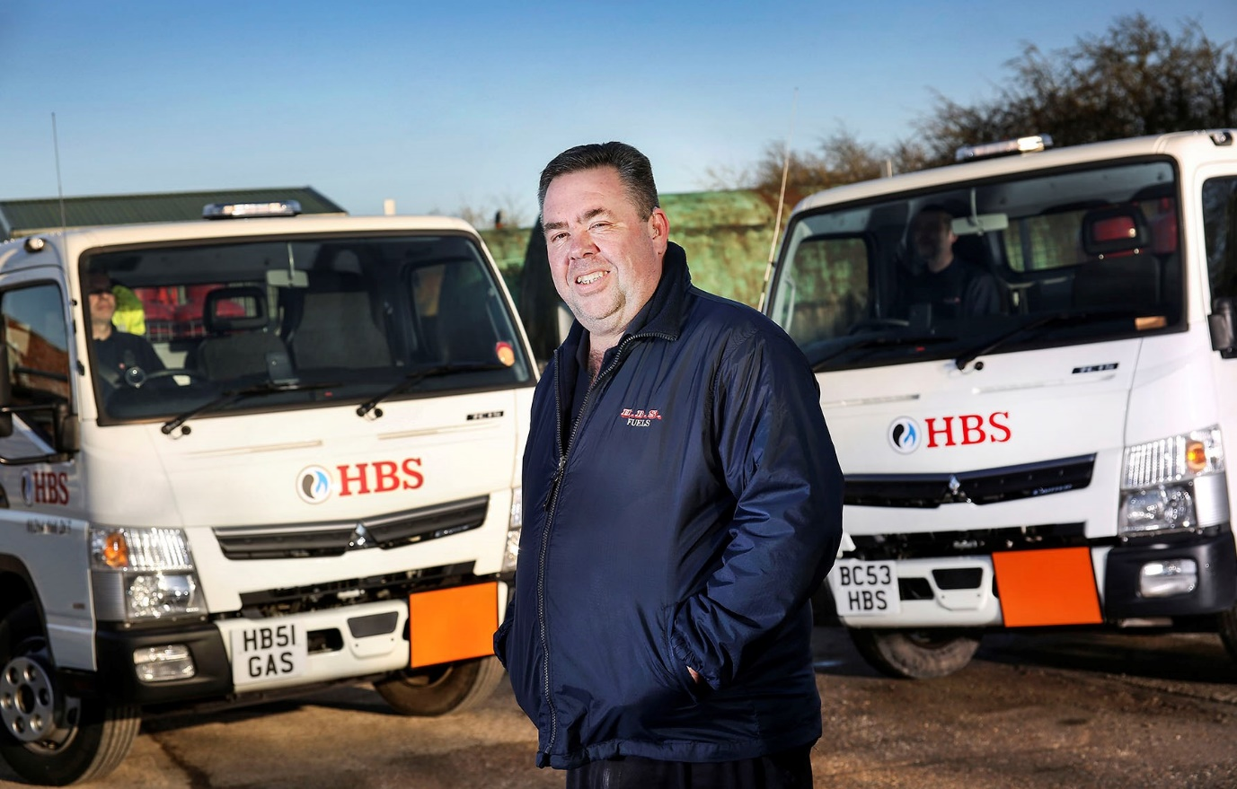

Seeing double: Operations Manager Steve Walker, with HBS Fuels’ latest FUSO Canters

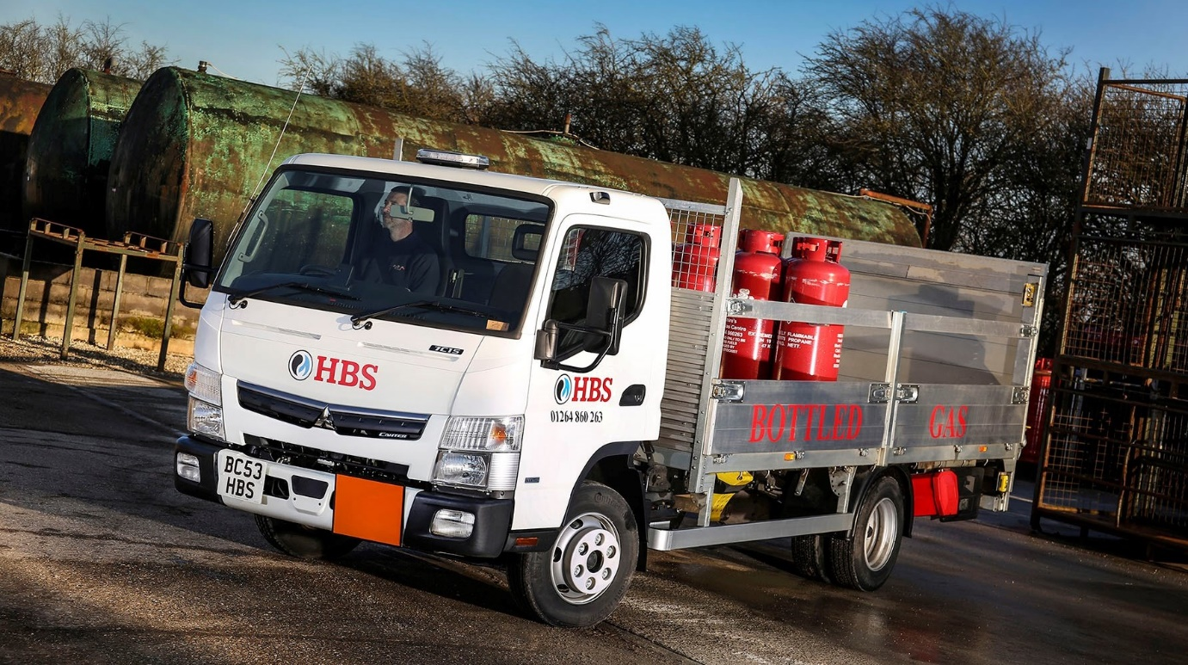

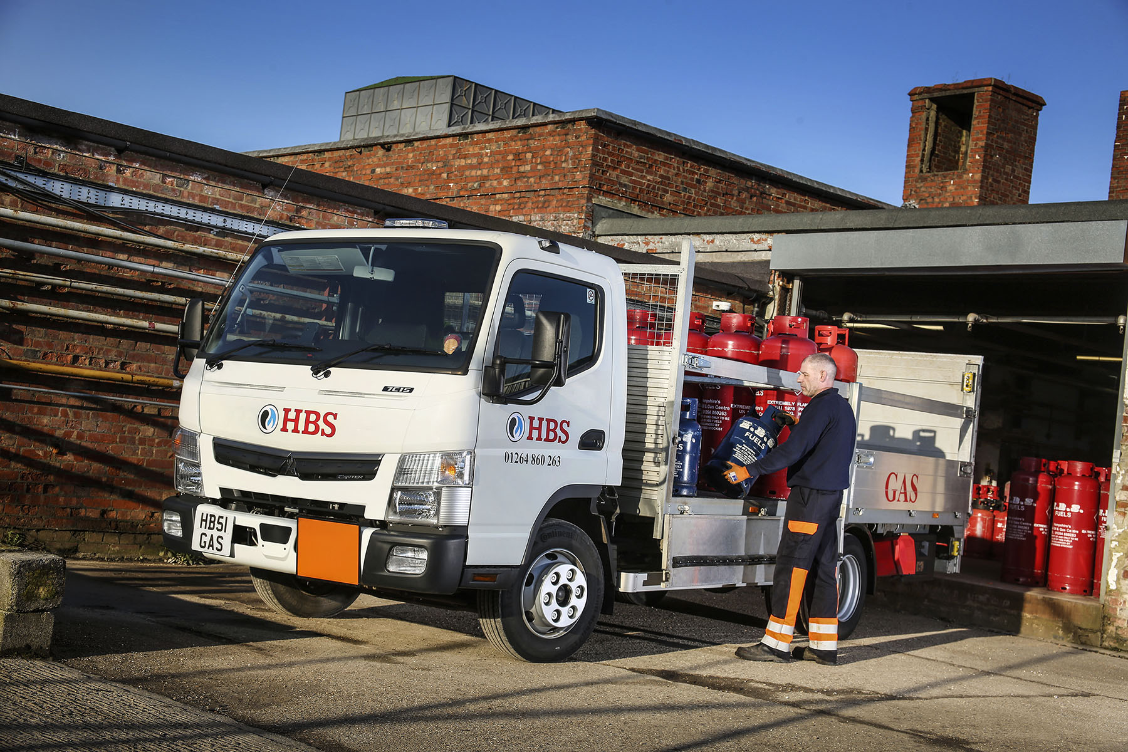

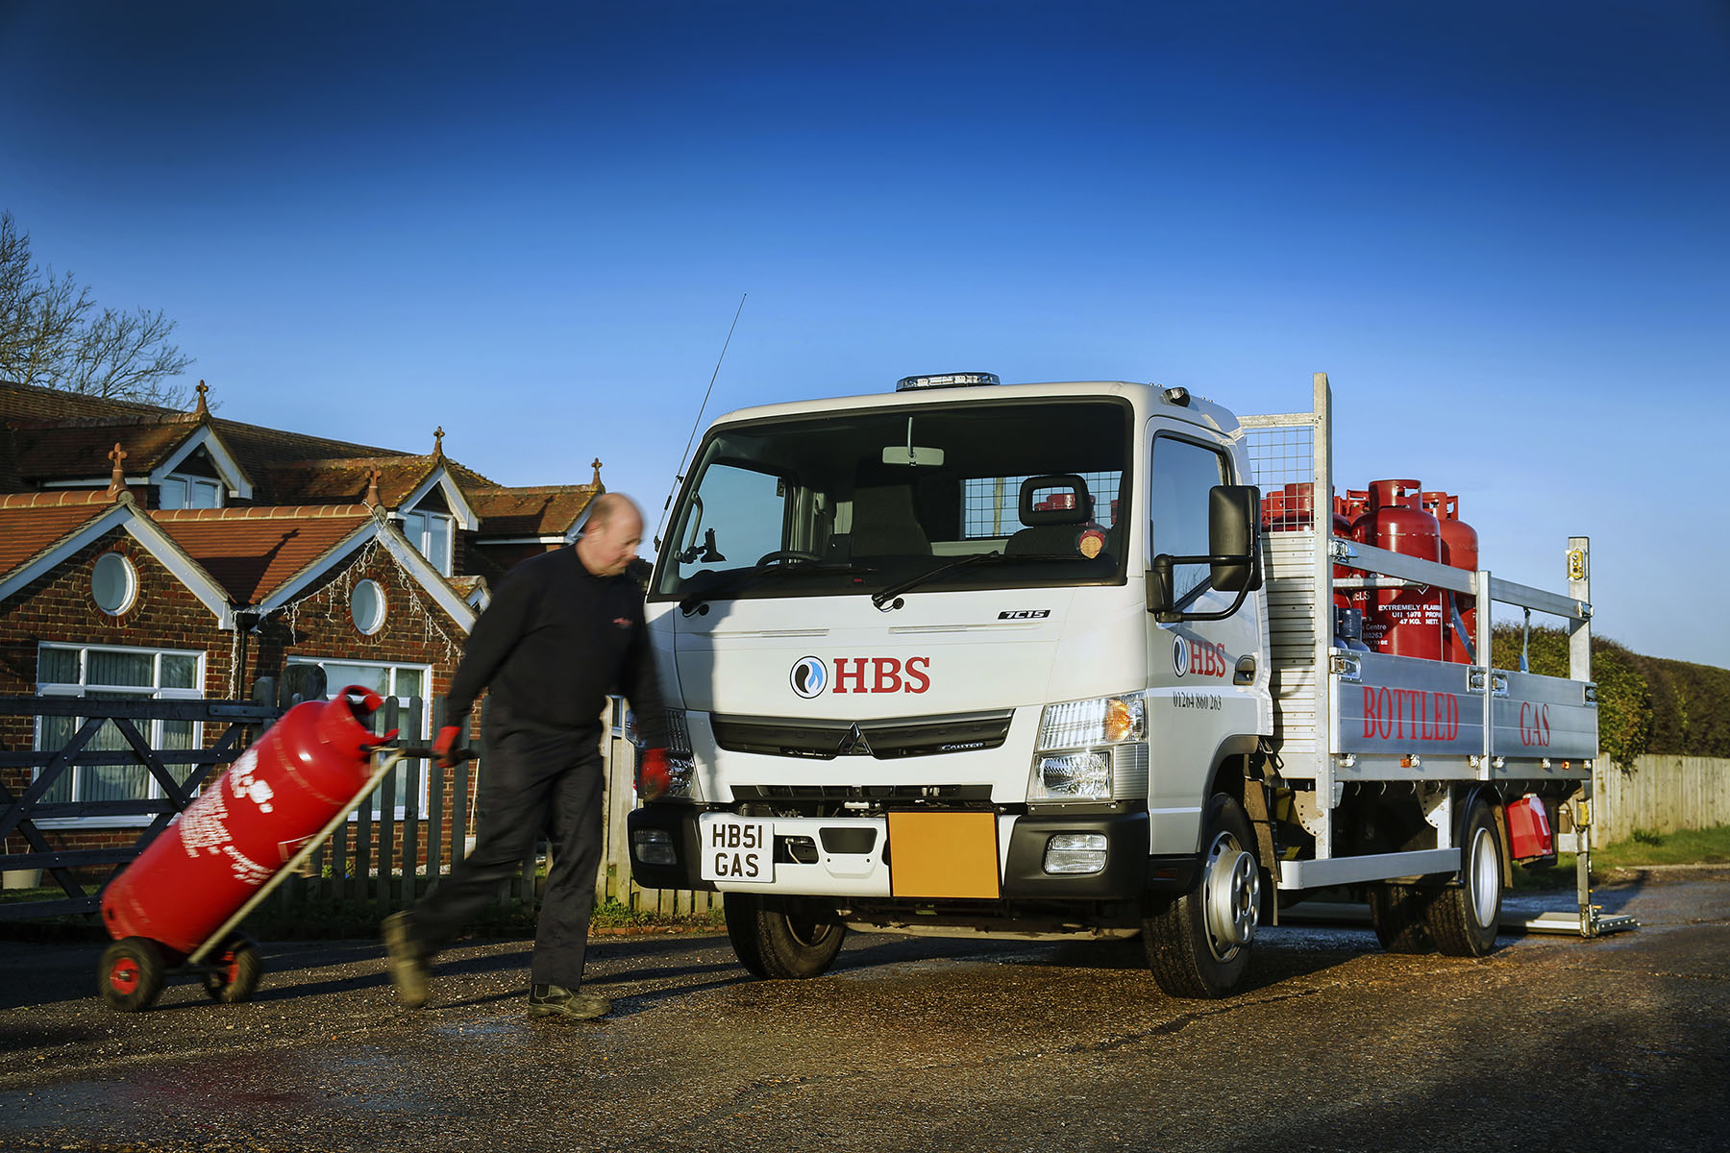

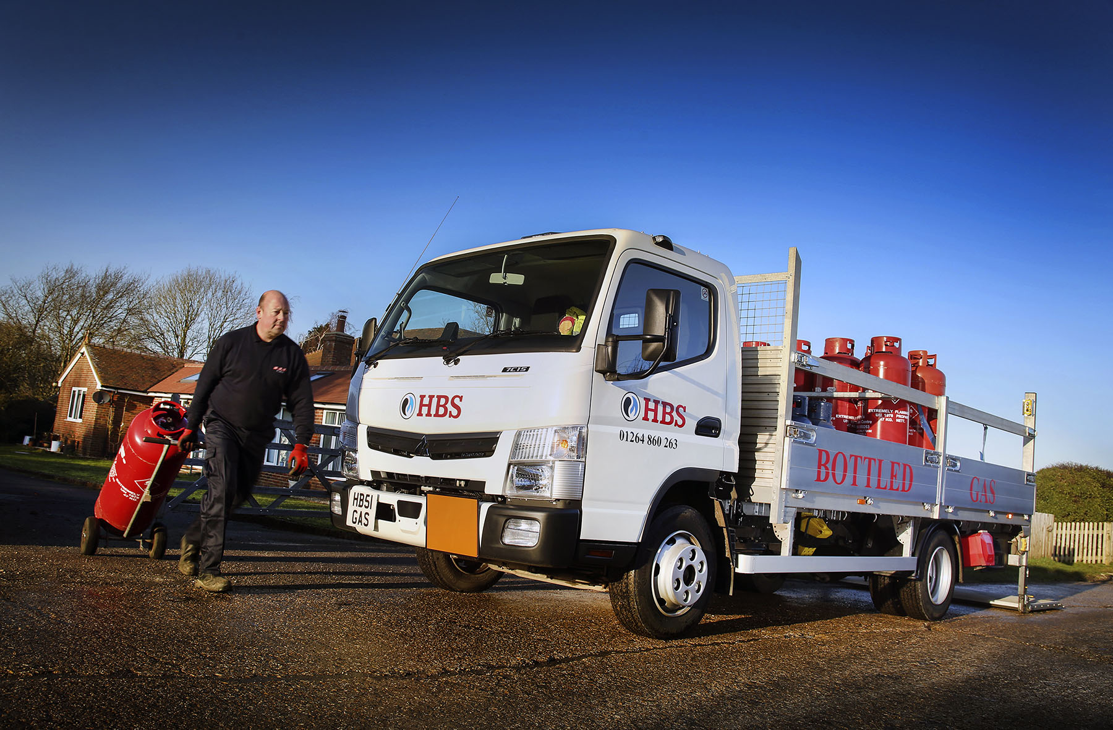

ends

For more information, or to request bigger/higher-res image files, please contact:
Steve Warren or John Ripley
Impact Communications, 01926 842126
Steve: 07770 470251, steve@impactcom.co.uk
John: 07771 484595, john@impactcom.co.uk

