

Date: 30 July 2019

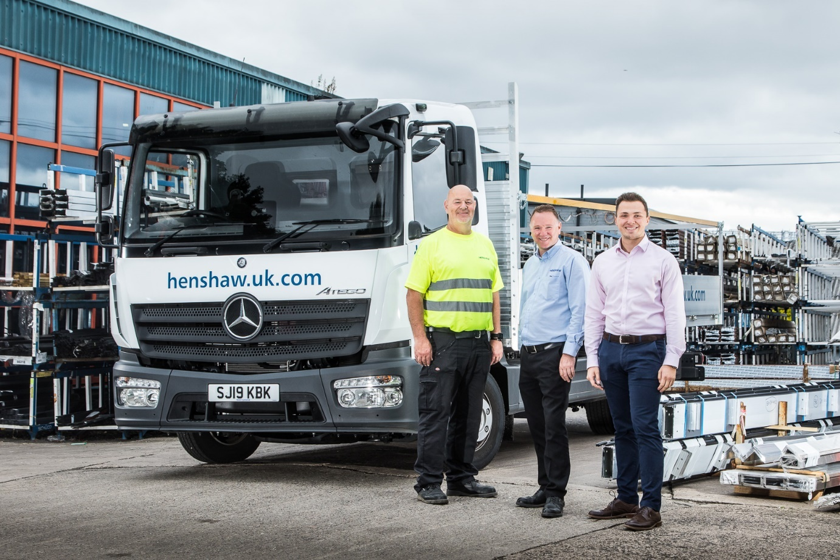

Advancing with Atego: Charles Henshaw & Sons’ James Gallon, centre, with colleague Jeff Ritchie, left, and Joseph Tome of Western Commercial

Façades specialist puts on a smart new front with Mercedes-Benz Atego from Western Commercial

A timely visit by Western Commercial truck sales trainee Joseph Tome was instrumental in convincing Edinburgh-based façades specialist Charles Henshaw & Sons to order its first Mercedes-Benz truck.

The 7.5-tonne Atego has a ClassicSpace S-cab, and is powered by a fuel-efficient 5.1-litre engine which produces 115 kW (156 hp) and is paired with a six-speed Mercedes PowerShift 3 transmission. Supplied from stock, the truck is fitted with a 20ft aluminium dropside body by DPH, of Bathgate.

Henshaw designs, manufactures and installs integrated façade solutions. The company, which was established more than a century ago, provides a range of products including curtain walling and structural bolted glazing for customers across a broad range of commercial, high-end residential, and public sectors.

It had previously been leasing a 7.5-tonne truck, but Production Manager James Gallon and his colleagues were weighing up their options when Joseph called to introduce himself and the Dealer he represents.

“The timing was just right, as the three-year contract on our last vehicle was coming to an end,” recalled Mr Gallon. “We were mulling over what to do about replacing it, and may well have ended up taking out another lease.

“Instead, Joseph made a persuasive case for the benefits of purchasing a vehicle, then backing it with a service contract. The sums certainly added up – outright acquisition should prove a more cost-effective solution over the longer-term.

“We work with internationally-recognised brands, and were also attracted to the reputation of Mercedes-Benz. The three-pointed star’s image of quality and prestige can only reflect positively on our own company in the eyes of our customers.”
The Atego is now working alongside another commercial vehicle that Henshaw operates, delivering products throughout the UK. It will be maintained at Western Commercial’s Broxburn workshop.

Purpose-designed for light- and medium-duty distribution work, the Mercedes-Benz Atego range offers advanced truck technology for the 7.5 to 16 tonnes GVW segment, with outstanding dynamics, comfort, safety and manoeuvrability.

“Our drivers, Jeff Ritchie and Steven Smith, are delighted with the new truck,” confirmed Mr Gallon. “It’s a lot more comfortable than our last, and they are particularly impressed with the automated gearbox, which makes their job so much easier and more enjoyable.

“We have every confidence that the Atego will live up to our expectations in terms of build quality and reliability, and would envisage running this vehicle for six, seven, maybe even eight years.”

Mr Gallon added: “We have high hopes, too, for our new relationship with Mercedes-Benz and Western Commercial. The service from Joseph, in particular, has been first class. He’s handled our enquiry in a very professional manner, answered all our questions, and is a very pleasant individual to deal with.”

Charles Henshaw & Sons’ order was the first that Joseph has won. He joined Western Commercial last autumn, having previously graduated from Edinburgh Napier University with a Financial Services Degree. Joseph is now on the award-winning Mercedes-Benz and FUSO Trucks Sales Trainee Programme, a 25-week course which combines ‘on the job’ learning at Dealerships with formal, block release training at the manufacturer’s headquarters in Milton Keynes.

“It’s a challenging market at the moment so I was really pleased to win my first order before I’d even completed my training, especially given that the customer had never operated a Mercedes-Benz before,” he said.

henshaw.uk.com

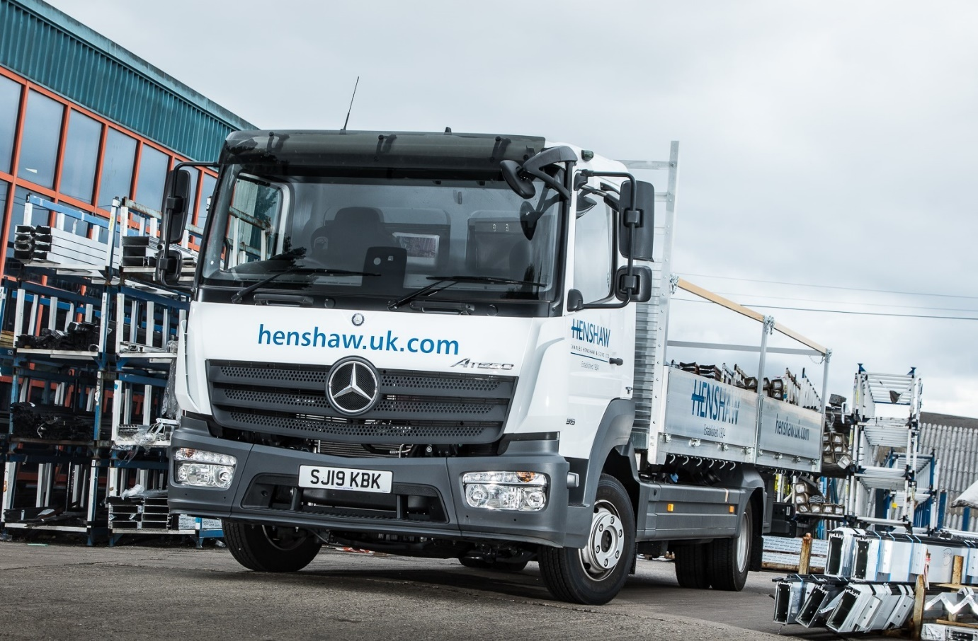

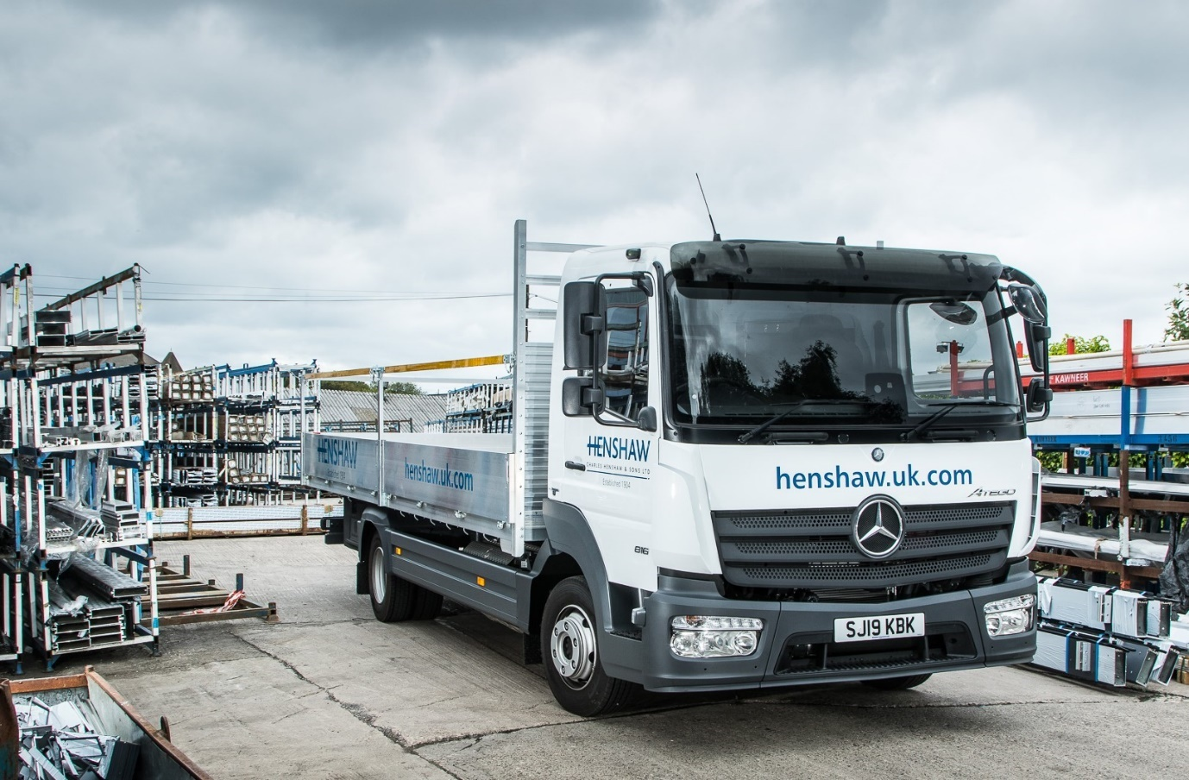

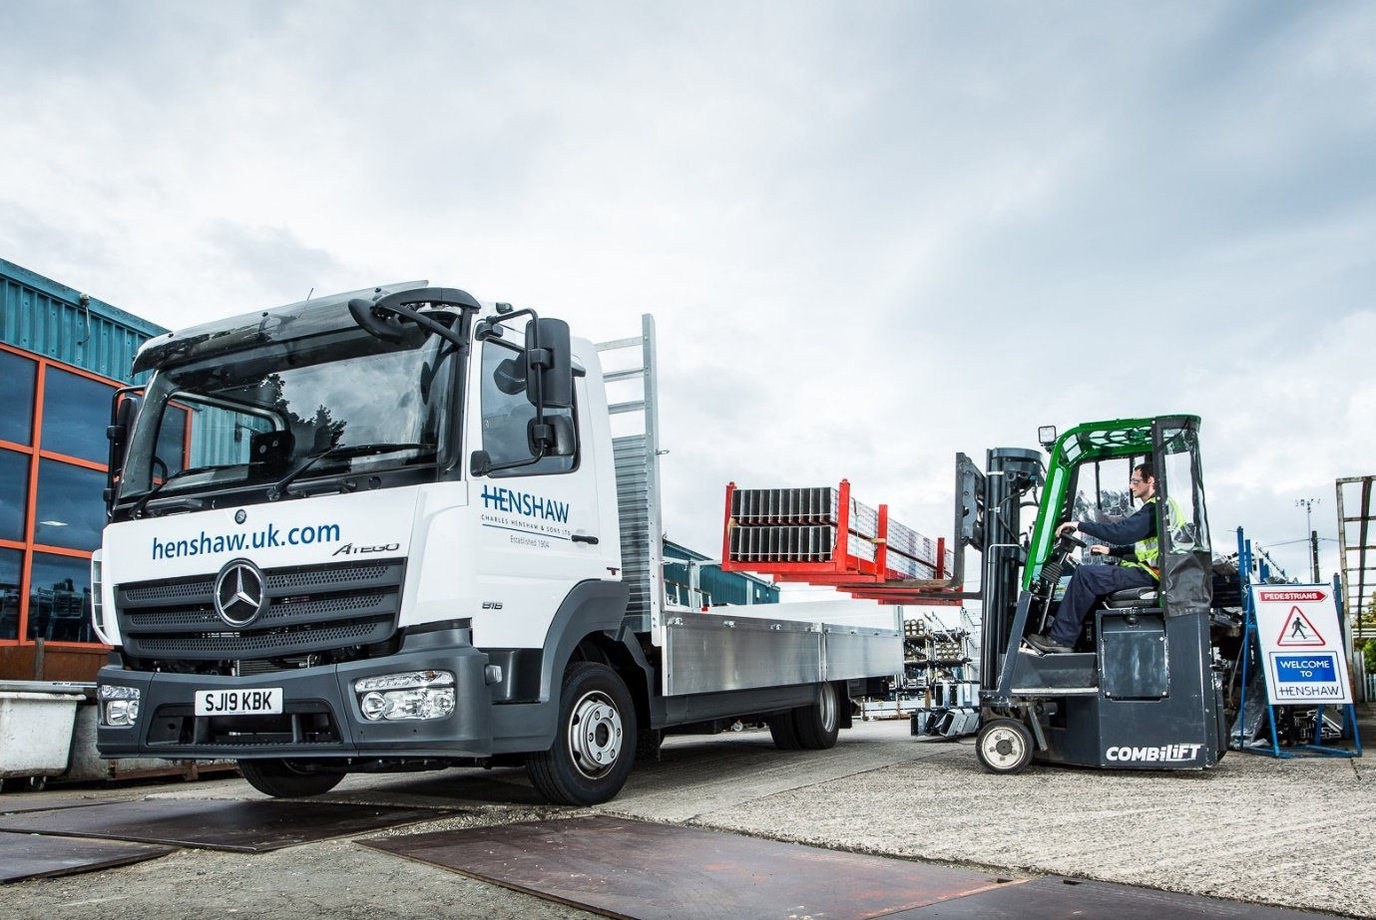

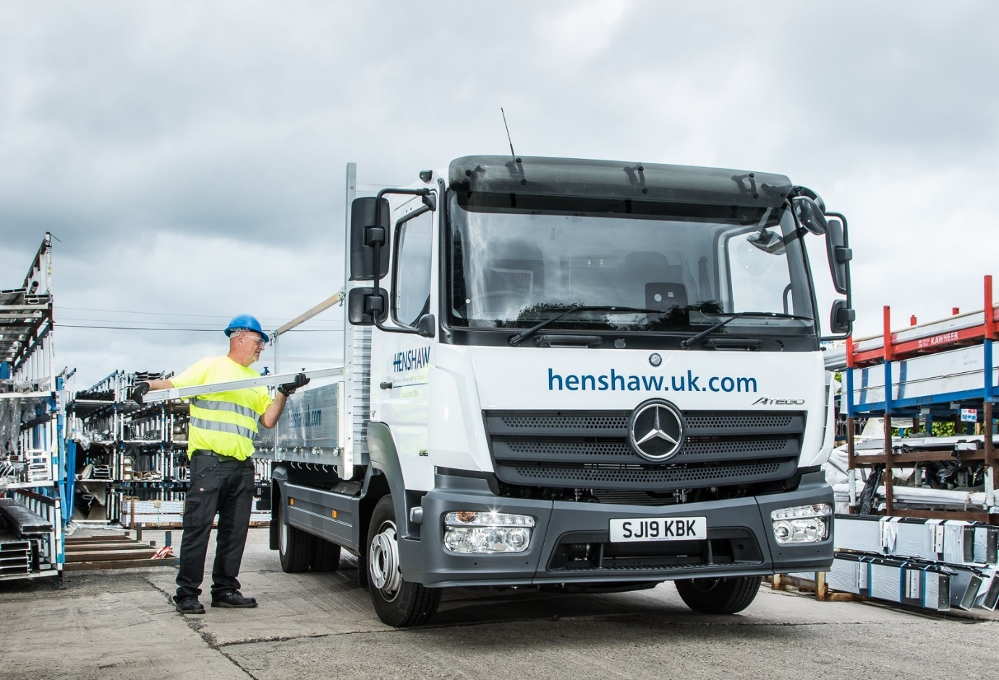

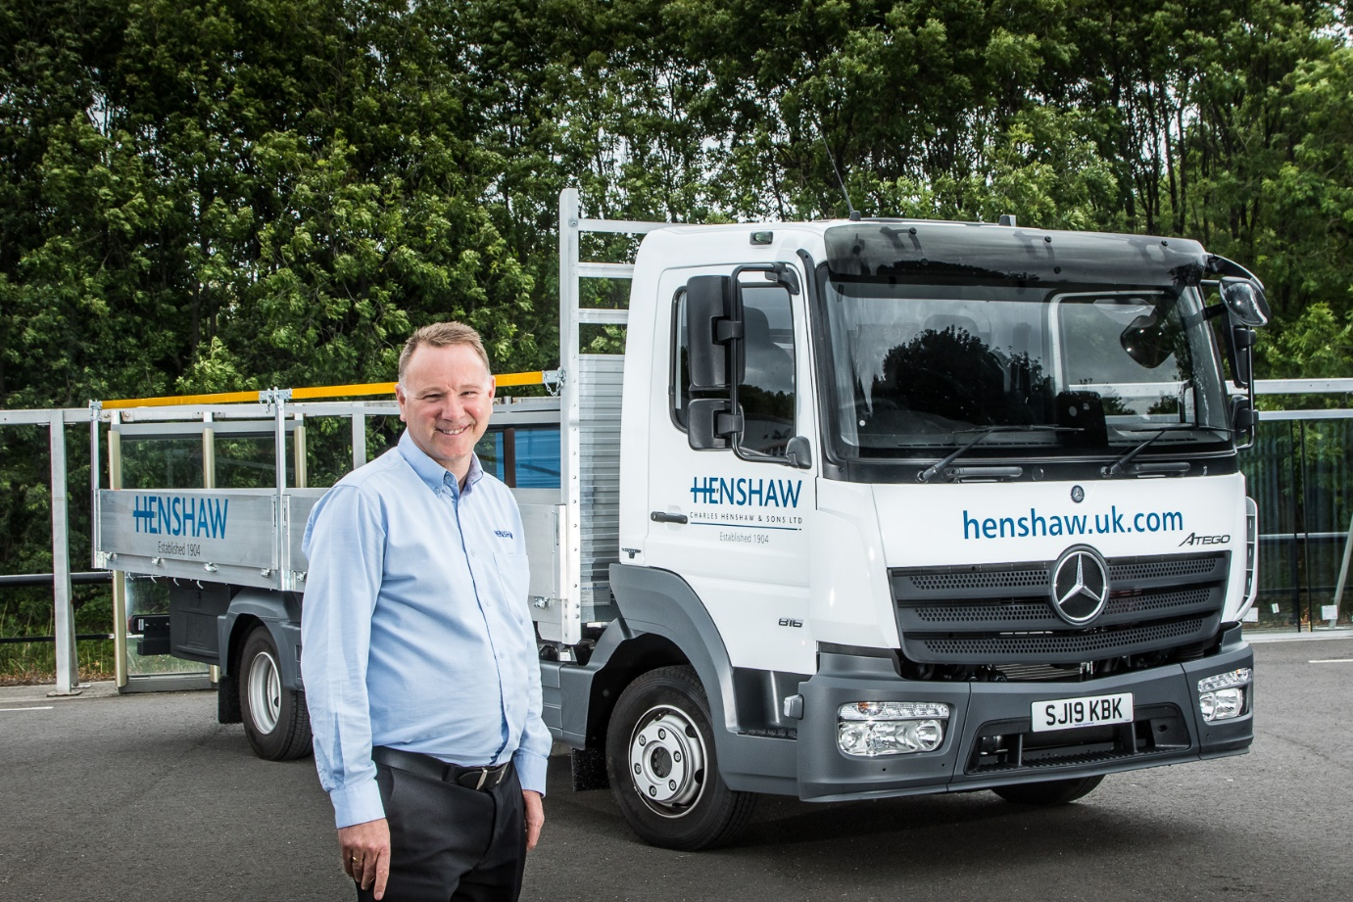

Brand values: James Gallon said the Mercedes-Benz image and reputation for quality and reliability were key factors behind Charles Henshaw & Sons’ decision to invest in the Atego

ends

For more information, or to request bigger/higher-res image files, please contact:
Steve Warren or John Ripley
Impact Communications, 01926 842126
John: 07771 484595, john@impactcom.co.uk
Steve: 07770 470251, steve@impactcom.co.uk

