

Date: 28 June 2019

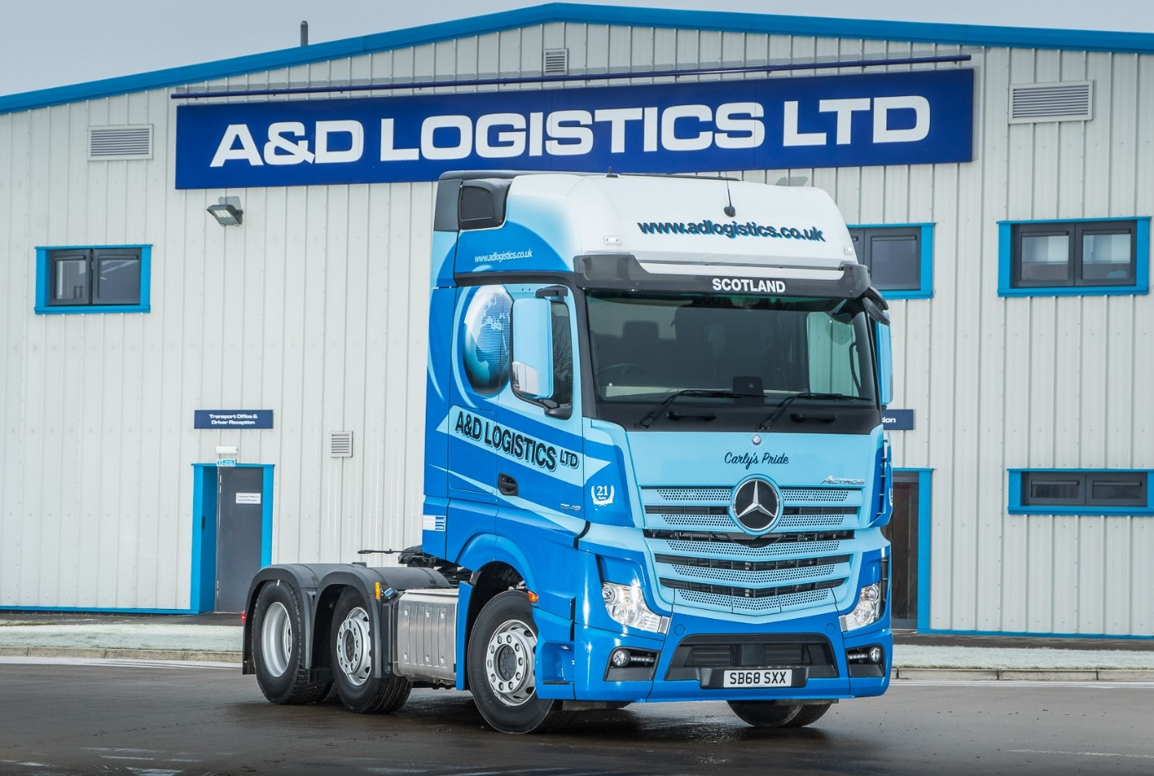
Off to a flying start: A&D Logistics’ Mercedes-Benz Actros was supplied by Western Commercial and has been impressing the operator in the first couple of months of its six-month evaluation

A&D Logistics turns to Western Commercial for extended Mercedes-Benz Actros evaluation

The first Mercedes-Benz truck to wear the colours of high-profile container haulier A&D Logistics has been quick to impress with its combination of fuel-efficiency and driver comfort.

The Actros 2548 ‘seed vehicle’ is being put to the test against similarly specified tractor units by two other manufacturers over six months. Supplied by Dealer Western Commercial, it has a range-topping GigaSpace cab, and is powered by a second-generation 12.8-litre straight-six engine producing 350 kW (476 hp).

A&D Logistics is based in Linwood, Renfrewshire. Its fleet of more than 90 tractor units is dominated by a Swedish brand, which has held sway for two decades. However, the operator is now reviewing its established truck acquisition policy, which explains why it has embarked on the evaluation exercise.

Former driver Eric MacLeod, who rejoined the company last summer as its Head of Driver Training & Recruitment, has played a key role in initiating the trial. He confirmed: “Mercedes-Benz and Western Commercial are definitely on the front foot at the moment.

“The Actros is extremely competitive on fuel. You wouldn’t normally start to see good mpg figures until a truck had properly loosened up, but that vehicle was hitting the 10s from brand new, which is very encouraging.”
The new Mercedes-Benz is being double-shifted, and has won a resounding ‘thumbs up’ from day driver Kieran McLafferty, whose brother Mark is piloting one of the other contenders. “Kieran is very pleased with the Actros, which he describes as a great all-rounder,” reported Mr MacLeod. “It’s very nice to drive, while the GigaSpace cab is exceptionally spacious and well appointed.”

The company, which moved to its £3.5-million headquarters in 2017, has high hopes for its new partnership with Western Commercial. It has history with the Dealer. “We ran an Actros Fuel Challenger for a fortnight last year, and it also did very well in terms of mpg returns,” recalled Mr MacLeod. “On the basis of this experience, Mercedes-Benz was always going to be on our shortlist for the extended evaluation we’re carrying out at the moment.”
He added: “Economy and driver acceptability are all well and good, of course, but it’s even more important to know that the back-up is going to be there when we need it. Western Commercial’s Govan workshop is conveniently located for us, and its Service Manager Brian Cooper is very approachable.

“A&D Logistics enjoys an excellent reputation within the transport community in this part of the world, and the Dealer certainly seems to have grasped the scale of the opportunity here. Whether it’s the driver training that we’ve received, or the way in which the inspections and maintenance have been carried out, I can’t fault the service.”

Eric MacLeod’s positive comments were echoed by Alan Bolsworth, co-Director of A&D Logistics with his brother Drew. Mr Bolsworth was a guest of Western Commercial at a recent Mercedes-Benz Trucks event in Barcelona, where the manufacturer presented the next-generation Actros, which reaches the UK later this year.

“It was a very interesting and useful experience,” said Mr Bolsworth. “Some of the new technology we were shown – like Active Drive Assist, and MirrorCam – was quite amazing, while the Multimedia Cockpit was also highly impressive. We were well looked after by Mercedes-Benz, and it’s fair to say that our own Actros trial is going very well indeed.”
adlogistics.co.uk

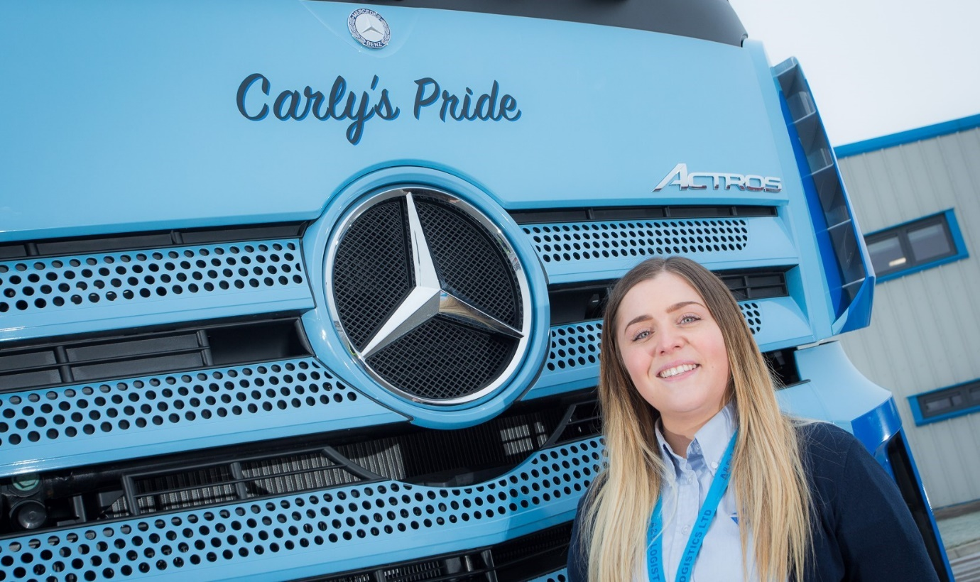

Carly’s Pride: In line with the operator’s established policy, A&D Logistics’ Actros bears the name of a member of its team. Senior Administrator Carly McDonald, who joined A&D in 2015, said: “I’m very proud to have my name on the front of a Mercedes-Benz”

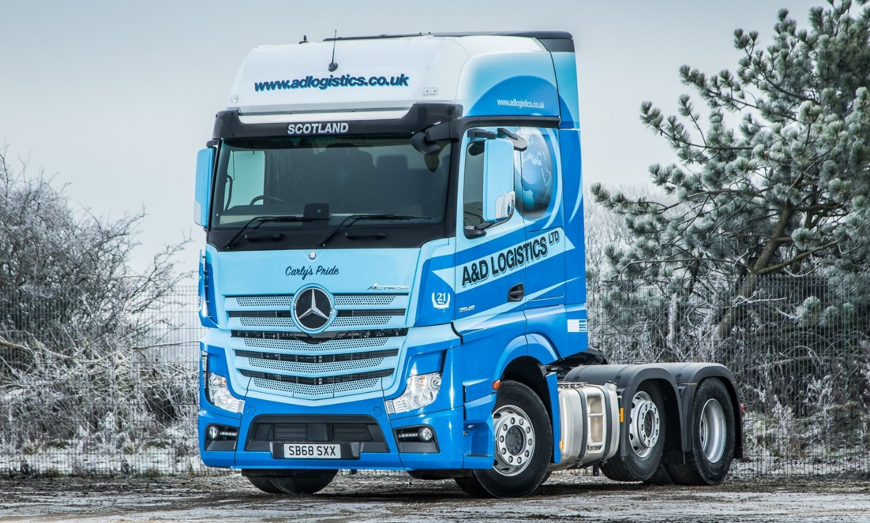
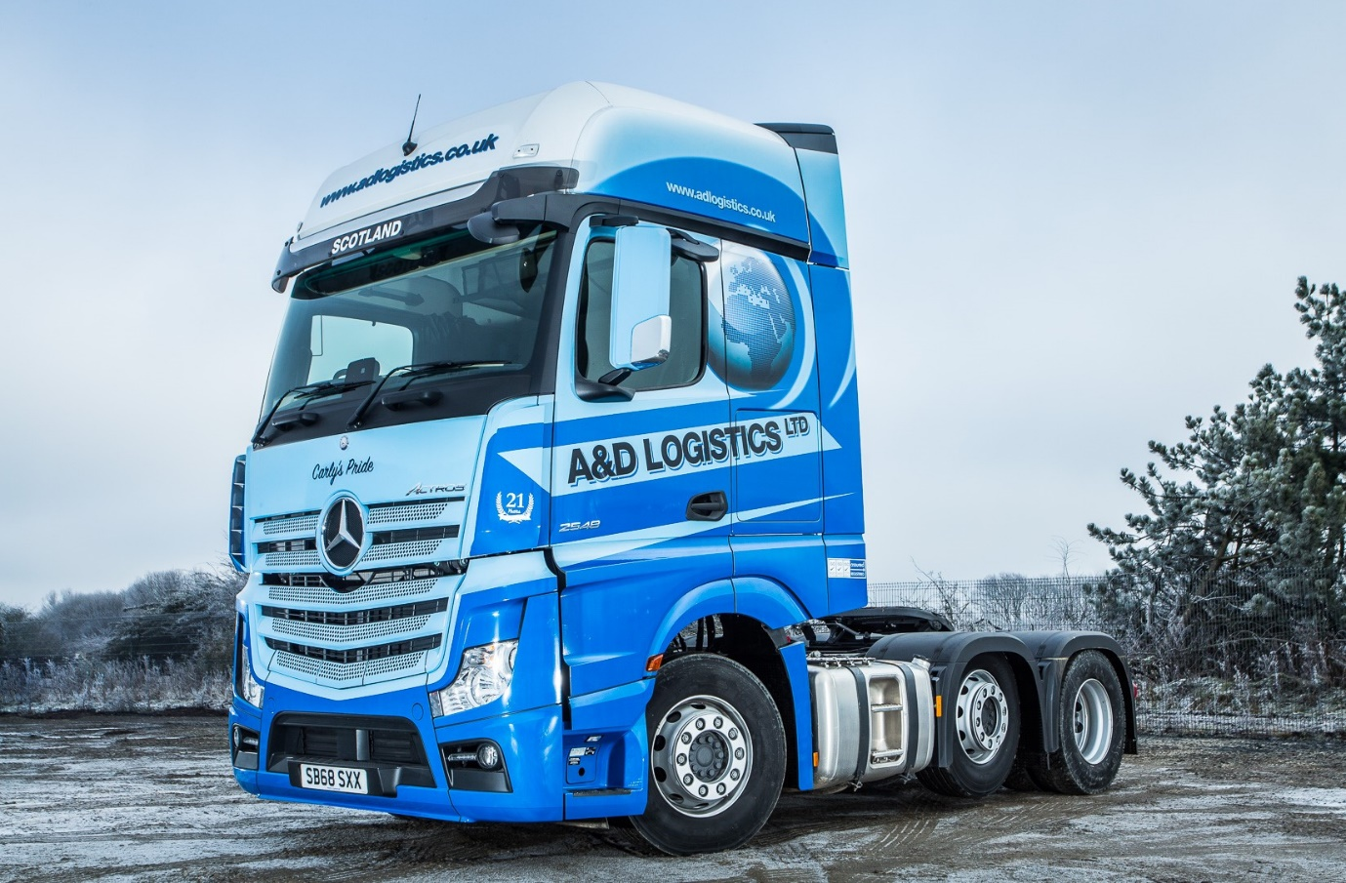

ends

For more information, or to request bigger/higher-res image files, please contact:
Steve Warren or John Ripley
Impact Communications, 01926 842126
John: 07771 484595, john@impactcom.co.uk
Steve: 07770 470251, steve@impactcom.co.uk

