

Date: 27 October 2021

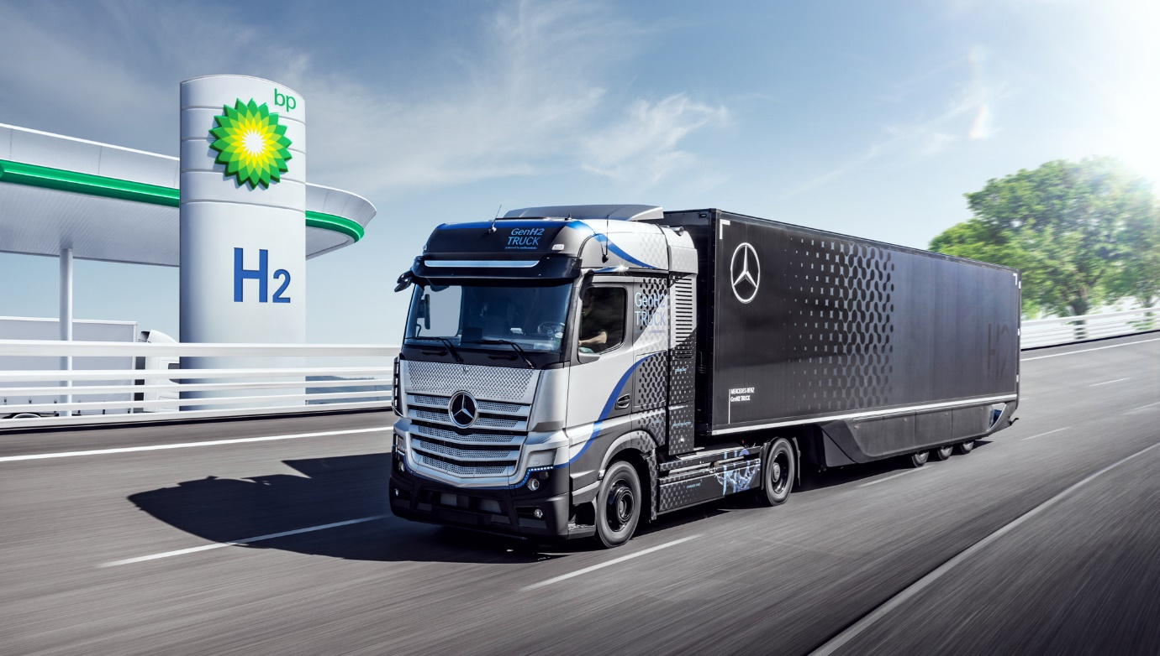

Trials underway: Daimler Truck is now testing an enhanced prototype of its Mercedes-Benz GenH2 Truck on public roads in Germany

Daimler Truck AG and BP to pioneer deployment of hydrogen infrastructure, supporting the decarbonization of UK freight transport

Stuttgart / Sunbury – Daimler Truck AG and BP Advanced Mobility Limited („BP“) today announced plans to work together to help accelerate the introduction of a hydrogen network, supporting the roll-out of a key technology for the decarbonization of UK freight transport. They intend to pilot both the development of hydrogen infrastructure and the introduction of hydrogen-powered fuel-cell trucks in the UK. Under their memorandum of understanding (MoU), BP expects to initially design, construct, operate and supply a network of up to 25 hydrogen truck refuelling stations across the UK by 2030. BP would supply these stations with ‘green’ hydrogen – generated from water using renewable power. Complementing this, Daimler Truck expects to deliver hydrogen-powered fuel-cell trucks to its UK customers from 2025.

Karin Rådström, CEO of Mercedes-Benz Trucks and Member of the Board of Management at Daimler Truck, said: “We are consistently pursuing our vision of CO₂-neutral transport. Especially for CO₂-neutral long-haul road transportation, the hydrogen-powered fuel-cell drive will become indispensable in the future. Together with BP, we want to jointly develop and scale the required hydrogen infrastructure by putting our hydrogen-powered fuel-cell trucks into our customers’ hands and thus supporting the decarbonization of the UK freight network. At the same time, political support plays an important role in promoting the creation of an infrastructure for green hydrogen and making an economically viable use of fuel-cell trucks possible for our customers.”

Emma Delaney, BP’s executive vice president for customer and products, said: “Hydrogen is critical to decarbonizing hard-to-abate sectors – and for heavy and long-distance freight it is sometimes the only answer. Working with a leading manufacturer like Daimler Truck, we can accelerate the deployment of both vehicles and infrastructure and pioneer the use of hydrogen to fuel the next generation of UK freight. From producing and supplying hydrogen through to building and operating the fuelling stations, BP is perfectly positioned to transform transport and ultimately build a better energy future.”

Daimler Truck has the ambition to offer only new vehicles that are CO₂-neutral in driving operation (“from tank to wheel”) in Europe, North America and Japan by 2039. The company is focused on both CO₂-neutral technologies, battery power and hydrogen-based fuel-cells. Currently, the truck manufacturer is testing a new enhanced prototype of its Mercedes-Benz GenH2 Truck on public roads in Germany. The first series-produced GenH2 Truck are expected to be handed over to customers starting in 2027. Daimler Truck has a clear preference for liquid hydrogen. In this state, the energy carrier has a far higher energy density in relation to volume than gaseous hydrogen. As a result, the tanks of a fuel-cell truck using liquid hydrogen are much smaller and, due to the lower pressure, significantly lighter. This gives the trucks more cargo space and a higher payload. At the same time, more hydrogen can be carried, which significantly increases the trucks’ range. This will make the series version of the GenH2 Truck, like conventional diesel trucks, suitable for multi-day, difficult-to-plan long-haul transport and where the daily energy output is high.

Convenience and mobility are core for BP’s strategy, including working with partners, to help deliver the future of mobility and services for customers. BP already has 11,000 electric vehicle charging points globally and is expanding its network to 70,000 by 2030. Complementing this today’s agreement represents BP’s first steps towards deploying hydrogen for transport. It also intends to develop hydrogen refuelling stations in Europe and already has plans for hydrogen refuelling stations in Germany.

BP aims to develop a leading market position producing and supplying low-carbon hydrogen. In the UK, BP has plans to build a hydrogen-producing facility in Teesside, which could produce 1GW of blue hydrogen, produced from natural gas integrated with carbon capture and storage. BP is also exploring the potential for green hydrogen in the region, including supporting the development of Teesside as the UK’s first hydrogen transport hub. These activities support the UK government’s target of developing 5GW of hydrogen production by 2030.

ends

Contact:

Florian Laudan, +49 711 17-4 15 26, florian.laudan@daimler.com
Alexandros Mitropoulos, +49 176 30 996021, alexandros.mitropoulos@daimler.com

BP press office London: bppress@bp.com, Tel: +44 (0) 207-496-4076 or +44 7919 217511

Further information on Daimler Truck is available at:
www.media.daimler.com and www.daimler-truck.com

Forward-looking statements:
This document contains forward-looking statements that reflect our current views about future events. The words “anticipate,” “assume,” “believe,” “estimate,” “expect,” “intend,” “may,” ”can,” “could,” “plan,” “project,” “should” and similar expressions are used to identify forward-looking statements. These statements are subject to many risks and uncertainties, including an adverse development of global economic conditions, in particular a decline of demand in our most important markets; a deterioration of our refinancing possibilities on the credit and financial markets; events of force majeure including natural disasters, pandemics, acts of terrorism, political unrest, armed conflicts, industrial accidents and their effects on our sales, purchasing, production or financial services activities; changes in currency exchange rates, customs and foreign trade provisions; a shift in consumer preferences towards smaller, lower-margin vehicles; a possible lack of acceptance of our products or services which limits our ability to achieve prices and adequately utilize our production capacities; price increases for fuel or raw materials; disruption of production due to shortages of materials, labor strikes or supplier insolvencies; a decline in resale prices of used vehicles; the effective implementation of cost-reduction and efficiency-optimization measures; the business outlook for companies in which we hold a significant equity interest; the successful implementation of strategic cooperations and joint ventures; changes in laws, regulations and government policies, particularly those relating to vehicle emissions, fuel economy and safety; the resolution of pending government investigations or of investigations requested by governments and the conclusion of pending or threatened future legal proceedings; and other risks and uncertainties, some of which are described under the heading “Risk and Opportunity Report” in this Annual Report. If any of these risks and uncertainties materializes or if the assumptions underlying any of our forward-looking statements prove to be incorrect, the actual results may be materially different from those we express or imply by such statements. We do not intend or assume any obligation to update these forward-looking statements since they are based solely on the circumstances at the date of publication.

Daimler Truck at a Glance
The Daimler Truck AG is one of the worldʼs largest commercial vehicle manufacturers, with more than 35 primary locations around the world and approximately 100,000 employees. The company brings together seven vehicle brands under one roof: Mercedes-Benz (light, medium and heavy trucks as well as city, intercity and touring coaches) and Setra (intercity, long-distance and premium coaches) are our traditional European brands; our U.S. brands Freightliner Trucks (trucks in weight classes 5 to 8 for a wide range of commercial vehicle applications), Western Star (heavy trucks for specialized and long-haul transports) and Thomas Built Buses (light to medium-duty buses); and our Asian brands Bharat Benz, based in Chennai, India (trucks in the weight classes 10 to 55 t and medium and heavy-duty buses) and FUSO with its headquarters in Japan (trucks and buses for Asia, the Middle East, Africa, Europe and Latin America). This allows the Daimler Truck AG to offer its customers around the globe a broad spectrum of commercial vehicles, ranging from minibuses to heavy-duty trucks for special-purpose transport applications – in short: products and solutions for everyone who keeps the world moving. Gottlieb Daimler and Carl Benz laid the foundation for the modern transport industry 125 years ago. Over the past decades, Daimlerʼs truck and bus divisions have consistently set standards for the entire transportation industry – in terms of safety, fuel efficiency and driver and passenger comfort. It is now time for the next evolutionary step: emission-free, automated and connected driving. Daimler Trucks & Buses is working to bring these important technologies to high-volume series production, across brands, divisions and regions. In this way the company intends to take a major step closer to realizing its vision of CO2-neutral transport and accident-free driving whilst also contributing to the sustainability of global goods and passenger transport. In 2020, a total of 378,500 trucks and buses were delivered. In 2020 the revenue of the individual areas of business amounted to € 35 billion for the Daimler Truck AG. The adjusted EBIT was € 678 million for the Daimler Truck AG.

