

Date: 6 October 2022

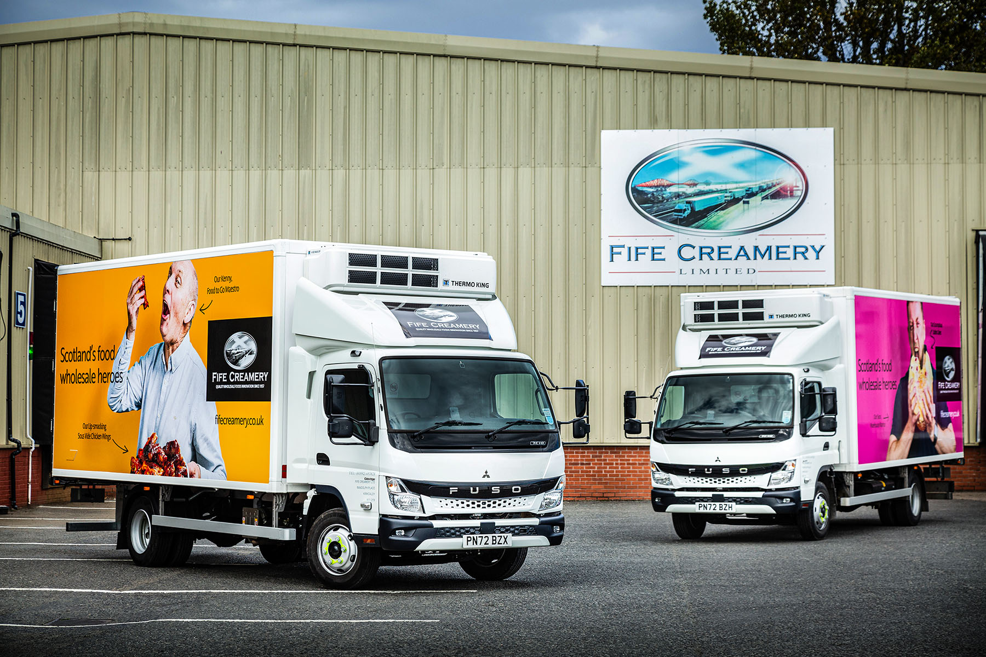

Fife Creamery presents a strikingly fresh face with 30 all-new FUSO Canters from Ciceley Commercials

The first vehicles to wear the eye-catching new liveries of leading food wholesaler Fife Creamery are also among the first from the latest FUSO Canter range to enter service in Scotland.

The family-run firm has ordered a fleet of 30 all-new Canter 7.5-tonners from Ciceley Commercials, as well as a couple of 18-tonne Mercedes-Benz Actros – like other members of the German manufacturer’s UK Dealer network, Ciceley also sells and supports the popular FUSO light truck range.

Most of Fife Creamery’s new Canters are already on the road. They deliver chilled, frozen and speciality ambient products to a broad customer base that includes independent sandwich bars, butcher’s shops, local convenience stores and large retail chains, as well as restaurants and hotels, universities and colleges, hospitals and other publicly-owned institutions.

The operator favours the FUSO for its industry-leading payload allowance and impressive fuel-efficiency, as well as the compact dimensions and agility that make it ideally suited to multi-drop delivery work in town and city centres.

The Canter also comes with a three-year, unlimited mileage warranty but, as previously, Fife Creamery has taken out additional ExtendPlus cover that provides a further two years’ peace of mind.

Its latest examples are easily distinguished from their predecessors by their redesigned cab, which features a striking new ‘face’. The new Canter is more comfortable than the version it replaces, thanks in part to the improved insulation that reduces in-cab noise, while reinforced rear underrun protection minimises the impact in the event of an accident.

A newly developed, compact exhaust system means the new model also meets the EURO VI – STEP E emission standard. As 7C18 variants, Fife Creamery’s trucks employ 3.0-litre common-rail powerplants that generate range-topping outputs of 129 kW (175 hp) and up to 430 Nm of torque, and drive through smooth-shifting DUONIC dual-clutch automated manual transmissions with Eco Mode, Parking and Creep functions.

Long-standing supplier Gray & Adams builds and fits the Canters’ dual-compartment, insulated bodywork at its Dunfermline manufacturing facility, where it also installs the powerful, dual-temperature Thermo King V-800 Series refrigeration units. Designed for fresh, frozen and deep frozen truck applications, the eco-friendly V-800 incorporates a road compressor which is powered by the vehicle’s engine, and a stand-by compressor that employs an electric motor.

Fife Creamery was established by John Simpson Snr in 1957, to supply fresh butter. Today, with his grandson Graeme at the helm as Managing Director, the company continues to forge ahead strongly – its expansion into frozen food services followed a £1.65-million investment last year in a new frozen cold store with capacity for up to 1,000 pallets.

Fife Creamery’s new branding features striking, ‘cut-out’ images of individual colleagues employed in a variety of roles, presented against brightly-coloured backgrounds on the sides of the trucks. It reflects Fife Creamery’s well-earned reputation as a ‘proper people business’.

Sales Director Steve Appolinari explained: “The campaign seeks to celebrate and acknowledge the vital contribution our food wholesale heroes make to our success, while highlighting the diverse and quality-driven range of food products we are proud to represent in the Scottish market.”

Fife Creamery purchased its first FUSO Canters in 2014. These are now being stood down, along with a number of Mercedes-Benz Atego 7.5-tonners from 2012 and 2013, although the company continues to operate nine Canters from 2019-20.

The fleet also includes five 18-tonne Actros – a sixth is on order – that pull drawbar trailers and are allocated to more distant runs, or those involving particularly high volumes.

Logistics Manager Richard Wishart commented: “The Canter is not a long-haul truck but it’s excellent for the kind of intensive delivery work that we undertake in busy urban centres such as Edinburgh, Glasgow and Aberdeen.

“Despite the fridge body, and with a driver and full tanks of fuel and AdBlue also factored in, ours will still take a 3.0-tonne payload – that’s almost a tonne more than you’d get on a conventional 7.5-tonner. At 18 miles per gallon, the Canter is also comfortably ahead in terms of fuel economy, and this contributes to its overall cost-effectiveness.

“We work these vehicles hard,” he continued. “Each will typically clock-up 70,000 miles a year, so the fact that the Canter is backed by Mercedes-Benz, and we can get a full five years’ warranty cover, is another important plus.”

This is also the first time that Fife Creamery has purchased vehicles from Ciceley Commercials. “The new Canter looks smarter and more modern than the outgoing model,” observed Mr Wishart, “while the Dealer’s FUSO Sales Executive Simon Fletcher has kept us up to date as regards production and delivery schedules, and provided an excellent service throughout.”

fifecreamery.co.uk

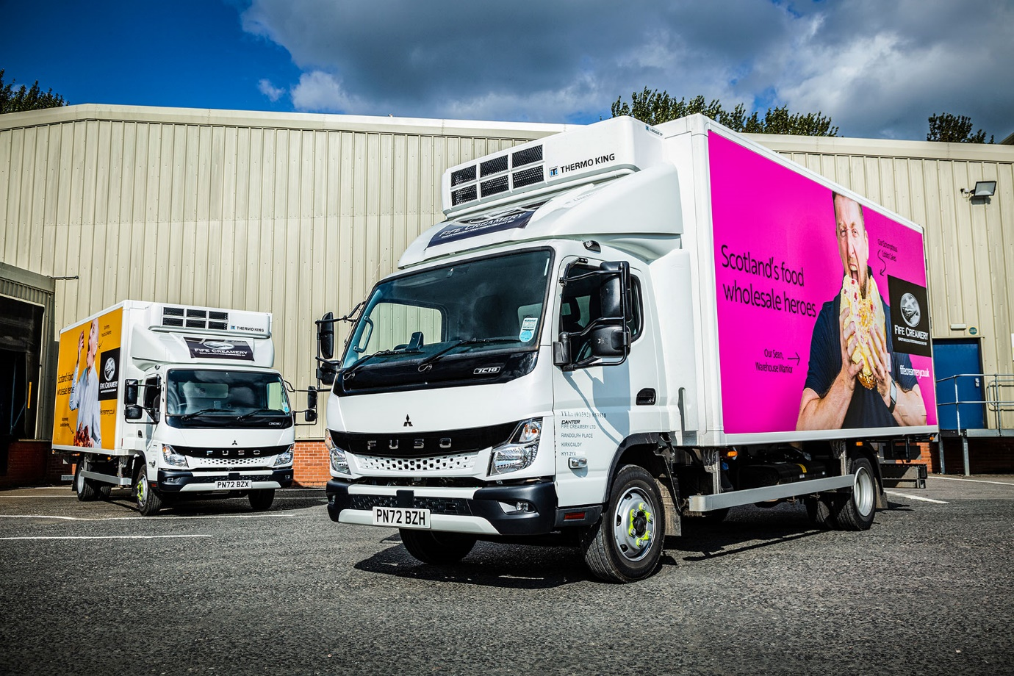

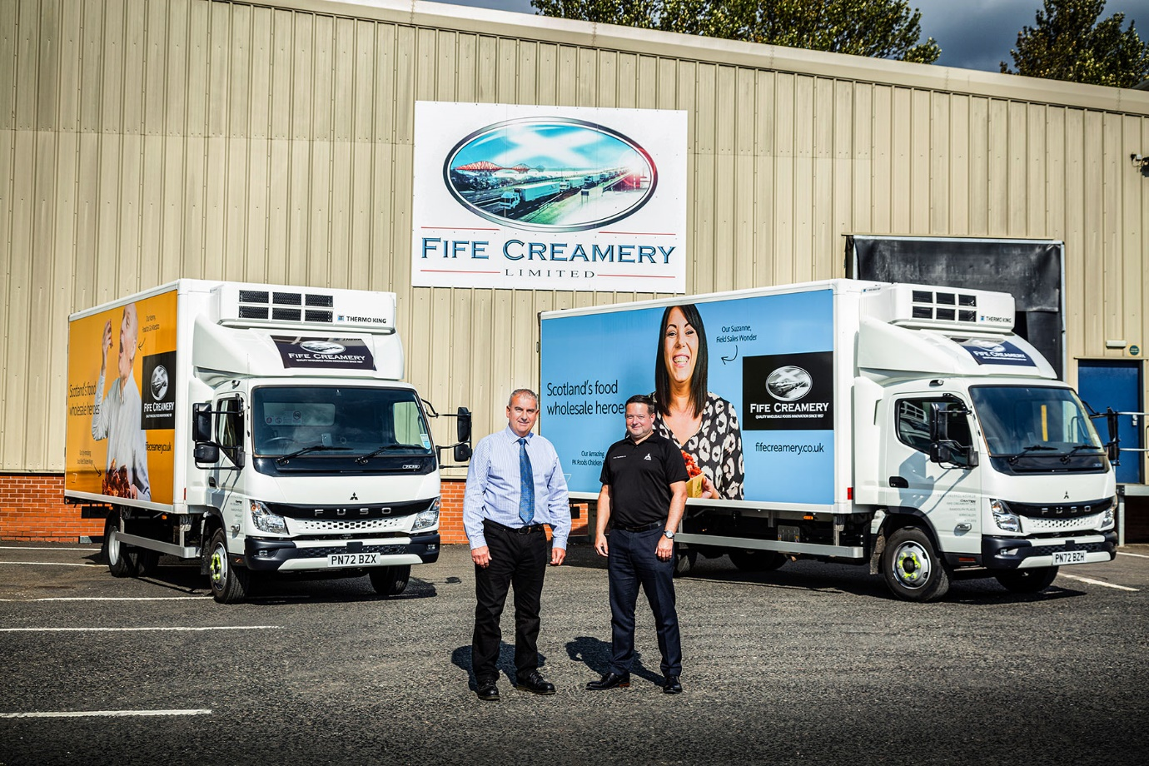

Promising partnership: Fife Creamery Logistics Manager Richard Wishart is pictured with Ciceley Commercials FUSO Sales Executive Simon Fletcher

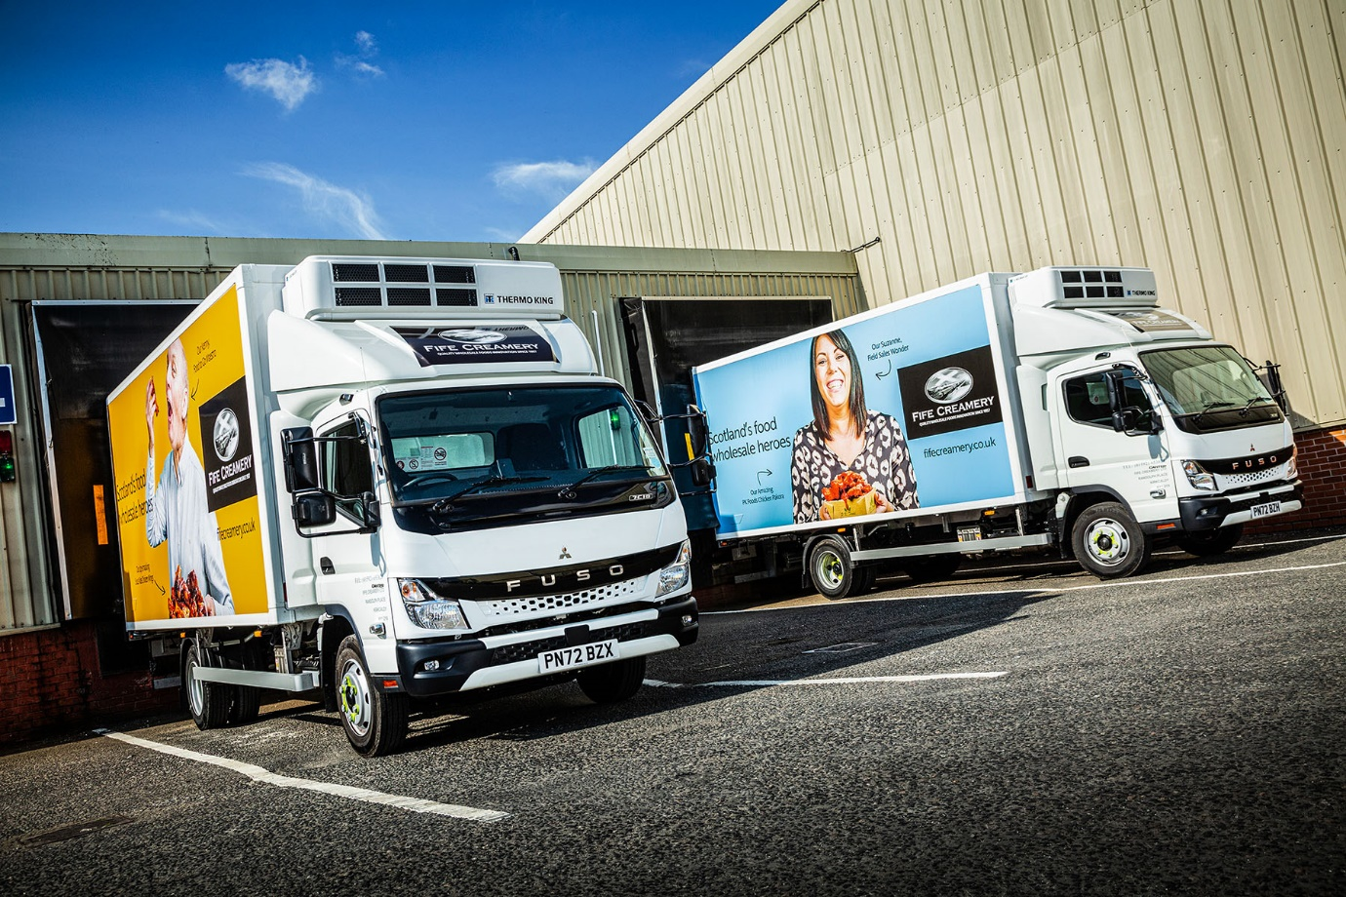

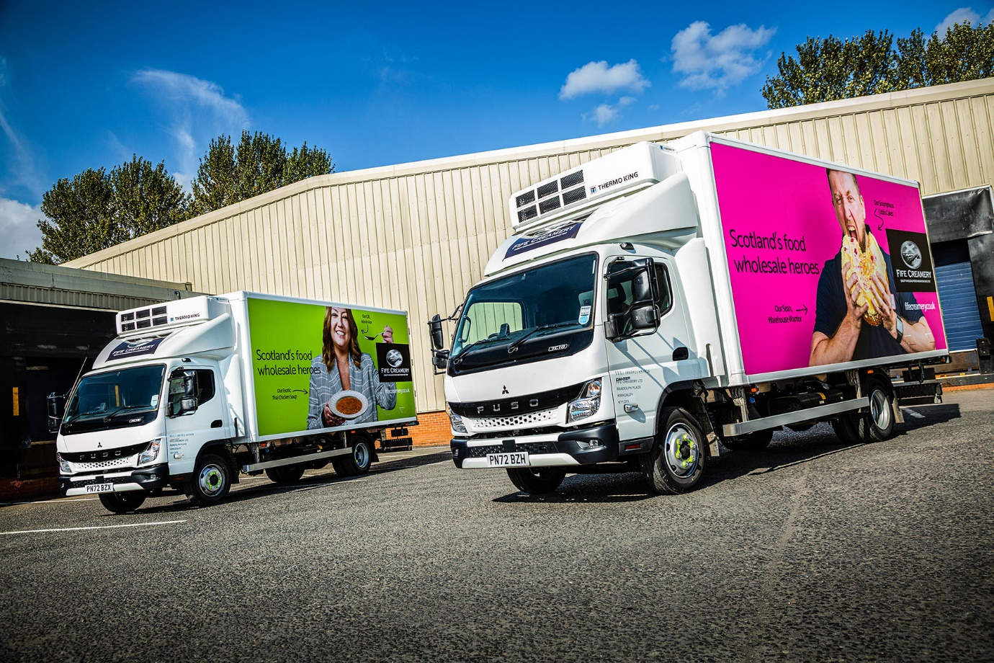

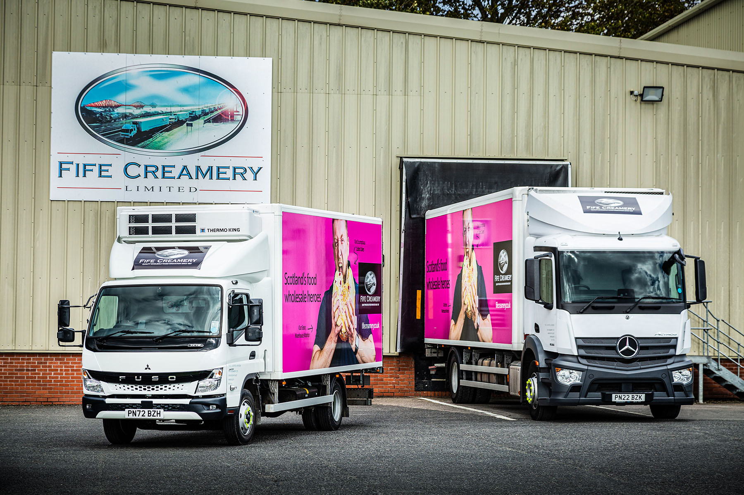

Family values: One of Fife Creamery’s new FUSO Canters and its latest Mercedes-Benz Actros – both brands are part of Daimler Truck
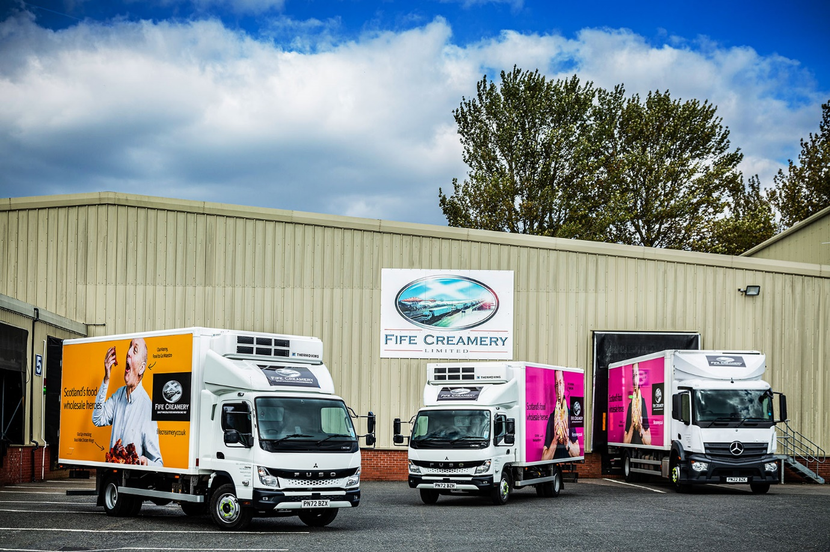

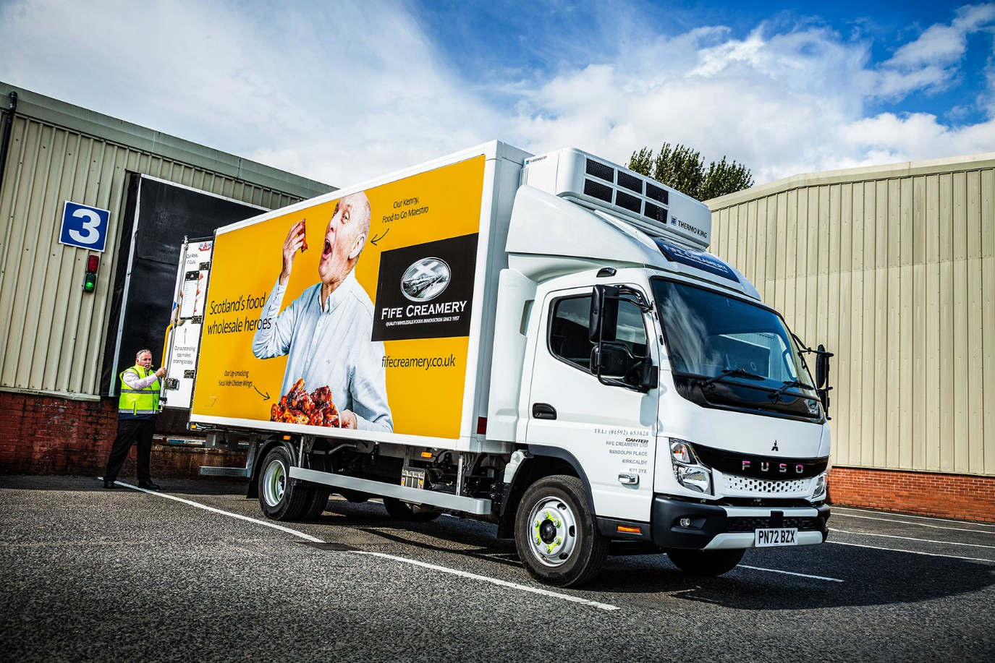

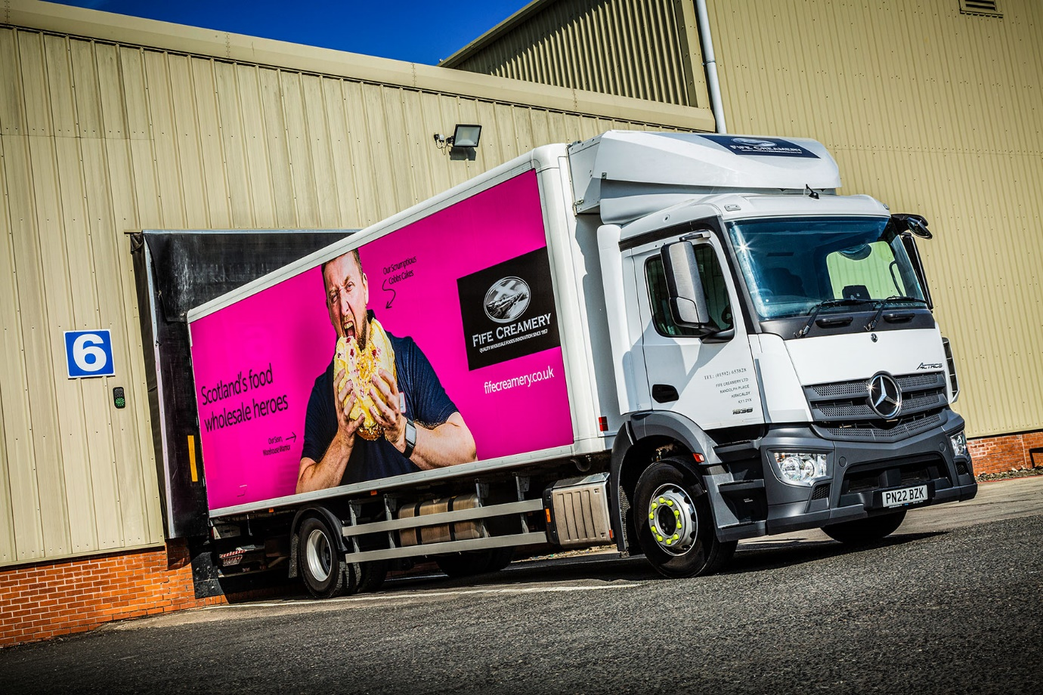

ends

For more information, or to request bigger/higher-res image files, please contact:
Steve Warren or John Ripley
Impact Communications
Steve: 07770 470251, steve@impactcom.co.uk
John: 07771 484595, john@impactcom.co.uk



