

Date: 4 September 2019

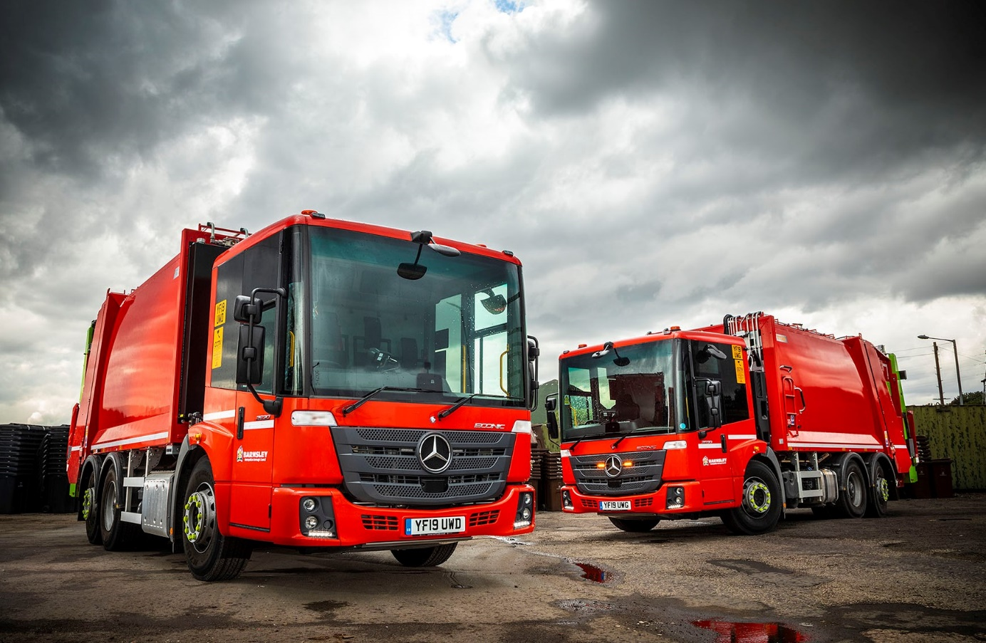

Barnsley Council turns to Northside for ‘magnificent seven’ Mercedes-Benz Econics

Barnsley Council has commissioned its first Mercedes-Benz Econics after awarding its latest tender for refuse collection vehicles to C P Davidson & Sons Ltd (CPD).

Supplied by Mercedes-Benz Trucks’ Dealer of the Year Northside Truck & Van, the South Yorkshire authority’s seven new trucks are fitted with Titan bodies and split low-level bin lifts by the Chorley-based prime contractor.

All are 6x2 Econic 2630 L models with 7.7-litre in-line six-cylinder engines which transmit their 220 kW (299 hp) outputs via six-speed Allison automatic gearboxes. Rear-steer axles enhance manoeuvrability, enabling the trucks to get in and out of tight areas.

The Econic’s air-conditioned, low-entry cab is easy to access and walk through, enhancing health and safety for crews. The benchmark level of direct vision afforded by its deep, wraparound windscreen, helps to protect vulnerable road users.

The vehicle also comes with a standard-fit armoury of driver assistance systems which exceed legislative requirements. To these, Barnsley Council has added the optional Rearguard Assist. This employs radar-based technology to support the driver when reversing at manoeuvring speed by displaying the distance from objects being approached via the instrument cluster and providing visual and audible warnings. It can also brake the vehicle to a controlled stop when the distance to an object becomes critical.

Replacements for seven RCVs which have been stood down, the new trucks are assigned to domestic duties. Most are making fortnightly collections of recyclables – cans, glass, and paper – although the Council has also committed a couple to ‘grey waste’ rounds.

Barnsley Council was impressed by the response of CPD and Northside Truck & Van to the invitation to tender for its latest refuse collection vehicles. The Dealer provided a demonstration vehicle for trial, while the competitively priced package reflected the Econic’s low whole-life cost of operation and incorporated the all-important assurances on aftersales support which the authority was seeking.

CPD and Northside have both sent technicians to instruct the Council’s own workshop team, who are now maintaining the trucks on a day-to-day basis, and the Dealer’s Vehicle Handover & Familiarisation Specialist Mick Bell has delivered a very effective programme of driver-training.

www.barnsley.gov.uk

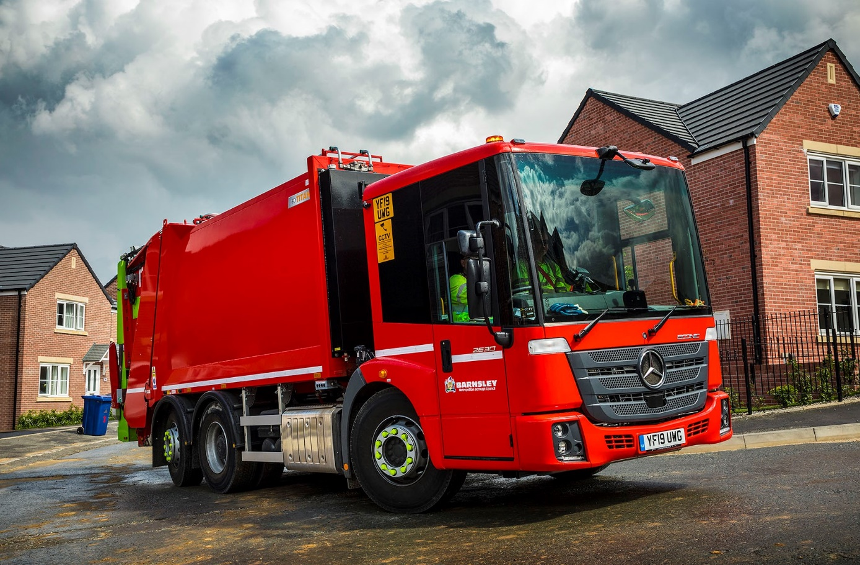

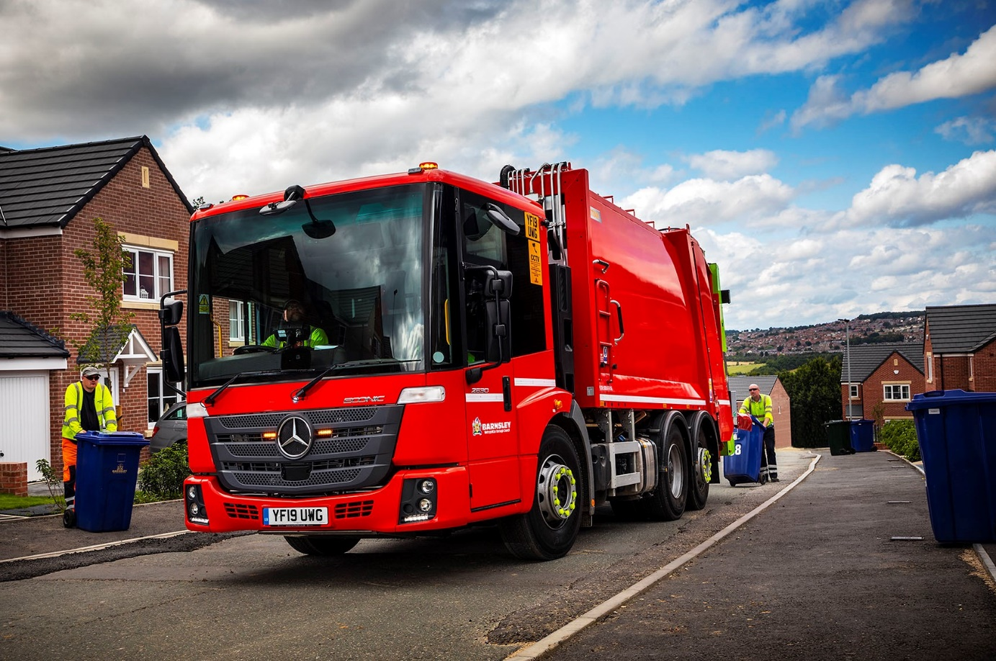

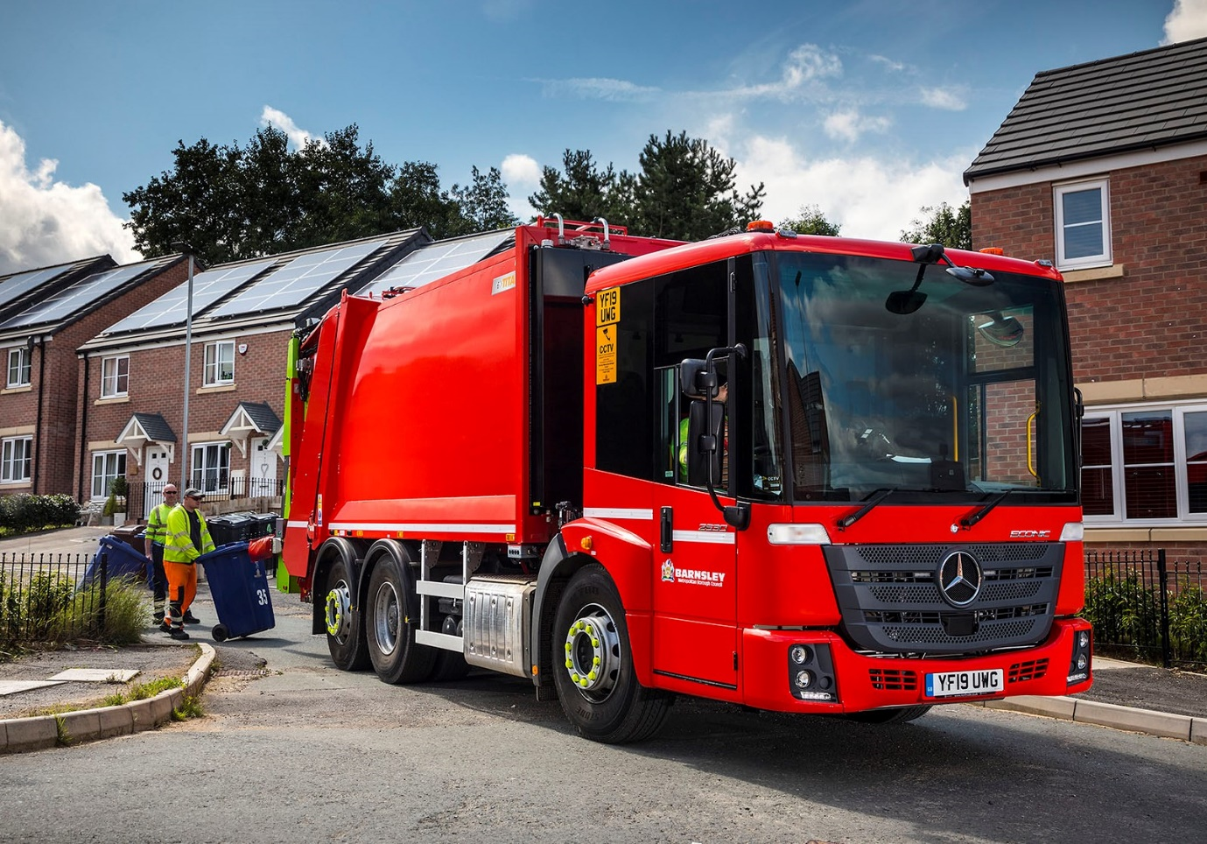

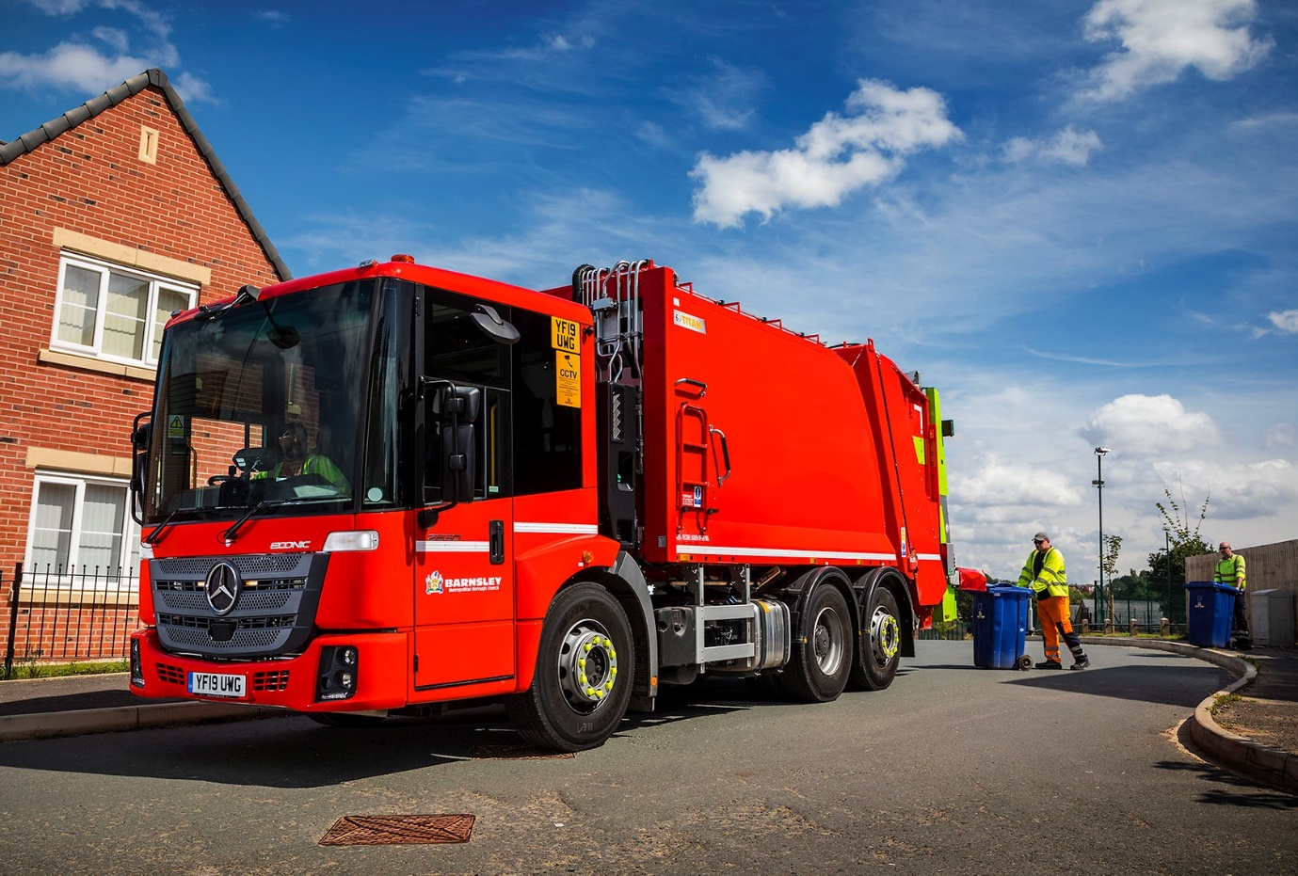

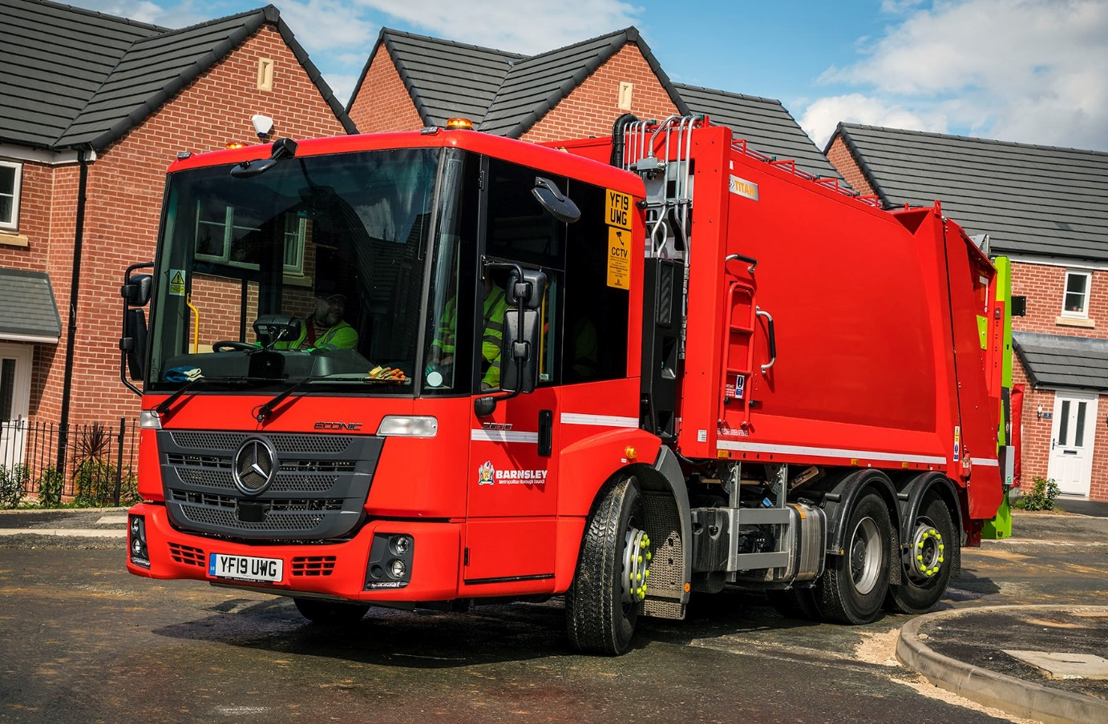

ends

For more information, or to request bigger/higher-res image files, please contact:
Steve Warren or John Ripley
Impact Communications, 01926 842126
Steve: 07770 470251, steve@impactcom.co.uk
John: 07771 484595, john@impactcom.co.uk

