

Date: 13 September 2021

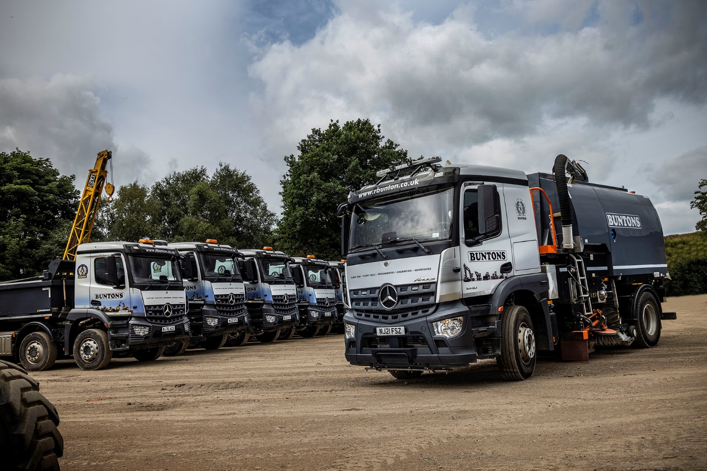

Mercedes-Benz sweeps the Buntons board again, with another six Arocs from Bell Truck and Van

Bigger was better for plant hire, groundworks and recycled aggregate specialist Buntons, when it returned to Bell Truck and Van for the latest addition to its Mercedes-Benz fleet.

The 18-tonne Arocs road sweeper is now working alongside the Bradford-based operator’s other sweeper, which is based on a 15-tonne Atego chassis.

Buntons also runs 10 eight-wheeled tippers, five of which were supplied by the same Dealer earlier this year. These are also from the muscular Arocs range, which is purpose-designed for construction-related applications.

Buntons Director Rob Hall commented: “We’ve developed an excellent relationship over a number of years with Bell Truck and Van Sales Executive Tony Birtwistle. He understands our business well, knows what we need and is always ready to help out.

“Our trucks must be reliable, cost effective and able to withstand the rigours of a tough working life. The Mercedes-Benz Arocs ticks these boxes and more, which is why Tony continues to win our business.”

An 1840 variant with ClassicSpace sleeper cab and 10.7-litre in-line six-cylinder engine producing 290 kW (394 hp), the new truck was bodied by Stock Sweepers, of Cinderford, Gloucestershire, which fitted its S8400 dual and simultaneous sweeping equipment.

Features include an 8.4m³ stainless steel hopper, wide-sweep and side brushes with adjustable pressure and positioning from the cab, gully suckers, and a low-pressure dust suppression system with 2,000-litre water tank. These functions are controlled by a CANbus Intelligent Sweep System and powered by a 68 kW auxiliary engine.

Transport Co-ordinator Richard Goodyear added: “The 18-tonner is bigger than any sweeper we’ve bought before. Going up a weight class means the truck has the capacity to stay out working for longer, before needing to tip or refill with water.

“This reflects the growing demand for our services from larger customers. We considered going for another 15-tonner but by comparison the bigger truck allows a more efficient way of working, and helps minimise the environmental impact of our operations by reducing vehicle movements.”

The 8x4 tippers delivered in February also have ClassicSpace cabs but are powered by ‘meatier’ 335 kW (456 hp) versions of the same 10.7-litre ‘straight-six’. Their lightweight steel bodies were built in Manchester by Marshalls Truck Bodies; one is additionally fitted with a Palfinger Epsilon M12Z crane grab.

“The tippers also represent a step up in terms of specification , as we’d previously chosen 430 hp engines,” continued Richard Goodyear. “Tony Birtwistle convinced us the more powerful unit would offer the optimum blend of performance and fuel efficiency for our work patterns, and the early signs would suggest he was spot on in his calculations.”

As with Buntons’ older tippers, the latest drive through 12-speed Mercedes PowerShift automated manual transmissions with Manoeuvring, Rocking and EcoRoll modes.

“PowerShift has proved to be very robust, effective and easy to use,” continued Mr Goodyear. “In fact, the availability of the auto ’box helps to explain why we based the new sweeper on an Arocs chassis. It’s not a model that many choose for this application, but we’re delighted with the result.”

Family-run Buntons celebrated its 50th anniversary last year. The company provides a portfolio of professional services including operated or self-drive plant hire, bulk excavations, ‘muckaway’, and street and site sweeping, to a growing list of clients. It is also an enthusiastic supporter of local events and good causes, as well as the construction industry charity Lighthouse Club.

www.rbunton.co.uk



Advancing with Arocs: Director Rob Hall with some of Buntons’ latest Mercedes-Benz trucks

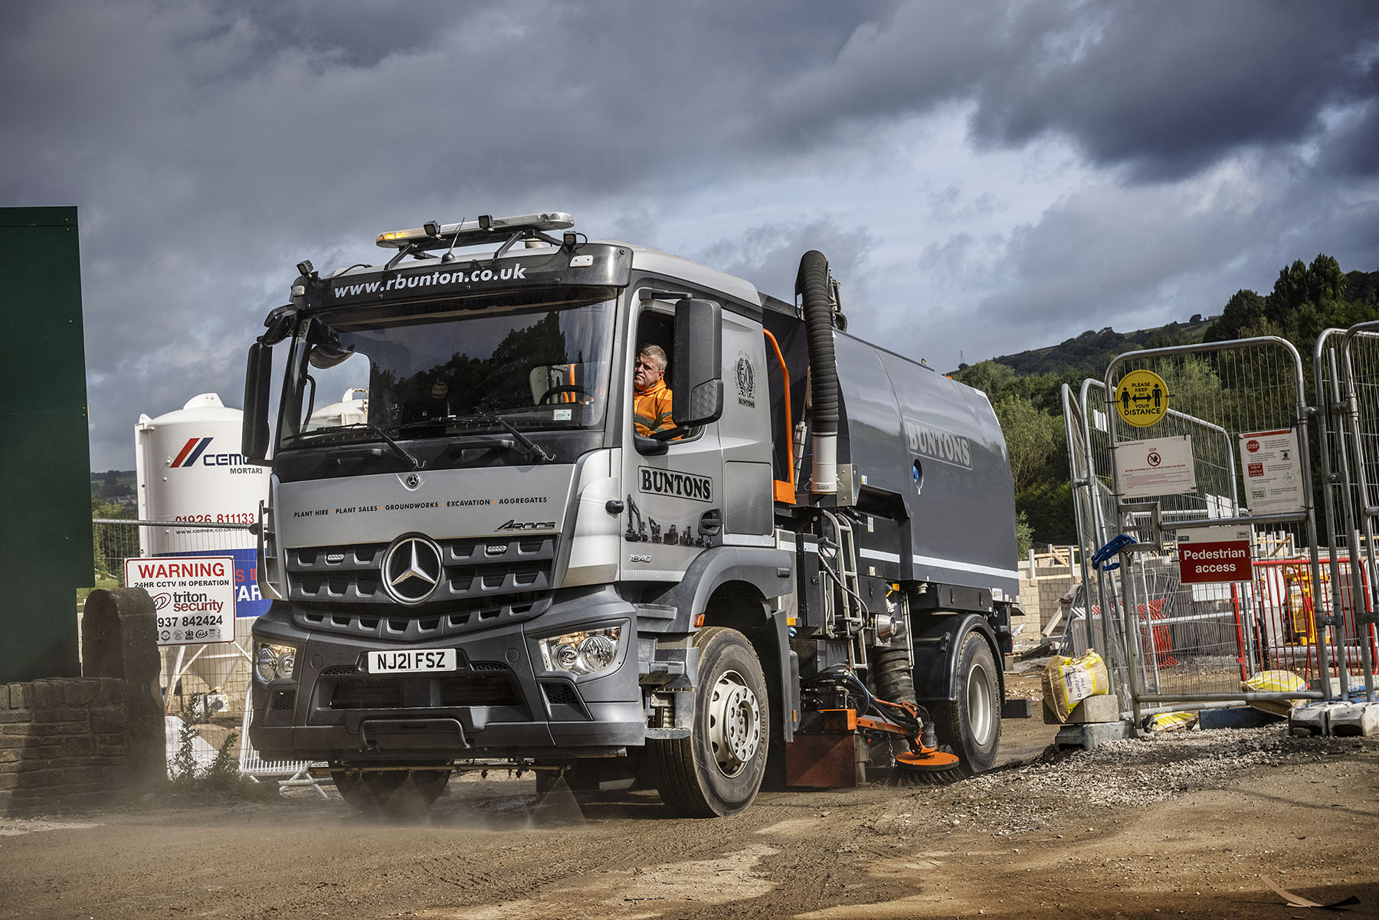

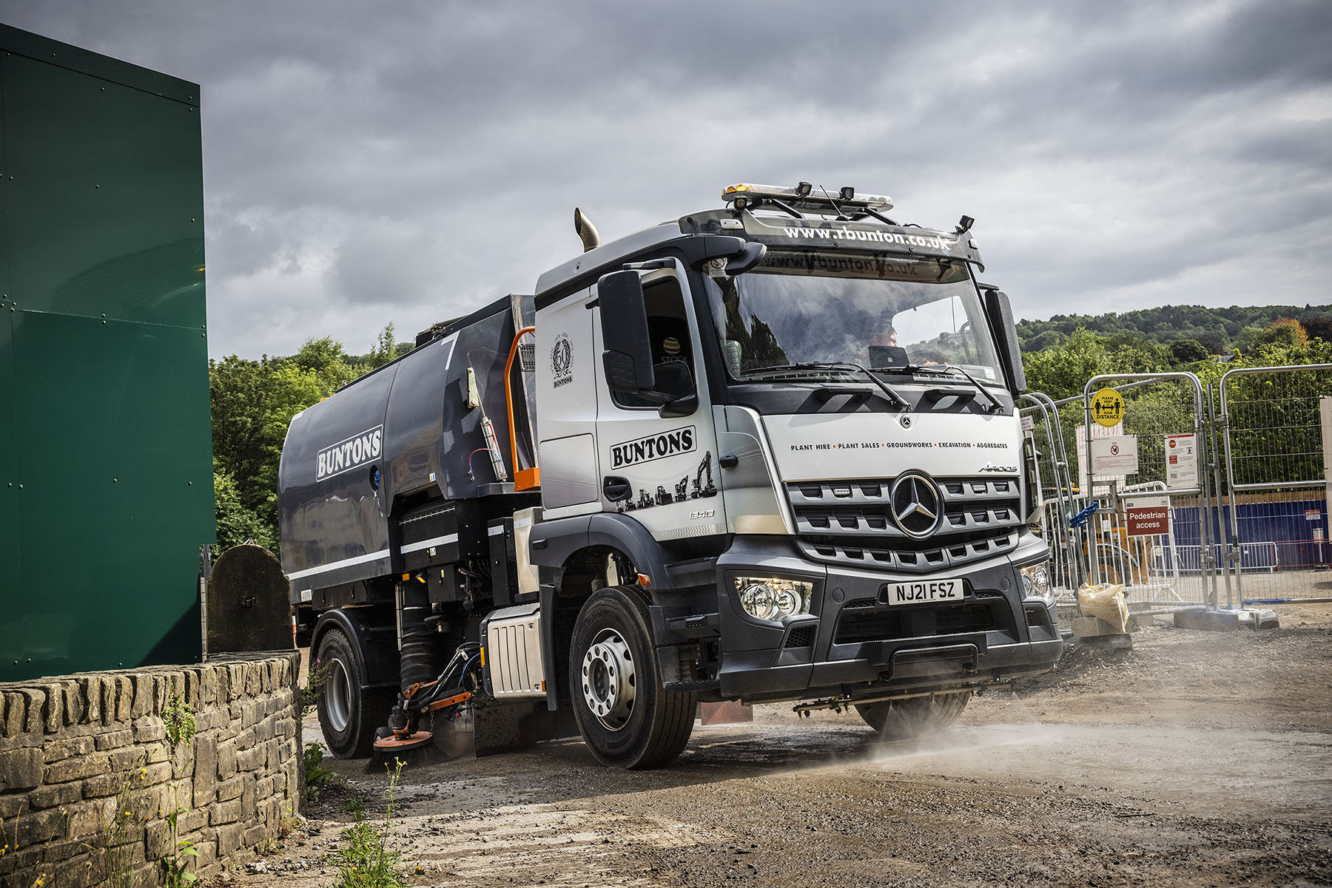

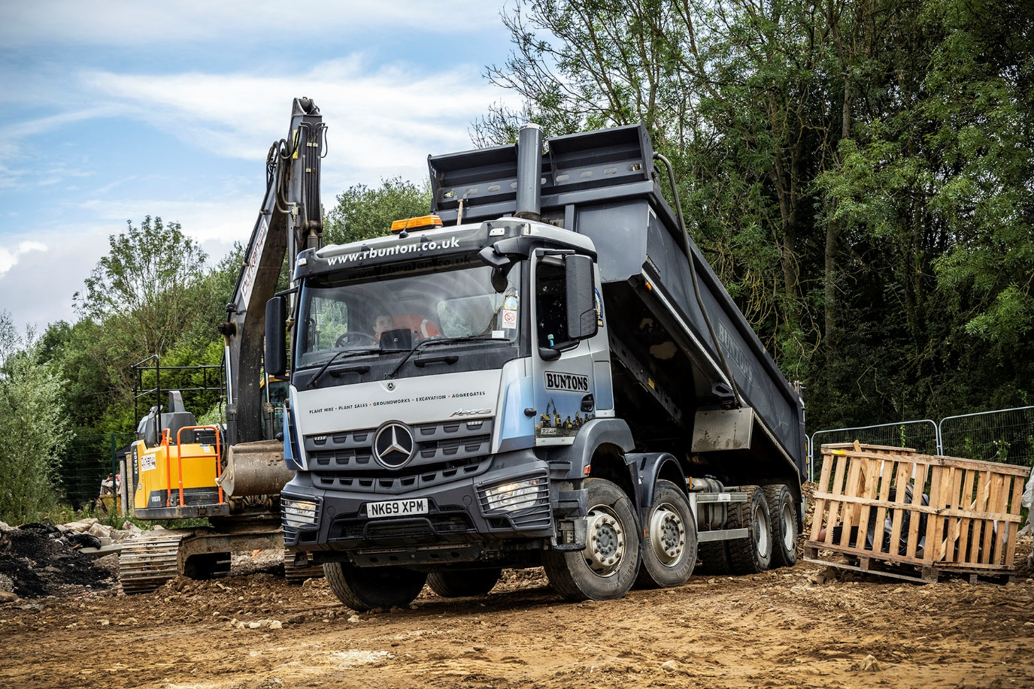

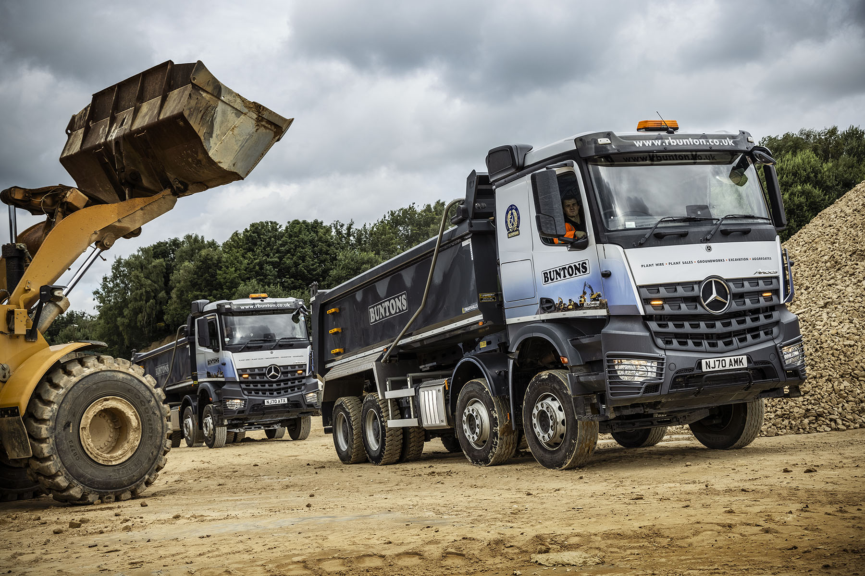

ends

For more information, or to request bigger versions of image files, please contact:
John Ripley or Steve Warren
Impact Communications, 01926 842126
John: 07771 484595, john@impactcom.co.uk
Steve: 07770 470251, steve@impactcom.co.uk



