

Date: 12 December 2018

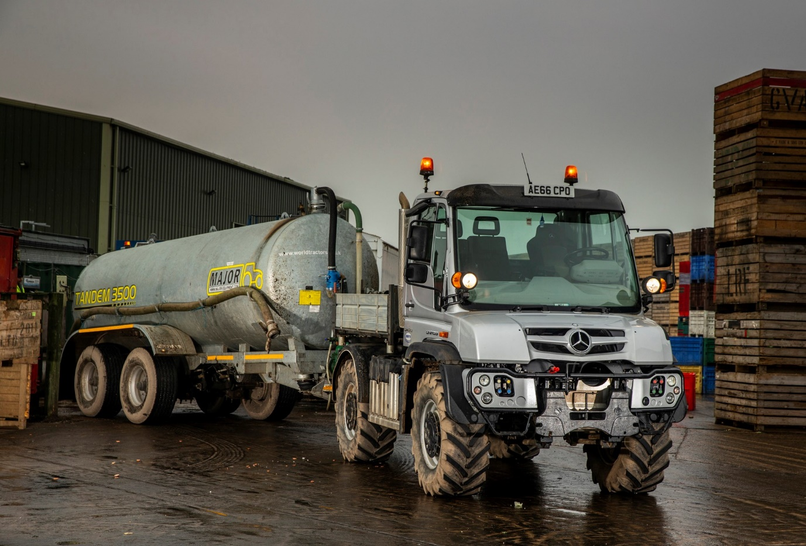

Agricultural contractor’s Mercedes-Benz Unimog wins hands down at the pumps

Tom Shepperson’s first Mercedes-Benz Unimog is undertaking a wide variety of tasks for customers across Cambridgeshire, while also delivering valuable fuel savings for its new owner.

Supplied by specialist Dealer Arthur Ibbett, of St Neots, the Unimog U423 is costing an estimated £40 per day less for diesel than the agricultural tractor it has replaced.

“No two days are the same for us, so we don’t measure average mpg performance,” explained Mr Shepperson. “However, the Unimog often works side by side with another of our tractors, covering the same ground and hauling the same loads.

“When that’s happened, and we’ve filled up at the end of the day, it has typically used around 30 litres less fuel. We work seven days a week, so this equates to around £1,200 per month. For a small operation like ours, that’s a massive saving.”

Trading as T. Shepperson Contracting, Mr Shepperson runs a diverse fleet of tractors and plant, including tanker and tipper trailers, diggers, teleporters, crushers and screeners. He undertakes a wide variety of work, from ground excavation and topsoil deliveries, as well as a host of agricultural tasks, one of which entails hauling waste vegetable oil to an anaerobic digestion recycling plant.

“We could be working in a muddy field one day, and on the road the next – or any combination of the two,” said Mr Shepperson. “That’s why the Unimog excels. It’s up there with the tractors in terms of off-road ability, but is far more economical on the road. It’s also more comfortable on a longer journey, and with a cruising speed of up to 56 mph can save valuable time.

“Unimogs are not a common sight on the roads but really, for our kind of work, it must be the most versatile and efficient vehicle available.”

T. Shepperson Contracting’s U423 has a factory-fitted tipping body with aluminium dropsides. Its four-cylinder, 5.1-litre diesel engine produces 170 kW (231 hp), and drives through a transmission with eight forward and six reverse gears, with AutomaticShift function which allows the driver to concentrate fully on the road and his implement attachments.

“The Unimog represented a departure for me,” Mr Shepperson continued. “I knew it has a great reputation but having never run one before was unsure as to what the maintenance costs would be. Arthur Ibbett have given me all the right assurances, though, while the service intervals for the Unimog are much longer than those for the tractor it has replaced, so I’m looking forward to even more savings.”

The off-road heritage of the iconic Unimog stretches back more than 70 years. Since the first model was launched in 1946, constant development by Mercedes-Benz engineers has kept it at the forefront of the off-road pack. It is widely acknowledged as the world’s leading all-terrain vehicle, with a reputation forged in the harshest operating conditions – the overwhelming majority of those built since 1951 are still in service today.

There are two core variants: an implement carrier like Tom Shepperson’s with front, side and rear attachment points, and a base truck for a range of other bodies. Both, are superbly adaptable to a huge variety of roles. All Unimogs have 4x4 chassis with single rear wheels. Gross weights vary from 7.5 to 16.5 tonnes and engines from 177 hp to 300 hp.
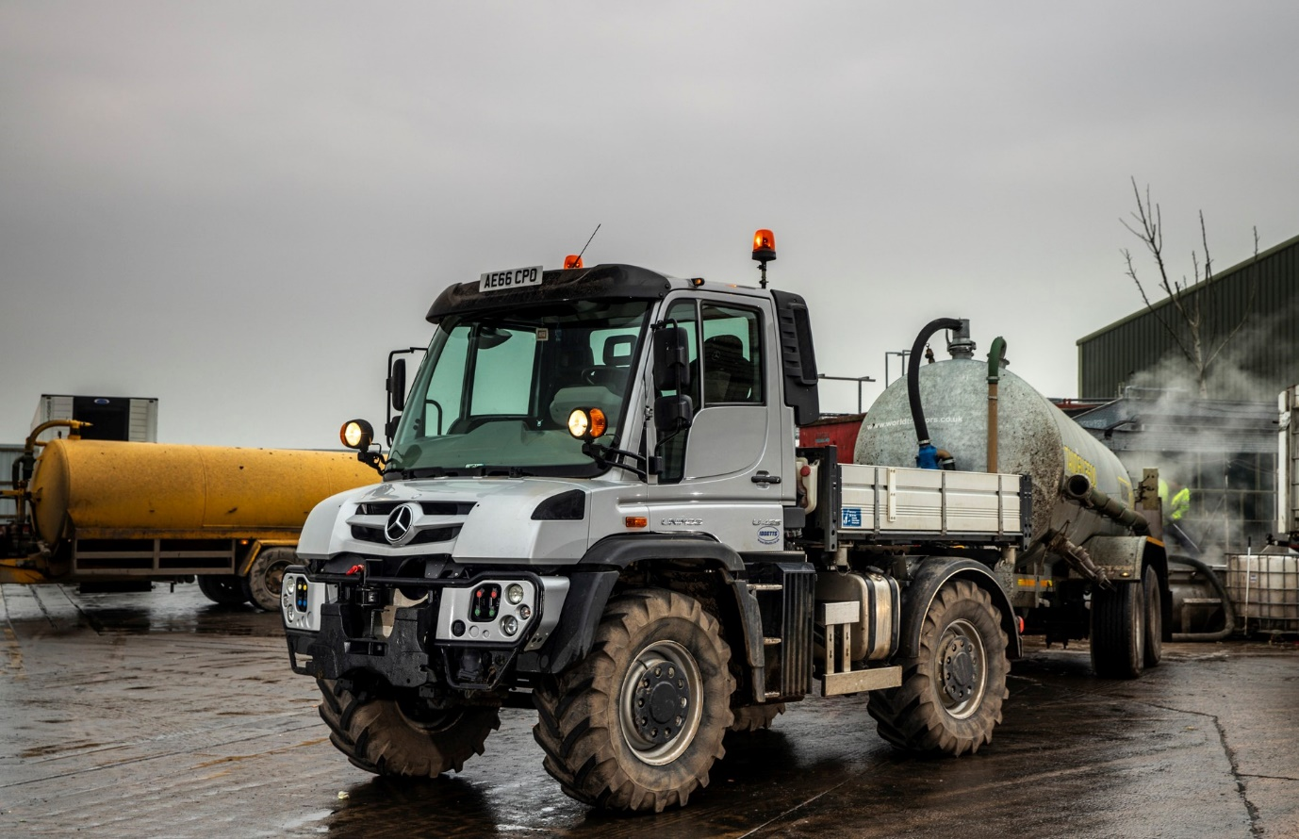

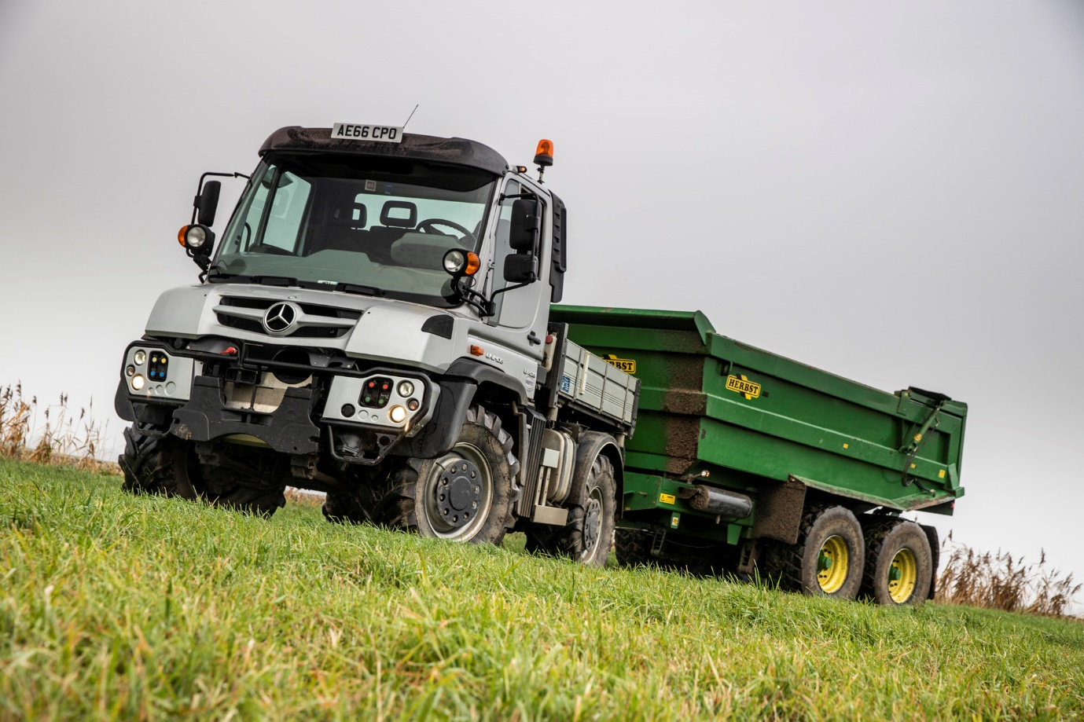

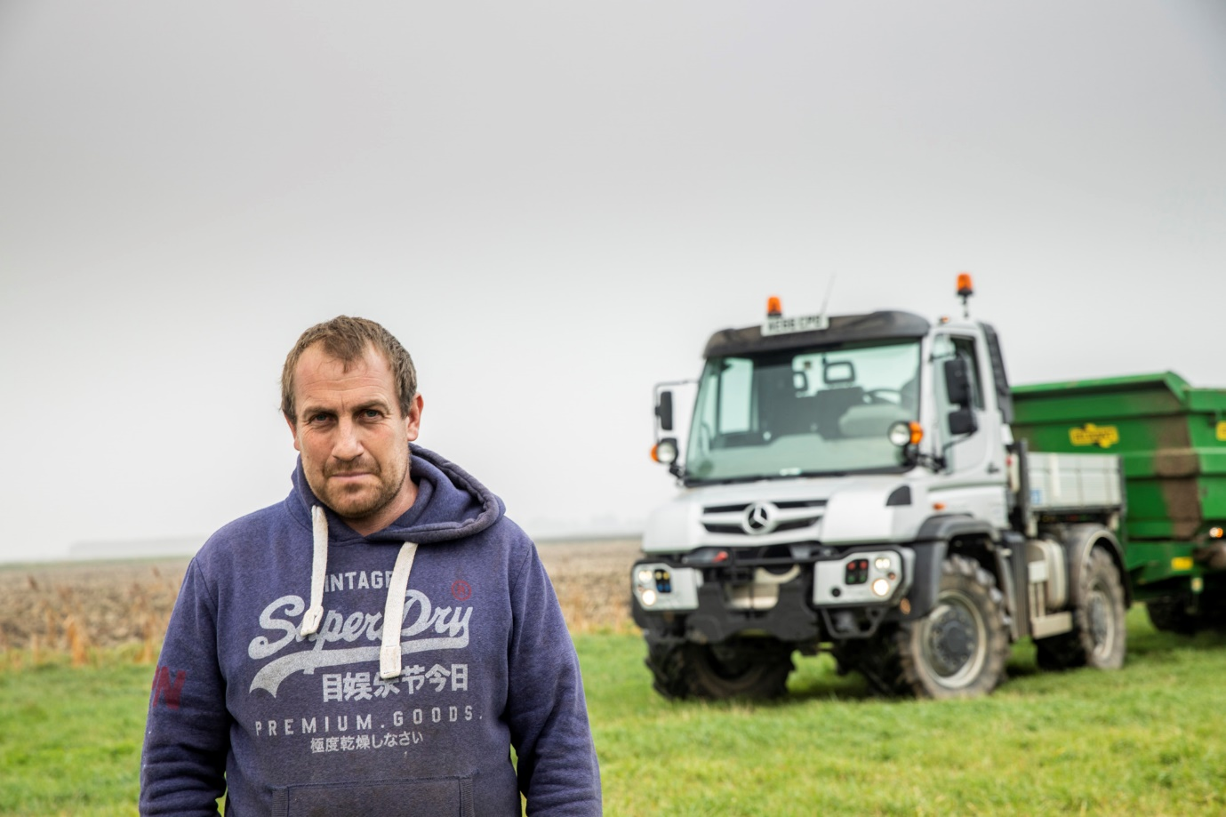

Taking the field: Tom Shepperson and his versatile Mercedes-Benz Unimog

ends

For more information, or to request bigger/higher-res image files, please contact:
John Ripley or Steve Warren
Impact Communications, 01926 842126
John: 07771 484595, john@impactcom.co.uk
Steve: 07770 470251, steve@impactcom.co.uk



