

Date: 2 January 2020

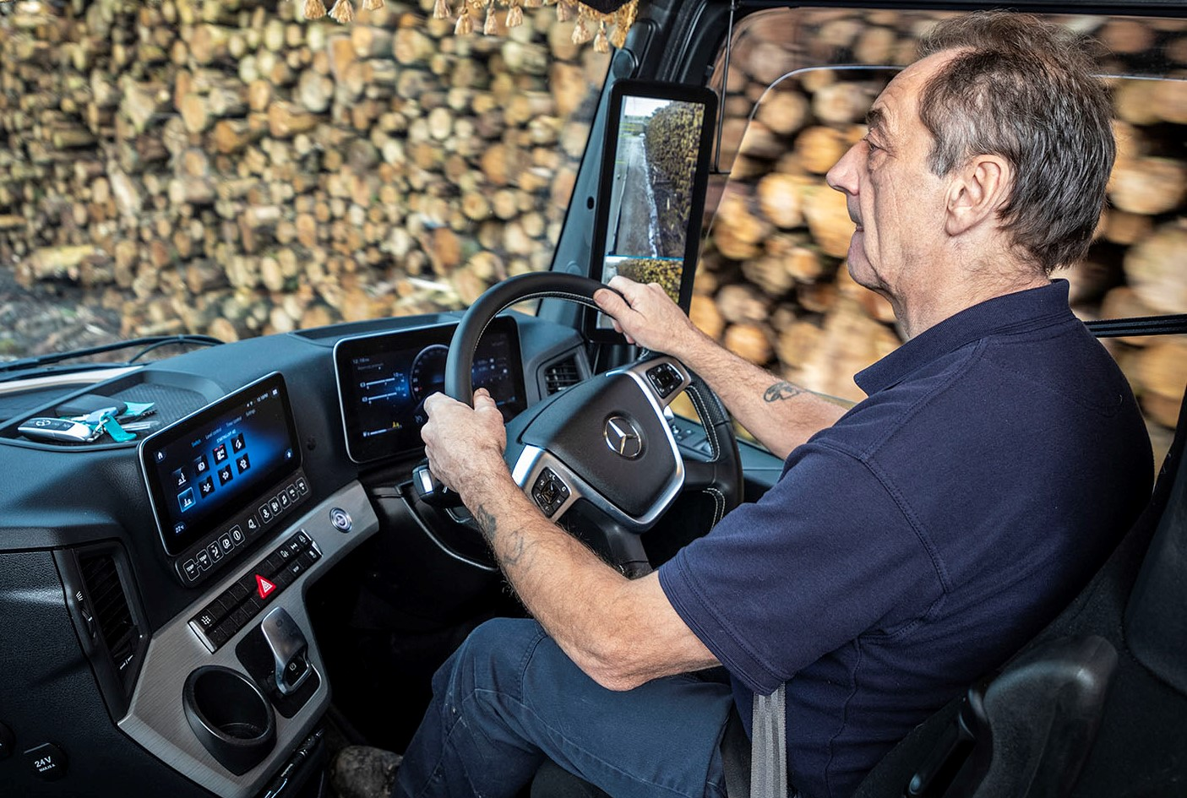

Room with a view: Arthur Selway’s Multimedia Cockpit Interactive features a 12in instrument cluster

MirrorCam wins a resounding ‘thumbs up’ from Mendip Wood Shavings’ drivers

He’s been driving trucks for more than 40 years, but Arthur Selway’s sights were set firmly on the future when he took delivery of his new Mercedes-Benz Actros.

One of two identical tractor units supplied to Bristol-based Mendip Wood Shavings by Dealer Group Rygor Commercials, Arthur’s truck came equipped as standard with MirrorCam technology. Six weeks on, he is already a big fan of the ground-breaking system.

“I’m getting on really well with MirrorCam,” enthused the 63-year-old. “The visibility is so much better. Gone are the blind spots you get with conventional mirrors, and I can still see even when the sun’s shining directly into the cameras, while I also like the fact that they show the back of the trailer when I turn a corner.”

MirrorCam delivers significant benefits when cornering or reversing, especially with an articulated rig. The image on the in-cab screens adapts automatically to provide the driver with a clear view – not possible with mirrors – of the full length of the semi-trailer. A guidance line in the display which shows where the end of the trailer is, assists with precision reversing.

MirrorCam also offers improved mpg performance – Mercedes-Benz estimates fuel savings of 1.5% – due to the compact, streamlined profile of the camera housings.

“The cameras don’t get anything like as dirty as mirrors,” observed Arthur. “In fact, they seem to be pretty well self-cleaning, which makes life easier. They don’t stick out as much either – having an extra foot of width on both sides of the truck certainly helped the other day, when I was swopping trailers in a congested part of west London.

“There’s a security benefit, too,” he continued. “When I’m parked up in a layby for the night and hear someone pull up behind me, I can just hit the button in the back of the cab which activates the cameras, have a nose at what’s going on outside, and reassure myself that there’s nothing to worry about.”

He added: “MirrorCam is so much better that I can really see these camera-based systems taking off. Give it five years and I reckon all trucks will have them.”

Arthur’s enthusiasm for MirrorCam is matched by that of his colleague David Moon, who drives the other new Actros. “It takes a very short time to get used to the cameras,” he confirmed. “Once you’ve done so they’re pretty incredible, because you can see so much more.”

Both trucks also feature the upgraded Multimedia Cockpit Interactive with twin screens, one the upgraded 12in central display, and improved versions of the Predictive Powertrain Control and Active Brake Assist systems. “Taken together, the new technology on these trucks is simply mind-blowing,” declared David.

A specialist supplier of animal bedding, family-owned Mendip Wood Shavings was established in 1980 by Philip Harris, who passed away six years ago, at which point his daughter Philippa took the helm as Managing Director. The company bought its first Mercedes-Benz trucks, a pair of first-generation Actros, in 2000. Today, all but four of the 21 vehicles on its fleet wear three-pointed stars.

A combination of tractor units and eight-wheeled rigids, these trucks are used primarily to deliver sawdust and wood shavings in bulk or bales to wholesalers, dairy farms, equestrian establishments, and country stores, as well as private customers, throughout southern England and South Wales. They also collect raw material from sawmills.

The latest additions to the Mendip Wood Shavings fleet are both Actros 2545 models. Powered by 12.8-litre in-line six-cylinder engines which produce 330 kW (450 hp), they have flat-floored BigSpace cabs with contemporary StyleLine interior trim packages, and Alcoa Dura-Bright alloy wheels. The new trucks pull box or curtainside semi-trailers, although having been fitted with hydraulic packs by SB Components, of Wisbech, Norfolk, they are also equipped for operation with walking floor versions.

The subject of Complete Service Contracts under which each is scheduled to cover 120,000 km a year, the Actros are now being inspected and maintained at Rygor Commercials’ Chilcompton branch. “Rygor’s workshop is only 15 minutes’ drive away, and its team look after all of our Mercedes-Benz trucks on R&M plans,” said Philippa Harris. “They’re flexible when we need them to be, and if we ever have an issue we know they’ll do whatever it takes to help us out. I can’t fault the Dealer’s service.”
Her cousin, Sales & Transport Manager Simon Wood, added: “Mercedes-Benz trucks are certainly reliable, fuel-efficient and well-liked by our drivers, particularly these two new units, which are very impressive. It’s the back-up, however, which is probably the single biggest factor that keeps us loyal to the brand – I’m convinced it’s the best out there.

“We’ve had our share of breakdowns over the years, as you always will with even the best trucks. But not once, even when the vehicle’s been in the back of beyond, have we been left stranded for hours – the emergency response has always been prompt and efficient.”
Rygor Commercials Sales Executive Marcus Cahalin commented: “It’s only when drivers experience technology like MirrorCam at first hand, that they can truly appreciate the benefits it offers. We’re dedicated at Rygor to Setting Standards, and with two of the safest, most advanced trucks on the road, that’s exactly what Mendip Wood Shavings is doing too.”

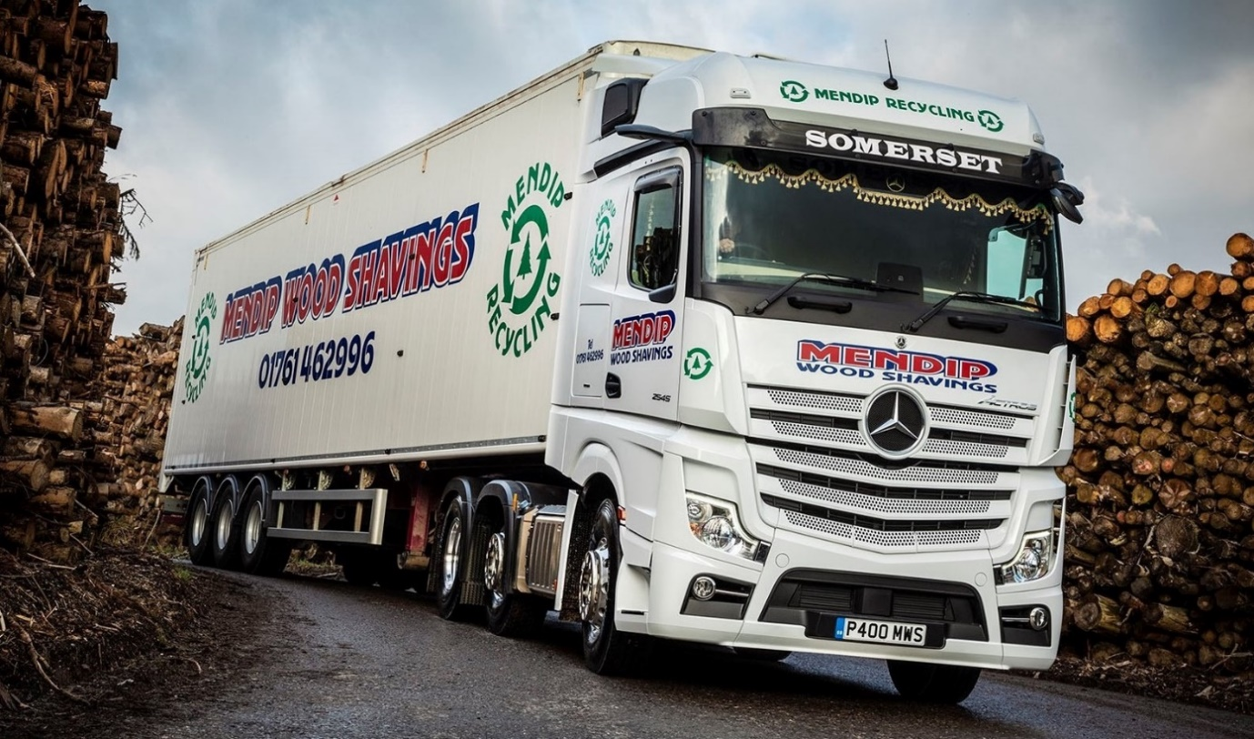
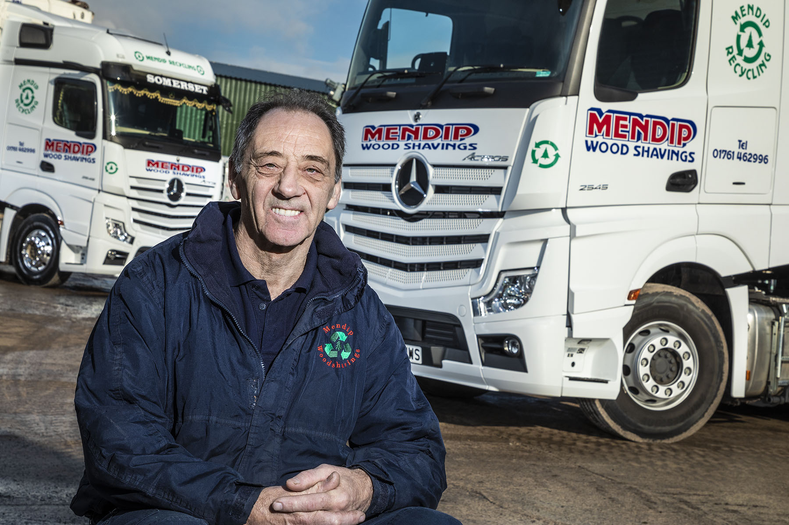

No looking back: Experienced Arthur Selway is convinced other manufacturers will follow Mercedes-Benz Trucks’ lead by replacing conventional mirrors with camera-based systems

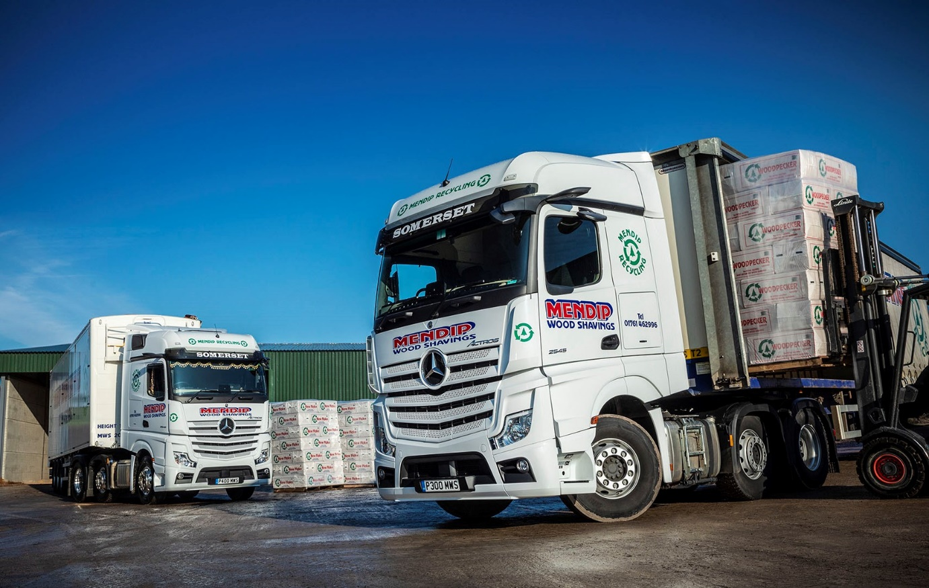

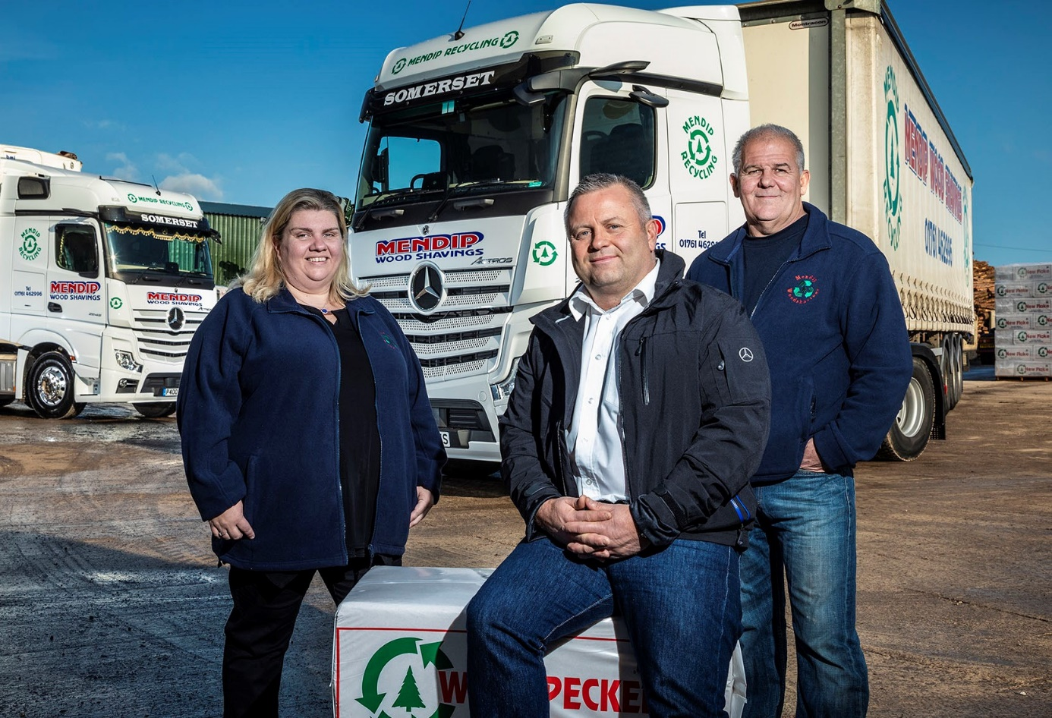

Advancing with Actros: The Mendip Wood Shavings management team, Philippa Harris, Simon Wood, centre, and General Manager David Kennea

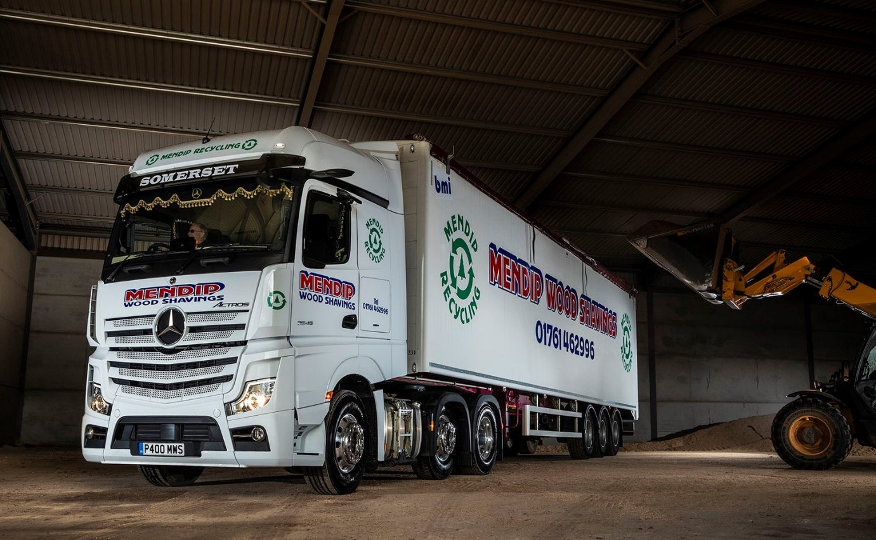

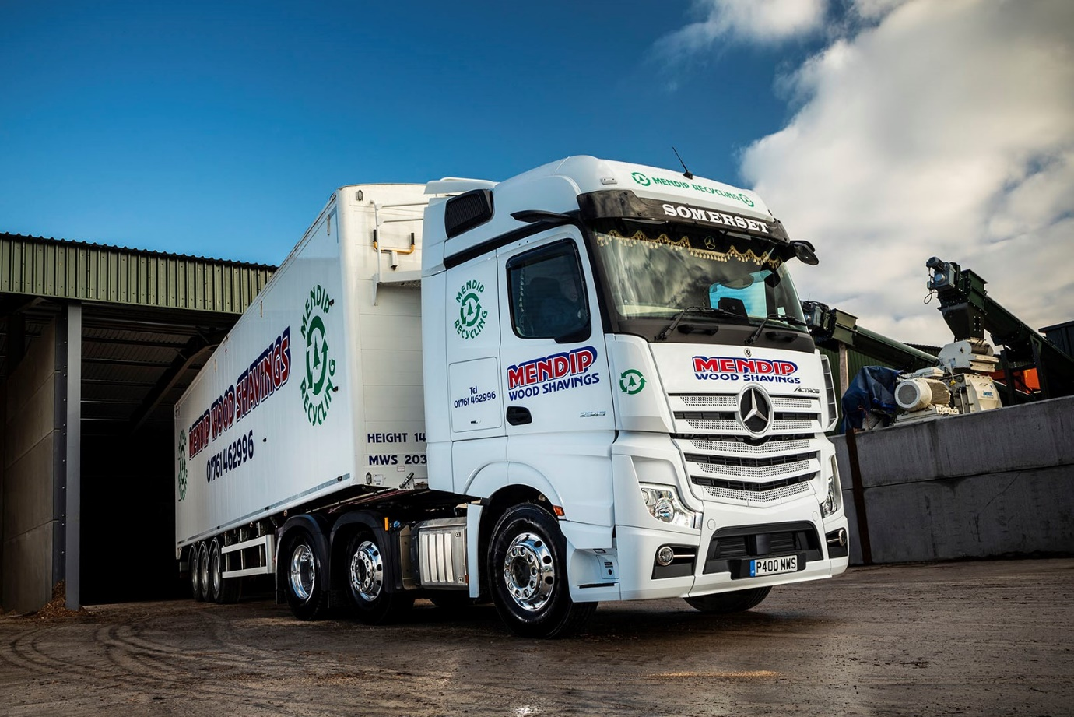

ends

For more information, or to request bigger/higher-res image files, please contact:
Steve Warren or John Ripley
Impact Communications, 01926 842126
Steve: 07770 470251, steve@impactcom.co.uk
John: 07771 484595, john@impactcom.co.uk

Notes to Editors: Rygor Commercials

Award-winning Mercedes-Benz Commercial Vehicle Dealer group, Rygor, has branches throughout Berkshire, Gloucestershire, Oxfordshire, Somerset, West London, Warwickshire, Wiltshire and Worcestershire, offering extensive coverage for customers throughout the M5, M4 and M42 corridors.

The Rygor business has expanded and gone from strength to strength in recent years, launching its flagship Gloucester branch in late 2016 (which won Showroom of the Year at the 2018 Commercial Motor Awards) and undergoing a significant refurbishment of its Oxford branch in 2018. Rygor was delighted to be announced as winner of the ‘Best Sales Team’ award at the 2019 AM Awards, demonstrating our continued commitment to our customers and dedication to providing exceptional customer service.

With a proven track record, Rygor is proud to be selling and supporting the most prestigious name in commercial vehicles.

For more information, in the first instance please contact Kate Ruberry-Shoemack, Head of People and Communications at Rygor – kateruberry-shoemack@rygor.co.uk

