

Date: 28 April 2020

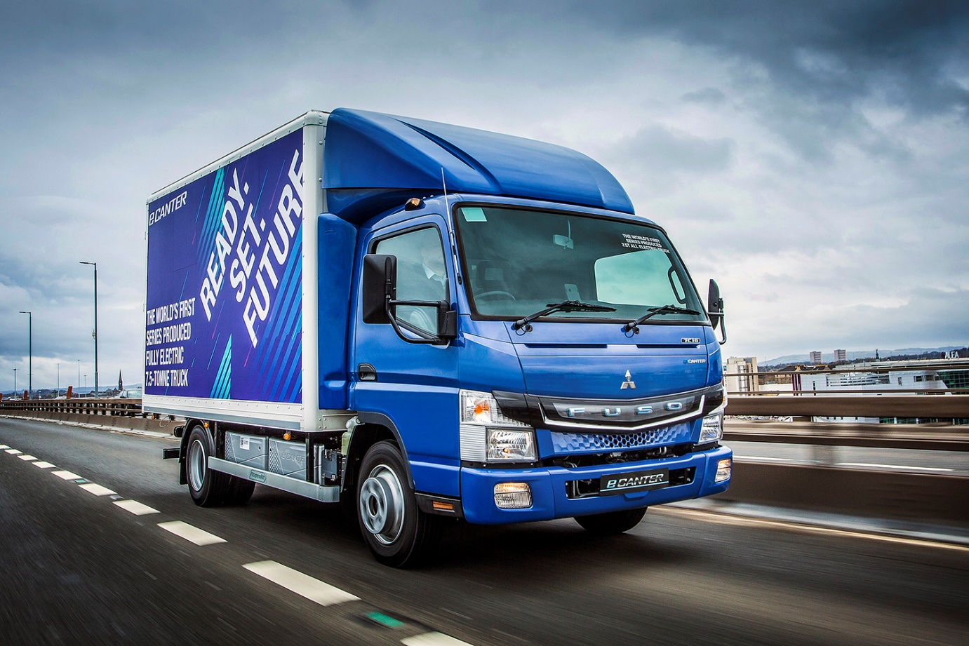

Electric dream: The FUSO eCanter combines zero tailpipe emissions with high productivity and low costs of operation

It’s déjà vu all over again as FUSO Canter lands another two top awards

With a fully electric model that’s “way ahead of the game” and a “feisty” off-road variant, the FUSO Canter delivered a repeat performance at the 2020 Trade Van Driver Awards.

Exactly as they did in the corresponding competitions in each of the last two years, the FUSO eCanter took the Best Alternative Fuel Truck title, and the all-wheel drive version was named Best Heavy Duty 4x4.

Remarkably, it was the seventh year running that the Canter 4x4 has been honoured by the leading magazine, which is aimed at owner-drivers and small fleet operators. As well as expert journalists, vehicles are judged by a panel of readers who use light commercial vehicles in their businesses.

The FUSO Canter light truck range is sold and supported by Mercedes-Benz Trucks and its Dealer network in Great Britain. The model family extends from 3.5-8.55 tonnes GVW.

Widely acknowledged as the first economically viable, fully electric truck, the 7.5-tonne FUSO eCanter produces zero tail-pipe emissions. It is powered by six high-voltage, water-cooled lithium-ion batteries, with a single charge allowing effective operating ranges of more than 62 miles (100 km).

Although the truck has yet to go on general sale, some of the biggest names on UK roads are already benefiting from the eCanter’s highly competitive body and payload allowance of up to 4.5 tonnes, as well as valuable operating cost savings compared to a conventional, diesel-engined truck.

Trade Van Driver’s judges reported: “While many of the major manufacturers are now entering the alternative fuel market, FUSO is way ahead of the game with the eCanter. Its technology is solid and proven, so any traders wishing to embrace environmental concerns can do so with confidence when choosing this vehicle.”
The 6.5-tonne Canter 4x4 is easily distinguished from its stablemates by its raised ride height. Powered by a 129 kW (175 hp) engine, and offering a body and payload allowance of up to 3,880 kg, it is equipped with selectable four-wheel drive. In 4x2 mode on road, the truck is impressively fuel-efficient, while all-wheel drive – which can be engaged or disengaged at the touch of a button – ensures powerful traction and impressive climbing ability on rugged terrain or for winter roads.

“Many operators require a vehicle that can deal with extreme conditions, and the FUSO Canter 4x4 offers that solution – and more,” enthused Trade Van Driver. “Off-road ability combined with functionality make this feisty off-roader the judges’ choice.”

FUSO Canter customers can choose from Comfort day cabs and Double crew cabs, and engine outputs from 96 kW (130 hp) to 129 kW (175 hp) – in addition to the eCanter, the line-up features a well-established diesel-electric Eco Hybrid model.

All employ a light yet strong ladder chassis, which contributes to the Canter’s low unladen weight – 7.5-tonne variants, in particular, offer market-leading payloads. The vehicle’s compact dimensions and excellent manoeuvrability also make it ideally suited to urban operation, and applications in which access is an issue.

Operators can also choose 3.5- and 7.5-tonne chassis pre-fitted at FUSO’s main European production facility in Tramagal, Portugal, with dropside and tipping bodies by the highly regarded Italian manufacturer Scattolini. This programme offers significant savings in time and administration.

www.canter.co.uk

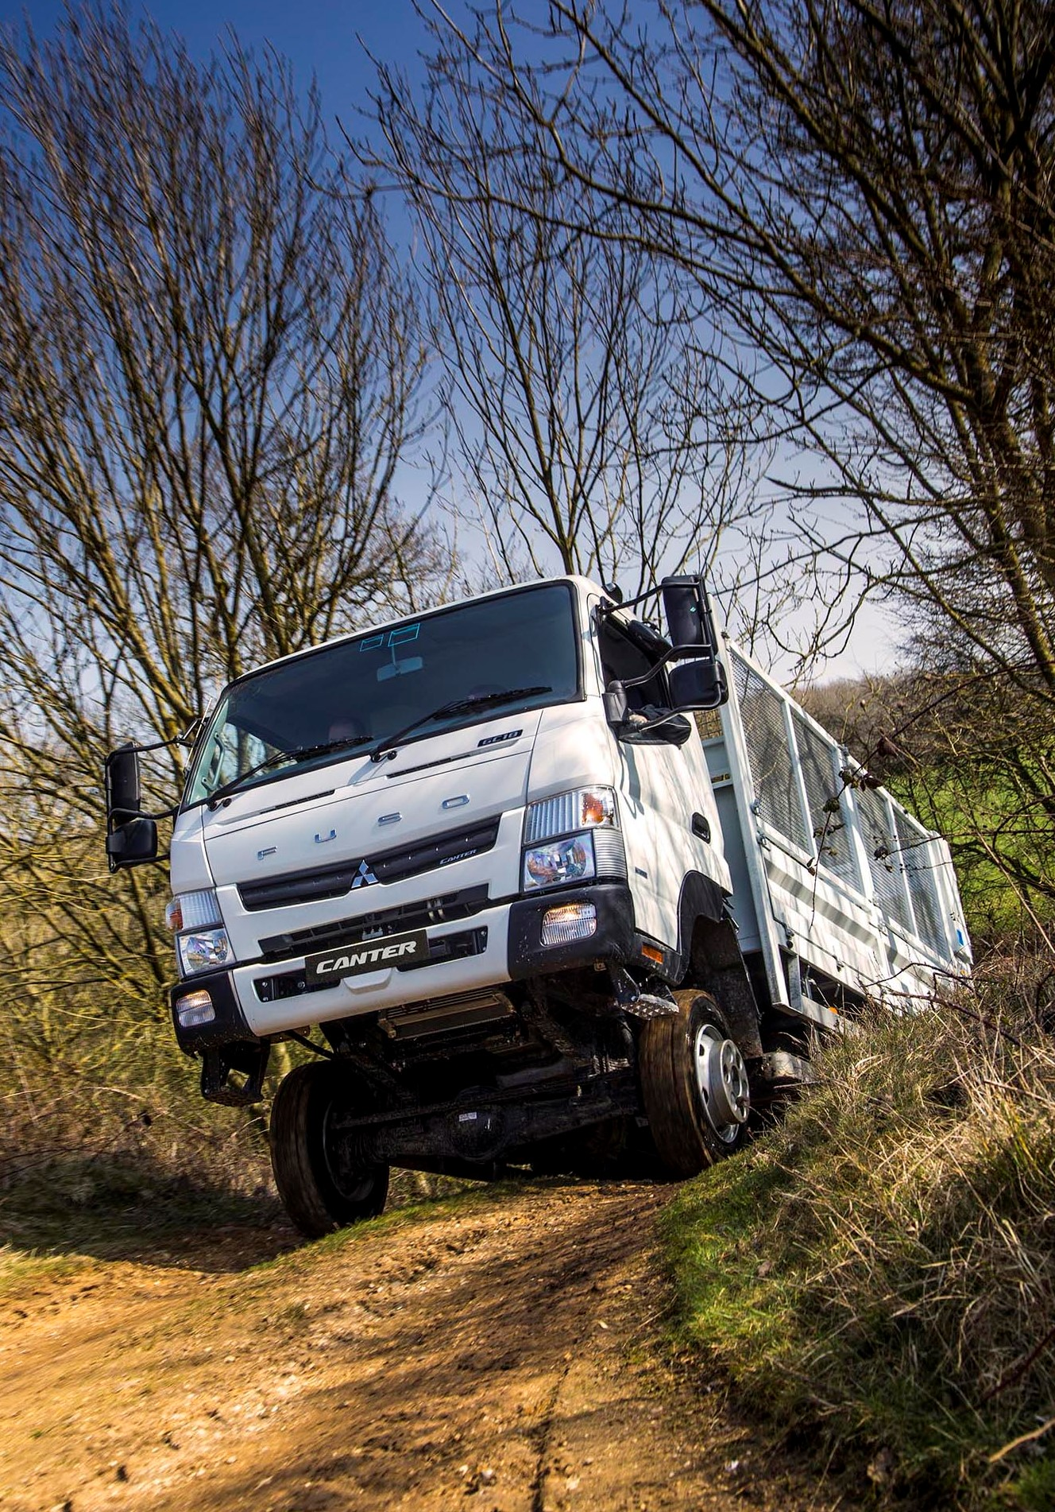

Still king of the hill: The FUSO Canter 4x4 has taken Trade Van Driver’s off-road award every year since 2014

ends

About Mercedes-Benz Trucks UK Ltd
Mercedes-Benz Trucks UK Ltd is the sales and marketing organisation responsible for all Daimler truck products in the UK, including FUSO Canter.

In 2019, the company registered 6,963 new trucks. Mercedes-Benz accounted for 6,188 new trucks registered in 2019, making it the third-biggest truck brand in the UK. Meanwhile, FUSO registrations hit 775 – including 580 new trucks over 6.0-tonnes.

The flagship new Mercedes-Benz Actros which won the 2020 International Truck of the Year award, features seven core innovations including MirrorCam, Multimedia Cockpit and Active Brake Assist 5. Our premium range of innovative trucks – Actros, Arocs, Atego, Econic and Unimog – draw upon more than 125 years of exceptionally high standards of quality, backed up by our promise of Trucks You Can Trust.

www.mbtrucks.co.uk

