

Date: 20 June 2022

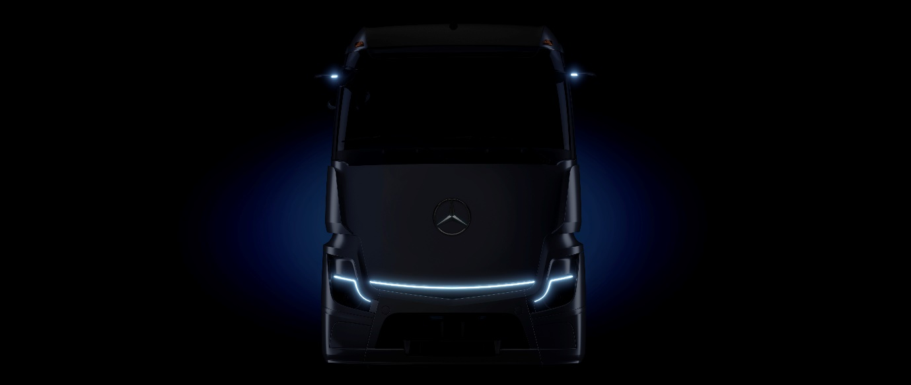

Mercedes-Benz Trucks to unveil the eActros LongHaul electric truck for long-distance transport in September

Trade show highlight at IAA Transportation 2022 in Hanover

Preview of the design theme of the series-production vehicle

- Megawatt charging: Batteries charge in well under 30 minutes from 20% to 80%

- Overall ranges on a par with conventional trucks possible

- LFP battery technology for long service life

- Customer testing begins in 2023

- Planned holistic transport solution consisting of vehicle technology, consulting, charging infrastructure and services

- Goal: Right choice for customers in terms of profitability, sustainability and reliability

- Mercedes-Benz Trucks to present further new electric trucks at IAA

- Karin Rådström, CEO Mercedes-Benz Trucks: “The electrification of heavy long-distance transport is the next milestone on our road to CO₂-neutrality. The eActros LongHaul is a battery-electric vehicle which is planned to be economically feasible for our customers. My team and I look forward to presenting this innovative truck to our customers and the public in September.”

Stuttgart – The battery-electric eActros LongHaul long-distance truck will be Mercedes-Benz Trucks’ trade show highlight at this year’s IAA Transportation in September in Hanover. The manufacturer announced the 40-tonne truck in 2020 and presents the “concept prototype” exactly two years later for the first time. The eActros LongHaul to be shown at IAA provides a preview of the design theme of the series-production vehicle. The tractor unit is also part of the eActros LongHaul test fleet. The first prototypes are already undergoing intensive testing and the eActros LongHaul will be tested on public roads this year. In the coming year, near-production prototypes will got to customers for real-world use testing. Series readiness is planned for 2024. On a single battery charge the eActros LongHaul will have a range of around 500 kilometres. The e-truck will enable high-performance charging – or so-called “megawatt charging.”

In addition to the eActros LongHaul, Mercedes-Benz Trucks will present further new battery-electric trucks at IAA. The eActros for heavy-duty distribution transport has been in series production at the Wörth plant since October 2021. The eEconic for municipal use will follow in July. Mercedes-Benz Trucks is pursuing the goal of increasing the proportion of locally CO₂-neutral new vehicles in Europe to more than 50% by 2030.

Karin Rådström, CEO Mercedes-Benz Trucks: “The electrification of heavy long-distance transport is the next milestone on our road to CO₂-neutrality. The eActros LongHaul is a battery-electric vehicle which is planned to be economically feasible for our customers. My team and I look forward to presenting this innovative truck to our customers and the public in September.”

As part of its pre-launch communications for IAA, Mercedes-Benz Trucks published the first teaser images of the eActros LongHaul concept prototype and announced further technical specifications planned for the production vehicle. The batteries used in the eActros LongHaul employ lithium-iron phosphate cell technology (LFP). These are characterised, above all, by a long service life and more usable energy. The batteries can be charged from 20% to 80% in well under 30 minutes at a charging station with an output of about one megawatt. The long range on a single charge in combination with megawatt charging results in overall ranges on a par with conventional trucks and thus enables two-shift operations. The vehicle is also characterised by a particularly well-balanced driveline for a very pleasant driving experience. In addition, the eActros LongHaul features the manufacturer’s numerous safety innovations. The core of the Mercedes-Benz Trucks concept for battery-electric long-distance transport is to offer customers a holistic solution consisting of vehicle technology, consulting, charging infrastructure and services. The eActros LongHaul should be the right choice for customers in terms of profitability, sustainability and reliability.

Advantages of the Mercedes-Benz eActros LongHaul

Battery-electric drives have the highest efficiency among alternative drives. The eActros LongHaul therefore provides a high level of energy efficiency with its purely battery-electric drive. This gives transport companies significant economic advantages in eActros LongHaul’s intended use scenarios.

The lion’s share of long-distance transport applications in transporters’ operational practices do not require a range beyond the approximately 500km the eActros LongHaul makes possible on a single charge. In addition, legal restrictions on the driving times for truck drivers limit the need for longer ranges, depending on the case. For example, truck drivers in the EU must take a minimum of a 45-minute break after a maximum of 4.5 hours of driving. During this time energy for the remaining route can be recharged. The eActros LongHaul is therefore the right choice for transport companies when used regularly on routes that can be planned, given appropriate distances and charging options.

Engagement with partners for charging infrastructure

Daimler Truck, TRATON GROUP and Volvo Group have signed a binding agreement to establish a joint venture for public charging for long-distance transport. This provides for the establishment and operation of a public high-performance charging network for battery-electric heavy-duty long-distance trucks and coaches in Europe. The charging network of these three parties should be available to fleet operators in Europe, regardless of brand. When it comes to depot charging, Mercedes-Benz Trucks works with Siemens Smart Infrastructure and ENGIE.

In addition, Daimler Truck participates in the “high-performance charging in long-distance truck transport” (HoLa) project. The goal of the project, under the patronage of the VDA, is the planning, construction and operation of a selected high-performance charging infrastructure for battery-electric long-haul trucking. Two high-performance Megawatt Charging System (MCS) charging points will be set up at four locations in Germany and tested in real-world use. Various other consortium partners from industry and research are involved in the project.

Ultimate goal: CO₂-neutral transport on the road by 2050

Daimler Truck’s ambition is to only offer new vehicles in Europe, Japan and North America by 2039 that are CO₂-neutral when driving (‘tank-to-wheel’). The two battery-electric models Mercedes-Benz eCitaro and Mercedes-Benz eActros have been in series production since 2018 and 2021 respectively. The Mercedes-Benz eEconic, the next-generation FUSO eCanter and the Freightliner eCascadia will follow later this year, and other locally CO₂-neutral vehicles are already planned. In the second half of this decade the company aims to add series-production trucks with hydrogen-based fuel cell drives to its range of vehicles. Putting CO₂-neutral transport on the road by 2050 is the ultimate goal.

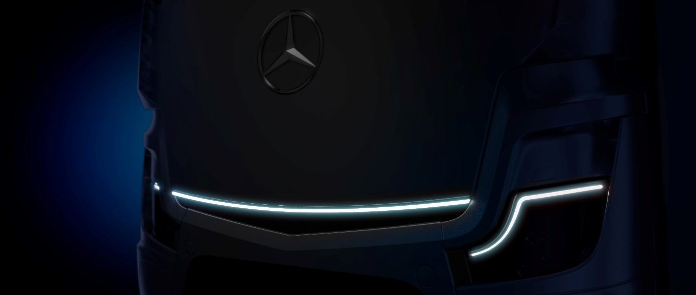

ends

For more information, please contact:

Jamie Fretwell at Mercedes-Benz Trucks UK Ltd
07712 519230, jamie.fretwell@daimler.com

or

Steve Warren or John Ripley
Impact Communications
Steve: 07770 470251, steve@impactcom.co.uk
John: 07771 484595, john@impactcom.co.uk

or

Akim Enomoto, +49 (0) 176 30995099, akim.enomoto@daimlertruck.com
Peter Smodej, +49 (0) 176 30936446, peter.smodej@daimlertruck.com

Forward-looking statements:
This document contains forward-looking statements that reflect our current views about future events. The words “aim”, “ambition”, “anticipate,” “assume,” “believe,” “estimate,” “expect,” “intend,” “may,” ”can,” “could,” “plan,” “project,” “should” and similar expressions are used to identify forward-looking statements. These statements are subject to many risks and uncertainties, including an adverse development of global economic conditions, in particular a decline of demand in our most important markets; a deterioration of our refinancing possibilities on the credit and financial markets; events of force majeure including natural disasters, pandemics, acts of terrorism, political unrest, armed conflicts, industrial accidents and their effects on our sales, purchasing, production or financial services activities; changes in currency exchange rates, customs and foreign trade provisions; a shift in consumer preferences; a possible lack of acceptance of our products or services which limits our ability to achieve prices and adequately utilise our production capacities; price increases for fuel or raw materials; disruption of production due to shortages of materials, labour strikes or supplier insolvencies; a decline in resale prices of used vehicles; the effective implementation of cost-reduction and efficiency-optimization measures; the business outlook for companies in which we hold a significant equity interest; the successful implementation of strategic cooperations and joint ventures; changes in laws, regulations and government policies, particularly those relating to vehicle emissions, fuel economy and safety; the resolution of pending government investigations or of investigations requested by governments and the conclusion of pending or threatened future legal proceedings; and other risks and uncertainties, some of which are described under the heading “Risk and Opportunity Report” in the current Annual Report. If any of these risks and uncertainties materializes, or if the assumptions underlying any of our forward-looking statements prove to be incorrect, the actual results may be materially different from those we express or imply by such statements. We do not intend or assume any obligation to update these forward-looking statements since they are based solely on the circumstances at the date of publication.

Daimler Truck at a glance
Daimler Truck Holding AG ("Daimler Truck") is one of the world's largest commercial vehicle manufacturers, with over 40 main locations and more than 100,000 employees around the globe. The founders of Daimler Truck have invented the modern transportation industry with their trucks and buses a good 125 years ago. Unchanged to this day, the company's aspirations are dedicated to one purpose: Daimler Truck works for all who keep the world moving. Its customers enable people to be mobile and get goods to their destinations reliably, on time, and safely. Daimler Truck provides the technologies, products, and services for them to do so. This also applies to the transformation to CO2-neutral driving. The company is striving to make sustainable transport a success, with profound technological knowledge and a clear view of its customers' needs. Daimler Truck's business activities are structured in five reporting segments: Trucks North America (TN) with the truck brands Freightliner and Western Star and the school bus brand Thomas Built Buses. Trucks Asia (TA) with the FUSO and BharatBenz commercial vehicle brands. Mercedes-Benz (MB) with the truck brand of the same name. Daimler Buses (DB) with the Mercedes-Benz and Setra bus brands. Daimler Truck's new Financial Services business (DTFS) constitutes the fifth segment, the product range in the truck segments includes light, medium and heavy trucks for long-distance, distribution and construction traffic and special-purpose vehicles used mainly in the municipal and vocational sector. The product range of the bus segment includes city buses, school buses and intercity buses, coaches and bus chassis. In addition to the sale of new and used commercial vehicles, the company also offers aftersales services and connectivity solutions.

