

Date: 16 September 2021

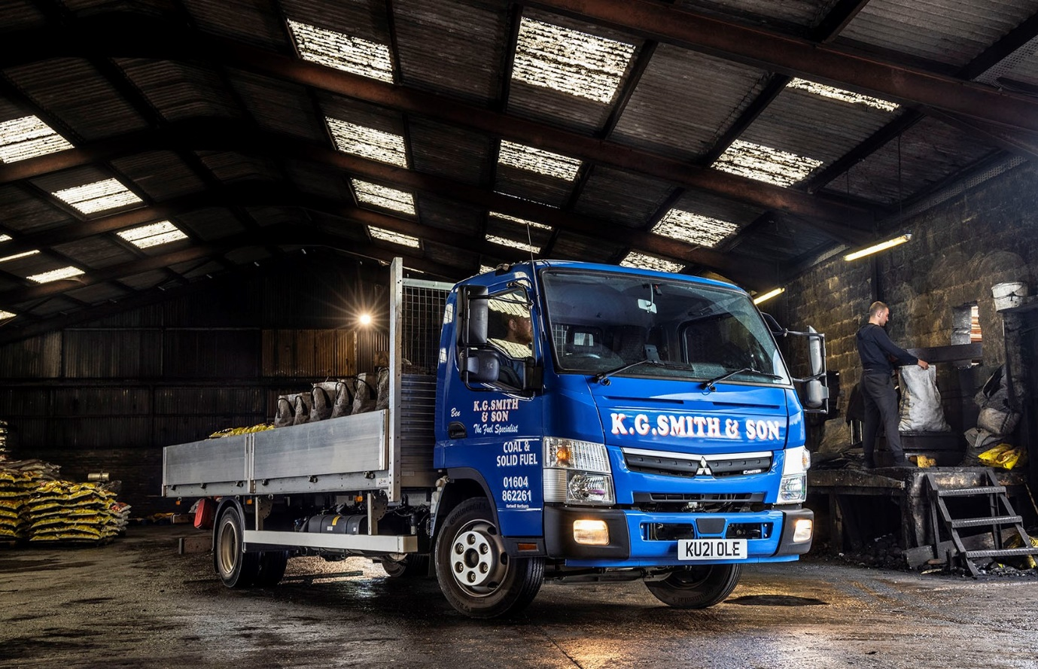

Intercounty Truck & Van fuels further success for KG Smith & Son with a fifth FUSO Canter

Solid fuels merchant KG Smith & Son has added a fifth FUSO Canter to the fleet that will be ensuring customers can once again warm their homes this winter.

Established in 1947, the UK’s largest independent supplier of house coal offers a broad range of products that includes smokeless alternatives such as natural anthracite and Homefire Ecoal 50, an ‘eco fuel’ made from crushed olive stones, a natural waste product of the olive oil manufacturing process.
The company’s firewood and wood briquettes come from renewable sources, while its extensive portfolio also includes barbecue gas, rock salt, wood chip mulch, compost and horse bedding.
KG Smith & Son is based in the village of Hartwell, near Northampton, and relies on its 13 trucks to serve customers across much of the East Midlands and Home Counties – deliveries to the rest of the country are entrusted to third-party transport providers.

The latest addition to its fleet is a 7.5-tonne FUSO Canter. The vehicle was supplied, like the company’s four other Canters, by local Mercedes-Benz Dealer Intercounty Truck & Van – the manufacturer’s franchised network in Britain is also responsible for sales and support of the popular FUSO light truck range.

All diesel-engined Canters from 3.5-8.55 tonnes GVW employ the same, advanced 3.0-litre common-rail powerplant; in KG Smith’s new 7C15 variant, this produces 110 kW (150 hp) and an impressive 370 Nm of torque.

Fitted with a dropside body by Commercial Vehicle Bodies (Northampton), the truck is the subject of a Mercedes-Benz Complete Service Contract. The operator’s Canters are inspected and maintained by the workshop team at Intercounty Truck & Van’s Milton Keynes branch, which is just seven-and-a-half miles from its own base.

KG Smith acquired its first FUSO from the Dealer in 2016, and has added the other four within the last three years. Transport Manager Chris Caws confirmed: “The Canter has proved to be a highly reliable workhorse and is now firmly established as our preferred 7.5-tonner.”

Key to the truck’s appeal for KG Smith are its unrivalled body and payload allowance – the Canter will carry upwards of a tonne more than most competitors in the same gross weight class. Built around a rugged, ladder frame chassis, the vehicle is also strong and durable.

“Payload is crucial as coal and solid fuel products are heavy,” continued Mr Caws. “We’ll get four tonnes on the back of our latest Canter – more traditional 7.5-tonne tonne trucks wouldn’t get close to that.”

The FUSO also has a compact footprint. This, coupled with a tight turning circle, makes it exceptionally agile. “We do a lot of village deliveries that can entail getting up and down little alleyways,” said Chris Caws.

“We’ll get a Canter into the sort of space for which you’d normally have to use a van, yet it will carry three times more product. The fact that it’s so manoeuvrable makes life a lot easier for our drivers.”
KG Smith’s five-year-old Canter has higher sides and a tail-lift, and is used primarily to transport gas bottles. Its 19-plater, meanwhile, is fitted with a crane and carries bulk bags of logs, together with gravel, topsoil and other garden products. The other three vehicles are assigned to the distribution of coal and associated products.

Belinda Smith supports her father, Managing Partner Keith Smith, in the day-to-day running of the family firm. “Business is good but we’re always looking at new ventures that will allow us to stay ahead of legislation,” she said.

“Smokeless fuels, for example, are becoming increasingly popular as they have a lower impact on the environment. The same is true of our ash, oak and beech firewood, which goes through a drying machine to ensure all moisture is removed. Given its attributes and the support we receive from our local Dealer, the FUSO Canter is sure to feature prominently as we continue to grow the fleet.”

Intercounty Truck & Van’s account with KG Smith is managed by its FUSO Sales Manager Gabriel Candler. “We’ve bought the last four Canters from Gabriel and he provides a first class service,” confirmed Chris Caws.

“Although the latest was a straight purchase, we’ve used Mercedes-Benz funding in the past. Gabriel has always made the process very simple, while he also liaises with the bodybuilder and suppliers of ancillary equipment to ensure that everything goes as smoothly as possible.

“The Dealer’s aftersales back-up is excellent, too,” he added. “We drop off our vehicles at the end of the day and the work is always done overnight so they’re ready for collection again next morning and we don’t incur any downtime.”

www.coalmerchantsuk.co.uk

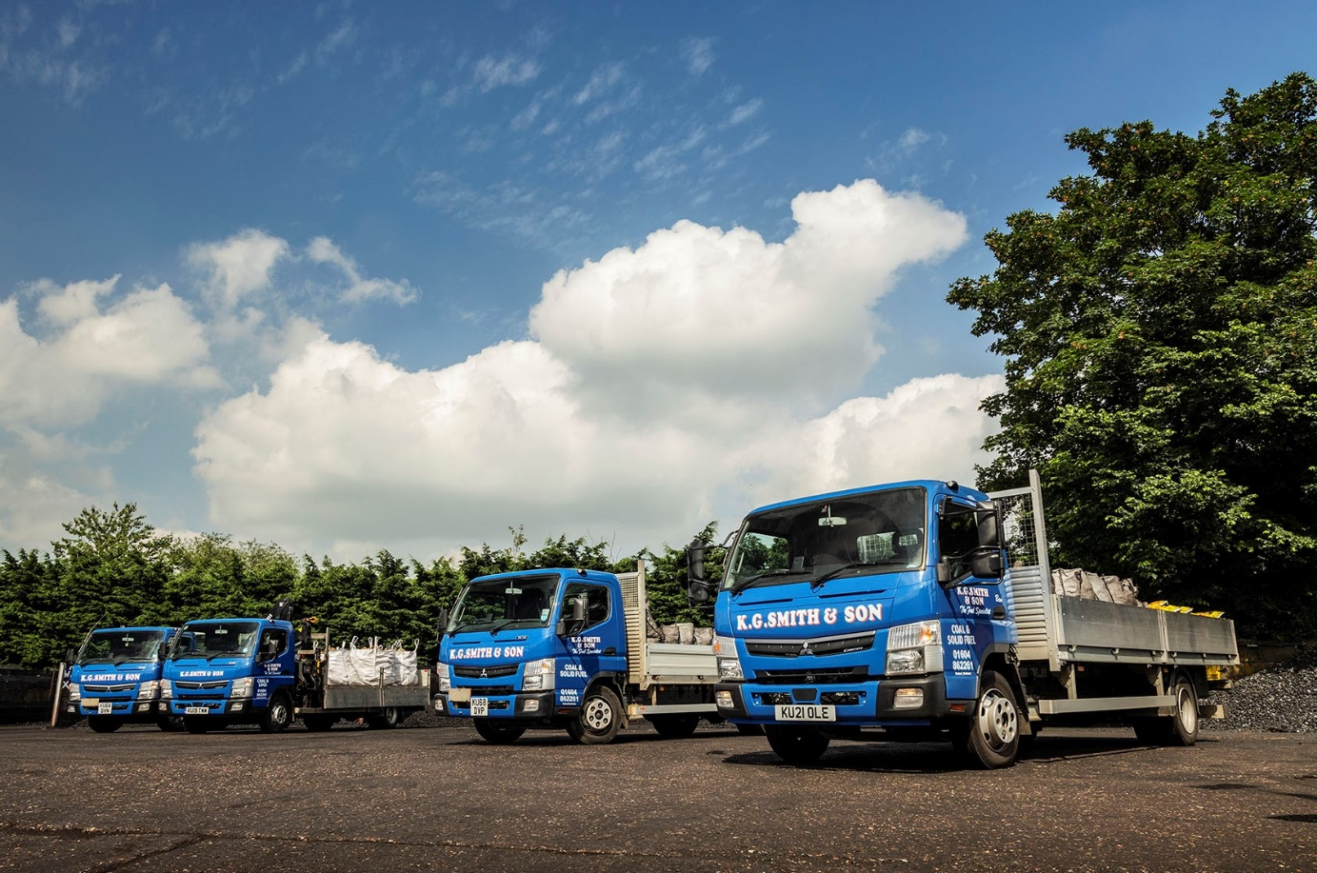

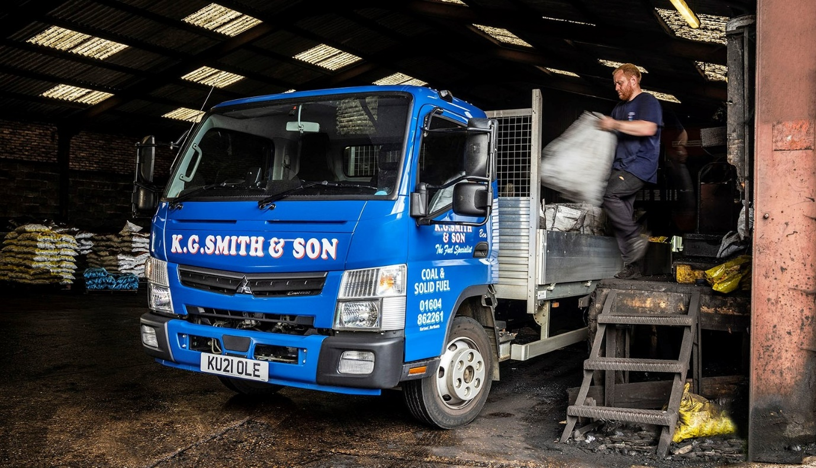

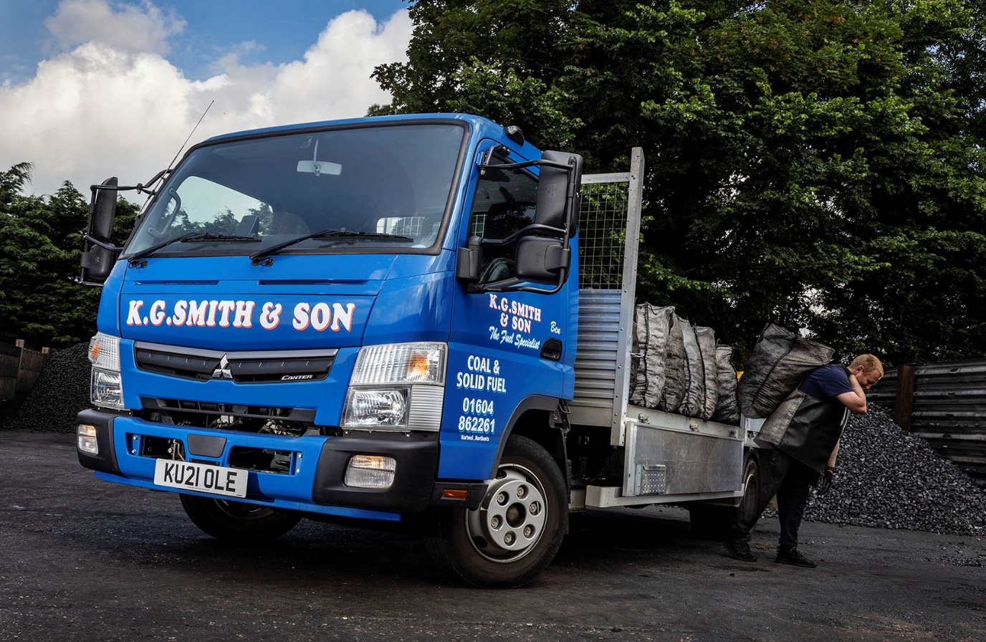

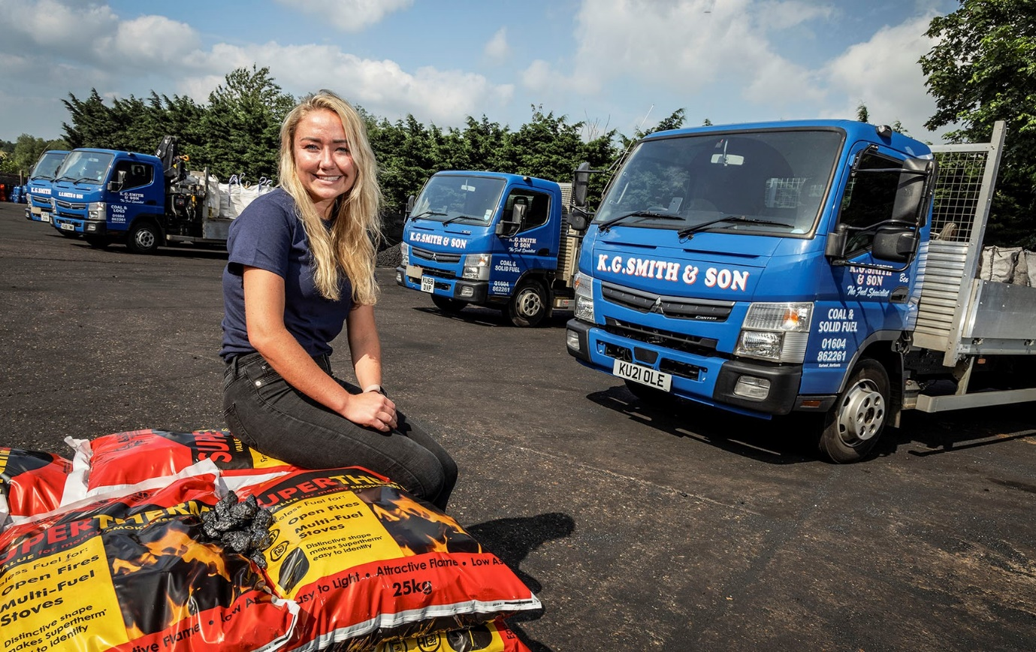

Relative values: Belinda Smith supports her father, Managing Partner Keith Smith, in the day to day running of a long-established family business that prides itself on its traditional values

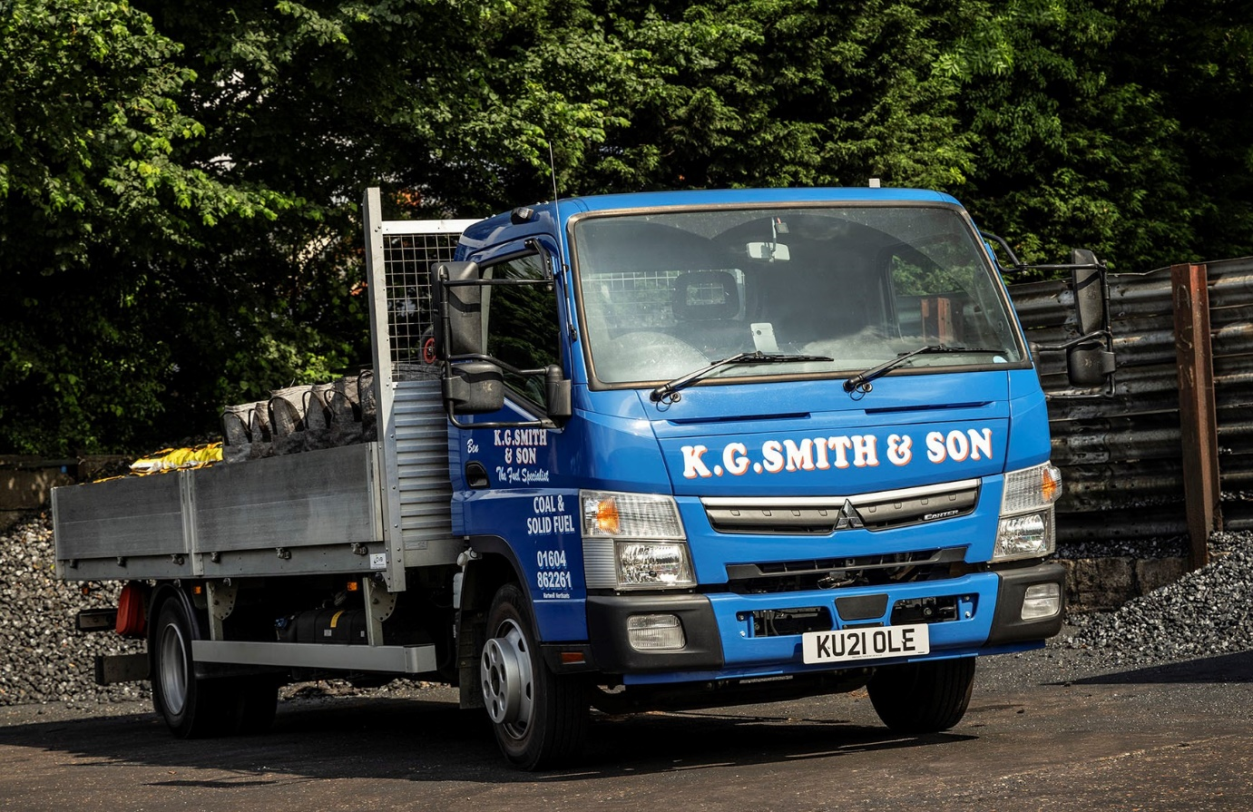

ends

For more information, or to request bigger/higher-res image files, please contact:
Steve Warren or John Ripley
Impact Communications, 01926 842126
Steve: 07770 470251, steve@impactcom.co.uk
John: 07771 484595, john@impactcom.co.uk

