

Date: 8 January 2019

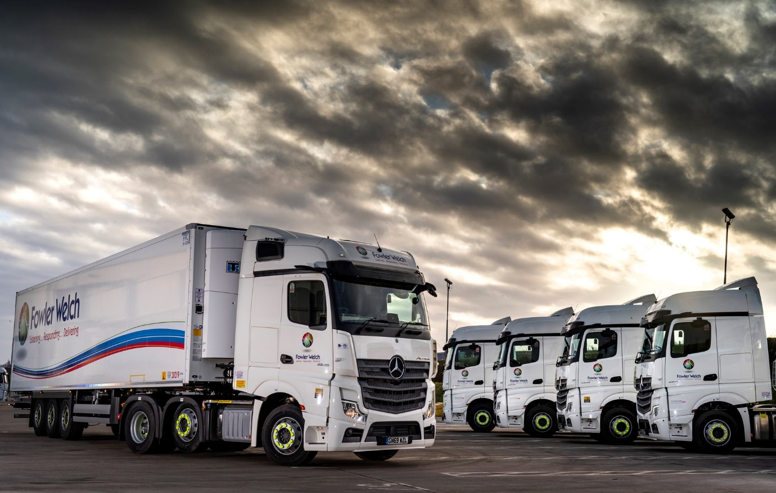

Fowler Welch looks to the future with new fleet of 21 Mercedes-Benz Actros

The growing partnership between Fowler Welch and Mercedes-Benz Trucks ‘came of age’ in December, as the chilled and ambient supply chain logistics specialist took delivery of 21 tractor units from the new-generation Actros range.

Fowler Welch operates a core fleet of some 450 tractor units and 800 semi-trailers. Maurizio Romano, the company’s Head of Fleet, recalled: “The evaluation outputs on the Actros we trialled earlier in the year were certainly favourable. Fuel-efficient trucks are vital, not only because of the contribution they make to our ‘bottom line’, but also because one of Fowler Welch’s core objectives is to do everything possible to reduce our carbon footprint.”

Fowler Welch’s latest Mercedes-Benz tractors were supplied by Dealer Sparshatt Truck & Van, and are operating from a depot in Teynham, Kent. Like the units which joined the company’s fleet in 2018, all are Actros 2545 models with flat-floored BigSpace cabs and 330 kW (450 hp) in-line six-cylinder engines.

The new arrivals, however, are from the fifth-generation Actros range, which in November won for Mercedes-Benz a record ninth International Truck of the Year title. New features include MirrorCam, which replaces conventional mirrors and promises increased safety as well as reductions in diesel consumption thanks to the compact, streamlined profile of the camera housings; the state-of-the-art Multimedia Cockpit; and an enhanced version of the Predictive Powertrain Control system, which makes a more substantial contribution to economy, while also ensuring that life at the wheel is easier for drivers.

Fowler Welch initiated and worked closely with Mercedes-Benz Trucks and Sparshatt Truck & Van on a painstakingly thorough ‘pre-life’ programme, to ensure that everything was in place before the trucks arrived. This covered everything from driver training, and the familiarisation for members of its Teynham-based team with key personnel and the aftersales support available from new service provider Sparshatt, to arrangements for regular performance reviews, and the manufacturer’s ‘road map’ for further advances in technology.

“Driver engagement and operational feedback were also very important factors in the decision-making process,” reported Maurizio Romano. “We don’t underestimate the impact on drivers and local teams of asking them to change from one make of truck to another, so it was important that their views were also considered.”

He continued: “Our relationship with Mercedes-Benz is still a relatively new one but it’s fair to say that Fowler Welch has been extremely pleased with the support it’s received, both during the procurement process, and in laying the necessary groundwork prior to delivery of the vehicles to site.

“Mercedes-Benz Trucks’ Key Account Manager Leanne Clark has been incredibly supportive, and the same goes for Sparshatt. Having executed the ‘pre-life’ element well between us, the focus now switches to the ‘in life’ phase.
“We’ll certainly be very interested to see how the drivers progress with MirrorCam, and to get a better feel for the benefits it offers from a safety perspective. I’ve been particularly impressed, too, with the strength of the Mercedes-Benz Dealer network, and am optimistic that the great relationships we’ve developed will help to ensure that when we need a particularly quick response – maybe on delivery of a part, or getting a truck back on the road – that’s exactly what we will get.”

Operating from headquarters in Spalding, Lincolnshire, Fowler Welch provides flexible, cost-effective and innovative supply chain solutions covering ambient and temperature-controlled products to many of the UK’s biggest and best-known food suppliers and retailers. Mr Romano added: “Long-term partnerships are what Fowler Welch is all about, and I’d like to think we’re now building one with Mercedes-Benz.”

www.fowlerwelch.co.uk

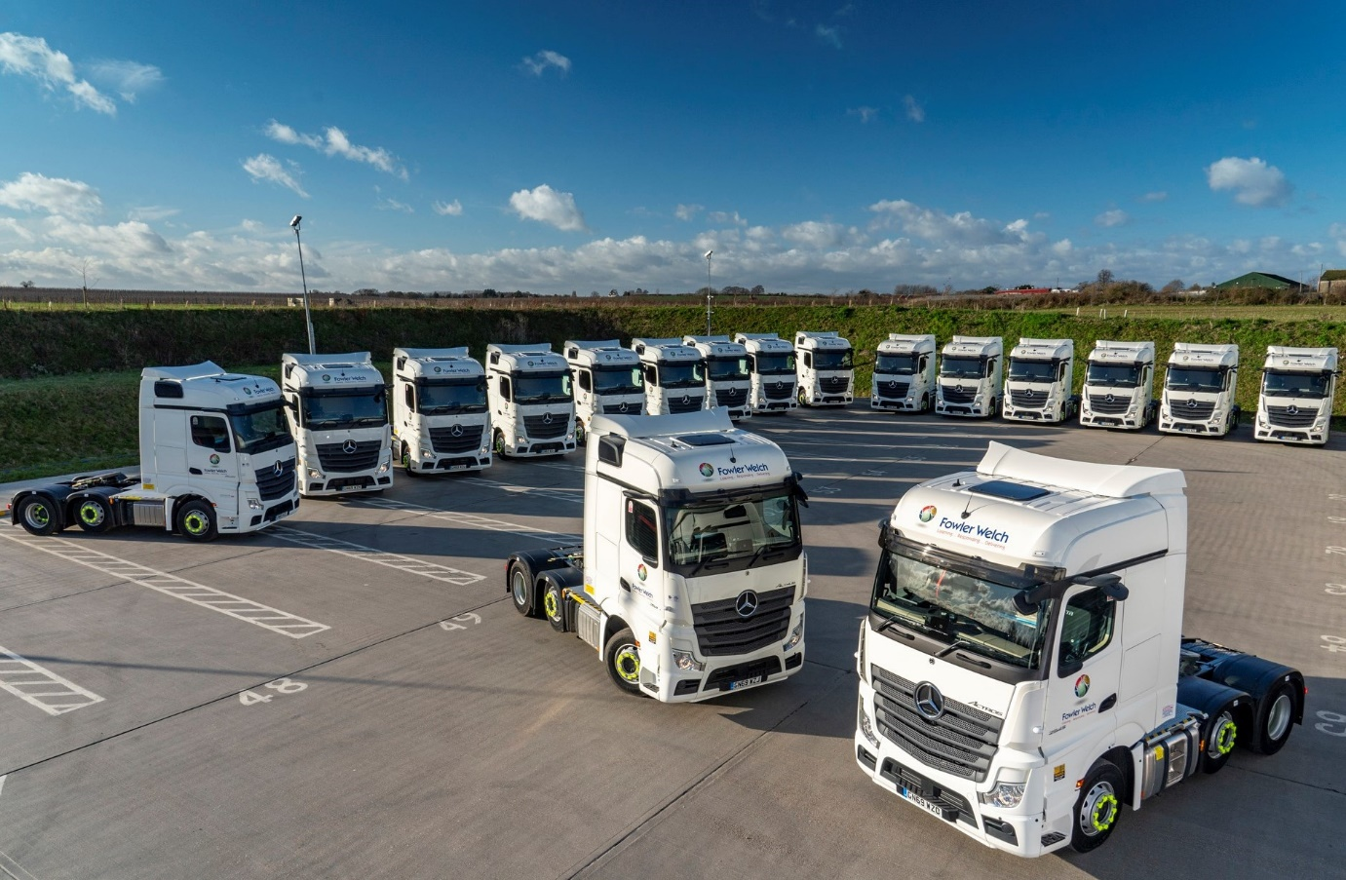

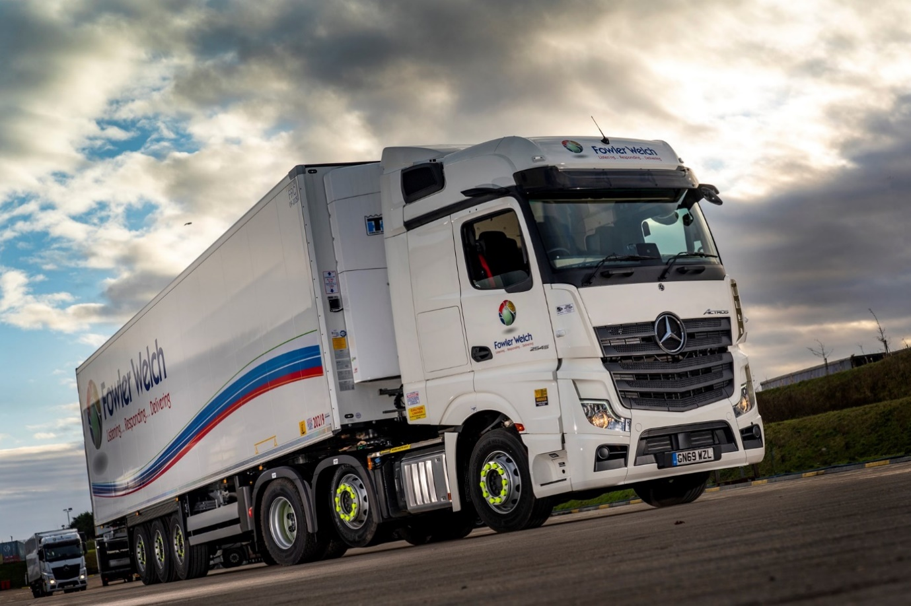

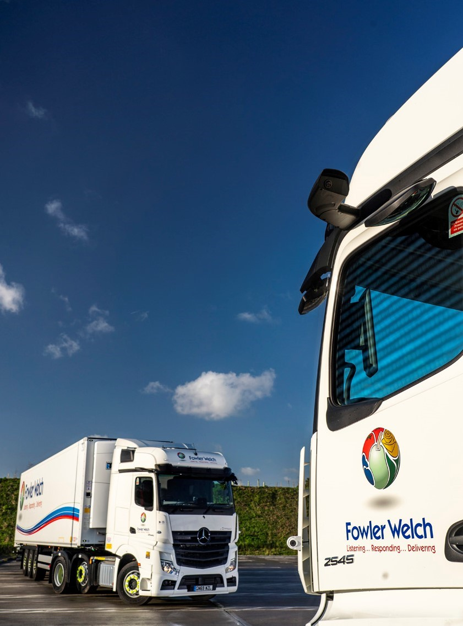

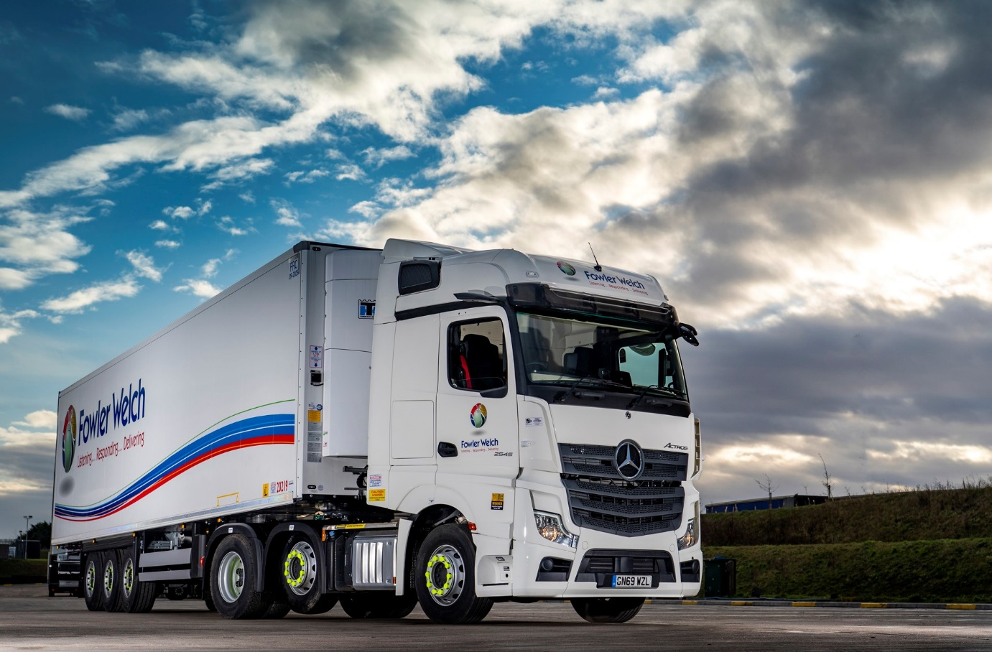

ends

For more information, or to request higher-res image files, please contact:

Jamie Fretwell at Mercedes-Benz Trucks UK Ltd
07712 519230, jamie.fretwell@daimler.com

or

Steve Warren or John Ripley
Impact Communications, 01926 842126
Steve: 07770 470251, steve@impactcom.co.uk
John: 07771 484595, john@impactcom.co.uk

About Mercedes-Benz Trucks UK Ltd
Mercedes-Benz Trucks UK Ltd is the sales and marketing organisation responsible for all Mercedes-Benz truck products in the UK, including FUSO Canter.

In 2018, the company registered 8,061 new trucks. Of them, 7,223 were Mercedes-Benz trucks, ensuring the brand retained its title as the second-biggest truck marque in the UK.
Meanwhile, FUSO registrations reached 838 – including 675 new trucks over 6.0-tonnes.

For more than 125 years, Mercedes-Benz has stood for innovative commercial vehicles that meet exceptionally high standards of quality. Our claim to perfection, sustainability and avant-garde design is now embodied in the next generation of trucks: Actros, Arocs, Atego, Econic and Unimog.
www.mbtrucks.co.uk

