

Date: 3 December 2020

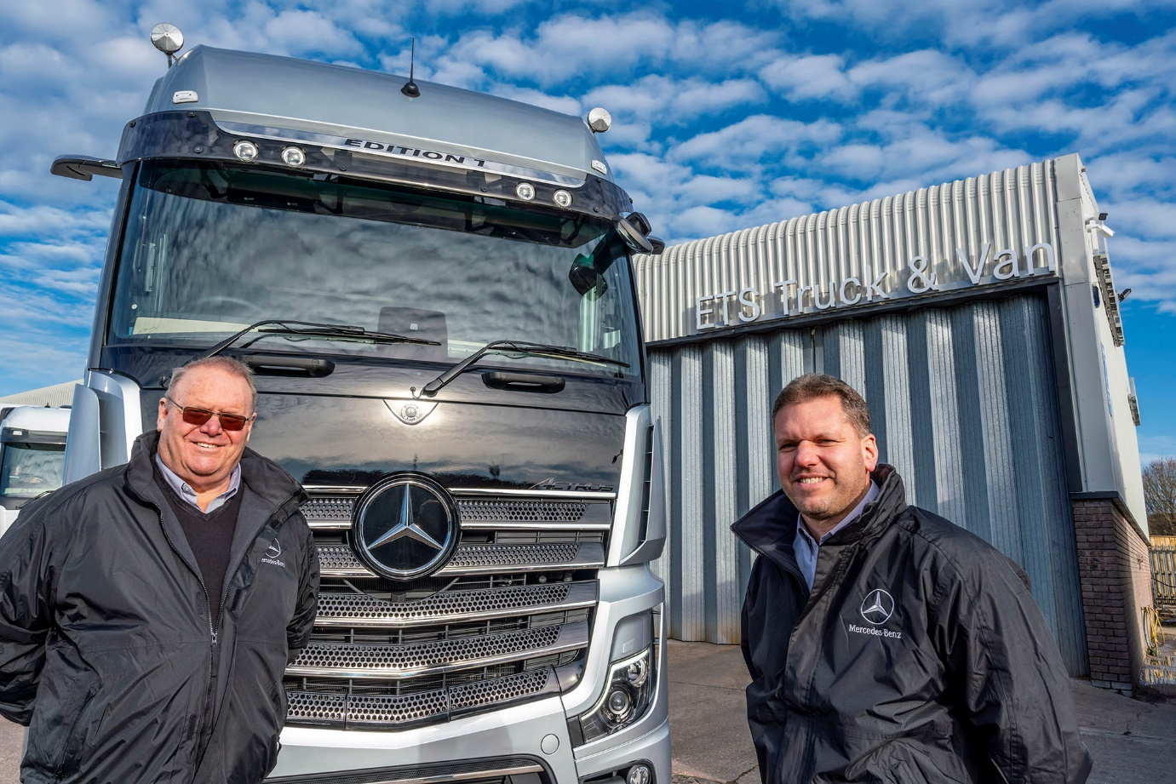

Gale force: Father-and-son Colin and Darren are committed to providing “high-quality maintenance, repair and parts services at sensible prices”

ETS is the new name driving Mercedes-Benz Trucks aftersales service in Dorset

More than 25 years after he last worked for a member of the Mercedes-Benz commercial vehicle network, Colin Gale has re-established his association with the manufacturer – this time, though, it’s the name of his own business that’s above the workshop doors.

ETS Truck & Van, of Blandford Forum, Dorset, is the latest addition to Mercedes-Benz Trucks’ expanding roll call of Authorised Repairers. Its appointment in November means that locally-based operators of trucks bearing the three-pointed star and three diamonds badge of FUSO, another Daimler brand, will continue to receive the timely and efficient, customer-focused back-up they are entitled to expect.

The opportunity to partner with Mercedes-Benz Trucks followed the acquisition by ETS Truck & Van in October 2019 of an established commercial vehicle maintenance facility on a site of more than half an acre in Shaftesbury Lane.

The company, which already represents two other truck manufacturers at its head office location in Poole, immediately embarked on a major programme of much-needed refurbishment to the six-bay workshop – two with pits – parts department and offices, before reopening on an independent basis.

Colin and his son Darren, ETS Truck & Van’s Operations Director, approached
Mercedes-Benz Trucks UK after learning that following the opening of its own flagship branch in Southampton, established franchisee Marshall Truck & Van had resolved to shut its workshop in Poole.

That closure last month coincided with the installation of the Mercedes-Benz signage 15 miles away at ETS Truck & Van’s depot in Blandford Forum, ensuring continuity of representation and a seamless transition for locally based operators.

“We’ve retained the overwhelming majority of customers who’d been using the Blandford facility and were ticking along quite nicely, despite the Covid-related disruption,” recalled Colin. “But the chance to take a big step up by becoming an Authorised Repairer for Mercedes-Benz Trucks was one we didn’t want to pass up.

“It’s certainly put the icing on the cake. The manufacturer’s representatives were positive from the outset and our new operation really stacks up now from a commercial perspective.”

The Blandford workshop is currently open from 6am until 8pm on weekdays, and from 7am until noon on Saturdays. It is also the base for a Mercedes-Benz Service 24h van which is manned by dedicated technicians who provide round-the-clock emergency roadside assistance.

While Colin retains oversight as Managing Director, responsibility for the day-to-day running of the operation falls to Darren, who is supported by Service Manager James Lalor-Ricketts, and Group Parts Manager Ryan Parker.

Other key members of the team include Administrator Rosie Goddard, who worked for the previous owner and is already a familiar figure to many customers, and Parts Advisor Lewis Coles and Delivery Driver Debbie Harvey, both of whom were recruited from Marshall Truck & Van, Poole.

“We have some great people who are proud to be representing the Mercedes-Benz Trucks brand,” continued Colin. “Our interest has always been in forging long-term relationships, by providing high-quality maintenance, repair and parts services at sensible prices.

“The aim, as far as possible, is to be a ‘one-stop shop’ for customers. To that end there’s a dedicated ATF (Authorised Testing Facility) lane at our Poole workshop that can also be used to MoT test Blandford customers’ trucks, and we have introduced additional services at the new branch such as tachograph installation and calibration, and brake testing. We’re also aiming to add LOLER weight testing for tail-lifts and will continue to extend our offer as the business develops.”

Having served his apprenticeship during the 1970s, Colin joined the former Mercedes-Benz franchisee in Poole as a technician in 1986. Over the next eight years he rose through Service Advisor and Service Manager roles to become General Manager.

When he left in 1994 it was to launch his own venture with Darren, who was then 18. Trading as Euro Truck Services, and operating initially from a rented workshop, the pair grew their business quickly before signing-up with their first OEM – and adopting the ETS name – in 1997.

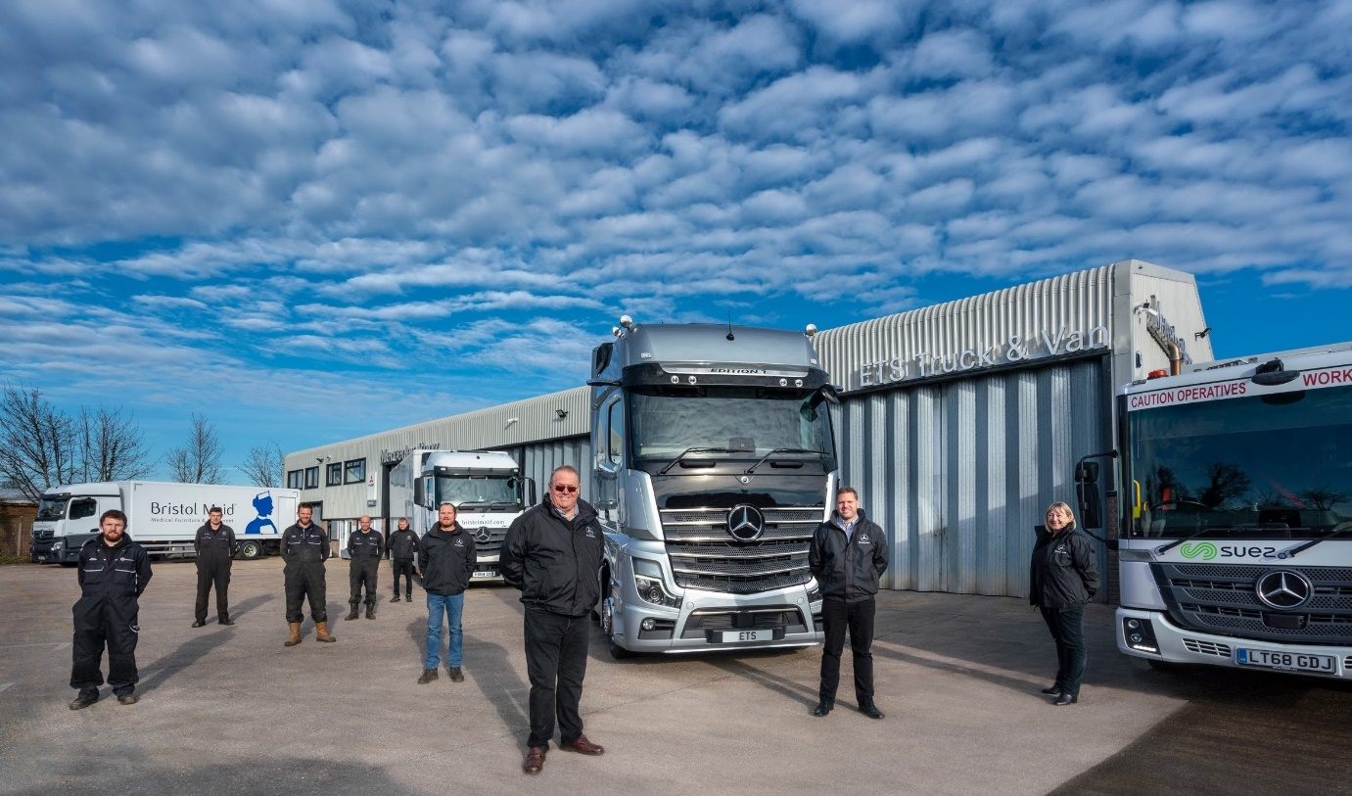

A new three-pointed star rises: ETS Truck & Van Managing Director Colin Gale and Operations Director Darren Gale, second from right, are pictured with colleagues, from left, Dave Corson, Jordan Young, Chris Kerley, Alan Mawer, Lewis Coles, James Lalor-Ricketts and Rosie Goddard

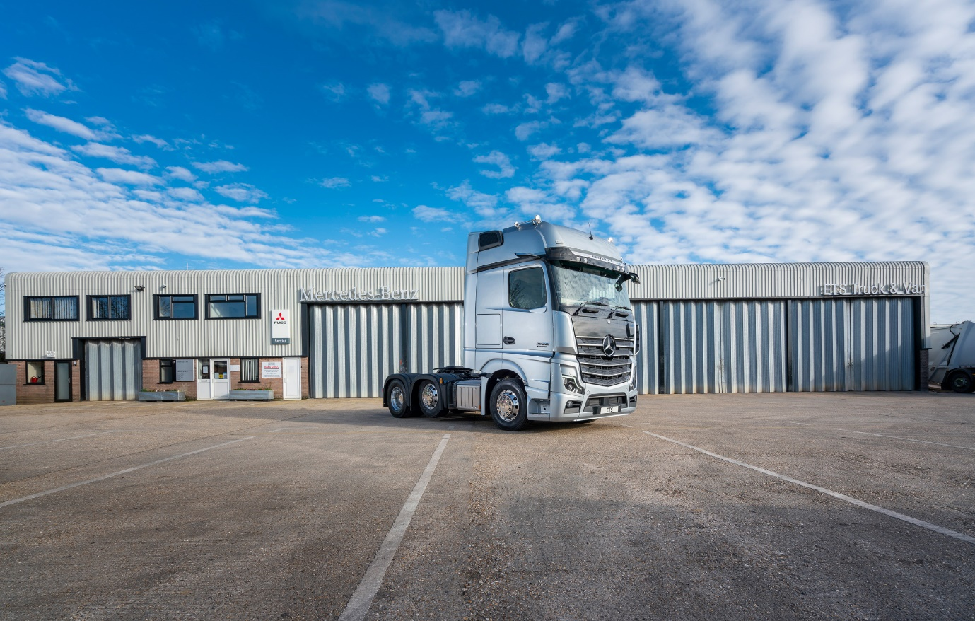

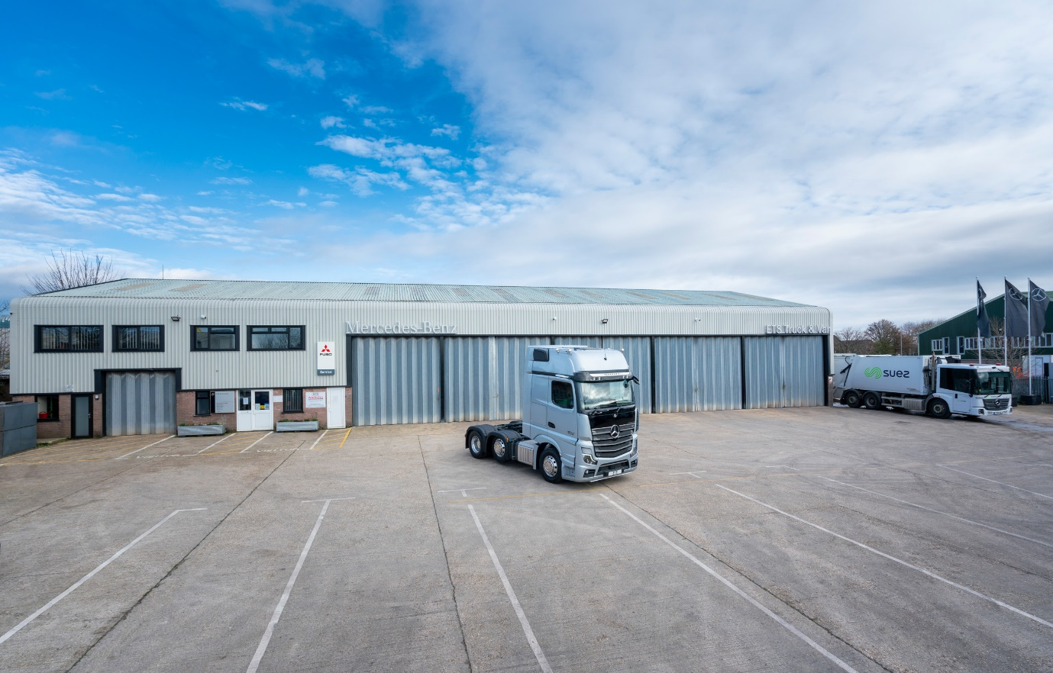

Space craft: ETS Truck & Van’s workshop in Blandford Forum offers plenty of room for customers to manoeuvre and park their vehicles
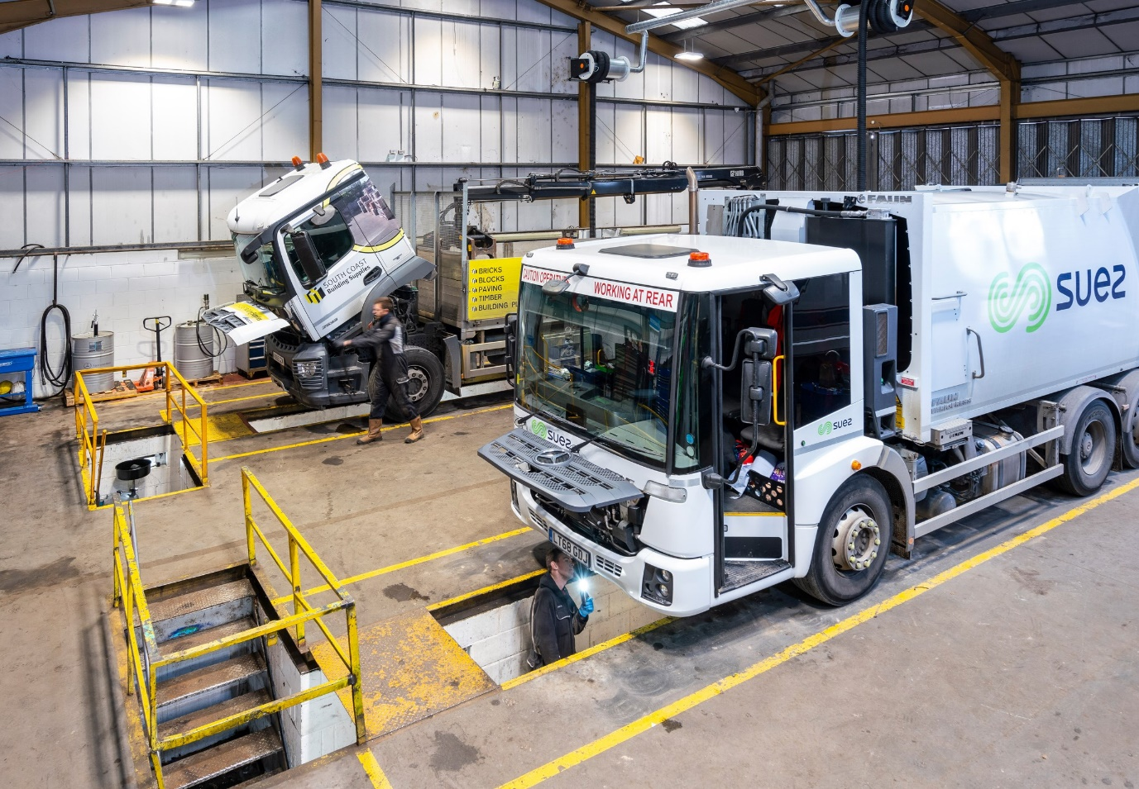

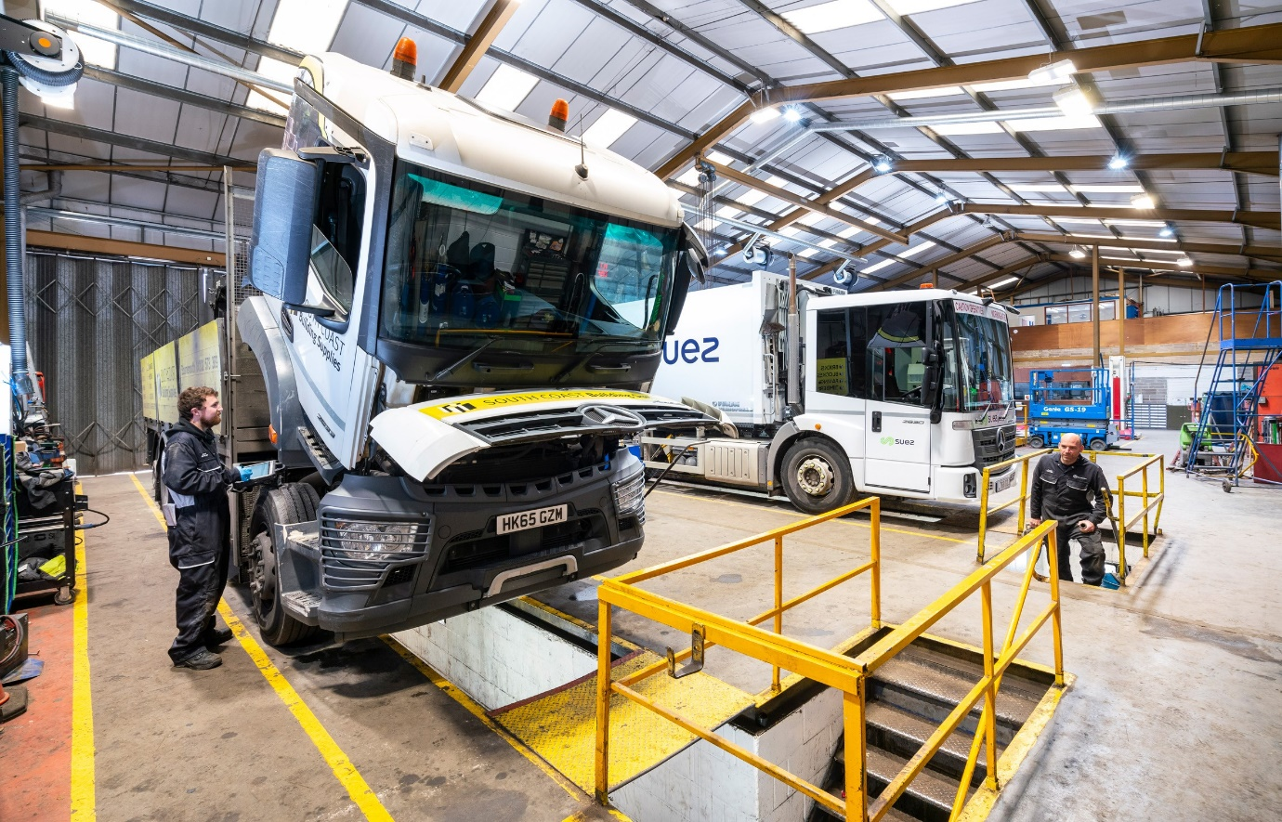

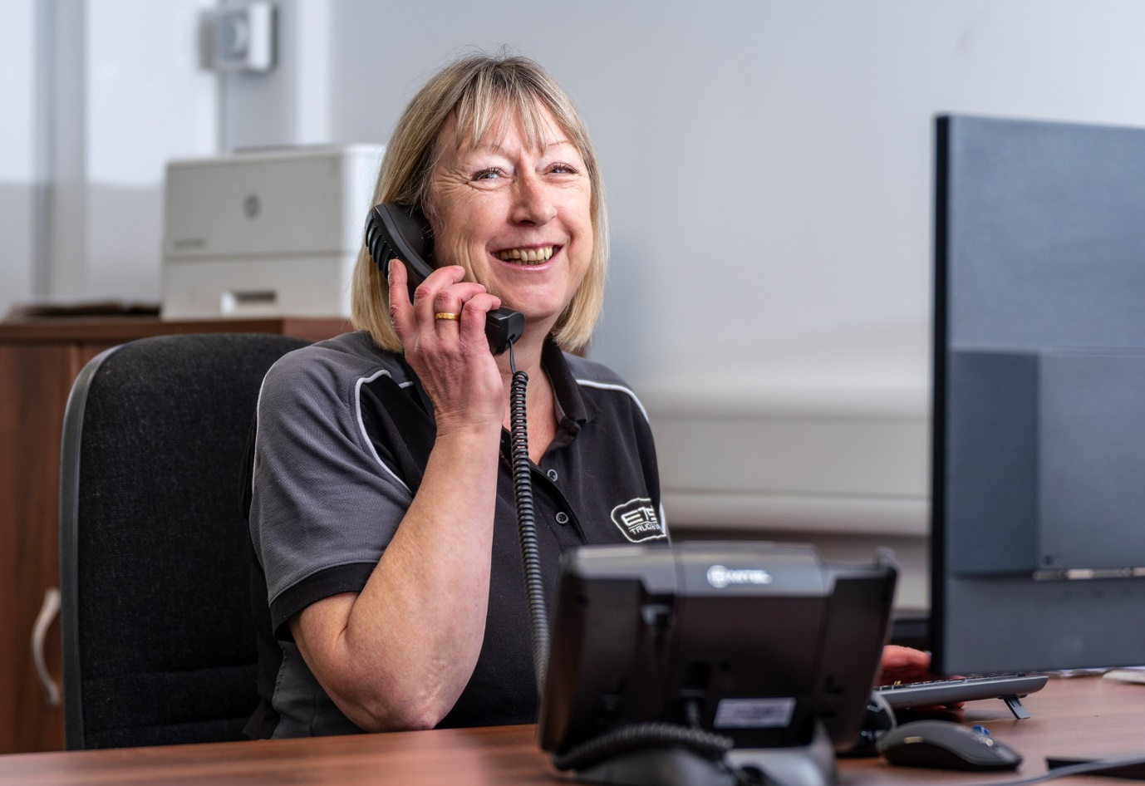

Familiar face: Rosie Goddard is already well known to many local truck operators

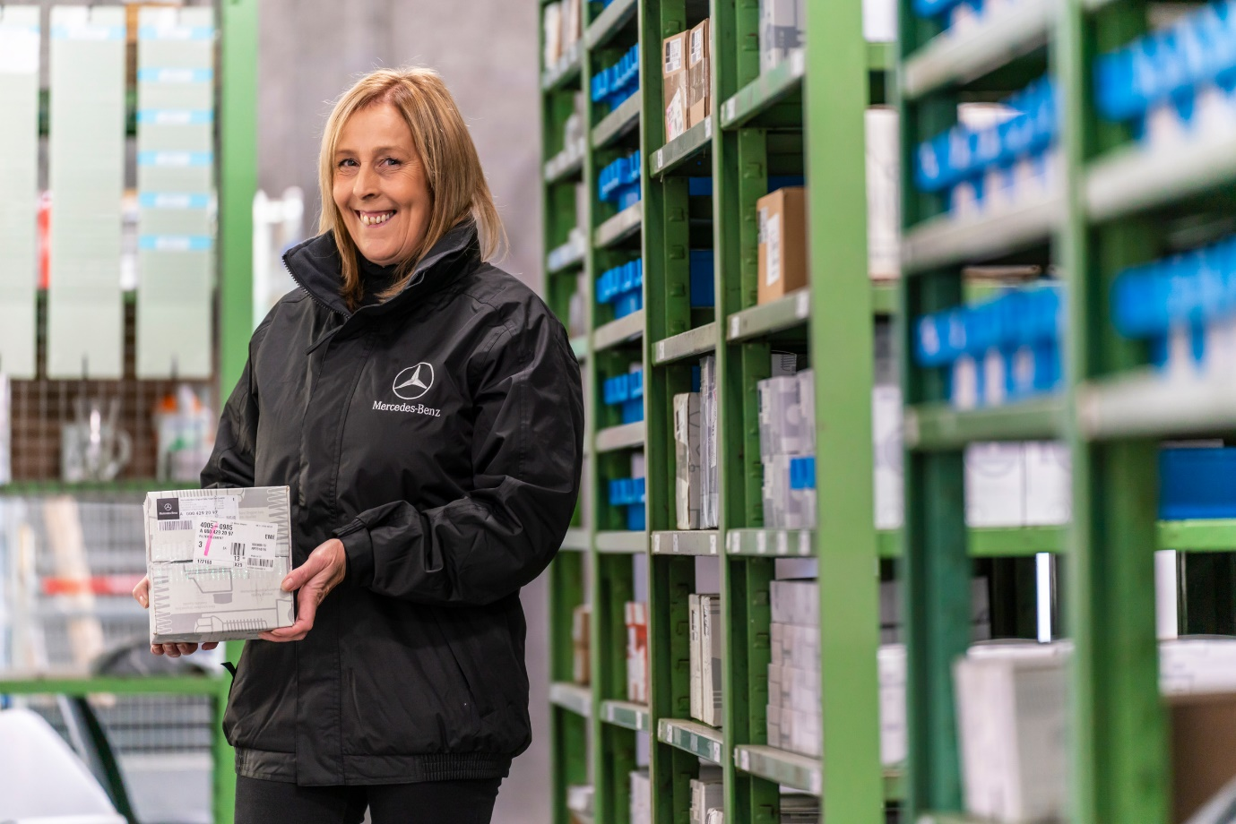

Playing her part: Experienced delivery driver Debbie Harvey is a recent recruit
ends

For more information, or to request higher-res image files, please contact:

Jamie Fretwell at Mercedes-Benz Trucks UK Ltd
07712 519230, jamie.fretwell@daimler.com

or

Steve Warren or John Ripley
Impact Communications, 01926 842126
Steve: 07770 470251, steve@impactcom.co.uk
John: 07771 484595, john@impactcom.co.uk

About Mercedes-Benz Trucks UK Ltd
Mercedes-Benz Trucks UK Ltd is the sales and marketing organisation responsible for all Daimler truck products in the UK, including FUSO Canter. In 2019, the company registered 6,963 new trucks. Mercedes-Benz accounted for 6,188 new trucks registered in 2019, making it the third-biggest truck brand in the UK. Meanwhile, FUSO registrations hit 775 – including 580 new trucks over 6.0-tonnes. The flagship new Mercedes-Benz Actros which won the 2020 International Truck of the Year award, features seven core innovations including MirrorCam, Multimedia Cockpit and Active Brake Assist 5. Our premium range of innovative trucks – Actros, Arocs, Atego, Econic and Unimog – draw upon more than 125 years of exceptionally high standards of quality, backed up by our promise of Trucks You Can Trust.
www.mbtrucks.co.uk

