

Date: 16 July 2019

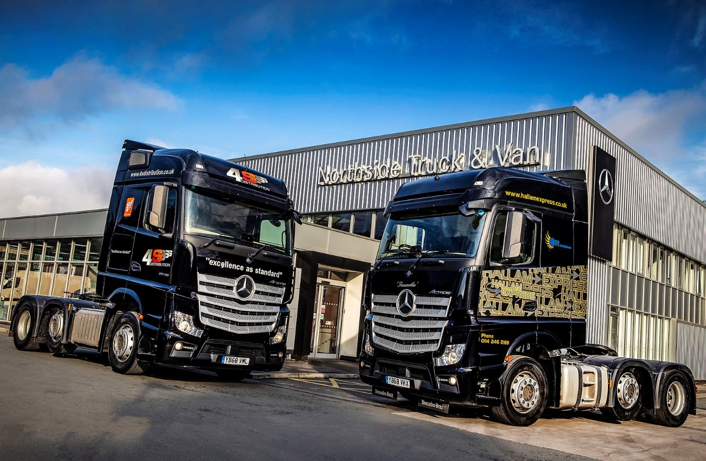

Mercedes-Benz Actros tractor units deliver valuable fuel cost savings for South Yorkshire operators

So pleased were sister companies 4S Distribution and Hallam Express with their first Mercedes-Benz Actros that less than six months after setting them on the road they had returned with an order for a combined total of 10 more tractor units from the new model range that arrives later this year.

The South Yorkshire general hauliers and pallet specialists each took delivery in January of a single Actros 2548 with flat-floored BigSpace cab, and second-generation 12.8-litre straight-six engine producing 350 kW (476 hp).

The subject of Mercedes-Benz Finance contract hire agreements, the two vehicles have proved highly economical, while the operators have also benefited from the efficient, customer-focused aftersales support provided by Mercedes-Benz Trucks’ reigning Dealer of the Year Northside Truck & Van.

4S Distribution is based in Rotherham and provides groupage and full load transport services, as well as representing the Palletforce network. It will be taking four of the next-generation Actros 2548s. The remaining six will be assigned to TPN (The Pallet Network) member Hallam Express, which has depots in Sheffield and Chesterfield.

The two companies previously favoured vehicles by the same Swedish manufacturer. However, David Simpson, who is Managing Director for both, confirmed: “The two Actros we’ve been trialling are very good on fuel, while Northside’s back-up is great.

“Our established supplier has been shutting at weekends, whereas the Mercedes-Benz Dealer’s Sheffield workshop remains open round-the-clock, seven days a week. The Actros have been efficiently maintained, with good turnaround times, and Northside also provides a collection and delivery service for preventive maintenance inspections (PMIs) and MoTs, which makes life a lot easier for us.

“Against this backdrop we had no hesitation in ordering a further 10 vehicles from the new Actros range. Some of these trucks will replace units that are coming off contract, but others represent extensions to the fleets, and will enable us to meet the continued growth in demand for our services.”

4S Distribution, which also provides transport and distribution services, runs eight tractor units. Operations Manager Ian Egan, who joined the company a year ago, reported: “In terms of mpg performance the Actros typically returns in the high nines or low tens, which means it’s between half a mile and a full mile per gallon ahead of our established vehicles.

“This doesn’t surprise me, as from previous experience of running Actros I know it to be exceptionally cost-effective as well as reliable to operate. Our own unit is on general haulage rather than pallet work, and assigned to a single driver who reckons it’s an excellent all-rounder.”

Mr Egan, who attended a new Actros launch event in Barcelona as a guest of Northside Truck & Van, continued: “I’ve worked with the Dealer before, and have strong contacts with its Sheffield team. They understand the crucial importance of vehicle availability, and will do whatever it takes to turn a truck round so it’s not off the road for any longer than is absolutely necessary.”
Ian Egan’s positive feedback is echoed by Steve Goodwin, his counterpart at Hallam Express. “The Actros is on a five-days-a-week bulk tramping operation, which involves anything from 44-tonne work to pulling very light loads,” he explained.

“The driver’s over the moon with his truck – he’s doing between 2,700 and 3,000 km a week, and averaging 11.7 mpg, with a best of 12.1. That compares very favourably to the Swedish-built units which are on broadly similar work, and in the mid-nines.”

Mr Goodwin has been with Hallam Express for three years but, like Ian Egan, has run Mercedes-Benz trucks in the past. “I’ve known Northside for over 10 years,” he said. “They’ve never let me down… ever!”

Northside Truck & Van’s latest Mercedes-Benz Truck Dealer of the Year award was its third in succession, and its fourth in five years. The company, which represents the three-pointed star in Yorkshire and north Lincolnshire, ascribes much of its success to its industry-leading staff training and development policies.

Reflecting this commitment to ‘growing its own’, the orders from 4S Distribution and Hallam Express were won by Vicki Light, who joined Northside in 2008 and was working as a Service Advisor before taking up a place on the Mercedes-Benz Trucks Sales Trainee Programme in 2017. She qualified in January, and passed her C+E test soon after, the Dealer having funded her training, so is now a fully qualified truck driver.

“We’re delighted to be doing business with 4S Distribution and Hallam Express,” Vicki commented. “Both are highly reputable operators here in South Yorkshire, and I can’t wait to deliver the new Actros, which are going to look fantastic in their liveries.”

4sdistribution.co.uk
www.hallamexpress.co.uk

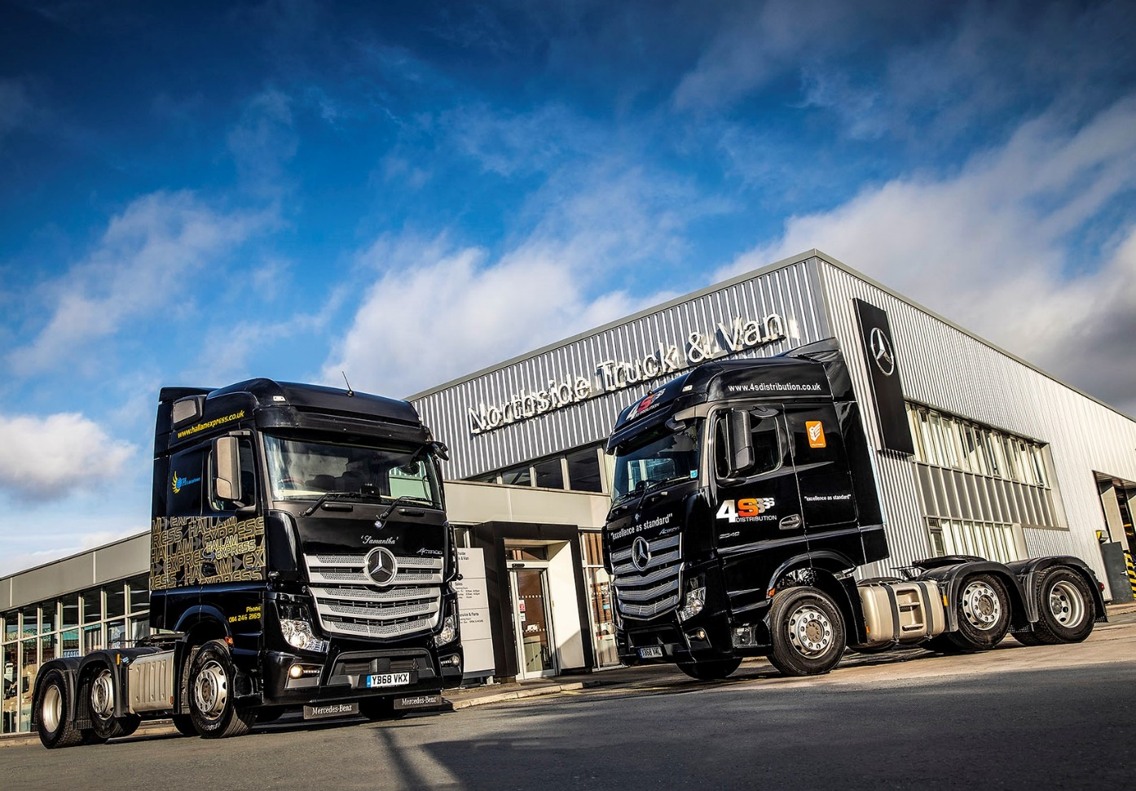

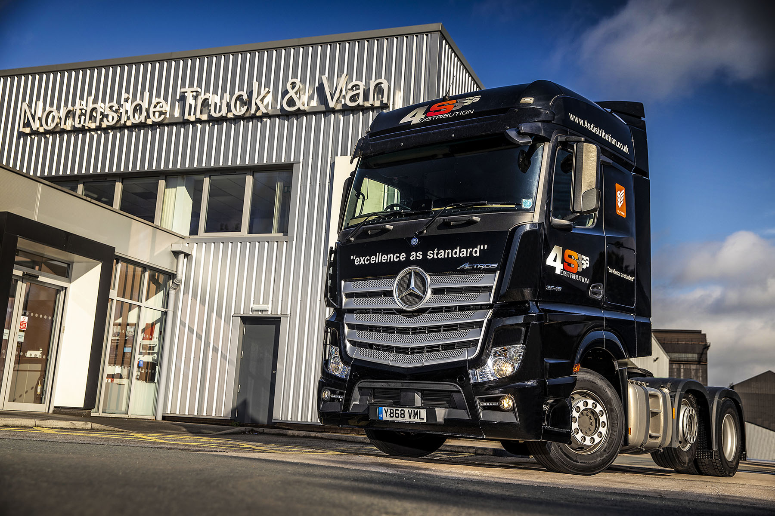

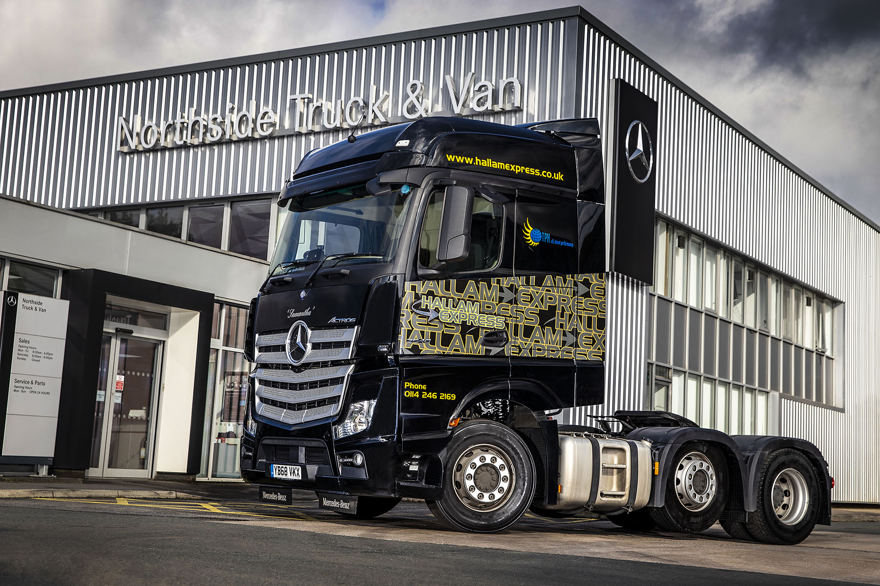

ends

For more information, or to request bigger/higher-res image files, please contact:
John Ripley or Steve Warren
Impact Communications, 01926 842126
John: 07771 484595, john@impactcom.co.uk
Steve: 07770 470251, steve@impactcom.co.uk

