

Date: 10 March 2021

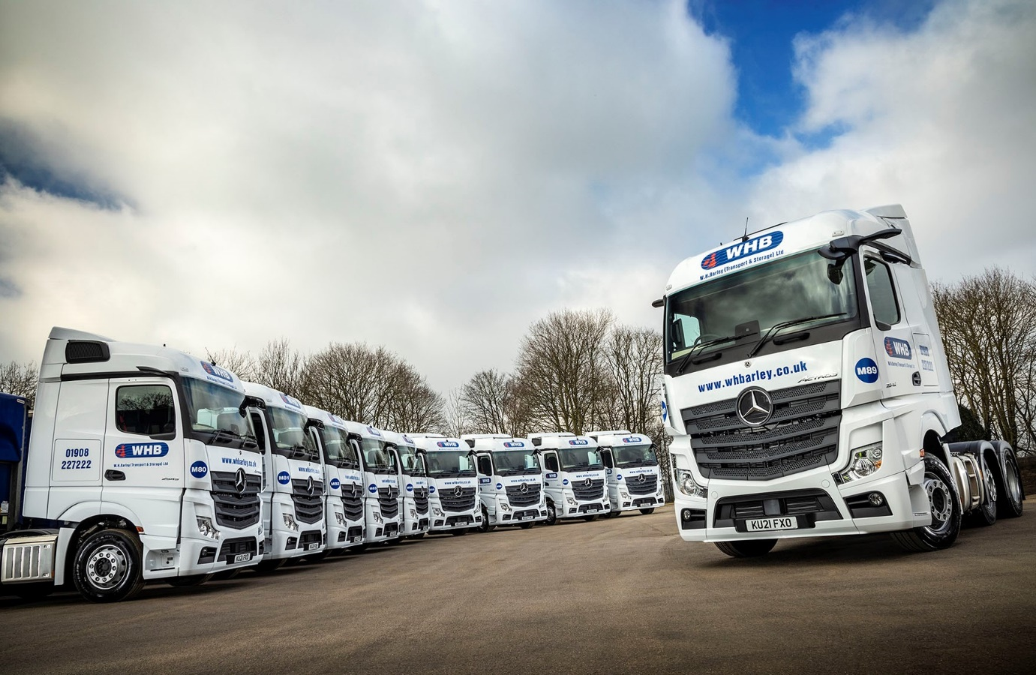

WH Barley fields 10 new MirrorCam-equipped Mercedes-Benz Actros from Intercounty Truck & Van

Reliable, cost-effective performance from its previous Mercedes-Benz Actros, coupled with a persuasive sales pitch from the local Dealer, were instrumental in convincing Milton Keynes-based WH Barley to grow its fleet by ordering another 10 tractor units bearing the three-pointed star.

Intercounty Truck & Van delivered the trucks on 1 March. All are Actros 2545 variants with aerodynamic StreamSpace cabs and 12.8-litre, in-line six-cylinder engines that produce 330 kW (450 hp). The subject of a Mercedes-Benz Finance contract hire agreement, they will be inspected and maintained at the Dealer’s Milton Keynes workshop.

WH Barley’s new tractor units are already hard at work for clients from the retail, wholesale and health sectors, hauling a variety of goods in curtainsided and refrigerated box trailers. Double-shifted, and running seven days per week, they will be expected to stand up to heavy use and high mileages without complaint.

The Palletline member’s fleet of more than 70 tractor units and rigid trucks includes another 16 vehicles by Mercedes-Benz. The new Actros, though, are its first since 2018.

They came equipped as standard with innovative MirrorCam technology. This replaces conventional mirrors with rear-facing cameras that relay their images to screens mounted inside the cab, on the A-pillars. As well as enhancing safety by providing much-enhanced all-round visibility, the system cuts diesel costs by an estimated 1.5% because the cameras’ compact, streamlined housings create far less wind resistance.

The latest, enhanced version of Mercedes-Benz Trucks’ well proven Predictive Powertrain Control (PPC) system also contributes to fuel efficiency, while WH Barley’s drivers benefit from Multimedia Cockpit, interactive. The optionally upgraded version of Mercedes-Benz Trucks’ radical, high-tech dashboard comes with a larger, 12in instrument panel and additional functionality.

Standard safety equipment includes a potential life saver in the form of Active Brake Assist 5, the emergency braking system that now employs cameras in addition to radar. At speeds of up to 50 kph, Active Brake Assist 5 can apply full braking automatically when encountering pedestrians crossing its path.

WH Barley Director Emma Barber, whose father Peter established the family business in 1970, said: “We’ve been running a pair of Actros tractor units for the last three years, and they’ve been exceptionally reliable, economical and popular with our drivers. We also enjoy a very good relationship with the service team at Intercounty Truck & Van’s local dealership, who have kept the trucks running smoothly, with minimal downtime.”

She continued: “Other manufacturers have raised their games too, though, so this latest order was definitely ‘up for grabs’. The fact that we’ve chosen to put our faith in Mercedes-Benz is largely down to the very impressive presentation and attentive, professional customer service of Intercounty’s Truck Sales Executive Amit Verma and his colleagues, as well as the attractive contract hire rates.”

WH Barley has high hopes for its new trucks’ ground-breaking technology. “Fuel efficiency is crucial,” said Ms Barber. “While our established Actros deliver excellent returns, we’re looking forward to seeing the additional contributions that MirrorCam and enhanced Predictive Powertrain Control can make toward reducing running costs.

“The camera housings give the trucks a clean, modern appearance too, and I’ve no doubt that equipment of this kind will become the norm before very long. We’ll also be gauging how much it helps our drivers in their day-to-day work, but the initial feedback has been very encouraging.”

WH Barley offers a range full-load, groupage and time-critical delivery services across the UK and beyond. It also boasts 100,000 sq ft of secure warehousing on its five-acre site at Old Wolverton.

Peter Barber is a former Chairman of the Road Haulage Association, while more recently Ms Barber has followed in her father’s footsteps by joining its Board of Directors. Currently Chairman of the Southern & Eastern Regional Council for the RHA and Vice-chairman of the Association’s Transport, Warehousing & Pallet Distribution Group, she has become a well-known figure within the industry. WH Barley is also a member of The Transport Association and currently holds the Fleet Operator Recognition Scheme’s Silver accreditation.

whbarley.co.uk

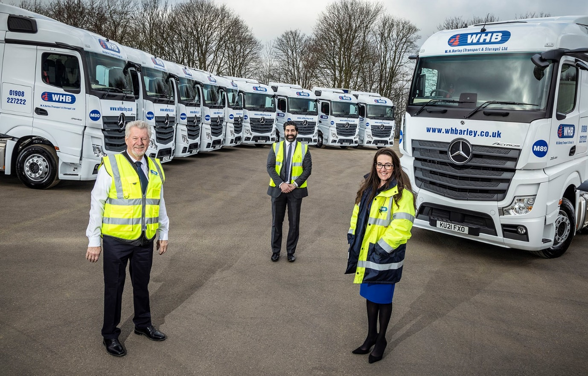

Looking forward: WH Barley’s Peter, left, and Emma Barber, pictured with Amit Verma of Intercounty Truck & Van, are expecting to reap fuel efficiency benefits from their high-tech Mercedes-Benz Actros

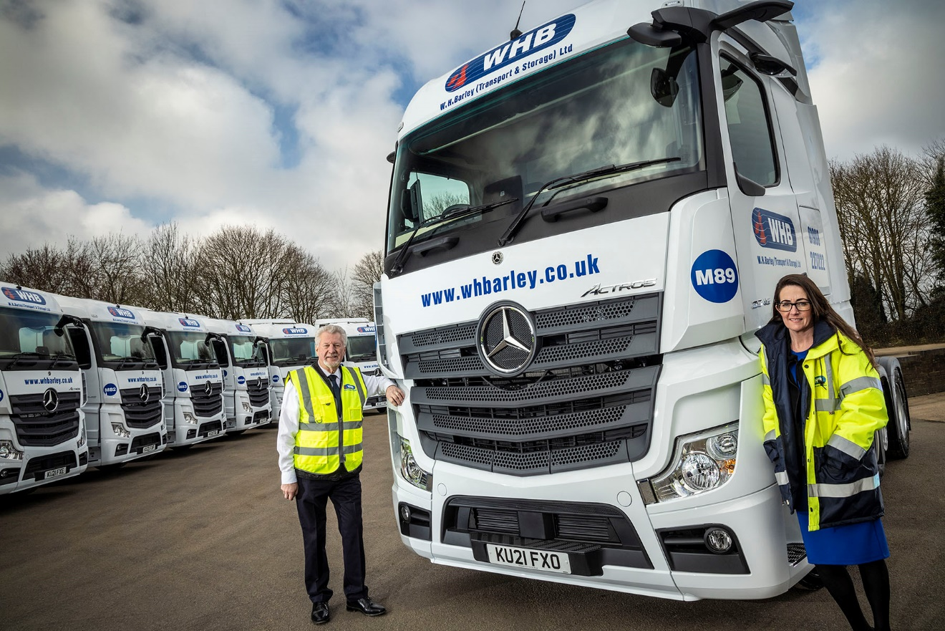

Family values: WH Barley Directors Peter and Emma Barber, with their new Actros

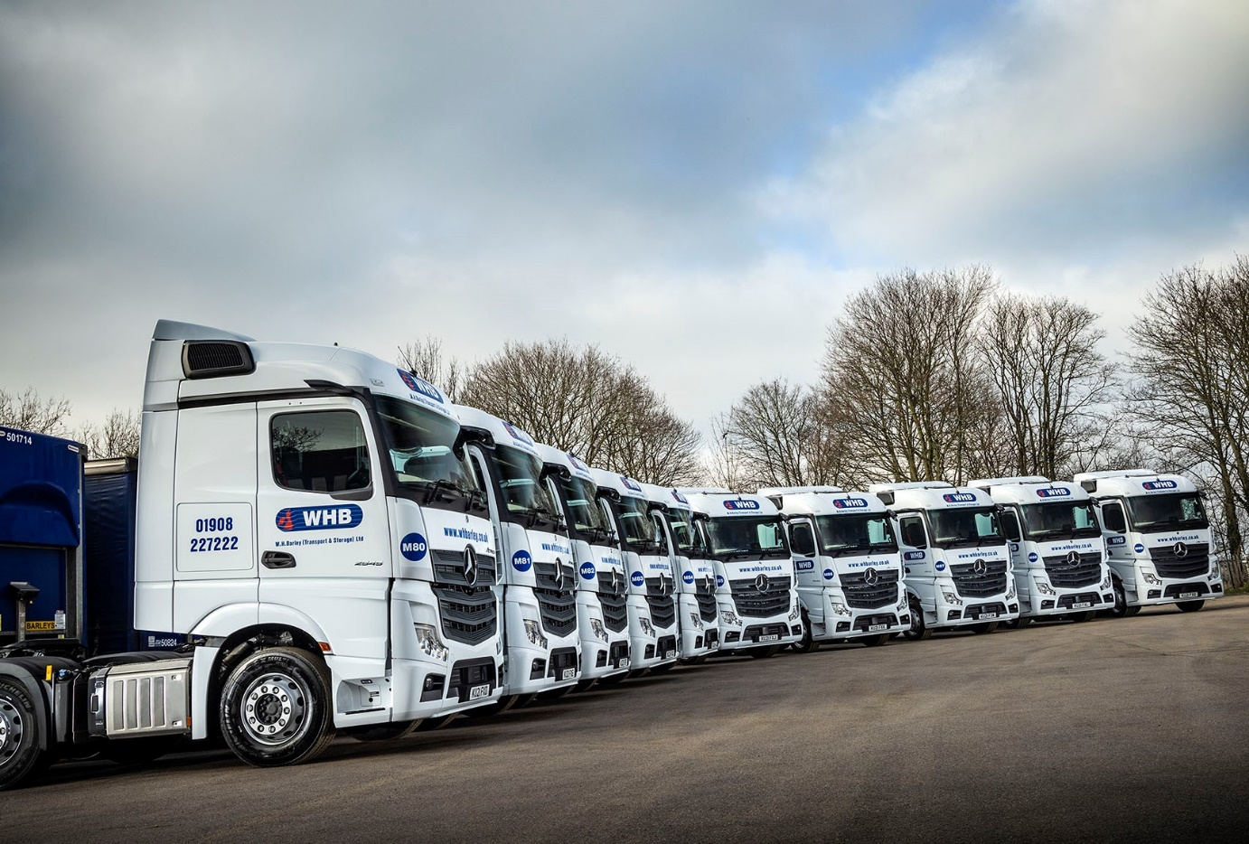
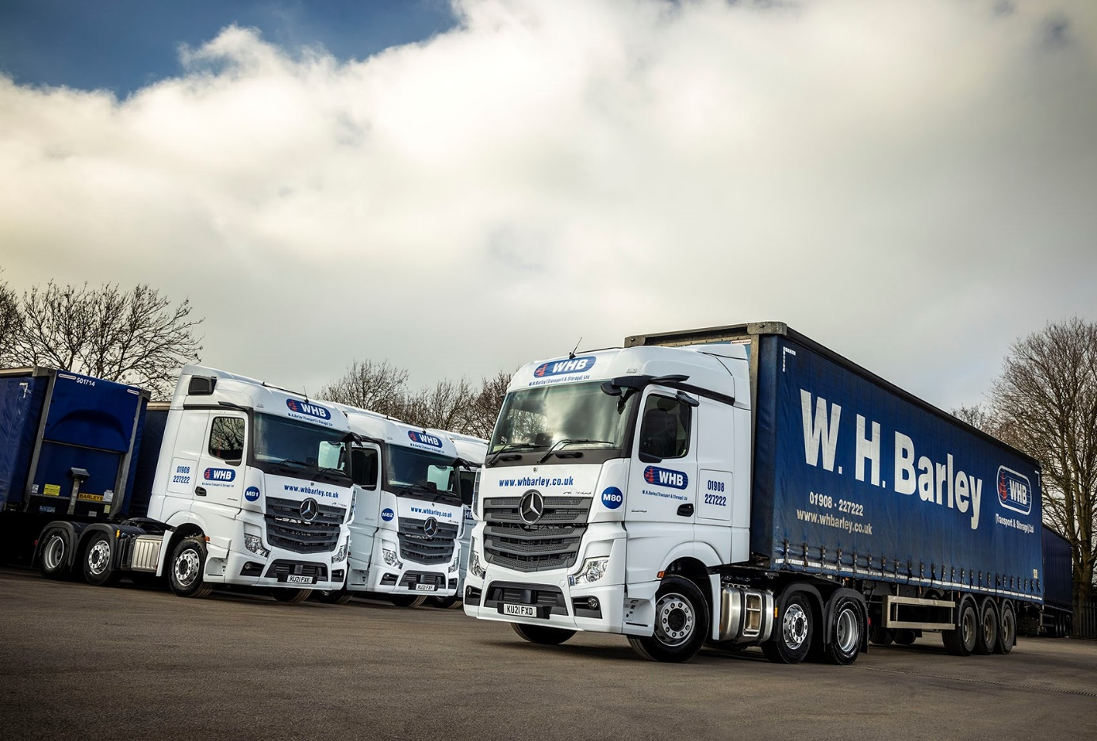

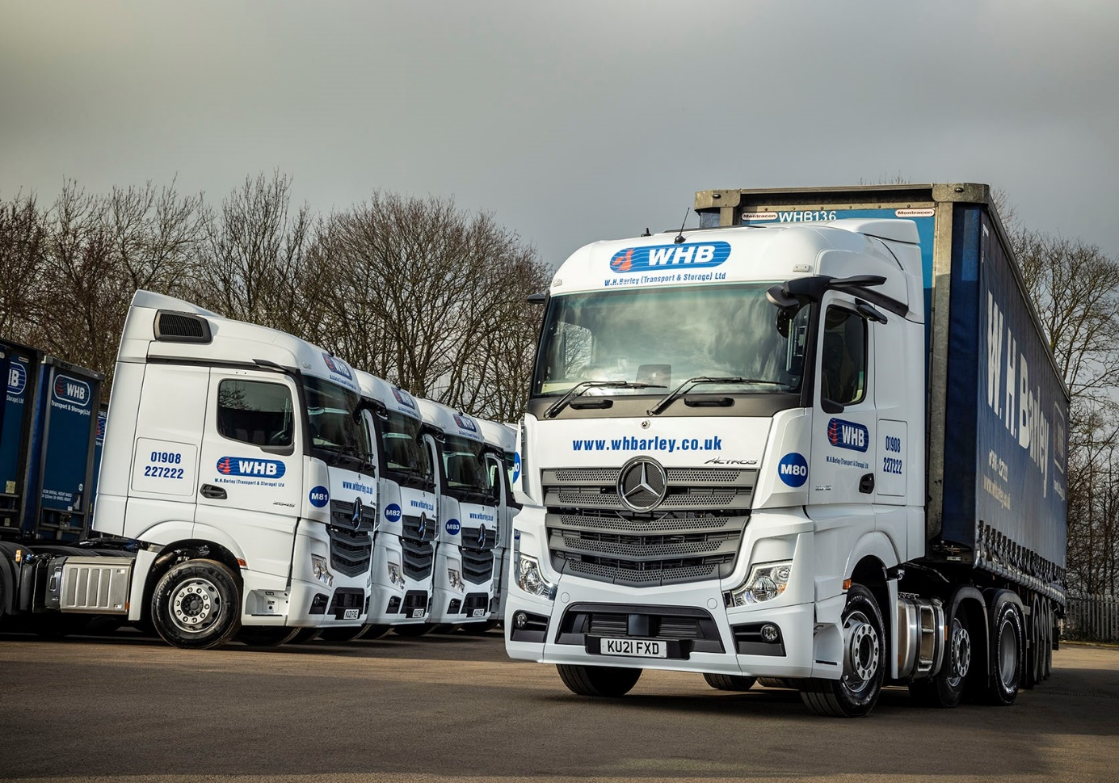
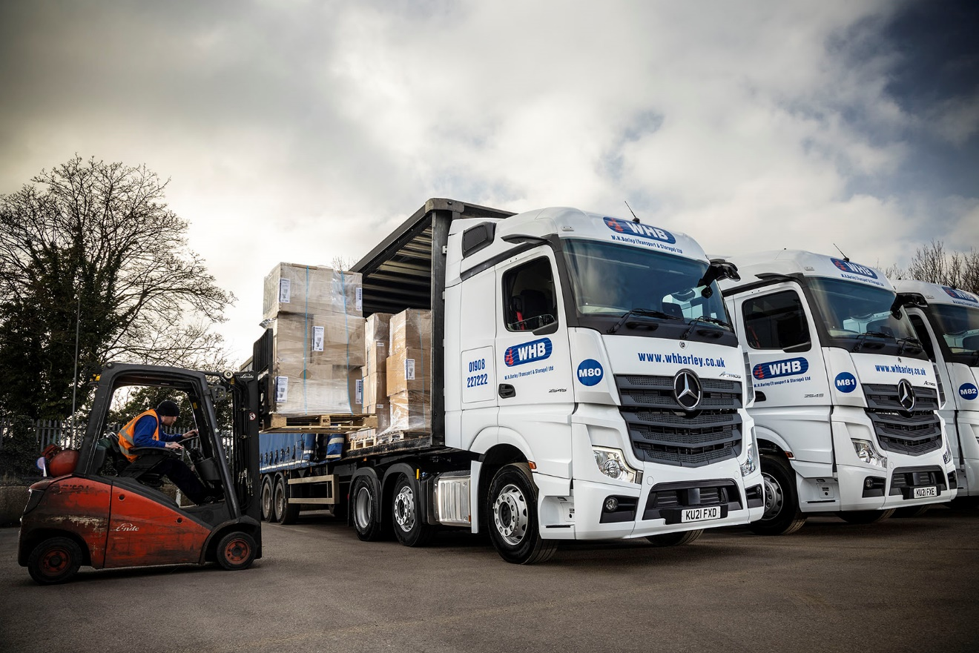

ends

For more information, or to request bigger/higher-res image files, please contact:
John Ripley or Steve Warren
Impact Communications, 01926 842126
John: 07771 484595, john@impactcom.co.uk
Steve: 07770 470251, steve@impactcom.co.uk

