

Date: 4 November 2019

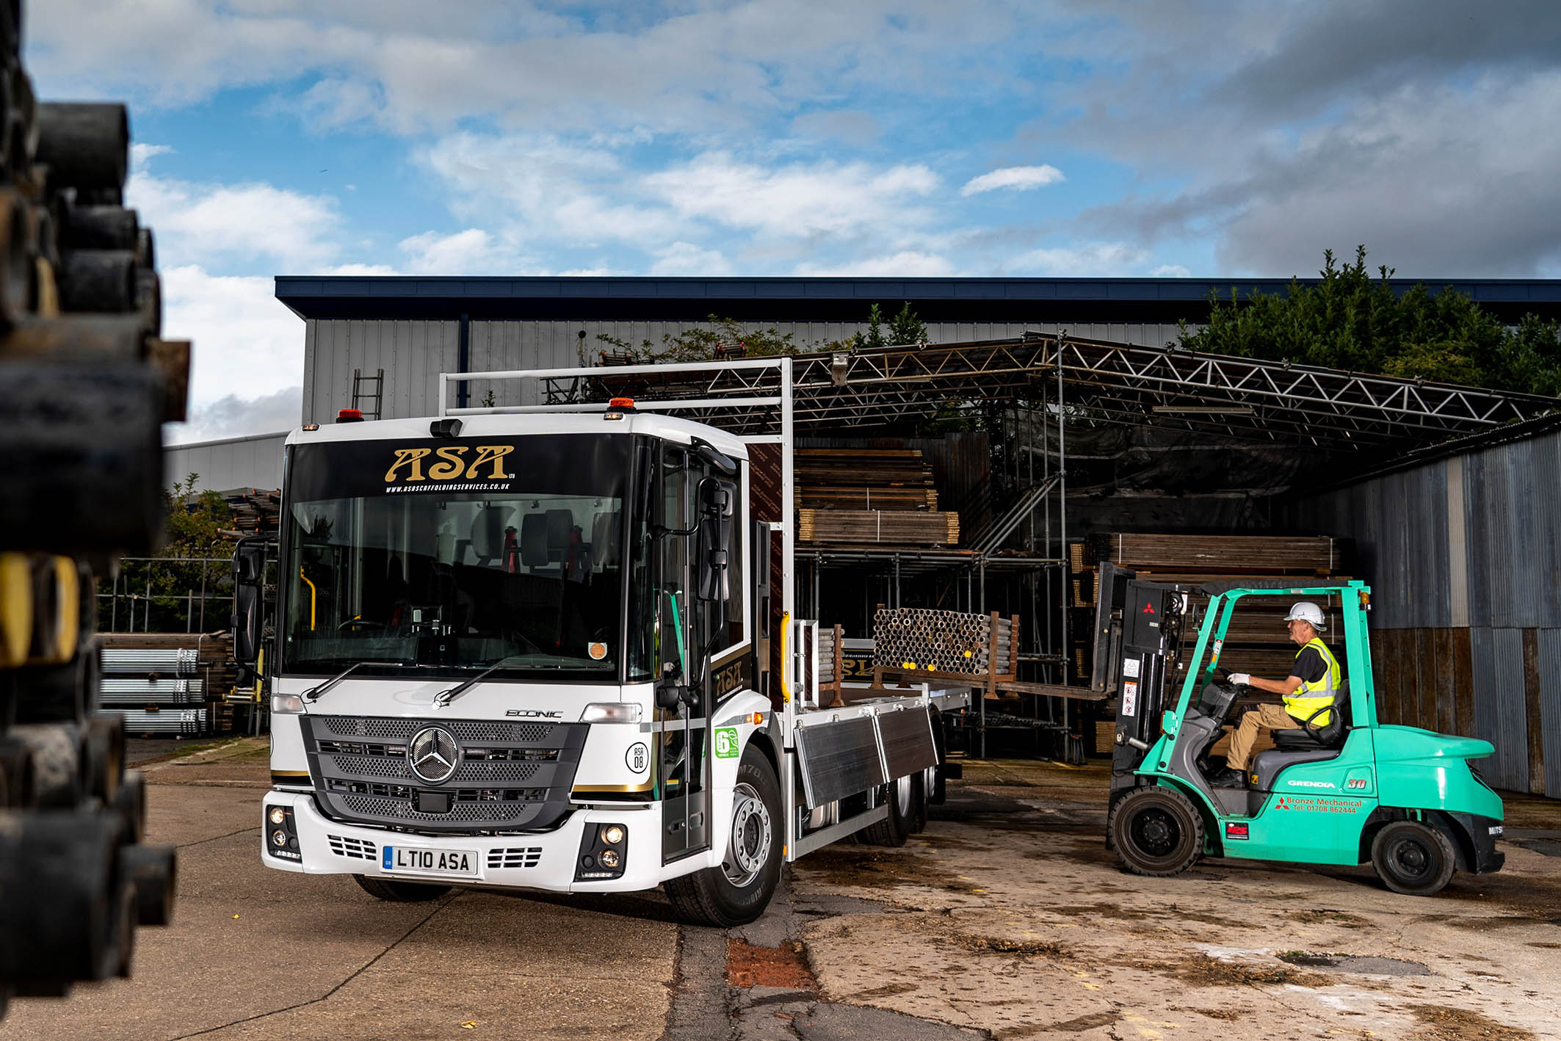

ASA Scaffolding raises safety standards with new Mercedes-Benz Econic from Marshall Truck & Van

One of the scaffolding industry’s first low-entry Mercedes-Benz Econic trucks has entered service with a south London firm for which safety and compliance are top priorities.

Croydon-based ASA Scaffolding Services undertakes much of its work in the centre of the capital, where the Econic’s unrivalled Direct Vision credentials are a major advantage.

Supplied by Dealer Marshall Truck & Van, the 26-tonne Econic 2627L has a lifting rear axle which can also be steered, significantly enhancing manoeuvrability in areas where access is restricted. The truck’s 7.7-litre six-cylinder engine produces 200 kW (272 hp) and is paired with a Mercedes PowerShift automated manual transmission, while its purpose-designed split dropside body is by Spectra Specialist Engineering, of Westbury, Wiltshire.

The Econic is now working alongside ASA Scaffolding’s five other Mercedes-Benz trucks – a muscular 26-tonne Arocs, and four 18-tonners based on a combination of Arocs and Atego chassis. Completing the line-up is a single 7.5-tonner from the FUSO Canter light truck range which is also sold and supported by Mercedes-Benz Dealers in Britain.

Greater Safety is one of the three pillars of Mercedes-Benz Trucks all-encompassing RoadEfficiency strategy. The Econic has been awarded a five-star Direct Vision rating by Transport for London, thanks to its deep, panoramic windscreen, and full-height, glazed folding side door. A seating position which is much lower than that of a conventional truck, also allows the driver to make direct eye contact with cyclists and pedestrians at junctions or in traffic queues.

To a comprehensive standard specification that includes Active Brake Assist 4 emergency braking technology with pedestrian recognition, ASA Scaffolding has added the optional Blind Spot Camera System and Sideguard Assist.

The Blind Spot Camera System comprises a seven-inch monitor, two blind spot cameras on the exterior mirrors, a front camera and a reversing camera to provide additional, indirect vision, further reducing the risk of injury to vulnerable road users.

Sideguard Assist, meanwhile, employs two short-range radar sensors mounted on the passenger side of the vehicle, which support the driver when making left turns or changing lines in congested areas, by triggering optical and acoustic warnings to alert them to the presence of cyclists and pedestrians alongside.

Mercedes-Benz has secured a string of high-profile orders in recent years for Econic-based mixers, tippers, tipper-grabs and skip-loaders, and for fridge-bodied rigids and tractor units which are now in service with food sector operators.

ASA’s truck, however, is one of the first to be commissioned by a scaffolding firm. Acquired with competitive funding support from Mercedes-Benz Finance, it is backed – like all new Econics supplied through the manufacturer’s UK Dealer Network – by a three-year/160,000 km warranty.

ASA Scaffolding was established in 2008 by Managing Director Lee Tolan, and serves commercial and domestic customers throughout London, Sussex, Surrey and Kent. Explaining the rationale behind its decision to purchase the Econic, Mr Tolan said: “Our very strong safety culture extends to the vehicles we run, as well as the scaffolding we erect.

“We’d heard and read a lot of positive reports about the safety benefits which the Econic offers, and these are clearly well founded. Thanks to its wraparound screen and glazed side door, the view is fantastic, which is particularly beneficial in the middle of the city.

“Factor in the optional safety aids we’ve added, and you can see how determined we are to protect other road users while also making the job less stressful for our driver. This applies not only to time spent at the wheel, but also when the truck is at our depot or out on site, as the lower deck height makes the job of loading and unloading that bit easier too.”

Mr Tolan continued: “We do a lot of our work for local authorities, so compliance is also very high on our agenda. It isn’t enough to operate in a safe and responsible manner, you have to be seen to be doing so. I’d like to think, therefore, that this new truck is also going to help us win more business from established and prospective customers.”

Having previously operated used Mercedes-Benz trucks, ASA Scaffolding bought its first new models – a pair of 18-tonne Arocs 1824s – in 2015. “The scaffolding industry hasn’t always had the best of images,” said Mr Tolan. “That’s one of the reasons I’ve remained loyal to the Mercedes-Benz brand.

“As well as being ultra-reliable and well capable of carrying the weights we need, the fact that our trucks have three-pointed stars on the front helps us to demonstrate that we’re a professional company capable of providing a high-quality service.”

Mr Tolan is a former champion Moto X motorcross rider who now runs his own team. He currently travels between events in a purpose-built motorhome which, like its two predecessors, is based on an 18-tonne Mercedes-Benz chassis.

www.asascaffoldingservices.co.uk

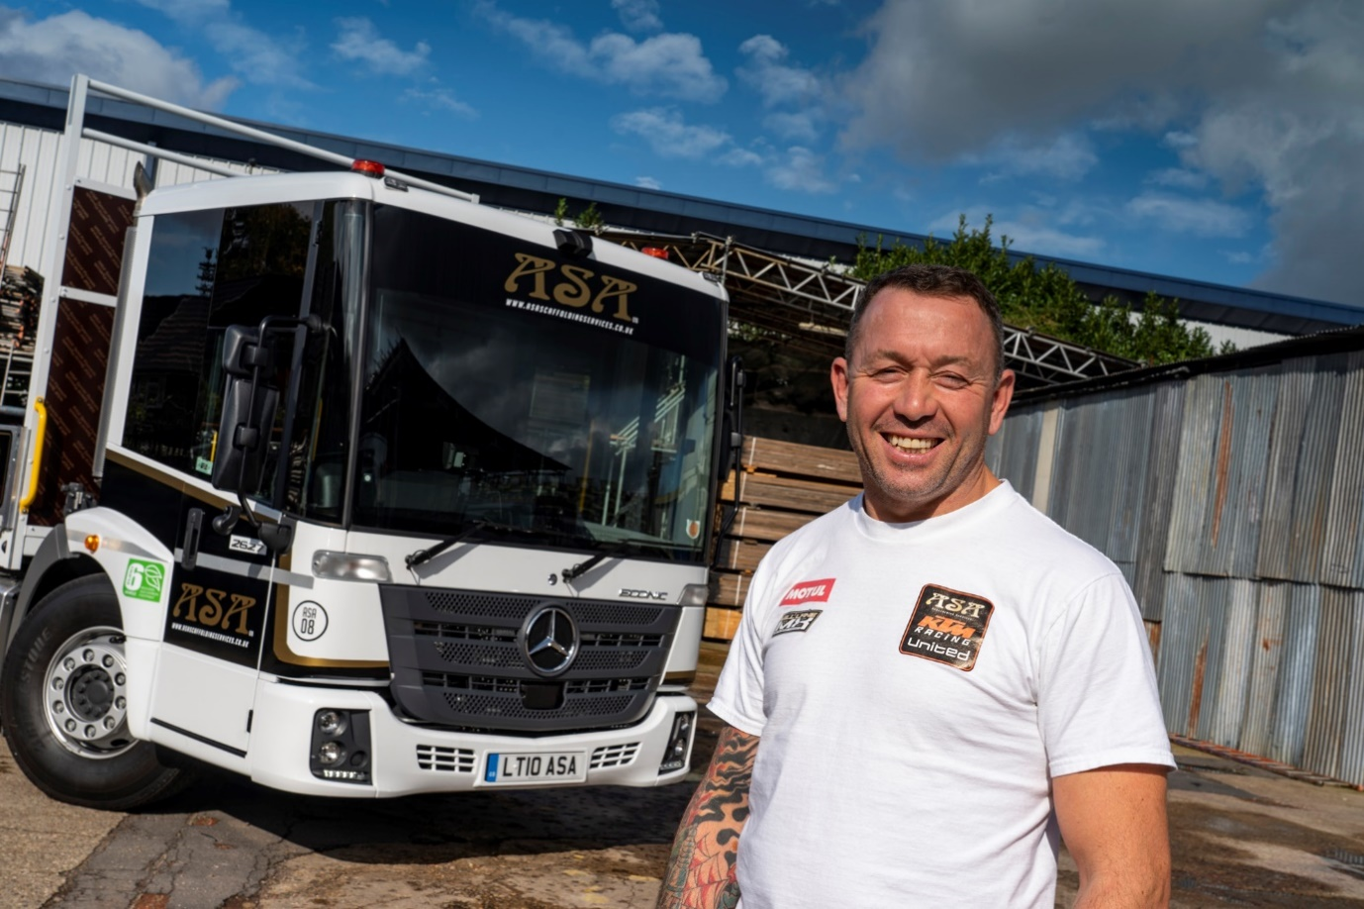

Aiming high by going low: Lee Tolan with ASA Scaffolding’s first Mercedes-Benz Econic

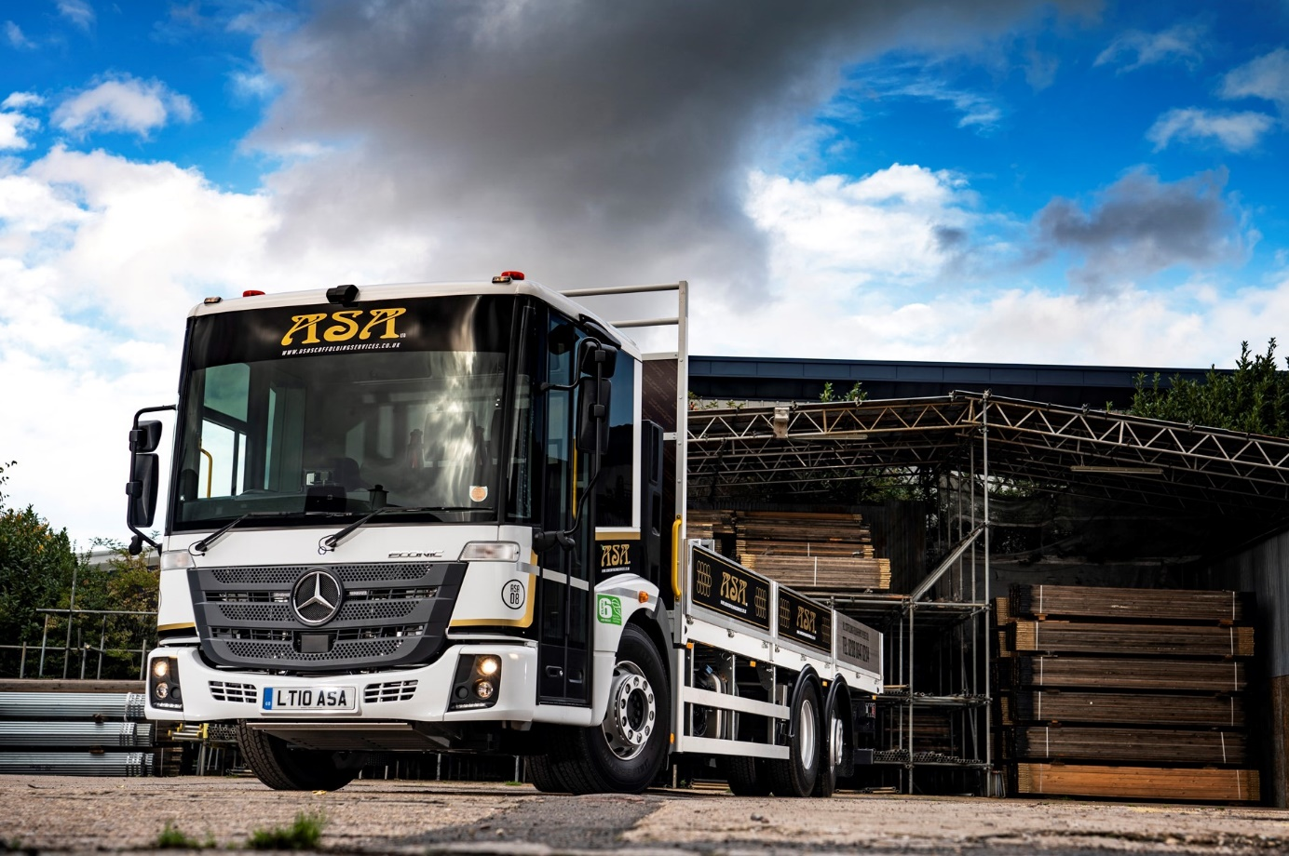

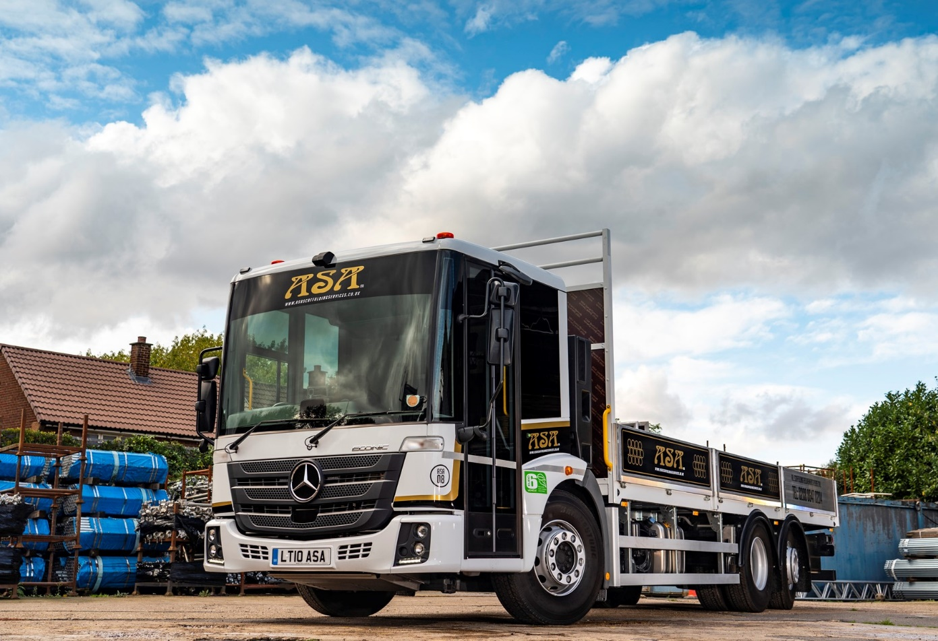

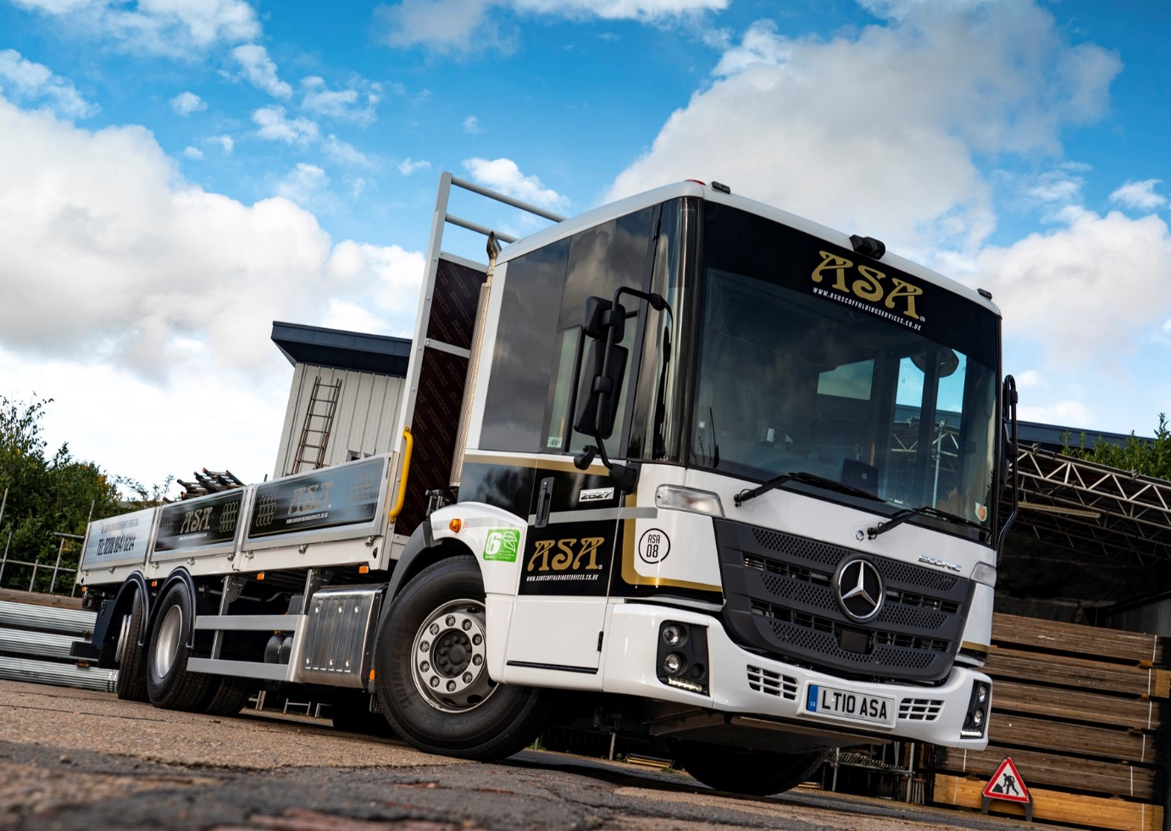

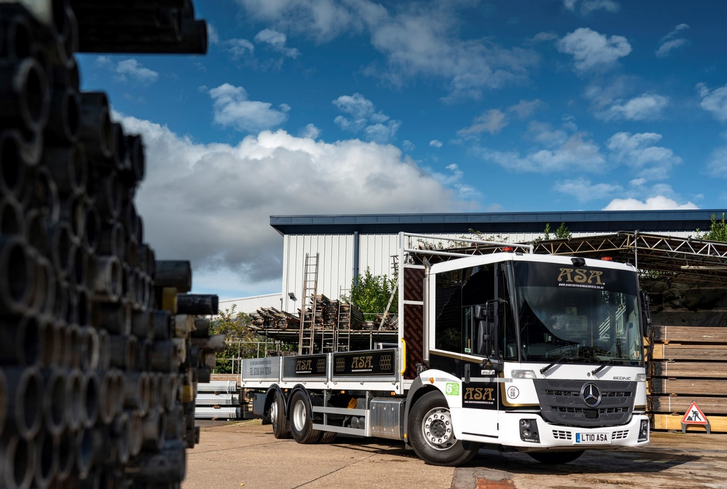

ends

For more information, or to request bigger/higher-res image files, please contact:
Steve Warren or John Ripley
Impact Communications, 01926 842126
Steve: 07770 470251, steve@impactcom.co.uk
John: 07771 484595, john@impactcom.co.uk

