

Date: 1 July 2019

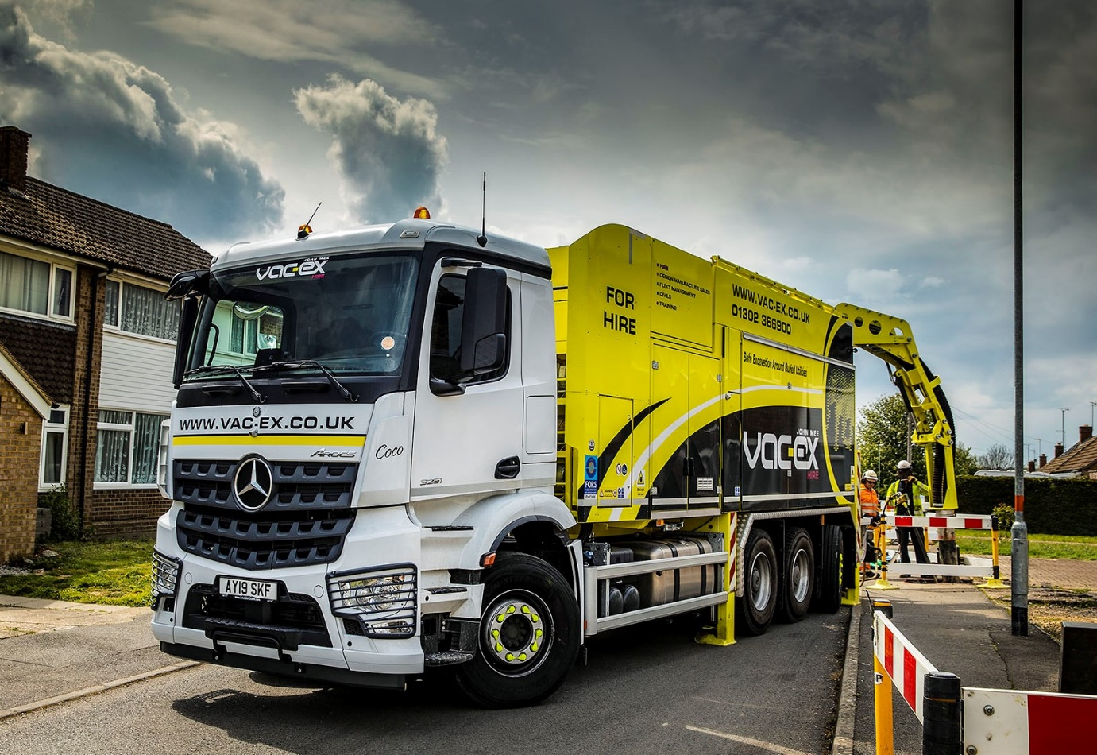

Going underground: Vac-Ex is running the first of the MTS-bodied Mercedes-Benz Arocs

Operators choose eight Mercedes-Benz truck chassis for ‘safe dig’ suction excavations

Leading customers of MTS Suction Systems UK are now undertaking safe excavations of roads and footpaths using impressive new Mercedes-Benz trucks supplied by Orwell Truck & Van.

The bodybuilder, which has a sales headquarters in Ely, Cambridgeshire, ordered the seven 32-tonne Arocs 3251 ENAs and a single 26-tonne Econic 2635 L ENA from the Dealer’s Newmarket branch. The trucks are being fitted with their high-performance bodies and ancillary equipment at MTS Suction Systems’ production facility in Germersheim, southern Germany.

The 8x4/4 Arocs have single front steer axles, double-drive bogies and rear-steer axles. The result is a significantly tighter turning circle than a standard construction eight-wheeler, and greatly enhanced manoeuvrability. The 6x2/4 Econic is also equipped with a rear-steer axle, for access to tight spots.

The first Arocs, a left-hand drive version, is now in service with suction excavation specialist Vac-Ex, of Doncaster. It is also due to receive another two, identical trucks before the end of the year. The remaining four Arocs have all been specified in right-hand drive form, for use by a prominent multinational infrastructure group.

The Econic has been built for another specialist operator of suction excavation equipment, which is based in Chesterfield. This company chose the low-entry chassis for its Direct Vision safety credentials, and is looking forward to the arrival of its new truck later this month.

Purpose-designed for construction applications, the muscular Arocs is ideally suited to site work. The trucks supplied to MTS Suction Systems employ second-generation 12.8-litre engines which produce 375 kW (510 hp) and drive through Mercedes PowerShift automated transmissions.

The bodybuilder’s UK Managing Director Russell Fairhurst said: “We are client-led when it comes to vehicle marque, and this is the first time we’ve sourced Mercedes-Benz chassis here in the UK, rather than from Germany.

“The experience of working with Orwell Truck & Van has been entirely positive. Its Sales Executive Chris Benefer was keen to win our business from the outset, took the time to listen and understand our requirements, then responded quickly and efficiently to our requests for quotations. We couldn’t have asked for more.”
Vehicles built by MTS Suction Systems typically cost between £350,000 and £400,000 apiece, so represent high-value investments. Despite this, the explosion over recent years in the use of fibre optics and other underground services mean the company’s vacuum excavators are becoming an increasingly popular alternative to traditional machinery such as mini-diggers, and even shovels.

Not only do they offer protection from injury for operatives who might otherwise hit live electricity cables or other utilities beneath the ground, but they also help contractors to minimise the risk of incurring potentially crippling fines for damaging infrastructure.

The surface of the footpath or roadway is first disturbed by a conventional road breaker – the new trucks all carry one. A compressed air lance is then used to further agitate and loosen the ground, before the debris is removed via a 250mm diameter suction hose.

Driven by a compressor and, in the case of the new Mercedes-Benz trucks, twin fans, the technology relies on high-velocity air movement. The process is highly efficient. The suction hoses are capable of picking up 75kg rocks the size of footballs, while an automated self-cleaning filtration system limits the amount of dust that escapes into the atmosphere.

As well as being non-destructive, suction excavation allows for very rapid removal of spoil – according to Vac-Ex, it is up to five times faster than digging by hand, and offers the capability to excavate very narrow and deep holes or trenches.

The Arocs’ bodies have containers with 12m³ capacities. Patented air flow technology ensures the debris collects at the centre of the chassis for better weight distribution, while the roof lifts and hydraulic rams facilitate tipping from the side.

“We used to be happy to sell two or three suction excavators per year, but we’re looking at between 25-30 now,” continued Mr Fairhurst. “The capital cost means this equipment will never replace conventional methods altogether, but for areas with high concentrations of underground services the benefits in terms of health and safety, and damage-free operations, are compelling.”
Vac-Ex proprietor John Mee commented: “We run a mixed-marque fleet currently, but moving forward will only be buying Mercedes-Benz trucks. The three-pointed star conveys an image of quality and professionalism, while experience has proved the Arocs to be exceptionally reliable and cost-effective to operate. The manufacturer’s contract maintenance provision also represents very good value, and the back-up we receive from our local Dealer is first class.”

Mr Mee’s company was trading under another name when it purchased its first suction excavator, which was also one of the UK’s first MTS-built vehicles, 12 years ago. “We knew the risks associated with working in the vicinity of underground services and felt this was the right way forward,” he recalled. “It’s proved to have been a wise decision.”
mammoth-mts.co.uk/mts-suction-systems/
www.vac-ex.co.uk

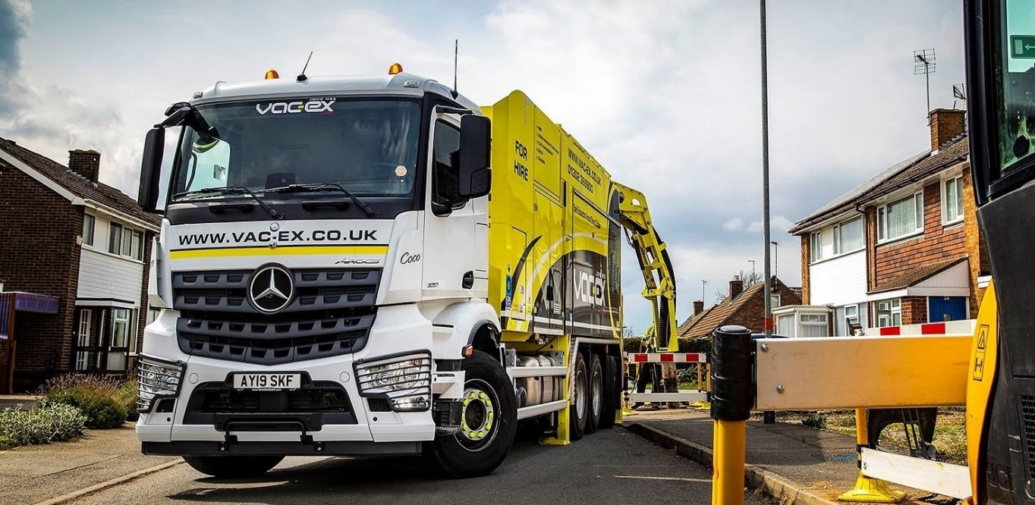
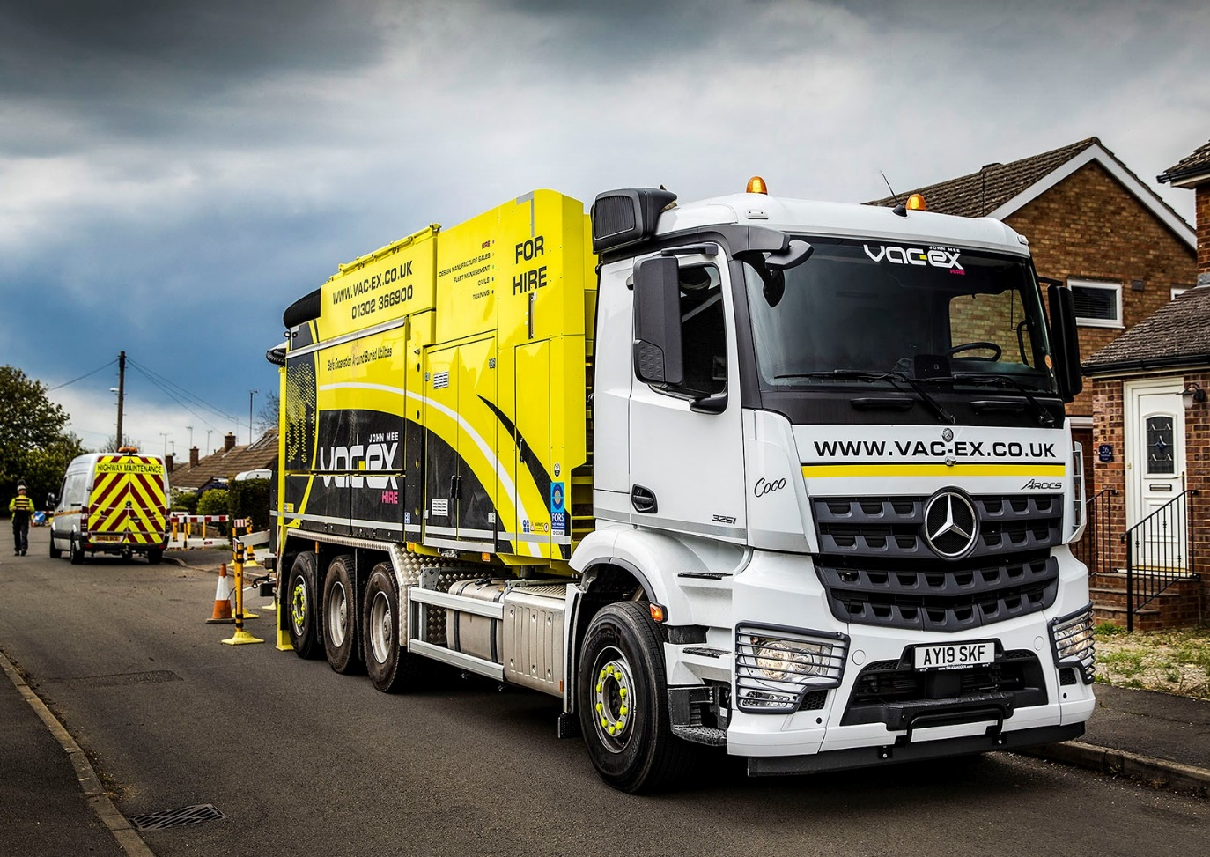

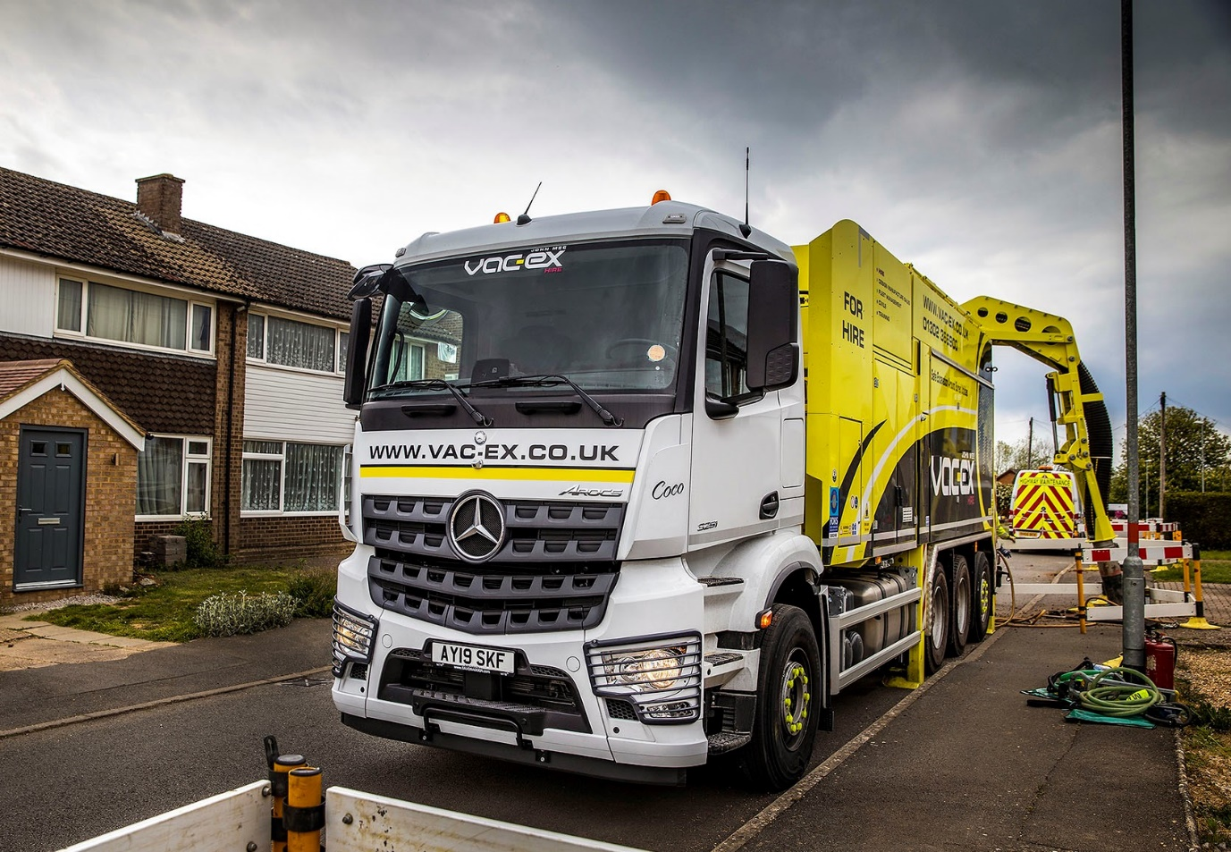

ends

For more information, or to request bigger/higher-res image files, please contact:
Steve Warren or John Ripley
Impact Communications, 01926 842126
John: 07771 484595, john@impactcom.co.uk
Steve: 07770 470251, steve@impactcom.co.uk

