

Date: 22 January 2020

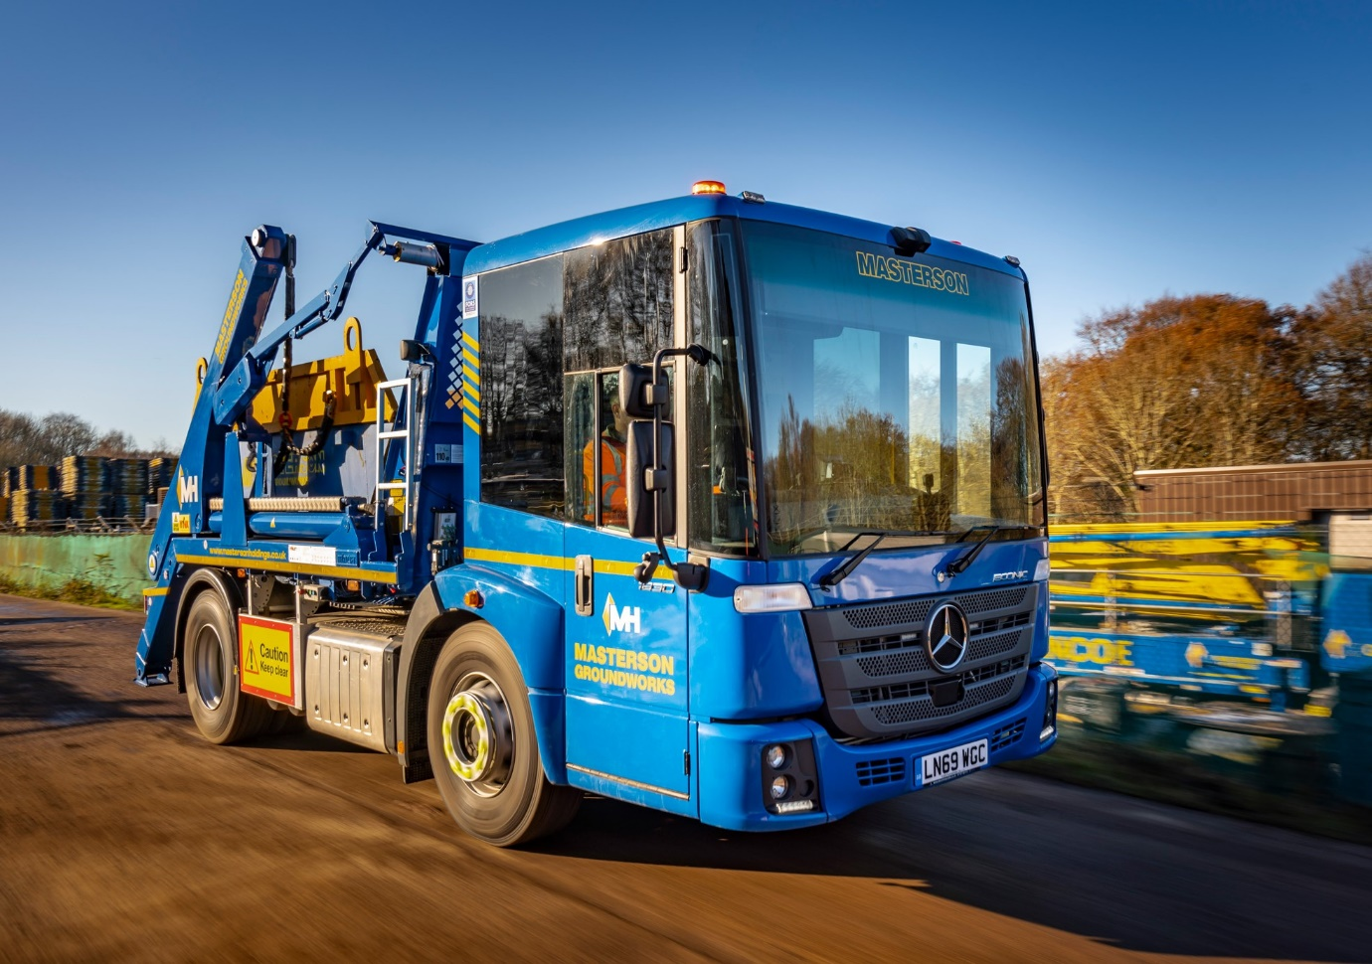

Glencoe Plant Services commissions first
Mercedes-Benz Econic skiploader

Glencoe Plant Services’ first skiploader is based on a low-entry Mercedes-Benz Econic, chosen for the five-star Direct Vision credentials which have made it a preferred truck for safety-focused operators working in busy urban areas.

Part of the Masterson Holdings Group, a family owned and managed construction business with a turnover of some £140 million, Glencoe Plant Services works from premises in Chalfont St Giles, Buckinghamshire.

The new 18-tonner was supplied by S & B Commercials and is being inspected and maintained under a five-year Mercedes-Benz Complete Service Contract at the Dealer’s workshop in Welham Green, Hertfordshire.

An Econic 1830L, the truck is powered by a high-torque, 7.7-litre in-line six-cylinder engine which generates 220 kW (299 hp) and drives through a fuel-efficient, 12-speed Mercedes PowerShift 3 automated manual transmission. It is fitted with Hyva skiploading gear.

Glencoe Plant Services runs a fleet of a dozen other trucks, most of them eight-wheeled tippers and six-wheelers with cranes, in which a Swedish manufacturer holds sway. However, the two 26-tonners it has purchased in the last couple of years from truck-mounted concrete pump specialist Schwing, are also by Mercedes-Benz.

The company is a dedicated provider of plant and equipment to two fellow members of the Masterson Holdings group: carpentry and joinery business Atlantic, and Getjar, which specialises in groundworks and reinforced concrete frames. Both work predominantly in London and the Home Counties.

Damian Kilcoyne, Plant Manager at Glencoe Plant Services, explained: “Having previously put the skip work out to sub-contractors, we saw an opportunity to gain more control and increase efficiency by purchasing our own vehicle for collecting construction waste material from sites and taking it to recycling centres.

“Given that this truck will spend so much of its time in and around London, an Econic was the obvious choice. Safety and compliance were our top priorities, and having driven and learned about the vehicle at an event hosted by the manufacturer we were confident the low-entry Mercedes-Benz represented the best way forward.”

Greater Safety is one of the three pillars of Mercedes-Benz Trucks’ all-encompassing RoadEfficiency strategy, and the fully air-suspended Econic comes with Active Brake Assist 4 emergency braking technology which incorporates a pedestrian recognition capability.
The truck was awarded a five-star Direct Vision rating by Transport for London, thanks to its deep, panoramic windscreen, and full-height, glazed folding side door. A seating position which is much lower than that of a conventional truck also allows the driver to make direct eye contact with cyclists and pedestrians at junctions or in traffic queues.

These attributes have helped Mercedes-Benz to secure a string of high-profile orders in recent years for Econic-based mixers, tippers and tipper-grabs as well as skiploaders, and for fridge-bodied rigids and tractor units which are now in service with food sector operators.

Mr Kilcoyne continued: “The great all-round visibility offered by the Econic’s cab can only help to make the roads safer for vulnerable road users. The fact that our driver can see so much more means that time spent at the wheel is less stressful for him, while the vehicle’s low height and easy cross-cab access also enhances health and safety because he can always choose the best side from which to exit.”

Like all new Econics supplied through the manufacturer’s UK Dealer Network the latest addition to the Glencoe Plant Services fleet is backed by a three-year/160,000 km manufacturer’s warranty.

Damian Kilcoyne added: “Safety was the key driver behind our decision to purchase a Mercedes-Benz on this occasion, but we’ll also be looking to the Econic to provide the reliability we need to support our ‘sister’ businesses, as well as competitive running costs.

“S & B Commercials’ National Fleet Sales Manager Sam Setterfield was very helpful when we came to specify the truck, and I’m optimistic that the Dealer will deliver on its promise of timely, customer-focused back-up.”

mastersonholdings.co.uk

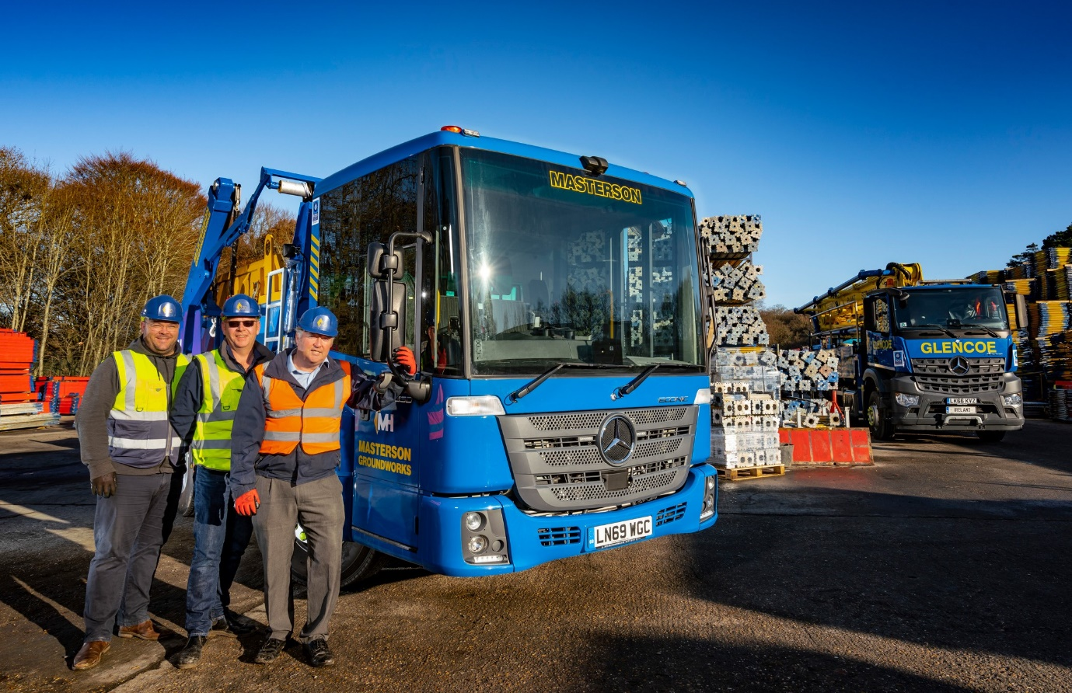

Moving forward with Mercedes-Benz: Damian Kilcoyne is pictured, right, with colleagues Transport Manager John Lawler, left, and Groundworks Transport Manager Donal Crowley, and Glencoe Plant Services’ new Econic, which bears the name of parent company Masterson Holdings Group

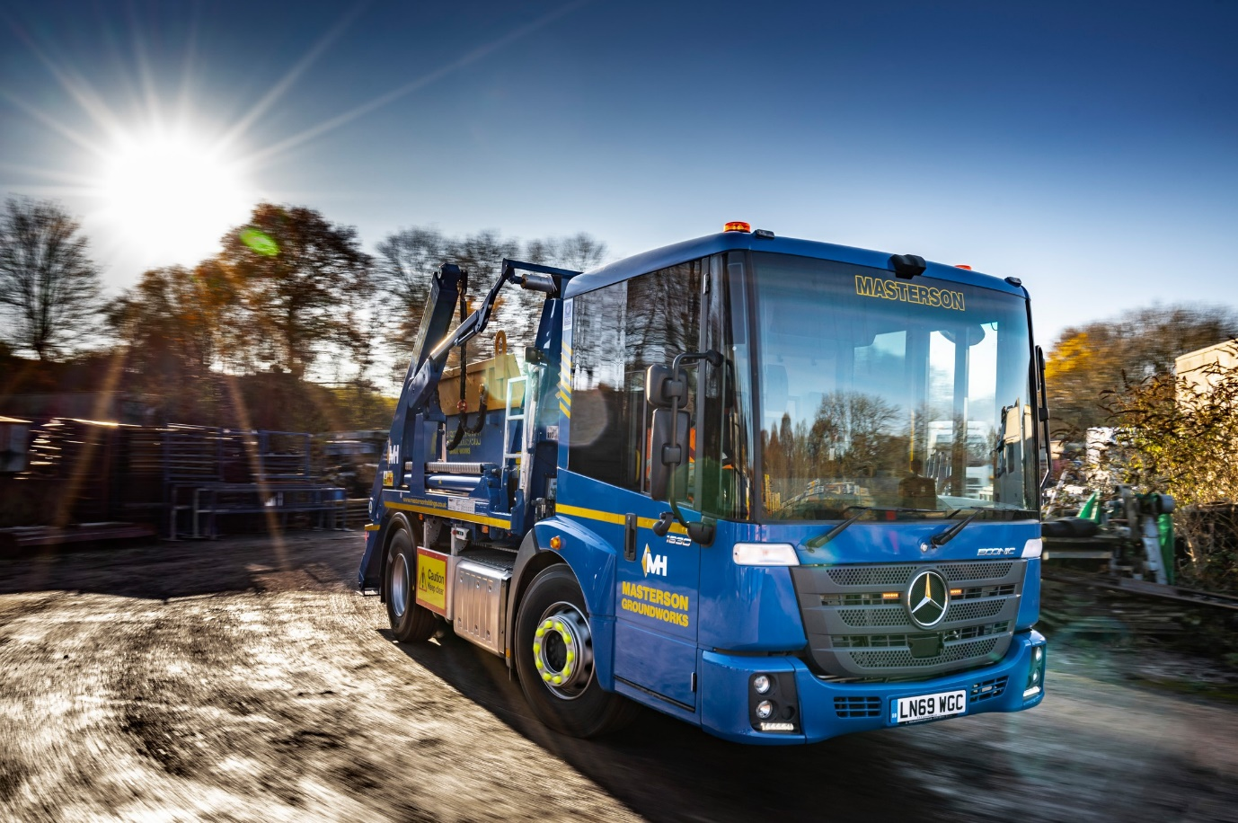

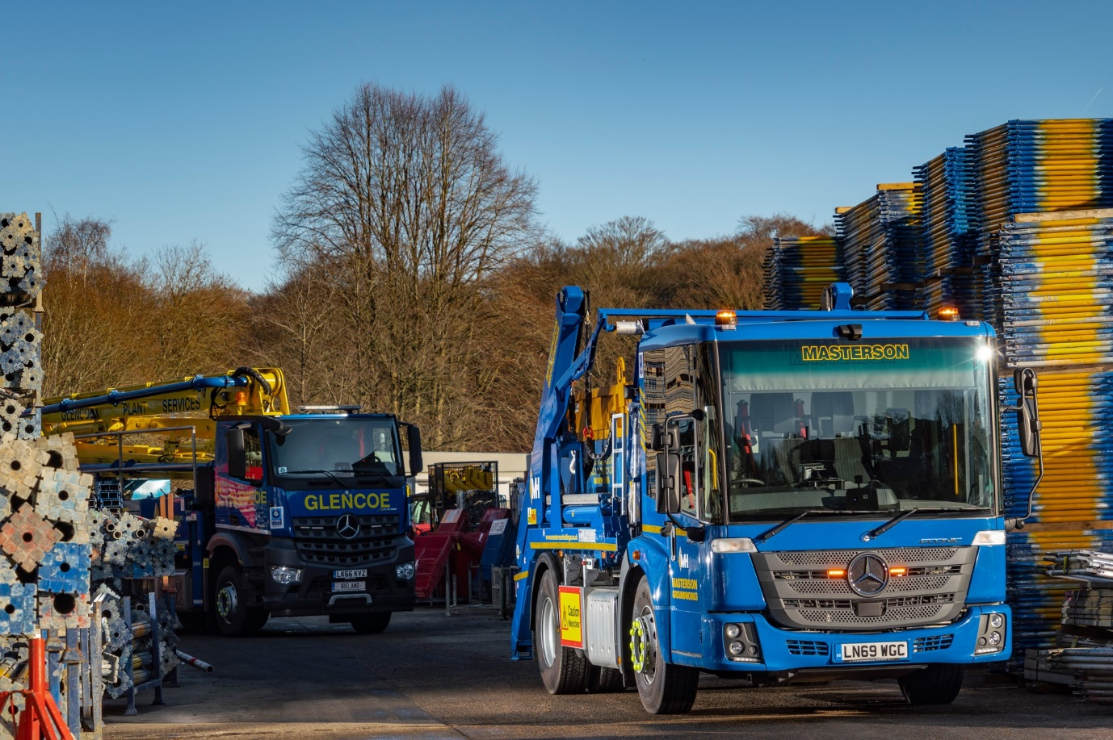

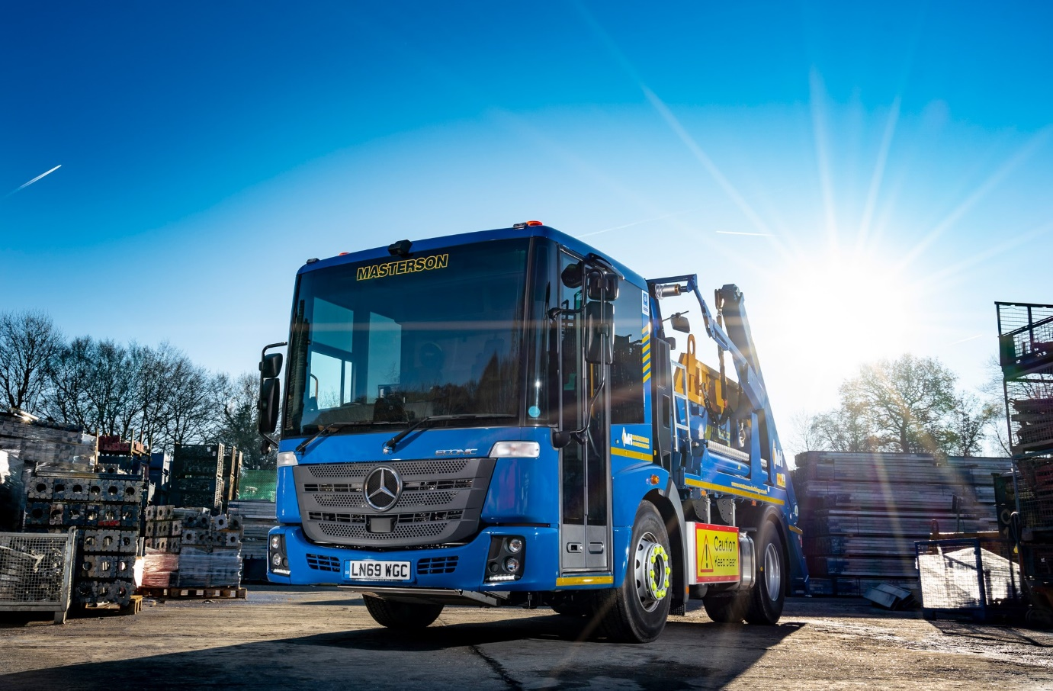

ends

For more information, or to request bigger/higher-res image files, please contact:
Steve Warren or John Ripley
Impact Communications, 01926 842126
Steve: 07770 470251, steve@impactcom.co.uk
John: 07771 484595, john@impactcom.co.uk

