

Date: 1 May 2019

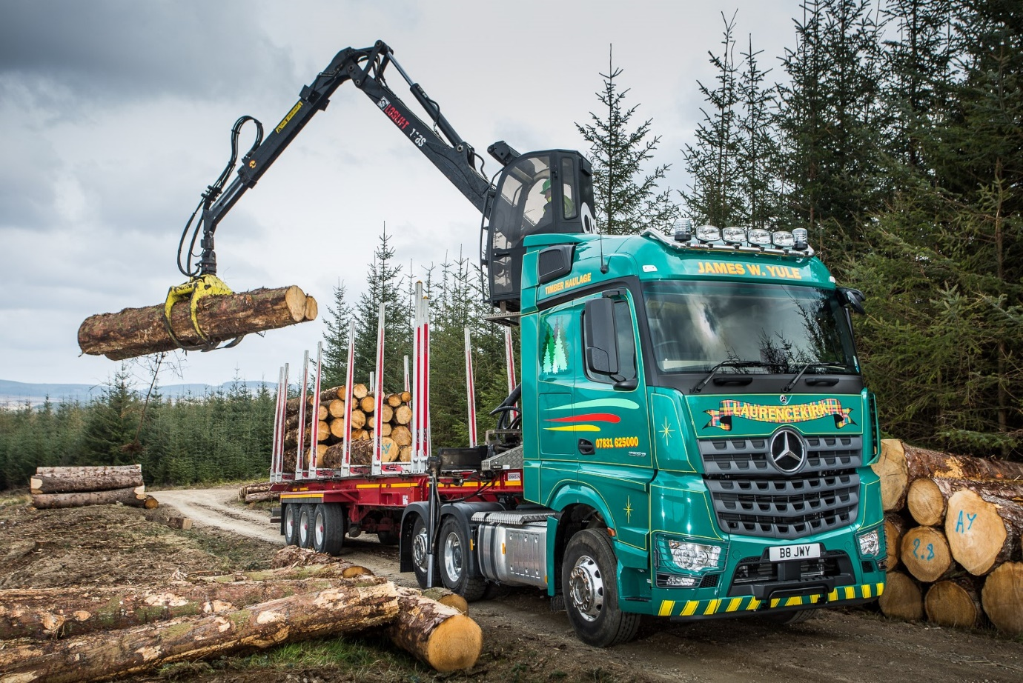

Owner-driver Yule logs in with rugged Mercedes-Benz Arocs

Timber haulier Jim Yule needs a truck that’s tough enough to cope with the demands of his work deep in the forests of North-East Scotland, which explains why he’s now running his second Mercedes-Benz Arocs.

The owner-driver, who is based in Laurencekirk, Aberdeenshire, took delivery of his strikingly finished tractor unit from local Dealer BLS Truck & Van. A 6x2 Arocs 2553 model with tag axle, the truck has a flat-floored, 2.5 metre-wide version of the aerodynamic StreamSpace cab. Its advanced, 12.8-litre straight-six engine, meanwhile, produces 390 kW (530 hp) and drives through a Mercedes PowerShift 3 automated transmission.

The muscular Mercedes-Benz came fitted as standard with the manufacturer’s Safety Pack. This incorporates the ground-breaking Active Brake Assist 4 system, which features a ‘first’ in the shape of pedestrian recognition, as well as Proximity Control Assist and a driver’s airbag.

Finished in gleaming metallic green, it boasts individual features including a top-mounted Kelsa chrome lightbar and beacons, aluminium chequer-plate catwalk, alloy wheels and headlamp protectors.

Mr Yule works mainly in the Fetteresso Forest, in southern Aberdeenshire. His tractor unit pulls a specialised Dennison timber trailer with Hiab Loglift crane – which has its own cabin, for full weather protection – so he can load up in the forest then unload when he reaches his destination. In most cases, this will be a local sawmill.

“The job involves a lot of off-road work,” explained Mr Yule. “I’m frequently in the heart of the forest, and up to half an hour’s drive from the nearest finished road. The 6x2 Arocs handles the trails without any problem, though. Its high ground clearance means deep ruts and bumps are never a problem, and lifting the rear axle enables me to gain more traction from the drive axle should I need it, while also improving manoeuvrability for tight turns.

“My truck is also significantly lighter than a 6x4 tractor, and the resulting increase in payload capacity makes for higher productivity. It really is the ideal package. I’ve considered other options but the Arocs is the only vehicle on the market that’s purpose-built for tough, off-road applications like mine.”

The new truck has replaced Mr Yule’s first Arocs, which he acquired in 2014. Like the previous vehicle, it is being inspected and maintained under a five-year Mercedes-Benz Complete Service Contract, by BLS Truck & Van.

“The Dealer’s Service team look after me exceptionally well, and the contract rates are very competitive,” he continued. “The arrangement makes good financial sense and gives me the peace of mind which comes from knowing there are no nasty surprises around the corner.”

Purpose-designed for operators in the construction and related sectors, the Mercedes-Benz Arocs excels in the toughest of working conditions. The comprehensive model range comprises rigids from 18-32 tonnes GVW, and tractor units in various configurations, including mighty SLT heavy haulers capable of working at up to 250 tonnes GCW.

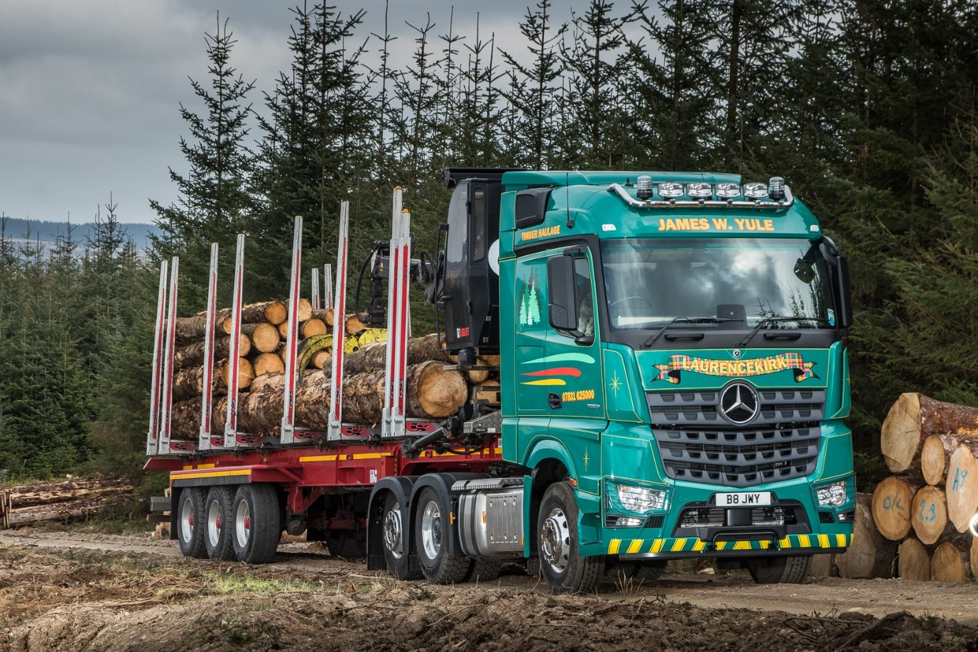

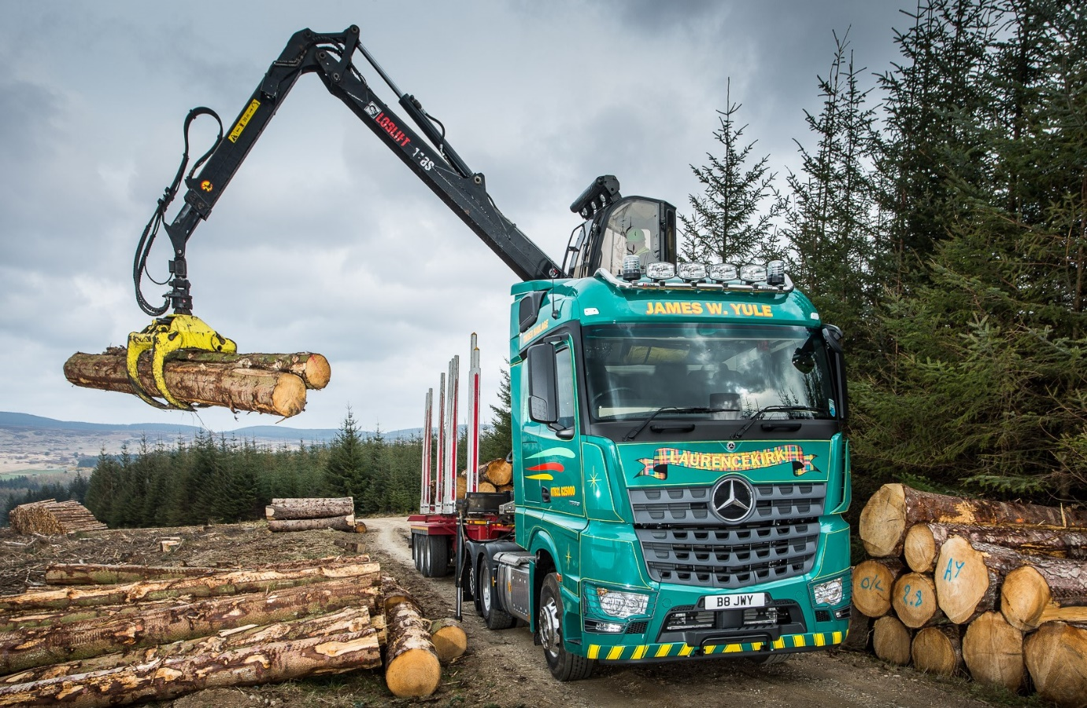

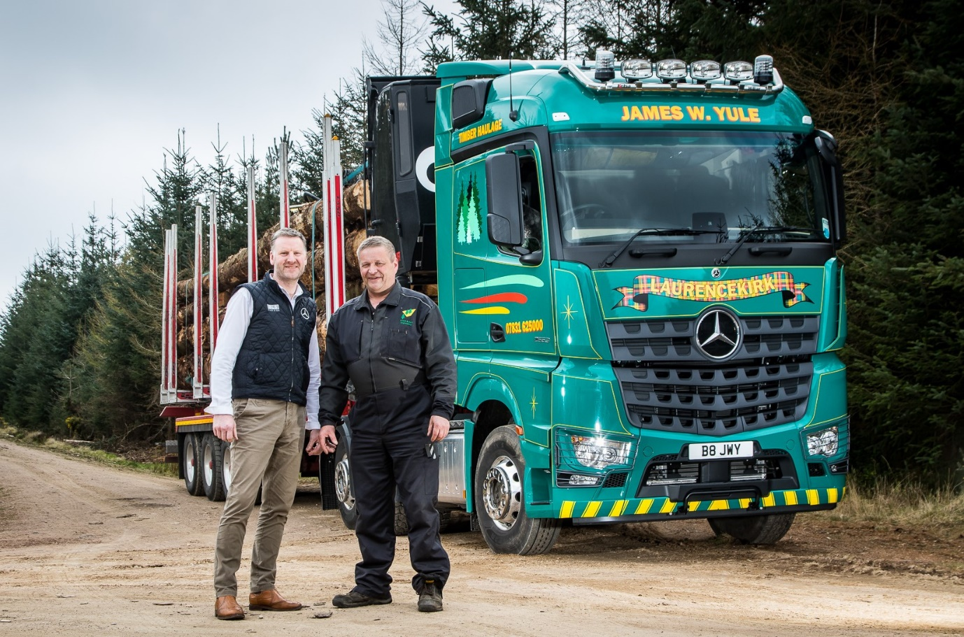

Green Giant: The mighty Mercedes-Benz Arocs with owner-driver Jim Yule, right, and Andrew Rennie, Head of Truck Sales at BLS Truck & Van

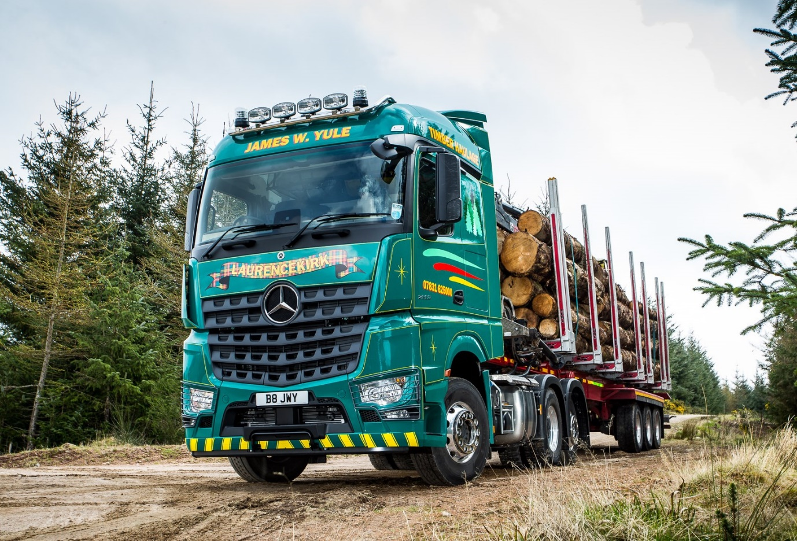

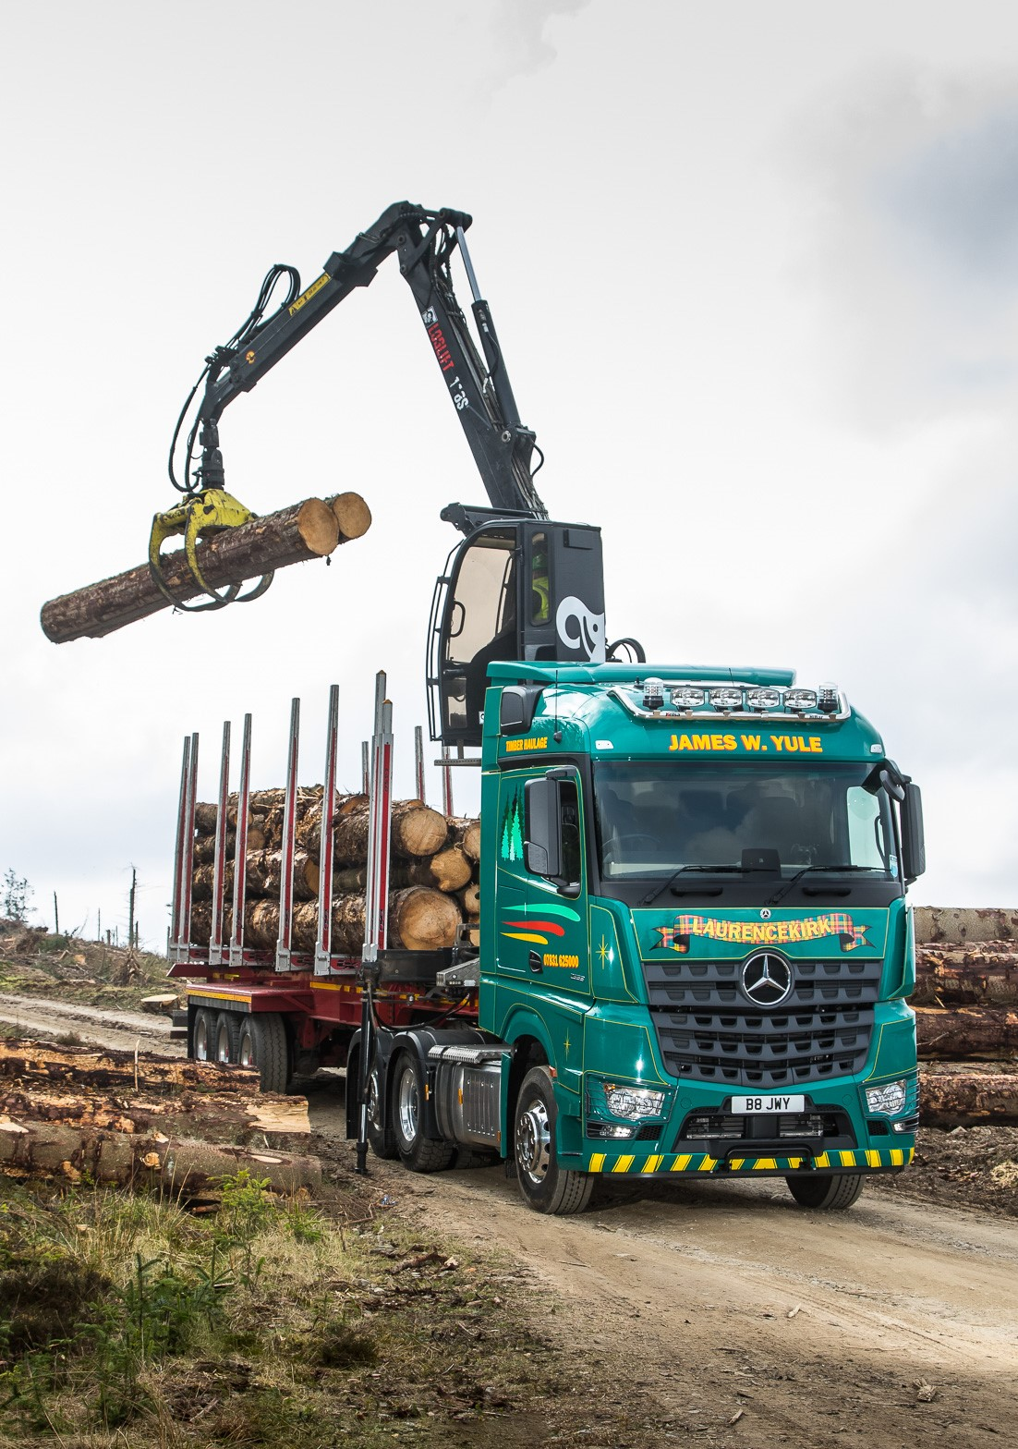

ends

For more information, or to request bigger/higher-res image files, please contact:
John Ripley or Steve Warren
Impact Communications, 01926 842126
John: 07771 484595, john@impactcom.co.uk
Steve: 07770 470251, steve@impactcom.co.uk



