

Date: 30 April 2020

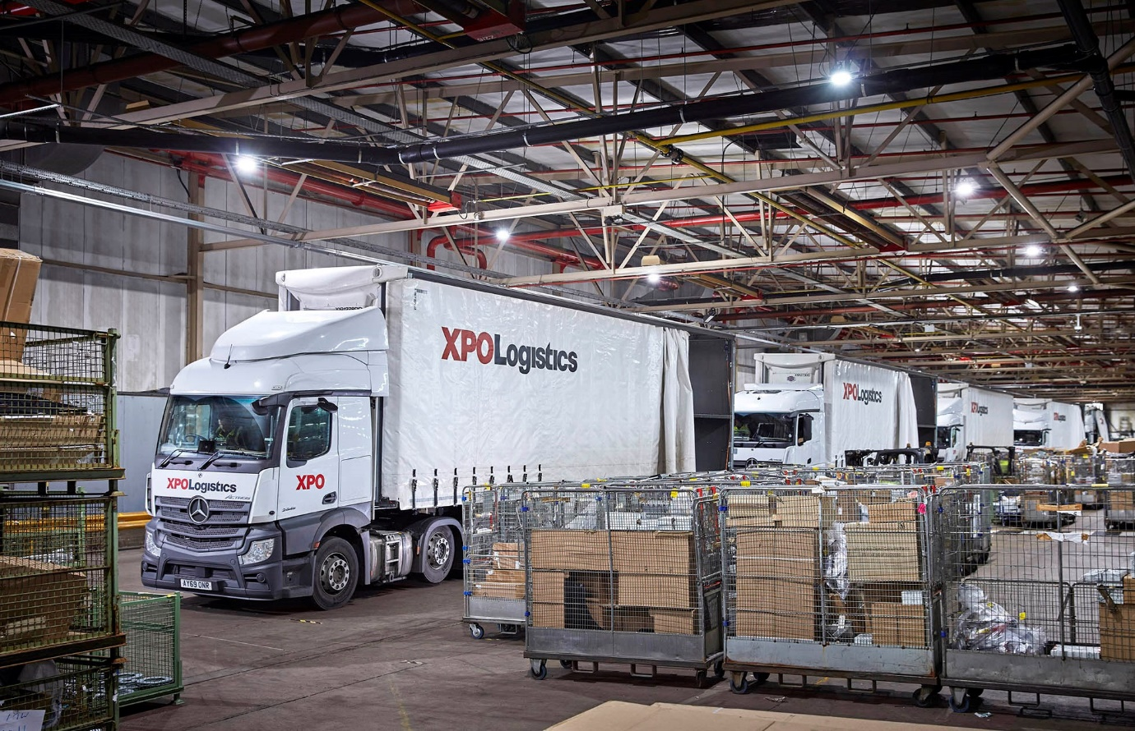

XPO Logistics plays its part for Mercedes-Benz customers with 43 new-generation Actros

A new fleet of Mercedes-Benz trucks is playing a crucial role in the campaign to keep the UK’s road transport sector moving during the COVID-19 pandemic.

XPO Logistics’ 43 new-generation Actros are now delivering automotive parts to Dealers representing Mercedes-Benz Trucks and Mercedes-Benz Vans, as well as to members of the manufacturer’s Passenger Car retail network. These dealers in turn are servicing commercial vehicles that provide a variety of essential services, among them ambulances and supermarket delivery trucks.
Most of the vehicles in the distribution network are Actros 2545 StreamSpace tractor units with 12.8-litre, in-line six-cylinder engines that produce 330 kW (450 hp). The line-up also includes 17 rigid 18-tonne 1824 models powered by 175 kW (238 hp) 7.7-litre ‘straight-sixes’, with ClassicSpace cabs and curtainside bodies by Lawrence David.

Mercedes-Benz Trucks and its franchised Dealers are doing everything possible to support operators through the pandemic. Working in partnership, the XPO team and Mercedes-Benz European Logistics Centre (ELC) colleagues are providing fast and efficient distribution of more than 750,000 parts numbers. While maintaining distancing to ensure personal safety, the ELC team are demonstrating their commitment daily by maintaining impressive ‘first pick’ service rates that comfortably exceed 90%, even during the coronavirus outbreak.

XPO Logistics commenced work at the ELC on 1 January, after signing a five-year partnership agreement with Mercedes-Benz Parts Logistics. XPO is managing UK parts distribution through an integrated, digitally managed transport network, and runs more than 40 routes daily, from the ELC in Milton Keynes, and from its own overnight-delivery depots in Motherwell, Leigh, Wakefield, Gloucester and Taunton.

Supplied by East Anglia Dealer Orwell Truck & Van, the Actros are being inspected and maintained under Mercedes-Benz Complete Service Contracts at the most conveniently located official workshops. The tractors are the subject of a Mercedes-Benz Finance operating lease under which each is scheduled to cover 155,000 km per year. XPO has purchased the rigids.

New Actros is a technological tour-de-force, and the reigning International Truck of the Year. Pioneering features include MirrorCam, which replaces conventional mirrors and offers safety benefits through enhanced visibility, as well as reductions in diesel consumption thanks to the compact, streamlined profile of the camera housings; the state-of-the-art Multimedia Cockpit; Active Brake Assist 5 emergency braking technology; and an enhanced version of the Predictive Powertrain Control system, which now makes a more substantial contribution to economy, while also ensuring that life at the wheel is easier for drivers.

Dan Myers, Managing Director, Transport – UK & Ireland, XPO Logistics, said colleagues were monitoring the performance of the new-generation Actros, as well as Mercedes-Benz Dealer support, to assess the vehicle’s suitability for other distribution work.

“Our initial perceptions of the new Actros are entirely positive,” he confirmed. “The trucks have already won positive feedback from our drivers for their fuel-efficiency, comfort and safety features.”

Mr Myers praised the support his team had received from Orwell Truck & Van, which delivered familiarisation sessions for members of XPO’s driver training team. “Orwell’s Fleet Sales Manager Rob Dale did everything we could have asked, managing the order process seamlessly by liaising with providers of ancillary equipment such as cameras, and delivering the trucks on time against a tight deadline,” he said.

XPO will wait until the trucks have been on the road for six months before commencing detailed fuel-efficiency analysis. “The early returns are certainly encouraging,” reported Mr Myers. “Every indication is that the tailored solution we are providing will lower distribution costs and increase efficiency for Mercedes-Benz in UK parts operations.”

In addition to direct driver feedback, XPO receives data on driver and vehicle performance from the trucks’ Daimler Fleetboard telematics systems, and through the new Truck App Portal.

“We’ll be focusing on the ‘whole life’ operating costs of these vehicles,” Mr Myers said. “We have a high uptime target and most deliveries are being made at night, so detailed data capture and Dealer back-up, including responsive out of hours support, will be vital.”

www.xpo.com

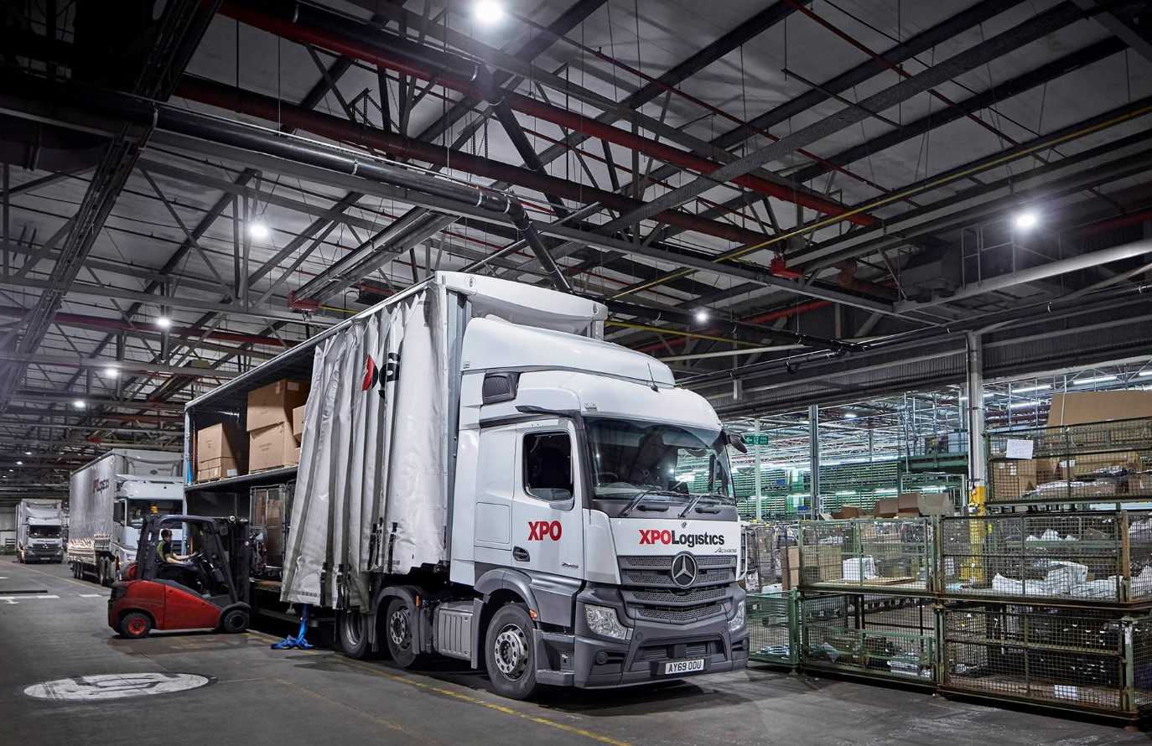

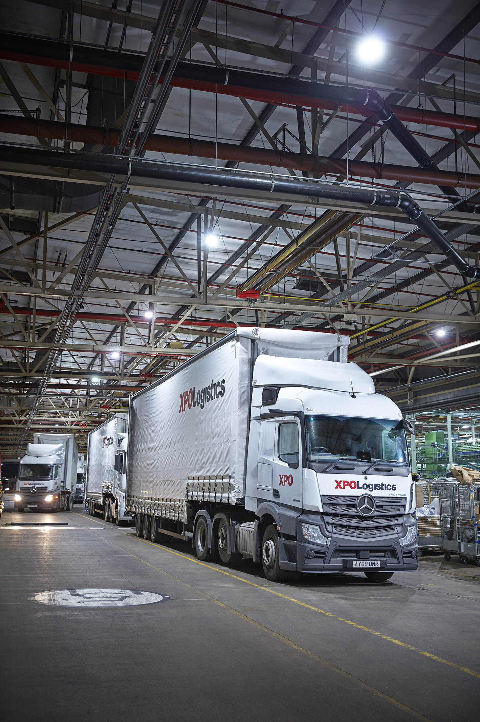

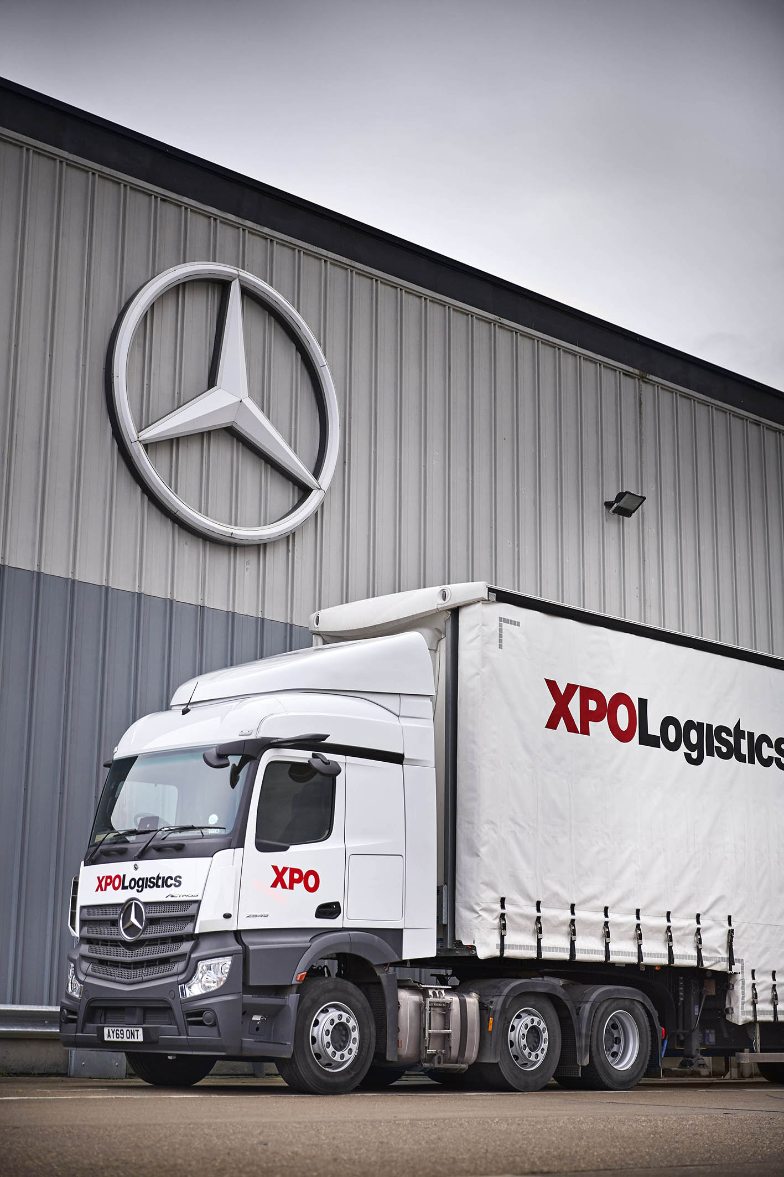

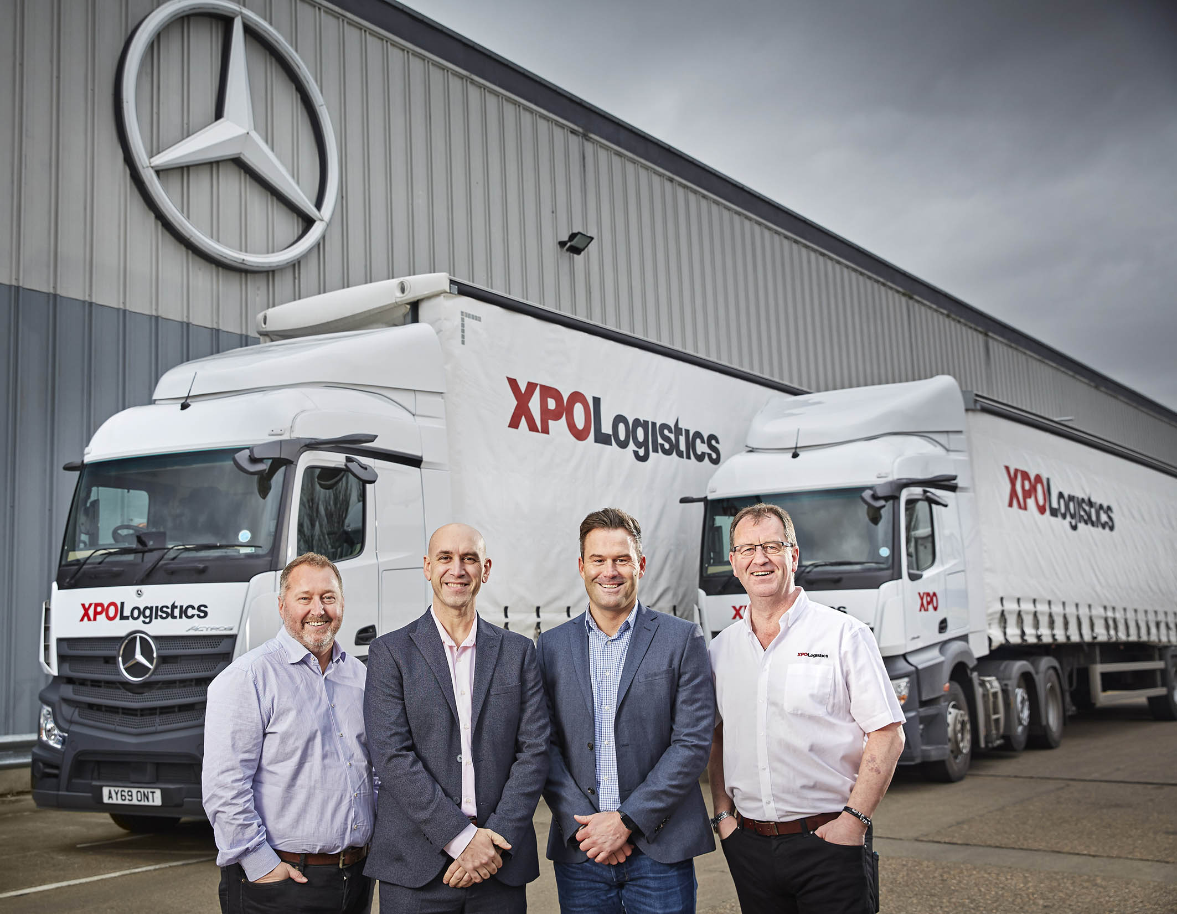

New partnership: Photographed in February, prior to the introduction of social distancing measures, are, from left, Jeff Hall, General Manager, Automotive – UK, XPO Logistics; Juan Manuel Santiago Mendez, CEO of Mercedes-Benz Parts Logistics UK; Richard Peake, Warehouse Operations Manager, Mercedes-Benz UK; and Simon Patton, XPO Logistics Operations Director, Transport Solutions – UK and Ireland

ends

For more information, or to request higher-res image files, please contact:

Jamie Fretwell at Mercedes-Benz Trucks UK Ltd
07712 519230, jamie.fretwell@daimler.com

or

Steve Warren or John Ripley
Impact Communications, 01926 842126
Steve: 07770 470251, steve@impactcom.co.uk
John: 07771 484595, john@impactcom.co.uk

About XPO Logistics and XPO Logistics Europe

XPO Logistics, Inc. (NYSE: XPO) is a top ten global logistics provider of cutting-edge supply chain solutions to the most successful companies in the world. The company operates as a highly integrated network of people, technology and physical assets in 30 countries, with 1,504 locations and approximately 100,000 employees. XPO uses its network to help more than 50,000 customers manage their goods most efficiently throughout their supply chains. The company's corporate headquarters are in Greenwich, Connecticut, USA, and its European headquarters are in Lyon, France. XPO conducts the majority of its European operations through its subsidiary, XPO Logistics Europe, which trades under the stock symbol XPO on Euronext Paris – Isin FR0000052870.
europe.xpo.com

About Mercedes-Benz Trucks UK Ltd
Mercedes-Benz Trucks UK Ltd is the sales and marketing organisation responsible for all Daimler truck products in the UK, including FUSO Canter. In 2019, the company registered 6,963 new trucks. Mercedes-Benz accounted for 6,188 new trucks registered in 2019, making it the third-biggest truck brand in the UK. Meanwhile, FUSO registrations hit 775 – including 580 new trucks over 6.0-tonnes. The flagship new Mercedes-Benz Actros which won the 2020 International Truck of the Year award, features seven core innovations including MirrorCam, Multimedia Cockpit and Active Brake Assist 5. Our premium range of innovative trucks – Actros, Arocs, Atego, Econic and Unimog – draw upon more than 125 years of exceptionally high standards of quality, backed up by our promise of Trucks You Can Trust.
www.mbtrucks.co.uk

