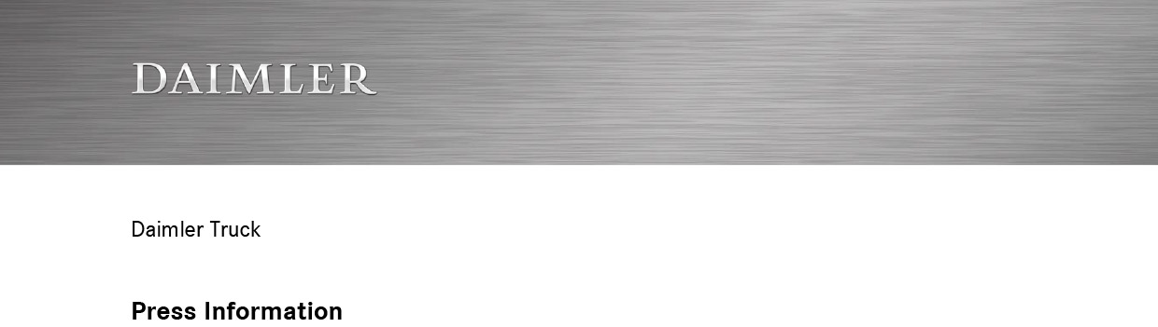

Date: 23 September 2020

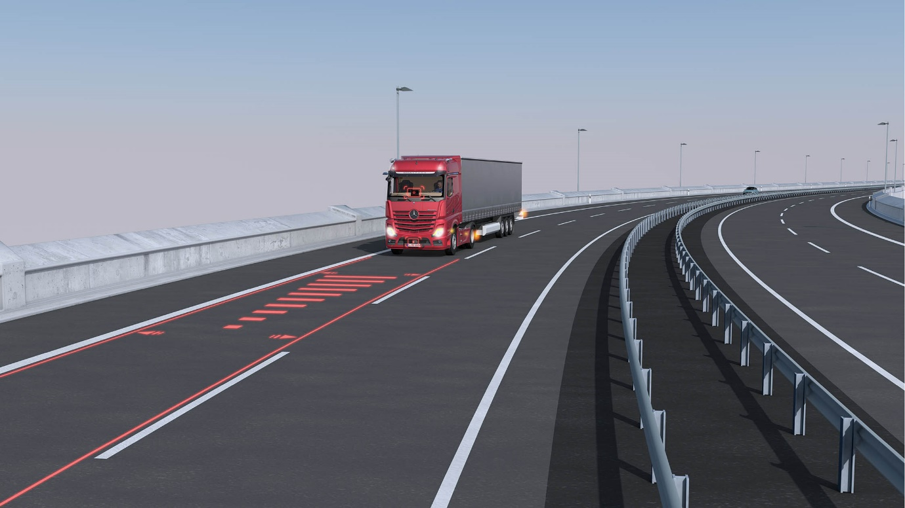

Mercedes-Benz Trucks presents another worldwide innovation for more safety on the road

- Available from June 2021 for most Actros assembly model series: Active Drive Assist 2 comprises an emergency stop function which can automatically brake the vehicle to a complete halt in case of an emergency

Stuttgart – When it comes to increasing vehicle safety, Mercedes-Benz Trucks has always been a pioneer in the industry. The company has invested hundreds of millions of euros per year in research and development, for assistance systems to provide even greater assistance to drivers in their work and increase safety for all road users. Recent examples include Active Drive Assist 2 with automatic emergency stop function.

Because each accident is one too many, everything has to be done to avoid an accident or at least ameliorate the consequences for all involved.

For more safety in traffic, assistance systems that can actively support the driver in situations recognised as dangerous by the systems without absolving him or her of responsibility are of crucial importance. For example, years ago the German Federal Association for Freight Transport, Logistics and Waste Disposal and the Trade Association for the Transport Industry (Bundesverband Güterkraftverkehr Logistik und Entsorgung and Berufsgenossenschaft für Transport und Verkehrswirtschaft, respectively) as well as the Kravag insurance company demonstrated in a field test with over 1000 vehicles that trucks equipped with driver assistance systems had a 34% lower probability of an accident than reference vehicles of the same type.

With systems such as the fifth-generation emergency braking assistant Active Brake Assist (ABA 5), Active Drive Assist for partially automated driving (SAE level 2), and MirrorCam in lieu of main and wide-angle mirrors, Mercedes-Benz has further increased the safety level of its trucks considerably. This is especially true for the current Actros generation as well as a large part of Arocs models which boast the highest standard of all current Mercedes-Benz trucks in terms of safety architecture and assistance systems installed.

New: Active Drive Assist 2 with emergency stop function

Active Drive Assist (ADA) represents a step forward in terms of safety and makes new Actros the world’s first series truck to be capable of partially automated driving (SAE level 2). Under certain preconditions it actively supports the driver in the longitudinal and lateral guidance of the truck and can automatically maintain the distance to the vehicle ahead, accelerate and also steer if the necessary system conditions such as sufficient curve radius or clearly visible road markings are met. If the driver comes too close to a vehicle in front, ADA can automatically brake the truck until the pre-determined minimum distance has been re-established. Once that is the case, the system can then re-accelerate the truck up to the pre-determined speed.

Available from June 2021, the newest-generation ADA 2 can do even more: the system is capable of initiating an emergency stop if it recognises that the driver has not been actively involved in the driving process for a longer period of time, e.g. due to health problems. First the system requests the driver via optical and acoustic signals to place his or her hands on the wheel. But if he or she does not respond after 60 seconds, even after multiple warnings, by responding e.g. with braking, steering, accelerating or operating the vehicle systems via the buttons on the steering wheel, within its limits the system can brake until the truck safely comes to a standstill within its lane while warning the following vehicles using the hazard lights. The emergency stop manoeuvre initiated by the system can be stopped by using a kick-down at any time. If the truck comes to a standstill, the system can automatically engage the new electronic parking brake. In addition, the doors are unlocked so that paramedics and other first responders can directly reach the driver in case of a medical emergency.

Active Brake Assist 5 – emergency braking assistant for motorways and city traffic

Active Drive Assist 2’s automatic emergency stop is not to be confused with Active Brake Assist 5’s emergency braking function. ABA 5 works with a combination of radar and camera systems. Compared to ABA 4, it can respond to moving persons not only with a partial, but with an automatic full-stop braking manoeuvre up to a vehicle speed of 50 km/h.

If ABA 5 recognises the danger of an accident with a preceding vehicle, a stationary obstacle or a pedestrian that is either oncoming, crossing, walking in their own lane or suddenly stopping in shock, an optical or acoustic warning can be issued to the driver first. If the driver does not adequately respond, the system can then initiate a partial braking manoeuvre in a second step, with a speed reduction of up to three metres per second squared, which corresponds to approx. 50% of maximum braking performance. If a collision is imminent nonetheless, within system limits ABA 5 can perform an automatic emergency full-stop braking manoeuvre and then engage the new electronic parking brake after reaching a standstill.

The following applies to all assistance systems by Mercedes-Benz Trucks: they are all designed to support the driver as much as possible within the system limits. However, and in accordance with the law, the driver remains fully and finally responsible for his or her vehicle.

Further information is available here: d.ai/NOWandNEXT2020-pressmaterial

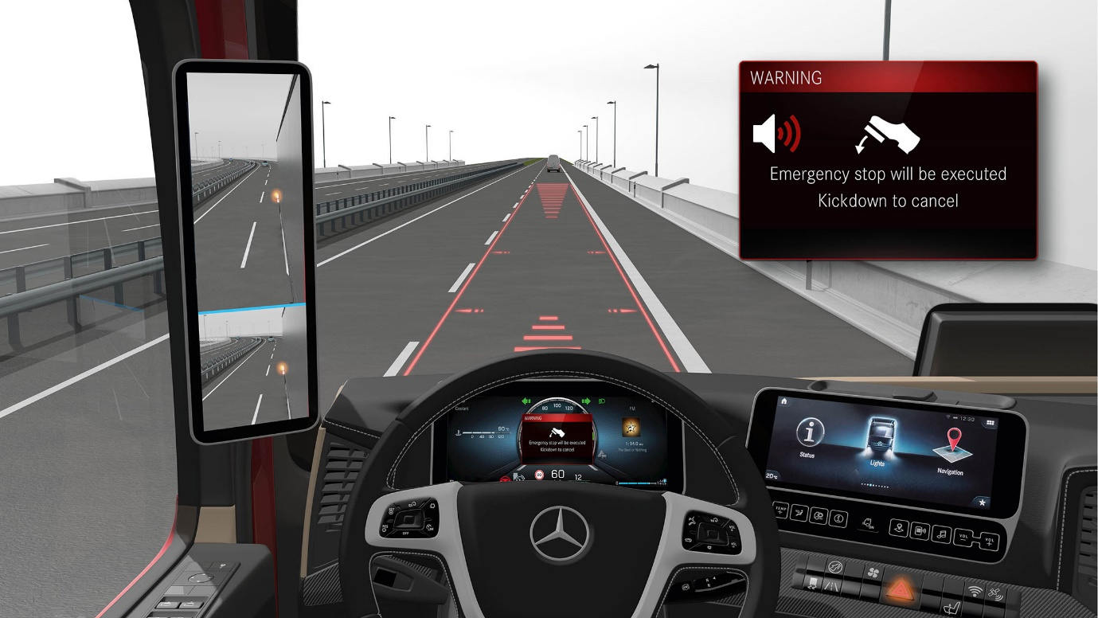

ends

For more information please contact:

Carola Pfeifle, +49 (0) 711 17-5 35 51, carola.pfeifle@daimler.com
Ulrike Burkhart, +49 (0) 711 17-5 87 74, ulrike.burkhart@daimler.com

or

Jamie Fretwell at Mercedes-Benz Trucks UK Ltd
07712 519230, jamie.fretwell@daimler.com

Further information on Daimler Truck AG is available at:
www.media.daimler.com and www.daimler-truck.com

Gottlieb Daimler and Carl Benz laid the foundation for the modern transport industry more than 120 years ago. Over the past decades, Daimler's truck and bus divisions have consistently set standards for the entire transportation industry – in terms of safety, fuel efficiency and driver and passenger comfort. It is now time for the next evolutionary step: emission-free, automated and connected driving. Daimler Trucks & Buses is working to bring these important technologies to high-volume series production, across brands, divisions and regions. In this way the company intends to take a major step closer to realising its vision of CO₂-neutral transport and accident-free driving whilst also contributing to the sustainability of global goods and passenger transport.

This document contains forward-looking statements that reflect our current views about future events. The words “anticipate,” “assume,” “believe,” “estimate,” “expect,” “intend,” “may,” ”can,” “could,” “plan,” “project,” “should” and similar expressions are used to identify forward-looking statements. These statements are subject to many risks and uncertainties, including an adverse development of global economic conditions, in particular a decline of demand in our most important markets; a deterioration of our refinancing possibilities on the credit and financial markets; events of force majeure including natural disasters, pandemics, acts of terrorism, political unrest, armed conflicts, industrial accidents and their effects on our sales, purchasing, production or financial services activities; changes in currency exchange rates and tariff regulations; a shift in consumer preferences towards smaller, lower-margin vehicles; a possible lack of acceptance of our products or services which limits our ability to achieve prices and adequately utilize our production capacities; price increases for fuel or raw materials; disruption of production due to shortages of materials, labor strikes or supplier insolvencies; a decline in resale prices of used vehicles; the effective implementation of cost-reduction and efficiency-optimization measures; the business outlook for companies in which we hold a significant equity interest; the successful implementation of strategic cooperations and joint ventures; changes in laws, regulations and government policies, particularly those relating to vehicle emissions, fuel economy and safety; the resolution of pending government investigations or of investigations requested by governments and the conclusion of pending or threatened future legal proceedings; and other risks and uncertainties, some of which we describe under the heading “Risk and Opportunity Report” in the current Annual Report or the current Interim Report. If any of these risks and uncertainties materializes or if the assumptions underlying any of our forward-looking statements prove to be incorrect, the actual results may be materially different from those we express or imply by such statements. We do not intend or assume any obligation to update these forward-looking statements since they are based solely on the circumstances at the date of publication.
Daimler Trucks & Buses
Daimler Trucks & Buses is one of the world’s largest commercial vehicle manufacturers, with more than 35 primary locations around the world and approximately 100,000 employees. The company brings seven vehicle brands under one roof: Mercedes-Benz (light, medium and heavy trucks, city buses, overland buses and coaches) and Setra (overland, long-distance and premium coaches) are its European traditional brands; North American brands include Freightliner Trucks (in weight classes 5 to 8 serving a wide range of commercial vehicle applications), Western Star (heavy and long-haul heavy-duty trucks) and Thomas Built Buses (light to medium weight buses); and Asian brands BharatBenz, based in Chennai, India (9- to 55-ton trucks, medium- and heavy-duty buses) and FUSO, headquartered in Japan (trucks and buses for Asia, the Middle East, Africa, Europe and Latin America). Thus, Daimler Trucks & Buses offers its customers around the globe a broad portfolio of commercial vehicles, from minibuses to heavy trucks for specialized transport. In short: products and solutions for all who keep the world moving. More than 120 years ago, Gottlieb Daimler and Carl Benz laid the foundation for the modern transport industry. Over the past decades, Daimler’s Truck and Bus divisions have consistently set standards for the entire transportation industry - in terms of safety, fuel efficiency and driver and passenger comfort. Now it’s time for the next evolutionary step: emission-free, automated and connected driving. Daimler Trucks & Buses is working to bring these important technologies to volume series production, across brands, divisions and regions. The company aims to take its vision of CO2-neutral transport and accident-free driving a major step closer and contribute to the sustainability of global goods and passenger transport. In 2019 Daimler Trucks & Buses delivered a total of around one-half million trucks and buses to customers. In 2019 sales for individual business units amounted to €40.2 billion at Daimler Trucks and €4.7 billion at Daimler Buses. EBIT came to €2.5 billion for Daimler Trucks and €283 million for Daimler Buses.

