

Date: 13 January 2022

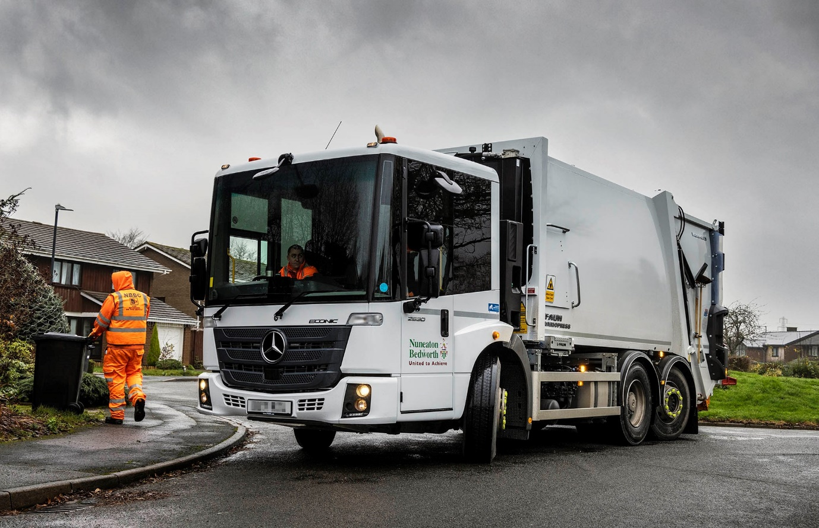

Mercedes-Benz Econic is a proven winner for Nuneaton & Bedworth Borough Council

Nuneaton & Bedworth Borough Council adhered to a tried and tested formula when commissioning its latest refuse collection trucks, a pair of Mercedes-Benz Econics.

The 26-tonne chassis arrived with the West Midlands authority via the Coventry branch of Dealer Midlands Truck & Van.

As 2630 L variants the new trucks are powered by 7.7-litre ‘straight-six’ engines that produce 220 kW (299 hp). They drive through six-speed Allison automatic transmissions, while steered rear axles enhance manoeuvrability.

Fitted with FAUN Variopress compactor bodies and Zoeller Delta high-level automatic split binlifts, Nuneaton & Bedworth Council’s latest six-wheelers have joined a Mercedes-Benz- dominated fleet of 16 refuse collection vehicles.

The authority serves approximately 57,000 households, from which it collects recyclable material, general waste and garden cuttings in wheeled bins.

Head of Waste & Transport Glen McGrandle said: “The 6x2 rear-steer Econic with FAUN Zoeller bodywork is now firmly established as our preferred configuration. The chassis offers excellent build quality and reliability, cost-effective performance, a high level of safety, and comfort and ease of use for our crews.

“Operatives appreciate the ease of access, while the cab is spacious, airy and well laid out. The low seating position and deep, panoramic windscreen provides drivers with a great view and makes it much easier for them to keep a close eye on colleagues working around the vehicle as well as other vulnerable road users, particularly cyclists and pedestrians.

“Our area has a lot of narrow terraced streets,” he continued, “and the rear-steer set-up means these trucks are also very nimble for their size.”

As with all new Econics supplied through the official Mercedes-Benz Trucks Dealer network, Nuneaton & Bedworth Borough Council’s new vehicles are backed by comprehensive three-year/160,000 km manufacturer’s warranties, and came with an impressive arsenal of standard safety equipment.

The Active Brake Assist 5 emergency braking aid, for example, combines camera and radar technology to detect vehicles ahead and stationary objects in its own lane, at speeds of up to 56 mph (90 km/h). Detection of a dangerous situation triggers a three-stage reaction: first, the system warns the driver with visual and audible alerts; then, if the driver fails to react, it applies partial (approximately 50%) braking; finally, if the driver has still not intervened, it initiates maximum braking to bring the truck to a halt, applying the Electronic Parking Brake and activating the hazard warning lights to alert drivers behind.

At speeds of up to 31 mph (50 km/h) Active Brake Assist 5 is capable of applying full braking when encountering pedestrians crossing its path, approaching from the front or walking ahead. Not only does this remarkable technology increase safety for vulnerable road users and vehicle crews, but it also helps to relieve stress for drivers.

Mr McGrandle continued: “These new trucks were part of our rolling replacement programme and have slotted seamlessly into our bin collection operation. Experience has proved that the Econic is extremely well engineered and can be trusted to provide many years of dependable service.

“The HGV fleet is maintained primarily by our transport partner Coventry City Council, supported by NBBC’s internal transport team and by regular parts deliveries from Midlands Truck & Van, and if expert warranty or technical advice is ever needed we know it’s only a phone call away.”

Midlands Truck & Van Sales Executive Alan Stokes said: “We are delighted to be a trusted partner to Nuneaton & Bedworth Borough Council and it’s great to know these trucks will be working hard on streets just a few miles from our Dealership site.”

Stewart Gregory, Commercial Director with primary contractor FAUN Zoeller, added: “Working in partnership with Midlands Truck & Van we’ve provided top-quality vehicles with a simple, headache-free procurement process – a very effective solution all round.”

www.nuneatonandbedworth.gov.uk

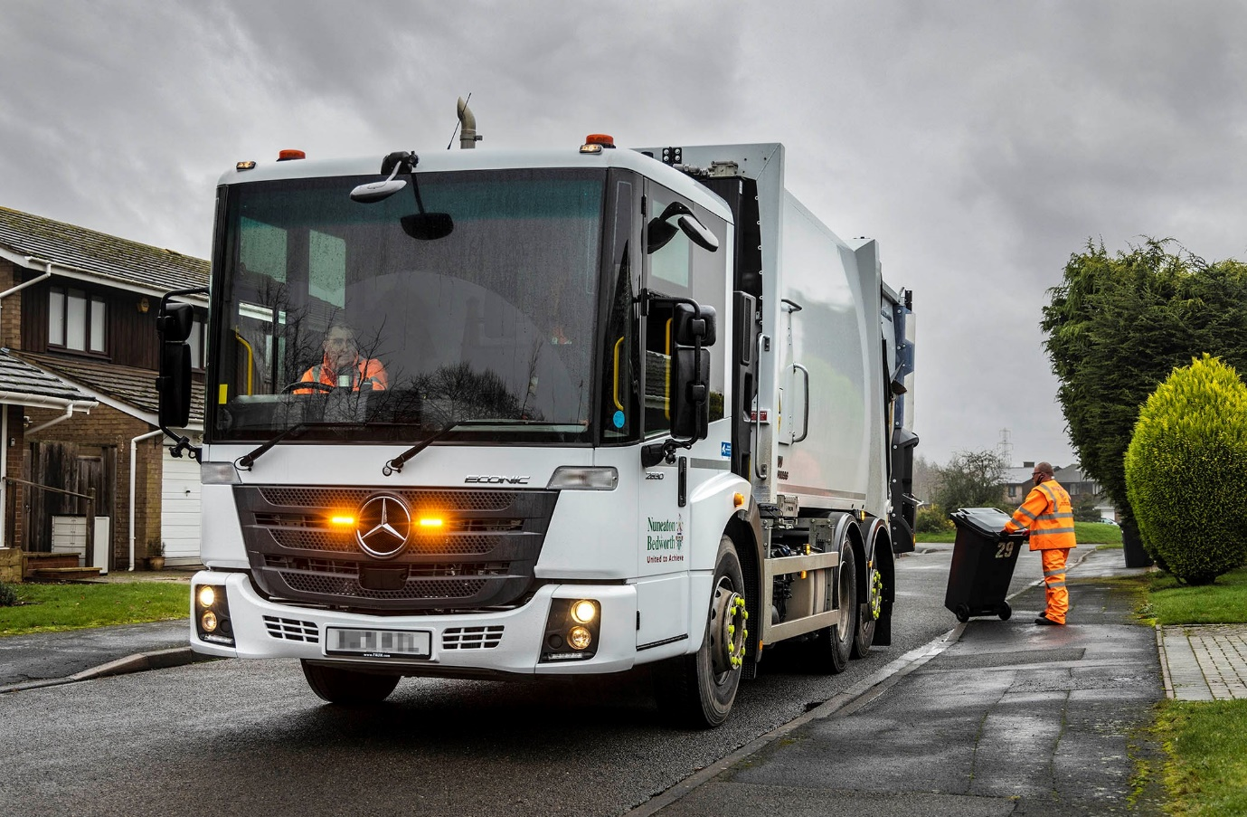

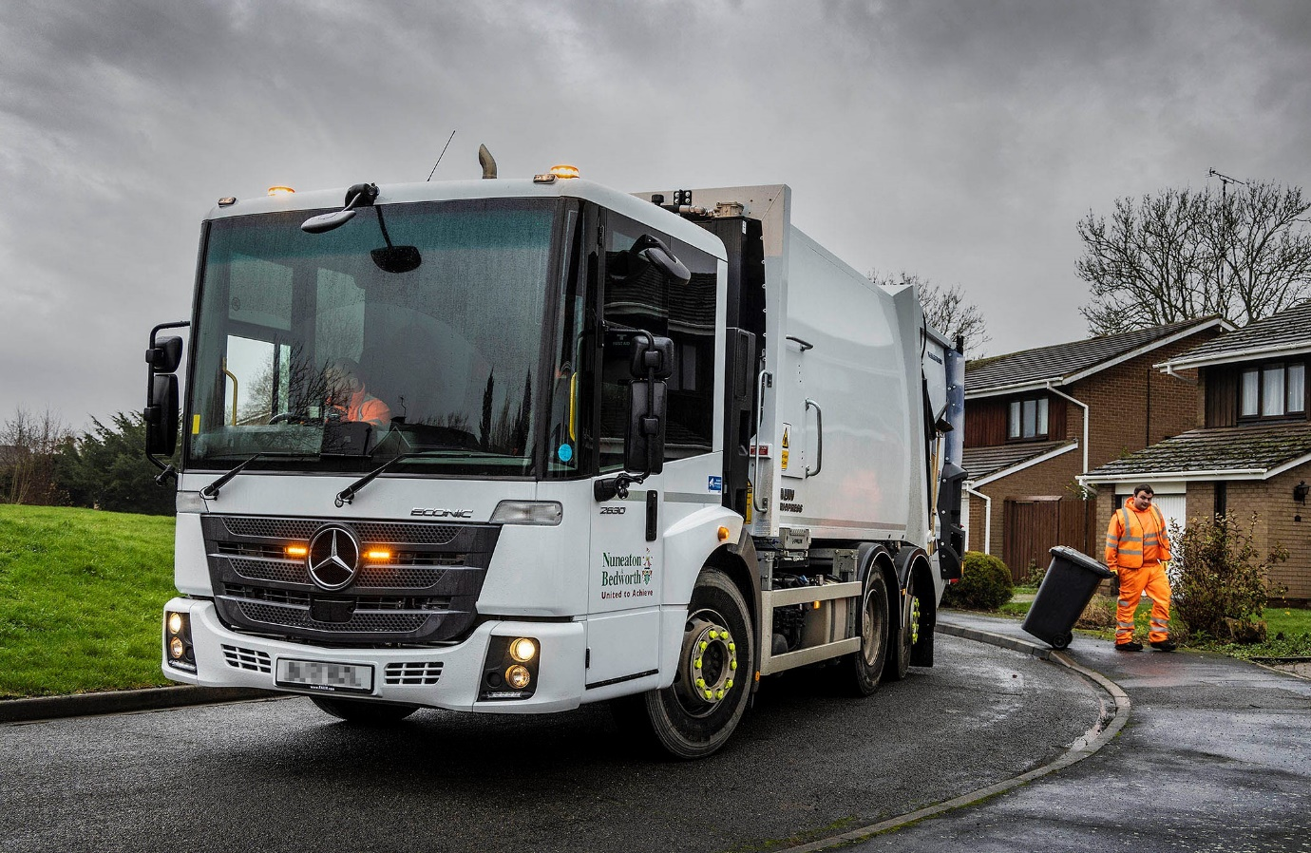

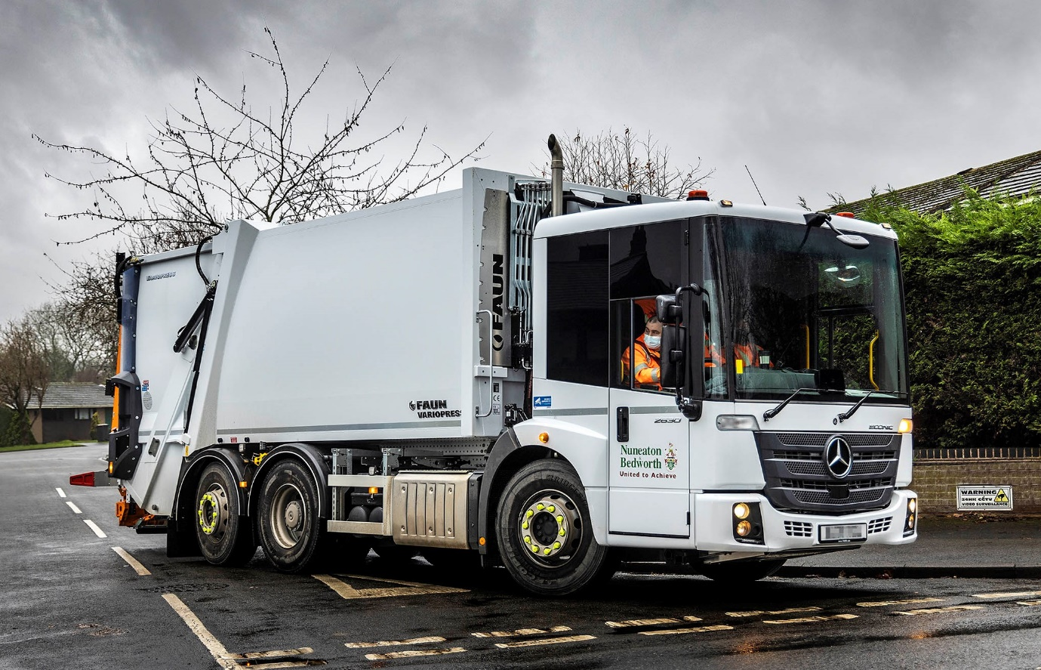

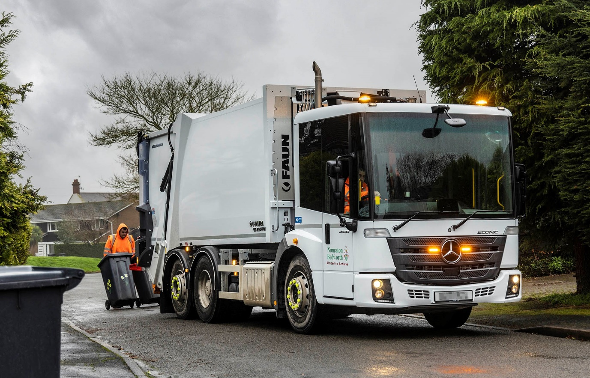

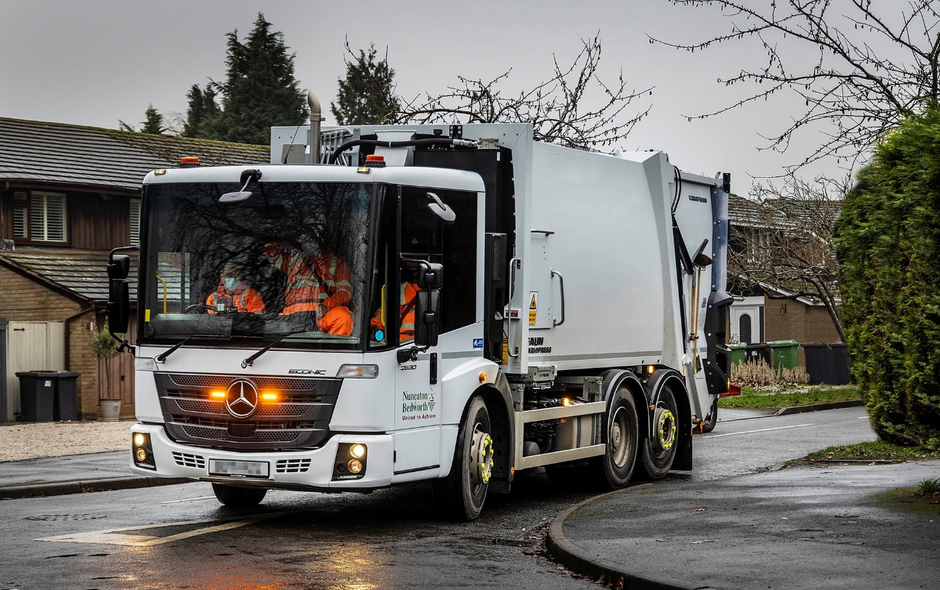

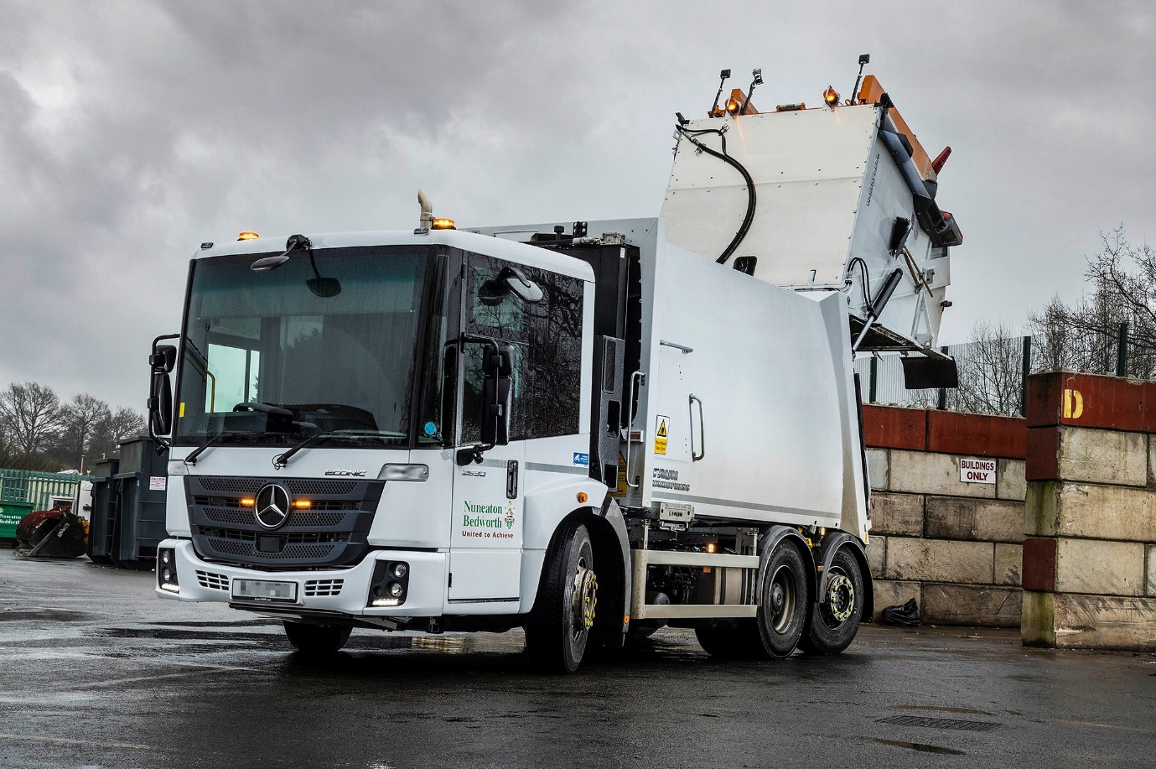

ends

For more information, or to request bigger/higher-res image files, please contact:
Steve Warren or John Ripley
Impact Communications, 01926 842126
Steve: 07770 470251, steve@impactcom.co.uk
John: 07771 484595, john@impactcom.co.uk



