

Date: 17 August 2022

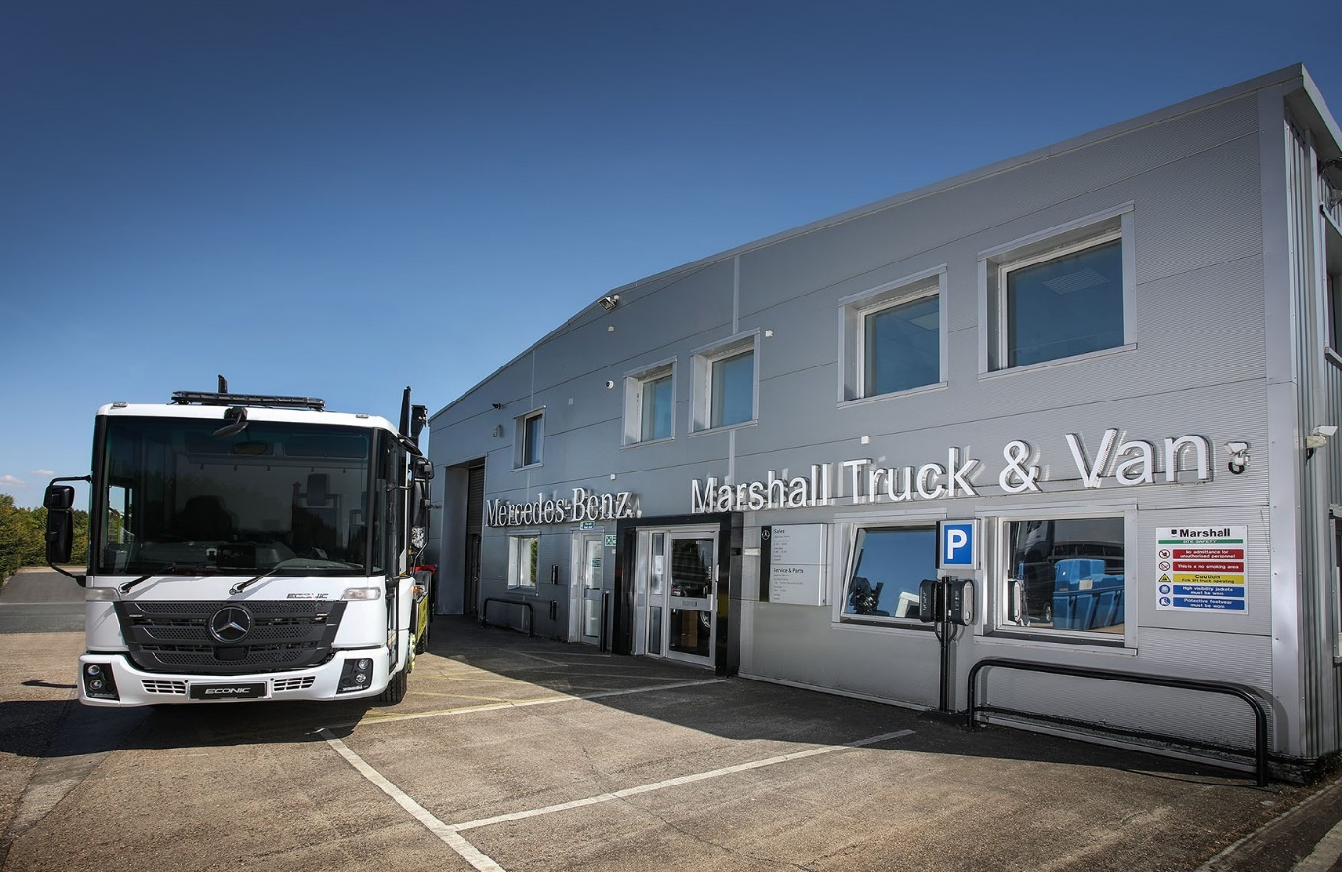

Mercedes-Benz Dealer Marshall Truck & Van raises its service game in Andover

Operators of Mercedes-Benz and FUSO trucks located in north-west Hampshire and beyond are now reaping the benefits of a £1-million facilities upgrade by their local Dealer.

Marshall Truck & Van has extended the workshop at its branch on the Walworth Industrial Estate in Andover, adding an additional couple of bays to the previous four.

One of the new bays is equipped with rollers and other equipment required to undertake tachograph installations, calibrations and repairs. These tasks were previously assigned to an independent specialist that only worked during normal working hours – the Dealer’s decision to bring this service in-house means it can now carry out such tasks late into the night, increasing convenience and restricting downtime for customers.

The nine-month project also entailed the creation of a comfortable new waiting area for drivers, while members of the Marshall Truck & Van team have benefited too – the sales offices have been facelifted, with a new meeting room installed, and technicians who previously took their breaks in a portable unit now have their own canteen and washroom.

Marshall Truck & Van Head of Business Wayne Edwards declared: “The very substantial investment we’ve made at Andover is benefiting customers and colleagues alike, and reflects our determination to be the number one provider of truck and light commercial vehicle sales, maintenance and repair, and parts services on the South coast.”

The Andover facility now exceeds the standards required of its franchised partners by Mercedes-Benz Trucks UK. The comprehensively equipped and stocked Mercedes-Benz Service 24h van based at this site is allocated to highly trained technicians who provide round-the-clock emergency roadside assistance.

Marshall Truck & Van also operates from other branches in Fareham and Croydon, as well as the flagship £3.8-million Dealership at Nursling, Southampton, which it opened towards the end of 2019.

Wayne added: “Our Andover General Manager David Collard and his team have made great strides over recent years, in attracting new aftersales business from locally-based operators.

“The timely, customer-focused back-up that they have worked so hard to deliver has been instrumental not only in enhancing established relationships, but also – as word of mouth has spread locally – in enabling us to win new converts to the Mercedes-Benz and FUSO brands.”

David Collard commented: “The development here at Andover is great news for operators, not least because it means that if a truck comes in at night with a tachograph-related issue we can jump straight on it, rather than having to tell the customer they’ll have to book a separate visit during the day. We aim, as far as possible, to provide a ‘one-stop shop’ service, so the tacho bay adds another important string to our bow.”

He continued: “Colleagues are delighted, too. From a motivational point of view, this is now a smarter, more appealing place to come to work. We’re now endeavouring to bring in more technicians and the enhancements we’ve made can only help with recruitment.”

High-profile operators that rely on Marshall Truck & Van’s Andover team to maintain their vehicles include Howard Tenens Logistics, which purchased its first 16 new-generation Actros tractor units last year. These vehicles are the subject of Mercedes-Benz Complete Service Contracts.

Key to the family-owned company’s decision to place its landmark order, was the Dealer’s support over the previous three years, in looking after the leased units from the outgoing Actros model range that were up for replacement.

Alan Pellow, Howard Tenens’ National Fleet & Compliance Manager, enthused: “The Dealer’s back-up is superb – General Manager David Collard and his workshop team are very helpful and can always be relied upon to get a truck in when we need them to do so.”

Kevin Witts, who manages the operator’s Andover depot, added: “I’ve been in this industry for years and Marshall is the best main Dealer I’ve ever worked with. They are honest and up front, where a lot aren’t, and if I’m struggling to get a vehicle into the workshop they will always move things around to accommodate me. That’s all any transport manager can ask for.”

Meanwhile, electrical goods distributor Ken White Distribution, also of Andover, ran only Swedish-built trucks five years ago. Today, all but three of its 26 vehicles wear the three-pointed star of Mercedes-Benz, and the transformation of its fleet owes much to the aftersales support it receives from Marshall Truck & Van.

“The maintenance contracts are very cost-effective and the service we receive from the Dealer’s Andover workshop is absolutely fantastic,” enthused Director and Transport Manager Ian Reeve. “They’re very flexible and when an issue crops up, as one always will from time to time with even the best trucks, they can always be relied upon to resolve it quickly and efficiently.”

He added: “We still have our own workshop, but we entrust the maintenance of our Mercedes-Benz trucks to the Dealer because it makes our lives so much easier.”

Downes Transport, of Amesbury, Wiltshire, undertakes some maintenance work in-house, but also signs-up to Mercedes-Benz Complete Service Contracts and relies on the support of Marshall Truck & Van, Andover.

“The Dealer’s back-up is excellent,” said Proprietor Douglas Downes. “Its workshop team are very flexible and will always attend to our trucks in the evenings or on Saturdays. On the rare occasions we’ve had a problem, Mercedes-Benz Trucks’ 24-hour breakdown service has also performed every bit as well as we could have hoped.”

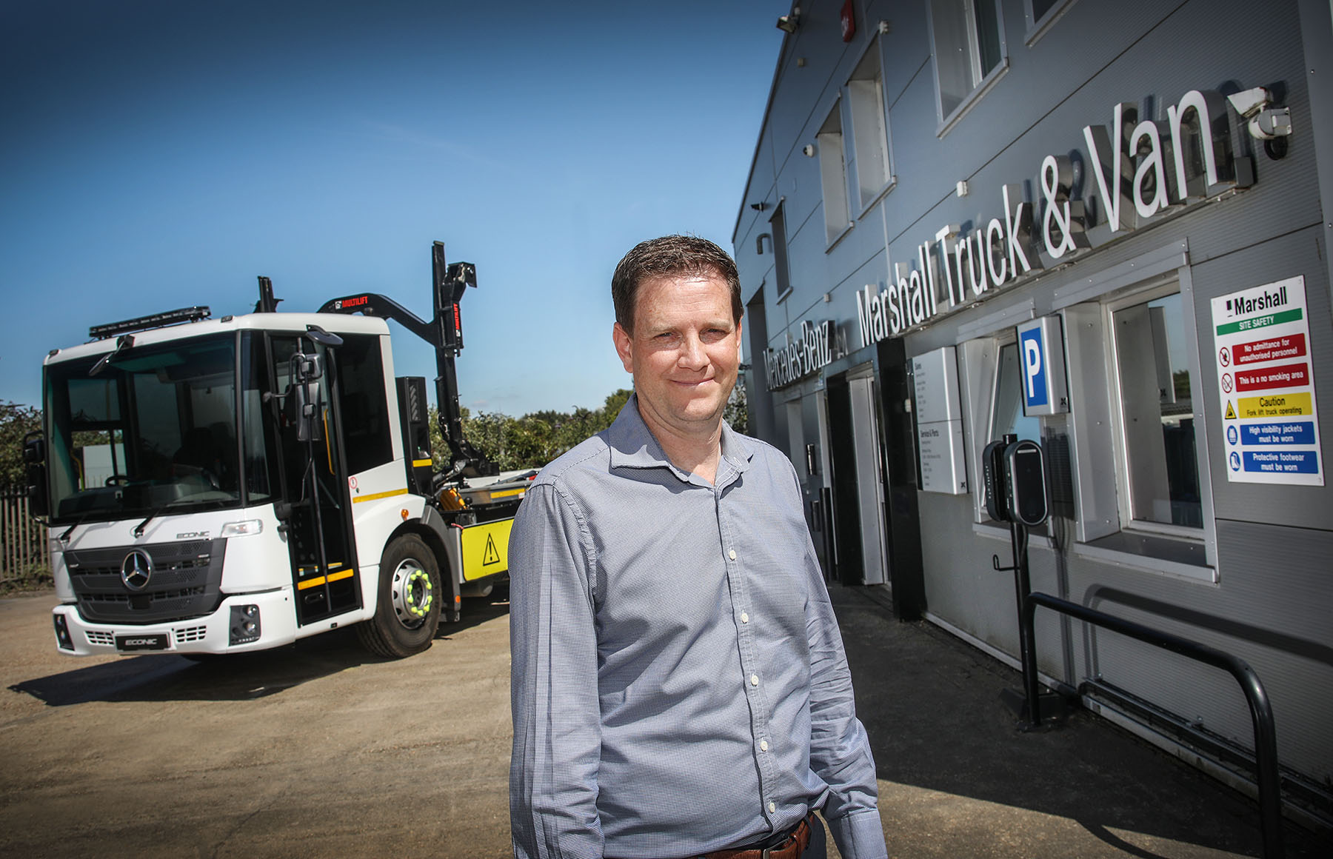

Leading from the front: David Collard, General Manager at Marshall Truck & Van’s Andover branch, has long experience of the Mercedes-Benz and FUSO brands

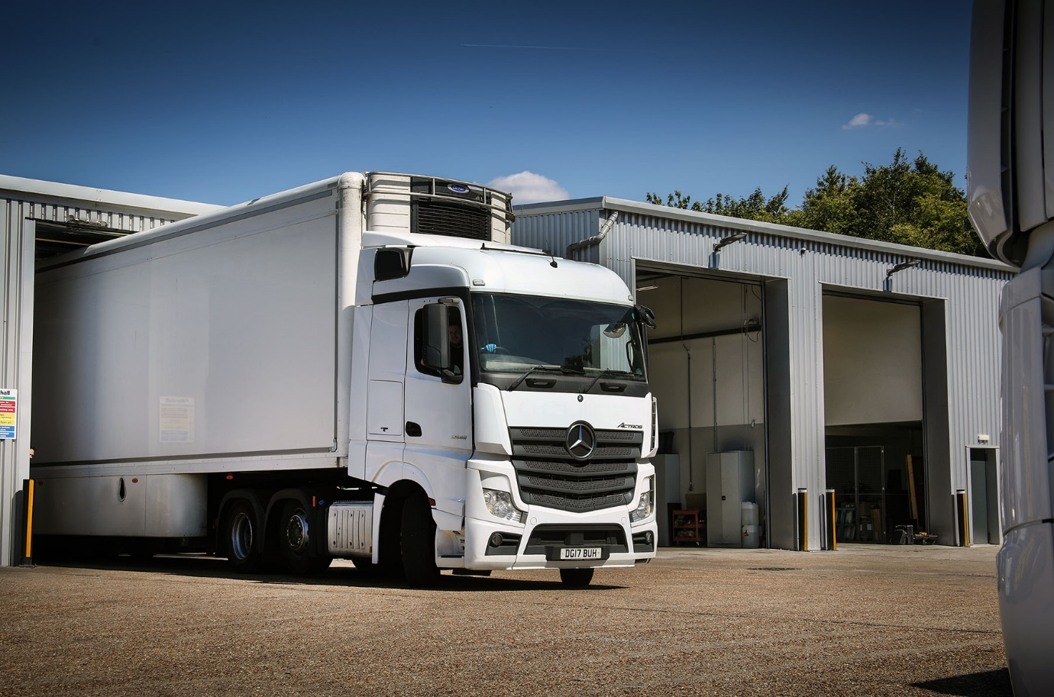

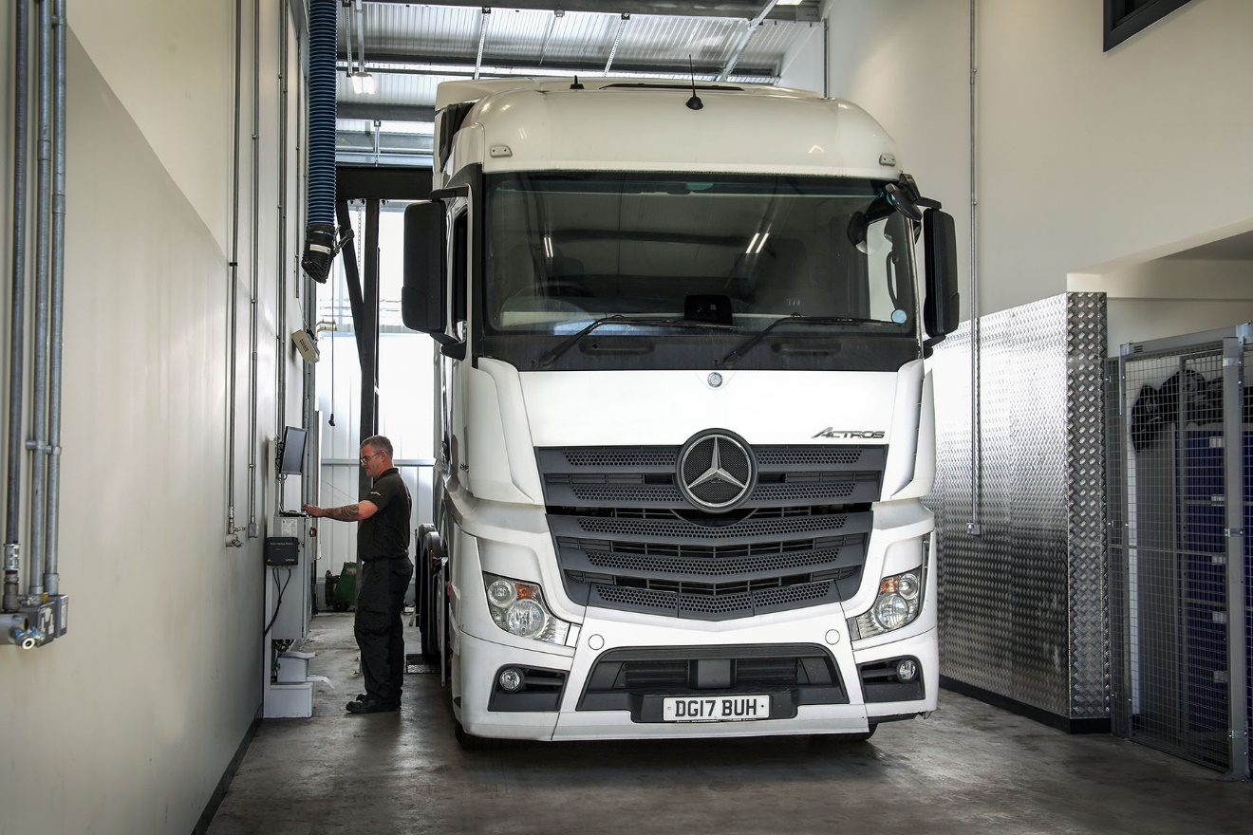

Another ‘string to the bow’: Technicians at Marshall Truck & Van, Andover, can now work on tachographs in their new, dedicated bay, at times that suit customers

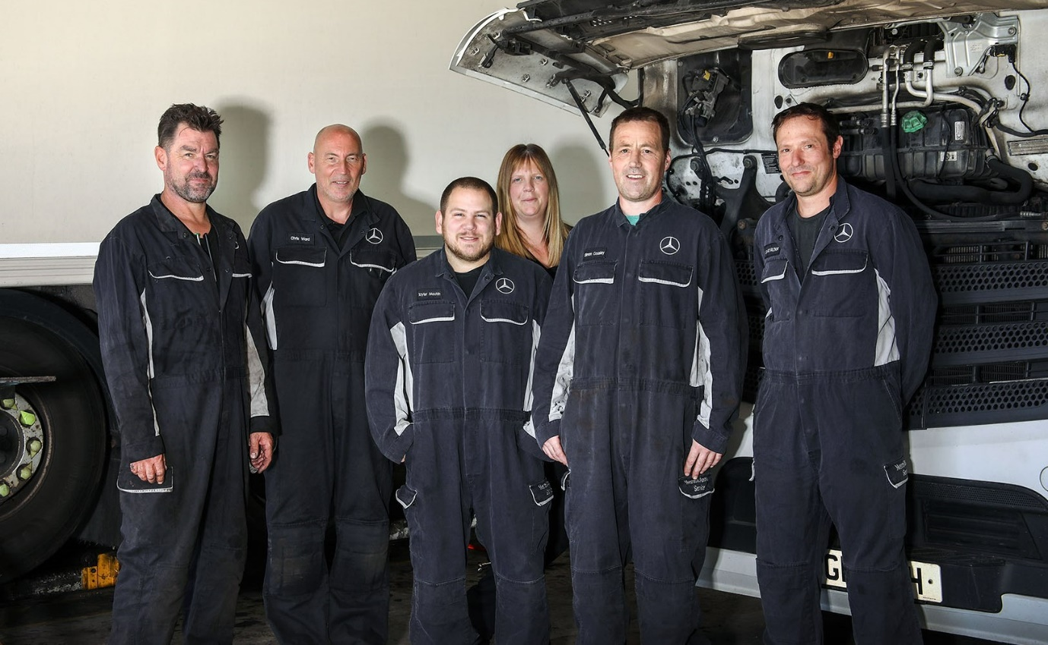

At your service: Andover Workshop Manager Kate Leonard is pictured with technicians, from left, Gary Hayward, Chris Ward (Technical Specialist), Tayler Machin, Simon Causley and Stuart Glover
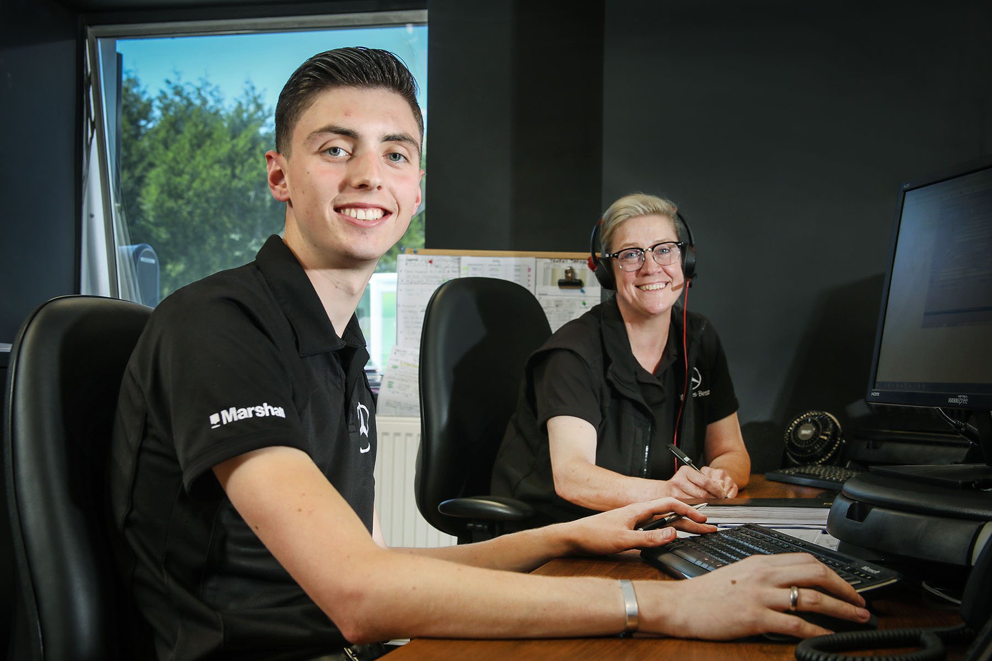

Point of contact: Service Advisors Kim Banwell and Charlie Francis, a relatively new member of the team, are ready to help customers

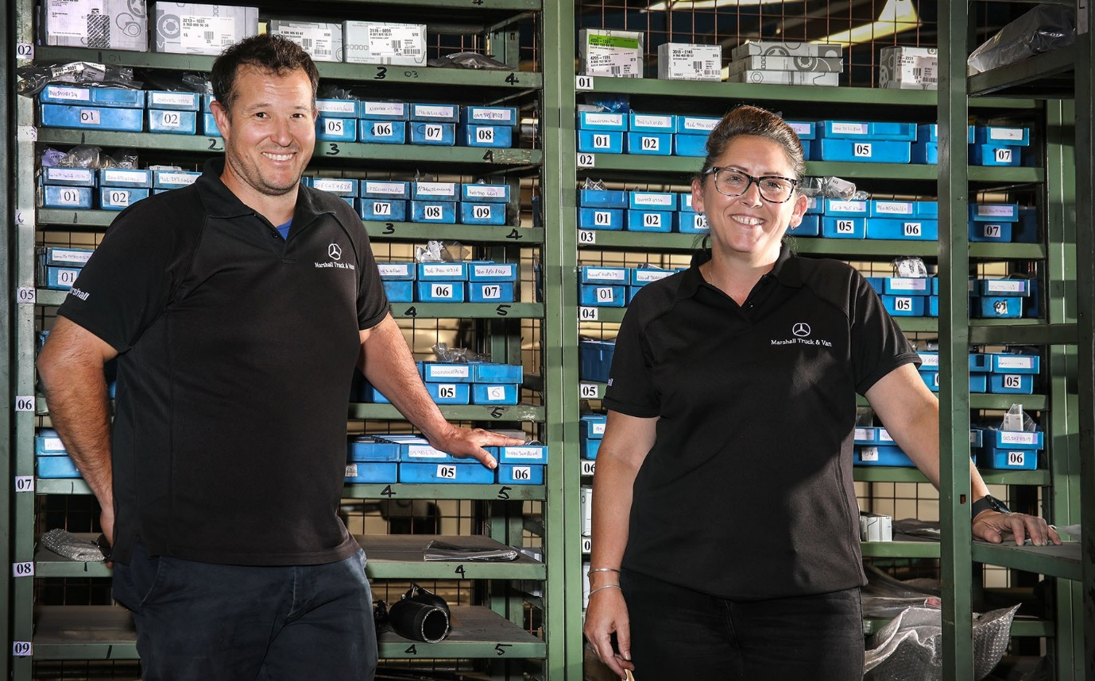

Playing their Parts: Supervisor Anthony Gillmore and Advisor Wendy Miller ensure the shelves are always well stocked

ends

For more information, or to request bigger/higher-res image files, please contact:
Steve Warren or John Ripley
Impact Communications
Steve: 07770 470251, steve@impactcom.co.uk
John: 07771 484595, john@impactcom.co.uk

