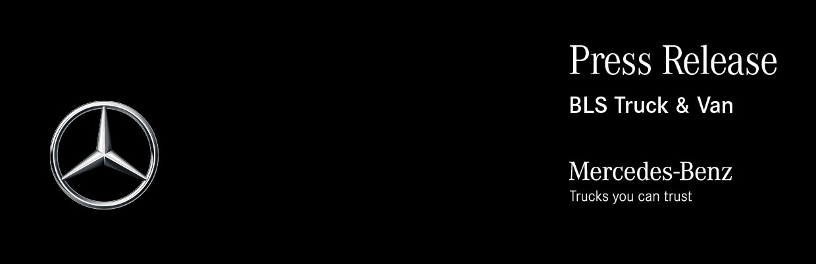

Date: 27 June 2022

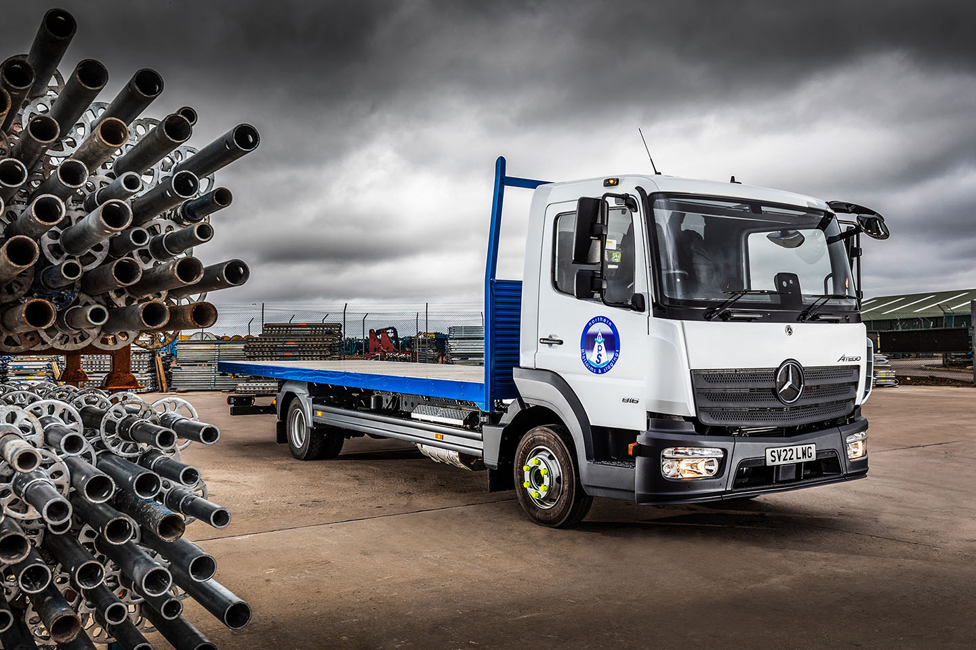

Scaffolding firm keeps on climbing with another new Mercedes-Benz Atego from BLS Truck & Van

The dependable performance of its Mercedes-Benz trucks, coupled with positive feedback from their drivers, help to keep Northern Platforms & Stagings at the top of its game.

So when the Aberdeenshire scaffolder needed another 7.5-tonner, its first call was to the manufacturer’s representative in the north of Scotland.

The new Atego is the fourth that Peterhead-based Northern Platforms & Stagings has purchased from BLS Truck & Van, since the Dealer’s appointment in 2018.

Like its predecessors, the truck is an 816 variant with ClassicSpace S-cab and a 5.1-litre engine that produces 115 kW (156 hp) and is paired with a smooth and fuel-efficient Mercedes PowerShift 3 automated manual transmission. Its platform body, meanwhile, was built in Mirfield, near Huddersfield, by Advance Commercial Bodies.

Acquired with funding support from Mercedes-Benz Finance, the Atego is now being inspected and maintained under a Mercedes-Benz Complete Service Contract at BLS Truck & Van’s workshop on the Altens Industrial Estate, Aberdeen.

Northern Platforms & Stagings was established in 1984 by John Johnston, who remains at the helm as Managing Director. The company offers a comprehensive range of scaffolding services at competitive prices but without compromising on safety. It has extensive experience of serving customers from the petrochemical and marine engineering sectors in the Grampian region, as well as local builders and construction firms.

The Atego range from 7.5 to 16 tonnes GVW is purpose-designed for light- and medium-duty distribution work, and construction applications. As well as offering precise handling with exceptional ride comfort, it enjoys an unrivalled reputation for reliability and durability.

John Johnston confirmed: “We’ve been running Mercedes-Benz vehicles for well over 10 years and have never had any problems with them. The fact that they don’t let us down means they make a valuable contribution to the efficiency of our operation.”

In addition to the three trucks it currently relies upon to transport tubes, boards and other fixtures and fittings to and from sites, Northern Platforms & Stagings runs a small fleet of eight vans.

Mr Johnston continued: “The Atego is entirely fit for purpose. It’s the right size and carries the weight well, while the guys like their trucks because they’re so comfortable. As a business with an unwavering commitment to health and safety, and compliance, we’re also reassured by the knowledge that Mercedes-Benz Trucks leads the field when it comes to the protection not only of those who use its vehicles, but also of other road users.”

Commenting on the support his company receives from BLS Truck & Van, Mr Johnston added: “The repair and maintenance contracts work very well, not least because they allow us to fix our prices in advance. We had one or two early issues when the Dealer first took up its franchise but for some time now its service levels have been right where we need them to be.”

northernplatforms.co.uk

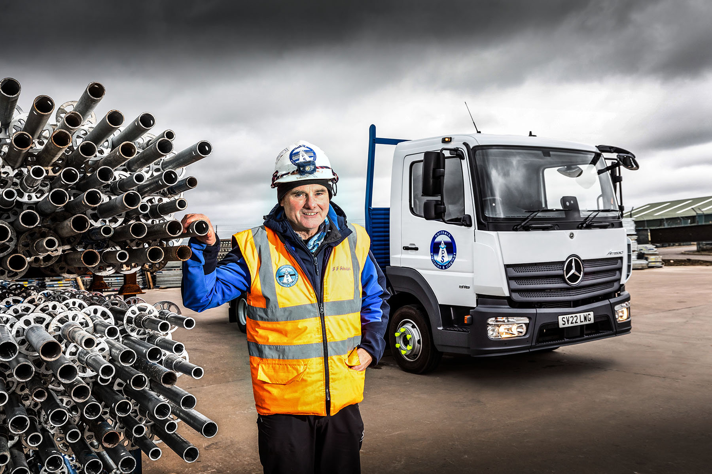

Just the job: There’s only one 7.5-tonner that offers John Johnston the reliability his company needs, and it wears the three-pointed star of Mercedes-Benz

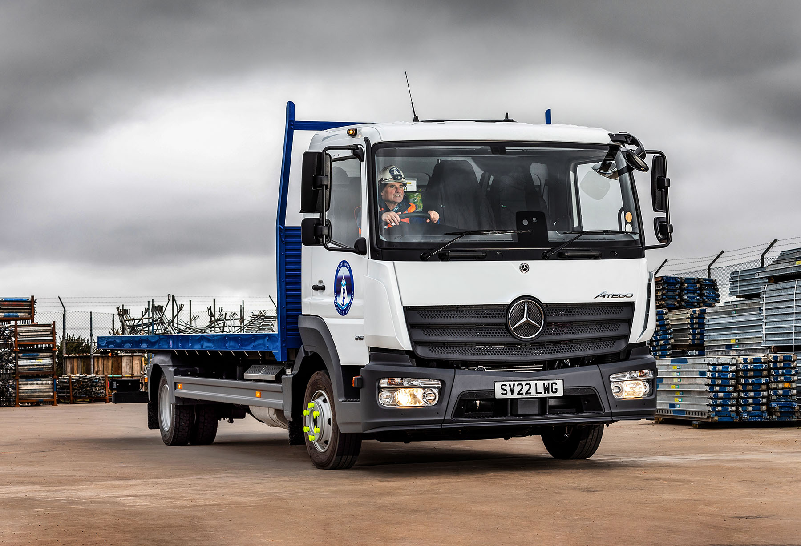

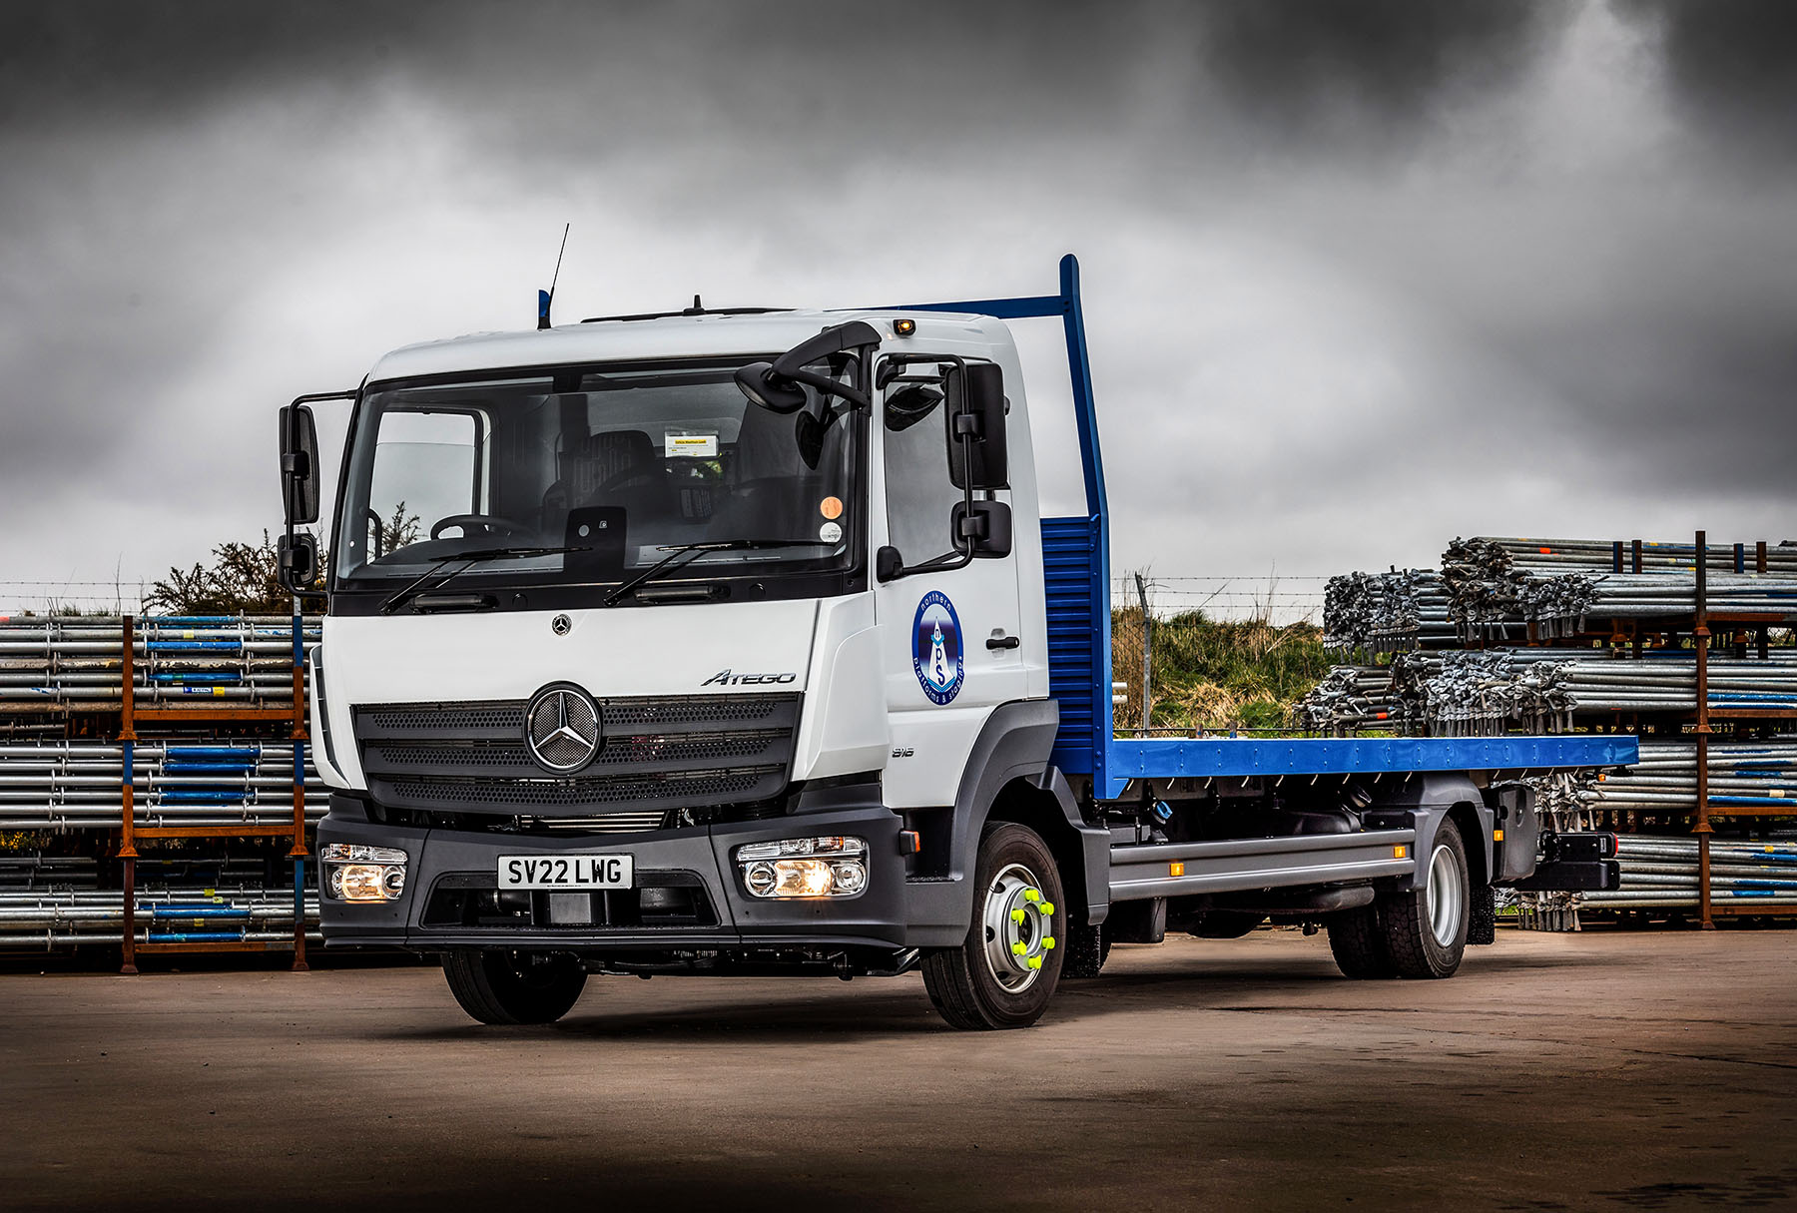

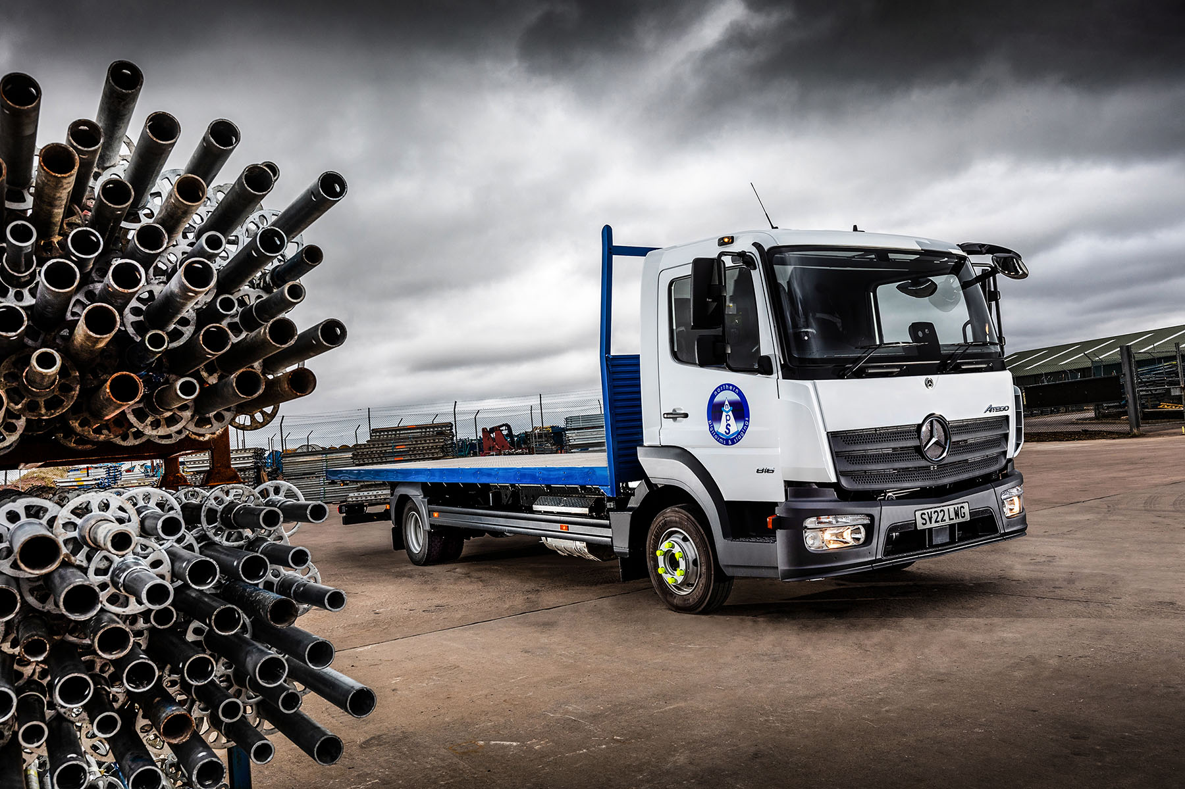

ends

For more information, or to request bigger versions of image files, please contact:
Steve Warren or John Ripley
Impact Communications
Steve: 07770 470251, steve@impactcom.co.uk
John: 07771 484595, john@impactcom.co.uk

